Mobile Application Development II
  - Lecture 11 Lab Tutorial Exercise

The Criminal Intent App Part VI

Objectives
In today’s exercise, you will update the app to use an implicit intent to take pictures with the device’s camera.

Exercise 1: Adding a Photo to the Layout
- The first step is to modify the layout for a place for the crime photo as well as a button to press to take the photo.
- This will mean modifying the existing layout a bit. But you will create a reusable layout part that can be used and included in both the portrait and landscape versions.
- Create a new layout file called view_camera_and_title.xml or whatever you want with a default Linear Layout style. Set:
  - Layout width: match parent
  - Layout height to: wrap content
  - Left and top margins.
  - Orientation: horizontal
- Add a child linear layout and set:
  - Orientation: vertical
  - Layout width and height: wrap content
  - Add the following to it:
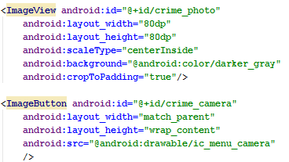
- Add another child linear layout after the last one and set:
  - Orientation: vertical
  - Layout width and height: wrap content
  - Layout weight: 1
  - Open the fragment_crime.xml layout file
    - Cut the Title TextView and Crime Title EditText view objects.
    - Paste these into the empty linear layout in the view_camera_and_title.xml layout file.
- Return to the fragment_crime.xml and add the following in place of the deleted textview and edittext view objects.
- Open the landscape version of the fragment_crime.xml and replace the Title TextView and Crime Title EditText view objects with the include layout statement too.
- You can close the layout files.

Exercise 2: Getting the Photo File Location

Updating the Model
- Each photo will be saved with a file name of the following format:
IMG + CrimeID
- Open up Crime.java and add the following method.
// Return the crime photo image filename
// The file name is a concatenation of the "IMG_" plus the crime ID
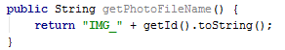

Update Crime Lab to Locate the Crime Photo
- Open up CrimeLab.java.
- Make the following highlighted correction to the CrimeLab constructor.
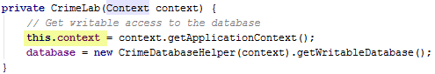
- Add the following new method to it.
// Return the photo file for a specified crime
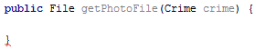
- Add the following to the getPhotoFile method.
  - // Get the pictures external storage directory folder
  - // Check that it found the directory
// If not, return null and exit early
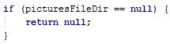
  - // Return the crime photo file from the directory

Exercise 2: Taking Photos with an Implicit Intent
- Add the following permission to the Manifest file as a direct child of <manifest>
- It is also good practice to tell potential users and Android when your app uses a feature like the camera or any other feature that varies from device to device. This will allow apps like the Google Play Store to refuse to install your app if it uses a device feature that it does not support.
  - Add the following declaration to the manifest to inform Android that this app uses the camera.
  - Setting the additional attribute required=false simply tells Android that your app will still work without this device feature as you do check in the code to see if the camera is supported. Thus, it is not a required feature.
- Open up CrimeFragment.java.

Initialising
- Add new declarations for the photo image view and the camera button objects.
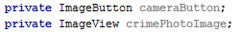
- Also add a variable to store the crime photo file.
- Initialise the photo image view and the camera button objects in onCreateView
- Create a click event listener for the camera button and don’t forget to bind the click event listener method to the camera button in the onCreateView() method.
- Next, locate the onCreate method and initialise the crime photo file variable using the method added to CrimeLab in the last exercise.
// Get the crime photo image file

Firing the Intent
- Next you need to start the implicit intent to take the photo.
  - The action will be: ACTION_IMAGE_CAPTURE
  - You will also expect this action to return a result (the photo), so you will use the startActivityForResult method.
- Add the following constant variable to the crime fragment class to identify the request for a contact.
- Also add the following declaration to initialise the implicit intent for capturing an image.
- Note: By default, the ACTION_IMAGE_CAPTURE action takes a small resolution thumbnail image. For a full-resolution output, you have to tell it where to save the image file on the filesystem by passing a Uri pointing to the file location using the MediaStore.EXTRA_OUTPUT extra information constant.
- Go back to the onCreateView method and add the following to disable the Camera button if there is no camera app on the device (add after the check for querying contacts).
// Check device has camera app, and if not disable camera button.
// Otherwise add the extra information (image file name to save photo) to the intent
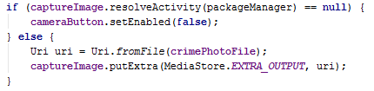
- Locate the click event listener for the camera button and start the intent activity.
// start the implicit intent to take a photo
// expecting a result back (the captured photo)
- Test your app – best tested on a real device.
- The camera hopefully worked, but you probably noticed that the image is not displaying yet – next step.

Exercise 3: Loading up and Displaying the Photo Image File.
- You need to load the image into a reasonably sized Bitmap object. Luckily the BitmapFactory class can be used for this.

Picture Utils Class
- Create a new class in your app called PictureUtils.java or whatever you wish.
- Add the following method to decode the image file and scale it.
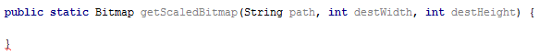
- Add the following to the method.
  - First read in the file to determine its dimensions and by how much you need to scale it to fit the display area.
// First decode with inJustDecodeBounds=true to check dimensions
// read in the dimensions of the image on disk
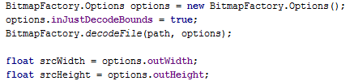

  - Calculate the scale size and then reread the file with the scale options to create a scaled down version to display.
// Calculate inSampleSize - scale to size
int inSampleSize = 1;
if (srcHeight > destHeight || srcWidth > destWidth) {
if (srcWidth > srcHeight) {
inSampleSize = Math.round(srcHeight / destHeight);
} else {
inSampleSize = Math.round(srcWidth / destWidth);
}
}
options = new BitmapFactory.Options();
options.inSampleSize = inSampleSize;

  - // Return the decoded image file with the calculated options
- See more on loading bitmaps here: https://developer.android.com/training/displaying-bitmaps/load-bitmap.html
- Unfortunately, you will not know in advance how large the view area is for the photo image until it loads the layout – a layout pass happens. The first layout pass happens after the onCreate(), onStart and onResume() initially run. There are two ways to solve this problem:
  - Wait until a layout pass happens
  - Use a conservative estimate – less efficient, but easier to implement. Nonetheless, this is the approach we will use.
- Add the following method to the PictureUtils class.
public static Bitmap getScaledBitmap(String path, Activity activity) {
Point size = new Point();
activity.getWindowManager().getDefaultDisplay()
.getSize(size);
return getScaledBitmap(path, size.x, size.y);
}

Crime Fragment Class
- Return to CrimeFragment.java.
- Create a new method called updatePhotoView with a return type of void and add the following to it:
// Check if photo file exists
// If not, make it non-drawable - hide it,
// Otherwise get a scaled bitmap of the photo and display it
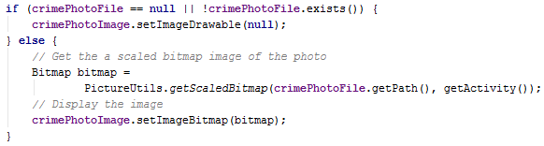
- You want to update the image when the take photo implicit intent returns the resulting photo image.
  - Locate the onActivityResult method and add another else if {} block as follows. Ideally, should have used a switch statement.
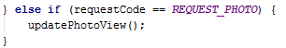
- You also want to load the photo if it exists, when the crime is loaded. Locate the OnCreateView() method and call updatePhotoView() at the end of the method before the view is returned.
- Test your app. Hopefully, it now displays the bitmap image.

Exercise 4: Challenge Exercise
- The thumbnail image is quite small as expected. Create a new DialogFragment that displays a zoomed-in version of the crime scene photo. When the user presses the thumbnail, it should show the DialogFragment.
- The more efficient method of getting the thumbnail size can be achieved using the ViewTreeObserver. Search Google for how you can implement the more efficient approach. Some suggested key terms to search are:
  - android getviewtreeobserver example
  - android viewtreeobserver example
- That’s all for today

Adapted from Android Programming: The Big Nerd Ranch Guide

