

HPDA6003
Independent Project
BA Dance

Title: Diminution of education dance and it’s effect on the Welsh dance industry, Colleges and Universities.

Contents
Page
Abstract 4

Chapter one
- Introduction 8

Chapter two
2.0. Review of Literature 12
2.1. Supporting dance in the National Curriculum 12
2.2. Closure of BA Dance in University of South Wales 13

Chapter three
3.0. Methodology 16

Chapter four
4.0. Results 20
4.1. Questionnaire
4.2. Interview 28

Chapter five
5.0. Discussion 35
5.1. Top UK University rankings research 36
5.2. Questionnaire evaluation 38
5.3. Interview Evaluation 40

Chapter six
6.0. Conclusion 45

Bibliography 48
Appendices 50
Appendix A: Interview questionnaires 50
Appendix B: Questionnaire question 51
Appendix C: Consent form 54

List of Tables
Table 1 – Top UK university rankings table 38

List of figures
Questionnaire answers
Figure 1– Gender 20
Figure 2– Age Category 20
Figure 3- Nationality 21
Figure 4- Year group/college/university 21
Figure 5- Hours of dance 22
Figure 6- Hobby 22
Figure 7- Dance participation in education 23
Figure 8- Taking dance further 24
Figure 9- At what level 24
Figure 10- more than a hobby 24
Figure 11- Courses in Wales 25
Figure 12- schools/colleges/universities offering more courses 25
Figure 13- Wider dance industry 25
Figure 14- Schools encouraging dance background 26
Figure 15- Core subjects more important than dance 27

Figure 16- Further education sector income 46

Abstract

This study aims to understand why dance is getting less popular within education, and the reasoning behind dance education courses closing within Wales. Firstly, this study will look at the UCAS rates between Wales and England that have stand- alone dance courses. And whether dance is losing its place on the national curriculum, and the reasonings behind this happening. This shall be achieved by thorough research into each university and university courses which involve dance in Wales and England, also looking into the place of dance within primary schools and secondary schools.
People’s views and opinions are a big part of this study. Which suggests that another aspect of this study is to gather information from 10 dancers in a local dance school via a questionnaire which will gain information such as their aspirations regarding dance, and whether they had or have the chance to study dance within education at GCSE, A-level or at university. Structured interviews were also a part of this study, these interviews were based on the importance of dance in the education sector, and more importantly why courses within Wales are closing. To gather all this information from lecturers and dancers it was felt that these were the most effective way to gather the correct information that was needed.
The study showed that most dancers who had taken part in this study didn’t know about the courses that are held in Wales, past and present courses. Many of the dancers didn’t want to take dance further than a hobby. This may explain the numbers dropping within university courses, and the reasoning behind some closing within Wales. The dancers stated that P.E and after school sessions were the only time they had within education to dance, and this wasn’t often enough.
After analysing the answers from the questionnaires, there was a lot of thorough information on the reasoning behind the course closure. The main problem stated was that dance within education is vital for the wider dance industry, and the lack of numbers within courses is problematic, and one of the main reasons why the course had closed at Coleg Sir Gar.

Chapter one
Introduction

- Introduction
Why do people dance? “Dance is the hidden language of the soul." Martha Graham. Do people wish to take it further? To study the art or as a profession? Or do they simply want to dance for leisure? According to Yell (2020) there are 250 community dance schools in Wales, a significant amount for a small country. In this case, if there are so many dance schools why are dance education courses lacking in Wales? Courses like dance GCSE, A-Level courses and university courses.
There is always an ongoing argument on how important or not the arts are within schools. Before the education reform act in 1988, dance wasn’t involved in the National Curriculum. Since then, it has become part of the National Curriculum, and used within Physical Education. This is due to the numerous similarities dance shares with P.E, as reported by Sanderson (1996) the association that dance has with P.E has an emphasis on performance qualities, and the endorsement of a healthy lifestyle and positive attitude to fitness and sport. Dance can also be used in other subjects and not only P.E. Children and students have different ways of learning, and dance has all the skills that can help a child to learn. For example, dancers are constantly counting as they dance, if a young child was somehow struggling with numbers and counting, dance could be a big help to this child.
Last year Wales offered two dance courses at a degree level, currently, there is only one university that offers a dance course, which is University of Wales Trinity St David. This course is purely a dance course and hasn’t been merged with any other subject. GCSE and A-Level courses have started to merge with performing arts or physical education, which suggests that the stand-alone dance courses are decreasing. Between Wales and England, there is an extreme difference in the total of courses that are on offer, according to UCAS, there are 212 courses from 67 universities, these courses are a mix between stand-alone dance courses and courses merged with another subject. Compared to Wales, where there are 2 courses, one of which is merged with sports. This suggests that dancers that wish to take their dancing further and into an educational field have many more options to travel and move further afield to have their education in dance. Dancers may also not want to move away from their families to start the courses in England, which then leaves them without the option of having a GCSE, A-level or degree in dance.
To collect data, I will be creating a questionnaire which will be sent out to dancers in a local dance school, these dancers are almost starting their GCSE’S, in the middle of them or in the middle of A-level courses who will then be thinking of universities and what they want to do. The questionnaire will be made up of questions regarding their past and current training, the experiences they have encountered in schools involving dance, and where they wish to take their training. The questionnaire was made using Google Forms, and will be sent out and completed electronically to the chosen participants. These individuals are currently dancing in a local dance school which makes it easier to get into contact with if they have any problems regarding the questionnaire. Before sending out the questionnaire, a consent form was sent out to ensure that their parents or guardians were happy for them to participate in the work and had an idea of what the work entailed. I will also be gathering information from college lecturers who are highly involved in the past and present dance and performing arts courses that are to be had. The interviews will involve a series of questions which will be answered by the chosen lecturers. The interviews will be recorded on a mobile phone if the interviewees are happy with this. The questions will involve their thoughts on the current and past dance courses that they have been involved in, whether it being their own studies or being a lecturer of a dance course.
Before reading and gathering research on this topic, my initial predictions of this work was that there would be a difference of numbers between dance courses in Wales and England, but unsure as to what extent this difference was.
Another prediction was the reasoning behind the dance courses merging, and even closing in Wales. This prediction was based on the costs of the courses running, and not enough community dance schools in rural areas where the courses were or are still running. For example, in places like, Swansea and Cardiff, there are lot more community classes around them areas so there’s the likelihood that dance and drama courses there would survive a lot longer than the rural places in Wales. This also brings up the problem of having to travel if you do wish to have an education in dance. Money is another problem in the dance industry. In this case, to keep a course running with only 4 dancers isn’t cost effective and instead of getting rid of the courses completely, courses are now merging with other subjects such as performing arts.
Another possibility would be that young dancers aren't educated enough in their own local dance schools to realise the opportunities out there regarding dance education and the amount of occupations dance brings, and not just becoming a dance teacher at the end of their studies.

Chapter two
Review of Literature

2.0. Review of Literature

2.1.

This blog made by Jan De Schynkel is about the reasoning behind why individuals should be encouraging to support dance in the National Curriculum. Jan De Schynkel is a dance manager at Arts Council England. And has a high amount of passion for dance to become part of the National Curriculum.
The reasonings behind supporting this is that there’s enough money behind P.E and Sports Premium to pay for it. Dance is mostly a part of P.E in schools, but only a small amount of it is demonstrated throughout the year in classes. Politicians know the worth that the arts have on the vital key skills that dance brings within the work force. “The creative Industries have grown faster than any other sector”
Saying this, the government also realises the influence that the art brings in a “broad and balanced curriculum.” Which makes STEM (Science, Technology, Engineering and Maths) become STEAM by adding in the Arts.
Apart from dance’s link with P.E within schools, dance is shown to become more popular amongst young people and children. Dance develops creativity, physical literacy and social skills. This benefits children and encourages them to use the same skills in other subjects all thanks to dance.
In England, schools are applying for an organisation called Arts Mark. The reasoning behind this is that the schools wish to develop dance further within their curriculum and not only within P.E.
The funding for P.E and Sports Premium gives dance within schools a huge opportunity to help build, with the budget that they are given. “A typical primary school will receive over £9,00 a year.” This money must be spent on P.E and Sports Premium only, to improve the subject, and the teaching qualities given by the teachers. This money can be used by training staff the techniques of dance, or to bring in dance experts or dance teachers to teach a class. This involves paying skilled teachers to lead a class, to send teachers on a course that involves dance training and paying for equipment or materials that are needed to help the session.
(Schynke, 2014)

2.2.
An article on The Stage made by Matthew Hemley explains the reasonings behind the dance course closure at University of South Wales.
“The University of South Wales has axed its dance degree, in a move described as short-sighted and devastating for students.”
There have been many cancellations at higher education institutions, but this curse is the most recent course to close. This closing followed on from the suspension of the acting and directing courses at the Drama Centre London. Similarly, the BA (hons) Dance and theatre and performance degrees at the Guilford School of Acting have also been dropped.
The course had its first graduation this summer, and there will only be 3 more to follow.
The university in Cardiff states that they are closing its BA Dance course while it works and continues to change the courses curriculum. This is to ensure that the students develop their own skills and to open new opportunities for their future careers.
From the university, a spokesman has said that “projected recruitment figures for the degree mean that we will not have enough students in future to be able to continue to provide a high-quality education”
The university have done everything to support the courses team over the years but haven’t seen the course numbers grow in order to continue and recruiting.
The course closure was said to be not taken lightly. University of South Wales are making sure that the students who are still studying on the course will get the best opportunities and educational experiences possible.
(Hemley, 2019)

Chapter 3
Methodology

3.0. Methodology
A qualitative approach was mainly used throughout this project. With a slight touch on quantitative research due to the statistics shown on the graphs and pie charts of the questionnaire analysis. The qualitative approach was due to the type of data needed, which was based on someone’s thoughts and feelings about the subject area. The definition of qualitative as said by Ashley Crossman (2019)
Qualitative research is a type of social science research that collects and works with non-numerical data and that seeks to interpret meaning from these data that help understand social life through the study of targeted populations or places.
Through my research, my aim was to have an understanding behind the reasoning of the courses closing and merging. And to understand a dancer's point of view, and their opinions on dance education and whether they would pursue a career within dance.
The most effective way to gain this kind of information was to conduct questionnaires and interviews. The questionnaires would go out to the dancers, and the interviews were used to speak to current and past lecturers of a dance course in Llanelli, Coleg Sir Gar. The reasoning behind these interviews were that the lecturers would have had first-hand experiences within this research field, whether it being as a lecturer or being a student and the struggles or benefits they had faced themselves. The reasoning behind having interviews with the lecturers instead of questionnaires were that they could expand more on their answers, which resulted in asking additional questions which wouldn’t have been possible through a questionnaire. “Expressing your opinion is one of the few ways, if the not the only way, society progresses” (O’leary, 2015).
The questions for the interviews were structured, but also open. The interviews were recorded, in order to not miss any important information. But notes were also taken during the interview.
As for the questionnaires, the target audience were dancers in a local dance school, between the ages of 13-18. The questions were also structured, which were made using Google Forms. The benefits behind using google forms is that pupils tend to use the same format in schools, it’s easy to send out to the individuals as it’s electronically, and a faster way to fill in the questionnaire. The software automatically converts the data into pie charts and percentages, and you can easily export the data into an excel spreadsheet. The questionnaire consisted of general questions about the dancers, questions about their dance training, questions regarding dance within education and their future aspirations involving dance. These individuals are from a variation of primary and secondary schools which will give the questionnaires an array of answers in that section. Before sending the questionnaires out, a consent form was made and given to the parents or guardians of the individuals. This was to ensure that the parents had an idea of what the work involved, and their permission to include their child within my study. A consent form also informs participants and parents that all their personal details and answers will be completely confidential, and their names will remain anonymous within the research (Oppenheim, 1992). The consent form was handed out with the strict instructions to email or phone the researcher if there were any problems or if they wish their child not to be included in the research by a certain date. Within the consent forms, the purpose and information about the study was stated, in order to ensure that the individuals had an idea of the sort of questions that they were going to answer beforehand, and to understand the concept of this study. The answers from the questionnaire are all anonymous and under password protection, and then deleted after analysing and evaluating each question and answer. This is to ensure the individuals confidentiality.
Having a small group of people involved in both questionnaires and interviews is a benefit for this type of research. This suggests that the work is reliable and valid. Reliability and validity are important within a study, Reliability is a measure of the stability or consistency of test scores (Stephanie, 2016). For this study, the easiest way to detect reliability was to find more qualitive research based on the same topic. If the finding were totally different to this study, it would suggest that it is unreliable.

Chapter four
Results

4.0. Results

4.1. Questionnaire

The results have been collected from the questionnaires, the answers were given from their own opinions and aspirations involving their future dance careers or studies. The questionnaire was answered by 10 dancers in a local dance school.

Question 1 - Figure 1
What gender do you most identify with?
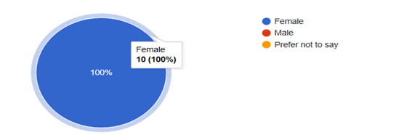

Question 2 – Figure 2
From the list below, please select the age category that you currently sit in.
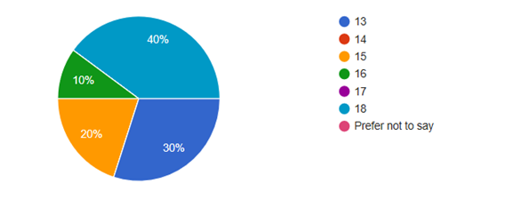

Question 3 – Figure 3
From the following, please select the nationality that you most identify with.
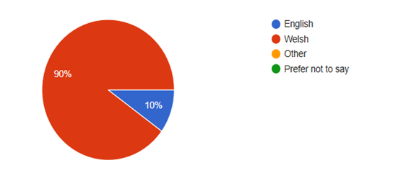

Question 4 – Figure 4
Please select your current year group or select whether you are in college or studying at university

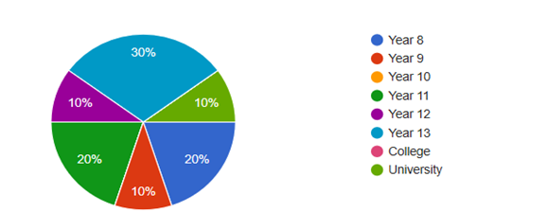

Question 5 – Figure 5
On average, how many hours of dance do you participate in during the week?
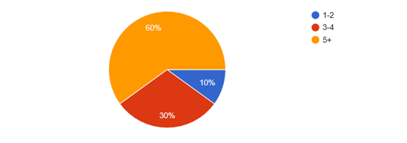

Question 6
Why do you dance?
- Releases my stress, fun
- Releases my stress
- I’ve been dancing since I was little, and I still really enjoy it
- Because it’s a form of exercise, as well as a stress relief
- My mother always wanted me to do something because my brother had football and I was always bored on the weekends, so my Nan brought me to dance when i was 3 and I loved it ever since
- Because it's fun and you learn new things.
- Keeps me fit and energized. And I enjoy it
- As it gives me a positive mind set, I get to meet new people weekly and it helps with my fitness
- Because I love dancing
- I have always danced, and I enjoy meeting new people and having new experiences.

Question 7 - Figure 6

Do you see dance purely as a hobby?
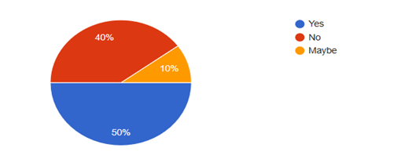

Question 8
What is your future aspiration regarding dance?
- I don’t have any
- I want to go to university and to become dance teacher in the future
- Nothing
- To be graded as a champ in the competitions
- To become a dance teacher as a 2nd job
- To continue with it until I am unable to do it or lose my passion for it
- I'm not sure
- I don’t see myself going professional, but I love dancing
- I would like to study dance at university
- To apply for a dance course at university

Question 9 – Figure 7
Have you participated in any dance lessons within school/college/university?
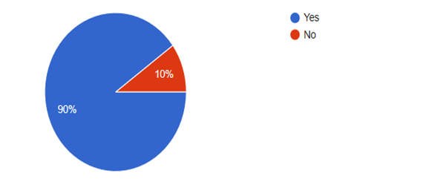
Question 10
If yes, state where, e.g after school classes, during a subject.
- School classes and Eisteddfod
- School Eisteddfod and during school time
- Sports lessons and dance club
- After school classes
- During P.E as it was optional
- During the school eisteddfod
- After school classes
- None
- Eisteddfod, small amount in P.E

Question 11 – Figure 8
Did/ do you have the chance to take dancing further within you studies?
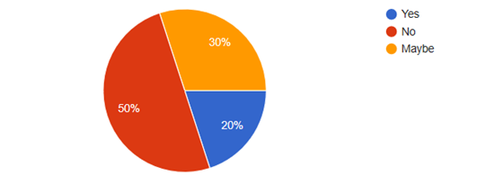
Question 12 - Figure 9
If so, at what level?
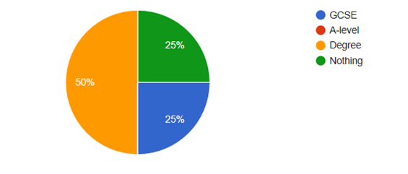

Question 13 – Figure 10
If you answered no to the previous question, would you have liked or like to take dance further than a hobby?
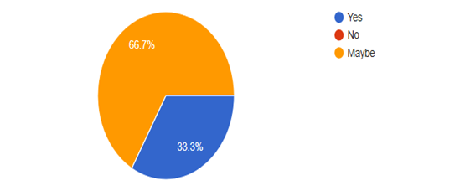

Question 14 – Figure 11
Are you aware of the courses that are to be had in Wales?

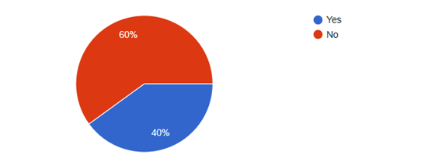

Question 15 – Figure 12
Do you think schools/ colleges and universities that are local to you should offer more dance courses?
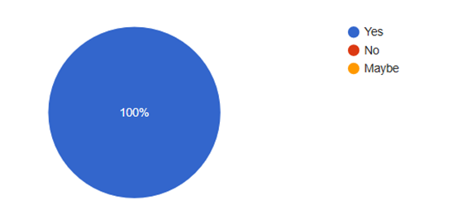

Question 16 – Figure 13
Do you think this will have a more positive effect on the wider dance industry in Wales?
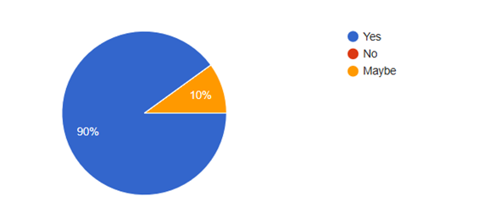

Question 17
If so, please give your reasons why below
- More people may go for it
- People may choose to go down that route
- Dancing helps with a lot of things and if someone enjoys what they are doing and want to carry it on in their education then they should be allowed to, therefore there should be more of a chance for education through dance so that individuals can do what they enjoy
- Gets children off the streets and into someone that they can enjoy and end up having a passion for
- I feel as though the dance community is very small and I would love more of my friends to do dance also
- It will bring different cultures and different styles of dance to wales
- More will want to go
- As you don’t see many young people/ teenagers dancing or not even a hobby
- Different dances different cultures
- It will give dancers more opportunities to extend their knowledge and help with work

Question 18 – Figure 14
Did or do your schools encourage your dancing background?
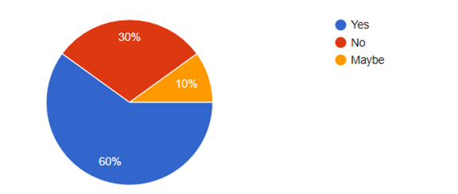

Question 19 – Figure 15
Do you think core subjects such as Maths and English are seen more important than expressive arts subjects like drama and music?
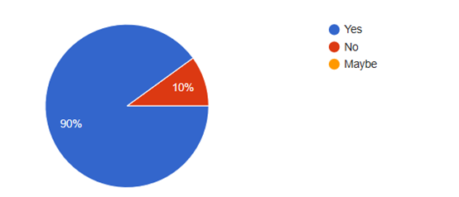
Question 20
If you answered yes to the previous question, please state why?
- They are priorities as they’re needed for sixth form and universities, etc.
- They are priorities as they’re needed for sixth form and universities, etc.
- Schools find that you need these subjects more than any other subject as you need grades to be able to have an occupation but sometimes students are not as good in them as what they would be in the subjects, they like
- Unsure
- for some people dancing may be better or easier for people who struggle with the core subjects today
- They are the only ones that are spoken about and encouraged to focus on more than drama and music
- More universities and colleges want you to have the core subjects
- As they want you to do good in the core subjects but anything else, they don’t mind
- They are the results they look for more in school
- I think dance helps with a lot of other subjects too as it has many different skills

4.2. Interviews

The answers from the interviews were recorded and typed up. This first interview was conducted by the author of this study and a Manager at a further education college who was a former lecturer within dance and performing arts. The second interview was with a current lecturer at the same college who is working with the performing arts students and the BA Dance students at University of Wales Trinity St David.

Question 1 - In your own opinion, how important is dance within an education sector for the wider dance industry?
I think it is very important, but it does depend on what avenue you are going down within the dance industry. If you look at somebody who's going to be doing skill level vocational level, that is pure talent, and sometimes you can’t teach someone that talent because you’re born with that talent, and its fostering that talent. And then you will be going away to a vocational school so the individual's pathway will be different. Those type of careers will only lead you into a performance type career within dance, that potentially when you retire, or you are injured and have to give up, you may not have the skills to do those other opportunities that involve dance. If you were doing it in a dance education, you’re looking at dance in a far bigger and wider kind of look. So, you're just not doing performance, you’re looking at wellbeing, health, you’re looking at education. So, the bracket of skills that going down the route of dance education is far more valuable for the possibility of a longer career in dance rather than a performance career that can last in some cases a year if you get injured. Doing it this way can give you far more scope to go into things and open up your doors to a lot more opportunities because it can be very narrow minded and so intense being in a performance company because you are in that studio from 8:00 in the morning to 8:00 at night compared to an education where you’re meeting different people from different backgrounds and industries within dance. Which is where you start building your networks which is extremely important within dance because it can lead you into new jobs.

Question 2 – Why do you think there’s a low number of dance courses in colleges and universities within Wales?
Education has changed, as in what’s expected of the national curriculum, which suggests that priorities are very different for schools. The Donaldson education is going to be for more creative students. So whereas they haven’t been able to explore creativity at times, I’m not saying that they don’t always because every school is different and every school is based on what primary school teacher that they have in front of them with whatever experiences they’ve got in front of them. So you can have a primary teacher that’s never done anything involving creativity so will not encourage that within lessons, but you may have another teacher that loves dance, music and will get the kids up on their feet doing different things so they can have a different experience. However, with the Donaldson now it’s allowing the students to have these opportunities because they have to because It’s part of the curriculum. Moving forward to secondary education, and again secondary education is changing to be exposed to those creative experiences for the students so again it’s nurturing that and enhancing that so they are able to move forward into the next stage of Further education. That said, things like dance and drama have had cutbacks in secondary schools. We delivered dance GCSE here at the college but I don’t know any schools within Carmarthenshire have delivered GCSE dance or drama for about 7/8 years. You could have 10/15 students doing it in a school it dilutes even more than as you find that only small pockets of people come to us.
Moving on to further education colleges, you tend to find then that the numbers are being diluted again, because every year it gets lower and lower to the point of you don’t have as many people exposed performing and creative arts, so it’s even harder to get them enthused about a subject that they haven’t done already or have no idea about. That’s one thing, secondly, it’s all about locality so you compare a college here to a college in Cardiff and what’s around the area and Swansea even, Gower college there’s a lot of commercial activity given in the area, like hip hop classes and dance schools. Carmarthenshire is rural so students have to travel far to get to places so again that dilutes the numbers even more. When they are looking at a college like college sir gar, you’re not going to have as many students as you would get in less rural places. We have to be responsive to the numbers here because for us it’s the cost of the courses running, so if we could put on every course that we wanted to, that would be amazing but the reality is I can’t have a course that’s costing me having 4 students in a room that’s costing me 30 hours of a lecturer a week because that’s not cost effective. It would benefit us more if we had 15 students in a room. So, we have to think about that as well. Which is the reasoning behind the courses merging, because they’re trying their best to save the course, so they are finding different ways to keep it and merging it with another subject is the most popular way to do it. We have done this in performing arts. We had dance stand-alone going back 4 years ago, because we had cuts in our areas, we could have lost the whole of performing arts. Again, looking at the craze at the time, Britain’s got talent, and all of the dance programs on Tv people were inspired by it, it’s a phase for all of 2 years and then it’s like suddenly where have they all gone.

Question 3 - Do you think individuals who attend dance lessons or classes as a hobby wish to take dance further if they were given the opportunity to dance at an educational level, or are they purely dancing for fun?
I think it’s each to their own, you can’t force a career on somebody a lot of people can take part in dance lessons just for enjoyment or physical fitness or wellbeing. And I would absolutely recommend that as well. Obviously if you see pure talent you would want them to pursue it but you have got to have fire in your belly and you have got to want to do it. What you tend to find here at college, especially at Further Education, it’s different to schools, I know at school you choose your options as well but there’s more options at college generally and I would only want kids who want to be here and that’s from teaching myself at FE. The kids most of the time want to be here and performing is one of those subjects that your immersed in like hair and beauty, you’re immersed in what you do it’s basically eat breath and sleep it. When it comes to the literacy part of the courses, you’re writing about what you’re doing so you have to have an interest in it. But I would never force it but if they had the talent, I would always encourage them to do it.
I went away at 11 years old. And it’s the best thing I could have done because it was ballet. You can’t start that career when you’re 16 so I had to do it that young the difference is it’s huge commitment, especially financially, you miss out on home life and schooling is a very different experience because it was so disciplined you were in a studio until whatever time you didn’t get back until 8:00 at night and it was tough going but you couldn’t do that career any other way. There were 14 students in my class, and out of 14 there is one girl working as a teacher in Dubai and another 2 girls working as dance teachers in schools around the UK and there’s me who’s a teacher but also gone into different aspects of teacher but the rest have given up. And now don’t have anything to do with dance. Another thing with dance is that you have to make your own careers, so making yourself entrepreneurial and having that mindset and skill and you’re not taught that at 11 years old but in college and educational environments you are reminded about how important entrepreneurship is and that takes you through to degree. It’s all about being diverse so you can still be a teacher but you can also do other things. I was still doing other teaching jobs as well as they were coming in, working with old age, working with people with Parkinson’s and that hasn’t given me a lot of experiences within my teaching. And the more contacts you get the more you can establish yourself further down the line.

Question 4 - Most dance courses within Wales have merged with other subjects, for example, performing arts and Psychology. Why do you think this is happening?
Cost saving. We lost numbers as I said previously, I think the influx of Britain’s got talents and everything with that really kind of brought people to us which was great. But when I look back now and the discussions that we had with the team that’s what we saw as the reasons why we were popular then. And it’s usually when you have a friend in a dance school they also come to the course when they are old enough and then it came to there being about 5/6 of them from one dance school coming to us which was good, and then we also had a couple of boys so suddenly our course numbers were building but it was quite short lived and whether we will get to that point again because we are doing everything we can to promote the course. I’m hoping that with the new curriculum that the schools and when the students are more exposed to creativity now will boost our numbers in the future to hopefully put the course back on. Because now what they are only exposed to is dance schools outside of education. So, these children may be unaware of the courses that we have within education because they are not doing dance through education.

Chapter five
Discussion

5.0. Discussion

According to UCAS, there are currently 206 Dance courses in the UK. These courses are mostly merged with subjects like performing arts, psychology and physical education. 170 of which are Bachelor courses, and out of the 170 courses, 22 are stand-alone dance courses. UCAS (2020). This is a substantial drop in courses around the UK. In Wales, there are currently 3 courses running that involve dance. Two of these courses are stand-alone courses. With one closing in the next 3 years. Which suggests that if someone wanted to apply for a university course within Wales this year, they only have two courses to choose from, one course being a physical education course with an element of dance.

It is the latest in a number of cancellations at higher education institutions, following on from Drama Centre London’s decision to suspend intake for its acting and directing courses, and a similar move at the Guildford School of Acting, where both the BA (hons) Dance and the Theatre and Performance degree have been dropped.
Matthew Hemley, 2019

The dance course within University of South Wales states that the course is undergoing changes to develop the course and its curriculum. To “ensure students have the best opportunities to develop their own skills and connections to enhance their future careers”. USW, (2019). Another statement from USW, (2019) states that

“We have tried to support the team as much as possible to recruit over the past years, but we have not seen growth in numbers or sufficient numbers of students to be able to continue to recruit”

This explanation from the university shows that the intake of numbers on these courses are low, and so low that courses are struggling to keep them running. Within the dance course that is held at University of Wales Trinity St David, there are currently 8 students across 2 years, with no second year. The third year are made up of 4 students, and 4 students across first year. Being involved in this course, and seeing people come and go throughout the years is daunting and worrying. When starting first year, there were 5 students, a total drop of 4 students from the 3rd year students that were studying at University of Wales Trinity St David. The reasoning behind the course having a year's gap between third year and 1st year was the lack of studio space and lecturers the university could offer. Going into second year, 2 students had dropped out of the course. One transferring to University of East London to study Urban Practise. After asking the individual, the reasoning behind the move was “I chose to apply for a transfer to UEL after one year of studying dance at a university in Wales. Once realising the lack of diversity in styles, and the style which was offered wasn’t my strongest style, it made me decide that I wasn’t happy there and I didn’t have a passion for that particular style” (Thomas, 2020)

5.1. This table below shows the Universities that are in Wales, and how they are ranked. This table is based on dance, drama and cinematics courses in each university. It shows the entry standards, which has no maximum measures, student satisfaction which is marked out of 5, the research quality which has a maximum measure of 4, the graduate prospects, which is out of a 100, and the overall course score, which is again out of a 100. This table lets us compare these different aspects of the courses within Wales, and which university has a better scoring in each category.
The statistics shown below on entry standards are based on the average UCAS Tariff score from each new undergraduate student. The Complete University Guide (2020) state that they work this data out by converting each students results into a numerical score which then gets added up to get a score total. In this table, the university with the highest entry standard is University of South Wales, and the lowest being Cardiff Metropolitan. Some universities have different ways of working out how to accept students who didn’t get the grades that they hoped for, or students with low grades, in this case the scores will be lower. “Universities which have a specific policy of accepting students with low grades as part of an access policy will tend to have their average score depressed.” (League Table Methodology, 2020)
The student satisfaction is worked out by the students themselves, this is based on the teaching quality of their lecturers, which comes from the National Student Survey which students in their final year undergo before graduating.

“The survey gathers opinions from students about their time in higher education, asking them to provide honest feedback on what it has been like to study on their course at their university/ college”
(The National Student Survey, 2020)

The University with the highest student satisfaction is Aberystwyth, scoring a 4.25 out of 5, and the lowest being Wrexham Glyndwr, scoring a 3.63, which is still above average.
The research quality is the capacity of the research quality used in the university, this comes from The Research Excellence Framework, which is undertaken by the funding councils. Only 2 out of these 5 universities in Wales has an amount for this, which is Aberystwyth and University of South Wales. The others stating n/a.
Lastly, the graduate prospects are the number of first-degree graduates who have been successful in employment. They work this out by dividing the number of graduates who take up employment or those who go on to study further by the number of graduates with a known destination. This is then worked out as an percentage. The highest again being Aberystwyth, and the lowest being Cardiff Metropolitan.
By looking at these results overall, the most successful university, according to these results is Aberystwyth University, with the university ranking 36th in the UK. This out of 102 universities.

Table 1
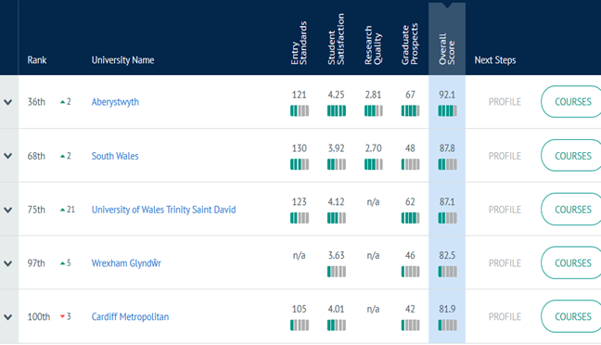(Drama, Dance & Cinematics - Top UK University Subject Tables and Rankings 2020, 2020)

5.2. Questionnaires

After analysing the questionnaire responses, the answers were varied, and some views were interesting. The main aim for this questionnaire was to find out whether the dancers had a chance to study dance at an educational level, and if the reasoning behind low dance course numbers was down to these dancers, some of which who wanted to dance purely as a hobby. The questionnaires were all filled out by females with one dancer being English. The dancers all varied in age, 40% being 18, 30% were 13, 20% were 15-year olds and 10% were 16. This range is needed for this study as they are all at different stages of study, from choosing their GCSE subjects to deciding what they want to do in university. Most of these dancers spend 5+ hours a week doing dance. Which is good for the dancer's health and also gives them extra skills that they can take into other aspects of life.

Dance makes you move, which burns calories and makes you physically fit. Dance promotes a healthy heart and makes muscles limber, helping to reduce injury and promotes rapid healing. You gain strength and flexibility through repetition. Coordination is developed through patterns and balance. Your brain is challenged to work with your body. The end result is an exercise in both physical and mental harmony.
(Labellarte, 2011)

The next question asked the dancers why they dance. Which gave an array of answers. But mostly the dancers stated that they dance because it's fun, with another saying that it’s a positive thing to do for your mind. 50% of the participants dance just as a hobby, which suggests that they don’t wish to take dance further in education. The others stating that they don’t see it purely just as a hobby, some of these participants later on in the questionnaire state that they would like to do more with it in the future.
The next question asked what their future aspirations within dance are. Again, there were some positive answers and some negative answers. Some dancers said that they don’t wish to take dance any further in the future, and that they enjoy it just as a hobby. Others have stated that they wish to do dance in university or become dance teachers in the future. As they are still young, these views may change in the near future.
90% of the participants said that they have partaken dance within schools, this being in physical education, during after school classes and for the Eisteddfod. Eisteddfod (2020) explains this as a traditional competition-based festival. And is the natural showcase for music, dance, visual arts and literature.
50% of these individuals declared that they didn’t have the chance to take dance further in their studies. Which is an alarming finding. And a key aspect to this study. Dancers aren't aware of the opportunities out there for dance, this being in education and careers. There aren’t many courses to be had in Wales, but looking at the responses, the courses that are to be had aren’t getting spoken about or offered in schools. 60% of these participants have also said that they haven't been made aware of the courses that are on offer. The question here is why? Why are these courses not selling in schools?
100% of the dancers stated that local schools, colleges and universities should offer more dance courses. Which is a good thing, and this also suggests that they think it is needed too. One stating that “more people may go for it” and another stating that “it will give dancers more opportunities to extend their knowledge and help with work”.
Schools in the UK highly encourage the core subjects such as maths and English. The last question asked the individuals whether they thought that dance was less important that these core subjects, this resulted in 90% saying no. The reasonings behind this was that they are prioritised because they are the subjects that get you into colleges, sixth forms and universities.
The questionnaire was a huge benefit to this study. The questions were answered clearly, and it was good to have an array of answers, and a variety of girls from different schools within the local area.

5.3. Interviews
The interviews were another key part to this study. Unfortunately, the responses were not the initial responses that the author of this study wanted. Due to this, only one interview was taken. The interviewee answered all of the questions in depth, and in detail. This means that the information given was enough to understand a lecturer's point of view.
The first question was answered thoroughly, and the importance of dance education is strongly said within this question, the interviewee explains that it depends what sort of avenue that you wish to go down. And where you would like to take dance. They explained the different ways to go into dance, and the different careers that are to be had within dance. Some dancers go into performance, this suggests that they may not have the knowledge that a dancer who’s gone into education to study dance may have. This being said, dancers who wish to go down the performance side of it may only have a limited number of years in that setting due to illnesses, or injuries which is popular within dancers. According to Deu, Greene, Lasner (2020) Some common injuries within dance are, hip injuries, such as hip impingement, foot and ankle injuries, and knee injuries. Doing dance through education can build on your opportunities, lead you down different avenues and also it can help you build your networks which is an important thing for a dancer to have. For example, if you work with someone once, you can maybe go down that avenue again a few years later and work with that person again. As a dancer in such a small place, having contacts and making yourself known is the best way to be and the best way to get the jobs that you wish to have.
The second question was again full of in-depth information. Within this question, the subject of course numbers and the cost of the courses running was brought up a lot. The interviewee stated that if the number of students who apply for the course is low, which is why they dropped the course at the college. Having 4-5 students with 30+ hours a week of teaching wasn’t cost affective which resulted in them having to close the course. The reasoning behind the low numbers was because dance wasn’t used enough in primary or secondary schools, which meant that dancers didn’t get the chance to do it through education at that level.
The third answer talks about the locality of the college which is one of the reasons behind the lack of people studying performing arts courses there. This being because, here aren’t many things around there such as community dance classes, they struggle to get people to come to them to study performing arts courses. Whereas in places like Swansea and Cardiff, where there are more community-based activities happening, it’s more likely that their course numbers in colleges around them areas are stronger. This being said, Gower college in Swansea have an A-level Dance course, this suggests that having a lot more community classes within an area may help a course stay afloat. This A-level course has been running for years. After speaking to the Director of the course, she states that

“The A-Level course has been running has been running since I was Student! I think A-level Dance began in 1986 and BTEC Tec Performing arts started in 1989. I currently have 14 A-level dance students (3 Second years and 11 first years)”
(Collins,2019)

For this course to be running for so many years, the dance industry around the college’s area must be huge. According to Yell (2020) there are 5 dance schools in Llanelli, and 30 dance/ stage schools or groups in Swansea. In comparison to Swansea, Llanelli has a huge market for dance schools, and to help courses like performing arts, having more dance schools or stage groups would benefit the town and the college.
With the final question, I found that the interviewee had already touched upon in previous questions. The interviewee mentioned that after looking back at the meetings they had as a team, the reasoning behind why they were so popular at one point was because of the craze in dance at the time. Especially with shows like Britain’s Got Talent and So You Think You Can Dance. These popular TV shows may have been the influence that these students needed to get on a dance course and want to dance themselves. But with this craze dying out, individuals may have lost interest which is why since then numbers have been so low which resulted in the course having to close.

Chapter six
Conclusion

6.0 Conclusion

With dance being a less popular subject in the educational system, but hopefully evolving now that the Donaldson Report has come into measures. The report will be “Organised into six “areas of learning and experience”: expressive arts; health and wellbeing; humanities; languages, literacy and communication; maths and numeracy; and science and technology” (Evans, 2015). Which subjects like dance and drama, will be more involved in the national curriculum in the upcoming years. This may then suggest that the GCSE, A-level and degree courses gain more numbers and interest which will save the courses from getting dropped, or colleges in Wales may get to pick the courses back up in the future due to children studying and learning through the expressive arts growing up.
This study aimed to find out the opinions of dancers between the ages of 13-18, and current and past lectures who have had experience in teaching dance at an educational level. To this end, interviews and questionnaires were carried out to gather this information together. These answers and opinions were then analysed, which is where conclusions were made.
In regard to the questionnaires, some alarming findings where made within these answers. To find that 60% of the individuals weren't made aware of the courses that are to be had within Wales is frightening. The dancers also stated that the schools encouraged their dancing backgrounds. Which is why understanding the reasons behind the schools not letting these students be aware of these courses are difficult. If schools are encouraging the dancing backgrounds that these students, then encouraging dance education should be easy. Because dancers aren’t educated about dance and the academical side to it within their local dance schools, they may not understand the work that goes into dance, and not only the physical side of it.
For example, learning about the body within dance, learning about nutrition, and learning about the psychological wellbeing of dance can help with subjects that they are participating in in schools such as health and social care, psychology and biology. Yet 90% of these dancers had said that core subjects are more important than expressive arts subjects. The skills gained from dance can carry them into other subjects too. 100% of these students also said that they would like to see more schools, colleges and universities around Wales to offer more dance courses. And some declared that they would possibly go down that route if this was the case. If there was anything to change in relation to these questionnaires, it would be having a larger number to individuals to test. Despite the amount of range these answers had given, having more of a larger group, or children from a different dance school to compare, it would have possibly made a change in the results.
This study created some interesting information. Especially when getting an inside scoop into the course itself at Coleg Sir Gar in Llanelli. At the beginning of this study, the implied idea was interviewing 2 lecturers from this College, but due to unforeseen circumstances, only one interview was conducted. In the future, time management would be the key to prevent this from happening. Having two sets of interview answer would gain more information, and to identify if there were any similarities and differences in both interviews to compare the both. Besides this problem, the interview answers were thorough enough to gain interesting information about why the course had closed, and reasonings behind this happening. The interviewer spoke about the costs of the courses running at the college and having a lack of numbers didn’t help this aspect. Below is a Pie chart showing the income sources that the further education sector has in 2015/2016

Figure- 16
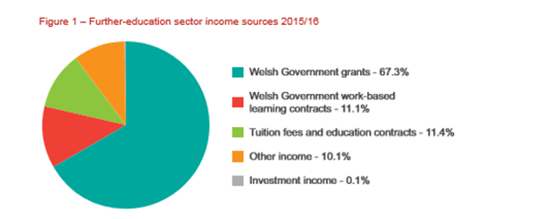(Welsh Government oversight of further-education colleges' finance and delivery, 2017)

As you can see, the Welsh Government gives a high percentage of grants to the further education sector. If the courses are low on numbers, then the cost of running them is proven harder, as colleges then would rather spend money on other courses where there are a lot of students to cover the money.

As said in the introduction, before going into this research study the initial thought was that there would be a difference in Dance course offerings within Wales and England, and after researching and gathering information from UCAS, this was proven to be correct. There is a gap in the market for dance education in Wales. Especially in Universities after there only being one stand-alone course in Wales. But to help this, dance needs to be made popular throughout the whole of the educational system. In order for dance to have its own place in the National Curriculum, it needs to be developed into a strong, and independent core subject that schools need rather than being hidden behind other subjects like Physical Education.

Bibliography
Audit.wales. 2017. Welsh Government Oversight Of Further-Education Colleges' Finance And Delivery. [online] Available at: <https://www.audit.wales/system/files/publications/FE-finances-eng-2017.pdf> [Accessed 19 March 2020].

Crossman, A. (2020). What Is Qualitative Research?. [online] ThoughtCo. Available at: https://www.thoughtco.com/qualitative-research-methods-3026555 [Accessed 27 Feb. 2020].

Deu, R., Greene, A. and Lasner, A., 2020. Common Dance Injuries And Prevention Tips. [online] John Hopkins Medicine. Available at: <https://www.hopkinsmedicine.org/health/conditions-and-diseases/sports-injuries/common-dance-injuries-and-prevention-tips> [Accessed 15 March 2020].

Eisteddfod.wales. 2020. About Us | National Eisteddfod. [online] Available at: <https://eisteddfod.wales/about-us> [Accessed 15 March 2020].

Evans, G. (2015) ‘The Donaldson Report: An At-A-Glance-Guide', Wales Online, 25th February. Available at: https://www.walesonline.co.uk/news/wales-news/the-donaldson-report-an-at-a-glance-guide-8713671 (Accessed: 19th March 20120)

Hemley, M. (2019) ‘University of South Wales latest to axe arts degree as dance course is closed’, The Stage, 24th October. Available at: https://www.thestage.co.uk/news/2019/university-of-south-wales-latest-to-axe-arts-degree-as-dance-course-is-closed/ (Accessed: 22nd March 2020)

K, Collins. (2020) Email to Cerys Worsfold, 19th March.

Labellarte, M., 2011. 7 Reasons Dance Is Good For You .... [online] Allwomenstalk. Available at: <https://health.allwomenstalk.com/7-reasons-dance-is-good-for-you/> [Accessed 15 March 2020].

N, Thomas. (2020) Message to Cerys Worsfold, 11th March

O'Leary, K. (2015). The Importance Of Opinion. [online] The Odyssey Online. Available at: https://www.theodysseyonline.com/the-importance-of-having-an-opinion [Accessed 27 Feb. 2020].

One Dance UK. 2020. New Plan For Music Education - One Dance UK. [online] Available at: <https://www.onedanceuk.org/new-plan-for-music-education/> [Accessed 10 March 2020].

Oppenheim, A.N. (2000). Questionnaire Design, Interviewing and Attitude Measurements, New Edition. Continuum: London.

Sanderson, P (1996) Dance within the National Curriculum for Physical Education of England and Wales. European Physical Education Review. 2, 1.

Schynke, J., 2014. Support Dance In The Curriculum | A New Direction. [online] Anewdirection.org.uk. Available at: <https://www.anewdirection.org.uk/blog/support-dance-in-the-curriculum> [Accessed 12 March 2020].
Stephanie. (2016). Reliability and Validity in Research: Definitions, Examples - Statistics How To. [online] Available at: https://www.statisticshowto.datasciencecentral.com/reliability-validity-definitions-examples/ [Accessed 3 Mar. 2020].

Thecompleteuniversityguide.co.uk. 2020. League Table Methodology. [online] Available at: <https://www.thecompleteuniversityguide.co.uk/league-tables/university-and-subject-league-tables-methodology> [Accessed 11 March 2020].

Thecompleteuniversityguide.co.uk. 2020. Drama, Dance & Cinematics - Top UK University Subject Tables And Rankings 2020. [online] Available at: <https://www.thecompleteuniversityguide.co.uk/league-tables/rankings/drama-dance-and-cinematics> [Accessed 11 March 2020].

Thestudentsurvey.com. 2020. The National Student Survey. [online] Available at: <https://www.thestudentsurvey.com/about.php> [Accessed 11 March 2020].

Yell, (2020). [online] Available at: https://www.yell.com/ucs/UcsSearchAction.do?find=Y&keywords=dancing+schools&location=wales&pageNum=1 [Accessed 22 Feb. 2020].

Appendices
Appendix A
Dissertation interviews - Questionnaire

- In your own opinion, how important is dance within an education sector for the wider dance industry?

- Why do you think there’s a low number of dance courses in colleges and universities within Wales?

- Do you think individuals who attend dance lessons or classes as a hobby wish to take dance further if they were given the opportunity to dance at an educational level, or are they purely dancing for fun?

- Most dance courses within Wales have merged with other subjects, for example, performing arts and Psychology. Why do you think this is happening?

Appendix B
Questionnaire Questions
- What gender do you most Identify with?

Male
Female
Prefer not to say

- From the list below, please select the age category that you currently sit in.
13
14
15
16
17
18
Prefer not to say
- From the following, please select the nationality that you most identify with.
Welsh
English
Other
Prefer not to say
- Please select your current year group or select whether you are in college or Studying at University
Year 8
Year 9
Year 10
Year 11
Year 12
Year 13
College
University

- On average, how many hours of dance do you participate in during the week?
1-2
3-4
5+
- Why do you dance
- Do you see dance purely just as a hobby?
Yes
No
Maybe
- What are your future aspirations with dance?
- Have you participated in any dance lessons within school/college/university?
Yes
No
- If yes, state where, e.g after school classes, during a subject.
- Did/ do you have the chance to take dancing further within your studies?
Yes
No
Maybe
- If so, at what level?
GCSE
A-level
Degree
- If you answered no to the previous question, would you have liked or like to take dance further than a hobby?
Yes
No
Maybe
- Are you aware of the courses that are to be had within Wales?
Yes
No
- Do you think schools/ colleges and universities that are local to you should offer more dance courses?
Yes
No
Maybe
- Do you think this will have a more positive effect on the wider dance industry in Wales?
Yes
No
Maybe
- If so, please give your reasons why below.
- Did, or do your schools encourage your dancing background?
Yes
No
Maybe
- Do you think core subjects such as, Maths and English are seen more important than expressive arts subjects like drama and music?
Yes
No
Maybe
- If you answered yes to the previous question, please state why below.

Appendix C
Dissertation Consent Form

I am a third-year student studying dance at University of Wales Trinity St David. I am currently working on my dissertation which involves dance education within Wales and England. I will be comparing the number of dance courses to be had in Wales to England, and whether dancers who dance as a hobby would go into dance as an education in the future, if it’s at GCSE level, A-level or studying dance at university. As part of my dissertation, I would like to include a questionnaire which will be sent out electronically to 15-17year olds who are currently dancing at Amman Valley School of Dance. The questionnaires will entail your child’s dance history, and future aspirations within the dance industry.

Throughout my work the completed questionnaires will only be read by me and will remain anonymous when evaluating them.
If you would like more information about the questionnaire that your child is
completing, contact me on:

Email – cerysworsfold15@gmail.com
Mobile – 07772918651

If you do not wish your child to complete the questionnaire, please contact me before Friday 21st February.

Many Thanks,
Cerys Worsfold

