
MSc Industry 4.0 Advanced Manufacturing
Research Methods and Professional Development ACFA7004
Written by: Gareth Frost
Cultural Resistance to Big Data usage in a Manufacturing Environment
Date: 9th October 2022
Contents

Abstract 2
Introduction 3
Literature Review 5
What is Big Data? 5
Big Data and Culture 5
Quality 4.0 6
Leadership 7
Management 7
Culture 8
Strategy 10
Methods 11
Key Questions 11
Quantitative research 12
Qualitative research 12
Quantitative and Qualitative research 12
Results 13
Experimentation 13
Observations & Ethnography 13
Surveys 14
Semi-structured interviews 14
Evaluation 14
References 15

Abstract
Over the last decade or so, the innovation within the digital world has taken hold, this digitisation of systems has facilitated vast changes in industry. These changes have to some degree simplified day to day activities and somewhat de-skilled other activities conducted in the workplace. This act of perceived de-skilling has had a potentially negative impact to manufacturing.
The use of big data analytical tools in the context of smart factories can present several obstacles and difficulties, but they are essential to achieving the goal of smart factories. These issues and problems show as mistrust and the worry that "Big Brother is monitoring." The goal of the study is to identify possible obstacles that prevent businesses from implementing big data solutions in their smart factory projects and to investigate the causal connections between these obstacles, and to answer the following,
“If the organisation has deployed its strategy, and is correctly underpinned with the appropriate cultural approach, does resistance to the utilisation of big data exist? or, does the leadership from middle management contradict the organisational culture and create a micro-culture of mistrust and negativity towards utilisation of Big data?”

Introduction
Technological advances in autonomous technology enable a smarter, more connected world and usher in the next industrial revolution known as Industry 4.0. This has become an important concept promoted by both sides, developed, and developing countries aiming for significant improvement in maximising efficiency and sustainability in manufacturing environments with new science and technology (Almada-Lobo, 2016).
(Saurabh Vaidya, 2018) discusses that the current revolution is taking manufacturing away from “Mass Production” and towards “Customised production” and therefore the pillars of the revolution intertwine to provide structure to facilitate the changes, they go on to discuss that there are 9 pillars of the industry 4.0 revolution.
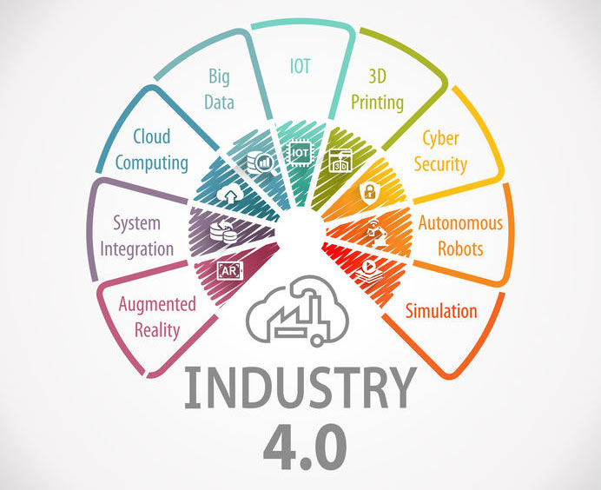
(Roche, 2019)
A key concept around the utilisation of technology is the “SMART” factory and has emerged along with the concept of Industry 4.0. As a result, smart factories handle the vertical integration of different components, making it easier to reconfigure factories to flexibly produce different types of products
Additional challenges arise when these connections become more commonplace. For instance, a significant amount of data is generated for each digital transaction, some of which is viewed as useful and some of which is recognised as having no additional value but is necessary for the system to function. This is known as Big data in the context of Industry 4.0 and is one of the Pillars of the Industry 4.0 revolution.
After gathering this data, a conscious or subconscious choice is made as to its relevance and importance to the actions being carried out in the business. What is obvious is the data being evaluated against technology developments; these changes are referred to as the Industrial Revolution since the idea is that a larger, better, more efficient machine or system would result in a better business model. What is being overlooked is data relating to the human aspect where interaction is necessary, whether in manufacturing, via industrialisation, or back to design. There appears to be a reluctance to use the generated data and look within to comprehend the human-induced mistakes.
Even though big data analytics and smart factories are powered by cutting-edge technologies, the application environment and organisational settings have a significant impact on their performance. In other words, it is not enough to just concentrate on technological advancement or engineering innovation to solve the issues and challenges associated with implementing big data solutions in smart factories; it is also necessary to consider how to effectively adopt and manage such technology in organisational contexts. As a result of this discussion, it was determined that there was a significant gap in the literature regarding research on the sociotechnical issues and difficulties related to integrating big data solutions into smart factories, especially from the intersections of technology, data, management, and people.
To truly accept and integrate Industry 4.0 into production, it must be combined with the 11 Quality 4.0 pillars. Without this, manufacturers would continue along the same trajectory, investing in better-networked systems while puzzling why these innovations have not had the expected and planned impact. The cultural, ethical, and socio-technological aspects of Big data must be examined, as well as how the appropriate organizational culture helps break through such obstacles.
This research will also look at the elements from the Axis of Quality 4.0 (Juran, 2019) that have a social interaction within manufacturing as change without communication or structure can dilute the organisational strategy and undermine and/or damage the culture.

Literature Review

What is Big Data?
(Marr, 2015) Discusses that Big data is at the centre of the smart revolution, this also provides us with the notion that everything we do from a digital aspect leaves a “Digital Trace”. This data that is recorded and held enables us or systems to learn and ultimately get smarter. (Davenport, 2014) They discuss ethics and its links to Big data, but this is only discussed as anonymous data which in some instances works perfectly well however when you need to understand reasoning you need to look at the data as a person, without doing this you are generalising the reasoning behind the error. This work ultimately only addresses the usefulness of Big data but does not help with the ethical dilemma faced by many businesses worldwide.
Big data is often split into attributes and characterised by the 5V’s, (Stedman, 2022)
- Volume – Size of the data (there is no size requirement).
- Variety – Multiple data types that are stored and processed in the same system.
- Velocity – fast-paced and real-time update.
- Veracity – this is the accuracy and how trustworthy the data sets are
- Value – does the data if used effectively have value to the business i.e., can it be used to make positive change?

Big Data and Culture
The Book Big data at work: dispelling the myths, and uncovering the opportunities (Davenport, 2014) discusses the use of big data within the working environment. They discuss the culture of big data throughout, but this is in the context of whether there is a culture to look at big data from an organisational approach rather than the cultural change necessary to embed this change from the working level upwards. However, they do introduce the notion that to succeed with big data there must be a buy-in from the management and executives to adopt this change. Based on this they give us an “Action Plan for Manager” which re-emphasises providing strong and passionate leadership.
(Kord Davies, 2012) Discusses that “Big data is ethically neutral” and it is the organisational values and people values that impact the ethical aspect of big data. Although there is no real concept of how to facilitate these changes in an organisation it is discussed that there are interdepartmental struggles that need to be overcome to enable the transparency of data.

Quality 4.0
Quality 4.0 has its links within the industry 4.0 revolution as much the same as the previous revolutions. However, it is important to distinguish the two elements to enable an understanding of what they bring to the tale for many businesses. Industry 4.0 is the utilisation of the technology around us to enable a more customisable manufacturing capability, whereas Quality 4.0 is “About how technology improves culture, collaboration, competency, and leadership” (Jacob, 2017).
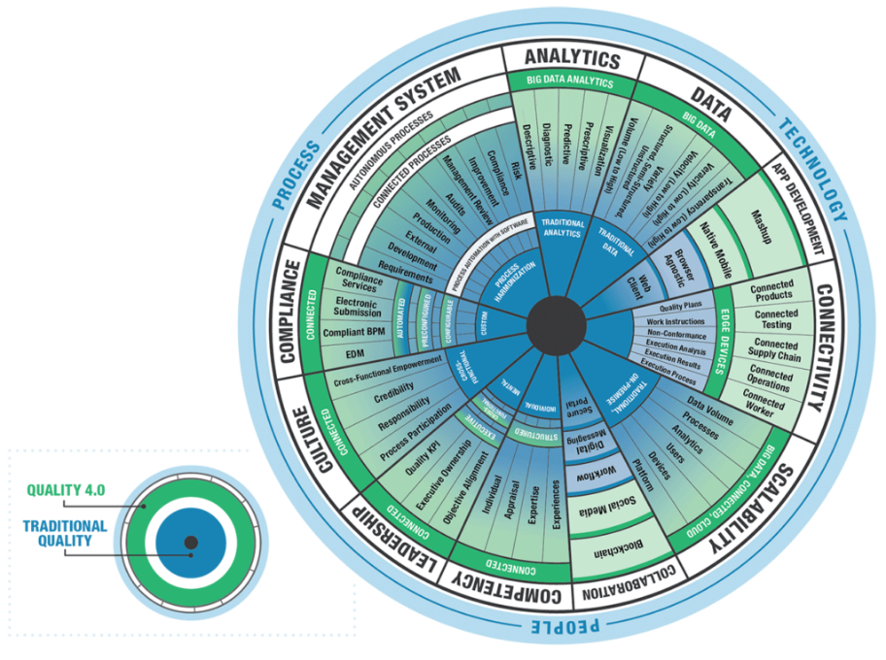
The Quality 4.0 axis is defined as follows.
- Data
- Analytics
- Connectivity
- Collaboration
- App Development
- Scalability
- Management systems
- Compliance
- Culture
- Leadership
- Competency
(Juran, 2019)
The links with Industry 4.0 and Quality 4.0 overlap but no longer sit with the Quality function. This is now a business-wide strategy and therefore its implementation is owned by all business functions, but its governance sits under the Quality function. Quality 4.0 has defined the interactions from a business level and discusses ownership as a cross-functional dynamic. The diagram shows all eleven axis and how they transition from traditional Quality to Quality 4.0, There is 2 key axis that without those you could argue the other nine do not bring about the required or any fundamental or sustainable business change, those are:
- Leadership
  - Quality KPI
  - Executive Ownership
  - Objective Alignment

- Culture
  - Cross-Functional Empowerment
  - Credibility
  - Responsibility
  - Process Participation

Leadership
Building and nurturing a team that thrives in the proper culture depends on leaders. They play a key role in demonstrating the correct behaviour in the workplace and in giving their team the training they need to succeed and meet their targets.
There are many ways to define leadership, (Miller, 2021) defines it as “the capacity to have an effect on the character, development, or behaviour of someone or something,” but without using “apparent exertion of force or direct exercise of command.” Also, they simplify it as “the practice of positive influence”. (Druker, 2020) defines leadership as “Leadership is doing the right things” whereas (Habib, 2022) describes it as the development of the business strategy and its deployment.
No matter how you look at these definitions and whichever you choose the fundamental approach must be a company-wide orchestration and deployment. (Canic, 2020) discusses that successful companies have strategies that are aligned and consistently pointed in the same direction. This consistency of approach lends itself to many challenges and hurdles and must be a fundamental pillar for ensuring effective change management.

Management
Management is the process of managing and controlling the activities of an organisation, regardless of its form, kind, structure, or size. It is the act of building and sustaining an organisational climate in which individuals of the company may collaborate and achieve business objectives efficiently and effectively. Management guides a group of individuals working in an organisation and coordinating their efforts to achieve a shared goal.
In other words, it is concerned with making the best use of the 5Ms,
- men (in name only)
- machines
- material
- money
- methods
this is only feasible when the processes and activities are properly directed, coordinated, and integrated to accomplish the intended results.
There are a wide variety of definitions of management, and some could be seen as completely outdated. (Koontz, 2012) defines management as “The process of designing and maintaining an environment in which individuals, working together in groups, efficiently accomplish selected aims”. (DuBrin, 2009) Shows strong links to the previous definition but introduces leadership to the equation. It also brings into focus the levels of management within an organisation and therefore we must understand the organisational mix of Leaders and managers.

Culture
An organisation's psychological and social atmosphere is influenced by culture. As a result, this atmosphere has a substantial impact on the overall work experience and levels of employee engagement. The company's reputation and branding reflect organisational culture. The culture of an organisation will also impact how new ideas originate and information flows through its structure.
Each organisation has its own organisational culture, which grows over time and generally changes over prolonged periods of time. While any organisational culture must be stable, it must also be pliable and dynamic. Change assists an organisation in developing and competing under difficult environments. While organisational change is often required, it is one of the most difficult components of an organisation to alter.
(Denison & Mishra, 1995) defines culture as “A set of values and beliefs that are the basis for the company’s Management”. This definition resonates with what we as people also hold onto and what creates our personality, therefore this is the organisation’s personality.
There are multiple models for organisational culture, however, one of the most notable models is the “Competing Values Framework” (Cameron & Quinn, 2011). It demonstrates that each business typically has a mix of these types of cultures however generally one culture type tends to be more dominant and the others passive or submissive.
Utilising this Model and understanding each sector establishes a company baseline, this can be utilised to re-enforce change and develop a plan of implementation or re-imagining.

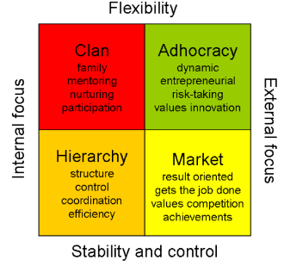
Competing Values Framework
- Adhocracy - the dynamic, entrepreneurial create culture.
- Clan culture – the people-oriented, friendly collaborative culture.
- Hierarchy Culture – the process-oriented, structured control culture.
- Market Culture – the results-oriented, competitive competition culture.
(Gardner, n.d.) (Eekhout, 2010)

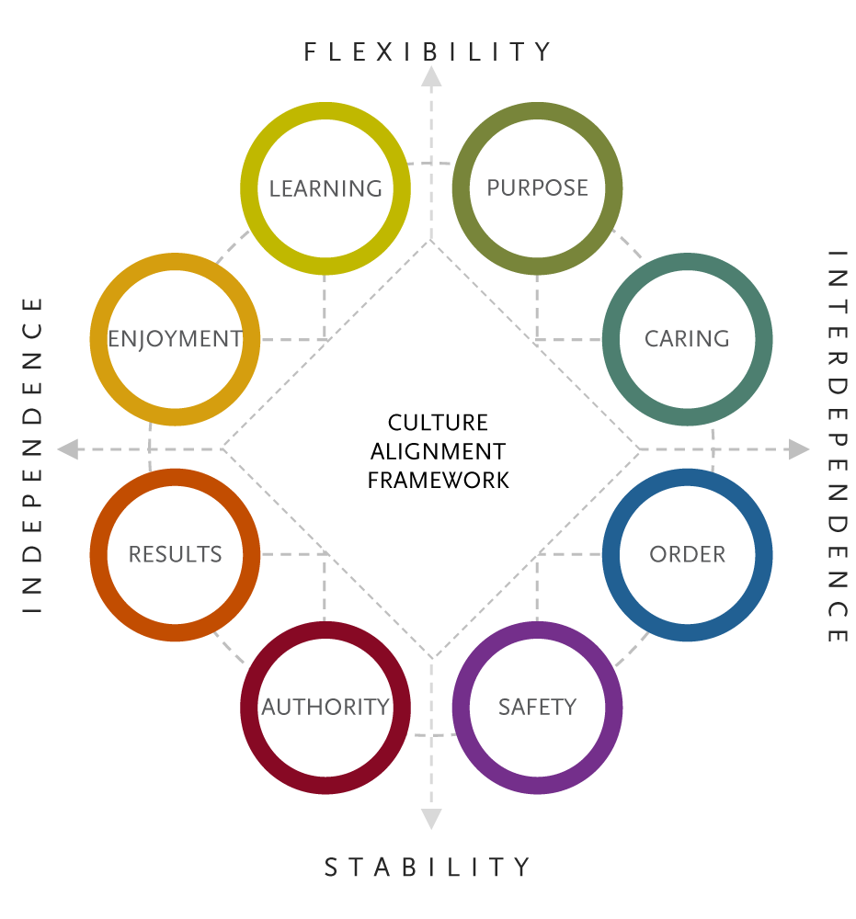

Further Organisational Cultural Models
- Caring – Relationships and Mutual trust
- Purpose – Idealism and Altruism
- Learning – Exploration, Expansiveness, and creativity
- Enjoyment – Fun and Excitement
- Results – Achievement and winning
- Safety – Planning, Caution, and preparedness
- Order – Respect, Structure and Shared norms
(Boris Groysberg, 2018)

Taking these eight further models and overlaying them to the same axis as the competing values framework, the cultural alignment framework is produced (Singh & Mark, 2017)

Strategy
Historically, the organisational strategy was considerably more inflexible, with yearly plans as well as longer-term business strategies that looked five years ahead. However, because we live in a period of fast change, any organisation that adopts a more flexible and dynamic approach to strategic planning and its management will have a competitive edge. This still necessitates a business plan that considers the requirements of the organisation on an annual basis; it simply must be reviewed more frequently, and there is an increased opportunity for a change in direction. Responding to changing business demands may entail developing new goods, entering new markets, or diversifying.
Defining a strategy is all well and good within itself however, the successful implementation relies on each objective being SMART.
- Specific (Tangible)
- Measurable
- Achievable
- Realistic
- Time-bound
When strategies are developed it is important to understand that Human resources and communication also play a role in supporting the wider organisation in supporting Leadership in aligning culture with strategy, ensuring that communications are conveyed in a way that is consistent with the brand's DNA, and motivating rather than overwhelming for employees.
(Dinkin, 2020) discusses how effective organisations can effectively maintain or re-implement strategy by knowing how to process issues at all levels of an organisation. They also discuss that ineffective organisations are unable to solve and learn from problems as they are unable to abandon their own notions about the organisation.

Methods
To answer the hypothesis “If the organisation has deployed its strategy and this is correctly underpinned with the appropriate cultural approach does resistance to the utilisation of big data exist? or, does the leadership from middle management contradict the organisational culture and create a micro-culture of mistrust and negativity towards utilisation of Big data?” Some key questions will need to be asked and the data collected.
When conducting the research, it is important to ensure that the anonymity of the people conducting the surveys is maintained, however, where this cannot be achieved i.e., the use of 360 reviews, the data published will not contain any personal information. Where generalised surveys are published no personal information will be gathered. During one-to-one or face-to-face interviews, the interview will be recorded for later transcription. If focus groups, observations or ethnography are utilised this will either be recorded for later transcription or written notes will be taken at the time.

Key Questions
- Does the Organisation have a coherent business strategy and cultural deployment?
  - What is the organisation’s strategy?
  - What is the cultural model?
    - Is there a clash between the strategy and cultural model?
- Is Leadership direction aligned with strategy and culture?
  - What are the methods of validation?
  - Do these methods contradict leadership direction?
- Leadership and Management
  - Are the terms of leadership and management understood?
  - Is there a check and balance to ensure interactions are aligned with strategy?
    - What happens if not?
- Is the strategy clear to all levels of the Organisation?
  - Is there a micro-culture based on the local management of the strategy?
- Do all levels within the Organisation understand the importance of Data?
  - How is data collection perceived?
To establish answers to these questions both Quantitative and Qualitative research methods will need to be utilised to enable engagement with literature and best practice.

Quantitative research
The quantitative Research method is the quantification of a subject through the generation of numerical data, which is typically converted into statistics. Statistics in research methodology aids in demonstrating or disproving a concept. The research Is typically conducted among a large population in the form of questionnaires, polls, and other surveys in which the individuals respond in numbers. This means that quantitative research falls within the umbrella of empirical or statistical studies. The use of experimentation, observations and surveys will aid when conducting this research method. The following Questions will require quantitative research
- Leadership and Management
  - Are the terms of leadership and management understood?
- Do all levels within the Organisation understand the importance of Data?
  - How is data collection perceived?

Qualitative research
Qualitative research approaches are most suited when little is known about a topic or when attempts are made to produce new hypotheses or alter established theories. Inductive rather than deductive research is used to explain events in depth without resolving issues about causality or proving obvious correlations between variables. The use of semi-structured interviews, ethnographies and focus groups will be the prime methodology when utilising this research method. The following Questions will require qualitative research
- Does the Organisation have a coherent business strategy and cultural deployment?
  - What is the organisation’s strategy?
  - What is the cultural model?
    - Is there a clash between the strategy and cultural model?
- Is Leadership direction aligned with strategy and culture?
  - What are the methods of validation?
  - Do these methods contradict leadership direction?

Quantitative and Qualitative research
- Is the strategy clear to all levels of the Organisation?
  - Is there a micro-culture based on the local management of the strategy?
- Leadership and Management
  - Is there a check and balance to ensure interactions are aligned with strategy?
    - What happens if not?

Results
From this study, several data collection streams will provide information for review. The utilisation of these streams will give insights into the study in different ways. These methods are required to provide a varied and wider business view ensuring narrowed focus is removed. The use of this data gathered and analysed will establish the course of action required to maintain or to change the organisational approach to the perceived questioning. The changes may result in transformation projects that will require executive sponsorship and run through steering committees to ensure the project receives the correct level of oversight to facilitate the change, or quite simply the changes or in part some will be quick wins that the shop floor staff will have a tremendous input into to facilitate, lead and govern the change.

Experimentation
Experimentation better known as Design of Experiments (DOE), by using (DoE), it is possible to comprehend difficult situations and obtain a thorough understanding of the method. This in turn can guide the organisation in choosing the appropriate strategy or cultural approach. This approach is methodical and requires variables to be altered or changed systematically and the output of those changes validated against the desired output.
An example of this in the context of this study would be, If all managers had ethics training would the resistance to the use of big data be alleviated? If there is a positive change then this variable had a positive impact, if there has been no change then another variable needs to be altered. This is not a static process and continues to move however small incremental steps are required.

Observations & Ethnography
This is a way of studying and describing a subject's behaviour by being immersed. It is a technique for gathering pertinent facts and information through watching and being part of the team. Because the researcher must build a relationship with the subject and do so by being immersed in that environment, it is also known as a participatory study. This data can then be later used without bias to establish or understand the reasoning.

Surveys
A survey is a technique for acquiring data from a sample of individuals by asking pertinent questions to evaluate populations. For everyone engaged, surveys are a vital source of information and insights. These insights can then be used to establish action/improvement plans and utilised with other data sources. The strategy and cultural model evaluation is done via this methodology as it gives statistical data that is measured against a predetermined scale.

Semi-structured interviews
The semi-structured interview is conducted informally with one participant at a time and comprises closed- and open-ended questions, commonly with follow-up why or how questions. Semi-structured interviews are ideal for a variety of useful activities, especially when some of the open-ended questions call for follow-up questioning. Semi-structured interviews that are properly performed should yield valuable insights and information while being labour-intensive. This process enables the researcher to monitor body language and allows the participant the opportunity to express in detail through conversation.

Evaluation
This study looks to fill the gap in the understanding between the implementation and utilisation of big data and organisational culture. Through research and analysis, a lack of awareness and readiness when implementing big data analytics can lead to a variety of organisational issues, including but not limited to a lack of support from top management. Furthermore, it may cause user resistance on a personal level. This study prompts an important recommendation:
Before investing blindly in big data and smart factory technologies, manufacturing leaders and managers should urgently increase their level of knowledge to better prepare themselves for this type of exciting but challenging technological innovation.
Therefore, rather than just seeing the development of big data and smart factories as a purely technological undertaking within the development framework of industry 4.0, business managers and practitioners should exercise considerable caution with respect to potential organisational and human difficulties and ensure that the lesser-considered aspects of Quality 4.0 are brought to the fore to assist in breaking down the organisational silos that can, and, are artificially created within manufacturing organisations.

References
Almada-Lobo, F., 2016. The Industrial 4.0 revolutionand the future of Manufacturing Exercution Systems (MES). Journel of Innovation Management, Volume 3, pp. 16-21.
Boris Groysberg, J. L. J. P. J. Y.-J. C., 2018. The Leader’s Guide to Corporate Culture - How to manage the eight critical elements of organizational life. [Online]
Available at: https://hbr.org/2018/01/the-leaders-guide-to-corporate-culture
[Accessed 3rd October 2022].
Cameron, K. S. & Quinn, R. E., 2011. Diagnosing and Changing Organizational Culture - Based on the competing values framework. 3rd ed. San Francisco: John Wiley & Sons .
Canic, M., 2020. Ruthless Consistency: How Committed Leaders Execute Strategy, Implement Change, and Build Organizations That Win. 1 ed. s.l.:McGraw-Hill Education.
Davenport, T. H., 2014. Big data at work : dispelling the myths, uncovering the opportunities. Boston: Harvard Business School Publishing Corporation.
Denison, D. R. & Mishra, A. K., 1995. Toward a Theory of Organizational Culture and Effectiveness. Organization Science, Volume 6, pp. 204-223.
Dinkin, P. B.-D. &. G., 2020. Your next five moves: master the art of business strategy. 1st ed. Newyork: Gallary Books.
Druker, P. F., 2020. The Essential Drucker. Revised ed. s.l.:Routledge.
DuBrin, A. J., 2009. Essentials of Management. 8th ed. Mason: South-Western;Cengage Learning.
Eekhout, V. V., 2010. Competing Values Framework by Cameron and Quinn. [Online]
Available at: https://vincentvaneekhout.wordpress.com/2010/01/07/competing-values-framework-by-cameron-and-quinn/
[Accessed 3rd October 2022].
Gardner, R., n.d. 12 Types of Organizational Culture and HR’s Role in Shaping It. [Online]
Available at: https://www.aihr.com/blog/types-of-organizational-culture/
[Accessed 3rd October 2022].
Habib, T. A., 2022. Strategic Leadership – Definition and Principles with Examples. [Online]
Available at: https://www.thestrategywatch.com/strategic-leadership/
[Accessed 2nd October 2022].
Jacob, D., 2017. QUALITY 4.0 IMPACT AND STRATEGY HANDBOOK - Getting digitally connected to transform Quality management, s.l.: LNS Research.
Juran, 2019. Quality 4.0: The Future of Quality?. [Online]
Available at: https://www.juran.com/blog/quality-4-0-the-future-of-quality/
[Accessed 28th September 2022].
Koontz, H., 2012. Essentials Of Management: An International And Leadership Perspective. 9 ed. New Delhi: Tata McGraw Hill education Private limited.
Kord Davies, D. P., 2012. Ethics of Big Data. 1 ed. Sebastopol: O'Reilly Media, Inc.
Marr, B., 2015. BIG DATA : Using Smart big data, analytics and metrics to make better decisions and improve performance. First ed. Chichester: John Wiley & Sons.
Miller, H. L., 2021. What is leadership, and how does it relate to influence?. Leaders, 11 November.
Question Pro, 2022. Quantitative Research: What it is, Tips & Examples. [Online]
Available at: https://www.questionpro.com/blog/quantitative-research/
[Accessed 5th October 2022].
Roche, 2019. The Nine Pillars of Industry 4.0 - Transforming Industrial Production. [Online]
Available at: https://circuitdigest.com/article/what-is-industry-4-and-its-nine-technology-pillars
[Accessed 28th September 2022].
Saurabh Vaidya, P. A. S. B., 2018. Industry 4.0 – A Glimpse,. Procedia Manufacturing,, Volume 20, pp. 233-238.
Singh, S. & Mark, S., 2017. Thinking about Culture - Five questions to ask yourself. [Online]
Available at: https://www.spencerstuart.com/research-and-insight/thinking-about-culture-five-questions#:~:text=We%20use%20the%20Spencer%20Stuart%20Culture%20Alignment%20Framework,with.%20Culture%20Alignment%20Framework%20Indicators%20of%20Cultural%20Performance
[Accessed 3rd October 2022].
Stedman, C., 2022. The ultimate guide to big data for businesses. [Online]
Available at: https://www.techtarget.com/searchdatamanagement/The-ultimate-guide-to-big-data-for-businesses
[Accessed 29 September 2022].

