

UNDERGRADUATE DISSERTATION
RESEARCH PROPOSAL FORM

NAME: Ben Lewis | STUDENT ID No.: 19422423
DRAFT RESEARCH TITLE QUESTION:

Evaluation of how frontline police officers in the UK are currently armed, and whether they should carry firearms?

INTRODUCTION:

This dissertation will evaluate how police officers in the UK are currently armed and whether all frontline police officers should carry out their duties whilst carrying a firearm. It will evaluate the risks, costs and benefits of frontline police officers carrying a firearm in addition to their current personal protective equipment. The research undertaken for this project will incorporate surveys completed by police officers and members of the public to gain an insight into the views relating to the topic.

Currently within the UK frontline police officers carry batons/ASP, CS / PAVA incapacitant spray and those who have completed the training carry a police issued taser (College of Policing, 2021).
Only specialist units within the UK carry firearms, some examples are:
- Specialist Firearms Officer (SFO)
- Counter Terrorist Specialist Firearms Officer (CTSFO)
- Tactical Support Officer (TST)

Unlike other countries around the world, the UK are one of the only countries that does not have a fully armed police service. The UKs perspective is that by having specialist officers trained to use firearms they can achieve a standard that is not replicated anywhere else (Police Firearms Officers Association).

SUMMARY OF RESEARCH OBJECTIVES:

- What equipment do frontline police officers in the UK currently carry?
- Why do only some police officers carry firearms?
- Is it necessary for all UK police officers to carry firearms?
- Public perception of police officers in the UK carrying firearms

LITERATURE REVIEW:

As per above background research, only specialist units are trained and authorised to carry firearms. The deployment of AFOs should only be authorised in the particular circumstances such as:
- “Where officers may have to protect themselves or others from a person who:
is in possession of, or has immediate access to, a firearm or other potentially lethal weapon, or is otherwise so dangerous that the deployment of armed officers is considered to be appropriate, or as an operational contingency in a specific operation (based on the threat assessment)” (College of Policing, 2022).
The Crown Prosecution Service (2017) states “violent crime covers a variety of offences – ranging from common assault to murder. It also encompasses the use of weapons such as firearms, knives and corrosive substances like acid”. “Violent crimes in England and Wales increased to more than 2.1 million offences, according to police recorded crime statistics, a huge increase of more than 1.5 million when compared with 2012/13” (Clark, 2022). The rising number of violent offences has increased significantly over the years which supports the question of whether frontline officers should be armed with a firearm. The graph below shows the rising statistics in violence against the person offences recorded in England and Wales from 2002 until 2022.

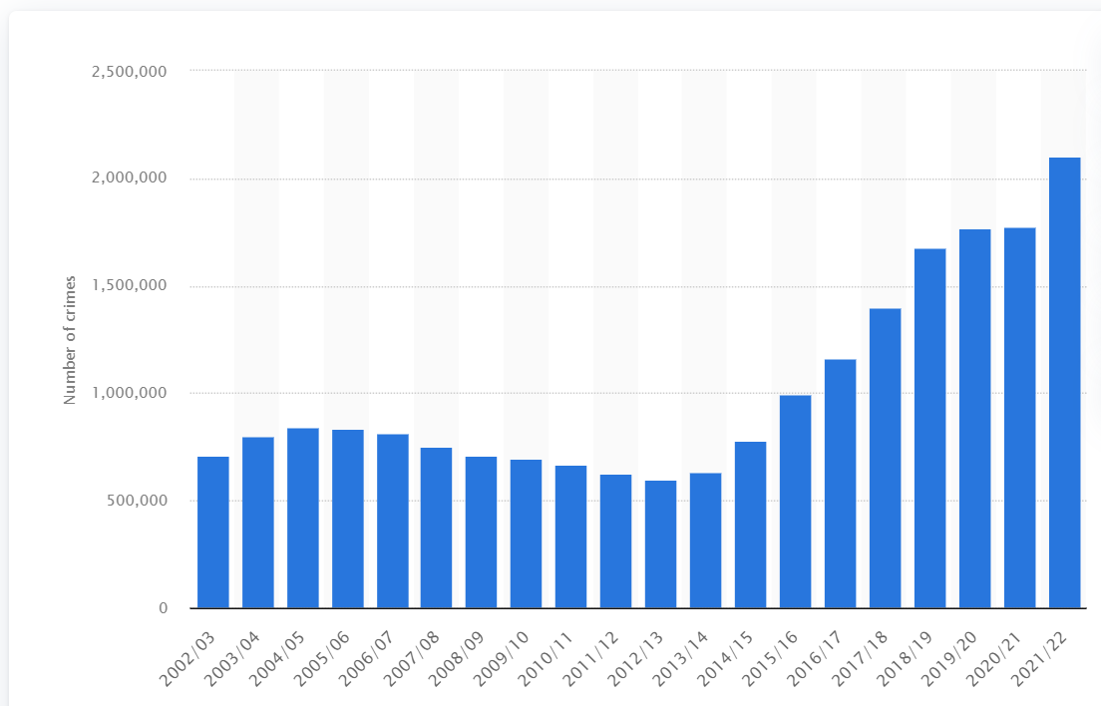

(Statista, 2022)

The Office for National Statistics (2020) details that in “March 2019, there were 9,787 offences in which firearms were involved; this is a 4% increase compared with the previous year…The number of offences has increased by just over a quarter (27%) compared with five years ago”.

Home Office (2022) statistics show that in 2021, West Midlands and London had the highest number of police firearms operations which creates the question, should only particular police forces frontline officers carry firearms, or whether all should?

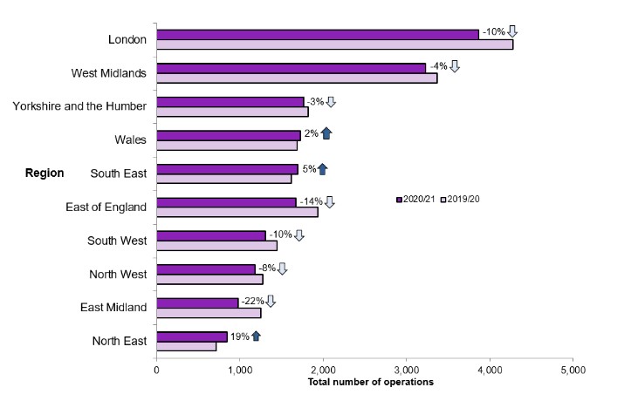

Home Office (2022)

Yesberg, Bradford and Dawson (2020) study on the responses to armed police in Great Britain concluded that “armed police seem to evoke some concern and discomfort” however it did not change the public’s trust and perception of the police.

SUMMARY OF RESEARCH –SURVEY METHOD:

Research will be conducted using questionnaires via survey monkey as a tool. Questionnaires to be utilised, using closed ended questions. By using closed ended questions this will give data that can be quantified and be easily analysed. By using a questionnaire as the research method, it will give the target audience the flexibility to complete the survey when it’s convenient and thus a wider target audience can be reached, ensuring a more accurate evaluation and diverse feedback. The data gathered will be primary data and aim to include a sample size of 100 participants, 50 police officers and 50 members of the public.

“Closed-ended questions limit answers: thus tighter stats” (Farrell, 2016).

“Questionnaires are a cost-effective, simple and quick way to gather data that comes straight from the sources” (Reference, 2019).

SUMMARY OF SAMPLING FRAMEWORK:

The target sample for this project are police officers within the UK and members of the public aged 18 and over. This sample best suits this project as it will include current police officers and their opinions on the research question as it would directly impact their duties. Members of the public are vital for this research as police officers serve the public and it would be the public who would be confronted with these firearms if frontline officers were to carry them as part of their duties.

Two questionnaires will be created with the same questions however the questionnaire for police officers will include questions to identify what department they currently work within and for what police force. Questionnaire A will be sent to police officers in various units and police forces with questions tailored to police officers for example: what department are you currently working within? What police force are you employed by? Questionnaire B will be sent to members of the public. This will ensure the data gathering process will be more accurate and streamlined as all data from A will be from police officers and all data from B will be from the public. It will be easier to compare/contrast the answers provided but will also be straightforward to collate them.

ETHICAL ISSUES:

Whilst conducting the research participants will be made aware that they are doing so on a voluntary basis, they will remain anonymous throughout the process, and they have the right to withdraw at any time. Participants will be informed that the answers they provide will be used for this dissertation and the results will be shared to whomever the university deems necessary. However, although the answers will be shared, their names will not be required when completing the survey, thus ensuring their anonymity. Participants will be aged over 18 and therefore will not need parental consent to complete.

TIME SCALE:

DATE | PLAN
Proposal & Ethics Form | 15/08/2022
Literature Review | 24/10/2022
Research Methods | 05/12/2022
Questionnaires – created & disseminated | 05/12/2022
Analysis of results | 23/01/2023
Findings & Conclusion | 27/02/2023
Final Dissertation | 27/03/2023

REFERENCE LIST:

Clark (2022). Violent crimes in England and Wales 2021. [online] Statista. Available at: https://www.statista.com/statistics/288256/violent-crimes-in-england-and-wales/ [Accessed 11 Aug. 2022].
College of Policing (2021). Control, restraint and searches. [online] College of Policing. Available at: https://www.college.police.uk/app/detention-and-custody/control-restraint-and-searches [Accessed 12 Aug. 2022].
College of Policing. (2022). Deployment of authorised firearms officers (AFOs). [online] Available at: https://www.college.police.uk/app/armed-policing/deployment-authorised-firearms-officers-afos [Accessed 14 Aug. 2022].
Farrell, S. (2016). Open-Ended vs. Closed-Ended Questions in User Research. [online] Nielsen Norman Group. Available at: https://www.nngroup.com/articles/open-ended-questions/ [Accessed 14 Aug. 2022].
Home Office (2022). Police use of firearms statistics, England and Wales: April 2020 to March 2021 second edition. [online] GOV.UK. Available at: https://www.gov.uk/government/statistics/police-use-of-firearms-statistics-england-and-wales-april-2020-to-march-2021/police-use-of-firearms-statistics-england-and-wales-april-2020-to-march-2021 [Accessed 14 Aug. 2022].
Office for National Statistics (2020). Offences involving the use of firearms - Office for National Statistics. [online] www.ons.gov.uk. Available at: https://www.ons.gov.uk/peoplepopulationandcommunity/crimeandjustice/articles/offencesinvolvingtheuseoffirearms/yearendingmarch2019 [Accessed 14 Aug. 2022].
Police Firearms Officers Association (n.d.). Armed police. [online] www.pfoa.co.uk. Available at: https://www.pfoa.co.uk/articles/armed-police [Accessed 12 Aug. 2022].
Reference (2019). Why Should You Use Questionnaires As a Research Method? [online] Reference. Available at: https://www.reference.com/world-view/should-use-questionnaires-research-method-1a6a5567acb545a4 [Accessed 14 Aug. 2022].
Statista. (2022). Violent crimes in England and Wales 2021. [online] Available at: https://www.statista.com/statistics/288256/violent-crimes-in-england-and-wales/ [Accessed 9 Aug. 2022].
The Crown Prosecution Service (2017). Violent crime | The Crown Prosecution Service. [online] www.cps.gov.uk. Available at: https://www.cps.gov.uk/crime-info/violent-crime [Accessed 14 Aug. 2022].
Yesberg, J.A., Bradford, B. and Dawson, P. (2022). An experimental study of responses to armed police in Great Britain. Journal of Experimental Criminology. [online] doi:10.1007/s11292-019-09408-8. [Accessed 12 Aug. 2022].

