Topic: The Impact of Strategic Supplier Relationship Management (SRM) on Supply Chain Performance in the Manufacturing Sector

Student Name: JASWANTH.K.B
Student ID: 2424937

Table of Contents
Chapter 1: Introduction 4
1.1 Research background 4
1.2 Research Aim, Objectives and Questions 5
1.2.1 Aim 5
1.2.2 Objectives 5
1.2.3 Questions 5
1.3 Research Rationale 5
1.4 Problem Statement 6
Chapter 2: Literature Review 6
2.1 Components of strategic SRM in the manufacturing sector 6
2.2 SRM influences supply chain performance indicators such as efficiency, flexibility, and customer satisfaction 7
2.3 Challenges and barriers that affect effective implementation of SRM 8
2.4 Recommendations to strengthen supplier relationships for improved supply chain outcomes 9
2.5 Literature Gap 10
2.6 Theoretical Concept 10
Chapter 3: Methodology 11
3.1 Research Philosophy 11
3.2 Research Approach 11
3.3 Research Design 11
3.4 Research method 12
3.5 Data Collection 12
3.6 Data Analysis 12
3.7 Ethical Consideration 13
3.8 Research Timeline 13
Reference 14

Chapter 1: Introduction

1.1 Research background
In the current competitive world of manufacturing, the cooperation of the supplier is central to being competitive. This manufacturing market is an increase from $34.5 trillion in 2023. Looking ahead, that dollar amount is expected to reach $36.7 trillion by 2029 at a compound annual growth rate (CAGR) of 1.01% (Fictiv, 2024). This industry is very relevant and involves a very complex supply network. Supplier Relationship Management (SRM) has emerged as a strategic move towards long-term cooperation with suppliers and value creation rather than a transactional role (Grant, 2024). Sound SRM improves quality, innovativeness, and responsiveness, and minimizes costs and operational risks.

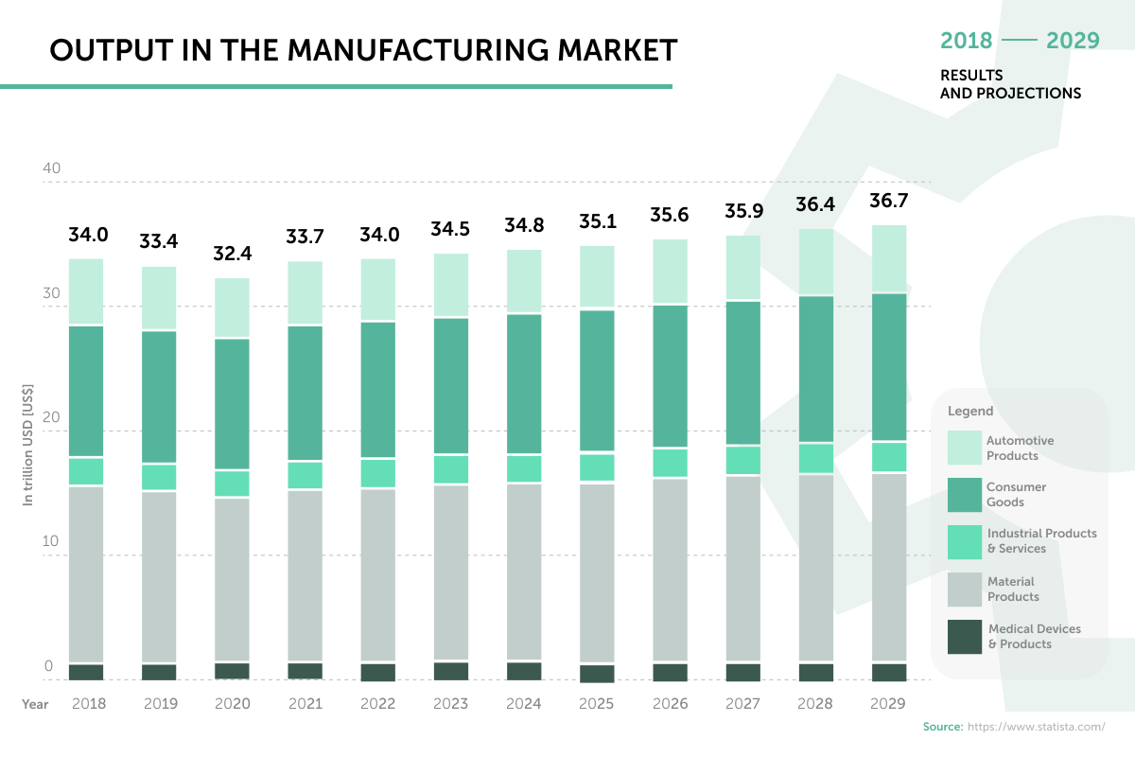
Figure 1: Output in the manufacturing market
Source: (Fictiv, 2024)
But, with all its demonstrated effectiveness, not every manufacturer has organized approaches to engage suppliers and address inefficiencies and performance gaps. With manufacturing increasingly technology-intensive and globalized, it is critical to understand the influence of strategic SRM on performance results, including flexibility, efficiency, and customer satisfaction. This study thus examines how the strategic effect of SRM practices impacts supply chain performance in the manufacturing industry.

1.2 Research Aim, Objectives and Questions

1.2.1 Aim
To evaluate the impact of strategic supplier relationship management on supply chain performance within the manufacturing sector.

1.2.2 Objectives
- To examine the core components of strategic SRM in the manufacturing sector.
- To analyse SRM influence on supply chain performance indicators such as efficiency, flexibility, and customer satisfaction.
- To identify the challenges and barriers that affect the effective implementation of SRM.
- To provide managerial recommendations to strengthen supplier relationships for improved supply chain outcomes.

1.2.3 Questions
- What are the core components of strategic SRM in the manufacturing sector?
- How does SRM influence supply chain performance indicators such as efficiency, flexibility, and customer satisfaction?
- What are the challenges and barriers that affect the effective implementation of SRM?
- What are managerial recommendations to strengthen supplier relationships for improved supply chain outcomes?

1.3 Research Rationale
This study is based on the rationale that an increasing number of manufacturing companies need to consider sustainable supplier relationships that can improve operational excellence and competitiveness. Strategic SRM helps to enhance collaborations, reduce risks, and innovations, which are essential in complicated global supply networks (Jones, 2025). However, few studies look at the direct relationship between SRM practices and performance outcomes in manufacturing settings. This paper bridges that gap by examining the elements of SRM, how it influences key performance indicators, and how to improve relationships.

1.4 Problem Statement
Even though most manufacturing companies have realised the need to work with their suppliers, a vast majority still use reactive and transactional strategies instead of strategic partnership models. This undermines performance indicators, including responsiveness, quality, and customer satisfaction. In addition, problems such as distrust, ineffective communication, and unstable assessment systems impair the effectiveness of SRM. The issue is that they have limited competence to achieve sustainable competitiveness because of the lack of knowledge of the impact of strategic SRM practices on the quantifiable supply chain performance in a manufacturing setting.

Chapter 2: Literature Review

2.1 Components of strategic SRM in the manufacturing sector
Strategic Supplier Relationship Management (SRM) aims at establishing long-term, mutually advantageous partnerships that contribute value along the supply chain. According to Vaka (2024), identifying key components such as supplier segmentation, collaboration, and performance monitoring is crucial for maximising supplier value and achieving operational excellence. As Patrucco, Frattini, and Di Benedetto (2022) point out, collaboration mechanisms, such as joint planning, shared data systems, and integrating suppliers, are crucial to improving innovation and coordination. In addition, Olaleye et al. (2024) focus on supplier development programs that foster continuous quality improvement and reduction of costs, which result in improved competitiveness. The technology-based supplier relationship management (SRM) systems improve communication transparency and supplier performance monitoring. These factors combined echo the tenets of the Resource-Based View (RBV), which argues that excellent supplier relations are a strategic resource that is valuable, rare, and imitable (Rishi, Dwivedi, and Ghosal, 2022). By employing systematic segmentation, building trust, and integrating technology, SRM builds intangible relational capital that helps sustain a firm's competitive advantage. Therefore, to enhance innovation, better coordination of suppliers, and long-term success of operations, it is important to identify and institutionalise such elements in the manufacturing industry.
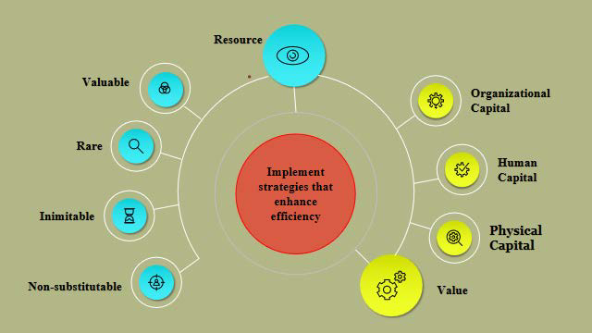
Figure 2: Resource Based View Theory
Source: (Rishi, Dwivedi, and Ghosal, 2022)

2.2 SRM influences supply chain performance indicators such as efficiency, flexibility, and customer satisfaction
Strategic SRM is a process that enhances important key performance areas, including cost-efficiency, responsiveness, and customer satisfaction. According to Riofiandi and Tarigan (2022), good supplier cooperation improves efficiency by lowering inventory expenses, lead times, and waste. As per the study, Sy Jr (2025) showed, the close buyer-supplier relationship enhances the quality of the product and process flexibility so that the firm can address demand changes quickly. Also, SRM enhanced information exchange and co-predictability, which enhanced the overall responsiveness and rates of fulfilling customers. In addition, Smith (2024) pointed out that digital SRM tools improve the coordination process in real time, raising the reliability and transparency of the entire supply chain. The outcomes are supported by the Theory of Transaction Cost Economics (TCE), which establishes that strategic partnerships decrease uncertainty and the cost of coordination and even lead to mutual efficiency (Li et al., 2024). When manufacturer operations are strategically integrated with strategic SRM practices, manufacturers can realize better operational results due to decreased delays, greater supplier reliability, and higher customer satisfaction. This integration, in turn, not only enhances performance but also increases adaptability in volatile markets. Thus, the SRM impact on the performance of the supply chain is that it can help in aligning strategic objectives, innovation, and the effective flow of both materials and information, which eventually leads to competitive advantage in the manufacturing industry.

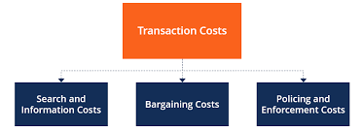
Figure 3: Theory of Transaction Cost Economics
Source: (Corporate Finance Institute, 2025)

2.3 Challenges and barriers that affect effective implementation of SRM
Despite the many advantages of SRM, some organisational and relational barriers to its implementation exist. According to Sankala (2024), poor communication, conflicting objectives, and cultural mismatches tend to hinder strategic alignment between manufacturers and suppliers. As per the study by Glavee-Geo, Engelseth, and Buvik (2021), the study underscores the idea that power imbalances and opportunistic behaviours deter open cooperation and sharing of knowledge, resulting in poor supplier engagement. In addition, Mankge et al. (2024) point out that insufficient managerial commitment and lack of technological infrastructural support are inhibiting factors to successful SRM implementation, especially in the developing manufacturing environment. Such problems may be attributed to the Social Exchange Theory (SET), which states that sustainable relations must rely on reciprocity and mutual benefit; in the case of lack of trust and fairness, relations worsen (Steiner et al., 2020). Moreover, disparate assessment systems and disconnected data do not enable firms to objectively evaluate supplier performance. Winning over these obstacles involves sustained communication, computer connectivity, and executive dedication. Firms that do not manage behavioural and structural barriers will find SRM initiatives fail to deliver desired improvements in the efficiency and performance of the supply chain. Cultivation of trust and alignment of strategic goals are thus critical success factors in the implementation of SRM in the manufacturing industry.
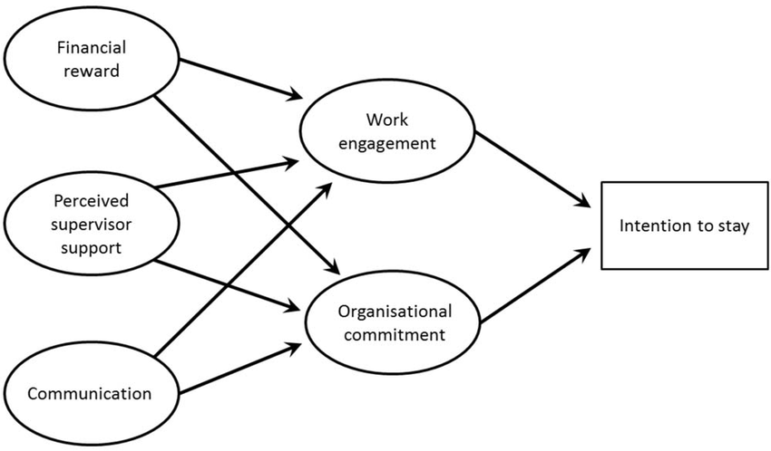
Figure 4: Theoretical Model based on the Social Exchange Theory.
Source: (Steiner et al., 2020)

2.4 Recommendations to strengthen supplier relationships for improved supply chain outcomes
Strategic commitment and technological innovation are necessary to strengthen relationships with suppliers. According to Jafari et al. (2023), supplier development and collaborative forecasting efforts are proposed to promote responsiveness and innovation. In addition, Sen et al. (2023) posit that relational capital (trust, joint learning, and information exchange) investments bring a competitive advantage in terms of value co-creation. Smith (2024) focuses on the digital SRM tools that should be provided to encourage transparency and enhance monitoring of performance. These suggestions are consistent with the Relational View Theory that suggests that inter-organisational relationships may produce unique benefits when firms pool knowledge and complementary capabilities (Bondin, 2022). Manufacturers can enhance the impact of SRMs by adopting a technology-supported performance dashboard, training together, and rewarding shared innovation. Additionally, top management should incorporate SRM principles into corporate strategy and make supplier working together a cultural and operating priority. A combination of these practices leads to greater efficiency, resilience, and innovation, so manufacturing companies realize high-level supply chain performance and sustainable competitive advantage in volatile global markets.

2.5 Literature Gap
Although past studies have determined the importance of SRM, few studies combine it as a strategy, technology, and relationship in the manufacturing industry. The majority of undertaken empirical studies extrapolate SRM practices across industry without evaluation of their role in industry-specific performance indicators (efficiency, flexibility, and customer satisfaction). Also, not many studies discuss ways in which companies can address barriers to the implementation of SRM to maintain long-term cooperation. This study fills these gaps by examining the influence of strategic elements of SRM on the performance results and suggesting feasible strategies to improve relations with suppliers.

2.6 Theoretical Concept
Resource-Based View (RBV): According to this theory, strategic supplier relationships are valuable, rare, and inimitable resources, which increase the long-term competitiveness of a firm. Collaboration and trust are essential internal capabilities enabling performance and innovation in SRM (Rishi, Dwivedi, and Ghosal, 2022).
Transaction Cost Economics (TCE): According to TCE, effective SRM lowers the cost of transactions achieved through better coordination and reduced opportunism between the suppliers and the manufacturers (Li et al., 2024). It facilitates effective decision-making and long-term stable relationships.
Social Exchange Theory (SET): SET emphasizes that supplier relations are developed based on reciprocity, equity, and confidence (Steiner et al., 2020). At a time when the two parties feel they are mutually benefiting, cooperation will increase, thus achieving better supply chain performance.
Relational View Theory: This theory builds on RBV by claiming that inter-organisational relationships generate joint competitive advantage by learning, exchanging information, and innovating together throughout the supply chain (Bondin, 2022).

Chapter 3: Methodology

3.1 Research Philosophy
In this study, an interpretivist philosophy will be used because the research will be done on the subjective meaning and perception of strategic supplier relationship management in the manufacturing industry. The research will attempt to explain the impact of SRM practices on supply chain performance using managerial experiences and industry reports. Interpretivism will be selected due to the fact that it provides a researcher with an opportunity to understand and explain complicated social interactions and realities in the context (Junjie and Yingxin, 2022). This philosophy will facilitate the understanding of behavioural, strategic, and relational attributes of SRM practice.

3.2 Research Approach
The inductive approach will be embraced because the research will not be testing the existence of previous theories and patterns but rather generating them based on observed data. This method will enable the researcher to develop conceptual knowledge based on literature and secondary data regarding SRM and performance results. An inductive method will be selected as it will allow the exploration process to be open-ended, allowing the researcher to discover new relationships and patterns (Diller and Passmore, 2023). In supplier management practices in the manufacturing industry, we ultimately make progress in theory development and recommendations.

3.3 Research Design
The research design of descriptive research will be employed to provide a proper overview of the influence of strategic supplier relationship management on the performance of the supply chains. This design will assist in outlining existing patterns, practices, and issues on how manufacturing firms are applying SRM. It will be selected as it will give a systematic manner of gathering, organising, and interpreting information on SRM strategies. The descriptive method will allow the study to demonstrate the associations between SRM elements, performance measurement, and implementation obstacles through the use of the already available secondary data.

3.4 Research method
The research will utilize a qualitative approach to research where deep insights into the literature, case study and industrial reports will be conducted. The relevant academic and professional sources will be retrieved with the help of search keywords like supplier relationship management in manufacturing, supply chain performance, SRM challenges, and strategic partnerships. The approach to be selected will be qualitative due to the fact that it enables a person to interpret the non-numerical data and have a better grasp of the relational and behavioural aspects in the context of the SRM practices (England, 2022). It will facilitate the study to develop detailed patterns and unfolding themes of the existing studies.

3.5 Data Collection
The proposed study will be based on the use of secondary data, as it will be based on peer-reviewed journal articles, industry publications, company reports, and the studies of supply chain performance. Google Scholar, Scopus, and ScienceDirect are relevant databases that will be used to select secondary data. The method will be selected as it will guarantee the availability of verifiable, reliable, and current information which is applicable in SRM in manufacturing. The secondary data collection will save time, comply with ethical practices, and be able to compare various case examples without any personal involvement, but also assure academic rigor and efficiency (Nii Laryeafio, and Ogbewe, 2023).

3.6 Data Analysis
The thematic analysis will be used in this research in order to explore patterns, ideas, and relationships in the secondary data obtained. These primary themes will be selected and grouped together (SRM components, performance implications, challenges, and strategies). The thematic analysis will be selected as it helps analyze qualitative data and enables the researcher to determine significant links between different data sources. The analytical method will assist in the development of informative conclusions regarding the impacts of strategic SRM practices on the performance of the supply chain and future managerial directions of the manufacturing companies.

3.7 Ethical Consideration
This study will also follow the high ethical standards set by the university to give credibility and integrity. The secondary data will be utilized, so all the information will be extracted from reliable and publicly available sources, including peer-reviewed journals, company reports, and government publications. The appropriate recognition will be realized by proper referencing to prevent plagiarism. No confidential or sensitive information will be given out and the intellectual property rights will be respected. The researcher will also uphold objectivity; no data manipulation or transparency will be compromised during the research study. Before data analysis and submission of the final dissertation, ethical approval will be obtained.

3.8 Research Timeline
Activity | Description | Timeline
Topic Selection & Approval | Finalising research title and gaining supervisor approval | Week 1
Literature Review | Reviewing academic sources and identifying theoretical framework | Week 2–4
Methodology Development | Designing research philosophy, approach, and method | Week 4–6
Data Collection | Gathering secondary data from academic and industry sources | Week 6–7
Data Analysis | Conducting thematic analysis and categorising findings | Week 7–8

Reference
Bondin, I., 2022. Inter-organisational relationships in construction projects: an analysis of inter-organisational relationships over time through the theoretical lens of trust and power (Doctoral dissertation, Loughborough University). Doi: https://doi.org/10.26174/thesis.lboro.21680366.v1
Corporate Finance Institute, 2025. What are Transaction Costs? [Online]. Available at: https://corporatefinanceinstitute.com/resources/economics/transaction-costs/ [Accessed on: 6 October, 2025]
Diller, S.J. and Passmore, J., 2023. Defining digital coaching: a qualitative inductive approach. Frontiers in Psychology, 14, p.1148243. Doi: https://doi.org/10.3389/fpsyg.2023.1148243
England, A., 2022. Quantitative and qualitative research methods. In Research for Medical Imaging and Radiation Sciences (pp. 71-96). Cham: Springer International Publishing. Available at: https://www.dufuhselibrary.com.ng/eBM/RGY/2022%20Research%20for%20Medical%20Imaging%20and%20Radiation%20Sciences.pdf#page=81 [Accessed on: 6 October, 2025]
Fictiv, 2024. 35 Manufacturing Industry Statistics and Trends [Online]. Available at: https://www.fictiv.com/articles/manufacturing-industry-statistics [Accessed on: 6 October, 2025]
Glavee-Geo, R., Engelseth, P. and Buvik, A., 2021. Power imbalance and the dark side of the captive agri-food supplier–buyer relationship. Journal of Business Ethics, 178(3), p.609. Doi: https://doi.org/10.1007/s10551-021-04791-7
Grant, O., 2024. The Role of Supplier Relationship Management in Ensuring E-Commerce Supply Chain Resilience. Doi: https://doi.org/10.20944/preprints202407.1136.v1
Jafari, H., Ghaderi, H., Malik, M. and Bernardes, E., 2023. The effects of supply chain flexibility on customer responsiveness: the moderating role of innovation orientation. Production Planning & Control, 34(16), pp.1543-1561. Doi: https://doi.org/10.1080/09537287.2022.2028030
Jones, J., 2025. A Systematic Literature Review on Supplier Relationship Management in the Context of Global Supply Chains. Doi: https://doi.org/10.20944/preprints202501.0460.v1
Junjie, M. and Yingxin, M., 2022. The Discussions of Positivism and Interpretivism. Online Submission, 4(1), pp.10-14. Doi: https://doi.org/10.36348/gajhss.2022.v04i01.002
Li, S., Zhou, Q., Huo, B. and Zhao, X., 2024. Environmental uncertainty, relationship commitment, and information sharing: the social exchange theory and transaction cost economics perspectives. International Journal of Logistics Research and Applications, 27(8), pp.1363-1387. Doi: https://doi.org/10.1080/13675567.2022.2141699
Mankge, F., Pogiso, K., Ndaba, Z. and Thango, B., 2024. A systematic review of success factors and failure reasons in enterprise systems for executive, managerial, and operational support. Doi: https://doi.org/10.20944/preprints202410.1670.v1
Nii Laryeafio, M. and Ogbewe, O.C., 2023. Ethical consideration dilemma: systematic review of ethics in qualitative data collection through interviews. Journal of Ethics in Entrepreneurship and Technology, 3(2), pp.94-110. Doi: http://dx.doi.org/10.1108/JEET-09-2022-0014
Olaleye, I.A., Mokogwu, C., Olufemi-Phillips, A.Q. and Adewale, T.T., 2024. Optimizing procurement efficiency: Frameworks for data-driven cost reduction and strategic vendor management. International Journal of Management Studies, 6(4), pp.121-130. Doi: https://doi.org/10.30574/msarr.2024.12.2.0192
Patrucco, A., Frattini, F. and Di Benedetto, A., 2022. Characteristics of supplier performance measurement systems in collaborative innovation projects: the role of the purchasing department. Supply Chain Management: An International Journal, 27(2), pp.207-231. Doi: https://doi.org/10.1108/SCM-11-2020-0551
Riofiandi, D. and Tarigan, Z.J.H., 2022. The effect of supplier collaboration on company performance through lean manufacture and inventory control (Doctoral dissertation, Petra Christian University). Doi: https://doi.org/10.9744/ijbs.5.1.74–86
Rishi, M., Dwivedi, P. and Ghosal, A., 2022. Application of RBV Theory in Business Management-A Bibliometric Analysis. Acta Universitatis Bohemiae Meridionales, 25(2). Doi: https://doi.org/10.32725/acta.2022.015
Sankala, A., 2024. Strategic Alignment: Evaluating Organizational Processes through the Lens of Global Standardization. Available at: https://www.theseus.fi/bitstream/handle/10024/866516/Sankala_Agata.pdf?sequence=2 [Accessed on: 6 October, 2025]
Sen, S., Budiman, A., Na, M. and Mohammadi, A., 2023. Role of Value Co-Creation between Information Interaction Capabilities and Competitive Advantage in SMEs, Henan Province, China. Journal of International Business and Management, 6(6), pp.01-22. Doi: https://doi.org/10.37227/JIBM-2023-05-5991
Smith, H.K., 2024. Digital Supplier Relationship Management Systems: Impacts on E-supply Chain Coordination and Long-Term Performance. Available at:https://www.researchgate.net/profile/Hussein-Smith/publication/384808378_Digital_Supplier_Relationship_Management_Systems_Impacts_on_E-_supply_Chain_Coordination_and_Long-Term_Performance/links/67081d87a12152019166bf19/Digital-Supplier-Relationship-Management-Systems-Impacts-on-E-supply-Chain-Coordination-and-Long-Term-Performance.pdf [Accessed on: 6 October 2025]
Smith, H.K., 2024. Digital Supplier Relationship Management Systems: Impacts on E-supply Chain Coordination and Long-Term Performance. Available at: https://www.researchgate.net/profile/Hussein-Smith/publication/384808378_Digital_Supplier_Relationship_Management_Systems_Impacts_on_E-_supply_Chain_Coordination_and_Long-Term_Performance/links/67081d87a12152019166bf19/Digital-Supplier-Relationship-Management-Systems-Impacts-on-E-supply-Chain-Coordination-and-Long-Term-Performance.pdf [Accessed on: 6 October, 2025]
Steiner, S., Cropley, M., Simonds, L. and Heron, R., 2020. Reasons for staying with your employer: Identifying the key organizational predictors of employee retention within a global energy business. Journal of occupational and environmental medicine, 62(4), pp.289-295. Doi: https://doi.org/10.1097/JOM.0000000000001820
Sy Jr, M.A., 2025. Buyer-Supplier Relationship and World Class Manufacturing as Correlates of Supply Chain Performance: A Literature Review. International Journal of Research and Innovation in Social Science, 9(1), pp.4988-4997. Available at: https://www.researchgate.net/profile/Melecio-Jr-Sy/publication/388554512_Buyer-Supplier_Relationship_and_World_Class_Manufacturing_as_Correlates_of_Supply_Chain_Performance_A_Literature_Review/links/679cbb6f645ef274a455cf42/Buyer-Supplier-Relationship-and-World-Class-Manufacturing-as-Correlates-of-Supply-Chain-Performance-A-Literature-Review.pdf [Accessed on: 6 October 2025]
Vaka, D.K., 2024. Enhancing supplier relationships: critical factors in procurement supplier selection. Journal of Artificial Intelligence, Machine Learning and Data Science, 2(1), pp.229-233. Doi: doi.org/10.51219/JAIMLD/dilip-kumar-vaka/74

