Digital Class – Session 1
September 30th 2020

Tutorial 1
THEME – MODERN ART DECO using Adobe Illustrator CC
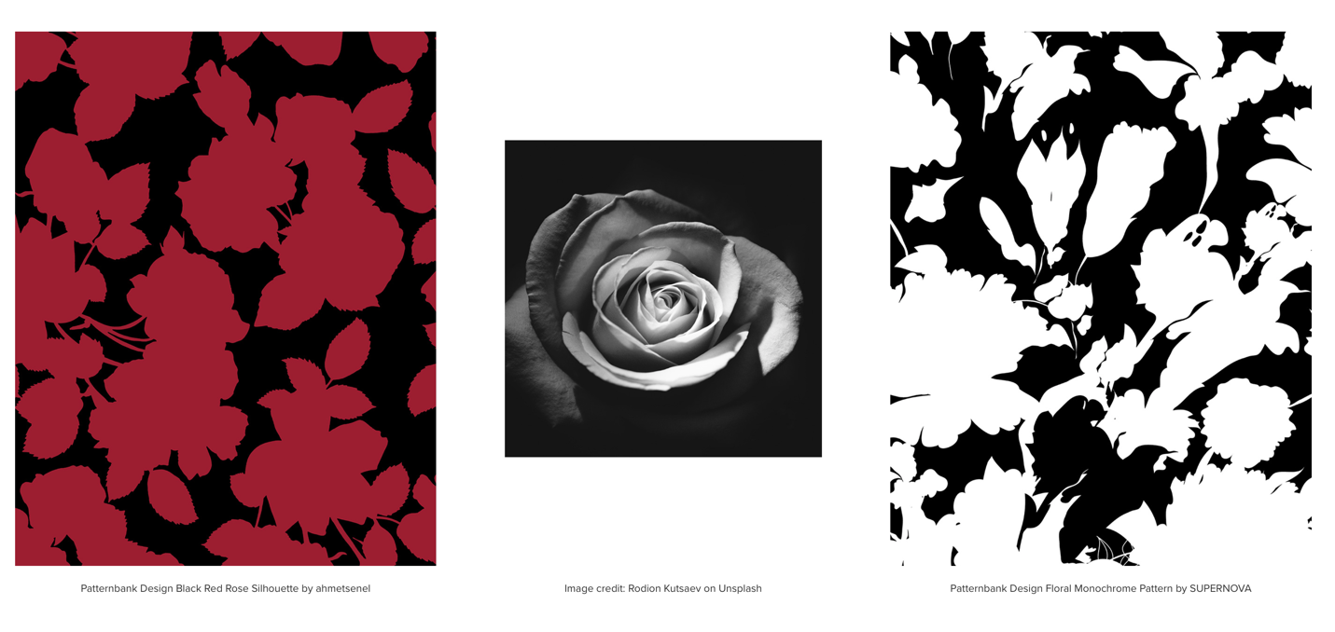
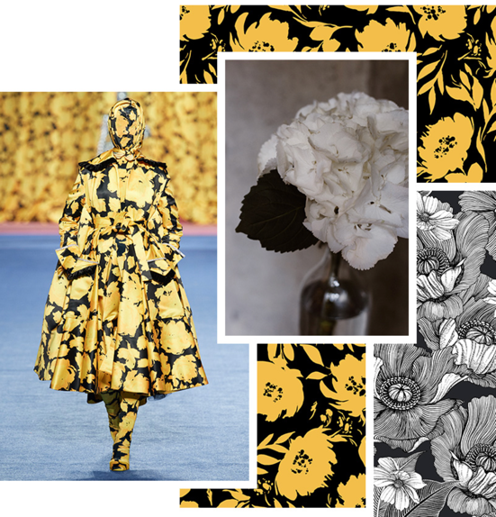

- Scan/photocopy/ and digitise your primary florals.

- Launch and sign into Adobe CC Illustrator

- https://unsplash.com / https://www.pexels.com

- Create a New Document – A3 size

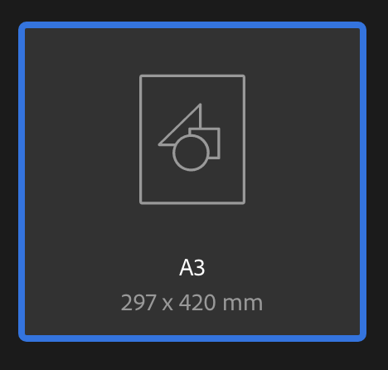

- Ensure you have the Essentials Classic mode set on.
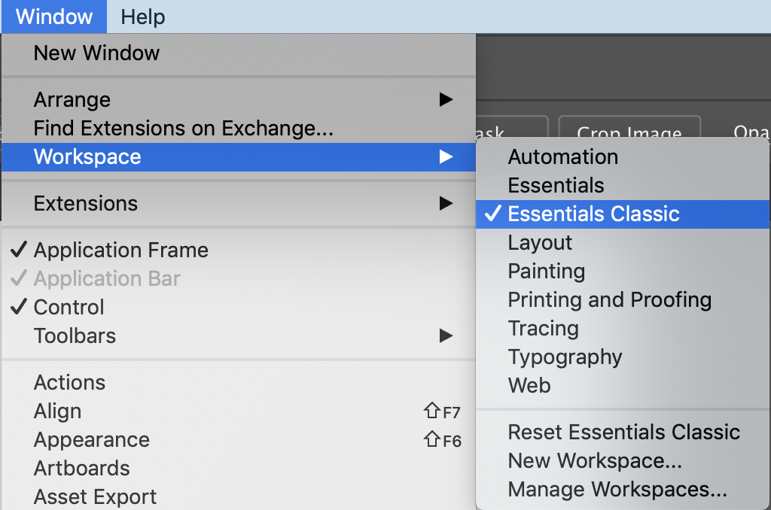

- Using your imagery, you will create a silhouettes of your florals to colour in 2 colours.

Make sure you save a master copy in black and white.

- Using the pen tool you will go around your blooms on a new layer.

- Using the black arrow you can embed images and rescale within illustrator itself.

- Take your time, looking at the edges of the flowers, stems, leaves and seed heads. You can add and develop your imagery from different elements such as drawing/scans and photography.

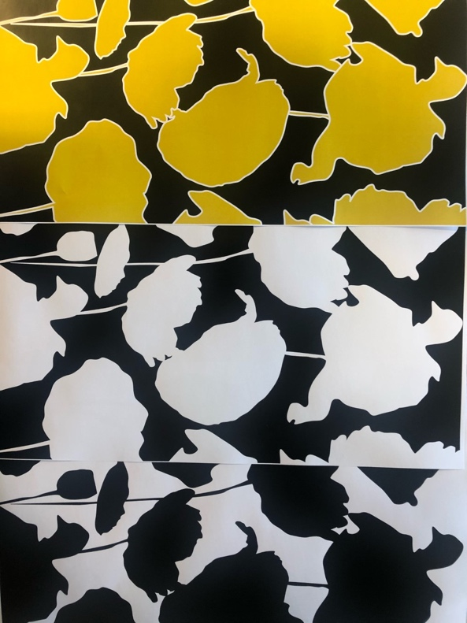
- You can change the stroke and fill colour of your silhouette; ensure you create white on black, black on white and 1 colour with black.
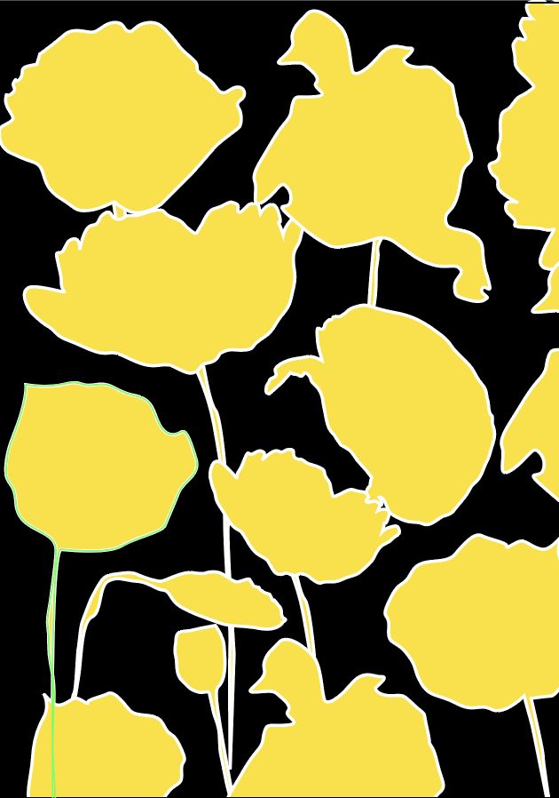

https://helpx.adobe.com/illustrator/user-guide.html
https://helpx.adobe.com/illustrator/tutorials.html?promoid=599F8QXB&mv=other

Add textures and patterns to the fills using the swatches palette.
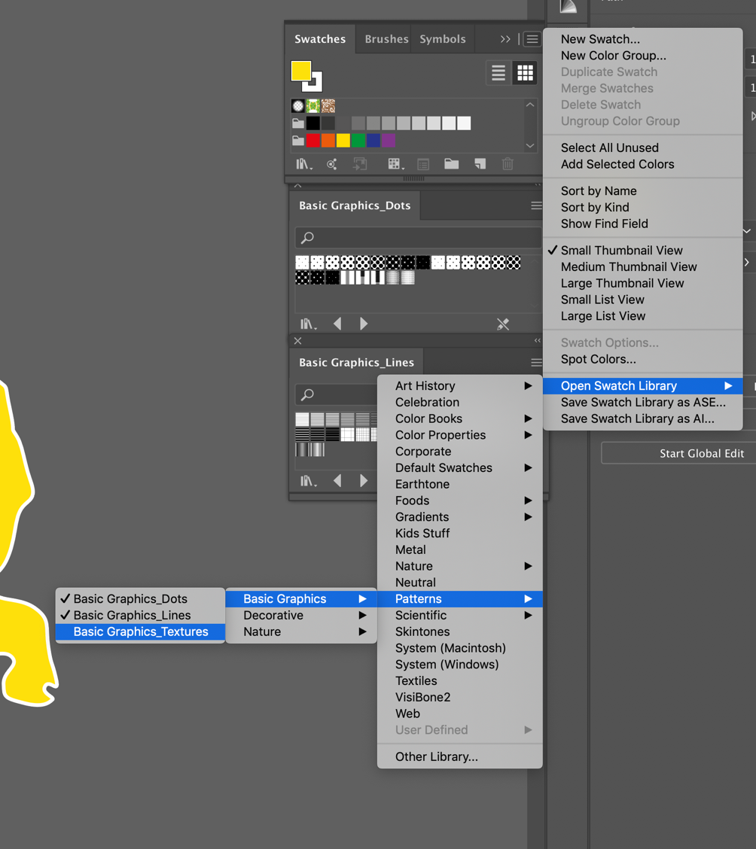

- Edit > Copy
- Edit> Paste in Place
- And change the fill with the swatches palette


