- Evaluate the advantages and disadvantages of the organisation structure in your organisation (or an organisation with which you are familiar) and evaluate the advantages and disadvantages of one other organisation structure. Within the evaluation, you should include the reasons underpinning the structure. (AC 1.1)

It been a challenge to identify a clear structure to my organisation. Having worked there for over 15 years I have seen significant change and a change based on business need at any given time. One could argue that this may imply that the structure could be organic in nature, however, there has been a fixed hierarchy at executive and senior management levels constantly. It has led me to believe that some organisations might use a mixture of structures dependant on the roles and requirements of operations, programme, and project criteria.

Divisional Structure

As defined by Kew and Stredwick (2016), a Divisional structure has its foundations in a traditional Bureaucratic structure; A workforce defined by specific expertise with a clear hierarchy and career progression through the ranks and a ridged adherence to the rules with no room for flexibility. Divisional structure evolved from business growth as centralised directives became more complex and the need to delegate ‘power’ and accountability, within the petametres of executive specialism, became essential. Divisional structures suit businesses which operate in the same way across multiple regions and locations. Ultimate strategic decision-making, financial control and monitoring still occurs at the top within is bureaucratic roots but smaller divisional teams can form micro-cultures and make more localised business decisions to suit local demographics; In more recent years, these structures have been extended to ‘Geographical Structures’ (saylor.org, n.d.).

Pros:
- Tailored outcomes for the local client.
- Greater potential to build closer interpersonal relationships to better understand the needs of all stakeholders.
- Decisions can be made more effectively.

Cons:
- Potential to lose overall company oversight.
- Disconnect from centralised systems.
- More variables to consider for the business.

Matrix Structure

A hybrid framework combining elements of functional and project-based structures. Employees report to both functional managers and project managers simultaneously: Functional managers and project managers.
Pros:
- Resources are shared across projects promoting shared knowledge and utilising diverse expertise. A by-product of this is that communication across the organisation is improved.
- Can motivate teams and individuals by increasing personal development opportunities and job satisfaction (Kew and Stredwick 2016).
- It can be a more flexible model if management lines work cohesively.
Cons:
- Dual reporting can lead to power struggles through management lines if objectives aren’t clearly defined and communicated. Disagreement on resource allocation and can hinder effective project implementation.
- Effective decision-making can be influenced by complex communication channels and problems of loyalty or insecurity ((Kew and Stredwick 2016).
- Roles can become ambiguous, and employees might experience confusion regarding their roles and priorities, therefore affecting performance (Tannenbaum et al.,1961).
Within the same company, I have experienced smaller matrix structures for short term projects. Within the third sector the nature of our work would sometimes attract funding and open fixed term employment opportunities or project work.
Organisations may choose this structure to find a balance between functional expertise and project-driven innovation and communication.

- Analyse connections between your organisation’s strategy (or an organisation with which you are familiar) and its products or services, and customers. (AC 1.2)

“Strategic alignment, for us, means that all elements of a business — including the market strategy and the way the company itself is organized — are arranged in such a way as to best support the fulfilment of its long-term purpose” (Trevor & Varcoe, 2016).

The mission of Leonard Cheshire (LC), the largest UK-based disability charity, is to empower people with disabilities to live a life without barriers. “…we provide support to people with disabilities to live, learn and work as independently as they choose whatever their ability… We believe in building a fairer, more inclusive society. One that recognises the positive contributions we all make” (Leonard Cheshire, n.d).
LC strategy focusses on community integration and within its workforce actively seeks to integrate and support disabled people into the workforce.
One of its programmes, directly aligning with it mission and influencing internal workforce practice, is focussed on providing employment support; ‘Change 100’, sets out an accessible and flexible recruitment strategy for interview and a mentoring programme for a period of 6 months plus, for example.

This is directly reflected in its inclusive approach in policy and procedure, supporting the diverse needs for the workforce and their customers. The inclusive approach applies to all, rather than only to employees identifying as having a disability, thus creating a culture of equity.

LC identifies as being ‘led by people with disabilities. An example of this is evidenced in the direct overall leadership of the organisations with the last two CEOs identifying as having a physical disability.

Feedback tools and access to advocacy are built into every operational process and analysed by each team, and overall, by a dedicated insight team. Team targets are governed feedback and communicated to teams through conferences, newsletters, bulletin board, supervision, appraisal and formal documents, well-being programmes and a range of 24/7 accessible services.

LC strategy includes ongoing training programmes for employees and awareness training for other businesses with a view to ensure they are equipped to support individuals with diverse needs effectively. An example being an embedded communication toolkit where every staff member is aware of the language used in the organisation on how to speak about disability.
I believe that, overall, internal strategies remain closely connected with the charity’s broader mission to influence public perception, policies, and practices, centred on understanding the unique requirements of disabled individuals and providing customised support.

- Analyse three external factors or trends currently impacting your organisation (or one with which you are familiar). The impact of these factors or trends could be positive, neutral or negative, some are short-lived whilst others are long-lasting. Identify organisational priorities arising from the factors or trends analysed. (AC 1.3)

Advancements in Technology

Positive:
The rapid advancement of technology can reduce staffing costs, increase productivity allowing four our main employee groups to provide enhance social care outcomes for the people we support.

Negative:
Initial investment for a large organisation requires significant initial and continued investment and a risk to falling behind competitors withing the industry. Potential job displacement depending on future funding factors.

Organisation Priorities: Ensure that investment is made in the most relevant technologies, training for key stakeholders in using new tech. and include innovative thinking into company culture.

Legislative Factors

Positive:
New regulations in Wales enable LC Cymru to comply with current standards and apply for tenders more competitively in Wales.

Negative:
The cost of compliance – updating regional policy, training, induction processes, potential disruptions to operations, increased legal complexities and communication and performance management across UK regions.

Organisational Priorities:
Communication about regulatory changes, invest in compliance measurement tools and processes, and adapt strategies to align with evolving legal frameworks.

Covid 19

Positive:
Increase awareness and compliance with health and safety related compliance.

Negative:

Increased consumable costs, negative effect on recruitment and retention, increased pressures on partner healthcare providers, necessity for a proactive approach with limited resources and financial investment.

Organisational Priorities:

Prepared contingency plans and effective communication internally and externally with partners, education for effective recruitment and diversity benefits, focus on preventive measures, education on health and wellbeing.

- When setting out its view on automation, AI and technology, the CIPD states, ‘Automation, artificial intelligence (AI) and other workplace technologies are bringing major changes to work and employment.’ Assess the scale of technology within organisations and how it impacts work. (AC 1.4)

The 21st century workplace has technology embedded within day-to-day activity, with a view to reducing the risk of human error and enhancing productivity.
The CIPD (2022) say, ‘Their organisation’s productivity and culture are at risk if their people can’t adapt to connecting and collaborating when they’re not physically in the same space.’; The potential threats to employee engagement and a disjointed workplace culture poses a risk to success in the age of the hybrid workforce.

The advantages are undeniable:
- Easy automation of routine and repetitive tasks freeing employees to focus on more complex and value-added aspects of their roles.
- Instant communication and collaboration through tools like email, instant messaging, video conferencing, and collaboration platforms; Liaising with colleagues and stakeholders regardless of physical location.
- Potential improvement of employee work-life balance and more easily integrated flexible working arrangements.
- Easily pull data analytics, gaining insight into stakeholder behaviours.
- Facilitates continuous learning opportunities that are in a flexible format (e-learning, online platforms and virtual workshops) which can be completed at the employees own pace.
- Contributing to creative problem solving through Virtual Reality or AI for example to formulate ideas and to prototype with reduced cost.

The Covid19 pandemic, acting as a catalyst for the fastest growth in hybrid and remote working models, forced the hand of employers to invest in heavy tech solutions to effectively integrate their employees remotely. People practices have had to adapt to new models of working to support hybrid workforces and remain relevant and competitive.

But how much technology is too much?

With the introduction of AI and monitoring/tracking software becoming commonplace, technology could be rapidly accelerating on from a more passive role into an, arguably, out of control micromanaging tool of our nightmares.

Are we, as people practitioners, in danger of inflicting an unhealthy, ‘big brother’ style common convention through around the clock programming with our accessible work-flow apps. Is this portraying and unashamed lack of trust attitude?
The CIPD (2022) learned that people are uneasy about increased monitoring at work, and to monitor those working remotely might backfire if people feel it’s unnecessary or intrusive. In a recent study, they found that 88% of managers and workers agreed that increased monitoring has more downsides than benefits. Of the survey, 73% said that introducing new technologies in the workplace will damage trust between workers and employers.

I believe that overuse of tech. could be an unsympathetic stepping stone toward the breeding of toxic cultures, increase the sense of employee isolation, reduced creativity and lead to an unsafe culture that influences both the office-life and home-life. HRM functions must carefully consider and monitor the use of tech. in the workplace through human-centric people practices and underpin these in precise guidance on behaviours in policy and procedures.

- Explain Edgar Schein’s model of organisational culture and explain one theory or model which examines human behaviour. (AC 2.1)

Schein’s model of organisational culture

Edgar Schein developed a model to explain organisational culture. His model consists of three levels which form an organisational culture:

The first level of organisational culture - Artifacts
These are observable elements and behaviours of the organisation: layout of the workspace, dress codes, and observable employee behaviours for example.

The second level of organisational culture - Espoused Values
These are the identified attitudes and promoted norms that employees of the organisation claim to adhere to. These values are often expressed in mission statements, policies and procedural documents, statements of purpose, and other official documents for example. These values aren’t always aligned perfectly with the actual behaviours and practices conducted by the workforce.

The third level - Underlying Assumptions
These are the core beliefs and unconscious ideals that guide behaviours and decision-making within the organisation. They are often deeply embedded in the organisational culture and not always easy to identify. Employees are not always consciously aware of these rules and traditions but are sometimes adopted as a ‘this is how we do things here’ approach.

Schein (1983) explains that leaders come to the organisation with preconceived ideals of what the culture should look like based on previous experience and that it’s up to them to communicate and reinforce their ideals effectively. He believes that a culture will transpire to be a combination of founder ideals and what a group have learned from their experiences within the organisation.
Schein acknowledges that during the process of ‘change management’, all three levels must be addressed by leaders in-order-for successful cultural transformation.

McClelland's theory

Also known as the three needs theory, can be used within people practice as a tool to identify motivators, identify leaders and to contribute to team building, regardless of gender, culture, or age, for example (Mindtools, 2024). The theory has been influential but has been criticised for being too simplistic in analysing the complexity of human need.

The theory suggests that affiliation, achievement, and power can be learned or acquired socially through life experiences and can affect the individual's performance in the work environment (Baptista et al., 2021).

The need for affiliation
Demonstrated by people who integrate themselves fully into the organisation where they feel they are well suited; They possess the innate desire to be well thought of and accepted. They are networkers who seek strong and positive colleague relationships and place a high value on collaboration and teamworking (Baptista et al., 2021).

Need for Achievement
The need to stand out from the rest and seek constant improvement in their performance. They will seek out learning opportunities, wishing to excel in all areas essential to the task at hand. They seek regular feedback from those who are engage with the subject matter, with accuracy and interest, in-order-to become more agile in the workplace.
These individuals are not motivated by money but use it as tool to maintain progression and improvement. They are resourceful, take moderate responsibility and are guided by goals (Baptista et al., 2021).

Need for Power
Characterised by individual need to be seen with value and admiration by others.
They are more competitive in nature and concerned with building their reputation. These individuals seek authoritative positions and tend to be more assertive or persuasive in-order-to influence others. They look to inspire and to be noticed and admired for their status (Baptista et al., 2021).

- Assess how people practices in your organisation (or one with which you are familiar) impact both on organisational culture and behaviour, drawing on examples to support your arguments. (AC 2.2)

.
“…all people professionals need a common understanding of the way culture and behaviour impact on people practices, and vice versa” (CIPD 2024).

Employee Development Programmes example

According to The Myers Briggs company (2023), "Self-awareness is important for everyone, but it’s critical for leaders. If a leader understands how their personality type influences their natural approach to risk-taking and identifies stress triggers, they're less likely to react to stress by making poor decisions."

Within my organisation, Managing for Excellence (M4E) training was introduced to support an employee restructuring initiative. Managers were asked to attend training, coaching and reflective practice sessions in-order-to assist in identifying their personality type indicators and management styles. It proved to be beneficial in understanding individual preferences, enhancing communication and open feedback within teams, and empowered employees.

Over the course of a few years, management practices were influenced and shifted further towards enhance inclusion individuals based on their merits, aligning their skills with departmental needs, and actively encouraging diversity within teams.

It also established an ethos centred around determining the necessary skills to accomplish tasks rather than adopting an 'it's not my job' mentality. The emphasis on self-awareness contributed to creating a more harmonious environment, cultivating a more supportive well-being culture and fostered a learning mindset.

In hindsight, had these people practices been underpinned in policy and procedure and a training package delivered to every new leader in the organisation on induction, the M4E programme would have been transformational to organisational behaviours and lasting culture. Sadly, without such practices and with the natural turnover of staffing in the care sector practices were deserted by the majority of services and no longer integrated into common practice.

Employee Induction Process

The transformation of our induction process, over the past few years, has had a positive impact on our organisational culture and behaviour within operational teams. By actively involving team leads who work daily with new recruits, existing support staff, and managers, we crafted a comprehensive induction program to align with our existing organisational frameworks, namely: performance management policies, probationary period policy, and government-approved guidance.

This initiative has significantly enriched the employee onboarding experience, ensuring a smoother transition for new recruits, and fostering effective integration into our organisational culture. Seeking the direct involvement of team leads into the process has complemented engagement initiatives like workshops and feedback sessions, contributing to a positive overall employee experience.

The strategic alignment with existing organisational frameworks has ensured a cohesive and consistent approach and adherence to existing performance management policies and the probationary period policy it has enhanced accountability and streamlined the workload when supporting new employees into their roles. A commitment to compliance with government guidelines has mitigated any legal risks and reinforced our reputation for reliability and integrity within regional service provision.

The benefits extend to quality assurance, where the rigorous induction process has resulted in high-quality employees and results from the start of the employee journey. As a result, this has positively contributed to tendering processes, showcasing our commitment to excellence and increasing our chances of winning contracts. The improvement in inspection feedback further enhances our organisational image during audits and inspection.

The success of our inductions has strengthened our relationships and reputation with local authorities and health boards to retain business and gain new contracts. Positive client experiences, built on trust and credibility, have expanded our portfolio in this regard. The overall initiative not only establishes a sense of reliability among stakeholders but also future proofs the organisation through ongoing awareness campaigns, positioning us to adapt to evolving changes and challenges in a changing environment.

- Peter Cheese, current CEO of CIPD asserts, ‘People professionals are a vital function in supporting businesses to adapt to rapidly changing circumstances’. Explain two different models or theories to managing change. (AC 2.3)

Lewin’s change management model (Mindtools, 2024).

Comprising of three stages, Unfreeze, Change, and Refreeze, the model provides a structured approach to navigating periods of organisational change.
1.The Unfreeze stage focusses on preparing for change by breaking down existing norms and communicating the necessity for change amongst the workforce.
2.The Change stage requires clear communication, allowing time to execute, and involvement of all employees to ensure individuals understand concepts and embrace the new direction.
3.The Refreeze stage puts emphasis on the changes made, fosters stability, and celebrates successes, creating a supportive culture for future initiatives

Kotters 8-step change model (Management Study guide, n.d.)

The steps are:

1. Create Urgency by highlighting threats and opportunities
Engage key stakeholders in honest communication about the need for change.
2. Form Powerful Guiding Coalitions by identifying dynamic leaders and stakeholders.
Creating a strong partnership and addressing any weaknesses within the team.
3. Develop a Vision and Strategy by defining core values and an exciting vision.
Forming strategies for achieving change and guaranteeing that leaders can successfully communicate the vision to other employees.
4. Communicate the Vision: Effectively communicate the vision of change with regularity, making it tangible by relating it to various organisational characteristics.
Tackle concerns transparently and engage stakeholders in the process.
5. Remove Obstacles by associating organisational processes and structures with the vision. Proactively pinpoint and remove barriers to change and reward employees who endorse and support the change.
6. Create Short-Term Wins by setting achievable short-term targets.
Use recognition and reward strategies to build momentum and enthusiasm.
7. Consolidate Gains by analysing successes and strive for continuous improvement. Incorporate change into the organisational culture and share success stories; It is important that leadership support is maintained.
8. Anchor Change in Corporate Culture by embedding change into organisational culture, ensuring that leaders provide ongoing support to do so. Every aspect of the organisation should champion the importance of change.

Both models are clear with step-by-step guidance. However, in each, the directive remains top heavy, and they can both risk employee frustrating if individuals’ needs are overlooked.

- A variety of models have been developed to explain how change is experienced. Discuss one model that explains how change is experienced. (AC 2.4)

Kubler-Ross Change Curve:

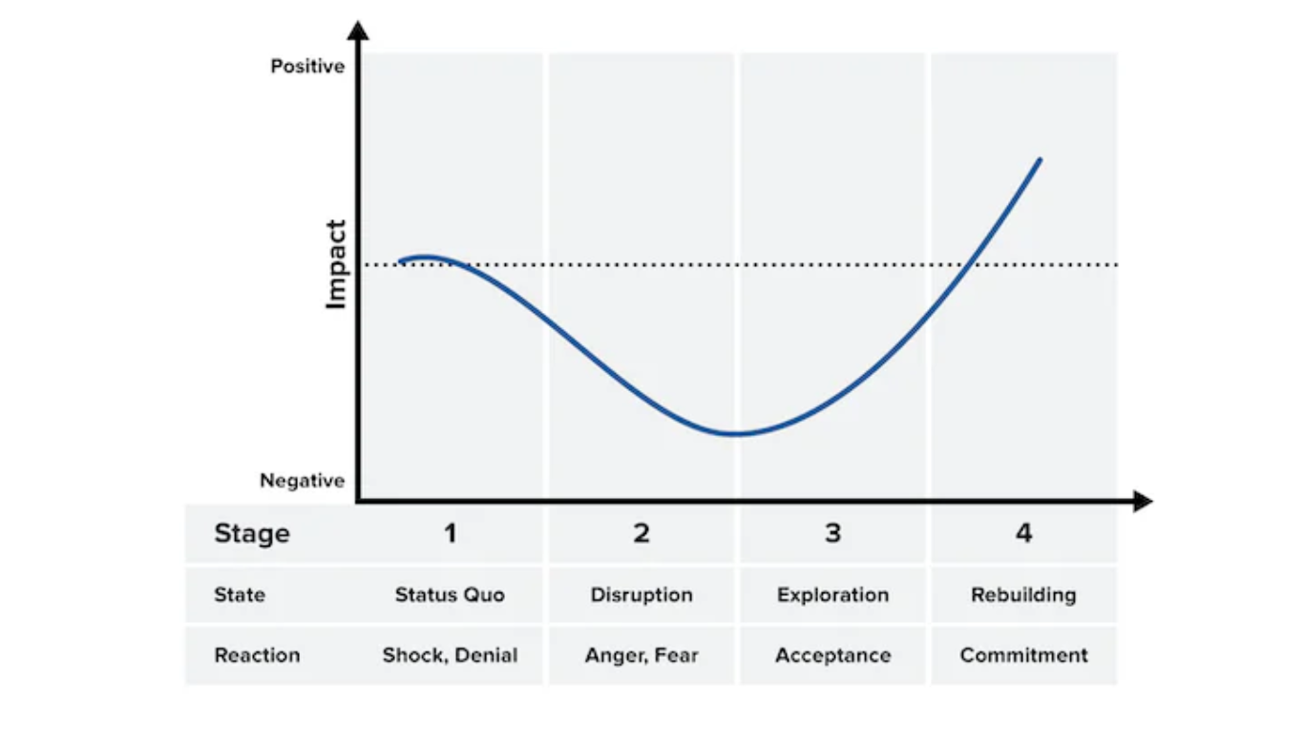
Mindtools (2024)

Key characteristics:

A focus on how employees experience change and cycle through the following four stages shock/denial, anger/fear, acceptance, and commitment. Organisations can provide support in a timely manger by anticipating employee rection to change. The model was originally developed to describe transition in grief and bereavement (Mindtools 2024).

Advantages:
Highlights the emotional impact of change which is useful for predicting reactions. People practice interventions can be targeted to help navigate challenges brought by change.

Disadvantages:
A generalised approach and not everyone will react in the same way. The model should be adjusted to suit the situation and relies on practitioner opinion. Not everyone goes through these stages in a linear fashion so is not always reliable. The model doesn’t consider the implementation of change so it could be used in conjunction with another model (apty 2020).

When choosing which change model to adopt, it is important to consider and factor this choice in and how it realistically will contribute to the future performance and culture of the organisation. Employee empowerment is essential to the success of change management. People practitioners should be aware of a variety of change management models to allow for individual difference and therefore support all employees.

- The CIPD’s Health and wellbeing at work survey 2022 found, ‘There is less management focus on health and wellbeing compared with the first year of the pandemic’, and goes on to remark that this is disappointing. Assess the importance of wellbeing at work and factors which impact wellbeing. (AC 2.5)

The CIPD (2023) says that encouraging overall well-being, and putting robust support systems in place, can prevent stress and nurture positive work environments posing advantages to the individual employee engagement and organisational performance alike.

Maslow's Hierarchy of Needs is a psychological theory that groups human needs into a pyramid shape, including physiological safety, security and belonging, self-esteem, and self-actualization needs. In a workplace context, the theory suggests that employees' motivation and job satisfaction addressed by fulfilling needs and 5 levels.

From bottom to top in the below image:
  - Basic needs - fair compensation, a safe work environment, and job security.
  - Creating a positive and inclusive workplace culture contributing to meeting social needs and a sense of belonging.
  - Acknowledging achievements, providing opportunities for skill development, and offering promotions contribute to fulfilling esteem needs.
  - Finally, supporting employees in pursuing personal and professional growth aligns with self-actualisation needs.

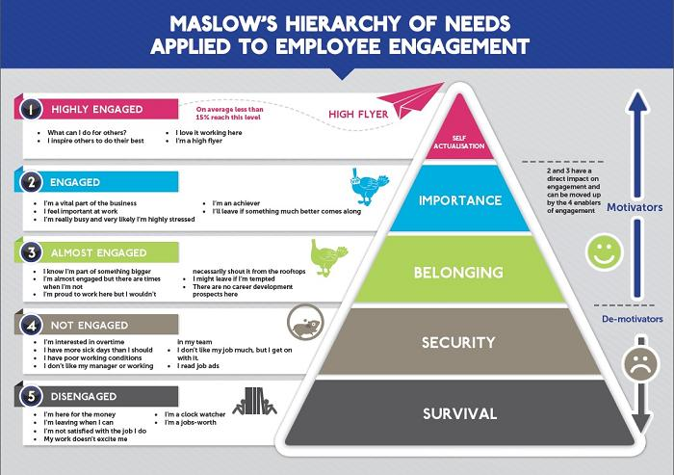
Stress Management Society (2019)

While Maslow's model is valuable in understanding employee motivation, we must recognise individual variations, like cultural norms for example, to consider the dynamic nature of human needs and understand specific factors which can impact wellbeing.

Dajnoki et al.(January 2020) identify the following as contributing factors:
- appropriate working conditions
- positive interpersonal relationships
- work motivation
- responsibility and autonomy
- respect for employees
- recognition and feedback on individual performance
- support from leaders

The CIPD (2022) reviewed the crucial link between leadership, employee well-being, and productivity and the correlation between leadership and organisational success. Research stresses the need for organisations to assess and enhance both technical and soft leadership skills. They recommend that these soft skills, specifically empathy and trustworthiness, should run through recruitment processes, training, performance reviews to significantly improve overall employee health, retention, and therefore overall performance.
A study performed across 3 organisations in Japan indicated that experiencing a sense of contribution and accepting selfishness in the workplace were both separately linked to reduced psychological distress and increased work engagement (Takaki, J., Taniguchi, T. and Fujii, Y., 2016).
It may be that HRM functions may need to contribute more directly in preparing the workforce for a ‘selfish approach’, defining what this means in their organisation and assisting employee understanding on acceptable boundaries. Leaders must be at the forefront of any positive change with regard to wellbeing strategy and visibly work by the same guidance as other employees.

- The CIPD Profession Map states ‘People practices are the processes and approaches that we use across the employee lifecycle’. Discuss the links between the employee lifecycle and different people practice roles. (AC 3.1)

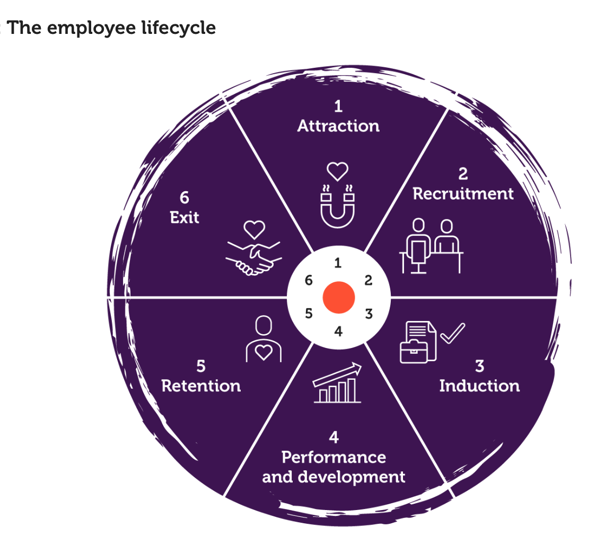
CIPD (2023)

The employee lifecycle plays a role in designing various people practice roles within the organisations. From recruitment to exit people practice has a role at each stage within the employees’ experience. Organisations have become more competitive and as such, requires competitive strategies to remain attractive to the employee.
In his you tube video, Jacob Morgan (2017) explains that the traditional idea of an employee lifecycle model may not accurately reflect the diverse experiences of employees. He describes that this perspective doesn’t consider employees as individuals. From the employee's viewpoint, their working timeline will include personal milestones like starting a family for example, not only focussing on professional aspects. He challenges predefined stages that may overlook the ongoing nature of personal development, which should be a continuous progression rather than a one-time experience.

Xiang et al. (2023) explain that the employee engagement model, embedded within the employee lifecycle, emphasises the need for a holistic approach, where employees are actively involved in influencing their overall performance. People practice roles, such as recruitment, onboarding, and development, are linked directly to different stages of the employee lifecycle. The model recognizes the importance of carefully planning employee experiences and encourages the use of tautomation and artificial intelligence to analyse and support engagement throughout the lifecycle. Despite recognising that there are different stages, the lifecycle it is though those resources available during each stage greatly impacts on employee development and wellbeing; with this, it is essential that people practice role in further development, progression, reward and wellbeing are utilised.
Artificial intelligence has a place in HR practices to further strengthens these links, determining positive outcomes in recruitment, administrative task automation, and monitoring employee retention. Xiang et al. (2023) explain that as organisations consider the advantages of more advancing technologies, people practice roles are advancing to incorporate these tools to become more competitive and to better manage the employee lifecycle.
“HR specialists have an opportunity to eliminate extra workload and deal with more ‘human’, creative tasks associated with motivating employees, improving working conditions, finding talents, and retaining valuable staff.” - Xiang, H. et al. (2023)

- Analyse how people practice connects with other areas of an organisation and supports wider people and organisational strategies. (AC 3.2)

In essence, people practice performs as a bond that connects a variety of operative areas within an organisation. The CIPD (2023) explains that strategic HRM is vital for aligning successful business strategies by recognising the employee as a crucial asset. The relationship between people practice and business strategy must be symbiotic in nature to ensure the realisation of organisational goals and contribution to the overall sustainability of the business.

Workforce planning, a key aspect of people strategy, translates business goals into action by continually assessing and addressing the workforce's capability and capacity (CIPD, 2023).
Talent Acquisition is the selection of the right people with the skills and behaviours, or potential to possess such attributes, that align to business strategies. HR will liaise with hiring managers to achieve this and identify talent and performance management strategies to include development objectives, retention methods, and contribute to succession planning.
Whilst HR professionals may not directly manage the workforce, people practices contribute to identifying talent on an individual basis by collaborating with managers, overseeing performance management processes, assist in setting performance objectives and contribute to identifying skills gaps. Learning and development professionals will design training programmes based on people practice feedback methods, as detailed below, to enhance workforce capability.

HRM plays a vital role in influencing and integrating positive strategy, contributing to positive employee relations. Addressing work issues, resolving conflict enforcing legal compliance, and supporting the organisation through periods of transition utilising change management methods and leading communication for the business positively support the workplace culture. As discussed earlier, HR will work with leadership teams to shape and reinforce the organisational culture, lead on employee engagement initiatives which should, in turn, enhance wellbeing and support a compassionate workplace culture., promoting values, ethics, and behaviours.

- Discuss processes you have, or could use, for consulting and engaging with internal customers of the people function in order to understand their needs. (AC 3.3)

Strategic Planning Workshops can align business strategy and HR initiatives with business; It fosters a collaborative mindset but can be resource intensive and requires commitment from all key stakeholders. Organisational KPI’s can be formulated to create a system of measurement which is most beneficial to analysing organisational performance.

Key Performance Indicators (KPIs) highlight areas which require attention, however they can lack some qualitative insight, the thoughts and feelings of employees, for example. If the identified KPI’s align with the organisational directive and strategy, they provide a good starting position for further analysis.

Direct communication channels
HR liaison meetings, open forums and employee councils can bridge the communication gap between employees and leadership roles. Regular communication can assist with understanding and promote transparency however doesn’t always address individual issues easily. Meetings can be subject to biases from the HR liaisons and there is potential for miscommunication. These methods depend on employee participation and a diverse inclusion amongst employees accessing these methods.

Feedback data collection tools
Focus groups, interviews, surveys, and pilot programmes vary in approach but provide a systematic method for feedback. Surveys rely on participant willingness to respond and may not capture sentiments that are current, however, other methods can be mandatory, and time focussed, they provide more in depth qualitative insight, particularly if diverse perspective are sought out; It’s worth noting that mandatory feedback could be misleading particularly if not anonymised.

Using technology for feedback
Whilst not the best tool for employees who are not tech savvy, technology enables real-time feedback and if anonymised employees can be frank and honest. With this in mind, in depth understanding can be more challenging to obtain.
While each approach has its strengths and weaknesses, all methods acknowledge the importance of open communication, employee involvement and engagement and a drive toward improvement. It is imperative that whichever process is used, that biases are eliminated in the collection and analysis of collected data. A combined and balanced approach would be most beneficial to balance the pros and cons of each method. There is a place for technology and artificial intelligence, with its reduced human idiosyncrasies, that could be utilised in providing insight into HR related process and strategy. Continuous improvement initiatives provide a culture for ongoing improvement and enable HR practices to remain current and responsive to changing organisational needs.

References

Apty (26 May 2020). 13 Types of Change of Management Models You Should Know. Available at: https://www.apty.io/blog/organizational-change-management-models/#:~:text=This%20model%20focuses%20on%20empowering,and%20confusion%20about%20major%20changes (Accessed at 11 February 2024)

Baptista, J. A., Formigoni, A., Silva, S., Stettiner, C. and Novais, R. (2021) “Analysis of the Theory of Acquired Needs from McClelland as a Means of Work Satisfaction”, Timor Leste Journal of Business and Management, 3(2), pp. 54-59. doi: 10.51703/bm.v3i2.48.

Cheung-Judge, M.-Y. (2012). Organization Development - a Practitioner’s Guide for OD and HR [Review of Organization Development - a Practitioner’s Guide for OD and HR]. Human Resource Management International Digest, 20(1). Emerald Group Publishing Limited. https://doi.org/10.1108/hrmid.2012.04420aaa.017

CIPD (18 Oct 2022) What monitoring measures are acceptable when managing remote workers? Available at: https://www.cipd.org/uk/views-and-insights/thought-leadership/insight/monitoring-measures/ (Accessed 3 Feb 2024)

CIPD (2024) Culture and behaviour. Available at: https://www.cipd.org/uk/the-people-profession/the-profession-map/explore-the-profession-map/core-knowledge/culture-behaviour/ (Accessed 03 February 2024)

CIPD (21 December 2023) People analytics: Guide for people professionals. Available at: https://www.cipd.org/en/knowledge/guides/analytics-practitioner-guide/ (Accessed 11 February 2024)

CIPD (22 June, 2023) Wellbeing at Work. Available at: https://www.cipd.org/en/knowledge/factsheets/well-being-factsheet/ (Accessed 2 February 2024)

CIPD (25 July 2023) Strategic human resource management. Available at: https://www.cipd.org/uk/knowledge/factsheets/strategic-hrm-factsheet/ (Accessed 04 February 2024)

CIPD (28 October 2022) The positive impact of quality leadership on employee wellbeing and performance, A look at how leadership can influence wellbeing and productivity to drive performance. Available at: https://www.cipd.org/uk/knowledge/bitesize-research/quality-leadership/ (Accessed 2 February 2024)

Dajnoki, K., Kőmíves, P., Szabados, N., Bácsné. B., (January 2020) List of wellbeing factors to consider. Available at: https://www.researchgate.net/publication/348820783_Factors_influencing_well-being_at_work (Accessed 03 February 2024)

Geographic Structure. Available at: https://learn.saylor.org/mod/book/view.php?id=60608&chapterid=48804#:~:text=Geographic%20structures%20resemble%20and%20are,%2C%20tastes%2C%20and%20cultural%20differences (Accessed 4 February 2024)

Greer, C.R. and Stevens, C.D. (2015) “HR in collaborative innovation with customers: role, alignment and challenges,” International journal of human resource management, 26(20), pp. 2569–2593. Available at: https://doi.org/10.1080/09585192.2014.1003086 (Accessed 10 February 2024)

Jacob Morgan (2017) Title of film or programme. Available at: https://www.youtube.com/watch?v=sBV0LLIPNmw (Accessed 11 February 2024).

Jonker, Jan., & Faber, N. E. D. (Niels E. D. (2021). Organizing for sustainability: a guide to developing new business models. Springer International Publishing AG.

Kew, J. and Stredwick, J., 2016. Human resource management in a business context. Kogan Page Publishers.

Leonard Cheshire. (n.d.). “About Us”, Leonard Cheshire. Available at: https://www.leonardcheshire.org/ (Accessed February 4 2024)

Management Study Guide (n.d) Kotter’s 8 step Model of Change. Available at: https://managementstudyguide.com/kotters-8-step-model-of-change.htm?utm_content=cmp-true (Accessed 5 February 2024)

Mindtools (2024) Lewin's Change Management Model. Available at: https://www.mindtools.com/ajm9l1e/lewins-change-management-model (Accessed 5 February 2024)

Mindtools (2024) McClelland's Human Motivation Theory. Available at: https://www.mindtools.com/aznjntj/mcclellands-human-motivation-theory (Accessed 01 February 2024)

Mindtools (2024) The Change Curve. Available at: https://www.mindtools.com/au03rgg/the-change-curve (Accessed 10 February 2024)

Mosca, M., 2020. Digitalization of HRM: A study of success factors and consequences in the last decade (Master's thesis, University of Twente).

Saylor.org (n.d.) Organizational Designs and Structures,

Schein, E.H. (1983) “The Role of the Founder in Creating Organizational Culture,” Organizational dynamics, 12(1), pp. 13-28-. Available at: https://doi.org/10.1016/0090-2616(83)90023-2.

Stress Management Society (2019) Maslow’s Hierarchy of Needs Applied to Employee Engagement. Available at: https://www.stress.org.uk/maslows-hierarchy-needs-applied-employee-engagement/ (Accessed 04 February 2024).

Takaki, J., Taniguchi, T. and Fujii, Y. (2016) “Confirmation of Maslow’s Hypothesis of Synergy: Developing an Acceptance of Selfishness at the Workplace Scale,” International journal of environmental research and public health, 13(5), pp. 462–1. Available at: https://doi.org/10.3390/ijerph13050462.

Tannenbaum et al., (1961). "Control in Organizations,".

The Myers Briggs Company (12 June 2023) How stress and personality type affect leader’s risk tolerance & decision-making. Available at: https://www.themyersbriggs.com/en-US/Connect-With-Us/Blog/2023/June/How-stress-and-personality-type-affects-leaders-risk-tolerance-and-decision-making#:~:text=Self%2Dawareness%20is%20important%20for,stress%20by%20making%20poor%20decisions (Accessed 5 Feb 2023)

Trevor, J., Varcoe, B. (16 May 2016) “A Simple Way to Test Your Company’s Strategic Alignment”, Harvard Business Review. Available at: https://hbr.org/2016/05/a-simple-way-to-test-your-companys-strategic-alignment (Accessed 4 February 2024)

Waite, K. (n.d.) People practice: a complete guide /. London, KoganPage.

Xiang, H. et al. (2023) “Sustainable Development of Employee Lifecycle Management in the Age of Global Challenges: Evidence from China, Russia, and Indonesia,” Sustainability (Basel, Switzerland), 15(6), pp. 4987-. Available at: https://doi.org/10.3390/su15064987 (Accessed 09 February 2024)

Zhang, J. and Chen, Z., 2023. Exploring Human Resource Management Digital Transformation in the

Bibliography

Bennett, V.M. and Levinthal, D.A. (2017) “Firm Lifecycles: Linking Employee Incentives and Firm Growth Dynamics,” Strategic management journal, 38(10), pp. 2005–2018. Available at: https://doi.org/10.1002/smj.2644.

Cameron, E. and Green, M. (2020) Making sense of change management : a complete guide to the models, tools and techniques of organizational change. Fifth edition. London ; Kogan Page.

CIPD (12 December 2023) Technology use in Learning and Development. Available at: https://www.cipd.org/en/knowledge/guides/technology-learning-development/ (Accessed 02 February 2024)

CIPD (2024) Technology and people. Available at: https://www.cipd.org/uk/the-people-profession/the-profession-map/explore-the-profession-map/core-knowledge/technology-people/ (Accessed 10 February 2024)

CIPD (3 October 2023) Has working remotely killed organisational culture? Available at: https://www.cipd.org/uk/knowledge/podcasts/hybrid-work-organisational-culture/ (Accessed 03 February 2024)
CIPD (30 September 2022) Can AI-assisted HR ecosystems improve employee engagement? Available at: https://www.cipd.org/uk/knowledge/bitesize-research/ai-assisted-employee-engagement/ (Accessed 1 February 2024)

CIPD (7 June 2023) Change management. Available at: https://www.cipd.org/uk/knowledge/factsheets/change-management-factsheet/ (Accessed at 1 February 2024)

Future Generations Commissioner for Wales (2024) Well-being of Future Generations (Wales) Act 2015. Available at: https://www.futuregenerations.wales/about-us/future-generations-act/ (Accessed at 1 February 2024)

Jacobs, S. et al. (2015) “‘The Matrix Reloaded’: A review of expert knowledge use for mapping ecosystem services,” Ecological modelling, 295, pp. 21–30. Available at: https://doi.org/10.1016/j.ecolmodel.2014.08.024.

Jonker, Jan., & Faber, N. E. D. (Niels E. D. (2021). Organizing for sustainability: a guide to developing new business models. Springer International Publishing AG.

Kotter, J.P. (2012) Leading change. Boston, Massachusetts: Harvard Business Review Press.

nibuisnessinfo.co.uk (n.d.) Business organisational structure. Available at: https://www.nibusinessinfo.co.uk/content/organisational-structure-geographical-area#:~:text=The%20advantages%20of%20a%20geographical%20structure&text=close%20communication%20with%20local%20customers,positive%20competition%20between%20different%20departments (Accessed 1 February 2024)

Slack, Nigel., & Brandon-Jones, Alistair. (2019). Operations management (9th ed.). Pearson.
Taylor, S. and Woodhams, C. (eds) (2022) Human resource management: people and organisations. Third Edition. New York, NY: Kogan Page Inc.

Wired (23 February 2023) Tech’s Productivity Obsession Is Toxic.
Workers are getting fired on the basis of metrics that don’t make any sense. Available at: https://www.wired.co.uk/article/techs-productivity-obsession-is-toxic (Accessed 8 February 2024)

Wright, T. (10 April 2023) Cascade: The 7 Best Business Strategy Examples I've Ever Seen. Available at: https://www.cascade.app/blog/the-5-best-business-strategies-ive-ever-seen (Accessed 1 Feb 2023)

