Submitted by: Sana Ali
Student id :2030389
Lecturer: Terry Wallcot
Module: Digital skills And Research Method
Module code: BMSW4003
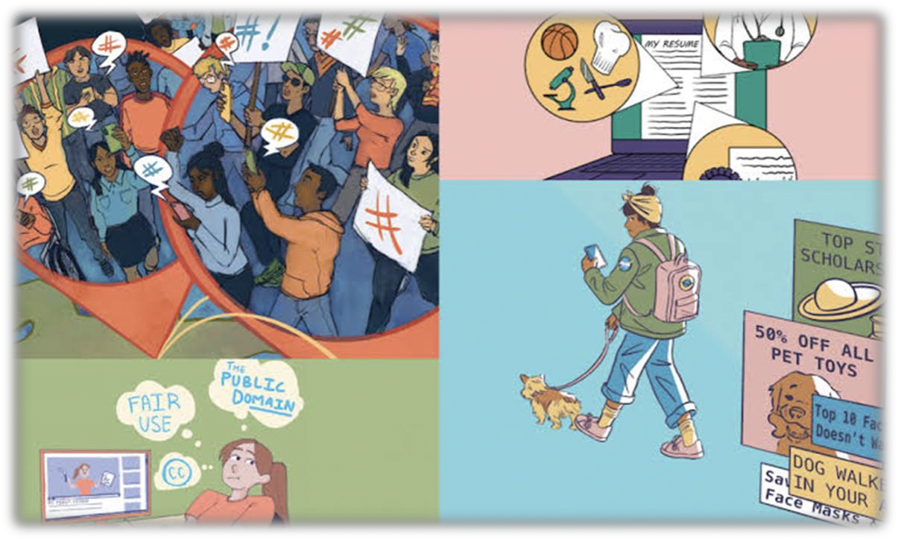

Impact of virtual learning environment on student’s learning experience at the University of Wales Trinity Saint David London Campus
- Introduction
COVID-19 pandemic that started in the end of 2019 and still affecting the lives of millions have had his impact on the learning experience of university students around the globe. Student’s learning experience at University of Wales Trinity Saint David London Campus was also greatly affected by the pandemic. Before the pandemic, university students were used to a more face-to-face interaction with professors and fellow course mates. But after COVID-19, due to the widespread of disease in face-to-face interactions, online learning platforms were introduced and widely used. Moodle and blackboard were widely used by academics to teach students and give as much access to course data as possible. Many studies have been done so far on the subject of effect of virtual learning on learning experience. Some studies have declared that virtual learning has been found to be useful for students in case of state emergency but some say that virtual learning has a negative impact on the type of experience that students are having. We will look into both these impacts and also collect direct reviews from students as to how they feel about learning virtually. Higher education processes were already progressing in terms of impact of innovation upon that amalgamation of burgeoning research methods, the reality seems to be that due to the captivity imposed by the coronavirus, it appears that the comprehensive utilization of ICTs in systematic acclimation has been imposed and its integration has been speeded up, as a test of strategic flexibility, and cultivated a transition which has also been ramped up to a staggering pace (Torres Martín, C., Acal, C., El Honrani, M. and Mingorance Estrada, Á.C., 2021).
- Virtual Learning Platforms and their Positive Impacts on learning environment
Virtual learning has its positive and negative impacts on the learning of students. First, we will look into the positive impacts:
  - Flexibility
Flexibility of learning at desired time and place has been provided by virtual learning platforms. Students do not need to be physically present in classrooms and designated times to learn now. Flexibility in learning has made students give more time to their education. With the growing economy and need to earn more with time, and for paying ones’ expenditures, some students opt for a career alongside their studies. Earlier, it was not possible because students had to check availability of time during their schedule classes, but with virtual learning, students can choose to work alongside their study. They just need to have a smartphone and an internet connection to connect at any time to Moodle
Not just the career side, virtual learning also allows students to study without distractions and choose a suitable time in which they feel least distracted. For example, if some maintenance is being done at home, a student can opt for a different time to attend classes when the distraction is over (Azlan, C.A., Wong, J.H.D., Tan, L.K., Huri, M.S.N.A., Ung, N.M., Pallath, V., Tan, C.P.L., Yeong, C.H. and Ng, K.H., 2020).
Moreover, when a student’s schedule isn’t dictated by scheduled classes, he/she can spend more time doing other things like spending time with themselves and their families. They can also focus on extracurricular activities necessary for mental growth instead of showing up to school at fixed time and assigning fix hours of ones’ life to study.
  - Financial Advantages
Expenditures of education can be reduced by online learning because students don’t have to commute to and from university. On average in UK, students spend about thousand dollars on transportation costs. Moreover, the cost of academic notes and course material (books, notes etc.) can be reduced by virtual platforms because students can access to documents online and hefty notes and books no longer need to be bought.
Tuition costs can also vary on virtual learning platforms as compared to physically attending classes. Courses that are offered online sometimes cost less than the ones that are offered on campus. It is because the university saves a lot of resources like electricity by students not physically being present on the campus (Woolliscroft, J.O., 2020).
  - Creative Thinking
A study was conducted by Ryan, E. and Poole, C. (2019), focused on the creative thinking skills, engagement and recall, on students of radiation therapy. This study focused on how the virtual learning helps students engage more and think creatively. A random trial was carried out where two teaching methods were used over the course of two weeks, one a face-to-face and other a virtual learning. After two weeks a questionnaire was filled by students. After standard deviation, means and chi-squared tests, the data received gave the conclusion that Virtual learning improved student satisfaction by more engagement and more time to recall already studied material. When students are not obliged to attend classes at scheduled hours, they get more time to do study at their desired time hence, they learn according to their will. It is verified from study that when students focus on studying at their own will they think creatively and create more useful material.
At university of whales Trinity Saint David London Campus, through the survey I conducted, it can be concluded that student’s relationships and communications are improved during the pandemic days due to virtual learning and virtual interactions. Moreover, teamworking skills of most students have also increased due to more comfortable study environment at home or some other desired place.

- Negative impacts of virtual learning on learning environment
There are many negative aspects to virtual learning as well. These impacts no matter how small or big effect virtual learning platforms and these platforms do their best to overcome these negative impacts to attract as much public as possible (Barker, J. and Gossman, P., 2013).
These negative impacts are:
- Feedback is limited in virtual interactions. Students can choose when to interact in an online meeting hence, interaction is rare and limited.
- Virtual learning requires time management skills.
- Cheating is very much common on virtual platforms during exams or tests.
- Due to less face-to-face interaction, some students face the problem of lack of confidence when interacting other than virtually.
- We live in a world where wealth is unevenly distributed. Hence, countries that are underdeveloped or still developing do not have access to many technological advancements. For example, some developing countries do not have access to fast running internet and other underdeveloped countries do not even have access to smartphones very commonly. Virtual learning has a very negative impact on students of such countries because learning environment requires constant time which is difficult to give when one has bad internet or no smartphone/laptop at hand.
- Virtual learning can only be done for limited courses. For example, medical or technical studies require constant physical practice and labs that are very difficult or impossible to conduct online.
- Quality assurance and accreditation is also limited in virtual learning.
- At university, students attend classes, participate in society activities and socialize which keeps them mentally and emotionally sound. It is different in virtual earning. Socializing and interacting is limited which has a negative impact on mental health.
- Health issues for eyes by staring for too long at desktop or mobile screen can also arise due to virtual learning.
- When attending classes at home, background noises of family and otherwise can cause disturbance for student and affect the learning experience (de Oliveira Dias, M., Lopes, R.D.O.A. and Teles, A.C., 2020).

- Questionnaire on ‘Impact of virtual learning environment on student’s virtual learning experience at the University of Wales Trinity Saint David London Campus’

The questionnaire consisted of a total of 12 questions, answered by students at University of Wales Trinity Saint David London Campus. A total of 38 responses were recorded by creating a questionnaire on 0365 apps. After receiving data, excel was used to further obtain pie charts and histograms. The plotted data is as follows:
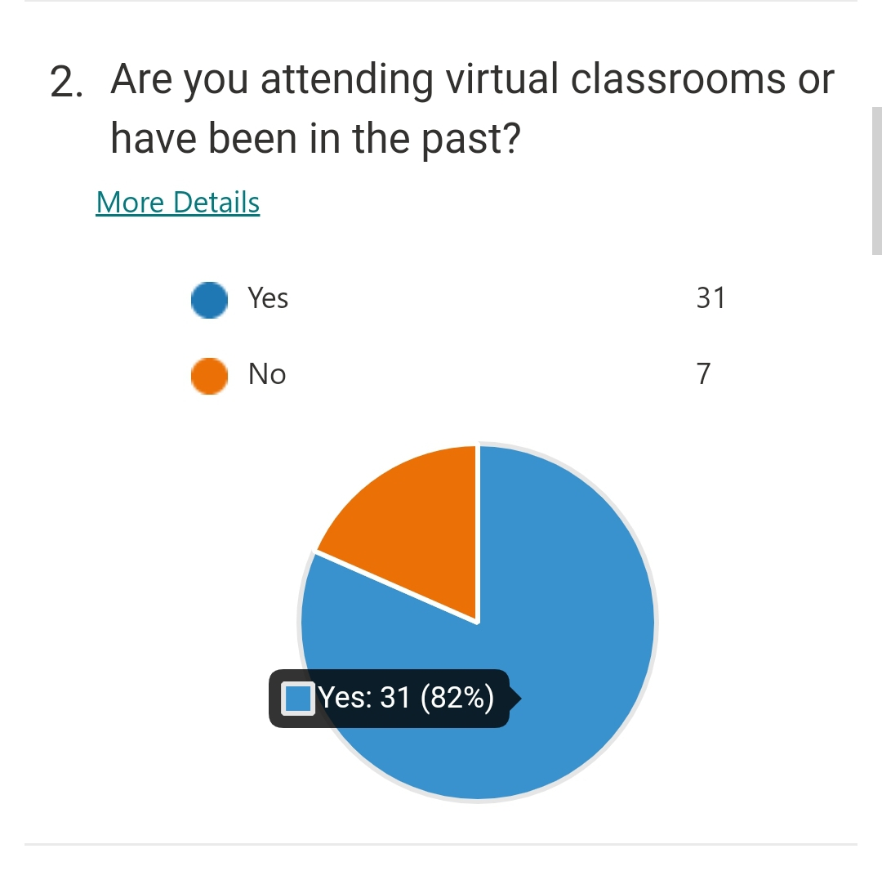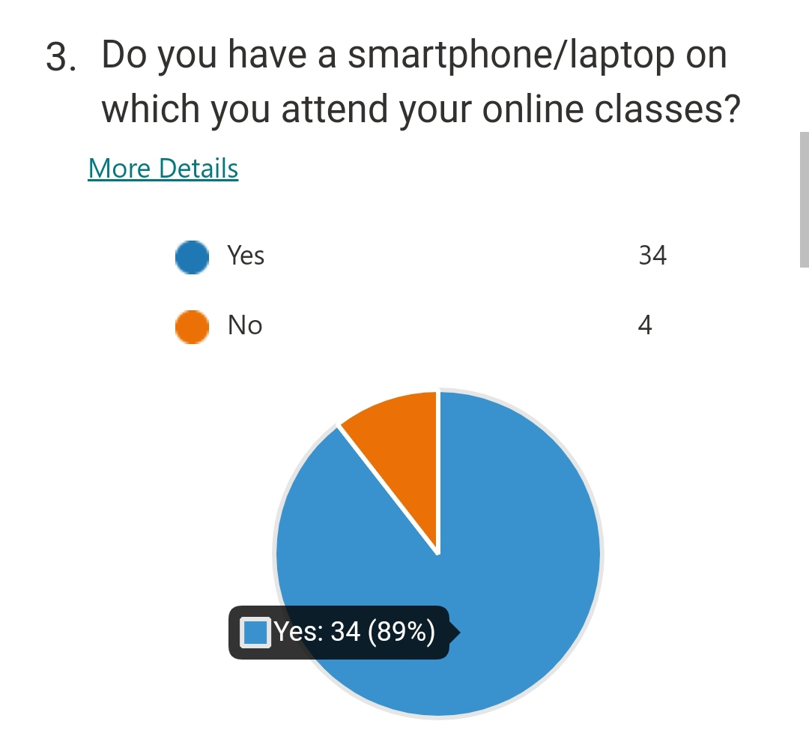
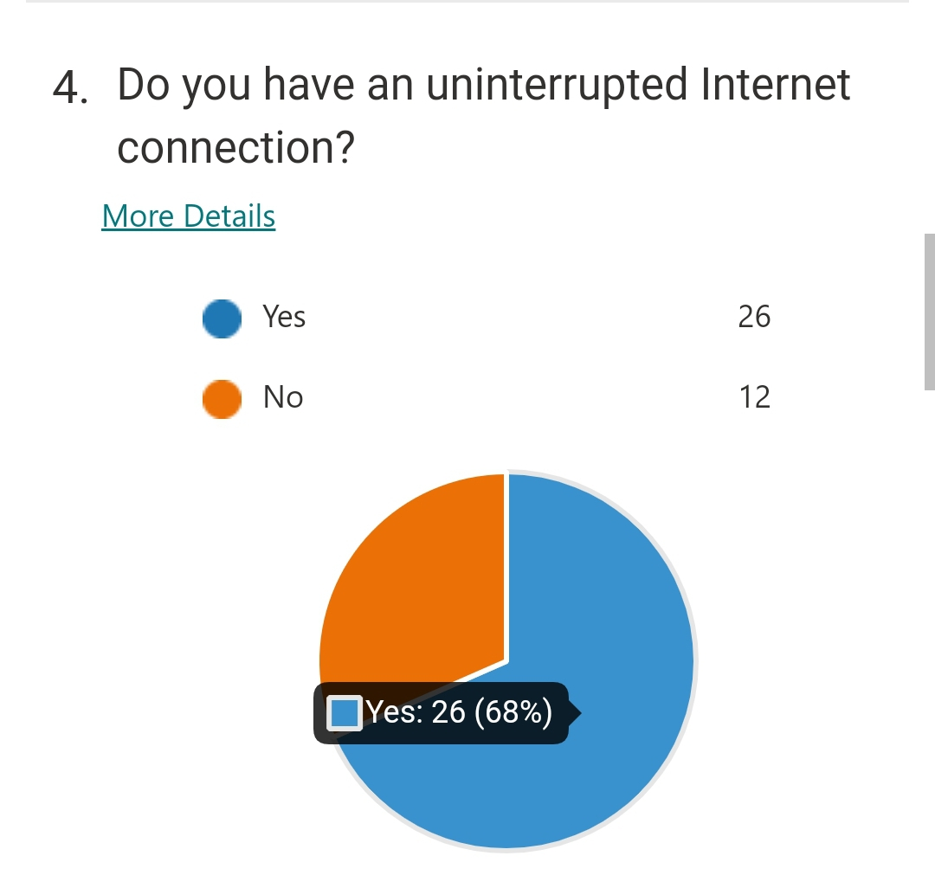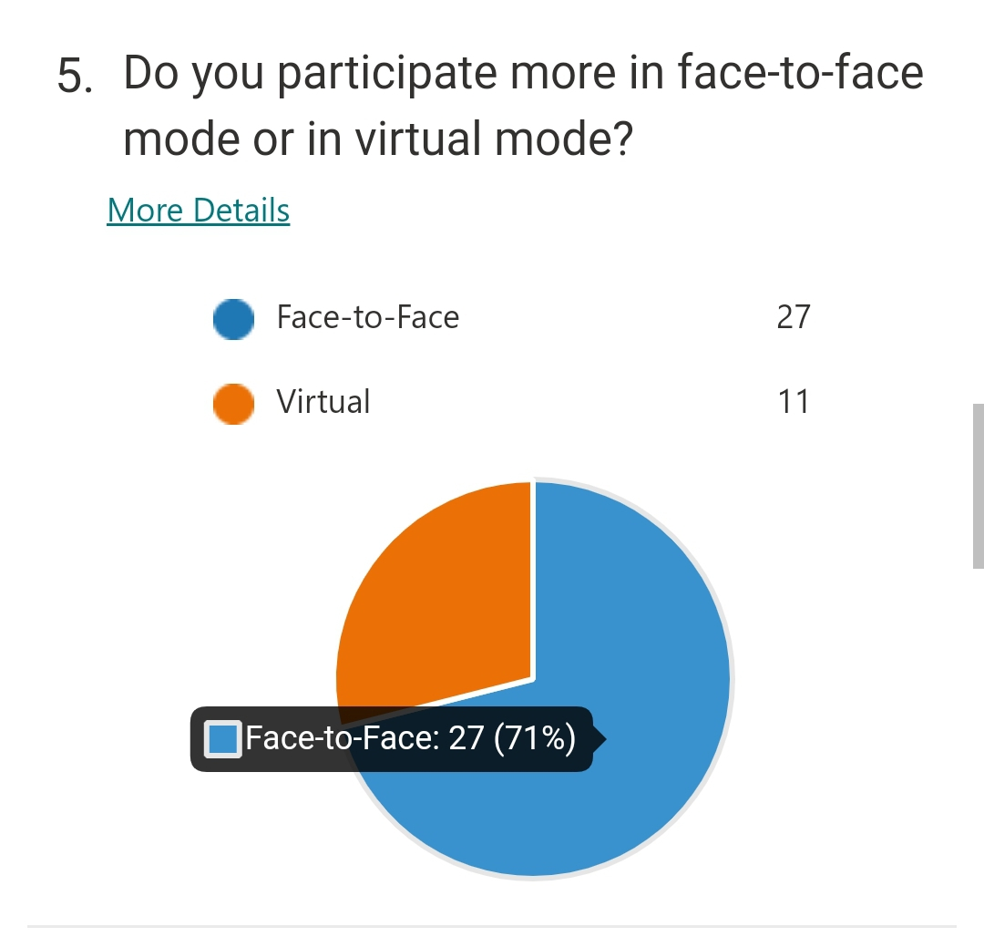

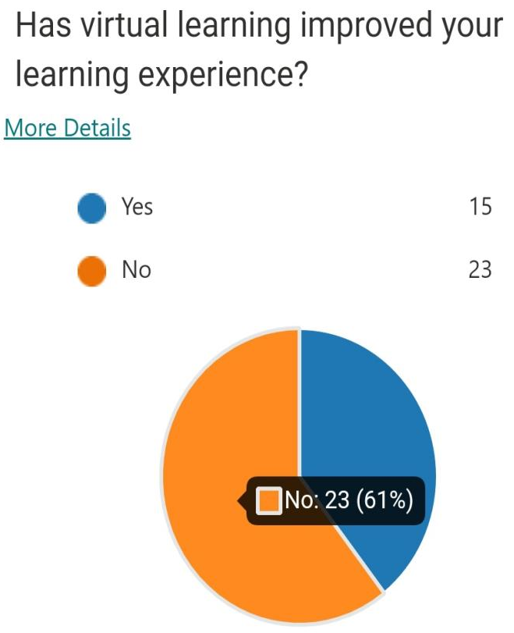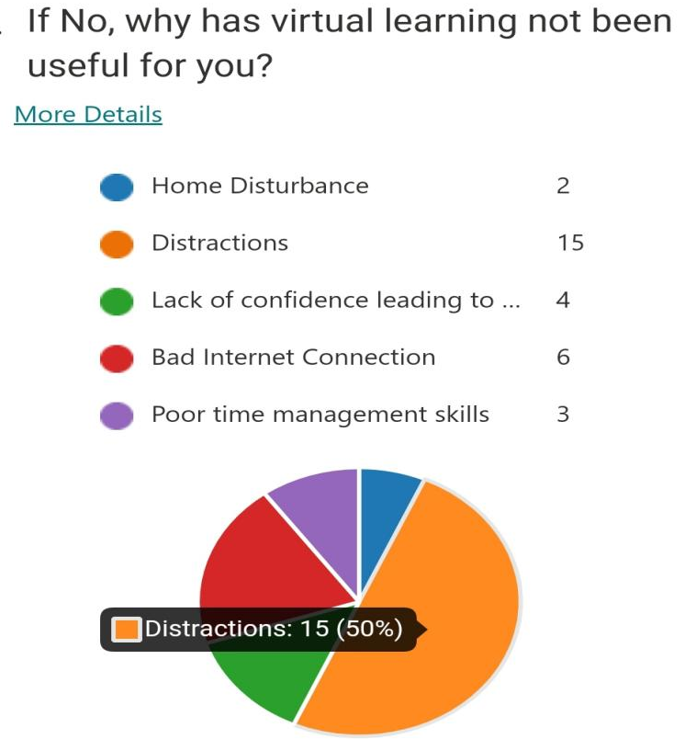
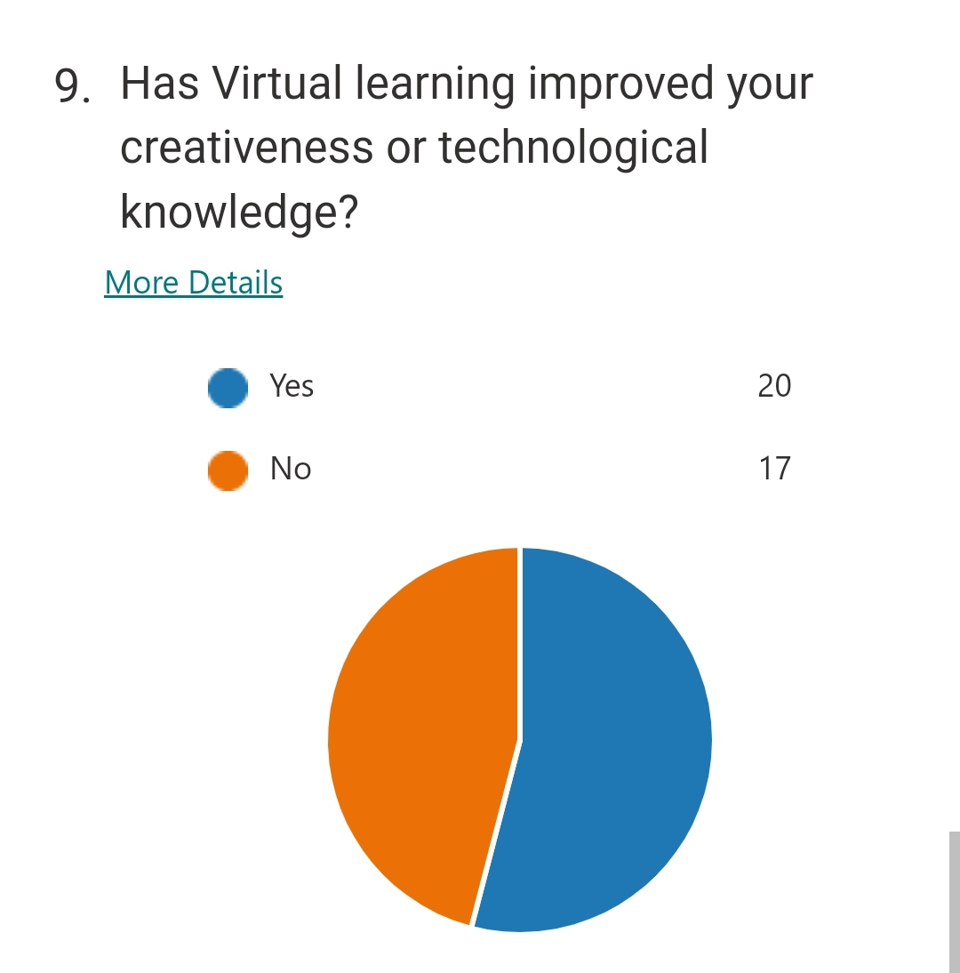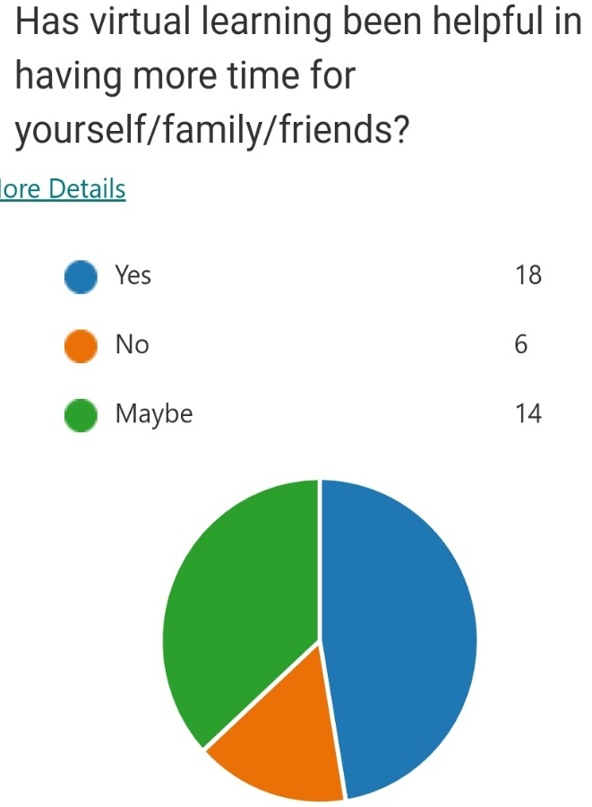
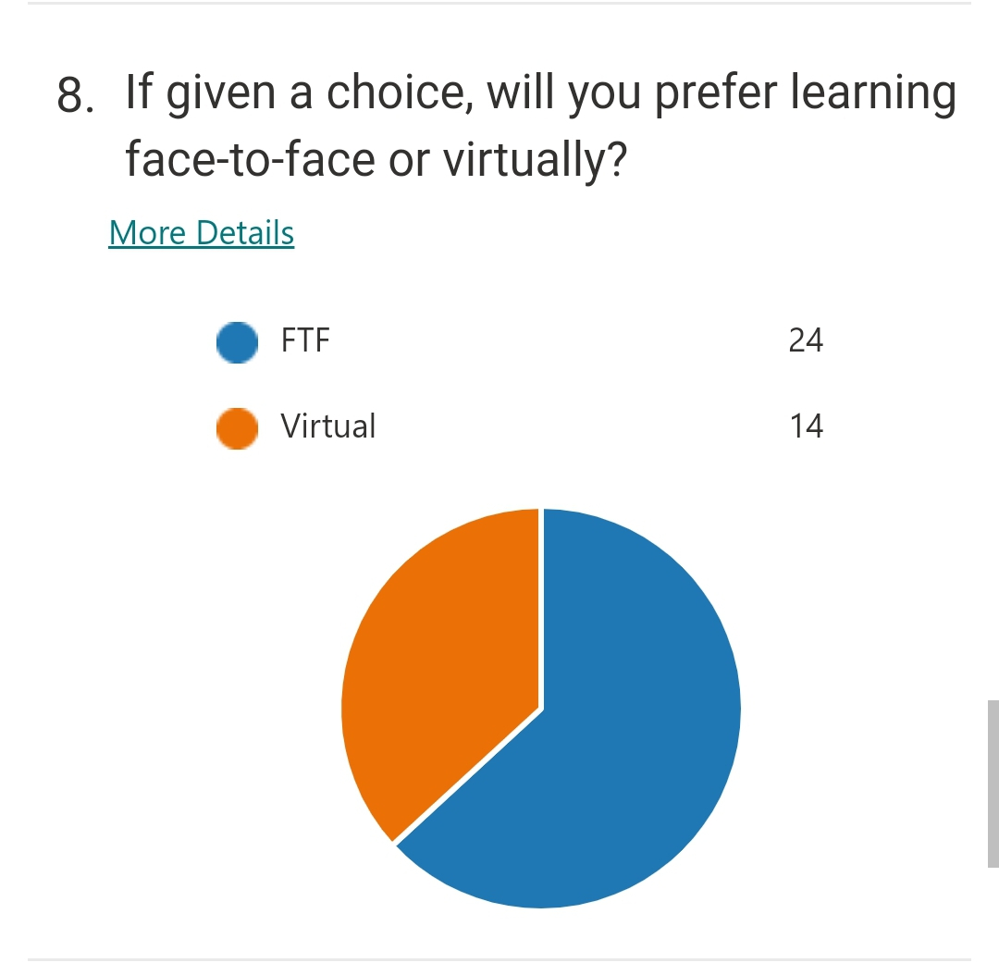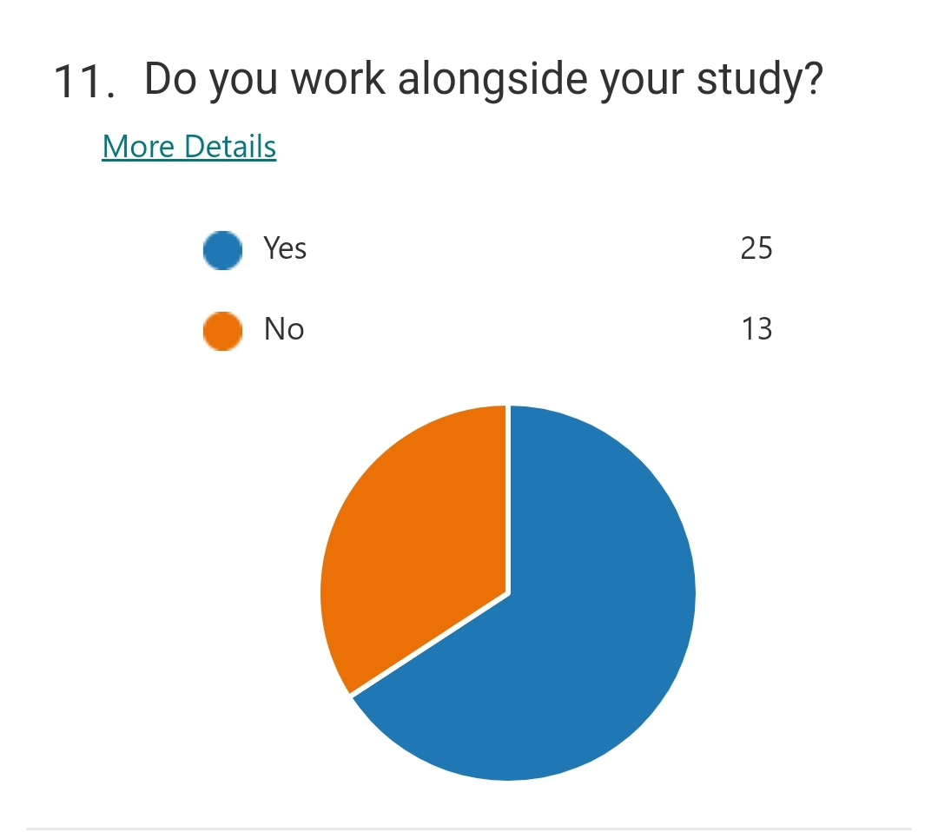
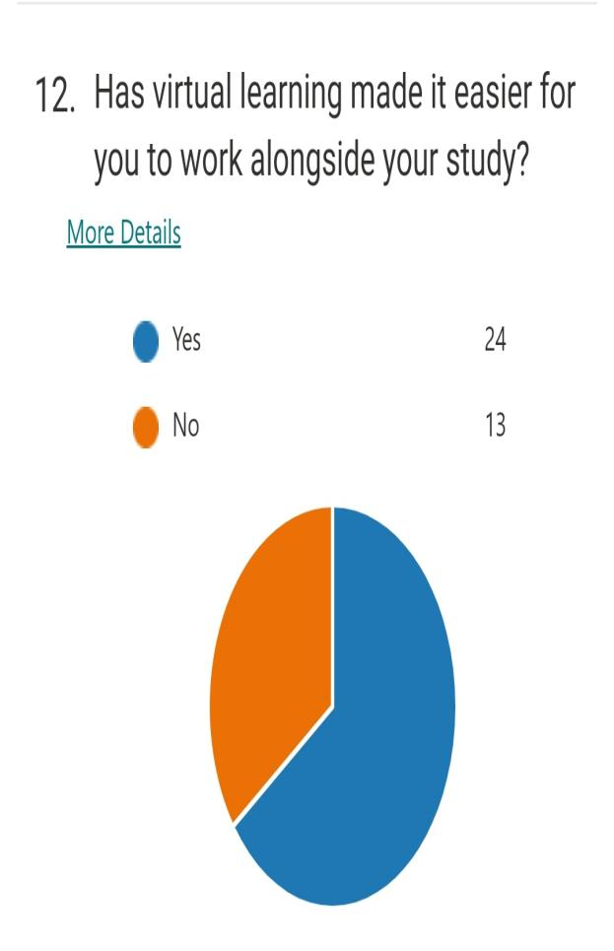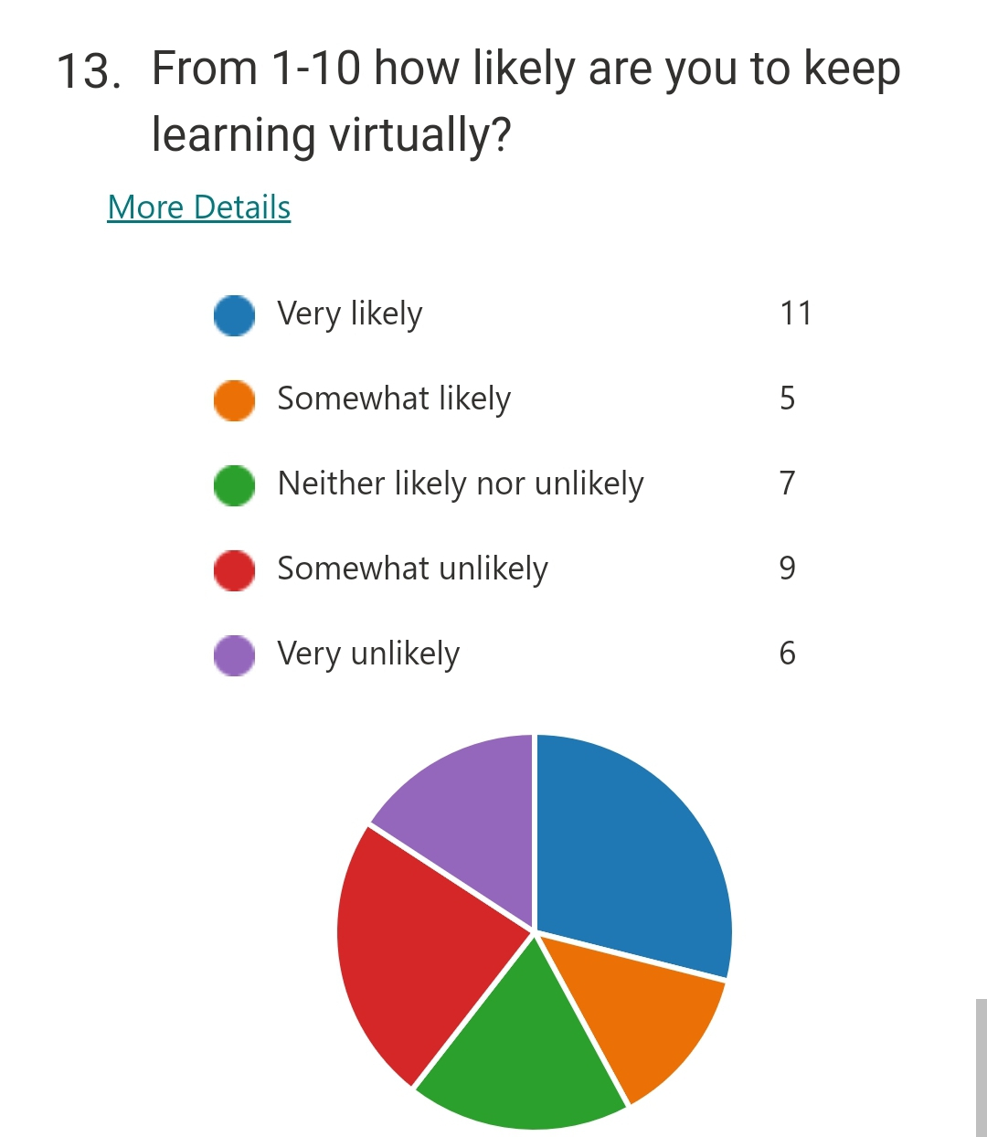

  - Survey Results:
The results obtained in the survey matched perfectly with the secondary data collected through research. The first question asked was if students were attending virtual modes of study of have had in the past. Out of 38 answers, 31 students are or have used virtual earning platforms and a total of 34 students have their personal laptops or smartphones that can be used to attend classes and access data online. It means that out of 39, 4 students do not have access to laptop/smartphone which can be a negative impact on their learning experience. Only 26 students have access to an uninterrupted internet connection and the remaining 12 student’s learning experience is affected by constant internet interruption during virtual classes, which is a very negative impact of learning virtually. A total of 27 students said that they participate more in face-to-face mode of learning rather than virtual. It means that about 71% students do not participate more in virtual learning, which can lead to lack of learning and knowledge due to non-participation. When asked if the virtual learning has improved learning experience, only 15 students agreed. It means that virtual learning has more negative than positive impact on the learning experience of students. 50% students said that their learning experience did not improve because of distractions. These distractions can be in home, on street or simply created by student himself (laziness, sleeping during class, over usage of social media etc.). But the positive impact is that virtual learning has improved creativeness of students. A total of 20 students agreed. It is because virtual learning takes away from students the usual course material following. Assignments are given such that students use their creative skills to solve them. When asked if virtual learning has given students more time for themselves and friends/family, a total of 18 students said yes and 14 may be. It means that almost 84% students have benefited from virtual learning when it comes to having more time for themselves. One positive impact of virtual learning discussed in the secondary research was that it has made working easier alongside studying. This point was proven right by my survey. A total of 24 students agreed on it. When asked if given choice will students still study virtually or face-to-face. In reply to this, 24 students preferred physical mode of learning. But when asked if they are likely to continue learning virtual, 16 students agreed that they will most likely continue to study on virtual learning platforms. It can be due to a few positive impacts that students see in learning virtually.
- Conclusion
On the whole, virtual learning has its positive and negative impacts. More cons than pros, virtual learning is somewhat not improving learning experience of students. COVID-19 pandemic made students isolate themselves at home and attend classes virtually. It had a toll on the mental and emotional health of students and likewise effected the learning experience.
It is my suggestion that virtual learning should be continued despite lifting restrictions because it is a very helpful source of learning and accessing data. Students can access their classes and learning material anytime anywhere which is not very possible in physical mode of learning. But with both negative and positive impacts, what virtual learning platforms need to do is to improve their services and reduce the negative impacts as much as possible. User experience should be made satisfactory and all possible actions should be taken to create as much ease-of-use as possible.

References:
- Torres Martín, C., Acal, C., El Honrani, M. and Mingorance Estrada, Á.C., 2021. Impact on the virtual learning environment due to COVID-19. Sustainability, 13(2), p.582.
- Ryan, E. and Poole, C., 2019. Impact of virtual learning environment on students’ satisfaction, engagement, recall, and retention. Journal of medical imaging and radiation sciences, 50(3), pp.408-415.
- Woolliscroft, J.O., 2020. Innovation in response to the COVID-19 pandemic crisis. Academic Medicine.
- Azlan, C.A., Wong, J.H.D., Tan, L.K., Huri, M.S.N.A., Ung, N.M., Pallath, V., Tan, C.P.L., Yeong, C.H. and Ng, K.H., 2020. Teaching and learning of postgraduate medical physics using Internet-based e-learning during the COVID-19 pandemic–A case study from Malaysia. Physica Medica, 80, pp.10-16.
- Barker, J. and Gossman, P., 2013. The learning impact of a virtual learning environment: students’ views. Teacher education advancement network journal (TEAN), 5(2), pp.19-38.
- de Oliveira Dias, M., Lopes, R.D.O.A. and Teles, A.C., 2020. Will virtual replace classroom teaching? Lessons from virtual classes via zoom in the times of COVID-19. Journal of Advances in Education and Philosophy, 4(05), pp.208-213.
- Pererva, V., Lavrentieva, O., Lakomova, O., Zavalniuk, O. and Tolmachev, S., 2020. The technique of the use of Virtual Learning Environment in the process of organizing the future teachers' terminological work by specialty.
- Wang, R., Lowe, R., Newton, S. and Kocaturk, T., 2020. Task complexity and learning styles in situated virtual learning environments for construction higher education. Automation in Construction, 113, p.103148.

