

MindConnect UK – Mental Health Campaign Poster
A national mental health awareness campaign and digital support platform for young adults (16–25).
Poster created using Canva (Canva, 2026)
&
Accompanying Pitch

Name: Uzma Amir Said
Student Id: 2426983
Module: Changemakers: Creativity and Value Creation
Module Code: BMHP5014

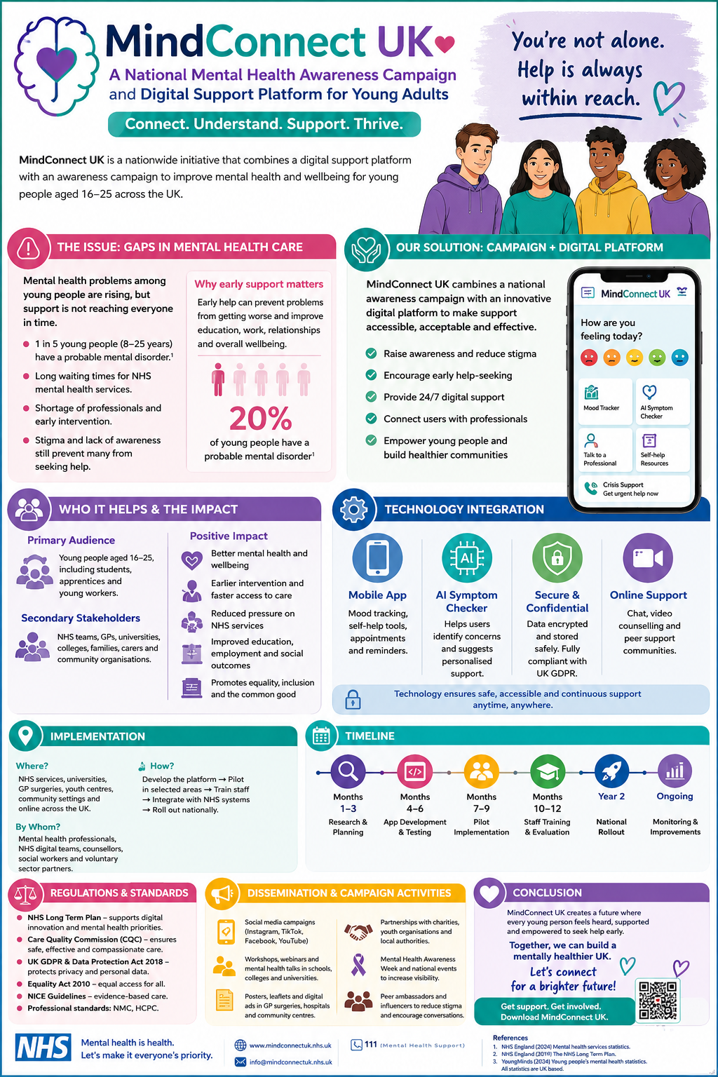
MindConnect UK: A National Mental Health Awareness Campaign and Digital Support Platform for Young Adults
Accompanying Pitch
Mental health is one of the most significant public health challenges facing the United Kingdom today. Increasing numbers of young people are experiencing anxiety, depression, stress, loneliness and other mental health conditions. According to NHS England (2023), approximately one in five children and young people aged between 8 and 25 years have a probable mental health disorder. Despite this increasing demand, many young people struggle to access support due to long waiting times, lack of awareness, and the continuing stigma associated with mental illness. These challenges highlight the need for innovative approaches that improve access to support and encourage early intervention.
MindConnect UK has been developed in response to these issues. It is an innovative initiative that combines a national mental health awareness campaign with a digital support platform specifically designed for young adults aged 16–25 years. The campaign aims to increase awareness of mental health, reduce stigma, promote early help-seeking behaviours and provide young people with easy access to support through digital technology.
The target audience for this initiative includes young adults in schools, colleges, universities and workplaces. This age group is particularly vulnerable because it represents a significant period of transition and change. Many young people experience academic pressures, financial difficulties, social isolation and uncertainty about their future, all of which can negatively affect mental wellbeing. Furthermore, research indicates that around half of all lifetime mental health conditions begin before the age of fourteen and three-quarters by the mid-twenties (Mental Health Foundation, 2023). Early intervention is therefore essential to prevent conditions from becoming more severe and to improve long-term health outcomes.
The MindConnect UK platform provides several innovative features, including a mood-tracking tool, self-help resources, an artificial intelligence symptom checker and direct links to healthcare professionals and crisis services. The mobile application allows users to monitor their mental health and seek support at any time, regardless of their location. Telehealth services and online counselling sessions can also help individuals who face barriers to accessing traditional healthcare services, particularly those living in rural or disadvantaged communities
The awareness campaign aspect of the initiative is equally important. Through social media campaigns, educational workshops, community events and partnerships with charities and educational institutions, MindConnect UK seeks to normalise conversations about mental health and encourage young people to seek support without fear of judgement. Public awareness campaigns have been shown to reduce stigma and improve knowledge about mental health conditions, leading to earlier engagement with healthcare services (World Health Organisation, 2022).
The proposed initiative will significantly improve the health and wellbeing of young adults. Early access to support can reduce the severity of mental health conditions, improve emotional resilience and prevent crises that may require emergency intervention. Better mental health is also associated with improved educational achievement, stronger social relationships and increased employment opportunities. By helping young people maintain good mental health, the initiative contributes to the wider common good by promoting healthier communities and reducing the economic burden associated with mental illness.
The successful implementation of MindConnect UK will require collaboration between several professional services and organisations. The National Health Service (NHS) will play a central role by integrating the platform within existing mental health services and providing professional support through mental health practitioners, nurses, counsellors and psychologists. Educational institutions, including schools, colleges and universities, will support the campaign by promoting awareness activities and encouraging students to access available resources. Community organisations and charities will also contribute by providing peer support networks and delivering educational programmes.
Several policies and pieces of legislation support the development of this initiative. The NHS Long Term Plan (NHS England, 2019) places significant emphasis on improving mental health services and increasing the use of digital technologies within healthcare. The initiative also aligns with the government's commitment to prevention and early intervention strategies.
Because the platform involves the collection and storage of personal information, compliance with the UK General Data Protection Regulation and the Data Protection Act 2018 is essential. These regulations ensure that personal data is processed securely and confidentially. Furthermore, the Equality Act 2010 requires healthcare services to be accessible to all individuals regardless of age, disability, gender, ethnicity or socioeconomic status (GOV.UK, 2013). Compliance with professional standards established by the Nursing and Midwifery Council (2018) and the Health and Care Professions Council (2024) also ensures that services are delivered safely and ethically.
Technology is a key component of MindConnect UK and provides several advantages. Digital interventions can overcome geographical barriers, offer flexible access to support and provide services outside normal healthcare hours. Artificial intelligence can assist in identifying early symptoms and directing users towards appropriate support pathways. Secure digital systems also facilitate communication between healthcare professionals and service users, improving continuity of care and patient engagement.
Public involvement is essential for the success of this campaign. Mental health affects not only individuals but also families, friends and wider communities. The public can support the campaign by participating in awareness-raising activities, sharing information on social media, and encouraging open discussions about mental health. Community engagement helps to reduce stigma and creates supportive environments where individuals feel comfortable seeking help. In addition, public support can influence policymakers and healthcare organisations to invest further in mental health services and digital innovations.
In conclusion, MindConnect UK offers an innovative and practical solution to one of the UK's most pressing health concerns. By combining a national awareness campaign with an accessible digital support platform, the initiative addresses current gaps in mental health services and promotes early intervention. The campaign has the potential to improve health outcomes, reduce inequalities and create a society in which young people feel supported, empowered and able to seek help when needed. Through collaboration between healthcare professionals, educational institutions, community organisations and the general public, MindConnect UK can contribute significantly to improving the mental health and wellbeing of young adults across the United Kingdom.

References
Canva (2026) Canva. Available at: https://www.canva.com (Accessed: 09 July 2026).
GOV.UK (2013). Equality Act 2010. [online] GOV.UK. Available at: https://www.gov.uk/guidance/equality-act-2010-guidance [Accessed 17 Jun. 2026].
GOV.UK (2018). Data Protection Act 2018. [online] legislation.gov.uk. Available at: https://www.legislation.gov.uk/ukpga/2018/12/contents [Accessed 28 Jun. 2026].
Health and Care Professions Council (2024). Standards of Conduct, Performance and Ethics. [online] Health and Care Professions Council. Available at: https://www.hcpc-uk.org/standards/standards-of-conduct-performance-and-ethics/ [Accessed 28 Jun. 2026].
Mental Health Foundation (2023). Children and Young People: Statistics. [online] www.mentalhealth.org.uk. Available at: https://www.mentalhealth.org.uk/explore-mental-health/statistics/children-young-people-statistics. [Accessed 20 Jun. 2026].
NHS England (2019). NHS England» NHS Long Term Plan to tackle major killer conditions and save up to half a million lives. [online] England.nhs.uk. Available at: https://www.england.nhs.uk/2019/01/long-term-plan/ [Accessed 03 July 2026].
NHS England (2023). One in Five Children and Young People Had a Probable Mental Disorder in 2023. [online] www.england.nhs.uk. Available at: https://www.england.nhs.uk/2023/11/one-in-five-children-and-young-people-had-a-probable-mental-disorder-in-2023/ [Accessed 25 Jun. 2026].
Nursing and Midwifery Council (2018). The Code: Professional Standards of Practice and Behaviour for Nurses and Midwives. Nursing and Midwifery Council. [online] Nursing and Midwifery Council. London: Nursing and Midwifery Council. Available at: https://www.nmc.org.uk/globalassets/sitedocuments/nmc-publications/nmc-code.pdf [Accessed 28 Jun. 2026].
UK Government (2025). Data Protection Act. [online] Gov.uk. Available at: https://www.gov.uk/data-protection [Accessed 26 Jun. 2026].
World Health Organization (2022). World Mental Health Report: Transforming Mental Health for All. [online] www.who.int. Available at: https://www.who.int/publications/i/item/9789240049338 [Accessed 26 Jun. 2026].

