

LCMB7001: MARKETING MANAGEMENT-ASSESSMENT 1

Student Name: Priyanka Myadari
University Name: University of Wales Trinity Saint David
Student ID: 2223911
Word Count: 3977
Date of Submission: 28/04/2023

Table of Contents
1. Introduction 3
2. Overview of the Business 3
3. Challenges facing by the Business 3
4. Modern efficient systems of marketing and strategies for the selected organisation 4
5. Differentiated value proposition of selected organisation 6
6. Future marketing strategies 8
7. Assessing the customer journey across different communication channels 9
8. Strategies for meeting the stakeholder expectations 10
9. Conclusion 11
Reference List 12

1. Introduction
Marketing is a set of activities, processes and institutions for the purpose of communicating, creating, delivering and exchanging of the offerings which is having value for the customers, partners, clients and society at the large (Deepak and Jeyakumar 2019). The process of marketing is important for the business so that the customers do have the awareness of the products and services along with engaging them and helping them for making the buying decisions. The plan of marketing is a part of the business which helps in creating and maintaining the demands, reputation, competition and relevance.
In this study, the emphasis will be on understanding the concept of marketing. The organisation which will be considered is Premier Inn of the United Kingdom. All the challenges faced by the organisation will be discussed carefully. Further, the current strategies and marketing methods will be explained for the company. Value proposition model will be evaluated for the hotel. Also, the future strategies will be provided and the customer journey will be analysed too. Lastly, the current and the future expectations of the stakeholders will be discussed carefully.

2. Overview of the Business
Premier Inn is a British hotel chain and they are known as the largest brand of hotel in the country. They are known to be having 72,000 rooms and 800 hotels. The hotel is seen to be operating in variety of locations which is including the suburbs, airports and city centres. The hotel chain was founded in the year 1987 (Premierinn.com 2023). Some of the competing companies or the hotel brands are Ibis and Travelodge. Premier Inn is accounting 70% of the Whitbread’s earnings. The mission of Premier Inn is to provide the quality and affordable hotels for the guests which helps in living and working well along with having positive impact all over the world. The customers are being provided with flexible set of options for managing the rates according to the choices and the flexibility. The services of the hotel are outstanding. They are striving to the force for good in everything which they are doing. They are having care for the communities and the world in which they are a part of.

3. Challenges facing by the Business
Change is known as a wonderful thing but there are challenges too. It is becoming difficult for the hospitality industry to manage the challenges. The difficulty lies in balancing smaller details and the big picture. The sustainability of the hotel needs to be aligned with the values of the company. With the recovery of the bookings there are issues of staff shortages. The hotel chain is planning for spending more than 20 million euros for increasing the salaries and paying one-off bonuses (Theguardian.com 2023). The hotel chain is making the recovery and is returning the pre-pandemic profits which is boosting the wages. There are issues of supply chain and the shortage of the staffs. There are risks and difficulty is gaining the early recovery. Premier Inn is seen to be outpacing in the market for the economy and the mid-scale hotels. The brand is having the plan for adding more than 8,000 rooms to the current portfolio. The company is seen to be facing a challenging environment during the summer and autumn owning to the higher levels of occupancy. This is combined with the market-wide issues of supply chain and the shortages for the staffs of hospitality sector. Apart from this there are challenges in the degree of caution over the political and the economic situation. The hotel is having robust set of demands for the travel of the business (Travelweekly.co.uk 2023). There is pressure of inflation in the sector of the consumers and there is a need for the degree of caution on the demands. There is a combination towards the commitment in the investment program and there is significant proportion of inflation over the short and the medium term. There is a need for delivering the sustainable growth in the dividends and the earnings along with strong return on the capital over the long term. In terms of solving the problems, the hotel is looking forward for dedicating the focus on the structural growth of the opportunities along with available to the Premier Inn in the UK and internationally.

4. Modern efficient systems of marketing and strategies for the selected organisation
Premier Inn majorly emphasises improved and reinforced customer services to increase guest experience and customer satisfaction. The hotel has invested dynamically to enhance its technological competencies to enrich guest satisfaction and experiences. The report from Premierinn.com 2023 suggests that the hotel business is available via major GDS-mediated platforms such as Amadeus, Galileo, and others, that allow customers to have easier access to its facilities over different online platforms. To elaborate on the current marketing strategies of Premier Inn, Keller’s Brand Equity Model can be used. In the view of Prachaseree, Ahmad and Isa (2022), developing a strong and reinforced brand requires business professionals to consider how customers may think or feel about a certain product and service offered by the given brand. Managers along with members of the workforce of an organisation must develop strategies that can offer the best customer experiences and remain competitive in the marketplace.
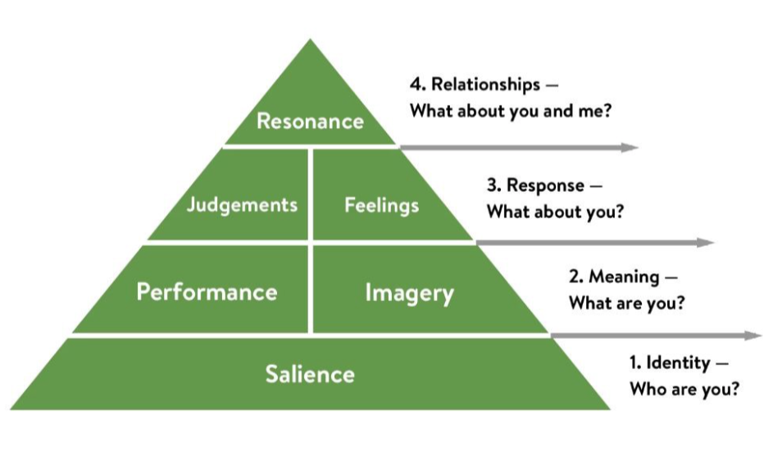
Figure 1: The Brand Equity Framework of Keller
(Source: Prachaseree, Ahmad and Isa 2022)

In the current case organisation, the key (salience) to marketing goals is through adverts channelised on different platforms including social media. Premier Inn leverages the reachability of social networking sites to make itself much more visible and recognised by people, thereby increasing the hotel's brand awareness among the right group the audience. This is how the brand image of the hotel business has strengthened across the country. Premier Inn promotes its hospitality services, discounted offers, new in-built facilities, and other key offerings via different platforms of social media, thereby promoting or marketing its corresponding services to a wider group of people (Premierinn.com 2023). The business has even invested as much as 20 million euros to boost its marketing strategies over several digital networks such that its online brand visibility could be increased. This one-time investment has proven to be improving the competitiveness and performance of Premier Inn in terms of brand awareness and customer services in comparison to other hospitality brands in the consumer marketplace of the UK.
The company not only mediates efforts to boost the identity of the brand but also develops strategies by which it can connect with customers across all phases of the buying process (feelings). This also represents the notion of imagery that allows a brand to meet diverse customer needs based on their emotional levels (Prachaseree, Ahmad and Isa 2022). Besides, Premier Inn gladly receives customer reviews, and feedback, and introspects its current services to identify challenges and deficits. This strategically keeps Premier Inn at the topmost level of the hospitality game in the market where customer satisfaction (judgment) is the key element boosting hospitality efficiency. This has enabled the business to acquire enormous brand responses all over the consumer marketplace of the UK (resonance). These strategic approaches of Premier Inn provide customers with the ability to avail of the services at a much more affordable rate without any marketplace or operational barriers. However, managerial consistency needs to be in place such that hospitality services do not require constant modifications in terms of customer satisfaction and retention.

5. Differentiated value proposition of selected organisation
According to Kristensen and Remmen (2019), value proposition is telling the customers the reason on why the products and the services are best suited for the particular set of customers. This model should be communicated to the customers in a direct manner, which means either from the website of the company or the marketing of the materials. For the successful value proposition there is persuasiveness and prospects for paying the customers. The value proposition is standing as the promise by the company to the customers or the market segment. This is helpful in the decision-making process. It is use of the proper structure and is being communicated for the benefits of the consumers.
Whitebread is the owner of Premier Inn and they are the biggest brands of hotel in the UK. They are also having a growing presence in Germany and they are offering the quality accommodations at the affordable prices. The brand is having 840 hotels in the UK and 83,000 rooms in great set of locations (Whitebread.co.uk 2023). They are known to be employing 35,000 people in 1,600 Premier Inn hotels and restaurants in the UK. Each month they are serving five million customers and people are known to be their heart of the business. These are mainly the products and services of the company. In terms of gain creators, they are providing the benefits of unique stays at affordable prices. The hotel chain is known to be having the value in terms of being genuine which means to care about the customers. Then they are confident for striving the best at what they are doing and is having the commitment for working hard for each other. They are having no such barriers to the entry or the limit for the ambition in terms of providing the meaningful work, career development, skills and opportunities for the teams. They are trying to solve the issues of the customers as compared to the higher prices which the competitors are having. The pandemic did create a challenge for them but the program of investing by the cycle is resulting for being well-placed in terms of enhancing the market leadership position in the UK (Whitebread.co.uk 2023). This is accelerating the growth in Germany and is driving the long-term value for the stakeholders.
In terms of the consumers, they are having the familiarity and the consumer confidence. The hotel chain has infiltrated the mind-set of the consumers. They are making use of the high-profile celebrities in their TV ads. They are seen to be working hard for instilling a sense of confidence in the consumers and this possible by achieving the differentiation from the competitors. They are having emotionally-led campaigns and is known to be valuing for the money. These are seen to be acting as the gain for the customers. It is the quality services and the ability for striking the balance between the quality and values for the consistency. Along with the staff satisfaction there is corporate reputation which is leading to the brand strength and commitment for the equality. There are student placement schemes as well which is being run by the brand and this is recruiting people from diverse set of backgrounds. It is regardless of the academic achievements. The chain is seen to be employing 700 apprentices in the UK at one time and there is offering for the opportunities which is rising up the ranks and is running the hotels or the teams at the corporate levels (Whitebread.co.uk 2023). The pain points for the customers are the staff shortage as they are not being treated in a proper way. At the time of discussing the value chain there lies a necessity for knowing the business model and the strategy of the hotel (Econsultancy.com 2023). There is a vertically integrated model which is combining the property, operations of the hotels, brands and the inventory distribution. This is leading to the growth of the hotel in a significant faster pace than the competitors. There is delivery of the superior experiences of the customers and there is generation of stronger returns on the capital for the shareholders over the last 15 years. As the value proposition, there are strategies which is including the growth and innovation in the core UK markets. This is enhancing the structural opportunities. Then there is focus on the strengths for the growth in Germany. This is leading to international expansion and this is replicating the success of the UK model. Lastly, there is enhancement of the capabilities for the supporting of the long-term growth.
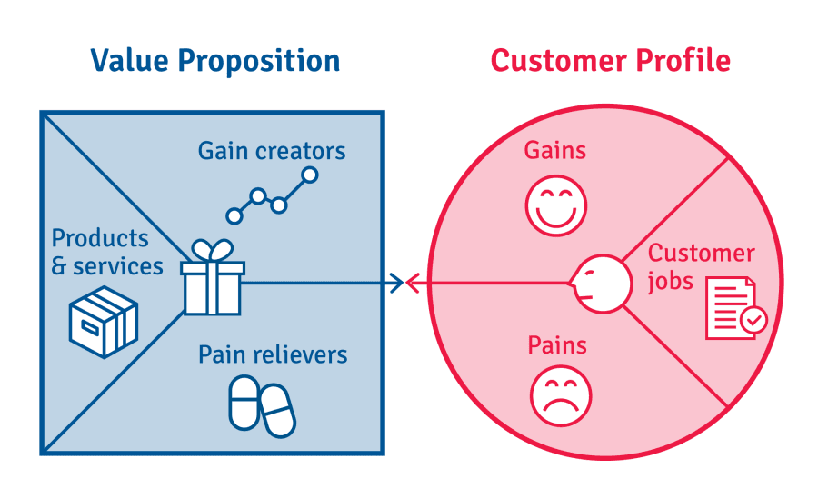
Figure 2: Value Proposition
(Source: Kristensen and Remmen 2019)

6. Future marketing strategies
According to Sánchez-Gutiérrez et al. (2019), innovative marketing is the method which helps in the promotion of new products and services. It includes the researching of the customer behaviour along with the needs and the trends which helps in the development of the change for the design of the products along with being successful. The innovative marketing is included the rebranding along with finding of new ways for launching of the products in the new market. The companies are making use of innovative marketing which is improving the success for the new products and the services when the company releases on the market. The consumers are giving more confidence in the purchase. It helps in increasing the profits along with providing of the opportunities for better innovation.
One of the future marketing strategies of Premier Inn can be rebranding. This is a method of innovative marketing which is matching the marketing content to the new set of products and the processes the company is selling or using. It helps the company in terms of analysing the strengths and weaknesses which leads to the improvement of the sales. The rebranding method is helpful in terms of introducing a new logo. This is something which will be implemented by Premier Inn. Apart from this, they will be taking up some new technologies for the purpose of giving personalised experiences to the customers (George 2021). It helps in appealing to the target market in the current country and also the new regions. The next strategy can be expanding to the new set of regions. The expansion can be taking place in a country like India. This will be providing the company with new set of opportunities and there will be improvement in the sales and base of the customers. This helps in influencing the innovation. There can be interactions of social media which will be easier for distribution of the information in a quick way. The company will be improving their presence in social media platforms like Twitter, Facebook and Instagram (Thinkwithgoogle.com 2023). There will be advertisements, online events with interaction with the customers. Various posts will be on the social media for Premier Inn. Apart from the social media, the company can be concentrating on the advertisement through emails. This will be creating a one-to-one coordination with the customers. For the better enhancement of the sales, and innovative marketing, there can be information provided through blogs. The blogs will be providing ample amount of information and hence it will be easier for the interpretation of the information

7. Assessing the customer journey across different communication channels
According to Sonowal and Sonowal (2022), communication is known as the essential part of the workplace because it is conveying the information to various departments and is also establishes relationships. Making use of the right channel for the communication of the message helps in conveying the information so that the recipients can be interpret it accurately. Learning on the various channels of communication can choose the right one for sending and conveying the message. With the effective communication helps in building and maintaining the long-lasting relationship across the organisation. It allows in increasing the productivity and creativity. There is allowance for achieving the organisational alignment along with making the communication efficient. There is reduction in the turnover of the employees and remote working is efficient. This means that there is implementation for the robust communication channel which is making the remote working efficient. This is in-turn improving the performance of the employees. In the strategies above, the main area of focus will be on the email marketing and social media marketing. It is seen that email marketing is making use of textual messages. It helps in recording the conversations or the sharing of the files. The organisations are making use of the email communication channel for sharing the essential documents in the workplace (Thinkwithgoogle.com 2023). It also provides the employees with regular set of company updates. This is like a personalised message which is being sent to the customers. The customer journey through this communication channel is beneficial and also positively acting on the minds of the customers.
The social media channels are also used for messaging. There are various set of platforms available for the customers. The companies like Premier Inn are making use of the communication channels like social media for following the trends and being connected with the customers. Some of the common channels for the social media includes Facebook and Instagram. These are the most utilised platforms. It helps in connecting with the customers through the messaging apps. This explains that personalised messages have been sent by the social media. The company is able to capture 40% more booking from the new set of customers through the Google Hotel ads. These advertisements are relevant in accordance to the location and the right data points. These communication channels have the ability of maximising the traffic along with driving of the incremental bookings (Thinkwithgoogle.com 2023). In this way the goal of reaching the new set of customers can be fulfilled. Also, there will be capturing of the users who are actively looking for booking the accommodations. There is increase in the direct bookings by the company website. Since the time of pandemic, the company is having the hope of getting more traffic through the social media. There will be promotion for the large number of the loyal guests by the social media, email and personal website. This shows that the positive journey of the customers will be there at the time of making the bookings at Premier Inn of the United Kingdom.

8. Strategies for meeting the stakeholder expectations
The stakeholders are usually looking for the positioning which helps in demonstrating the financial growth along with impacting on the key interests. The analysis of the KPIs is important for the stakeholder (Farmaki 2019). There lies a huge importance in the identification of the expectations of the stakeholders for the success of the project. It is because the stakeholders can understand the situation in a better way as they are having different set of perspectives. A necessity is there for prioritising the stakeholders because it helps in understanding on where to invest in the resources. It is helping the project managers for the identification of the key decision makers and there is assurance that all the talking is being done to the right people at the right time. In terms of the current strategies, Premier Inn is having the internal and the external stakeholders. The owners are the internal ones who are seen to be investing huge amount of money. Then comes, the employees and they are the important ones as the hotel cannot function without them. One of the most important objectives is assurance of the job and its security. On the other hand, the external stakeholders are the customers or the guests (Nalley and Gregory 2021). They are the most important external stakeholders. They would always want the quality set of services and also good value for the money. The next one is the competitors. The company is facing tough competition in the market from the strong and independent hotels. The suppliers are also the external stakeholders which means that they would easy financial returns along with proper services in terms of earning the profits (Farmaki 2019). Premier Inn is having a lot of stakeholders and there is always a need for communicating with each other and making them happy.
However, for the future, there are certain set of expectations which the internal and the external stakeholders of Premier Inn can be having. The employees as the internal stakeholders must be having the maximum expectations as they would want proper treatment, operations, management and functioning (Jones and Comfort 2021). The employee turnover is usually common and for the future the importance lies in improving the skills of the employees and fulfilling all their requirements. Then the external stakeholders are important like the customers. It is because they are the ones who wants all the unique set of features along with customising all the services for making the hotels comfortable. Apart from this in the future the pressure of competition will keep on increasing and hence it will be necessary for Premier Inn to get the competitive advantage within the market. There are a lot of suppliers available in the market. However, it will be important for the stakeholders and the company to maintain with the same set of suppliers in order to get the benefits. This shows that stakeholders will have to be coordinated for managing the operations in the near future. This will be leading to less of complications and future will be having less of competition in the market.

9. Conclusion
It can be concluded from the study that the light was shed on the concepts and theories related to marketing. The understanding can be gained through the example of the company named Premier Inn of the United Kingdom. The details of the organisation were provided. The challenges of the organisation were given and their current strategies and marketing was explained in details. The company’s value proposition was explained and accordingly the future aspects of innovative strategies of marketing was evaluated. There was evaluation of customer journey in various channels of communication. A provision for the strategies in terms of meeting the expectations of the stakeholders was explained.

Reference List
Deepak, R.K.A. and Jeyakumar, S., 2019. Marketing management. Educreation Publishing. [Available at: https://books.google.com/books?hl=en&lr=&id=_DmvDwAAQBAJ&oi=fnd&pg=PA1&dq=marketing&ots=u48VemcoYe&sig=dSyudwgj2uZKQ_dNbbs1pJ90LOI]
Econsultancy.com. 2023. Premier Inn the strongest hotel chain in the world. Available at: https://econsultancy.com/what-makes-premier-inn-the-world-s-strongest-hotel-chain/ [Accessed on 28th March 2023]
Farmaki, A., 2019. Corporate social responsibility in hotels: a stakeholder approach. International Journal of Contemporary Hospitality Management, 31(6), pp.2297-2320. [Available at: https://www.emerald.com/insight/content/doi/10.1108/IJCHM-03-2018-0199/full/html]
George, R., 2021. Marketing tourism and hospitality: concepts and cases. Springer Nature. [Available at: https://books.google.com/books?hl=en&lr=&id=oUgtEAAAQBAJ&oi=fnd&pg=PR5&dq=Innovative+marketing+strategies+for+premier+inn&ots=zZdZFEmRE3&sig=3KHruiztpixvUXaBg-wusBsOiXk]
Jones, P. and Comfort, D., 2021. Modern slavery statements and leading UK hotel companies. Athens Journal of Tourism, 8(3), pp.147-162. [Available at: https://eprints.glos.ac.uk/10100/]
Kristensen, H.S. and Remmen, A., 2019. A framework for sustainable value propositions in product-service systems. Journal of cleaner production, 223, pp.25-35. [Available at: https://www.sciencedirect.com/science/article/pii/S0959652619307656]
Nalley, M. and Gregory, A.M., 2021. A Case for Change, Market Segmentation and Brand Management. In SAGE Business Cases. International CHRIE. [Available at: https://sk.sagepub.com/cases/change-market-segmentation-brand-management]
Prachaseree, K., Ahmad, N. and Isa, N.M., 2022. Reviews of Brand Equity for Online Retailers. ABAC Journal, 42(1), pp.52-72. [Available at: http://www.assumptionjournal.au.edu/index.php/abacjournal/article/view/6077]
Premierinn.com 2023. Covid-19 and Premier Inn. Available at: https://www.premierinn.com/gb/en/business-blog/five-big-challenges-facing-travel-managers today.html. [Accessed on 28th March 2023]
Premierinn.com. 2023. About the company. Available at: https://www.premierinn.com/gb/en/why.html [Accessed on 28th March 2023]
Sánchez-Gutiérrez, J., Cabanelas, P., Lampón, J.F. and González-Alvarado, T.E., 2019. The impact on competitiveness of customer value creation through relationship capabilities and marketing innovation. Journal of business & industrial marketing, 34(3), pp.618-627. [Available at: https://www.emerald.com/insight/content/doi/10.1108/JBIM-03-2017-0081/full/html]
Sonowal, G. and Sonowal, G., 2022. Communication channels. Phishing and Communication Channels: A Guide to Identifying and Mitigating Phishing Attacks, pp.51-75. [Available at: https://link.springer.com/chapter/10.1007/978-1-4842-7744-7_3]
Theguardian.com. 2023. Premier Inn staff shortage. Available at: https://www.theguardian.com/business/2021/oct/26/premier-inn-staff-shortages-hotel-salaries-bonuses [Accessed on 28th March 2023]
Thinkwithgoogle.com. 2023. Marketing strategies of Premier Inn. Available at: https://www.thinkwithgoogle.com/intl/en-gb/marketing-strategies/search/premier-inn-captures-40-more-bookings-with-google-hotel-ads/ [Accessed on 28th March 2023]
Travelweekly.co.uk. 2023. Premier Inn challenges. Available at: https://travelweekly.co.uk/articles/314554/premier-inn-owner-issues-degree-of-caution-over-economic-and-political-situation [Accessed on 28th March 2023]
Whitebread.co.uk. 2023. About the company. Available at: https://www.whitbread.co.uk/about-us/ [Accessed on 28th March 2023]

