

Program: Master Of Business Administration
Module: International Marketing
Lecturer: Dian Mayasari
Tittle: Individual Report
Module Code: LCMB7026
Student Name: Payal Balubhai Odedra
Student Id: 2439521
Word count : 5111
Submission Date: 27th March 2026

Executive Summary
The purpose of the report is to analyse the international marketing strategy and marketing mix of Zara in India and Spain. Zara is one of the leading fast fashion brands, which is headquartered in Spain and also operates in India. The key findings denoted that the political instability of both Spain and India may negatively affect the business operations of Zara. Through the application of Hofstede's model, it has been identified that the behaviour of Indian consumers is shaped by cultures and beliefs. Spanish consumers are quite brand aware and also familiar with the identity of Zara as a domestic brand. The target customers of Zara are fashion-conscious men and women between 18 and 40 years old, who seek trendy and budget-friendly fashion products. The brand follows a premium pricing strategy in the Indian market. The findings further indicated that the garment workers in the factories of Zara in Karnataka accused the brand of not paying their legal minimum wage, for which their children are hungry. This denotes the labour practice issues in the Indian market. In terms of the international marketing strategies, it has been recommended that Zara use artificial intelligence (AI)-driven demand forecasting through which it can reduce excess production and enhance cost efficiency.
Table of Contents
1. Introduction 4
2. Section 1 4
2.1 Comparative analysis of the fast-fashion market in Spain and India 4
2.2 Comparative analysis of STP strategies 9
2.3 Analysis of the brand’s directional development strategy 14
2.4 Ethical issues of the brand’s marketing mix 16
2.5 Recommendations 17
3. Section 2 19
4. Conclusion 22

Introduction
The report evaluates the international marketing strategy and marketing mix of Zara in India and Spain. Comparing Spain and India offers strategic insight into how the global brands such as Zara balances standardisation and adaptation. Zara is one of the global fast fashion retail brands, which is headquartered in Spain. In the 2025 financial year, the revenue of Zara increased by 2.26% (Crossley, 2025). The macroenvironment of both countries will be analysed in the report. A comparative analysis of the STP strategies of Zara will be carried out. The report will also analyse the ethical issues of the brand's marketing mix. Some key recommendations will also be offered through which the company can go forward with their international strategies.

Section 1

2.1 Comparative analysis of the fast-fashion market in Spain and India
The PESTEL framework can be applied to carry out a comparative analysis of the macro-environment for Zara in Spain and India.
Political
The government of Spain is grappling with a large scale of political instability (Campati, 2025). Political instability may reduce the confidence of consumers, increasing price sensitivity. However, the strong infrastructure for fashion retail in Spain offers support for the growth of Zara. The direct trade routes and fast and reliable shipping in Spain have built a strong ecosystem for fast fashion (Deniz, 2025). However, compliance with consumer protection regulations and sustainability increases the operational costs of Zara in Spain.
On the other hand, India is a federal democracy with different state-level regulations. The Indian government strives to attract larger foreign direct investment (FDI) policies by removing any form of regulatory barriers and developing infrastructure (PIB, 2025). This can affect the business of Zara by facilitating capital inflows and driving technology transfers. India has entered into an era of political instability (Landrin, 2024). This may reduce the confidence of the investors in investing in the business operations of Zara.
Thus, political instability prevails in both countries, and this may affect the smooth business functioning of Zara.
Economic
Spain is a developed high-income economy which possesses a stable purchasing power. In January 2026, the inflation rate of Spain reached 2.3%, down from 2.9% in December (Trading Economics, 2026). This positively influences the purchasing patterns of consumers in discretionary sectors such as fashion. The Spanish consumers are price-conscious, however well accustomed to fast-fashion cycles. Policy changes may increase cost volatility and this contributes to a higher rate of final retail prices in Spain.
India is one of the growing emerging economies, having a large and youthful population. It is estimated that the GDP of India will increase by 6.9% in 2026 (Goldman Sachs, 2026). This can influence the spending pattern of consumers with respect to the fashion products of Zara. In India, the target audience of Zara is women who are above 17 years to early 40s, belong to the mid-income category segment and prefer trendy clothing (Saraswat, 2018). While the entire purchasing power per capita is lower in comparison to Spain, the aspirational consumer behaviour of the growing middle class presents long-term growth opportunities.
Social
The social and cultural differences between Spain and India shape the market positioning and consumer engagement strategies of Zara. Hofstede’s cultural dimension model can be applied in this context to compare consumer behaviour and culture of the two countries. This model explains the cross-cultural differences between two countries (Żemojtel-Piotrowska and Piotrowski, 2023). As per Hofstede's model, India is a collectivistic culture, having a score of 24 as indicated in Figure 1 (The Culture Factor, 2026). This indicates that the behaviour of the consumers is largely influenced by traditions, family values and festivals. The clothing choices of the Indian consumers balance modern Western fashion with traditional preferences. For example, Indo-Western dress blends the traditional Indian elements with modern Western silhouettes (Label S4U, 2026). The score of India is 77 in terms of the power distance dimension of Hofstede’s model (The Culture Factor, 2026). This indicates that the Indian consumers may defer to established brands.
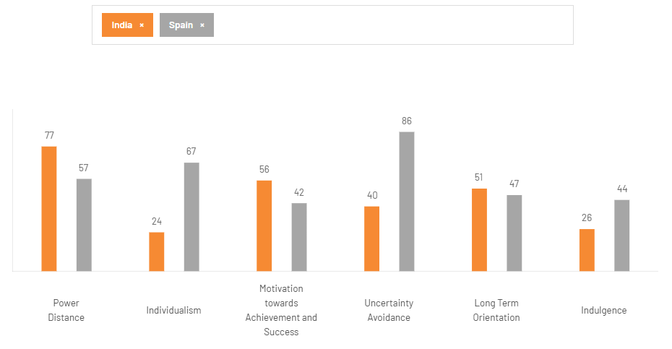
Figure 1: Country differences between India and Spain
(Source: The Culture Factor, 2026)
Spain, by contrast, demonstrates an individualistic culture as per Hofstede’s model. In terms of fashion, the Spanish consumers value uniqueness and prefer to spend more on better quality items rather than spending on cheaper items (Global Data, 2024). Spanish consumers are quite brand aware and also familiar with the identity of Zara as a domestic brand. It is estimated that the western wear market size in Spain will reach approximately USD 23.97 million by 2033, as indicated in Figure 2 (Deep Market Insights, 2026). This denotes the strong acceptance of Western apparel styles and seasonal fashion trends in Spain. The low power distance combined with high individualism in Spain also encourages self-expression through fashion.
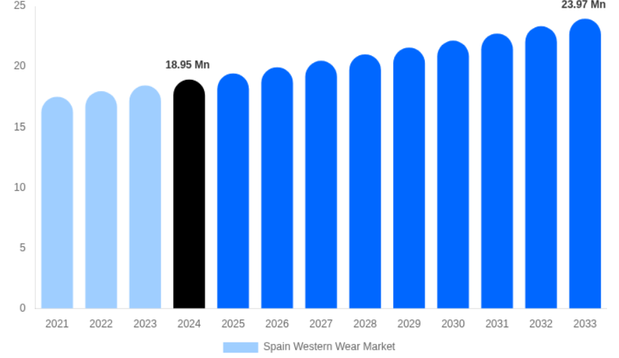
Figure 2: Western wear market size in Spain
(Source: Deep Market Insights, 2026)
Price sensitivity is quite pronounced in the Indian market. Often, consumers compare international fashion brands with domestic alternatives. Approximately 80% of the luxury consumers in India prefer purchasing high-end fashion products from the global fast-fashion brands (Deshmukh, 2025). This can influence the demand for the products of Zara in India. The pricing strategy of Zara is premium in India, and this creates the impression of a higher-value product and boosts a higher viewpoint for the brand (The Fashion of India, 2024). In Spain, Zara is mainly seen as an affordable brand, whereas in India, it mainly occupies a semi-premium space. Premium pricing is necessary since consumers compare alternatives such as H&M and Mango.
Digital behaviour of consumers also differs in India and Spain. Approximately 81% of the consumers in India follow the social media influencers (EY, 2024). The increasing use of smartphones has driven fashion discovery and purchases among consumers. Although India shows rapid digital growth, the consumers experience mixed trust levels. Before purchasing any products, Indian consumers compare prices on e-commerce sites (KNN, 2023). On the contrary, Spain possesses digital maturity with a seamless integration of both online and offline shopping. Approximately 65% of the Spanish consumers who shop online use both the online and offline channels (Ecommerce Bridge, 2024). The younger shoppers prefer to purchase products from the physical stores. Apart from this, the digital payments and trust in e-commerce platforms are also well established.
Technological
Technological advancements enhance the performance of the organisations operating in Spain. Spain possesses a robust digital infrastructure, which is more advanced than the EU coverage (Digital Strategy, 2025). The advanced infrastructure and efficient logistics networks allow Zara to ensure rapid distribution of the products across the EU.
The technological environment of India has enhanced on a large scale, specifically in e-commerce. E-commerce revenue is growing by 25 to 30% per year, and this indicates the demand for purchasing products online (Kaka et al., 2019). Digital engagement strengthens the aspirational positioning of Zara in the Indian market. However, the supply chain infrastructure challenges, such as the inefficiencies, delays, and increased costs, prevail on a large scale (Gupya, 2023). This may affect the inventory turnover of Zara. However, the rapid digital adoption of India supports the online retail expansion.
Environmental
In Spain, environmental awareness is high, and this is due to the sustainability directives of the EU. Despite environmental concerns, Spain leads global fast fashion with approximately 91.5% market share as Europe dominates (Salmon, 2025). This increases the demand for fast-fashion products from Zara. On the contrary, approximately 61% of the Spanish consumers are prioritising sustainability in their purchasing decisions (Ken Research, 2025). This requires Zara to adhere to the strict environmental regulations and sustainability standards. Sustainable production may increase costs, but strengthen the brand value of Zara.
India faces environmental issues such as pollution and waste management. The younger demographics in India are preferring sustainable and ethical fashion products (Times of India, 2025). Zara is thus required to focus more on sustainability to meet the demands of this group of consumers.
Legal
Spain follows the EU consumer protection laws and labour standards. Article 51 of the Spanish constitution ensures that the provision of consumer protection by the public authorities is one of the key guiding principles of social and economic policies (Menendez, 2026). This regulation increases operational transparency at Zara. In contrast, the legal framework of India involves labour laws and intellectual property protection. For example, the Minimum Wages Act 1948 ensures the enforcement of minimum wage rates for workers in factories (CLC, n.d.). The lack of adherence to these regulations may increase the regulatory complexity of Zara.

2.2 Comparative analysis of STP strategies
Segmentation
In Spain, Zara segments the market based on demographic and psychographic factors. The key segment involves the fashion-conscious men and women between 18 and 40 years old, who seek trendy and budget-friendly fashion products (Ahmad, 2024). The seasonal fashion cycles largely influence this buying behaviour.
In India, segmentation is quite complex due to socio-economic diversity and cultural differences. The brand has focused on metropolitan cities such as Mumbai, Delhi, Ahmedabad, Pune and China (Pinto, 2024). Segmentation is based on age and lifestyle, and also on the aspirational orientation of the consumers.
Targeting
In Spain, Zara applies a broad targeting strategy, which appeals to a wide customer base. The target market involves the students, young professionals and middle-income families. In India, the brand applies the differentiated targeting approach, which allows it to sell different products to different segments (Grzegorzek, 2024). The target customers of Zara in India are those between 17 and 40 years, residing in the mid-income category and are conscious towards fashion (Saraswat, 2018). The broader targeting in Spain mainly reinforces the identity of Zara as an accessible fast-fashion retailer. However, in the Indian market, narrower targeting may elevate the exclusivity of the brand.
Positioning
In Spain, Zara is positioned as a trend-driven and high-quality apparel brand with one of the fastest turnaround times. The brand is positioned as a high-price and high-quality brand in Spain, as illustrated in Figure 3.
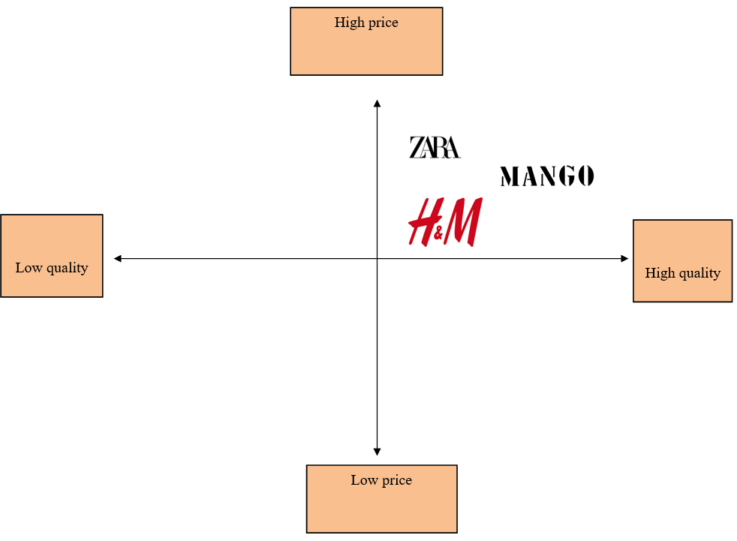
Figure 3: Positioning map of Zara in Spain
(Source: Self-developed)
In India, Zara is positioned as a premium and fashion trendiness brand, as indicated in Figure 4. This strategy differentiates the brand from its competitors in the Indian market.
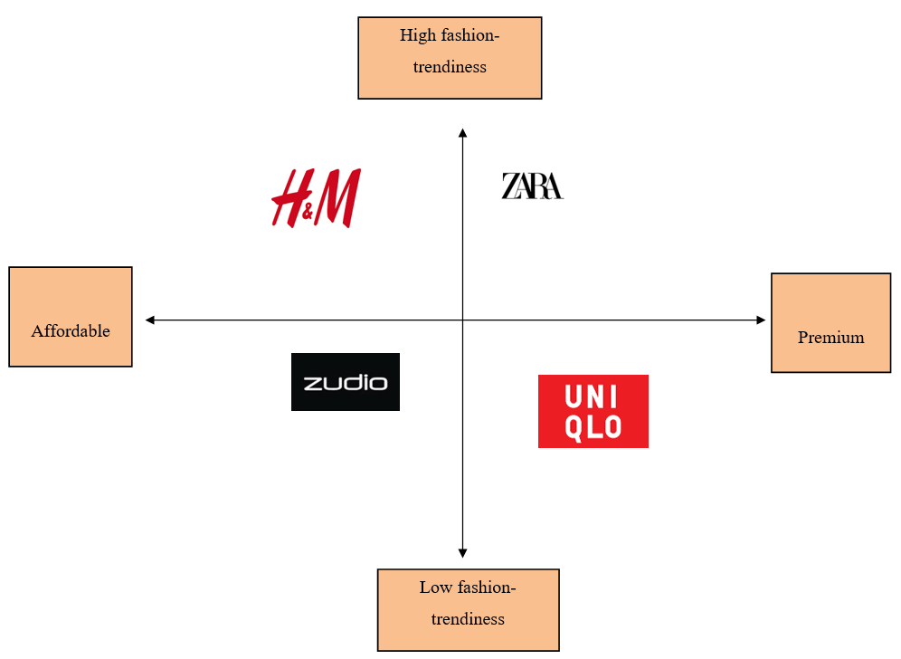
Figure 4: Positioning map of Zara in India
(Source: Self-developed)
Comparative analysis of International marketing mix strategies
Product: Zara maintains a standardised product strategy by offering Western fashion collections for men, women and children. In Spain, the product lines align with the seasonal trends of the EU, offering heavy winter coats, high-neck bomber jackets, smocked tops, mini dresses with a belt and knitwear (Zara, n.d.a). In India, adaptation takes place in fabric choice. For example, Zara has introduced striped shorts for women, which are lightweight in design and made from breathable fabrics that offer relaxation (Zara, n.d.b). These fabrics are prioritised due to the hot climate of India. While Spain follows a climate-driven seasonal model based on the European fashion cycles, the Indian market requires climatic adaptation instead of complete redesign of the product.
Price: In Spain, Zara faces intense competition from H&M, Mango and Gap (Martin Roll, 2026). Thus, this indicates that the brand applies the competitive pricing strategy in Spain. In terms of the pricing strategy in India, Zara applies the adaptation approach. In India, the brand uses the premium pricing strategy, which creates an impression of a higher value product (The Fashion of India, 2024). However, this limits its accessibility to lower-income consumers. Spain mainly represents a mature fast-fashion market with intense competition, whereas India is a developing market. Thus, cost economics have influenced the pricing differences.
Place: Zara applies the standardisation strategy in terms of this marketing mix in Spain and India. The exclusive distribution strategy is applied by the brand, which allows businesses to select a sole partner in each location to distribute the products or services (JWPM, 2023). In Spain, Zara sells its products through its own branded stores and official website. The customers in Spain visit the stores of Zara 17 times per year on average, in comparison to three times per year for the competitors (SCM Globe, 2020). In India, Zara operates through a joint venture with the Tata Group, Inditex Trent Retail India (Riano, 2025). The products are sold through the exclusive stores of Zara and its online platform. Thus, Spain reflects a fully controlled retail system and India requires partnership-based entry due to regulatory and market considerations.
Promotion: Zara mainly relies on store locations and word-of-mouth marketing. Rather than advertising, the brand uses its store location and store displays as promotional strategies in Spain (Martin Roll, 2021). However, the brand adopts the adaptation approach to promote its products in the Indian market. For example, during the festive seasons such as Diwali, Zara introduced a limited edition capsule collection and promoted it through an Indian artist on Instagram, as indicated in Figure 5 (Instagram, 2026). This indicates that the Indian consumers rely on Instagram influencers to purchase their fashion products. Spain demonstrates a low promotion strategy, whereas higher promotional engagement is required in India due to lower brand maturity and high influence of social media on the purchasing decisions of consumers.
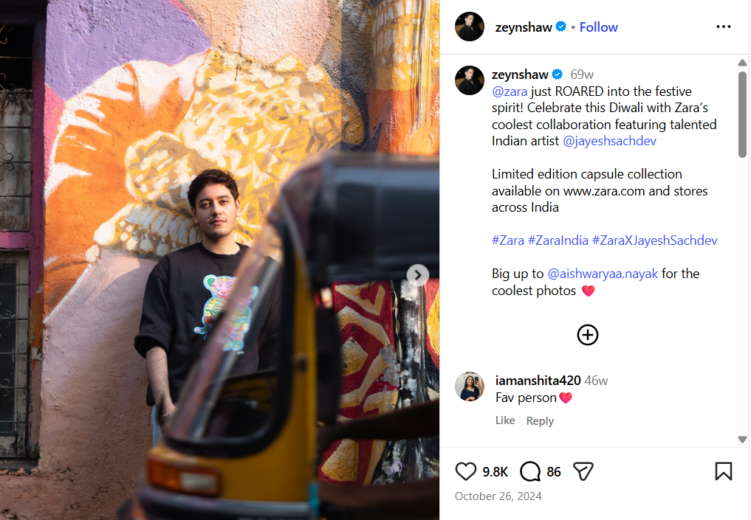
Figure 5: Promotion of Zara's product on Instagram
(Source: Instagram, 2026)
People: Approximately 30% of the staff of Zara is located in Spain (Inditex, n.d.). The review of Glassdoor (2026) illustrated in Figure 6 indicated that approximately 85% of the staff of Zara in Spain would recommend the organisation to a friend. This denotes that the staff in the stores of Zara in Spain are satisfied with their job. Higher employee recommendation rates in Spain denotes internal brand alignment and stable HR practices. On the contrary, Zara in India ensures that its staff are well-trained to offer superior services to the customers.

Figure 6: Reviews of employees at Zara
(Source: Glassdoor, 2026)
Process: The just-in-time (JIT) supply chain processes of Zara are globally consistent, which indicates the application of the standardisation approach. JIT ensures in minimising wastes and enhancing efficiency by producing goods as required (Rana, 2025). This strategy allows Zara to quickly respond to the needs of its customers.
Physical evidence: The store design of Zara in both markets is considered aesthetic, which appeals to the customers. This indicates that the company uses the standardisation approach for this marketing mix element. In the stores of Barcelona, Zara has combined the collections of both men and women in the same space with luxury decorations (Juarez and Alonso, 2025). In Mumbai, the stores of Zara are designed with ample lights and wooden accents to make it look aesthetic (Palod, 2023). This attracts consumers on a large scale.

2.3 Analysis of the brand’s directional development strategy
The directional development strategy of Zara in India can be analysed by applying Ansoff’s matrix. The model involves four quadrants, which are market development, market penetration, product development and diversification as indicated in Figure 7 (Kaar and Stary, 2019).
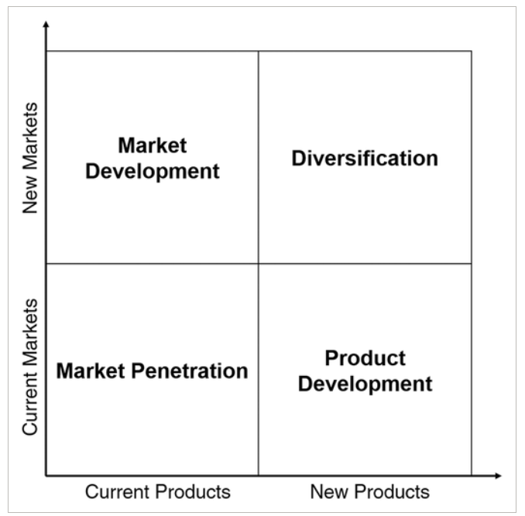
Figure 7: Ansoff matrix
(Source: Kaar and Stary, 2019)
Market entry and market development
Following the above discussion, Zara entered the Indian market following the joint venture strategy. Zara made a partnership with the Tata Group, and this provided the brand with the local market knowledge and improved interaction with the Indian customers (Economic Times, 2024). This approach reflected the internationalisation strategy, specifically aimed at mitigating risk and leveraging local expertise. Initially, the brand focused on metropolitan cities such as Mumbai and Delhi (Shukla, 2024). This denotes a concentrated market development strategy of Zara, targeting the urban centres with a high purchasing power. Instead of spreading the stores nationwide, the brand prioritised depth over breadth in the high-income urban markets.
Market penetration strategy
Zara strengthened its presence in the Indian market through market penetration. As of June 2025, Zara operated approximately 22 stores in India (Apparel Resources, 2025). The recent additions of the brand involve new outlets in Pune’s mall and Bengaluru’s mall. Market penetration is also driven by the expansion of the product categories such as menswear, womenswear and kidswear. Globally, Zara is considered an affordable fast-fashion brand; the products of the brand in Indian currency are much higher in comparison to the other local brands (The Fashion of India, 2024). Thus, penetration emphasises increasing the frequency of purchase among the affluent consumers. Seasonal sales and festive promotions promote repeat purchases among Indian consumers.
The digital and omnichannel development also contributes to the directional development strategy of the brand. The smartphone market of India grew by 7.3% in 2025 (IDC, 2025). In terms of the growth of smartphone penetration and online shopping, Zara integrated e-commerce with physical retail stores. For example, based on the click-and-collect services of Zara, the consumers can collect the order within 15 days from the store (Zara, n.d.c). This reflects the forward integration within the entire value chain. Digital expansion also supports a broader geographical reach without any major investment in physical outlets. This reflected the strategic adaptation to the infrastructure and consumer behaviour of India, where mobile commerce is dominant.
The directional strategy of Zara also reflects its competitive positioning. The Indian fashion retail market involves local brands such as Zudio and global brands such as Uniqlo and H&M (OCC Strategy, 2025). In this context, Zara differentiates itself through premium store ambience and unique collections. Zara largely focuses on fashion credibility and rapid adaptation of trends. This, in turn, reinforces its aspirational brand image and also supports sustainable growth among the wide range of urban professionals.
Zara has committed towards sustainability initiatives under the parent company, Inditex. The brand has turned its focus towards responsible sourcing. Zara has increased its commitment towards generating and sourcing renewable energy to reduce the greenhouse gas emissions (Zara, n.d.d). The urban consumers in the Indian market have become responsive towards ethical fashion. Thus, the long-term directional strategy of Zara may support making the sustainability initiatives successful.

2.4 Ethical issues of the brand’s marketing mix
Product-related ethical issues
In India, sustainability awareness is growing on a large scale. Textile waste is a critical challenge in the Indian market, and the industry generates approximately 7,800 kilotonnes of waste per year (Garg and Verma, 2025). The brand has been working to introduce more sustainable collections and introduce measures to reduce emissions caused by the delivery of orders (Zara, n.d.e). Thus, environmental ethical issues of Zara are high in the Indian market.
Labour and supply chain issues
One of the key ethical concerns is the labour practices in the supply chains of fast-fashion brands. The garment workers in the factories of Zara in Karnataka accused the brand of not paying their legal minimum wage, for which their children are hungry (Kelly, 2021). Although Zara maintains strict supplier codes, these kinds of labour practices issues affect their brand reputation. Carrolls’ Corporate Social Responsibility (CSR) model focuses on four social responsibilities of companies, which are philanthropic, ethical, legal and economic as indicated in Figure 8 (Saleh, 2022). The labour practices of Zara do not align with the ethical responsibilities as stated in Carrolls’ model. The issue questions the ethical labour standards across the supply chain of Zara.
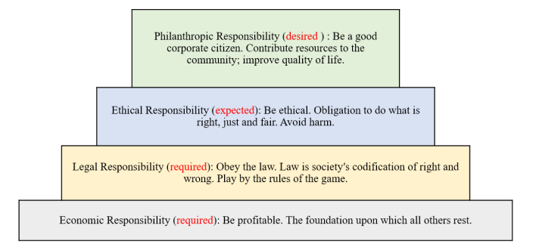
Figure 8: Carrolls’ CSR pyramid model
(Source: Saleh, 2022)
Pricing ethics
Pricing strategies may raise ethical considerations when they differ in two countries. In India, from 2025, the clothes and accessories of Zara, which are priced above ₹2,500, are charged 18% GST (Agarwal, 2025). This indicates that Zara may exploit aspirational demand through the maintenance of high mark-ups. As a result, this raises ethical questions about price fairness and transparency when the identical products cost less in Spain than in India after the conversion of currency.
Promotion and cultural sensitivity
In India, cultural sensitivity is immensely important in terms of advertising. Fashion campaigns which are acceptable in Western regions may be considered culturally inappropriate for the Indians. For example, Zara collaborated with an Indian artist to introduce a collection, Reverie, which reflected the festive look of Diwali (NDTV, 2024). The lack of consideration of cultural sensitivity leads to ethical issues by disregarding the values and beliefs of the population.
Place and retail expansion
In India, the stores of Zara are mainly concentrated in premium malls. The stores mainly occupy prime mall locations with designed interiors, which emphasise premium positioning (Singh, 2025). Ethical concerns in retail expansion may relate to the displacement of local retailers along with the reinforcement of socio-economic inequality. The growth of Zara reflects broader structural shifts in the retail landscape of India.
Transparency
Modern consumers mainly demand transparency with respect to sourcing, designing of stores and ethical standards. The leadership of Zara in Energy and Environmental Design (LEED) is one of the leading sustainable construction certifications (Zara, n.d.e). Following this certification, the brand works to make the stores of India reach the highest levels of sustainability. Zara is required to maintain its sustainability commitments to enhance transparency.
From a critical perspective, most of the ethical concerns surrounding Zara are related to its fast-fashion model instead of any country-specific misconduct. Environmental sustainability, labour practice issues and overconsumption are the key challenges facing the company. Ethical transformation requires the slowdown of the production cycle and the reduction of consumption, which can conflict with its competitiveness.

2.5 Recommendations
The following are the key recommendations, which outline how Zara must move forward to strengthen long-term competitiveness.
- One of the key priorities for Zara is incorporating sustainability deeply into the international marketing strategy. The brand can increase the proportion of sustainable fabrics across all its collections instead of limiting them to specific product lines. Natural fabrics contribute to sustainable fashion in terms of their biodegradability and less environmental impact than synthetics (Islam, Hossain and Covington, 2025). The brand can also enhance transparency through effective communication of the supply chain practices. Zara can focus more on sustainability reporting to boost consumer trust. Sustainability reporting discloses the environmental, social, and governance practices and their key progress towards the achievement of SDGs (Alsayegh et al., 2023). In India, where awareness is increasing among the urban youth, the maintenance of sustainability can enhance the aspirational brand value of Zara.
- Zara is required to evolve towards a smart fashion model for the maintenance of responsiveness to trends, along with optimising inventory through data analytics. Zara can use artificial intelligence (AI)-driven demand forecasting, through which it can reduce excess production and enhance cost efficiency. AI forecasting engines have the potential to automate approximately 50% of the workforce tasks (Amar et al., 2022). This can allow Zara to shift from fast fashion towards smart fashion, enhance profitability and increase ethical responsibility.
- Digital transformation must remain central to the international marketing strategy of Zara. Technological development enables the development of an omnichannel strategy to offer a seamless experience to the customers (Thaichon et al., 2024). Zara can enhance mobile app functionality by incorporating AI-powered styling recommendations. AI-powered recommendations allow consumers to preview garment fit and aesthetics without any form of physical contact (Gao and Liang, 2025). In India, smartphone penetration is high, and this strategy can offer scalable growth for Zara. On the contrary, in Spain, omnichannel innovation can enhance the convenience and retention of customers in a retail environment.
- The modern consumers largely expect diversity and inclusion from the global brands. In this context, Zara can expand representation in marketing visuals across body types and ethnicities. Diversity in fashion involves bringing in a diverse group of people who share distinctions such as skin colour, race and body type (Suradkar and Chanana, 2024). The inclusive representation at Zara can strengthen relatability across diverse cultural contexts. This can offer brand differentiation to Zara.
- In terms of competing with the digital-native brands, Zara can transform the selected stores into experiential hubs that portray interactive displays and personalised styling services. Through experiential fashion retailing, the retailers can create immersive environments, which not only attract but also retain customers (Ustazah, Setijanti and Hayati, 2025). This strategy can be effective for the urban areas of Spain and India. Besides this, through the adoption of this strategy, Zara can achieve long-term competitive advantages in its business. This can also encourage store visits and differentiate the brand from its competitors.
- The economic conditions differ across different markets. Zara can incorporate more flexible pricing strategies to maintain an enhanced brand positioning. In terms of the increasing aspirations of price-conscious consumers, affordable and trend-led value fashion has become a significant element in the apparel industry of India (Sharma, 2025). The brand can thus introduce more affordable product lines in price-sensitive markets such as India instead of diluting brand value. This can enable Zara to remain aspirational and accessible to all consumers.

Section 2
The reflective account applies Kolb’s reflective cycle to analyse the process followed in researching, analysing and preparing the previous sections of the assessment. The four modes of Kolb’s reflective model are concrete experience, reflective observation, abstract conceptualisation and active experimentation (Egan et al., 2023). The reflection will also demonstrate the way I developed analytical thinking, research skills and key understanding in the field of international marketing.
Concrete experience
The concrete experience began while selecting Zara and comparing its international marketing strategies in Spain and India. Initially, I felt quite confident while choosing Zara since it is a globally recognised brand with a strong relevance in the international marketing field. However, after I started researching, I identified the complexity of analysing the macro-environmental factors, STP strategies and marketing mix adaptations in a structured manner. I faced difficulties while finding Spain-specific social data. At this point, my motivation reduced on a large scale.
I collected significant information from academic journals, industry reports and credible online sources. I applied the PESTEL framework, the Ansoff matrix and various other international marketing theories to structure and guide my analysis. At this particular stage, I experienced difficulties in balancing description and critical evaluation. Initially, I also found myself focusing too much on explaining what Zara does instead of analysing the reasons why it does so and the way it differs between Spain and India. Another key experience was the identification of cultural differences between the two countries. Although I am quite familiar with the market context of India, analysing Spain largely required deeper research into the EU regulations, sustainability standards and the patterns in consumer behaviour. In addition, this stage also required an appropriate synthesis of varying perspectives to avoid any form of generalisations.
Reflective Observation
Upon reflecting on the entire process, I realised that one of the key challenges was shifting from surface-level comparison towards critical analysis. At first, I mainly tended to describe the strategies of Zara in both countries without any critical evaluation of their effectiveness and ethical implications. Through the entire reflection, I recognised that the post-graduate level work requires justification, critique and incorporation of theories into practice. Apart from this, I also observed that my level of understanding of the international marketing frameworks enhanced to a significant extent. For example, while applying the PESTEL framework, I treated it as a checklist. However, as the task progressed, I identified that the macro-environmental factors are connected with each other. I recognised that I hold an unconscious bias towards the concept of standardisation, assuming that strong global brands maintain consistency across markets. However, through critical engagement with theory and evidence, I identified that contextual sensitivity is vital to international marketing strategy. At this point, I realised that I hold strong critical thinking skills. Critical thinking allows individuals to reflectively and logically evaluate the information and make well-informed decisions (Hajmási et al., 2025). I also became aware of the way cultural context shapes the perception of consumers. Through the analysis, I identified that Zara is regarded as a mainstream brand in Spain and an aspirational one in India. Another key observation was the significance of ethical evaluation. Initially, I viewed sustainability and labour issues as general industry issues. However, I developed an understanding of the way how these issues manifest in a different way in developed and emerging countries. The task strengthened my ability to critically appraise the marketing practices beyond profitability.
Abstract Conceptualisation
At this particular stage, I connected my key experiences to the theoretical concepts of international marketing. In this task, I incorporated theories such as standardisation and adaptation, Ansoff matrix, STP strategy and the 7p marketing mix. I conceptualised that Zara maintains a global brand consistency while adapting to the local market conditions. Applying the standardisation versus adaptation framework reshaped my understanding of international strategy. The integration of STP and the 7p marketing mix allowed me to understand the way pricing is not a financial decision, rather a positioning mechanism. In some countries, adaptation is required due to varying standards and needs of the consumers (Chabowski et al., 2025). Through abstract thinking, I identified the strategic trade-off between fast fashion efficiency and ethical responsibility. The fast fashion model relies on speed and is also distinguished by high turnover rates (Arimany Serrat, Arribas-Ibar and Erdoğan, 2025). However, sustainability largely requires slower production and reduced scale of waste. Based on this conceptual tension, I developed an improved understanding of the ethical challenges within the field of international marketing.
Through the task, I identified that directional development in India requires market penetration instead of diversification. By linking the strategy of Zara to the Ansoff matrix, I enhanced the analytical depth of my discussion. The task enhanced my systematic understanding of how theory informs real-world strategies. Instead of only viewing the frameworks as academic requirements, I began observing them as practical tools for the managerial decision-making process.
Active experimentation
The assessment has influenced me on a large scale about the way I will approach similar tasks in the future. In future tasks, I will focus on critical evaluation from the beginning instead of revising descriptive content. I will also structure my overall research process in a strategic way. Rather than gathering excessive information, I will apply concept matrices to filter relevance. This can enhance both clarity and coherence. Apart from this, I will also enhance my skills of comparative analysis. In similar tasks like this in the future, I will highlight the contrasts between the markets by using comparison tables. Comparative structure may strengthen the development of arguments and demonstrate strong cognitive skills. I also recognised the significance of ethical awareness in marketing strategy. In the future professional context, I will focus more on sustainability, transparency and cultural sensitivity as the key components of strategic planning instead of operational considerations.

Conclusion
The international marketing strategy of Zara is required to balance profitability, ethical responsibility and innovation. While the Spanish market requires experiential differentiation, deeper localisation and digital expansion is required in the Indian market. By transitioning from fast fashion to sustainable fashion, the brand can secure long-term competitiveness across the global markets. The key factor involves the maintenance of brand consistency along with adapting towards economic, cultural and technological changes in both countries.

References
Ahmad, H. (2024) ‘Zara, the Global Fast Fashion Pioneer from Spain’, Journal of Global Awareness, 5(1), pp.1-9. Available at: 10.1-ase.ObjectConstraintLanguage Pre Post.pptx (Accessed: 19 February 2026)
Agarwal, R. (2025) ‘Shopping from Zara, H&M to get costlier: Impact of GST 2.0 on textiles’, Business Standard, 4 September. Available at: https://www.business-standard.com/economy/news/gst-2-0-textiles-zara-hm-price-hike-what-gets-costlier-cheaper-125090400381_1.html (Accessed: 19 February 2026)
Alsayegh, M.F., Ditta, A., Mahmood, Z. and Kouser, R. (2023) ‘The role of sustainability reporting and governance in achieving sustainable development goals: An international investigation’, Sustainability, 15(4), pp.1-18. Available at: https://doi.org/10.3390/su15043531
Amar, J., Rahimi, S., Surak, Z., and Bismarck, V.N. (2022) ‘AI-driven operations forecasting in data-light environments’, McKinsey, 15 February. Available at: https://www.mckinsey.com/capabilities/operations/our-insights/ai-driven-operations-forecasting-in-data-light-environments (Accessed: 19 February 2026)
Apparel Resources (2025) Zara expands India presence with new stores, refurbishments and tech-driven formats. Available at: https://in.apparelresources.com/business-news/retail/zara-expands-india-presence-new-stores-refurbishments-tech-driven-formats/ (Accessed: 19 February 2026)
Arimany Serrat, N., Arribas-Ibar, M. and Erdoğan, G. (2025) ‘Fast fashion sector: business models, supply chains, and European sustainability standards’, Systems, 13(6), pp. 1-40. Available at: https://doi.org/10.3390/systems13060405
Campati, A. (2025) Political turmoil in Spain as Europe faces US trade wars and global conflict. Available at: https://360info.org/political-turmoil-in-spain-as-europe-faces-us-trade-wars-and-global-conflict/ (Accessed: 19 February 2026)
Chabowski, B.R., Gabrielsson, P., Hult, G.T.M. and Morgeson III, F.V. (2025) ‘Sustainable international business model innovations for a globalizing circular economy: a review and synthesis, integrative framework, and opportunities for future research’, Journal of International Business Studies, 56(3), pp.383-402.Available at: https://doi.org/10.1057/s41267-023-00652-9 (p 396)
CLC (n.d.) Minimum Wages Act, 1948. Available at: https://clc.gov.in/clc/sites/default/files/MinimumWagesact.pdf (Accessed: 19 February 2026)
Crossley, I. (2025) Zara sees India profits rise 23% in FY25. Available at: https://in.fashionnetwork.com/news/Zara-sees-india-profits-rise-23-in-fy25,1739966.html (Accessed: 19 February 2026)
Deniz, S. (2025) Spain’s Strategic Role in the Textile Sector. Available at: https://intertexspain.com/spain-textile-industry-importance/ (Accessed: 19 February 2026)
Deshmukh, S. (2025) Why Indians still prefer shopping luxury abroad—despite homegrown labels on the rise? Available at: https://www.harpersbazaar.in/fashion/story/why-indians-still-prefer-shopping-luxury-abroad-despite-homegrown-labels-on-the-rise-1171512-2025-02-23 (Accessed: 19 February 2026)
Digital Strategy (2025) Spain 2025 Digital Decade Country Report. Available at: https://digital-strategy.ec.europa.eu/en/factpages/spain-2025-digital-decade-country-report (Accessed: 19 February 2026)
Ecommerce Bridge (2024) E-commerce in Spain: 77% Shop Online, But Age Gaps Grow. Available at: https://www.ecommercebridge.com/e-commerce-in-spain-77-shop-online-but-age-gaps-grow/ (Accessed: 19 February 2026)
Economic Times (2024) From Zara to Starbucks: Popular brands owned by Ratan Tata's Group. Available at: https://economictimes.indiatimes.com/news/company/corporate-trends/from-zara-to-starbucks-poplular-brands-owned-by-ratan-tatas-group/starbucks/slideshow/114121891.cms (Accessed: 19 February 2026)
Egan, J.D., Tolman, S., McBrayer, J.S. and Ballesteros, E. (2023) ‘Reconceptualizing Kolb's Learning Cycle as Episodic & Lifelong’, Experiential Learning and Teaching in Higher Education, 6(1), pp.24-33.Available at: https://files.eric.ed.gov/fulltext/EJ1422266.pdf (Accessed: 19 February 2026)
EY (2024) 78% of Indian consumers prefer human customer service support when shopping online: EY Report. Available at: https://www.ey.com/en_in/newsroom/2024/08/78-percent-of-indian-consumers-prefer-human-customer-service-support-when-shopping-online-ey-report (Accessed: 19 February 2026)
Gao, Y. and Liang, J. (2025) ‘The impact of AI-powered try-on technology on online consumers’ impulsive buying intention: The moderating role of brand trust’, Sustainability, 17(7), pp.1-29. Available at: https://doi.org/10.3390/su17072789
Garg, K., and Verma, P. (2025) ‘India’s fashion paradox: As the industry booms, it is being buried under heap of its own waste’, Down to Earth, June 5. Available at: https://www.downtoearth.org.in/waste/indias-fashion-paradox-as-the-industry-booms-it-is-being-buried-under-heap-of-its-own-waste (Accessed: 19 February 2026)
Glassdoor (2026) Zara Spain Reviews. Available at: https://www.glassdoor.co.in/Reviews/Zara-Spagna-Reviews-EI_IE17544.0,4_IL.5,11_IN219.htm (Accessed: 19 February 2026)
Global Data (2024) Spain Apparel Consumer Insights – Who Shops, What do they Shop, How do they Shop and Why do they Shop. Available at: https://www.globaldata.com/store/report/spain-apparel-consumer-trend-analysis/ (Accessed: 19 February 2026)
Goldman Sachs (2026) The Outlook for India’s Economy in 2026 amid A New US Trade Deal. Available at: https://www.goldmansachs.com/insights/articles/the-outlook-for-indias-economy-in-2026-amid-new-us-tradedeal (Accessed: 19 February 2026)
Grzegorzek, J. (2024) ‘Targeting Strategies: Differentiated Marketing’, Medium, July 14. Available at: https://medium.com/@jerrygrzegorzek/targeting-strategies-differentiated-marketing-723047e7bf5b (Accessed: 19 February 2026)
Gupya, O. (2023) ‘Digital Transformation in Supply Chain India: Challenges and Opportunities’, Psychology and Education, pp.420-427. Available at: https://pdfs.semanticscholar.org/df11/e5a61d8aaac9a53e99064673ce82cf4b855c.pdf (Accessed: 19 February 2026
Hajmási, K., Machová, R., Korcsmáros, E. and Fehér, L. (2025) ‘Global Research Trends on the Relationship Between Critical Thinking and Tertiary Education: A Bibliometric Analysis from the Perspective of Countries with Varying Human Development Levels’, Administrative Sciences, 15(8), pp.1-22. Available at: https://doi.org/10.3390/admsci15080296
IDC (2025) India’s Smartphone Market Grew 1% YoY in 1H25 to 70 Million Units. Available at: https://my.idc.com/getdoc.jsp?containerId=prAP53737525 (Accessed: 19 February 2026)
Inditex (n.d.) People. Available at: https://static.inditex.com/annual_report_2016/en/our-priorities/people/ (Accessed: 19 February 2026)
Instagram (2026) Zara just roared into the festive spirit. Available at: https://www.instagram.com/p/DBlYSMmoXYp/?hl=en (Accessed: 19 February 2026)
Islam, T., Hossain, M.M. and Covington, S.M. (2025) ‘Natural fibers towards fashion sustainability: a review of raw materials, production, application, and perspective’, Journal of Natural Fibers, 22(1), pp.1-43. Available at: https://doi.org/10.1080/15440478.2025.2462218 (Accessed: 19 February 2026)
Juarez, I. and Alonso, T. (2025) Zara Steps into Luxury: Unveiling Exclusive Designs at New Barcelona Flagship. Available at: https://www.modaes.com/global/back-stage/zara-in-the-luxury-league-design-and-exclusivity-in-its-new-flagship-store-in-upper-barcelona (Accessed: 19 February 2026)
JWPM (2023) Understanding Distribution Strategies: Intensive, Selective, and Exclusive Distribution. Available at: https://jwpm.com.au/reference/understanding-distribution-strategies-intensive-selective-and-exclusive-distribution (Accessed: 19 February 2026)
Kaar, C. and Stary, C. (2019) ‘Intelligent business transformation through market‐specific value network analysis: Structured interventions and process bootstrapping in geomarketing’, Knowledge and Process Management, 26(2), pp.163-181.Available at: https://doi.org/10.1002/kpm.1587 (Accessed: 19 February 2026)
Kaka, N., Madgavkar, A., Kshirsagar, A., Gupta, R., Manyika, J., Bahl, K., and Gupta, S. (2019) ‘Digital India: Technology to transform a connected nation’, McKinsey, 27 March. Available at: https://www.mckinsey.com/capabilities/tech-and-ai/our-insights/digital-india-technology-to-transform-a-connected-nation (Accessed: 19 February 2026)
Kelly, A. (2021) ‘‘Worst fashion wage theft’: workers go hungry as Indian suppliers to top UK brands refuse to pay minimum wage’, The Guardian, 16 December. Available at: https://www.theguardian.com/global-development/2021/dec/16/worst-fashion-wage-theft-workers-go-hungry-as-indian-suppliers-to-top-uk-brands-refuse-to-pay-minimum-wage (Accessed: 19 February 2026)
Ken Research (2025) Spain Sustainable Fashion and Eco-Apparel Market. Available at: https://www.kenresearch.com/spain-sustainable-fashion-and-eco-apparel-market (Accessed: 19 February 2026)
KNN (2023) Indians Compare Prices On E-commerce Sites Before Buying Goods: Survey. Available at: https://knnindia.co.in/news/newsdetails/knowledge-resource/indians-compare-prices-on-e-commerce-sites-before-buying-goods-survey (Accessed: 19 February 2026)
Label S4U (2026) Indo-Western attire. Available at: https://label-s4u.com/collections/indo-western-attire?srsltid=AfmBOor1tF6pPsm-hNoKgRlrGCn7Mdu_ZOl0-4DTKWhu6qTMFUwJrTNh (Accessed: 19 February 2026)
Landrin, S. (2024) With hung parliament, India and Modi face risk of political instability. Available at: https://www.lemonde.fr/en/international/article/2024/06/05/with-hung-parliament-india-and-modi-face-risk-of-political-instability_6673833_4.html (Accessed: 19 February 2026)
Martin Roll (2021) The Secret of Zara’s Success: A Culture of Customer Co-creation. Available at: https://martinroll.com/resources/articles/strategy/the-secret-of-zaras-success-a-culture-of-customer-co-creation/#:~:text=Again%20in%20its%20home%20market,fast%20fashion%20retail%20market%20pie. (Accessed: 19 February 2026)
Menendez, U. (2026) A general introduction to consumer finance law in Spain. Available at: https://www.lexology.com/library/detail.aspx?g=8a498e64-f7b4-4535-b3a8-88e3d9babfee (Accessed: 19 February 2026)
NDTV (2024) Zara's Latest Capsule Collection Has An India And Diwali Connect. Available at: https://www.ndtv.com/lifestyle/zara-collaborates-with-indian-artist-jayesh-sachdev-to-introduce-diwali-capsule-collection-6801221 (Accessed: 19 February 2026)
OCC Strategy (2025) Fashion Forward: Winning in India’s Fast-Growth Apparel Market. Available at: https://www.occstrategy.com/usa/article/fashion-forward-winning-in-indias-fast-growth-apparel-market/ (Accessed: 19 February 2026)
Palod, A. (2023) Revamped Outlets, More Sections: Why Retail Brands Are Focusing On Physical Stores. Available at: https://www.thecore.in/business/revamped-outlets-more-sections-retail-brands-physical-stores-zara-h-and-m-2028230 (Accessed: 19 February 2026)
PIB (2025) FDI Policy Under Continuous Review to Maintain India’s Attractiveness as an Investment Destination. Available at: https://www.pib.gov.in/PressReleasePage.aspx?PRID=2197654&reg=3&lang=1 (Accessed: 19 February 2026)
Pinto, S.V. (2024) Zara struggles to find right fit as rival brands boom. Available at: https://www.financialexpress.com/business/brandwagon-zara-struggles-to-find-right-fit-as-rival-brands-boom-3525446/ (Accessed: 19 February 2026)
Rana, K. (2025) Just-in-Time production is a lean manufacturing strategy focused on minimizing waste and improving efficiency by producing goo. Available at: https://www.logisticsinsider.in/zaras-just-in-time-production-the-secret-behind-its-fast-fashion-success/ (Accessed: 19 February 2026)
Riano, P. (2025) Inditex Strengthens Presence in India by Acquiring 80% Stake in Zara Joint Venture. Available at: https://www.modaes.com/global/companies/inditex-strengthens-its-presence-in-india-with-the-purchase-of-an-80-stake-in-zaras-joint-venture (Accessed: 19 February 2026)
Salmon, K. (2025) Spain tops global fast fashion charts as Europe dominates market. Available at: https://cmotech.uk/story/spain-tops-global-fast-fashion-charts-as-europe-dominates-market (Accessed: 19 February 2026)
Saleh, Y.A.B. (2022) ‘Using the Concept of Precedence as an Approach to Explain the Logical Interaction and Interrelationships among Corporate Social Responsibilities: Battal’s CSR Train VS. Carroll′ s CSR Pyramid’, Universal Journal of Business and Management, 2(1), pp.1-37. Available at: https://www.researchgate.net/profile/Younis-A-Saleh/publication/365452216_Using_the_Concept_of_Precedence_as_an_Approach_to_Explain_the_Logical_Interaction_and_Interrelationships_among_Corporate_Social_Responsibilities_Battal's_CSR_Train_VS_Carroll_'s_CSR_ (Accessed: 19 February 2026)
Saraswat, S. (2018) ‘Strategies v/s Consumer Perception of Brand Zara-India’, IITM Journal of Management and IT, pp.68-80.Available at: https://journalskart.com/journals/iitm/article/download/512/493 (Accessed: 19 February 2026)
SCM Globe (2020) Zara Clothing Company Supply Chain. Available at: https://www.scmglobe.com/zara-clothing-company-supply-chain/ (Accessed: 19 February 2026)
Sharma, D. (2025) India’s Value Fashion Juggernaut Is Just Getting Started. Available at: https://in.apparelresources.com/business-news/retail/indias-value-fashion-juggernaut-just-getting-started/ (Accessed: 19 February 2026)
Shukla, A. (2024) ‘How Ratan Tata started India's romance with Zara’, Times of India, October 10. Available at: https://timesofindia.indiatimes.com/life-style/fashion/buzz/how-ratan-tata-started-indias-romance-with-zara/articleshow/114105630.cms (Accessed: 19 February 2026)
Singh, M. (2025) The Indian Retailer Beating Zara and H&M at Their Own Game. Available at: https://indiadispatch.com/p/zudio-beating-zara-hm-india (Accessed: 19 February 2026)
Suradkar, N. and Chanana, B. (2024) ‘Inclusivity in fashion: Perceptions in India’, Journal of Operations and Strategic Planning, 7(1), pp.65-79.Available at: https://doi.org/10.1177/2516600X241245566 (Accessed: 19 February 2026)
Thaichon, P., Quach, S., Barari, M. and Nguyen, M. (2024) ‘Exploring the role of omnichannel retailing technologies: Future research directions’, Australasian Marketing Journal, 32(2), pp.162-177. https://doi.org/10.1177/14413582231167664
The Culture Factor (2026) Country Comparison tool. Available at: https://www.theculturefactor.com/country-comparison-tool?countries=india%2Cspain (Accessed: 19 February 2026)
The Fashion of India (2024) Why Is Zara Perceived As Luxury In India? Available at: https://www.thefashionofindia.in/article/why-is-zara-perceived-as-luxury-in-india-1 (Accessed: 19 February 2026)
The Fashion of India (2024) Why Is Zara Perceived As Luxury In India? Available at: https://www.thefashionofindia.in/article/why-is-zara-perceived-as-luxury-in-india-1 (Accessed: 19 February 2026)
Times of India (2025) The rise of eco-conscious consumers in the fashion industry. Available at: https://timesofindia.indiatimes.com/life-style/fashion/style-guide/the-rise-of-eco-conscious-consumers-in-the-fashion-industry/articleshow/125642321.cms (Accessed: 19 February 2026)
Trading Economics (2026) Spain Inflation Rate. Available at: https://tradingeconomics.com/spain/inflation-cpi#:~:text=Revised%20Slightly%20Down-,Spain's%20annual%20inflation%20rate%20was%20revised%20to%202.3%25%20in%20January,down%20from%202.9%25%20in%20December. (Accessed: 19 February 2026)
Ustazah, E.N., Setijanti, P. and Hayati, A. (2025) ‘Experiential retailing in cultural spaces: A case study of multisensory design in batik boutiques’, F1000Research, 14, pp.1-26. Available at: https://doi.org/10.12688/f1000research.163519.2
Zara (n.d.a) Zara Spain: Women’s clothes. Available at: https://www.zara.com/es/en/search/home (Accessed: 19 February 2026)
Zara (n.d.b) Women’s striped shorts. Available at: https://www.zara.com/in/en/woman-shorts-striped-l7722.html (Accessed: 19 February 2026)
Zara (n.d.c) SHIPPING METHODS, TIMES AND COSTS. Available at: https://www.zara.com/in/en/help-center/DeliveryMethods (Accessed: 19 February 2026)
Zara (n.d.d) Decarbonisation. Available at: https://www.zara.com/in/en/woman-decarbonization-mkt17310.html (Accessed: 19 February 2026)
Zara (n.d.e) Our Stores. Available at: https://www.zara.com/in/en/sustainability-our-stores-mkt1454.html (Accessed: 19 February 2026)
Żemojtel-Piotrowska, M. and Piotrowski, J. (2023) ‘Hofstede’s cultural dimensions theory’, In Encyclopedia of sexual psychology and behavior, Cham: Springer International Publishing, pp. 1-4. Available at: https://www.researchgate.net/profile/Magdalena-Zemojtel-Piotrowska/publication/371822907_Hofstede%27s_Cultural_Dimensions_Theory/links/65ba71e434bbff5ba7db3ff0/Hofstedes-Cultural-Dimensions-Theory.pdf (Accessed: 19 February 2026)

