Coaching and Mentoring Skills for the Workplace

Programme BA Leadership and Management Skills for the Workplace
Module Coaching and Mentoring Skills for the Workplace
Module code BMSW6105
Student name David Beltic
Student ID 2020289
Lecturer Dennis Pepple

Contents
Introduction 3
Critical evaluation of the purpose of coaching and mentoring within a workplace. 3
Critical Analysis of Coaching and Mentoring Models: RAW Coaching Model and Johari Window Model 5
RAW Coaching Model Definition and Overview 5
Critical Analysis 5
Johari Window Model Definition and Overview 6
Critical Analysis 6
Reflection on Practical 1 Coaching session using RAW coaching model (Appendix 1) 7
Reflection on Practical 2: Mentoring session using Johari Window (Appendix 2) 8
Conclusion 9
Appendix 1 14
Appendix 2 15

Coaching and Mentoring Skills for the Workplace

Introduction
This report examines the significance of coaching and mentoring within the workplace. In the United Kingdom alone, over £35 million were invested in coaching and mentoring across various organizations, including public and private sectors, before 2016 (Gray, Garvey, and Lane, 2016). Successful companies have recognized the long-term benefits of investing in coaching and mentoring, which enhance business performance and contribute positively to the broader global context (Gray, Garvey, and Lane, 2016). Effective coaching and mentoring programs can significantly improve employee satisfaction, retention, and productivity (Ong and Siau, 2021).
Coaching is a structured process that enhances specific skills and performance, often short-term, with goals the coach sets. It involves regular, focused sessions aimed at improving competencies. Mentoring originates from Greek mythology. It focuses on long-term development and nurturing potential, with goals set by the mentee. It is a more flexible, relationship-oriented approach (David, 2016).
Effective coaches use the RAW model (Reflect, Act, Win) to encourage reflection, guide actionable steps, and celebrate successes. Key attributes include active listening, empathy, and goal setting (Harari, McCombs and Wiernik, 2021). Mentoring identifies driving and restraining forces impacting mentee development, helping to strategize for optimal growth (Ong and Siau, 2021).
Coaching and mentoring are not only tools for individual development, but also catalysts that promote a culture of continuous improvement in organizations. Coaches and mentors enable employees to reach their full potential by providing personalized guidance and support that increases job satisfaction and loyalty. As businesses navigate an increasingly complex and dynamic landscape, investing in coaching and mentoring becomes indispensable for sustainable growth and success (David, 2016).

Critical evaluation of the purpose of coaching and mentoring within a workplace.
In modern workplaces, coaching and mentoring have become essential elements of professional development. These practices nurture a continuous learning and collaboration culture, allowing employees to share knowledge, hone skills, and solve problems more effectively (Waaland, 2023). Through structured interactions, colleagues engage in meaningful exchanges that foster growth and innovation. This approach boosts individual performance and strengthens team cohesion and organizational resilience. By prioritizing coaching and mentoring, companies can develop an adaptable, skilled, and motivated workforce, ultimately driving sustained success and competitiveness in a constantly changing business landscape (Sherish Khakwani et al., 2012).
Also, these programs contribute significantly to creating an environment in which workers feel appreciated and encouraged to work at their best, leading to feelings of job satisfaction and retention (Jones, Woody & Guillaume, 2016). Additionally, organizations that invest in training and mentoring demonstrate a commitment to the personal and professional growth of their employees, fostering loyalty and a positive company culture. This investment in human capital is critical to maintaining competitive advantage and achieving long-term strategic goals (Jones, Woods, & Guillaume, 2016).
While coaching and mentoring may seem similar, they serve distinct roles with unique purposes and dynamics (Viera, 2021). Coaching is typically short-term and performance-driven, aiming to enhance specific skills and achieve immediate goals. It involves structured interactions where coaches provide targeted feedback and guidance to improve job performance. Conversely, mentoring is more long-term and development-oriented, focusing on the mentee's overall growth and career progression. Mentors offer holistic support, sharing experiences and advice to navigate career challenges. While coaching relies on formal frameworks and techniques, mentoring emphasizes personal relationships and wisdom sharing (Viera, 2021). Understanding and leveraging the unique characteristics of coaching and mentoring can empower individuals to reach their full potential and drive overall organizational success (Clutterbuck, Megginson, and David, 2016).
Coaching and mentoring, as illuminated in literature, embody distinct roles and methodologies within organizational frameworks. Coaching primarily revolves around short-term, task-oriented guidance to refine specific skills and bolster performance. In contrast, mentoring entails a longer-term, comprehensive developmental partnership to foster career growth and personal advancement. Clutterbuck and Megginson (2005) underscore coaching's emphasis on skill enhancement in contrast to mentoring's focus on career navigation and psychosocial support. Grant (2017) delineates coaching's structured sessions with predefined objectives and performance metrics while mentoring relationships are characterized by informality, mutual trust, and experiential wisdom sharing (Eby et al., 2008). Coaching and mentoring significantly contribute to individual and organizational success despite these variances. Coaching correlates with heightened performance and leadership skills, fostering a culture of continuous improvement (Jones et al., 2016), while mentoring is associated with career progression and heightened organizational commitment (Ragins & Scandura, 1999). Understanding these nuances is paramount for organizations to harness employee development practices and managerial excellence effectively.

Critical Analysis of Coaching and Mentoring Models: RAW Coaching Model and Johari Window Model

RAW Coaching Model Definition and Overview
The RAW (Results, Awareness, and Way Forward) Coaching Model is a structured approach designed to help clients achieve their goals by focusing on results, increasing awareness, and defining a way forward. Principles of positive psychology and solution-focused coaching underpin this model.
- Results: Emphasizes setting clear, measurable goals.
- Awareness: Enhances the client's self-awareness and understanding of their current situation.
- Way Forward: Develop actionable plans to achieve the desired outcomes.
The RAW model is grounded in the theory that effective coaching combines goal-setting (Locke & Latham, 2002), self-awareness (Goleman, 1995), and actionable planning (Grant, 2013). These elements are critical for fostering personal and professional growth.

Critical Analysis

Advantages:
Goal-Oriented: The model's focus on results aligns with the SMART criteria for goal-setting (Doran, 1981), ensuring objectives are specific, measurable, achievable, relevant, and time-bound.
Self-Awareness: By enhancing awareness, clients can identify barriers and leverage their strengths, which is crucial for long-term success (Boyatzis & McKee, 2005).
Actionable Plans: The "Way forward" component ensures clients leave sessions with clear steps to follow, enhancing accountability and progress tracking (Whitmore, 2009).

Disadvantages:
Rigidity: The structured nature of the RAW model can be limiting for clients who need a more flexible approach (Bachkirova et al., 2014).
Overemphasis on Results: Focusing too heavily on outcomes might neglect the importance of the coaching journey and personal development (Stober & Grant, 2006).
Short-term Focus: The model's goal orientation might favour short-term achievements over long-term personal growth and transformation (Kauffman & Hodgetts, 2016).
The RAW model is particularly effective in corporate and performance coaching, where clear, measurable results are critical. For instance, in a sales environment, coaching a team to increase their quarterly targets would benefit from the structured, results-driven approach of the RAW model.

Johari Window Model Definition and Overview
The Johari Window, introduced by psychologists Joseph Luft and Harrington Ingham in 1955, is a tool designed to improve self-awareness, relationships, and communication. This model divides personal awareness into four categories:
- Open Area: Information known to both you and others.
- Blind Area: Information others know about you, but you do not.
- Hidden Area: Information you know about yourself but keep fromf others.
- Unknown Area: Information unknown to both you and others.
Frequently applied in organizational development and personal growth, the Johari Window fosters enhanced communication and trust (Luft, 1984). It aids individuals and teams in understanding their perceptions and promotes openness and feedback.

Critical Analysis

Advantages:
Enhanced Self-Awareness: Encourages individuals to understand their strengths and weaknesses from different perspectives (Luft, 1984).
Improved Communication: Promotes transparency and openness, leading to better team dynamics and trust (Harvey et al., 2004).
Feedback Mechanism: Provides a structured way to give and receive feedback, which is crucial for personal and professional growth (Silberman, 2004).

Disadvantages:
Dependence on Trust: The model relies heavily on a trusting environment, which might only occasionally exist (Luft, 1984).
Potential for Misuse: Feedback can be misinterpreted or misused, leading to conflicts (Harvey et al., 2004).
Complexity in Implementation: Requires skilled facilitation to be effective, which can be a barrier in some contexts (Silberman, 2004).
The Johari Window is particularly useful in team-building and leadership development. For example, in a leadership workshop, the model can help participants understand how their peers perceive them and how they can improve their interpersonal skills.

Reflection on Practical 1 Coaching session using RAW coaching model (Appendix 1)
Using the Jasper (2013) ERA model, I reflected on my first assessed experience of coaching and goal setting. The ERA model emphasizes Experience, Reflection, and Action.
Experience
In this initial coaching session, my client, Vasi, recently completed a BA in Leadership and Management Skills for the workplace and aimed to become an area manager by the end of the year. The goal of this session was to help Vasi set realistic and achievable goals using the RAW coaching model. Building rapport with Vasi was essential to make her comfortable and open to discussing his challenges and aspirations.
We started by discussing Vasi's background and current role as a team leader, which provided a solid foundation but also revealed areas for development, such as managing workload and prioritizing tasks. Vasi felt overwhelmed with work and sometimes doubted her readiness for the next step.
Reflection
Reflecting on the session, I realized the importance of adapting my coaching approach based on the client's needs and background. Listening more at the beginning of the session allowed me to understand Vasi's perspective and build a strong relationship. This approach helped Vasi feel supported and understood, which is crucial for effective coaching.
Using the RAW coaching model, I guided Vasi in setting specific, measurable, achievable, relevant, and time-bound (SMART) goals. This structured approach helped Vasi focus on one goal at a time, avoiding feeling overwhelmed. The session highlighted the importance of prioritizing tasks and delegating effectively to manage workload better.
One significant insight was Vasi's realization that her attention to detail, while a strength, could sometimes be overly critical. This feedback surprised her but provided a valuable perspective for her development. It emphasized the need for balancing thoroughness with supportiveness in his interactions with his team.

Action
To enhance my coaching skills, I will implement several strategies. Firstly, I will prioritize establishing solid relationships with my clients at the start of each session. This strategy fosters a secure and supportive atmosphere for open dialogue.
Second, I will use structured coaching models like RAW and SMART to guide goal-setting discussions. These models provide a clear framework for setting realistic and achievable goals, ensuring clients are not safe.
Thirdly, I will motivate clients to reflect on their strengths and areas needing improvement. Offering balanced feedback enables clients to comprehend how their traits are perceived by others and pinpoint areas for development. Encouraging self-reflection and gathering input from others will be integral to my coaching approach.
Finally, I will schedule follow-up sessions to review progress and make necessary adjustments. This ongoing support ensures that clients stay on track with their goals and continue to develop their skills.

Reflection on Practical 2: Mentoring session using Johari Window (Appendix 2)
Experience
The mentoring session with Vasi aimed to enhance his self-awareness and communication skills, which are essential for his goal of becoming an area manager. Building on our previous coaching session, Vasi has progressed in prioritizing tasks and delegating effectively. During this session, we used the Johari Window model, which categorizes personal traits into four quadrants: open area, blind spot, hidden area, and unknown area.
I introduced the Johari Window to Vasi, who was familiar with it but needed its practical application. We focused on the open area, identifying traits known to both Vasi and her colleagues. Vasi recognized herself as organized, a good listener, and reliable—traits crucial for a managerial role.
Reflection
Reflecting on the session, I realized the importance of using models like the Johari Window to structure conversations around self-awareness. This model helped highlight Vasi's strengths and areas for growth, enhancing our discussion's depth. Vasi's organizational skills and ability to listen were affirmed by her self-perception and colleague feedback, reinforcing her confidence.
However, the session also revealed unexpected feedback. A colleague mentioned that Vasi's attention to detail sometimes made her seem overly critical. This feedback surprised Vasi and prompted a deeper reflection on balancing thoroughness with supportiveness. This insight was invaluable for both Vasi's development, and my understanding of the complexities involved in mentoring.
Action
I plan to implement several actions to improve my mentoring skills. First, I will continue to use structured models like the Johari Window to guide discussions and ensure a comprehensive exploration of self-awareness and feedback. This structure provides a clear framework that benefits both the mentor and the mentee.
Second, I will focus on actively seeking and incorporating feedback from my mentees. Vasi's reaction to her colleague's feedback highlighted the importance of addressing both positive traits and areas for improvement. Encouraging an open dialogue about feedback can lead to significant personal growth for the mentee.
Finally, I will work on balancing the feedback I provide. While it is crucial to acknowledge and reinforce strengths, it is equally important to discuss areas for growth constructively. This balance ensures that the mentee feels supported while being challenged to improve.

Conclusion
This report underscores the critical importance of coaching and mentoring in the workplace, supported by relevant theories and literature. Effective coaching and mentoring programs boost individual performance and job satisfaction and contribute to organizational success by fostering a culture of continuous learning and development. Understanding the distinctions between coaching and mentoring, as outlined by Clutterbuck and Megginson (2005) and further elaborated by Grant (2017), is crucial for appreciating their unique roles within organizational frameworks. Coaching focuses on structured, short-term skill enhancement, while mentoring emphasizes long-term development, career progression, and personal growth (Eby et al., 2008; Jones et al., 2016; Ragins & Scandura, 1999).
The RAW coaching model, which emphasizes results, awareness, and actionable plans, aligns well with goal-setting theories and the need for self-awareness and planning (Locke & Latham, 2002; Goleman, 1995; Grant, 2013). However, it can be rigid and overly focused on short-term outcomes (Bachkirova et al., 2014; Stober & Grant, 2006). The Johari Window, focusing on self-awareness and feedback, is instrumental in enhancing team interpersonal relationships and communication (Luft, 1984; Harvey et al., 2004). Despite its reliance on a trusting environment and the potential for feedback misinterpretation, it offers significant benefits for personal and professional development (Silberman, 2004).
My practical experiences, reflected through the ERA model, highlight the value of adapting coaching and mentoring approaches to individuals' specific needs and backgrounds. Building rapport, setting realistic and achievable goals, and encouraging self-reflection and feedback are essential for effective coaching and mentoring. Moving forward, these experiences will guide my practice by emphasizing the importance of structured models, balanced feedback, and continuous support to help individuals achieve their full potential and drive organizational success. This reflective approach ensures that coaching and mentoring remain dynamic and effective.

References

Bachkirova, T., Cox, E. and Clutterbuck, D. (2014). The Complete Handbook of Coaching. 2nd ed. London: Sage.
Boyatzis, R.E. and McKee, A. (2005). Resonant Leadership: Renewing Yourself and Connecting with Others through Mindfulness, Hope, and Compassion. Boston, MA: Harvard Business School Press.
Clutterbuck, D. and Megginson, D. (2005). Differentiating Between Coaching and Mentoring. In: M. Cavanagh, A.M. Grant and T. Kemp, eds., Evidence-Based Coaching: Volume 1: Theory, Research and Practice from the Behavioural Sciences. Routledge, pp.79-96.
David, S. (2016). Beyond Goals: Effective Strategies for Coaching and Mentoring. [online] Google Books. Routledge. Available at: https://books.google.co.uk/books?hl=en&lr=&id=zEMHDAAAQBAJ&oi=fnd&pg=PP1&dq=Beyond+Goals:+Effective+Strategies+for+Coaching+and+Mentoring+&ots=IBQnkyl1zd&sig=k2ZOsE-GklSstq9bSYj_g6c9B9w#v=onepage&q=Beyond%20Goals%3A%20Effective%20Strategies%20for%20Coaching%20and%20Mentoring&f=false [Accessed 1 Jun. 2024].
Department for Business, Innovation & Skills and Fallon, M. (2013). Business mentors are ready and waiting to support SMEs. GOV.UK. Available at: https://www.gov.uk/government/news/business-mentors-are-ready-and-waiting-to-support-smes [Accessed 7 July 2024].
Doran, G.T. (1981). There's a S.M.A.R.T. way to write management's goals and objectives. Management Review, 70(11), pp.35-36.
Eby, L.T., Allen, T.D., Evans, S.C., Ng, T. and DuBois, D. (2008). Does Mentoring Matter? A Multidisciplinary Meta-Analysis Comparing Mentored and Non-Mentored Individuals. Journal of Vocational Behavior, 72(2), pp.254-267.
Gray, D.E., Garvey, B. and Lane, D.A. (2016). A critical introduction to coaching and mentoring: debates, dialogues and discourses. London: SAGE Publications Ltd.
Goleman, D. (1995). Emotional Intelligence: Why It Can Matter More Than IQ. New York: Bantam Books.
Grant, A.M. (2013). The efficacy of executive coaching in times of organizational change. Journal of Change Management, 13(2), pp.258-280.
Grant, A.M. (2017). What is Evidence-Based Coaching? In: J. Passmore, D.B. Peterson and T. Freire, eds., The Wiley-Blackwell Handbook of the Psychology of Coaching and Mentoring. John Wiley & Sons, pp.37-60.
Harvey, P., Martinko, M.J. and Gardner, W.L. (2004). Promoting authentic behaviour in organizations: An attributional perspective. Journal of Leadership & Organizational Studies, 10(2), pp.15-26.
Harari, M.B., McCombs, K. and Wiernik, B.M. (2021). Movement Capital, RAW model, or circumstances? A meta-analysis of perceived employability predictors. Journal of Vocational Behavior, 131, p.103657. Available at: https://doi.org/10.1016/j.jvb.2021.103657.
Jones, R.J., Woods, S.A. and Guillaume, Y.R. (2016). The Effectiveness of Workplace Coaching: A Meta-Analysis of Learning and Performance Outcomes from Coaching. Journal of Occupational and Organizational Psychology, 89(2), pp.249-277.
Kauffman, C. and Hodgetts, W.H. (2016). The New Frontier for Professional Coaching: A Practical Guide for Change and Transformation. International Journal of Evidence-Based Coaching and Mentoring, 14(1), pp.89-108.
Locke, E.A. and Latham, G.P. (2002). Building a practical theory of goal setting and task motivation. American Psychologist, 57(9), pp.705-717.
Luft, J. (1984). Group Processes: An Introduction to Group Dynamics. 3rd ed. Palo Alto, CA: Mayfield.
Ong, A.M.-L. and Siau, K. (2021). Value of a Growth Mindset: Improving Endoscopy Coaching and Mentoring. Digestive Diseases and Sciences, 67(3), pp.753-756. Available at: https://doi.org/10.1007/s10620-021-07294-7.
Ragins, B.R. and Scandura, T.A. (1999). Burden or Blessing? Expected Costs and Benefits of Being a Mentor. Journal of Organizational Behavior, 20(4), pp.493-509.
Sherish Khakwani, S., Aslam, H.D., Azhar, M.S. and Mateen, M.M. (2012). Coaching and Mentoring for Enhanced Human Resources Learning in Organizations: Rapid Multiplication of Workplace Learning to Improve Individual Performance. 2(1), pp.257-257.
Silberman, M. (2004). The 2004 ASTD Team and Organizational Development Sourcebook. Alexandria, VA: American Society for Training & Development.
Stober, D.R. and Grant, A.M. (2006). Evidence-Based Coaching Handbook: Putting Best Practices to Work for Your Clients. Hoboken, NJ: John Wiley & Sons.
Wayland, T. (2023). Workplace mentoring: Investigating the influence of job characteristics on mentoring. International Journal of Evidence-Based Coaching and Mentoring, 21(1), pp.147-165. Available at: https://doi.org/10.24384/y573-v883.
Viera, C.A. (2021). A Comparison of Mentoring and Coaching: What's the Difference? Performance Improvement, 60(7), pp.13-20. Available at: https://doi.org/10.1002/pfi.21993.
Whitmore, J. (2009). Coaching for Performance: GROWING Human Potential and Purpose. 4th ed. London: Nicholas Brealey Publishing.

Appendix 1
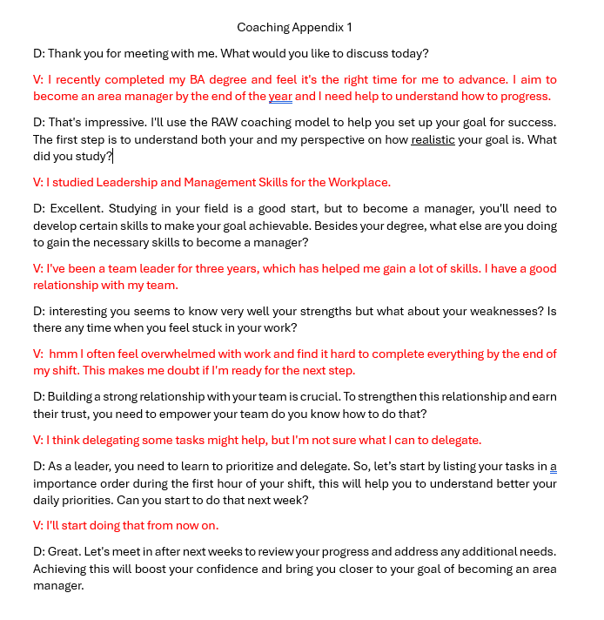

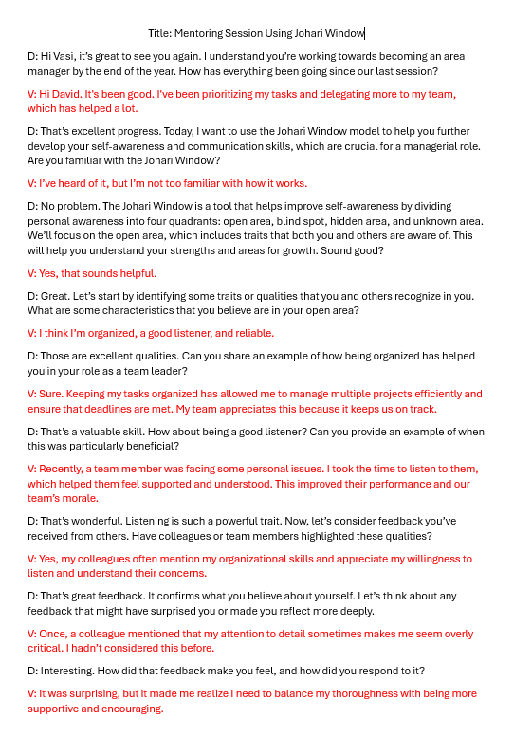
Appendix 2



