University of Wales Trinity Saint David
LONDON CAMPUS
Individual Report
Module Name: Digital Skills and Research Methods
Module Code: LCHS 4007
Student name: Jovita T Carpio
Student ID: 2514539
Lecturer’s Name: Sadique Imam Shaikh

Table of Contents
Research Topic: Global Health Issues 2
Introduction 2
Problem Statement 2
Justification 2
Information Sources and Justification 2
Task 2: Research Methodologies 2
Give a brief overview of quantitative and qualitative research. 2
What type of research methodology will you use for your research and why? 3
Task 3: Data Collection 3
Overview of primary and secondary data collection 3
What form of data will be used to address your research problem, and why? 3
Conclusion 3
References 3

Research Topic: Global Health Issues

Introduction

This research explores global health issues to understand how they affect real people and why they matter to all of us. As a college student, I’ve realised that these challenges like unequal access to healthcare, rising chronic diseases, and the impacts of climate change aren’t just global headlines but everyday struggles for millions. The purpose of this study is to examine the key factors driving these problems and consider how communities and countries can respond more fairly and effectively. By focusing on both the global patterns and the human stories behind them, the research aims to highlight why improving health internationally is a shared responsibility.

Problem Statement

One major global health issue affecting the Health and Social Care sector is the rise of non-communicable diseases {NCDs} such as heart disease, diabetes and cancer. These illnesses now cause over 70% of deaths worldwide, making them one of the leading challenges for modern healthcare systems {World Health Organisation, 2023}.
This problems affects patients most directly, Many people live with long term conditions that require ongoing treatment, medication, lifestyle support and regular monitoring. For families. This often means emotional strain, financial stress and navigating complex care systems, especially in low and middle income countries where access to treatment is limited {United Nations, 2023}.
Care workers are also heavily impacted. The rise of chronic illness adds pressure to an already stretched workforce, increasing workloads and the risk of burnout. Nurses and community health workers often provide long term support to patients managing multiple conditions, which can be demanding both physically and emotionally {Marmot, 2020}.
Health and Social Care organisations face significant challenges too. Hospital and community services must manage rising demand, invest in long time care models, and address inequalities that drive NCD rates such as poverty, limited care access and unhealthy living environments {Institute for Health Metrics and Evaluation, 2022}. These pressures strain budgets and make it harder to deliver timely, quality care.
As a college student learning about these issues, what strikes me most is how deeply personal they are. Behind every statistic is someone trying to live a healthier, more stable life and a health system working hard to support them.

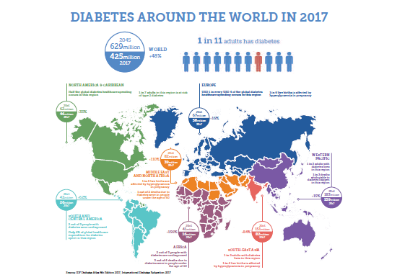
https://www.openaccessgovernment.org/diabetes-a-global-health-challenge/46992/

https://www.forthwithlife.co.uk/blog/uk-heart-health-statis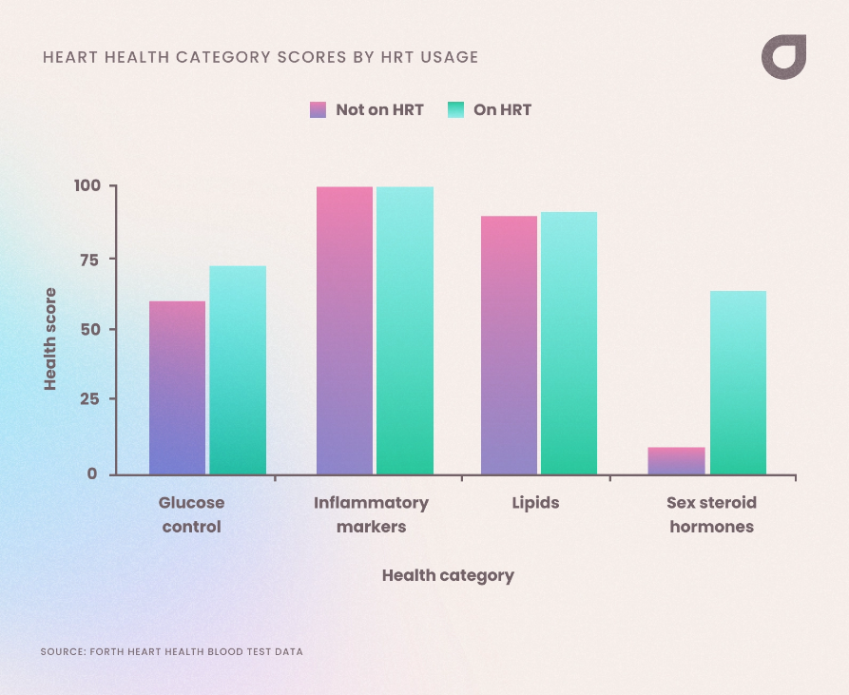tics/

Justification
Research on global health issues especially the rise of long term conditions like heart disease, diabetes and cancer is essential because these problems affect millions of real people every day. Not just in theory but in deeply personal ways. As a student learning about health and social care, I’ve realised how easily statistics can hide the human stories behind them. Families struggling with long term illnesses, communities facing unequal access to care, and health care workers dealing with heavy caseloads all show why this topic matters.

Conducting research help us understand why these conditions are escalating, who is most affected, and what barriers prevent people from getting the care in need. With health systems across the world under pressure, research can uncover practical solutions like improving early diagnosis, reducing health inequalities, supporting overworked staff, and shaping policies that genuinely help people live healthier lives.

This inquiry is also important because global health issues don’t stay contained. What affects one community whether it’s rising chronic diseases or lack of access to treatment can ripple across countries through economic strain, workforce loss, and social inequalities. Learning this topic isn’t just an academic exercise; it’s a way to understand how to build fairer, stronger , and more compassionate health systems that put people, not just numbers first.

Information Sources and Justification
The content of my research focuses on global health issues, especially the rising impact of non-communicable disease NCDs such as heart disease, diabetes and cancer. These illnesses now account for around 75% of global deaths, making them a major challenge for health and social care systems worldwide, (World Health Organisation, 2023). I explore how NCDs affect different groups, patients living with long-term conditions, families providing daily support, and care workers who face increasing workloads and emotional strain (United Nations,2023). I examine how health organisations struggle with rising demand, funding pressures, and inequalities in access to services (Institute for Health Metrics and Evaluation,2022).
This content is relevant because NCDs shape the everyday lives off millions of people, often in ways that aren’t immediately visible. As a student, I was struck by how unequal theses health outcomes are the disadvantaged communities face higher risks, younger people are increasingly affected, and many families lack the resources to cope with long-term illness. Researching this topic helps highlights these inequalities and shows why prevention, global cooperation, and stronger health system are essential.
I chose this topic because it feels both globally significant and personally meaningful. Nearly everyone knows someone living with a chronic condition, and understanding the wider context helped me appreciate the pressures faced by patients, carers, and healthcare workers. Studying NCDs isn’t just about numbers, it’s about recognising the real human struggles behind them and thinking about how we can build healthier, fairer futures.

Task 2: Research Methodologies

Give a brief overview of quantitative and qualitative research.
Quantitative and qualitative research are two fundamental methods used to understand health and social care issues, and both have strengths depending on what you want to learn. Quantitative research focuses on numbers, measurements, and statistical patterns. It gathers data through survey, experiments, or large datasets to show trends such as disease rates, risk factors, or service use (Bryman, 2016). For instance, if we want to know how many people are affected by diabetes in a specific region, it’s methods help us measure this clearly and compare results across groups (Creswell, 2014).
Qualitative research, on the contrary, explores people’s experiences, feelings, and perspective in depth. It uses interviews, focus groups, and observations to understand how individuals make sense of their health, how carer cope, or why patients might avoid certain treatments (Silverman, 2017). For example, if we want to understand what life is like for someone managing a long term condition, qualitative methods help us hear their voice directly (Green and Thorogood, 2018).
The main difference between the two is that quantitative research tells us “how many” or “how often”, while qualitative research explores “why” and “how” people experience something. In my opinion, I’ve realised both are essential: numbers help us see the bigger picture, but personal stories help us understand the real human impact behind those numbers. In health and social care, combining the two approaches gives a comprehensive and compassionate understanding of the issues that affect people’s everyday lives.

What type of research methodology will you use for your research and why?

For this research, I will use a mixed methods approach because global health issues involve both large scale patterns and real human experiences. Quantitative data shows the scale of problems like rising chronic diseases, while qualitative insights help capture how patients, carers and communities actually live through these challenges, making the findings more meaningful and human. Finally, combining methods allows you to cross-verify results, enhancing the credibility, validity, and reliability.

Task 3: Data Collection

Overview of primary and secondary data collection
Primary and secondary data are both important in research, but they serve different purposes. Primary data is information you collect yourself for the first time. This can include surveys, interviews, observations, questionnaires and experiments (Creswell, 2014). For example, If I interview patients about their experience managing diabetes, that’s primary data because I’m gathering new, firsthand information. It’s useful when you want detailed, specific insights directly from the people involved.
Secondary data, on the other hand, comes from the information that has already been collected by others. This includes journal articles, government reports, health records, or global databases like those from the World Health Organisation (WHO, 2023). For instance, using published statistics on global disease rates would be secondary data (Bryman, 2016).
The ,ain difference between the two is that primary data is newly collected for your own research, while secondary data already exists and is reused for analysis. As a student, I think of it like talking to people yourself versus reading what others have already written. Both are valuable, especially in global health. Primary data gives you human stories and lived experiences, whereas secondary data helps you understand overall perspective, such as trends and global patterns. Using both can make research deeper, richer, and more meaningful.

What form of data will be used to address your research problem, and why?

For this research, I will use both primary and secondary data, although secondary data is usually the most practical and reliable choice. This is because global health trends like disease prevalence, vaccination rates or mortality patterns require large-scale information that individual students or researchers can’t realistically collect on their own. Secondary data from sources such as the World Health Organisation or government health reports is already gathered, checked and compared across countries, making easier to spot patterns and inequalities. Using this type of data also saves time and ensures the information is accurate enough to guide decisions and discussions. Overall, secondary data lets us understand global problems in a clearer, more meaningful way (World Health Organisation, 2021).

Conclusion
Overall, it may be said that this research shows that the global health issues, especially the rise of non-communicable diseases affect people on both a large scale and a deeply personal level. The key findings highlight that these conditions place heavy pressure on patients, families, care workers and health organisations. Quantitative data revealed the scale of the problem, while qualitative insights showed the real human experiences behind the statistics. This project helped me understand that improving global health isn’t just about numbers; it’s about recognising people’s struggles and working towards fairer, more supportive health systems worldwide. Ultimately, Global Health issue in the 21st century requires a paradigm shift towards shared responsibility, sustainable practices, and a commitment to health equity to manage interconnected threats and secure well-being for everyone.

References
- World Health Organisation (2023). Noncommunicable diseases: Key facts. Geneva: WHO.
- United Nations (2023), The Sustainable Development Goals Report 2023. New York: United Nations Publications.
- Institute of Health Metrics and Evaluation (2022). Global Burden of Disease Study 2022 Results. Seattle: IHME.
- Bryman, A. (2016). Social Research Methods. 5th edition. Oxford: Oxford University Press.
- Creswell, J.W. (2014). Research Design: Qualitative, Quantitative and Mixed Methods Approaches. 4th edition. Thousand Oaks, CA: Sage Publications.
- Silverman, D. (2017). Doing Qualitative Research. 5th edition. London: Sage Publications.
- Green, J. and Thorogood, N. (2018), Qualitative Methods for Health Research. 4th edition. London: Sage Publications.

