
Student name: Alina-Ionela Scoipan
Student number: 1816722
Module Title: Problem Solving and Decision Making
Module code: BMSW4004
Assignment title: Problem Solving and Decision Making
Lecturer’s name: Yajesh Kumar

Content pages

Page 3 ………. Introduction
Page 4 ………. Where does NHS have a shortage?
Page 7 ……… PESTLE Analysis
Page 8 ……… SWOT Analysis
Page 10 …….. FISHBONE Diagram
Page 13 ……… Stakeholders
Page 14 …….. Conclusion and references

Introduction

The aim of this report is to identify the problems in NHS field, their cause, to make de SWOT Analysis, PESTLE Analysis and Fishbone Diagram, to try to find the solutions and communicate them to stakeholders and see if this was the right solution.
As it is already known the biggest problem in NHS is the lack of funding and lack of staff, overstressed staff and because of the improvement of the treatment offered there is an aging population which cost more the NHS as with the age the are others disease appearing like diabetes or different types of cancer.
What is NHS? NHS is a complex system made up of a wide range of different organisation with different roles, responsibilities and specialist which provides a variety of services to patients and carers. Over the last years the system had improved and it will allow to patients to access easier the local GPs or hospital but it affected those who hold the budget and pays for these services.
Where does NHS have shortage? There are shortage of staff like nurses, GPs, midwives, mental health practitioners and radiologist.
The key challenges are an ageing population, a growing population, increased cases of obesity, diabetes or antibiotic resistance plus the advance payments they get help saving lives but rise the cost considerably.
The current NHS issues are the current mental health services, the BREXIT referendum result, the vaccinations, junior doctor contracts and the 7 day NHS. Financial the organisation always been struggling , to help they could move the patients care outside hospitals to Clinique in GP surgeries. The centralisation have caused the closing of some local A&E and maternity wards.
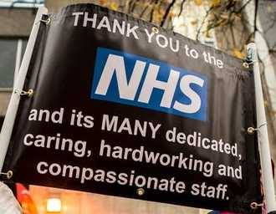

Across England NHS had 106.000 shortage of staff including 44.000 in nursing homes; staff is leaving as a result of low job satisfaction and the recruitment and retention is a continuous growing problem. In the same time the lack of government funding force the staff to do unpaid overtime to help NHS to cope with the hi demand of service. In A&E department it was reported that in October 2019 only 83.6% patients been seen in the normal 4 hours waiting time which it dropped from 89% in October 2018.
The is a huge crises in recruitment and retention of nurses and the leading nurses said that ,, don’t feel able to provide the level of care they should”. Researched showed that more or less 70% of nurses leave the NHS within first year since they got their qualification; in addition after BREXIT result 28% European nurses quit and overseas application had split fifty-fifty. Whit the cuts in nursing bursaries others 33% dropped in university application.
Other series issue in NHS is that there are not enough midwives which leads to temporary closing units or patients without a consultant midwives.
General problem is the recruitment and training of new GPs or the retention of current GPs. From March 2016 to March 2018 the number of GPs dropped by 1340 and the studies that a third of GPs are over 50 years old and the early retirement have doubled, also from December 2017 to 2018 27 full-time GP were lost and 593 are less qualified.
Studies showed that from 2017 to 2018 7 in 10 hospital doctors reported gaps between their shift rota. To be able to fill the shortage of hospital doctors it is needed extra 2840 medical students over 5 years . also 4 in 10 doctors are planning to move overseas as result of Brexit referendum.
As an example we can give A&E department from Weston-Super-Mare which it declared in June 2017 that will be a ,,temporary” closing over night between 10pm to 8am; however in July 2018 the hospital was still closed.
Staff shortage in mental health professional ( nurses therapists and psychiatrist) dropped by 15% since 2010 also some of the staff take sick leave as a result of their own mental health issue which increased by 22%, the number of mental health nurses dropped by thousands.
In less than 2 years the number of radiologist dropped by 9%to 10%.

NHS recruit their staff from other countries to be able to meet the growing staff shortage. Yearly it is needed a number of 5000 extra nurses. 12% of workforce are not British ( at 1000 workers , 873 are from UK, 56 are from Europe, 43 from Asia, 19 from Africa and 9 from other places). The biggest lack is from Europe as the number who join the NHS dropped by 7,9% from 2017 to 2018.

PESTLE ANALYSIS

What is PESTLE Analysis? Is an shortening tool used to identify the macro forces facing the organisation. The letters stands for Political, Economic, Social, Technological, Environmental and Legal.
Political factor which affect the NHS now is BREXIT uncertainties as the medication and equipment’s are coming from Europe. Also the medical professionals originally from other European countries may leave UK.
Economical factors : since the 2008 crisis the NHS faces financial troubles also the lack of qualified staff, because of the mediocre salary.
Sociocultural factors are the aging population , as whit the age the patients may get diabetes or various cancers which can be extremely costly to treat or manage also the patients are having access to information and they expectations are higher as they have knowledge about the treatment available.
The technological factors are the improved healthcare as the scanning tools are more affordable than ever. With various pumps and tools for treating and managing condition been developed it reduced the morbidity; the patients receive higher standard and the NHS is able to speed up and automate more clinical tasks. The technology helps the patients and also the clinical professionals.
Legal factors: patients or their family which are not satisfied with their treatment tend to take the cases to court to get retribution.
There are no environmental factors apart of the toxic waste added to current situation the climate is facing it is needed a higher expectation to treat their waste.

SWOT Analysis

What is SWOT Analysis? SWOT Analysis is a simple but powerful tool to help to develop of the business strategy. It stands for STRENGHTS, WEAKNESSES, OPPORTUNITIES and THREATS.
Strengths- even if the NHS isn’t monopoly there is no real competitor for the trust;
- there are private hospitals all over the UK, the A&E is unique to the NHS.
- The NHS was founded in 1948 and keeps continues to raise and develop.
- There is a continuous 24-hour care of waiting list that attest it is a gigantic request of outstrips stock.
Weaknesses: - the trust is unable to cope with the HI demand due to increasing population
- The management of linkage of the chain
Opportunities: - the use of marketing to make NHS profile to grow.
- The growing of private investment
Threats: - the image is affected by the contractors work
- The staff turnover is hi.
Fishbone Diagram

What is Fishbone Diagram? Source and result analysis helps you to think through the causes of a problem thoroughly, including its possible root causes. It is only by identifying the main causes that you can permanently remove the problem, or reduce the delay. It does help to get an opinion about the problem and create a solution. It is used only when it is wanted to understand why a specific problem happened.
Why there is shortage of staff in NHS? Because their payment is quite low and they have to work long hours of unpaid overtime to help the trust to coop with the hi demand of patients, another problem is the uncertain future of Great Britain after the Brexit which made a lot of nurses and doctor to quit on they jobs in UK and return to their original country or to move to another European country which can give them a view for their future also there are just half or less than half candidates who want to come to work in UK.
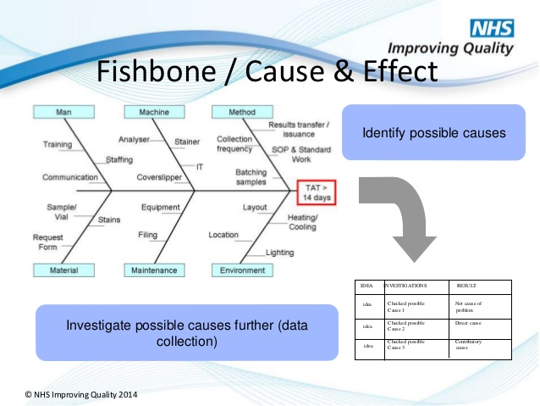

How can we manage the personal shortage?
We can purpose a few ideas like the redesign the work process and new technologies should be introduced and these will lead to increasing the practice effectiveness , productivity and worker pleasure.
It is needed a new generation of workers to work better and a new manager should be appointed to help the Clinique to survive.
The doctors must know and understand the patients needs simple by asking them so they will be able in future to make the practice better in the view of patients.
With a shortage of staff already the NHS can not risk to loose anymore of to one they already got so it is needed staff who is loyal and will stay with the trust even if they have to work longer hours or working under pressure.
It is needed to give the opportunity to hire the younger generation even if they don’t have the experience.
The medical students must be allowed to deliver care for patients as well.
As we are facing now Covid-19 we realise how much it helps us the videocalls or telephone calls with our practitioner specially when you need to be seen by your GP or you need your prescription, for this the NHS created an application that you can just ask for it when you need your new prescription and you can just pick it up from your local pharmacy; so it will save a lot of time as you don’t need to go to surgery and then to the pharmacy after a few days; but these telephone conferences can help if you are travelling.
It is need an positive work environment so the staff can work in busier condition but not getting stressed . The managers should create flexible rotas so the staff will be able to work without getting stressed.
Who are the stakeholders? They are engaging a wide variety of people suck as clinicians, administrative staff, patients , insurance companies , pharmaceutical firms and the government. Their main responsibility is to make money and improve the healthcare system.
The main focus of insurance company is to keep as many people from getting health insurance; proper healthcare is hard to get because of the financial hardship. They need to get a balance between the shareholders and patients.
Pharmaceutical companies play a key role as well in healthcare system as many patients rely on their products. The prices are hi but there are no cap limits to their prices.
Physicians are ensuring their patients get a proper healthcare but they also control the rising costs of healthcare, as an example we can use the GPs who will try to keep the cost of medicines quite low and try to prescribe only the cheapest medicines.
The role of the patients is to keep control of their own healthcare and try to keep a healthy life style, to reduce or stop smoking.

Conclusion

In this report it was identified the causes of NHS shortage of staff, done the SWOT Analysis, PESTLE Analysis, FISHBONE diagram it was tried to find solution for this crisis and also identified the stakeholders of the trust. As we could see there are many factors to NHS crisis specially the lack of government funding, the BREXIT referendum result, the stressful condition in which the staff got to work, which lead to sick pay for their own mental heath condition, or in this day the most feared Covid-19 which put hold on the planet and have suck a disaster result.
References

(stakeholders engagement strategy, 2017)
(marketing analysis of the NHS, 2017)
(Farooq, 2020)


