

Student name:​ Mutiat Shobajo
Student ID: ​ 1910057
Module name: Mental Disorders and Psychopathology​
Module code: BMHP6006
Lecturer name: Bianca Sanfilippo ​
Date: 14/04/2022

Table of Contents
Introduction 4
General Anxiety Disorder 4
Classification 5
Causes of anxiety (Aetiology) 5
Signs and Symptoms 5
Diagnosis 6
Treatment 6
Measurements of Rehabilitation 7
Recommendations for Improvement 7
Principles of Care 7
Schizophrenia 7
Classification 8
Causes (Aetiology) 8
Signs/Symptoms 8
Diagnosis 8
Current treatments 9
Measurements of rehabilitation 9
Guidance and Principle of Care 9
Recommendations for Improvement of Schizophrenia 10
Autism 10
Classification 10
Causes (Aetiology) 10
Signs /symptoms 11
Diagnosis 11
Current Treatments 11
Measurements of Rehabilitation 11
Recommendations for Improvement of Autism 12
Guidance and Principle of Care 12
Conclusion 12
Reference List 13
Appendix A 15
Appendix B 17

Introduction
Mental health is very critical among individuals operating under daily stressors. It is for that reason that psychopathology is conducted to maintain a positive mental status. Psychopathology refers to the study of the nature of mental health disorders and how such developments impact an individual’s quality of life. Such a study describes various causes, symptoms, developments, as well as treatments of mental illnesses. This report entails a critical examination of various mental disorders through their classification, diagnosis, treatment, and measurements of rehabilitation.

General Anxiety Disorder
This is a condition described by NHS 2021 as a persistent feeling of stress, great panic, and fear and which has the potential to negatively affect an individual’s daily life as well as their physical and mental wellbeing, GAD can be a long-term mental condition that makes someone feel anxious about a series of situations or issues. Among most patients with such a condition, once a single anxious thought gets resolved, a different one appears, and this forces such individuals to keep struggling with thoughts of when they last relaxed. Sometimes feelings of anxiety may be normal but worries, fears, and emotions may at times escalate and cause distress, hence affecting daily living.

Classification
From ICD-10 Version:2010, GAD is classified under ‘F41.1’ Neurotic, stress-related and somatoform disorders. The condition is generally classified as persistent anxiety that is not restricted to particular environmental situations. GAD is a common condition in the United Kingdom (UK) since it affects close to 5% of the population. While the condition is also shown to be prevalent among individuals aged between 35 and 59, NHS 2021 shows that it slightly affects more women when compared to their male counterparts. Between 2017 and 2018, it is estimated that about 15.4 million days were lost in Britain to work-related stresses. This illustrated an increasing trend of the GAD condition where work-related stress was highlighted as a growing epidemic that demanded critical intervention. The sample demonstration on appendix B visually describes the people suffering from GAD in the UK:

Causes of anxiety (Aetiology)
Several factors are associated with causing GAD. These factors are regarded to be ‘associates’ due to the role they play and because the exact cause of GAD is not recognized. Research indicates a combination of such factors to include an individual’s misuse of alcohol or history of drug abuse, traumatic experiences, and inherited genes. In most cases, it has been established that an individual whose close relatives have GAD has 5 times more likelihood of developing the condition. Traumatic experiences such as child abuse or domestic violence and long-term health issues such as arthritis also contribute to the development of GAD (Tiirikainen et al., 2019, p. 32). In addition, over activity of brain areas responsible for emotions and behavior or imbalance of mood-regulating chemicals in the brain such as serotonin also acts as potential causes of GAD.

Signs and Symptoms
Even though the dominant symptoms of GAD vary, the common ones include complaints of persistent nervousness, dizziness, trembling, excessive sweating, and muscular tensions. Palpitations, epigastric discomforts as well as fears that an individual will soon have an accident or become ill are also potential signs of GAD. Such physical signs and symptoms and others such as dry mouth, headache, insomnia, and shortness of breath are potential triggers of anxiety. As mentioned in NHS 2021, psychological symptoms such as restlessness, irritability, and concentration difficulties tend to change how individuals think and feel about their environment. These symptoms vary from one person to another depending on how severe they are. Some of them may show a single symptom, others two and in some cases, someone may demonstrate many symptoms. Other signs include social contact withdrawal and more occasions of having difficulties in going to work.

Diagnosis
GAD can be a difficult condition to diagnose because of its inability to be distinguished from other mental health disorders like depression. However, an individual is most likely to be diagnosed with GAD if the foregoing symptoms have been recurring for at least 6 months. At first, a self-diagnosis is important. From NHS 2021, anyone can deduce that they have the condition if they find it difficult to manage their feelings of anxiety and that the inability of such worries to be controlled affects their daily life by upsetting and stressing them. These indications prompt seeing a general practitioner (GP) help with the diagnosis. The GP helps with the diagnosis by carrying out blood tests or physical examinations to rule out other conditions that are mostly associated with the causing symptoms. These conditions may be an overactive thyroid gland or anemia due to iron or vitamin B12 deficiency.

Treatment
The positive treatment options for the GAD condition are mostly psychological therapies that are conducted before medical prescriptions are made. Applied relaxation and cognitive behavioral therapy (CBT) are some of the psychological therapies refereed to GAD patients to help evaluate if they can learn how to cope with anxiety (Newman et al, 2020, p. 203). These therapies are self-guided and may also be conducted by a qualified therapist in groups weekly for 3-4 months. CBT helps a patient to question the anxious thoughts and thrive in performing activities that initially contributed to an anxious feeling. Applied relaxation involves focusing on particular muscle relaxation techniques during anxious situations. Even though the benefits of both therapies have been shown to last longer than medications, it is essential to note that no single treatment works for everyone.
The negative treatment options involve medications that depending on the symptoms, are designed to be taken on either a short or long-term period. According to NHS 2021, Selective serotonin reuptake inhibitors (SSRIs) are the initial medications prescribed to a GAD patient. If the antidepressant fails to ease anxiety, a GP prescribes serotonin and noradrenaline reuptake inhibitors (SNRIs) to increase serotonin and noradrenaline amounts in the brain. Benzodiazepines are the ultimate medications for patients with severe anxiety disorders (Guina and Merrill, 2018, p. 8). Essentially, these medications are considered to be negative due to their adverse side effects. This may include drowsiness, low sex drive, blurred vision, agitation, and headaches.

Measurements of Rehabilitation
These are tools that help in projecting the progress and effectiveness of the rehabilitation process/treatments. Consequently, the effectiveness of treatments provided to a GAD patient is a critical measurement of rehabilitation. This is because it helps in quickly noticing and changing an ineffective treatment. As shown in Appendix A, the Generalised Anxiety Disorder Questionnaire (GAD-7) is an efficient tool that measures anxiety levels over two-week periods.

Recommendations for Improvement
Complementary therapies are appropriate for the improvement of anxiety. Studies made by Shohani et al. (2018, p. 3) validated the effectiveness of yoga in reducing anxiety among women. Yoga has immense positive impacts that considerably lower drug use and its side effects. Mental health specialists also recommend family and friends’ support as better alternatives to medications in the prospect of improving anxiety.

Principles of Care
Working with GAD patients requires collaborative relationships that embrace a shared decision-making process that is non-judgmental and open. It is mandatory for the discussions made with such patients to be confidential, private, and dignified. Independent interpreters should be provided when needed to ensure patients have appropriate information based on their understanding levels. Equally, families should be provided with emergency contact numbers and information about what to do when a crisis arises.

Schizophrenia
Schizophrenia affects the thinking, feeling, and behavior abilities of an individual (Holm et al, 2021, p. 62). Concentration and memory difficulties are some of the attributes of schizophrenia. The lifetime prevalence of schizophrenia is indicated to be almost 1% with about 10–15% of the patients being in gainful employment. From a Global Burden of Disease Study, He et al. (2020, p. 2) reported that schizophrenia global rates were at almost 1.13 million in 2017 with more males being affected than females. The highest cases were shown in China and the East Asian countries while the lowest was present in Oceania. In the UK, the prevalence of schizophrenia across all ages is estimated to be 0.7% (Whiskey et al., 2021, p. 344). This is a report made in 2019 where 377,000 adults in the UK were reported to be living with schizophrenia in 2018. Due to different health provision systems, the underlying reasons for the variations in schizophrenia rates are difficult to ascertain.

Classification
Schizophrenia is placed within the ICD-10 Version:2010 under ‘F20’ Schizophrenia schizotypal and delusional disorders. Several schizophrenia categories have also been classified to describe its related disorders. Such include paranoid, hebephrenic, catatonic, undifferentiated, residual, and other simple forms of schizophrenia. These forms are described according to their stages of development in distorting thinking and perception.

Causes (Aetiology)
Various factors that are genetic, psychological, and environmental mostly cause schizophrenia (Diaz-Castro et al., 2021, p. 2). There is a 0.1% likelihood of someone developing the condition and this implies that genes do not mainly influence the development of schizophrenia. A connection is made between neurotransmitters and schizophrenia because the drugs used to alter the chemical levels have been shown to relieve various schizophrenia symptoms. Complications before and during birth are also potential causes of schizophrenia due to subtle effects on brain development. Equally, stress and drug abuse also indirectly leads to the development of schizophrenia.

Signs/Symptoms
Due to the slow development of schizophrenia, the condition’s signs can be hard to identify. However, NHS 2021 indicates that hallucinations and delusions are some schizophrenia signs where individuals tend to have confused thoughts that other people cannot understand. Disorganized and unpredictable behaviors such as feelings by an individual or someone else guiding their actions also describe schizophrenia. More negative symptoms of include lack of sleep, concentration, and interest/motivation in life. Occasions of an individual being less likely to initiate or engage in conversations or feeling uncomfortable with others are potential symptoms of schizophrenia that can be mistaken for laziness or even rudeness.

Diagnosis
Schizophrenia is usually diagnosed after a mental health specialist assesses the symptoms to ensure they are not a result of other causes like drug abuse. As indicated in NHS 2021, the diagnosis should never be conducted in the presence of acute depression, overt brain disease or under drug intoxication/ withdrawal states. A diagnostic checklist is mostly used to diagnose schizophrenia. This condition can be diagnosed if an individual has experienced once or severally symptoms such as flat emotions, hallucinations, hearing voices, and incoherent speech. Other related mental illnesses such as bipolar disorder are also established when conducting a schizophrenia diagnosis.

Current treatments
Positive treatments of schizophrenia involve the use of antipsychotics at the initial stages of the condition. The antipsychotics act to reduce anxiety feelings by blocking the effect of dopamine in the brain (Galimi, 2022, p. 109). In addition, psychological treatments such as family, and arts therapies tend to work best when combined with antipsychotics. These therapies alleviate the negative symptoms and provide patients with experiences that enable them to improve how their relation abilities.
According to NHS 2021, a care programme approach (CPA) is mostly used to offer treatments to individuals with complex schizophrenia. However, CPA does not always suit everyone because some patients receive care from their GP while others get attended to by a specialist/therapist. Crisis resolution teams (CRTs) are obligated with treating people with severe mental health conditions. Such treatments are negative since more acute schizophrenia episodes’ prompt voluntary as well as compulsory detention to a psychiatric ward/clinic to protect others and the patient's health and safety interests.

Measurements of rehabilitation
With schizophrenia, care and treatment measurements help in managing the condition. This helps in eliminating complications such as suicide and drug abuse. The Quality Indicator for Rehabilitative Care (QuIRC-SA) elaborately demonstrates specific care indicators essential in managing the condition. Autonomy, social interface, recovery-based practice, and living and therapeutic environments are the indicators to be considered in rehabilitative care. Schizophrenia being a long-term condition makes it important to measure rehabilitative care.

Guidance and Principle of Care
At first, the positive and negative signs and symptoms of schizophrenia should be recognized. An assessment of the patient's medical history should be done to establish an appropriate support system. To maximize a patient's level of functioning and adherence to therapy, trust and rapport are essential in such a relationship. Discussions regarding treatment plans for schizophrenia are required to be carried out openly and comprehensively to help patients in providing their perspectives on acceptability and adherence to treatments. Caring for schizophrenia patients should be integrated with other psychological, social, and educational interventions at the earliest opportunity.

Recommendations for Improvement of Schizophrenia
Since schizophrenia has disabling experiences among most patients, family intervention is quite essential in the improvement of the condition. Family members being the main care providers can be subjected to a social skills training exercise that will help in reducing patient relapse or readmission to the hospital. Considerably, working with families is one of the most effective ways of delivering community-based interventions among schizophrenia patients. Equally, conducting more clinical trials is important to determine the best antipsychotic effect with minimal effects. This will help in limiting fast considerations of medications in the treatment of schizophrenia.

Autism
In ICD-10 Version:2010, autism is a mental disability expressed through challenging social skills. This mental disorder has been known to begin in early childhood periods. Even though children may appear to have normal growth within the first year, 18-24 months of their age sometimes gets marked with a period of regression and this is when they begin developing symptoms of autism. Autism disorder has no cure, but early intensive treatment has been highlighted to greatly influence the lives of autistic individuals.

Classification
From ICD-10 Version:2010, autism is classified under ‘F84.0’ Disorders of psychological development, specifically within 'F84 Persuasive developmental disorders. Globally, there is a 0.01% chance of children being diagnosed with autism (Zeidan et al., 2022, p. 785). Autism is mentioned to be more common among the male gender, especially in rural populations. In 2016, autism prevalence estimates were shown to be almost similar for all racial profiles but lower for Hispanic children. In the UK, black pupils have a 12.4% increased prevalence of autism, and this is said to be due to their social disadvantage (Roman-Urrestarazu et al., 2021, p.7). The Chinese and black pupils are indicated to have a 38% and 28% more likelihood of being reported with autism when compared to white pupils in England.

Causes (Aetiology)
Even though the causes of autism are unclear, genetic factors are presumed to be the sole contributors to the condition. Genetic anomalies such as gene mutations, deletions, and copy number variants have been persuasively linked to autism (Landrigan, 2010, p.219). Apart from the inherited vulnerabilities, there are environmental exposures that account for the autistic condition. Embryonic vulnerabilities in the first trimester of pregnancy tend to contribute to immature brain development hence possibly causing autism.

Signs /symptoms
Common autism signs involve a child’s inability to respond to their name, avoidance of eye contact, and lack of interest in talking. A child may also get upset if they dislike a certain smell or sound and this serves as a potential symptom of autism. Among older children, the signs of autism can be described through a child’s difficulty in making friends and understanding the thoughts and feelings of other people. In most cases, these children find it hard to express how they feel, and they prefer being on their own. Potential autistic girls are known to be quieter and better placed to cope with social environments or hide their feelings when compared to boys. This makes it difficult to spot autism in girls.

Diagnosis
NHS 2021 mentions that any signs of autism demonstrated by a child prompt a parent/guardian to speak to a GP. This helps in gaining insights on whether the best action is to seek autism assessment from autism specialists. An assessment team seeks to ask about the problems expressed by the child in their interaction with other people to briefly establish if a child is autistic. In other cases, a professional may visit the child while at school to study their patterns. At the end of the assessment, a conclusive report can be made to indicate whether a child is autistic or not.

Current Treatments
Such treatments are limited to their side effects. However, cannabinoids have increasingly been said to manage seizure experiences among autistic children (Nezgovorova et al., 2021, p.11). Since there are no treatments for autism itself, doctors sometimes advise taking special diets that affect other conditions of autistic individuals. Diet supplements such as vitamins are options that do not work. Other considerations such as GcMAF are harmful when conducted on autistic patients. The same applies to medications recommended to help with memory by changing hormone levels or through chelation.

Measurements of Rehabilitation
The childhood autism rating scale (CARS) helps in measuring the assistance accorded to autistic children. An observation scale can always be obtained to indicate normal and severely abnormal status ratings. The total score generated by these tools may range between 15 and 60. Scores between 30 and 36.5 imply mild autism while those ranging from 37 to 60 represent acute autism.

Recommendations for Improvement of Autism
Complementary therapies, such as yoga in autism have been demonstrated to be effective in managing children with autism. According to (Laxman, 2022, p.158), recent school-based interventions have shown yoga to positively influence the development outcomes of a child. More research has recommended yoga for its emotional, physical, and psychological health benefits for autistic children.

Guidance and Principle of Care
All autistic children should have full access to health, social, and mental care regardless of any coexisting diagnosis. The physical environment of care should be considered by professionals to minimize negative impacts. This can be achieved by providing visual support and creating enough personal spaces. Individual sensory sensitivities of the autistic should be considered in lighting, wall colors, and levels of noise. Families and young people with autism should be provided with information related to the management of the condition. A collaborative approach to care should be offered if autistic children express any interest in decision-making.

Conclusion
Based on the Equality Act 2010, a person-centered approach is important in strengthening the protection of laws in the wider society. The act which discriminates unlawfully helps in safeguarding various personal orientations such as gender, age, disability, race, and religion. Through a person-centered approach, equalities of opportunity are advanced. Equally, good relations get fostered and this makes health and social care critical to the protection of people’s dignity. Also, anti-discriminatory practices are enhanced through person-centered approaches that make care provision fundamental with a solid ethical basis. Essentially, person-centered approaches under the Equality Act 2010 provide empowerment opportunities within the private and public sectors.

Reference List
Díaz-Castro, L., Hoffman, K., Cabello-Rangel, H., Arredondo, A. and Herrera-Estrella, M.Á., 2021. Family History of Psychiatric Disorders and Clinical Factors Associated With a Schizophrenia Diagnosis. INQUIRY: The Journal of Health Care Organization, Provision, and Financing, 58.
Galimi, R., 2022. Interaction Between anti-Alzheimer’s Disease Drugs and Antipsychotic Agents in the Treatment of Behavioral and Psychological Symptoms: Extrapyramidal Side Effects. Adv Neur Neur Sci. 5 (2), 108, 119.
Guina, J. and Merrill, B., 2018. Benzodiazepines II: waking up on sedatives: providing optimal care when inheriting benzodiazepine prescriptions in transfer patients. Journal of clinical medicine, 7(2), p.20.
He, H., Liu, Q., Li, N., Guo, L., Gao, F., Bai, L., Gao, F. and Lyu, J., 2020. Trends in the incidence and DALYs of schizophrenia at the global, regional and national levels: results from the Global Burden of Disease Study 2017. Epidemiology and psychiatric sciences, 29.
Holm, M., Taipale, H., Tanskanen, A., Tiihonen, J. and Mitterdorfer‐Rutz, E., 2021. Employment among people with schizophrenia or bipolar disorder: A population‐based study using nationwide registers. Acta Psychiatrica Scandinavica, 143(1), pp.61-71.
Landrigan, P.J., 2010. What causes autism? Exploring the environmental contribution. Current opinion in pediatrics, 22(2), pp.219-225.
Laxman, K., 2022. Socio‐emotional well‐being benefits of yoga for atypically developing children. Journal of Research in Special Educational Needs, 22(2), pp.158-166.
Newman, M.G., Zainal, N.H. and Hoyer, J., 2020. Cognitive‐Behavioral Therapy (CBT) for Generalized Anxiety Disorder (GAD). Generalized anxiety disorder and worrying: A comprehensive handbook for clinicians and researchers, pp.203-230.
Nezgovorova, V., Ferretti, C.J., Taylor, B.P., Shanahan, E., Uzunova, G., Hong, K., Devinsky, O. and Hollander, E., 2021. Potential of cannabinoids as treatments for autism spectrum disorders. Journal of Psychiatric Research, 137, pp.194-201.
NHS (2021) Anxiety and panic attacks (Online). Available at: Anxiety and panic attacks - NHS (www.nhs.uk)
Roman-Urrestarazu, A., van Kessel, R., Allison, C., Matthews, F.E., Brayne, C. and Baron-Cohen, S., 2021. Association of race/ethnicity and social disadvantage with autism prevalence in 7 million school children in England. JAMA pediatrics, 175(6).
Shohani, M., Badfar, G., Nasirkandy, M.P., Kaikhavani, S., Rahmati, S., Modmeli, Y., Soleymani, A. and Azami, M., 2018. The effect of yoga on stress, anxiety, and depression in women. International journal of preventive medicine, 9.
Slee, A., Nazareth, I., Freemantle, N. and Horsfall, L., 2021. Trends in generalised anxiety disorders and symptoms in primary care: UK population-based cohort study. The British Journal of Psychiatry, 218(3), pp.158-164.
Tiirikainen, K., Haravuori, H., Ranta, K., Kaltiala-Heino, R. and Marttunen, M., 2019. Psychometric properties of the 7-item Generalized Anxiety Disorder Scale (GAD-7) in a large representative sample of Finnish adolescents. Psychiatry research, 272, pp.30-35.
Whiskey, E., Barnard, A., Oloyede, E., Dzahini, O., Taylor, D.M. and Shergill, S.S., 2021. An evaluation of the variation and underuse of clozapine in the United Kingdom. Acta Psychiatrica Scandinavica, 143(4), pp.339-347.9
World Health Organisation, WHO (2010) ICD-10 VERSION (Online). Available at: https://icd.who.int/browse10/2010/en#/F30-F39
Zeidan, J., Fombonne, E., Scorah, J., Ibrahim, A., Durkin, M.S., Saxena, S., Yusuf, A., Shih, A. and Elsabbagh, M., 2022. Global prevalence of autism: a systematic review update. Autism Research, 15(5), pp.778-790

Appendix A
Generalised Anxiety Disorder Questionnaire GAD –7.
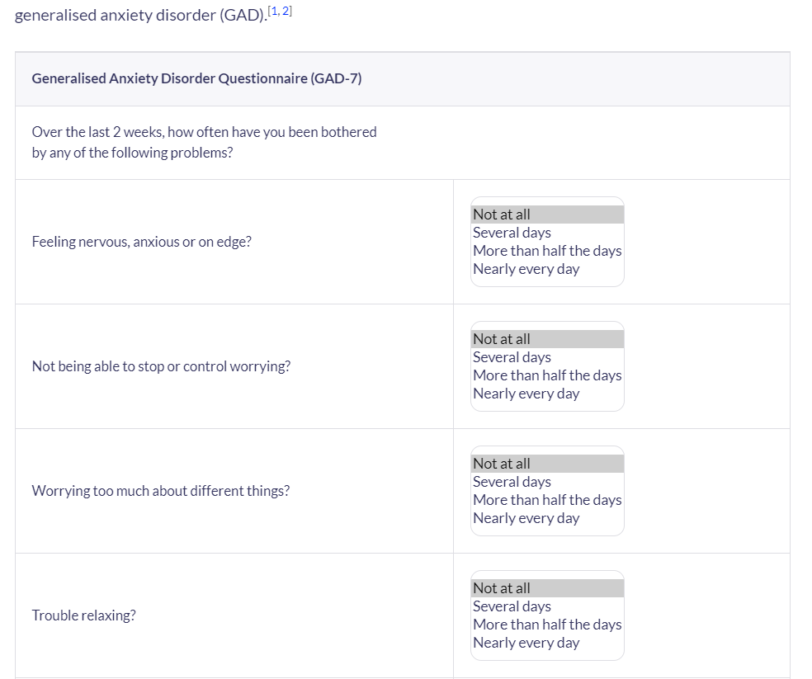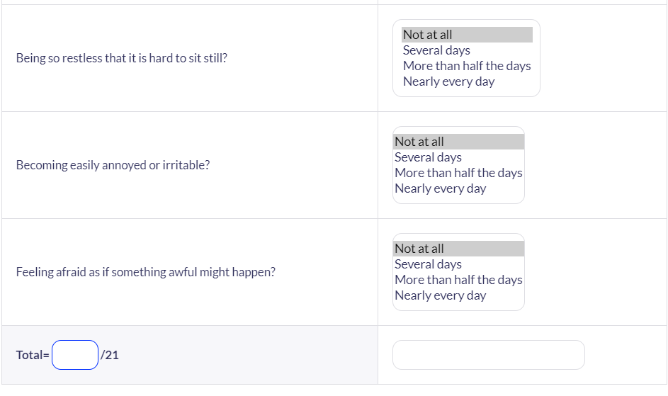

Appendix B
Source: anxiety in UK percentage 2020 - Bing images
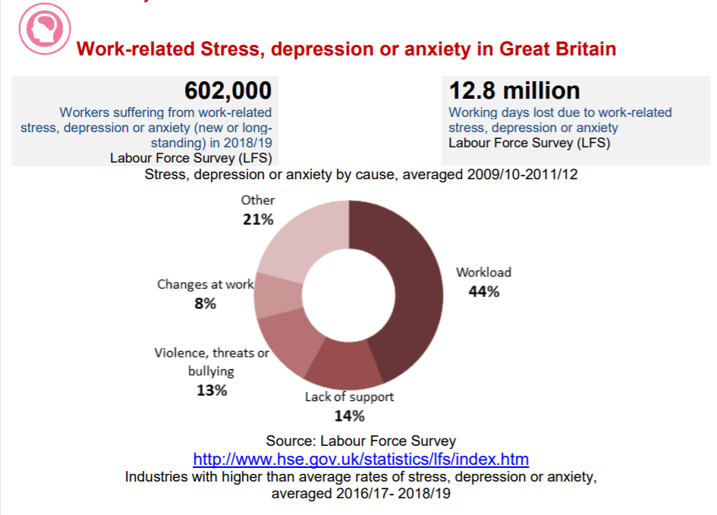
Source: anxiety in UK percentage 2020 - Bing images

