Strategic Management (LCMB7003)

Shirina Begum
Student ID 1709360
MBA- Masters of Business Administration
Strategic Management
University of Wales Trinity Saint David

Table of Contents
2. Peripheral Environment and Markets 4
2.1 Threats of New Entrants 4
2.2 Bargaining Buying Powers 5
2.3 Bargaining Supplier Power 5
2.4 Threat of Substitutes 6
3.0 Products 6
4.0 Nike’s Competitive Advantage 7
4.1 Resources and Capabilities 7
4.1.1. Resources 7
4.1.2 Capabilities 7
5.0 Marketing Environment and Success Strategy 8
6.0 Drivers to Superior Performance 9
7.0 Strategic Management Tools 10
8.0 Marketing Strategy and International Markets 12
9.0 Competitive Advantage and Value Creation 13
10.0 Future Prospects 15
11.0 Business Model Canvas 17
11.1 Key Partners 17
11.2 Key Resources 17
11.3 Key Activities 18
11.4 Value Propositions 18
11.5 Customer Relationships 19
11.6 Customer Segments 19
12.0 Stakeholder Analysis 20
13.0 Culture of The Organization 20
14.0 SWOT and PESTEL analysis of Nike 21
14.1 PESTEL 21
14.1.2 Factors of Politics 21
14.1.2 Economic Factors 21
14.1.3 Social Factors 21
14.1.4 Technological Factors 22
14.1.5 Environmental Factors 22
14.1.6 Legal Factors 22
14.2 SWOT 22
14.2.1 Strengths 22
14.2.2 Weaknesses 23
14.2.3 Opportunities 23
14.2.4 Threats 24
16.0 Conclusion 24
15.0 Recommendations 25
References 26

1.0 Introduction
Worldwide apparel and sportswear company Nike Inc. is based in the US. The company is the world’s leading sports footwear and apparel retailer. Its primary objective was to create inexpensive, high-quality footwear for the American market to destroy the German grip on domestic trade. Its goal is to stay the most genuine, linked and different brand. Nike has a commanding lead in the industry. By Mintel’s estimations, Nike has a 20% share of the American athletic market. To a large extent, the brand has a good name because it is linked to famous athletes like sports teams like Barcelona LeBron James. Here, we’ll look at the external environment, market, and current strategies. It sells to consumers in Europe, Asia, and the U.s, to name a few continents. The Nike Skateboarding and Nike Pro labels are just two of the companies many. The Nike Company and its strategic management and tools are the subjects of this paper (Kiseleva et al., 2021).

2. Peripheral Environment and Markets

2.1 Threats of New Entrants
- Competition from other industries.
- Competition from current leaders.
- Based on the first-mover benefit in the economy of scale.
- Production costs are too high.
- Product prices that are too high.
- Nike has a lot of competition because it operates in various industries.
New competitors face few dangers because other prerequisites are challenging to meet despite the low initial investment. A new entrant may have to compete on a local or smaller scale as a starting point. It’s not just about making things; there’s a lot more to it than that: advertising, dispersion, and supplier management.

2.2 Bargaining Buying Powers
- Little switch costs
- Sensible substitute convenience
- The small size of buyers
Thanks to the low switching barriers, clients can effortlessly switch from Nike athletic footwear to others. Customers can compare products more easily when replacements are readily available, which increases the likelihood of purchasing products from other brands. However, the tiny size and number of customers reduce their impact on the business.

2.3 Bargaining Supplier Power
- High supply costs
- The large populace of sellers
- Rational size of individual suppliers
Sellers have little sway over Nike’s pricing. 621 factories in 42 countries produce its brands. The amount of their suppliers is enormous, and they are located all over the globe. Even though service companies are small in size, they lack the capability of forwarding assimilation, significantly reducing the likelihood of competition from suppliers. However, the distributor would lose a significant source of income in this scenario. Nike has a massive supply stance in a gross casing.

2.4 Threat of Substitutes
Nike faces a low level of competition from low-cost alternatives. Due to the significant number of competitive products producing identical or similar goods. Several other footwears are less expensive than Nike in both domestic and international markets. These companies make Nike’s cheaper knockoffs. The design and quality of Nike products help to mitigate this danger to some extent. Replacement products pose a relatively low threat.

3.0 Products
Nike produces a wide variety of products classified per the sport they are intended for use. A racecourse shoe was one of Nike’s first creations, but the corporation has since produced athletic footwear for various sporting events and events other than track and field and trying to run. It’s because the company’s products are becoming increasingly popular. The air zoom Yorker sports footwear is the company’s newest product. The Air Zoom Yorker is 30 percent lighter than Reebok's version. Nike has also released a new basketball shoe, the Air Jordan XX3.
A radio gadget, which is put inside the sneaker and linked to the iPod nano, has been crafted by Apple Inc. and Nike as part of their cooperative marketing plan. Lunar lite foam and Flywire are two other technologies Nike has incorporated into its shoes to reduce their weight. The Nike sports brand keeps track of the distance traveled, the calories burned, and the amount of time spent exercising. Strategy implementation in advertising is based on product distinction and product positioning. Nike’s strategic goal has been to satisfy the expectations of its consumers (Dupree, 2020).

4.0 Nike’s Competitive Advantage

4.1 Resources and Capabilities
As a result of the effectiveness of its dominant business strategy, Nike has the edge over the competition. Because of their resources and capabilities, they can do this.

4.1.1. Resources
Because of their resources and competencies, they can do this. Nike is one of the biggest companies, employing more than 73,100 people across 1,000 retail locations. Over 700 manufacturers in 42 nations are part of Nike’s manufacturing units. A system of 18,500 accounts and 140,000 general merchandise doors distributes each good from 57 distribution facilities. On the other hand, Nike does not own any factories where it produces its shoes and clothing. Aside from that, Nike enjoys a high level of recognition thanks to its iconic brand. Off-white, Michael Jordan, and Apple Watch are just a few of Nike’s many collaborations with other clothing companies, apparel, and sportswear. As a result, the company has a sizable client base and an excellent reputation for its goods (Shtal et al., 2018).

4.1.2 Capabilities
Nike has a simplified managerial framework that supports it to save money and make more money. Investing more in R&D is another way the company ensures that its products live up to the expectations of its buyers. They often hire celebrities and athletes to endorse their products and appear in advertisements as part of their marketing strategy. Consumers are likely to purchase their sports clothing instead of simply wearing something borrowed from a friend. In addition, Nike’s human resources management emphasizes coaching, and the company’s inventory management is generally excellent. However, Nike’s product development abilities have decided to make them so effective. A team of researchers and creatives works in laboratory facilities to help Nike make the perfect amalgamation of achievement, fashion, and comfort. Nike also has a unique service quality.
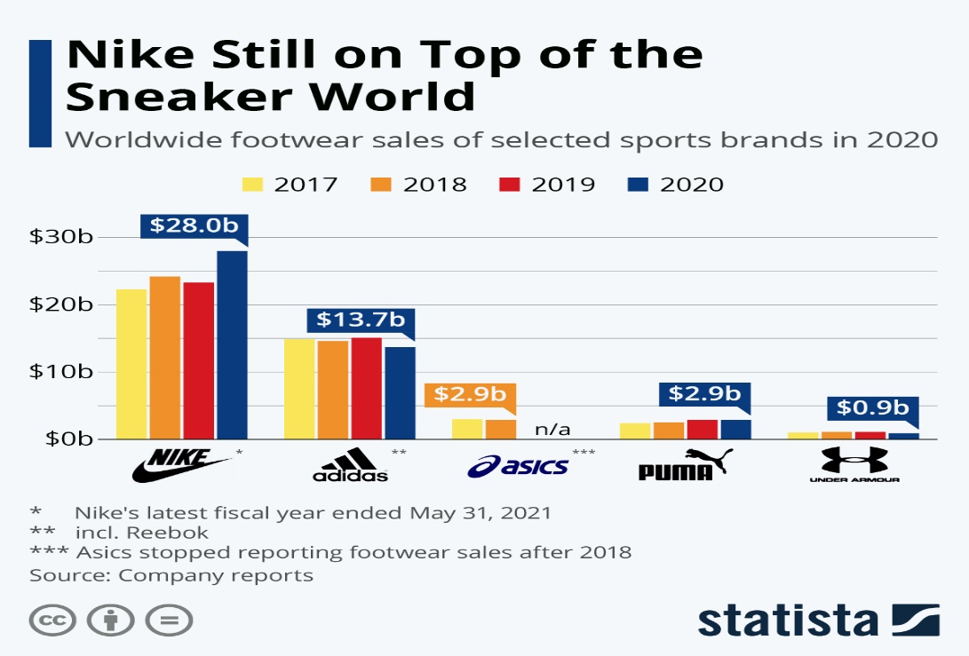
Figure 1 Nikes' competitive advantage

5.0 Marketing Environment and Success Strategy
Nike’s success can be attributed to its marketing strategy. The slogan ‘Just Do It’ has enticed its customers to buy its products. Nike has also partnered with well-known athletes for their celebrity endorsement deals. Kennedy and Wieden came up with the concept for the first commercial while running the New York City marathon..
Nike has made use of six different models, which helps to map out the overall structure of the business. External circumstances such as potential entrants, alternate solution goods or services, trying to negotiate the impact of buyers and suppliers, and competing and animosity among other rivals have been helped by this framework (Анво and Туль 2021).
Since many other companies in the clothing and accessories sector could generate sporting goods if given a chance, Nike has faced a threat from newcomers. Nike has reduced some of its production costs due to new entrants. This has had an impact on prices.
Regulatory requirements and customer loyalty have, even so, reduced the danger. In addition, Nike tries to avoid intense competition from its rivals because doing so could harm its profit margins. Since vital customers can lower product prices and thus increase costs, Nike Inc. views the bargaining power of customers as a threat. The purchasers can buy in large quantities, making a lot of money while the company loses money. The corporation has figured out a way to reduce the negotiating power of its customers by balancing manufacturing and expenses. As a result, Nike can overcome the threat posed by vendors, who can raise the prices of raw materials. Nike has a network of trusted suppliers who alert the company to rising raw material prices before the rest of the industry.

6.0 Drivers to Superior Performance
By fostering open lines of communication, the company makes sure that all levels of management are aware of each other’s contributions. Employee training allows them to develop, grow, and contribute to the company's success. Staff members recognized and rewarded are more likely to perform at their highest level and strive for continuous improvement. Customers can also expect Nike to replace their products if they have a problem with them. Any decision that the manager makes is not subject to management approval.
As a result of the input of employees and customers, the necessities of the latter managed to meet. Clients provide their conditions, and staff members act and start producing items that match the client’s requirements, so institutions' procedures are driven to improve. This advantages everyone involved (Li, 2022). Cooperating with providers is also a critical factor in boosting productivity. Collaborating with suppliers to improve procedures enables the sharing of resources and improvement. Through various communication techniques, open-mindedness and trust are fostered within Nike’s different stakeholder groups. It’s much easier to consider employee suggestions when an interaction is open between all levels of an organization.
Nike’s success has been aided by the company’s ability to foster a culture of creativity and innovation. Changes in organizational framework and involvement in new products have led to this outcome. When it comes to managing its resources, Nike has also taken a proactive approach. The patient’s value is maximized when its characteristics are protected. Nike also uses achievement and performance analysis as a driving force to achieve superior results. It has used an equitable scoring system to track progress toward the company’s goals to track operational efficiencies (Epperson, 2021).

7.0 Strategic Management Tools
Nike, Inc. has employed strategic management to determine how well the company is performing in its current position and how well it should perform in the following years. Management now has significantly improved tools with which to plan out the future course of the firm. Aspects of strategic management that the organization’s leaders employ include perceptions of the organization’s goals and objectives, strategy formulation, strategy implementation, environmental analysis, and strategy evaluation.
The corporation has employed strategic management strategies to understand its current status better and predict its future course of action. A group’s intended destination can be determined using a strategic plan as a guide for supervisors. Stated mission, SMART goals, SWOT, and benchmarking are strategic management tools.
A clear understanding of the organization’s current and future perceptions is made possible through mission and vision statements. To differentiate itself from competing companies like Reebok, the company ponders its unique selling proposition. The company’s strengths, weaknesses, opportunities, and threats (SWOT) have been analyzed.
The company has taken full advantage of its strong points and minimized the effect of weak points through this assistance. Other variables, such as open positions and potential risks, have helped the company make better decisions based on the SWOT analysis results (Kovacevic, 2020). SMART objectives are precise, measurable, assessed attitudes, realistic, and time-bound. For the Nike administration, SMART goals are essential since they have eliminated the feelings of frustration that come from unreasonable expectations. If the set goals are met, the leadership has been exact. In addition to benchmarking, other institutions’ best practices are examined and adapted as needed. As previously stated, management teams have successfully enhanced the company’s performance to achieve its objectives and gain an edge over its competitors.
Project management also uses assessment results, which allow a business to assess a project from beginning to end. It has helped the management determine how much time is left to complete the tasks. Those programs and projects are what Nike relies on to accomplish its goals.
Break the company uses even assessment to determine how many products are being sold to break even and become financially beneficial. Price increases or new product introductions are two ways gamification is used in the marketplace to predict how customers will respond.
Companies can better manage and balance their operating expenses using expenditures, quality audits, and budgetary breakdowns. Management of the organization’s income and spending, and the distribution of resources to various projects and programs, is accomplished through expenditures (Zintsova et al., 2020, p. 398).
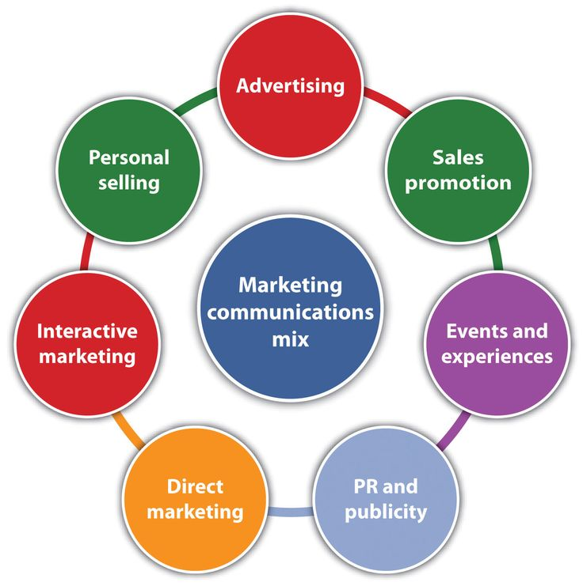
Figure 2 Nikes marketing strategy

8.0 Marketing Strategy and International Markets
Nike uses various tactical management methods, organized into stages that help the company achieve its goals. There are several ways a company can use environmental analysis to collect data from its surrounding environment. This tool will examine the company’s competitors, employees, products, and vendors. The next stage in Nike’s strategic planning process is selecting the right plan from various options to achieve the corporate goals. The managers must set organizational and performance regulations during this phase. Having taken the best approach and putting it into action is strategy implementation. In this step, the company's structure is developed, resources are allocated, employees are hired, and a had hitherto process is developed. As part of strategic planning, the cognitive strategies are evaluated to ensure the best appropriate action is taken if it has diverged from its intended path. The goal of the assessment is to ensure that the company’s objectives are being met (Orosová, 2020).
Since Nike was on the world market, it gained a competitive edge. There is a constant focus on worldwide industry trends and competition by its marketing executives. Due to various advances in communication and transportation, international trade is becoming more commonplace. A wide variety of merchandise is available for Nike’s customers in their countries. Nike initially only exported a small number of its goods, but as it opened up more opportunities, the company moved on to the next stage. There were so many orders from other countries that the company was able to begin exporting its products around the world. Products like Nike’s track and field shoes and clothing line constantly improve. Customers can search out more about the new model on Nike’s online platform (nike.com). Nike has gained new clients who’ve never purchased the firm’s existing offerings by promoting the new product (Li et al., 2018, p. 925).

9.0 Competitive Advantage and Value Creation
Compared to Puma and Reebok, Nike’s products have become very powerful. Even though their goods are sold at a higher cost, clients are willing to pay extra for their products of excellent quality with various styles. Their mystery is brand governance. Nike’s strong brand competitive edge has allowed it to gain market share worldwide. Its prices are much higher than its competing companies, but it has traded more units than its rivals. Nike, Inc. has a significant benefit over the competition in market share. It provides customers with more excellent quality and great goods to accomplish this goal. The company’s value proposition is superior to that of its rivals. When it comes to gaining a competitive edge, Nike relies on Michael Porter’s strategies such as competitive pricing, laser-like focus, and product differentiation.
As a result of this assessment process, Nike, Inc. has a competitive advantage over its competitors. It includes evaluating resources, trying to define clients, and analyzing contenders.
The company’s resource assessment is based on the available resource base and the strategies it has in place to make the best use of them. Setting goals is an essential part of Nike’s strategic planning process. Looking at the goods and services that competing companies do not offer is critical in determining a client’s strategic plan. Nike, Inc. can use this information to better understand and interact with its clients about their requirements and desires and solicit extra info. Competitive analysis can help determine other businesses aiming for a specific market. As a result, Nike can assess how well it stacks up against the competition.
According to Jun (2018), various strategies are employed To gain an advantage over the competition. Differentiation strategy, differentiation strategy, individual distinctions, different points of view, performance distinctions, and technology divergence are some of the techniques applied. As a result of its differentiated products, Nike appears to offer a wide variety of goods.
Nike has also used image distinctions to distinguish itself from its rivals. Having a bad reputation can quickly ruin a company’s reputation. Because the “Nike” brand stands for good and is easily recognizable, Nike engages in a wide range of activities to promote its image. As a result, Nike differentiates itself from the competition by selling high-quality goods. When it comes to determining a product, continuous improvement is a necessity. Procedure advancements lower the cost of production, but competing companies may take some time to figure out how the corporation is gaining an advantage over them. Because Nike’s competitive edge is short-lived, the company works hard to maintain it. They are giving consumers value, creating non-copyable products, and producing products that clients can’t easily replace; all contribute to the firm’s survival. Given its knowledge of customers' needs, Nike, Inc. can choose a competitive edge that other companies can’t easily replicate. In the eyes of the business, the distinction is not the same as a wide range. Because of Nike’s attempts and techniques, the company has worked hard to maintain its strategic advantage. It’s been up against a lot of competition since other businesses have wanted to imitate its benefits in the changing marketplace. As a result, creating and maintaining a market advantage is critical.
According to Jun (2018), creating value for the customer is something Nike has done in many aspects. In the company, client incentive plans are a fantastic success. Nike gives away tickets, sales, sponsorships, and discounts to its customers. A wide variety of athletes benefit from Nike’s subsidies. Roger Federer and James Blake are two examples of athletes who have significantly helped from sponsorship deals. Additionally, it endorsed the Indian cricketers and nationwide soccer teams in countries like India, Netherlands, and Malaysia for a five-year time frame. Nike has sponsored many top golfers, including Tiger Woods and Lucas Glover.
With over a hundred companies, Nike still uses conventional and non-traditional ways of distributing its products. As a result of global economic crises and other risks, Nike has differentiated its distribution network and industrial production. In addition to Thailand and Vietnam, it has many contractual distributors in other countries. In over 35 countries, other construction companies have started manufacturing the company’s products (Liu et al., 2021, p. 440).

10.0 Future Prospects
To put it another way, Nike has set a five-year goal of reaching $50 billion in sales by 2020, which would entail an increase of roughly $20 billion in revenue. Nike’s ambitions were questioned by some who argued that it had taken 13 years to add $20 million in sales the last time around. E-commerce, women’s clothing, and Jordan goods were all part of the strategy. Nike’s revenues are affected by four factors:
Growth in the digital world: Nike’s Digital Group has played a significant role in the company’s revenue growth. NIKE and SNKRS are two of the primary reasons for this increase in sales volume. Nike Inc. achieved its third goal, selling 300 times per second on average, by managing purchases of Jordans, which brings us back to their first two goals. On the other hand, the Nike App increased sales by 40%. To put it another way, Nike is making an effort to broaden its innovation infrastructure. Nike is gaining a foothold in this market by concentrating on women's empowerment. Nike Inc.’s earnings have risen due to increased sales of female wear.
Taking advantage of the opportunity in China: China’s fitness industry has only recently started to develop. It is already the world’s most prominent business in terms of apparel and footwear. Nike recently endorsed several Chinese activities, including the Shanghai Marathon and the China Premier League, indicating that they are beginning to see opportunities for expansion in China. Continuing to work with the Various Sports ministries, they are heavily promoting the inclusion of sporting events in school systems.
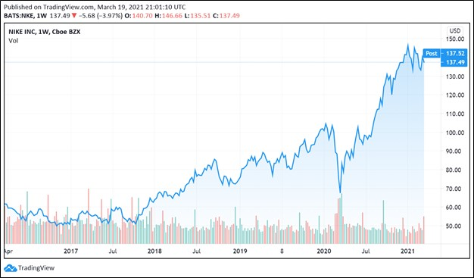
Figure 3 Nikes digital marketing strategy

11.0 Business Model Canvas

11.1 Key Partners
Nike is a global corporation with many critical collaborators from all over the globe. One of Nike’s key stakeholders is the company’s content supplier and factory. For industrial production, they employ contract workers. There are approximately 150 Nike Shoes industries in Vietnam, India, and China; there are also about 400 Nike Garments industries in China, Russia's former Soviet Union countries, and the Democratic People’s Republic of Korea. EA Sports’ playing games division and Apple, which distributes Nike apps on the Google play store, are both critical stakeholders for Nike. To help its customers get more out of their workouts, Nike has teamed up with strength and conditioning equipment manufacturers TomTom, Wahoo and Garmin. Nike has also partnered with several sports players, including Rory Mcilroy and Michael Jordan, and several other athletes’ organizations.

11.2 Key Resources
Nike’s primary resources are its human and physical ones. Nike’s distribution network stretches to around 50 nations, with approximately 800 industrial facilities and about one million employees worldwide. Nike is among the best sports companies. Approximately 65,000 Nike staff members are enrolled in a curriculum designed to help them become more aware of the company and its values. Staff members at Nike enjoy a high level of well-being. Patent rights are an essential intellectual source of information for Nike, making annual investments to ensure that it has the exclusive option to market modern technology. Using Nike’s company information, the company sees an opportunity to ascertain the next step in their luxury brand. Shareholders provide such a large portion of Nike’s monetary backing because the company is publicly traded. This demonstrates that the more significant market has a concept of Nike’s business practices.

11.3 Key Activities
Advertising, brand recognition, and advancement are Nike’s primary activities. Nike’s advertising aims to sell more than just shoes and apparel; it promotes an entire way of life. As one of its goals, Nike’s brand management has the promotion of this way of life. It uses the Heroic actions brand marketing method to entice customers worldwide to buy its products. When the hero is allowed to take on an enemy that is more powerful than him, he rises to the occasion.
Along with the well-known tagline, “Just do it.” Everybody can come up with their interpretation of it because it attaches ubiquitously. For the brand and its fans, it establishes a connection. We now hear this expression regularly.

11.4 Value Propositions
The most successful athletic label in the world is Nike. Not just for its coherent product quality and distribution network, but because of Nike’s capacity to assist people in recognizing the benefits of Sports shoes in their lifestyles. Nike’s clients can choose from a wide variety of footwear and apparel choices, including Hurley Worldwide and Converse, combining innovation, customization, and a strong product sense. This focus on advancement was a significant part of Nike’s strategy. The Nike Discover Sports Team and the Nike Accelerated Design And production Center stay focused on product and process design and technological integration. Clients can also customize their Nike products with Nike ID, which allows them to choose the colour schemes, sporting events fashion, and even type someone on the sock. Nike has built a strong product because it has won numerous awards, such as Worlds largest Most Inventive Corporation.

11.5 Customer Relationships
Designed to help users keep tabs on their performance, Nike Digital Sport was introduced by the brand in 2010. Nike gathered and analyzed data on consumer needs and patterns. Nike can freely and successfully communicate with the customers' thanks to NDS. Aside from Nike+, the company has its online platform, Nike+ Interpersonal, which aims to build social media networks among individuals and society. Recognizing the wants and needs of Nike’s clients has allowed the company to develop relationships with them. Store staff are offered unique training to assist the client in learning more about Sports shoes, and this is how the relationships between a business with its clients. In addition, there are commonly asked questions answered on the firm’s site. Individual aid is provided via e-mail, phone, and chat support.

11.6 Customer Segments
Nike’s business plan is geared toward the masses. An athletic footwear and apparel firm is seeking to appeal to a broad audience. While most of Nike’s clients are 18 and 40, the company also caters to younger customers by offering athletic footwear and clothing, particularly soccer cleats. Sports enthusiasts and folks who want to improve their performance and efficiency are Nike’s most loyal customers. Nike’s clients can be characterized as people who have a lot of money and are interested in purchasing new athletic goods. Nike’s primary market is the United States. Nike’s retail locations represent approximately 190 countries in the world.

12.0 Stakeholder Analysis
Stakeholders are the people who have a stake in the business in a specific manner. Nike CSR’s efforts protect stakeholders. Given that Nike is a global corporation, many different parties have a say in how well the company does financially. Nike’s Current strategy has a hierarchy of importance, with clients at the top of the list. The sales of shoes, clothing and sporting goods directly impact the company’s bottom line. Nike offers elevated goods that take advantage of the latest technological advancements. As part of the Innovation fund, Nike also helps build local communities. All of Nike’s product lines are made with the help of the company’s employees, who are therefore considered a stakeholder group. As a result, Nike employees enjoy several benefits, including compensation and career advancement. A group of stakeholders that includes the government is also formed. Government agencies have an impact on the legal operations of a business (Riwayadi et al.,2021).

13.0 Culture of The Organization
Like other companies with “cool cultures” such as Apple, Google, Amazon and Facebook, Nike has a “cool” culture. People are drawn to this culture because it gives them a sense of “tribal belonging” and a “purpose.” Nike’s slogan is “We've got the best-kept secrets." There is something to be protected at Nike. Because of this, Parker is working toward a time when all Nike employees will be treated equally and respectfully, with no form of bias whatsoever.

14.0 SWOT and PESTEL analysis of Nike

14.1 PESTEL

14.1.2 Factors of Politics
Since Nike's headquarters are in the United States, they benefit significantly from low rates and well-coordinated global tax arrangements. However, given Nike's global reach, barter and shipping arrangements will be impacted if there are political problems. Nike, for instance, will not be able to keep its accord with the Iranian soccer team as a result of US sanctions against Iran, which will have a detrimental effect on the Iranian product. In addition, there's a chance that the company will run into issues with the authorities.

14.1.2 Economic Factors
Nike's business is most at risk right now from a global economic downturn, resulting in higher labour costs or more costly natural resources in countries like the United States and Asia, in which the business sources its goods. And Nike's concentration on developing nations like China is a boon to the Chinese economy because it opens up new possibilities for them at a lower price tag.

14.1.3 Social Factors
Products manufactured by Nike have a high "healthy lifestyle" due to their focus on sports players' wellbeing. Nike Experiment scientists are constantly working to improve their products to make them safer and more quickly recoverable for athletes. Sadly, Nike's employment environment is frequently criticized. There was even a Wikipedia page devoted solely to Nike Inc's treatment of their employees in the sweatshop conditions in Asia and that they have low-cost labor because of social networks.

14.1.4 Technological Factors
Nike has a well-deserved reputation as a trailblazing brand. Nike has a technological innovation research lab staffed by scientists with Ph. D.s or Masters’ degrees. One shoe innovation takes them a long time, and they conduct all of their exams on top athletes. Nike also has a strong presence on social media. Athletes are wearing their products on the internet, drawing in potential subscribers. Instagram accounts for every sport, with 86.2 million followers on the original version.

14.1.5 Environmental Factors
Nike's widespread manufacturers pollute the air and sometimes even the rivers around the production plant, causing significant environmental harm.

14.1.6 Legal Factors
Because Nike does business in a wide range of countries, it has to deal with various rules and regs. When it comes to exporting and importing, each nation has its limitations because of how those who treat their staff and cheap labour, Nike has a lot of problems with the Asian authorities. They had to deal with many speculations in Vietnam because of child workers' unlawful and immoral use. According to numerous rumors, Nike has also been accused of evading large amounts in taxes, mainly in developing nations.

14.2 SWOT

14.2.1 Strengths
Dominating position in the market with a strong portfolio
Without a moment's delay, Nike is one of the world's largest providers of shoes for sportspeople. In 2016, Nike was ranked as one of the 30 most valuable brands in the United States, with a share of 45 per cent. As a result of the strength of their brands, such As Nike, Jordan, Converse, and Hurley, they hold the top place in the market. The converse is more like a streetwear product, whereas Jordan is more of a basketball-specific line of athletic wear for the athletes themselves.
Focus on research and development activities
To remain at the top of the industry, Nike relies on technology innovation to provide athletes with greater comfort while mitigating risk and decreasing the possibility of injury. Coaching staff, tutors, and sportspeople are among the experts on athletes they discuss when developing new products.

14.2.2 Weaknesses
Too much reliance on outside contract machiners
All of Nike's cloth purchases are made outside the U. S. As a result, they have limited control over the quality of their products, including Asia, India, and Vietnam manufacturers. It implies that if the manufacturers make mistakes, they'll have to hire more quality assurance staff to deal with it.

14.2.3 Opportunities
The global footwear market is expanding
Over the last few years, the revenues generated by the shoe industry have grown massively. The revenue rose by 4.8% between 2010 and 2014, and the same source predicts a rise of 19.9% between 2014 and 2019. Because of its excellent brand investment, the business is well-positioned to capitalize on the growing demand for shoes.

It's a two-pronged strategy
Many people prefer online shopping to a brick-and-mortar location. It can be seen in the fact that the amount of money being spent on online stores by US citizens has been rising steadily over the last few years. Similar patterns have been observed in Europe as well. Nike's online shops, www.nike.com and www.converse.com, can help them take advantage of this to increase their market sales (Behounek, 2020).

14.2.4 Threats
Counterfeit Goods Are Getting More Popular
The unauthorized production or sale of counterfeit goods under another brand is prohibited. There will, without hesitation, be negative consequences to the rise in internet usage. It played a role in the global spread of phoney goods. Copyright convulsions in the U. S. are increasing at around 25% per year, indicating the rapid influx of counterfeit goods into the industry.
Attacking the Rivals
As among the most competitive fields in the U.S and the world, Nike is a major player. Adidas and PUMA are two of the strongest competitors. Because of this, Nike is required to keep coming up with new and better ways to stay on top.

16.0 Conclusion
Competitive positioning and value creation have been the primary means Nike; Inc. has excelled. To do this, the company relied on advertising and brand awareness, product innovation, and a relentless focus on staying on top of the competition. Nike uses a wide range of tactics and strategies, including strategy formulation models and tools, product diversification, and appropriate distribution channels. Swoosh Logo and Just Do It has made their items instantly recognizable to many people. Because of their high-quality products and distinctive marketing techniques, they have been able to keep their clients.

15.0 Recommendations
Nike possesses a great brand image and a high level of functioning. The fact that they are implementing an asset vision strategy is significantly assisting them in increasing their skills. Nike has its flaws like every good organization, and Nike is no exception. Here are a few suggestions for Nike's long-term viability:
- The employment environment at Nike must be improved because they reflect poorly on the company's brand. Nike also should consider their business social duty in terms of environmental protection and safety for the individuals who live in the surrounding area when it comes to their businesses.
- Nike must eliminate any content that could be considered controversial to avoid any political or societal concerns about their commercials. Nike is doing an excellent job and appears to be on the path to the results of this case.

References

Анво, О.О. and Туль, С.І., 2021. The competitive strategy of «Nike, Inc.» in the global sportswear market.
Behounek, H., 2020. ASSESSING SUSTAINABILITY ACTIVITIES IN SPORT-RELATED SOFTWARE START-UPS–AN APPLICATION OF THE TRIPLE-LAYERED BUSINESS MODEL CANVAS.
Li, H., 2022, April. Research on How Products and Marketing Strategy Affects the Market Shares of Nike and Adidas. In 2022 International Conference on Creative Industry and Knowledge Economy (CIKE 2022) (pp. 197-202). Atlantis Press.
Dupree, A.R., 2020. The Impact of Nike Inc.’s Utilization of Sustainable Business Practices in Their Marketing Strategy on Brand Equity, Brand Image and Brand Loyalty (Doctoral dissertation).
Orosová, S., 2020. Social Media Marketing Strategies of Nike in Different Parts of the World-Dubai, Hong Kong, and New York.
Kolačević, T., 2020. Strateški menadžment na primjeru poduzeća Nike (Doctoral dissertation, VERN University of Applied Sciences).
Hoffman, A.N., Gold, N. and Curtin, C., 2019. Nike, Inc.: Late Arrival to the “Athleisure-wear” Trend. Rotterdam School of Management, Erasmus University. (Hoffman et al., 2019)
Kiseleva, M.A., Vasilev, K.V., Protopopova, P.A., Inin, A.A. and Evtodev, M.D., 2021. NIKE SHOE REDESIGN. In СТУДЕНЧЕСКИЙ НАУЧНЫЙ ФОРУМ 2021 (pp. 48-51).
Riwayadi, E., Deliabilda, S.A. and Panahatan, M.B., 2021, August. PESTLE ANALYSIS OF FINANCIAL TECHNOLOGY IN INDONESIA. In International Conference on Innovations in Social Sciences Education and Engineering (ICOISSEE) (Vol. 1, No. 1).
Shtal, T.V., BURIAK, M.M., AMIRBEKULY, Y., UKUBASSOVA, G.S., KASKIN, T.T. and TOIBOLDINOVA, Z.G., 2018. Methods of analysis of the external environment of business activities. Revista Espacios, 39(12).
Zintsova, M.V., Vovk, D.I. and Guriev, S.A., 2020. MARKETING THE PREMIER LEAGUE BRAND: FEATURES AND FUTURE PROSPECTS. In Современные проблемы управления внешнеэкономической деятельностью (pp. 395-403).
NEUMANN, K., 2020. Stakeholder Value Creation and Capturing–Theoretical Perspectives (Doctoral dissertation, The University of Innsbruck). (NEUMANN, 2020)
Epperson, J., 2021. Creating Optimized Value Creation Conditions: An Additive Manufacturing Model (Doctoral dissertation, Massachusetts Institute of Technology).
Li, Y., Ye, F., Sheu, C. and Yang, Q., 2018. Linking green market orientation and performance: Antecedents and processes. Journal of Cleaner Production, 192, pp.924-931.
Jun, F., 2018. Study of Relationship Between Liquidity Risk (Quick Ratio) and Internal and External Factors in NIKE Company. Available at SSRN 3301113.
Liu, X., Ma, L. and Zhou, Y., 2021, September. Supply Chain Management of Nike. In 2021 International Conference on E-Commerce and E-Management (ICECEM) (pp. 437-441). IEEE.

