

LEVEL 7 ASSESSMENT SPECIFICATION

Student name: | Lawrence Qin | Student ID number: | 2031014
Programme: | MBA
Module: | Marketing Management
Module code: | HKBM 7012 | Contribution to Overall Module Assessment (%): | 75%
Lecturer: | Dr. Arion WONG | Internal Verifier: | Dr. Katherine Mo
Assignment Title: | Report | Word count (or equivalent): | 3000 words
Submission deadline: | 12 July 2021 | Return date of provisional marks & written feedback: | Within 20 days after submission
Submission method: | All written assessments, where practical and possible, must be submitted via Turnitin unless otherwise instructed by the Lecturer. (Please DO NOT put this assessment specification into Turnitin or it will match many similarities with other students’ submissions.)  Alternative submission method (if applicable):  Late submission of the assessment will result in a late penalty mark. Penalties for late submission: Up to one week late, maximum mark of 50%. Over one week late, 0%. Only the Extenuating Circumstances Panel may approve a change to submission dates.
Academic honesty / referencing: | Academic honesty is required. In the main body of your submission you must give credit to authors on whose research and ideas your work is based. Append to your submission a reference list that indicates the books, articles, etc. that you have used, cited or quoted in order to complete this assessment.

Where the Future Holds for Virtual Banks in Prospect Segmentation, Technology and Marketing Mix:
A View into Mox Bank Marketing Strategy

Executive Summary

This report begins to assess how financial technology is adopted in today’s banking industry, and its disruptive force has brought a positive impact on daily banking life and behavior in Hong Kong. It then focuses on Mox, one of the first 3 early adopters of virtual bank licenses from Hong Kong Monetary Authority (HKMA), of its current marketing strategy in comparisons with Mox’s 7 competitors. In turn, to identify what Mox could improve in elevating its competitive advantage among the market contenders and be unbeaten in its future strategy and growth.

Mox was debuted uniquely through a joint force of an international bank, a leading city telecommunication firm (HKT) and a pioneer in online travel (Ctrip). It started its marketing incubation in late 2019 and fully launched its service in Q3 2020.

With the interest of studying its current marketing strategies and plans, this research will embrace a mixed methodology to explore with both readily available qualitative and quantitative data through market literature reviews and contrasts. The existing environment and challenges of Mox are assessed, its segmentation and positioning strategies are studied, and Mox’s current marketing mix is also carefully analyzed.

Based on the above data analysis, it logically aids Mox to determine what its future market development holds within its existing organization in terms of marketing mix, targeted technology assumption, as well as segmentation enhancements; from where Mox’s forthcoming opportunities sit. The study thus recommends Mox to utilize an Ansoff matrix approach and explore its future marketing acquisition framework in a combination of market and product mixes to increase its market growth and shares.

If all these recommendations could be absorbed successfully in its future marketing operations, it should well become a solid foundation for Mox’s formulation to compete with opponents fruitfully in product positioning, rate tactics as well as improved target segmentation in aged population with matching technology platform.

Table of Contents
- Introduction 5
  - Industrial Environment 5
  - Company Background 5
  - Research Scope 6
  - Research Question 6
  - Research Objectives 6
- Situation Analysis 7
  - Macroenvironment 7
  - Microenvironment 9
  - SWOT 11
- Segmentation, Targeting and Positioning 12
  - Segmentation Strategy 12
  - Targeting Strategy 12
  - Positioning Strategy 12
- Marketing Mix Strategy 14
  - Product 14
  - Price 15
  - Promotion 15
- Findings and Recommendation 17
  - Findings 17
  - Future Marketing Plan 17
  - Organizational Impact 18
  - Technology Disruption 18
  - Proposed Growth Strategy 19
- Conclusion 22
Academic Reference 23
Bibliography 25
Appendix 29

1. Introduction
The difference between internet banking and virtual banks, where virtual banks fulfill most of the banking needs from account opening, borrowing, debit & credit cards to even insurance, solely online without the necessity of any brick-and-mortar locations.

1.1 Industrial Environment
Today, 8 virtual bank licenses were granted by HKMA: Mox, Livi, ZA, Ant, WeLab, Airstar, Fusion and PingAn. The Fintech incubation started in late 2017 announced by HKMA CEO Norman Chan and was only materialized in late 2019 (Bray and You, 2019). Since its debut, the competition among virtual banks had been fierce and stern, from a conventional mass media to a coherent technological push in various online social medias: frequently along with its revamped product features and promotional incentives.

Nevertheless, the achievements so far are still dreadfully partial among eight virtual banks combining of 420,000 customers and HKD 15 billion of deposits since its launches (Yiu, 2021). Yet, the ‘loss before tax’ in Figure 1.1-1 from the virtual banks are urgently needed a recovery to post potential profits in 2021.
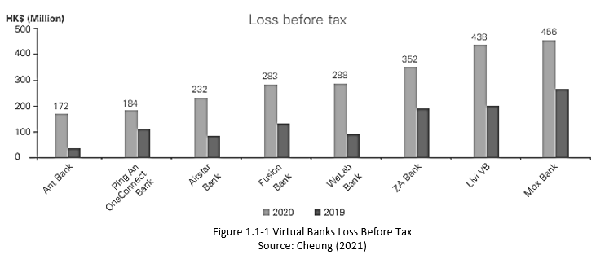

In comparison, the retail size of conventional banks in Hong Kong is about HKD 373.9 billion with top 4 banks including Standard Chartered take 62% of total deposits and 54% of total lending markets (Quinlan & Associates, 2021).

1.2 Company Background
To compete with traditional banks, fintech in this case, as Romanova and Kudinska (2016) predicted this specific technology has helped nonfinancial institutions to become also more competitive in financial services; thus changing the banking landscape and eagerness for innovation to compete further in its consumer models. Mox matches perfectly in this scenario, a virtual spinoff from a conventional international banking group: Standard Chartered Bank, along with its other financial investors in a totally different business sector and industry: namely telecommunication and travel (Standard Chartered, 2020). Received its virtual bank license in March 2019, Mox was not officially launched until September 2020 (China Banking News, 2020).

1.3 Research Scope
With its novelty in mind, this report intends to evaluate, based on publicly available data, several key areas of Mox’s marketing plan and how these core marketing strategy components could be further developed as ‘…emerging activities that should provide new sources of profit’ (Johnson et al, 2018). As a result of these findings, further recommendations to clearly devise a future plan in these mission critical domains.

1.4 Research Question
Here a question of how Mox could further fences its marketing competitive advantage among market contenders, with sound market segmentation and mix will stream through the whole article.

1.5 Research Objectives
A list of objectives to be achieved at the end is also listed here to guide the vibe of the flows below.
- To identify future customer segmentation Mox could target in order to gain further advantage from
- To identify improvements on marketing mix that Mox should further foster
- To gauge technology and relationship management that Mox can adopt to secure its customer base

2. Situation Analysis

Virtual banks had a slow start due to looming economy and pandemic fears, nevertheless the competition has grown intensely and sternly in recent days, since all competitors are eager to capture market while most of them launched relatively in a close proximity of 2021. It also faces the competition from 160 strong traditional banks, of which are also gearing up for its online banking capabilities.

2.1 Macroenvironment
Du and Kim (2021) stated that new ventures could see a collection of external competitive challenges while business search for high returns, which requires a more adaptive strategy to best align with the intricate external situations it faces.

Ongoing COVID-19 pandemic obviously introduces a level of stimulus and benefits for virtual banks’ success, where people increasingly treat online banking as a new norm and ecommerce as a daily routine for even necessity goods in Figure 2.1-1, to avoid crowds and physical contacts.
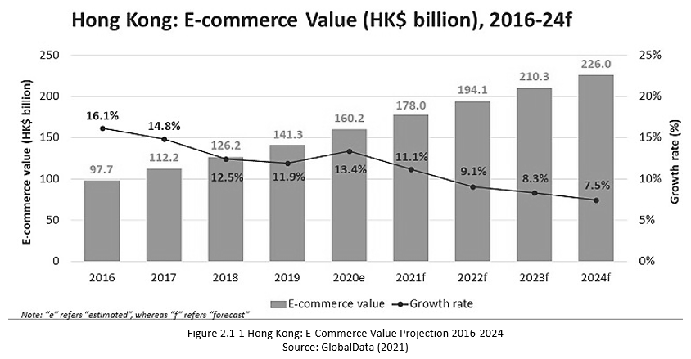

While most of the virtual banks began by design targeting the young and technologically affluent customers, a bank in this new technological era should never forget about the successful mature generation and their socioeconomic needs and wants. Based on the government statistics shown in Figure 2.1-2, this aging group is growing naturally by 4% in 5 years. Any visionary firm should look ahead and be ready for this customer segment that the majority is today’s mainstream workforce and technologically savvy. Through a detail modeling and study done by Smith (2008), he concluded that seniors’ desire in using digital ecommerce is highly motivated by their perceived needs and wants, regardless the level of complexity of a particular platform.
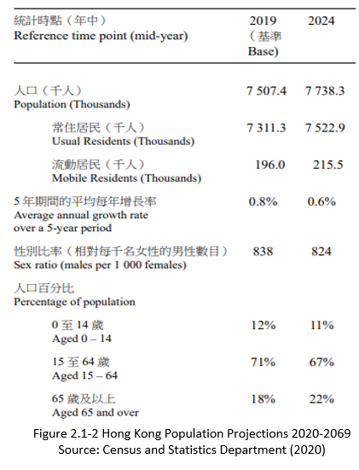

The obvious threats to Mox are also real. Intensified business wars, showing in Table 2.1-1, for market shares among the virtual banks is clear, along with increased battles with its traditional brick-and-mortar “ancestors” who are hungry to fence customer bases with new technology enhancements in Figure 2.1-3.
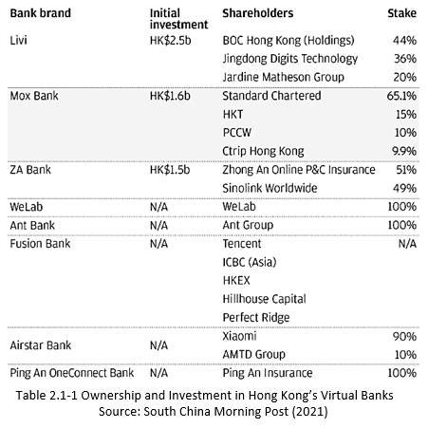
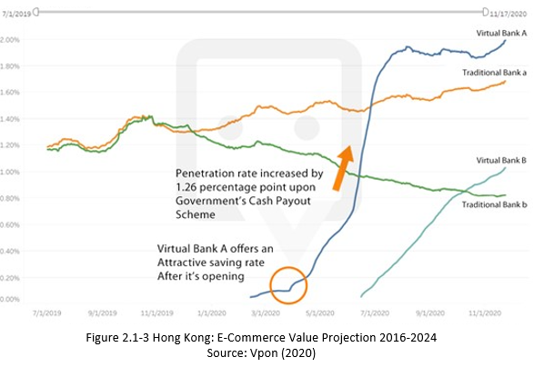
The alarming and hesitant future economy is also overcasting the luck of virtual bank’s destiny in Figure 2.1-4 and 2.1-5.
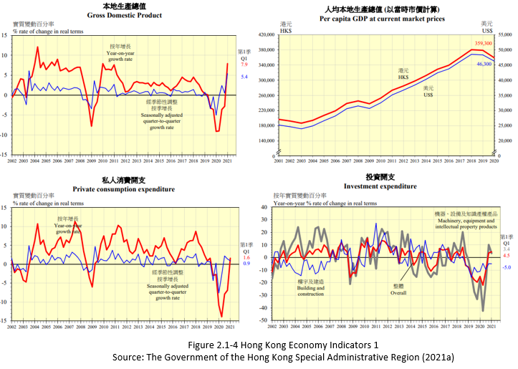
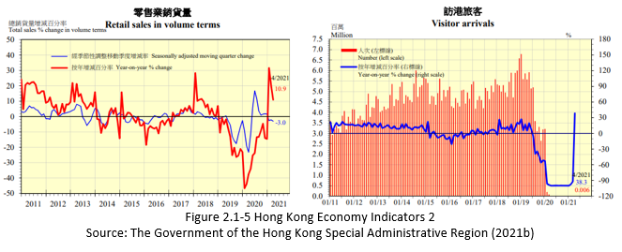

Furthermore, being virtual, it also introduces great challenges in customer trust and service availability, of which incumbent banks too are fighting for survival today.

2.2 Microenvironment
Dr. Lamarque (2000) suggested ‘value chain’ developed for heavy industry was also invaluable for financial and banking industries to produce competitive advantages. In Figure 2.2-1, primary and support activities for Mox bank are highlighted for further discussions.

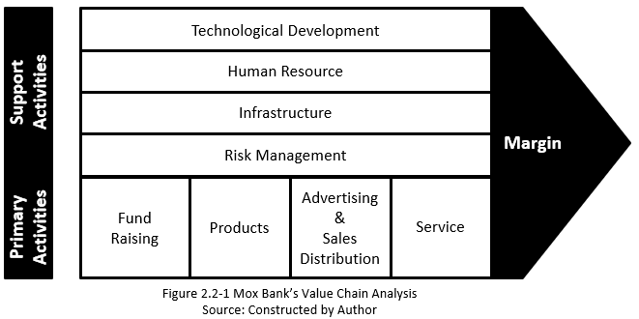

Fund Raising:
Mox bank has backing from Standard Chartered bank, also two giant corporate investors. Still, refer to Table 2.1-1, the size of Standard Chartered’s investment is somewhat limited so the volume of its customer base among the top 4 conventional banks.
By going all virtual, the cost savings on physical locations could regenerate as part of the product tactics to attract customers and compete with other contenders.
Products:
Mox shall not underestimate its competitors’ financial products, where Mox is still purely focusing on retail consumers, letting alone narrower scope in savings account and credit card only.
Advertising & Sales Distribution:
With the volume of existing customer bases from 3 investors, of which most of these clients are already digital and familiar with online technologies. Once a cross selling strategy is articulated, the opportunity is beyond imagination if the target market is chosen correctly.
Service:
The lack of live agents to answer calls is yet a challenge for Mox.

Technological Development & Infrastructure:
Mox has chosen top notch cloud native banking engines: ThoughtMachine and Paymentology to handle its product development and payment processing respectively. It also partners with Oracle in ERP enhancement adopting state-of-the-art Netsuite for business management, plus FICO a leading US credit risk management firm to innovate its credit vehicle. All these instruments have provided Mox a definitive edge in technology to advance a smoother sailing in digital banking experience (Mox Bank, 2019).
Human Resource:
In the sense of talent acquisition, Mox has been working closely with the group company and devoted to acquiring the best people around the globe. Mox CEO, Deniz Guven explained, it started with only 10 to work around clocking building the bank, but by the end of 2019 it had 100 strong with 60% local talents and the rest 40% from all over the world (Mox Bank, 2019).
Risk Management:
While heavily relying on technology, Mox’s emphasize on cyber security is inevitable. At the same time, it starts to think hard on market and business risk controls with the group company (efinancialcareers, 2021).

2.3 SWOT
In the context of Mox, a unique SWOT chart could certainly help to summarize and understand the strength, weakness, opportunities, and threats currently facing in Table 2.3-1 below.
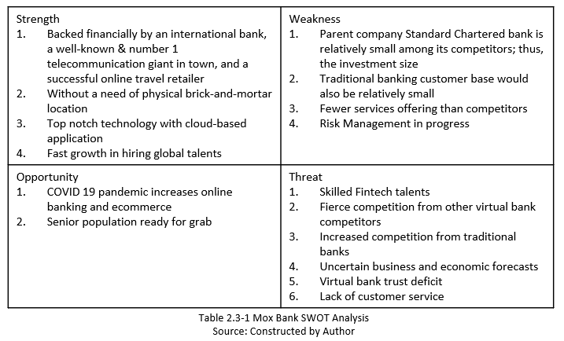

3. Segmentation, Targeting and Positioning

Camilleri (2018) stated that business has a challenge to satisfy all customers at same time; so, the company must choose unique and potential customer base identified to serve the best. Therefore, Mox ought to explore on market segments where specific target group(s) could be profitable for the bank and execute a marketing mix to position itself for these clients. Noticeably, this is also a typical BCG portfolio move to search for its star, showing in Figure 3-1.
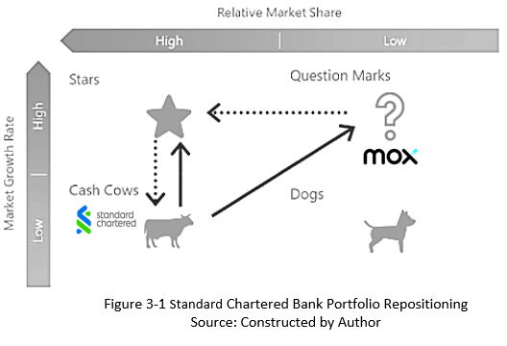

3.1 Segmentation Strategy
Virtual bank today is evidently only segmenting its client base by age as well as technology efficiency, but weights more on the age side of the young. Nevertheless, research has shown visionary institutions are putting extra efforts these days in education preparation to diffuse latent segment of the elderlies (Villarejo-Ramos, Peral-Peral and Arenas-Gaitan, 2019).

3.2 Target Strategy
Standard Chartered Bank Group CEO, Bill Winters, expressed last year that the virtual bank spinoff could help the traditional bank to generate group market share but only targeting the young and the technology savvy population in this sense (Yiu, 2020). Namely, Generation Z and Millennial who are not afraid of venturing digitally and certain population who had some experience in fintech.

3.3 Positioning Strategy
Mox’s marketing positioning of product is still slightly imperfect today, in comparison with major competitor: ZA bank. Mox only focuses on simple savings and debit card features. The addition of credit card function came just recently but is still far from the ideal coverage of client focus today.

Bray and Yiu (2021) reported in April that Mox has acquired just over 100,000 customers in a short of eight months since it was officially launched in 2020. But is shy away from the 300,000-mark ZA Bank made in March this year. Both banks take an 86% current market share, while Mox’s CEO ambitiously to expect a double of customer base in 2021. Figure 3.3-1 illustrates the current position of Mox and unmistakably its major rival: ZA Bank.
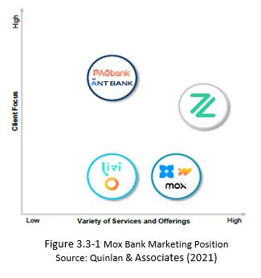

4. Marketing Mix Strategy

Being still niche and novel in fintech market, this paper would only look Mox at the relevant marketing mix currently dominates its key user features – product, pricing, and promotion. This is exactly what Londhe (2014) mentioned that Dr. Bob Lauterborn emphasized through niche market analysis in understanding clearly consumer wants and matching marketing mix.

4.1 Product
As mentioned previously and demonstrated below in Table 4.1-1, Mox bank has not been able to differentiate itself outstandingly among competitors, other than having a budget tool and a recent credit card offer. Mox still cannot have absolute competitiveness above the others, letting alone the above average revenue, which proves growth-stage firms need to differentiate its competitors through product diffusion (Shankar, Carpenter and Krishnamurthi, 1999).
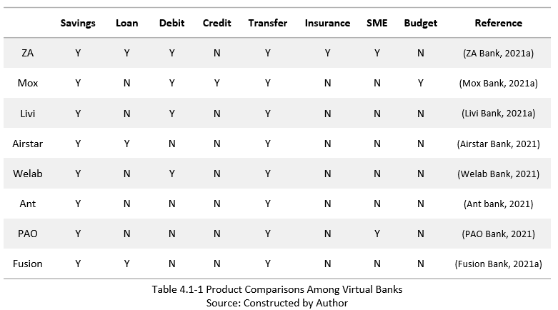

Kuncoro and Suriani (2018) had explained distinctly the concept of sustainable competitive advantage and a firm’s product is production innovation and product education through market driving, which are the effective keys in the process of building this competitiveness and limiting its competitor to imitate.

Mox has a very sound customer service platform by design, adopting a neat chatbot for live communication as well as a phone service pre-prescribed specific customer inquiry to the right queue. The challenge is the poor call pickup rate.

The Mox app itself is quite ‘cumbersome’ to use. Even with someone who’s highly savvy with mobile wallets, it still takes quite some time to get familiarized with the UI, plus a struggle to locate needed features. An Agile approach in software release sprints sometimes made it even worse to have features being reshuffled around, introducing another wave of learning curve.

4.2 Pricing
In the sense of pricing for banks, its deposit and spending rebate rates would be everyone’s interest to exam. Table 4.2-1 captures various current rates.
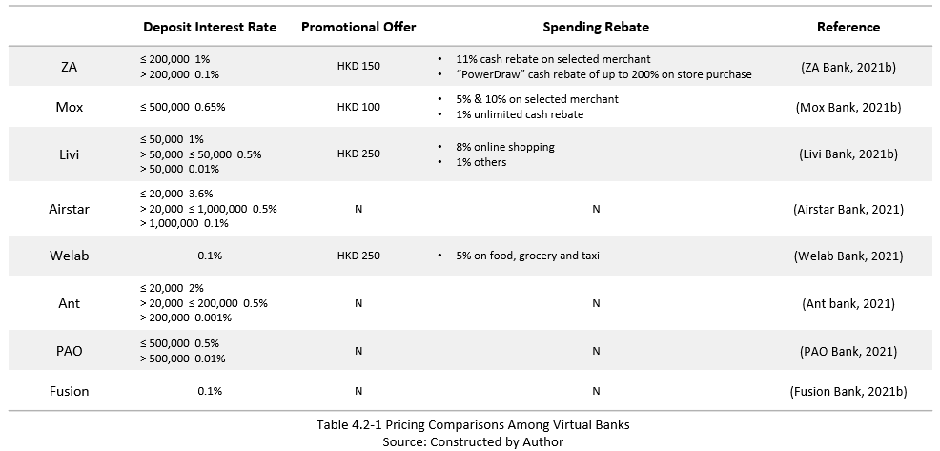
Mox’s pricing strategy is competitive but could be improved to further attract customers. Melser (2006) concluded through an in-depth research that a high-tech product usually appears to be discounted in the introduction stage of its life cycle and then endures a further reduction in price to penetrate market shares. In the sense of bank rates, this is exactly Mox needs to explore.

4.3 Promotion
A promotional mix perspective is being examined here.

Advertising:
Being part of the fintech DNA, it’s not surprised that the virtual banks, on top of what is being done traditionally in promotion, would go all out on digital: Facebook, Instagram, MeWe and WeChat are the arenas to battle for target audience. Mox has about 8,850 likes, ZA about 8,100, with the others tailing at around 6,000 or less on Facebook for example (Facebook, 2021). In comparison with its actual customers, the ratio is still relatively low.

Some of them also use celebrities to boost campaigns with recent senior idols (see Appendix). Mox invited Johnnie To spicing the new credit card campaign, while at initial launch it was all ‘funky’ with celebrity dancer Haruna Kunisawa. Livi Bank stared opera singer Law Kar-Ying.

Table 4.3-1 is a summary of promotion channels each virtual bank is utilizing today.
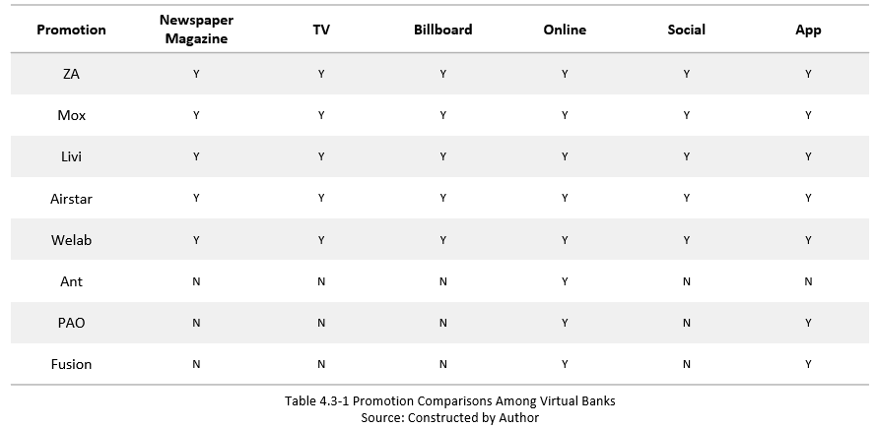
Sales Promotion:
Various sales promotional offers were mentioned in Table 4.2-1.

Personal Selling:
Most of virtual banks also employ its bank app to launch personal referral programs with unique promotional codes to track the campaign statistics.

Public Relations
Mox took advantage of Standard Chartered Hong Kong Marathon ‘Together VRun’ to inspire its virtual image (Yuen, 2021).

In summary, Table 4.3-2 recaps Mox’s blend.
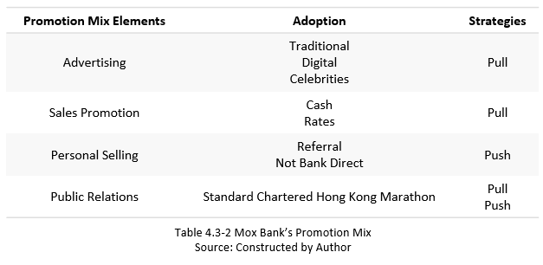
5. Findings and Recommendation

Enacted market today is changing fast, but this sometimes is also an indication that an organization was not well primed rather in a rush to the existing mandate. Downs, Durant and Carr (2003) argued that an organization needs to acknowledge the existence of uncertainty and a clear willingness to address it constantly and simultaneously.

5.1 Findings
The virtual banks are still in a ferocious contest to battle for market shares and improvements at infant stage. Mox has advantage technologically and commitment in talents, plus a positive economic predicament. However, Mox needs to accept its deficiency reality in client focus, product varieties, and service – a gap between its number one rivalry, while the others are catching up.

Low fertility rate and an aging population have always been the challenge for Hong Kong.

As such, The Asset (2021) also suggests virtual banks to make a difference in offering competitive rates, launching new products and services such as loans and credit facilities, and eventually wealth management for a wider variety of consumers, according to Johnson (2018) that these ‘emerging activities that should provide new sources of profit.’ Technology, segmentation, and marketing mix particulars are the key areas to be developed.

5.2 Future Marketing Plan
As politically it has been stable since late 2019 and various achievements in fighting the pandemic, all is hopeful to see a steady and gradual recovery. Local Financial Secretary (2021) has predicted a per annum 3.3% economic growth from 2022 to 2025.

In Figure 2.1-2 previously, it’s easily to project a 2.8% growth of overall population by late 2024, where the 65+ population will jump by 4% in contrast to a 4% drop of people below 65 to 15: the main potential labor force.

Mox could take advantage of these vital demographic and financial projections to prepare emerging strategies during the next 3 years, while being patient watching for economic opportunities and sensible adjusting its marketing approaches. It could emphasize more on customer education through technology not just among the youngsters but also the aging populations, gaining competitive advantages in customer bases. Even after the resolution of pandemic, consumers’ ecommerce behavior probably continues as a norm, which is advantageous for virtual banks. Technical talents and technology adoptions are also the keys to success.

5.3 Organizational Impact
Virtual banks have adopted heavily on fintech technologies. The gap between trained fintech professionals in Hong Kong and the right skillsets needed to meet flourishing demands from employers could put a brake on developments, just when businesses are gearing up for changes fighting for technology advantages beyond its competitors (HKUST Business School, 2020). This exactly reflected what Mox CEO had also pointed out at the launch to tackle talent war and multiplying demand in technology advancement (Mox Bank, 2019).

5.4 Technology Disruption
Mox clearly needs to probe how technology could be better utilized and served for its new targeted customers, positioned to elevate clientele focus as well as to enhance product features. This could take Mox a leap above its major rivalries.

Figure 5.4-1 demonstrates a steep and speedy technology and social media utilization trend by the seniors today in Hong Kong. Undeniably, Mox must carefully shift its technology focus to this huge potential in the next 3-5 years of an improved marketing mix for this additional segment, plus a clear what, who and how to execute.
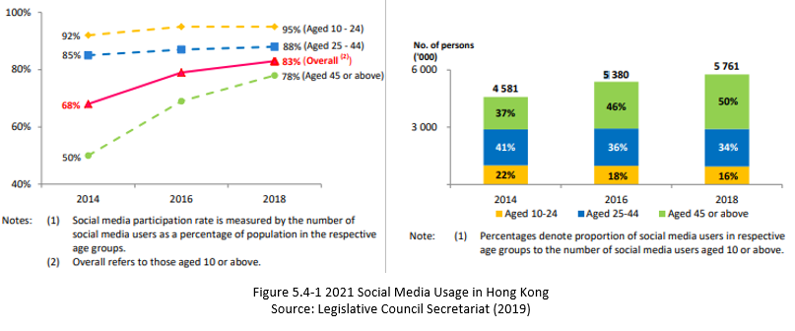
In Figure 5.4-2, it also exhibits unmistakably the leading social media platforms in Hong Kong, which could help Mox to laser focus onto the podium where can generate the best profits for the future positioning.
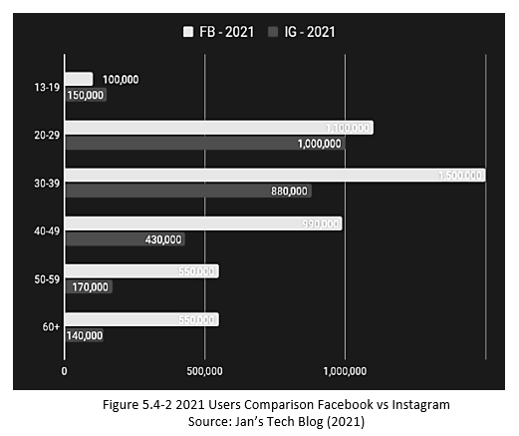
Mox could use a multichannel approach to amplify its brand equity, where psychological, economic, and financial perspectives are unified to increase marketing mix responses and reduce future operational costs (Das, 2020).

5.5 Proposed Growth Strategy
Derived from previous analysis streams, this report has reasonably reached following recommendations based on Ansoff matrix in Table 5.5-1, where Eisenmann (2006) said first movers should spend more efforts in its marketing acquisition strategies that are economically making sense.
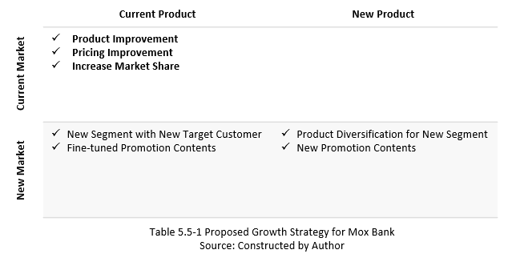

Current Product & Current Market:
- Current product’s sophistication could be expanded and looked further into financing capabilities of small loans or cash advance facilities, especially for tax season.
- As part of the pricing strategy, the interest scheme could be strategically marketed to compete with competitors and make it most eye catching. For example, the cash schemes could be broken into a staggered approach in smaller amounts with higher interest rate in the lowest tier. This could also provide savings for Mox in interest payout, looking more attractive at the same time as showing in Table 5.5-2. Avlonitis, Indounas and Gounaris (2005) found pricing objectives could be situationally specific and staged flexibly in its life cycle.
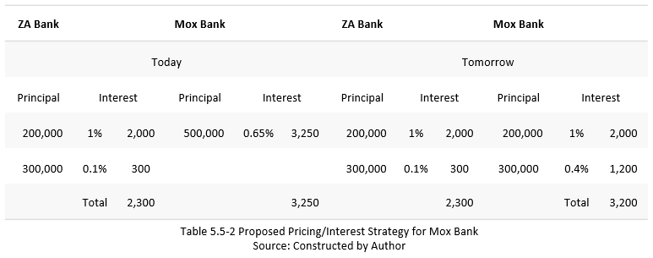

Current Product & New Market:
- With improved product and pricing, Mox should start exploring with aged group who are savvy with digital technologies, especially on smart wallets.
- Facebook is still a better vehicle for seniors in Hong Kong today to target this customer base with enriched pricing and products, with sales promotions and referral awards: cash credits or additional interest points.

New Product & New Market:
When a new market is technologically uncertain, this gives firms opportunities to focus on both aims: market profits and competitors ahead of time (Kim, Min and Chaiy, 2014).
- With seniors, Mox’s or competitors’ basic banking products are still not attractive enough. Mox could consider a new set of products that fit well with aging customers’ wants and needs as well as being competitively advantageous.
  - Conservative investment
  - Will & power of attorney features
  - Online personal consultancy
  - Relationship balance credits
Improved customer service hotline with enough live agents could also help seniors to gain confidence of a ‘virtual’ banking experience.
- If the App itself could be treated as a marketing place, the design could be adapted to suit better for seniors: a senior App. A recent study done by Chaouali and Souiden (2019) found that psychological and functional barriers could very well affect elderly’s willingness in mobile banking.
  - Larger fonts
  - Simpler UI
  - More functions with QR codes, for example: referrals
- Free training session at shopping or community centers is a good PR promotion to enhance its image in public’s eyes.
- A mixture of traditional and technological promotions to innovate an end-to-end social conversion circle through OmniChannel touches, where relationship management could be additionally enhanced in Figure 5.5-1.
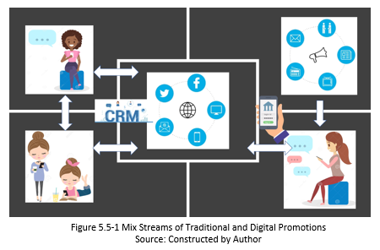

6. Conclusion
As Mox CEO had expressed that he would like to double its customer base in 2021, this is not unachievable if Mox could examine the growth strategies carefully. Based on the stream of Mox’s marketing mix and segmentation analysis, the conclusion is evident that the incubating Mox has a favorable future ahead if it can exercise cautiously its brand uniqueness and build distinctive mix for majorities if it’s not yet everyone!

Academic Reference
Avlonitis, G.J., Indounas, K.A. and Gounaris, S.P. (2005) ‘Pricing objectives over the service life cycle: some empirical evidence’, European Journal of Marketing, vol. 39, pp. 696-714. DOI: 10.1108/03090560510590773.

Camilleri, M. (2018) ‘Market Segmentation, Targeting and Positioning’, Travel Marketing, Tourism Economics and the Airline Product, chapter 4, pp. 69-83. Available at: https://www.um.edu.mt/library/oar/bitstream/123456789/21433/5/Market%20Segmentation%20Targeting%20and%20Positioning.pdf (Accessed: 29 May 2021).

Chaouali, W. and Souiden, N. (2019) ‘The role of cognitive age in explaining mobile banking resistance among elderly people’, Journal of Retailing and Consumer Services, vol 50, pp. 342-350. DOI: 10.1016/j.jretconser.2018.07.009.

Das, S. (2020) ‘Innovations in Digital Banking Service Brand Equity and Millennial Consumerism’, Digital Transformation and Innovative Services for Business and Learning, pp. 18. DOI: 10.4018/978-1-7998-5175-2.ch004.

Downs, A., Durant, R. and Carr, A. (2003) ‘Emergent Strategy Development for Organizations’, Emergence, 5(2), pp. 5-28. DOI: 10.1207/S15327000EM050204.

Du, Y. and Kim, P. (2021) ‘One size does not fit all: Strategy configurations, complex environments, and new venture performance in emerging economies’, Journal of Business Research, vol 124, January, pp. 272-285. Available at: https://www.sciencedirect.com/science/article/abs/pii/S0148296320308122 (Accessed 29 May 2021).

Eisenmann, T. (2006) ‘Internet companies' growth strategies: determinants of investment intensity and long-term performance’, Strategic Management Journal, 27(12), October, pp. 1183-1204. Available at: https://onlinelibrary.wiley.com/doi/abs/10.1002/smj.567 (Accessed: 4 June 2021).

Kim, N., Min, S. and chaiy, S. (2014) ‘Why Do Firms Enter a New Product Market? A Two-Dimensional Framework for Market Entry Motivation and Behavior’, Journal of Product Innovation Management, 32(2), pp. 263-278. DOI: 10.1111/jpim.12223.

Kuncoro, W. and Suriani, W.O. (2018) ‘Achieving sustainable competitive advantage through product innovation and market driving’, Asia Pacific Management Review, vol. 23, pp. 186-192. Available at: https://reader.elsevier.com/reader/sd/pii/S1029313215200966?token=B3E220559D87EB395EE688B445F1527B71FFAF5B1BEF9FBC5E4DD5E07A7F78F98968B084E1DA184E1F19B92939E8BBE2&originRegion=us-east-1&originCreation=20210529174613 (Accessed: 30 May 2021).

Johnson, G. et al. (2018) Fundamentals of Strategy, 4th Edition, New York: Pearson.

Lamarque, E. (2000) Key Activities in The Banking Industry: An Analysis By The Value Chain. Paris: Université de Paris 1 Panthéon-Sorbonne.

Londhe, B.R. (2014) ‘Marketing Mix for Next Generation Marketing’, Procedia Economics and Finance, vol 11, pp. 335-340. Available at: https://reader.elsevier.com/reader/sd/pii/S2212567114002019?token=91B161E9666ED9129707FBFC1F7D5487B9B19CE4D5D24564E2B945D32A70D96592C55A16A73A53A61D436E45487207EB&originRegion=us-east-1&originCreation=20210529151156 (Accessed: 29 May 2021).

Melser, D. and Syed I. (2006) Pricing Over the Product Life Cycle: An Empirical Analysis. Caulfield: Monash University.

Romanova, I. and Kudinaska, M. (2016) Contemporary Issues in Finance: Current Challenges from Across Europe, pp. 21-35. DOI: 10.1108/S1569-375920160000098002.

Shankar, V., Carpenter, G.S. and Krishnamurthi, L. (1999) ‘The Advantages of Entry in the Growth Stage of the Product Life Cycle: An Empirical Analysis’, Journal of Marketing Research, 36(2), pp. 269-276. DOI: 10.1177/002224379903600210.

Smith, T. (2008) ‘Senior Citizens and E-commerce Websites: The Role of Perceived Usefulness, Perceived Ease of Use, and Web Site Usability’, Informing Science: the International Journal of an Emerging Transdiscipline, vol 11. Available at: https://www.inform.nu/Articles/Vol11/ISJv11p059-083Smith447.pdf (Accessed: 2 June 2021).

Villarejo-Ramos, A. F., Peral-Peral, B. and Arenas-Gaitan, J. (2019) ‘Latent segmentation of older adults in the use of social networks and e-banking services’, Information Research, 24(4), pp. 841. Available at:
https://idus.us.es/bitstream/handle/11441/93836/latent_segmentation_of-older_adults_in_the_use_of_social.pdf?sequence=1&isAllowed=y (Accessed: 3 June 2021).

Bibliography
Airstar Bank (2021) Personal Banking. Available at: https://www.airstarbank.com/en-hk/index.html (Accessed: 2 June 2021).

Ant Bank (2021) Rates, Fees and Charges. Available at: https://www.antbank.hk/rates?lang=en_us (Accessed: 2 June 2021).

Bray, C. and Yiu, E. (2021) ‘Hong Kong issues four more virtual bank licences to spur innovation and disrupt bricks-and-mortar financial services’, South China Morning Post, 9 May. Available at: https://www.scmp.com/business/article/3009574/hong-kong-issues-four-more-virtual-bank-licenses-spur-innovation-and (Accessed: 29 May 2021).

Bray, C. and Yiu, E. (2021) ‘Standard Chartered-backed virtual bank Mox wants to double its customer base in 2021, CEO says’, South China Morning Post, 25 Apr. Available at: https://www.scmp.com/business/banking-finance/article/3130883/standard-chartered-backed-virtual-bank-mox-wants-double (Accessed: 30 May 2021).

Census and Statics Department, The Government of the Hong Kong Special Administrative Region (2020) Hong Kong Population Projections. Available at: https://www.censtatd.gov.hk/en/EIndexbySubject.html?pcode=B1120015&scode=190 (Accessed: 29 May 2021).

Cheung, Steve (2021) ‘Assessing the initial impact and growth prospects of virtual banks’, KPMG Hong Kong Banking Report 2021, pp. 12-13. Available at: https://assets.kpmg/content/dam/kpmg/cn/pdf/en/2021/06/hong-kong-banking-report-2021.pdf (Accessed: 21 June 2021).

China Banking News (2020) Standard Chartered’s Virtual Bank Mox Announces the Launch of Trial Operations in Hong Kong. Available at: https://www.chinabankingnews.com/2020/04/14/standard-chartereds-virtual-bank-announces-the-launch-of-trial-operations-in-hong-kong/ (Accessed: 28 May 2021).

efinancialcareer (2021) Risk & Control Manager – Mox. Available at: https://www.efinancialcareers.hk/jobs-Hong_Kong-Hong_Kong-Risk__Control_Manager_-_Mox.id11285937 (Accessed: 23 June 2021).

Financial Secretary, The Government of the Hong Kong Special Administrative Region (2021) The 2021-22 Budget. Available at: https://www.budget.gov.hk/2021/eng/pdf/e_budget_speech_2021-22.pdf (Accessed: 29 May 2021).

Fusion Bank (2021a) Banking. Available at: https://www.fusionbank.com/banking.html?lang=en-GB (Accessed: 2 June 2021).

Fusion Bank (2021b) Deposit. Available at: https://www.fusionbank.com/deposit.html?lang=en-GB (Accessed: 2 June 2021).

GlobalData (2021) Hong Kong’s e-commerce growth will continue beyond COVID-19 pandemic, says GlobalData. Available at: https://www.globaldata.com/hong-kongs-e-commerce-growth-will-continue-beyond-covid-19-pandemic-says-globaldata/ (Accessed: 22 June 2021).

HKUST Business School (2020) ‘Addressing the Fintech Talent Gap’, South China Morning Post, 31 Aug. Available at: https://www.scmp.com/presented/news/hong-kong/education/topics/new-normal/article/3098761/addressing-fintech-talent-gap (Accessed: 2 June 2021).

Jan’s Tech Blog (2021) [Facebook] 18 Jan. Available at: https://www.facebook.com/janstechblog (Accessed: 3 June 2021).

Livi Bank (2020) [YouTube] 7 December. Available at: https://www.youtube.com/watch?v=FnuXX6wYc3Y&t=14s&ab_channel=livibank (Accessed: 3 June 2021).

Livi Bank (2021a) Features. Available at: https://www.livibank.com/# (Accessed: 2 June 2021).

Livi Bank (2021b) Happiness. Available at: https://www.livibank.com/# (Accessed: 2 June 2021).

Mox Bank (2021) [Facebook] 2 June. Available at: https://www.facebook.com/search/posts/?q=mox%20bank (Accessed: 2 June 2021).

Mox Bank (2021a) Features. Available at: https://mox.com/ (Accessed: 2 June 2021).

Mox Bank (2021b) Promotions. Available at: https://mox.com/promotions/ (Accessed: 2 June 2021).

Mox Bank (2021c) Promotions. Available at: https://mox.com/promotions/ (Accessed: 3 June 2021).

Mox Bank (2019) Redefining the Hong Kong banking scene. Available at: https://mox.com/zh/media/redefining-the-hong-kong-banking-scene/ (Accessed: 30 May 2021).

Pao Bank (2021) Retail. Available at: https://www.paob.com.hk/en/retail-mobile-account-opening.html (Accessed: 2 June 2021).

Quinlan & Associates (2021) ‘Branching Off’ The Outlook For Hong Kong’s Virtual Banks. Available at: https://www.quinlanandassociates.com/wp-content/uploads/2021/03/Quinlan-Associates-Branching-Off.pdf (Accessed: 29 May 2021).

Research Office, Information Service Division, Hong Kong Legislative Council Secretariat (2019) Social Media Usage in Hong Kong. Available at: https://www.legco.gov.hk/research-publications/english/1920issh15-social-media-usage-in-hong-kong-20191212-e.pdf (Accessed: 3 June 2021).

Standard Chartered (2020) We’ve officially launched a new virtual bank Mox in Hong Kong. Available at: https://www.sc.com/en/media/press-release/weve-officially-launched-a-new-virtual-bank-mox-in-hong-kong/ (Accessed: 28 May 2021).

The Asset (2021) ‘Hong Kong virtual banks in uphill fight to gain market share’, Treasury & Capital Markets. Available at: https://www.theasset.com/article/43964/hong-kong-virtual-banks-in-uphill-fight-to-gain-market-share (Accessed: 22 June 2021).

The Government of the Hong Kong Special Administrative Region (2021a) Gross Domestic Product and its major components. Available at: https://www.hkeconomy.gov.hk/en/pdf/domestic_eng.pdf (Accessed: 22 June 2021).

The Government of the Hong Kong Special Administrative Region (2021b) Retail and other economic indicators. Available at: https://www.hkeconomy.gov.hk/en/pdf/others_eng.pdf (Accessed: 22 June 2021).

Vpon (2020) Virtual Banking Apps’ Market Share Surge within Two Months and Exceeds Traditional Banking for The First Time. Available at: https://www.vpon.com/en/appvois_virtualbanks_pressrelease/ (Accessed: 22 June 2021).

Welab Bank (2021) Features. Available at: https://www.welab.bank/en/ (Accessed: 2 June 2021).

Yiu, E. (2020) ‘Standard Chartered will target tech-savvy young customers as it gears up to join Hong Kong’s virtual banking race, says CEO Bill Winters’, South China Morning Post, 20 Jan. Available at: https://www.scmp.com/business/banking-finance/article/3046715/standard-chartered-will-target-tech-savvy-young-customers (Accessed: 30 May 2021).

Yiu, E. (2021) ‘HKMA piles pressure on small lenders to digitise as Hong Kong’s virtual banks gain traction with customers’, , South China Morning Post, 17 Mar. Available at: https://www.scmp.com/business/banking-finance/article/3125662/hkma-piles-pressure-small-lenders-digitise-hong-kongs (Accessed: 21 June 2021).

Yuen, S. (2021) ‘Standard Chartered HK hosts virtual run, aim to support fresh grad work force’, Marketing Interact, 16 June. Available at: https://www.marketing-interactive.com/standard-chartered-hosts-virtual-run-to-support-employment-for-fresh-grads (Accessed: 25 June 2021).

ZA Bank (2021a) Bank. Available at: https://bank.za.group/en/ (Accessed: 2 June 2021).

ZA Bank (2021) [Facebook] 2 June. Available at: https://www.facebook.com/search/posts/?q=za%20bank (Accessed: 2 June 2021).

ZA Bank (2021b) Spend. Available at: https://bank.za.group/en/za-card (Accessed: 2 June 2021).

Appendix
Virtual Banks recent launch of senior celebrities in its advertisement.

Mox’s recent advertisement
- Mox invited Joyce Cheng, Johnnie To and Anson Lo to spice the new credit card campaign, while at initial launch it was all ‘funky’ with celebrity dancer Haruna Kunisawa. A clear shift to start targeting the prosperous seniors.
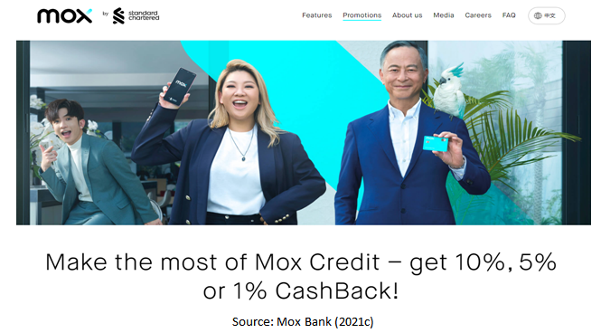

Livi advertisment using a senior figure
- Livi Bank stared opera singer Law Kar-Ying and actor Alex Lam in conjunction with Dairy Farm’s club yuu - something worth noticing again of the mature figure.



