

Programme: MSc Public Health and Social Care in Practice

Module code and Title: LCHS7002 Health Care System Organisation and Leadership

Student Name: Bhargaviben Mistry

Student ID: 2540089

Case Study Analysis Report

Lecturer Name: Pascal Navelle

Words: 5283

Submission Date: 11 August 2026
Table of Contents
1. Introduction 3
2. Main Body and Analysis 4
2.1 Identifying the Problem and Setting the System Context: Applying Systems Thinking and the Rich Picture 4
2.2 Centralisation or Decentralisation within the Case Study 10
2.3 Leadership Theories and Application to the Case Study 13
2.4 Improvement and Lessons Learned 16
3. Recommendations 18
4. Conclusion 20
References 22

1. Introduction
This report analyses Case Study 2, based on the Health Services Safety Investigations Body investigation “Medication not given: anticoagulation before and after a procedure”. The case refers to the treatment of Patient X, an 87-year-old patient admitted with dyspnea and epistaxis. Apixaban therapy was stopped due to bleeding events and the need to conduct a pleural procedure. However, due to the delays in performing the procedure, it was not restored for ten days. Despite the intention to restore it after the procedure, this never happened. The patient suffered from a stroke two days after and died (Dresti, 2025). Such a case cannot be treated as an individual prescription mistake, since it shows the weaknesses in the medication review, documentation, electronic prescribing, access to specialists, workforce capacity, communication and organisation. This report appraises the role of leadership, governance and system design in these cases. Healthcare and social care leadership may be defined as the process of influencing, directing and enabling the working towards common goals and providing safe person-centred care. Good leadership is critical in driving change projects such as PCC. It is the leaders who are key in providing the required environment for PCC to thrive, including an organizational culture that is reflective of person-centred ethics (Klinga et al. 2026).
Organizational power might be either centralized where power, standards, and controls are kept at high levels of organization or decentralized where power and controls are passed down to lower organizational levels. Decentralization ensures efficiency and responsiveness while the former allows for uniformity and accountability. The problem is that even when the organizations and tasks take place at the right level, the desired results do not come up because of the failure of governance (Euro Health Observatory, 2018). Ministries of health lack the capacity to manage the system as they face problems in making complex policies due to lack of competent people owing to continual cuts in the ranks of public services.
The paper will examine if the hospital struck the right balance of standardization of anticoagulant controls and clinical autonomy. These theories will be employed in the report on transformational, transactional and situational leadership. Transformational leadership helps in sharing common vision, learning and motivation of staff. On the other hand, transactional leadership focuses on clearly assigned duties, supervision and adherence, while situational leadership changes their leadership style based on the level of risk involved, capabilities of employees and changing situations.
The importance of selecting the appropriate theory or combination of these approaches lies in the fact that inappropriate leadership may allow ambiguities, lack of accountability and delayed escalation, while context-specific leadership can help improve communication and safety culture of patients (Singh et al. 2024). Hence, the report will address the problem through systems thinking and Rich Picture, centralisation and decentralisation, leadership theory application and analysis of improvements and lessons learned.
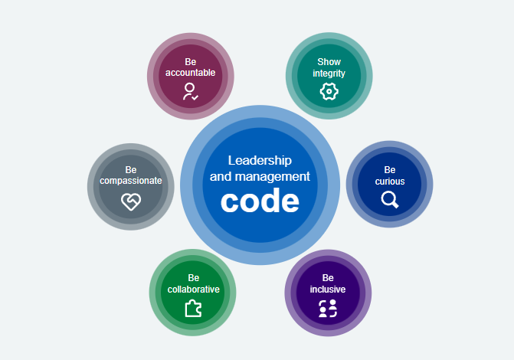
Figure 1: Core leadership principles in health and social care
(Source: NHS, 2026)

2. Main Body and Analysis

2.1 Identifying the Problem and Setting the System Context: Applying Systems Thinking and the Rich Picture
The main issue was the extended period in which the use of apixaban by Patient X was halted without proper evaluation and subsequent resumption. Patient X was 87 years old, and he was under treatment using apixaban to prevent stroke. Clinicians halted the drug appropriately due to epistaxis. However, the procedure on pleura was delayed, and as a result, apixaban was suspended for ten days. Patient X got a stroke two days following the procedure and eventually died (Dresti, 2025). This is not simply a case of forgetting to prescribe a particular drug by a single doctor. HSSIB has revealed that there were interacting failures regarding clinical decision-making, communication, staffing, digital technology, specialty services, documentation, and governance.
The risk-benefit assessment was not documented. The ePMA system showed that the drug had been paused but no review reminder was generated. Post-procedure documentation also did not have any reminder to re-evaluate the need for anticoagulation. These gaps made it impossible to have a shared and up-to-date view of the risks.
This incident has universal significance since medication harm has been recognized as an ongoing patient safety issue globally. According to WHO, medication harm accounts for roughly half of the preventable harm associated with medical treatments. An estimated loss of 42 billion US dollars is incurred annually globally due to medication error (WHO, 2022). WHO attributes this to substandard systems, fatigue, unfavourable working environment, understaffing and medication error throughout the prescribing and monitoring stages.
The national evidence proves that the safety burden is significant in England. NHS England has recorded 804,069 patient safety incidents from January to March 2026. Out of the incidents where the level of physical harm is recorded, 4,126 cases were fatal and 3,611 have caused severe harm. Acute, general, or specialist services accounted for 57.6% of the recorded service areas. Medications were the highest recorded agent involved apart from the 'none' classification (NHS England, 2025). These figures must be interpreted with caution. LFPSE measures report an event and not the actual number of incidents in the NHS. Increased reporting does not indicate poor care but a more reporting culture.
However, the scale indicates vast learning opportunities in the system. It also links the patient's death to the national issue. Staffing pressure adds another dimension. There were 97,475 NHS vacancies in England in March 2026 indicating a 6.5% vacancy rate. This is not an indication of causation in the Trust. However, it indicates staffing problems in the country that may affect supervision, continuity and medication review capacity (NHS England, 2026). The local evidence shows how these staffing pressures affected Patient X. One consultant and three resident doctors attended to the 28-bed general medical ward. The ward was usually occupied by one or two extra patients. It had been noted that there was lack of medical senior leadership and the middle-grade doctor did not attend. Coordinating nurse was present in one out of six-day shifts
The WHO introduced the Medication Without Harm campaign as the third global patient safety challenge in order to cut down the number of preventable harms associated with medicines by 50% within five years. The Medication Without Harm campaign acknowledges the fact that medication errors can happen at all stages of medication use, such as ordering, dispensing, administration, and monitoring and evaluation.
Moreover, it is pointed out that sustainable changes can only be achieved through collaboration of health care organizations, policymakers and health care professionals in terms of strengthening medication safety systems (WHO, 2022). The situation with Patient X fits in perfectly with the global concerns about medication safety.

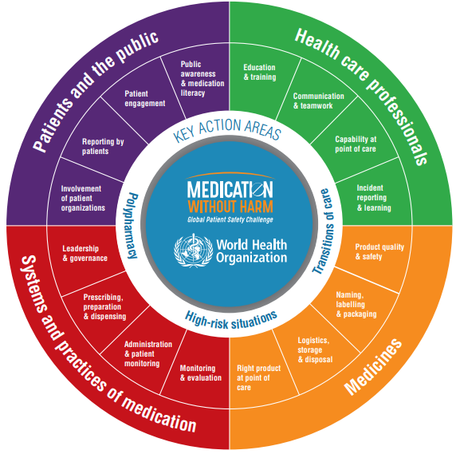
Figure 2: Strategic Framework of the WHO Global Patient Safety Challenge: Medication Without Harm
(WHO, 2022a)
Patient safety still stands out as a major issue in the global health care sector because according to the World Health Organization (WHO, 2023), one out of every ten patients is harmed when using health care services, and more than half of these incidents can be prevented. Errors related to drugs are responsible for many of these preventable injuries, especially during the transition period since the process of communication and clinical decision-making becomes less coherent. These figures demonstrate that medication safety problems usually emerge not due to individual mistakes of medical practitioners but owing to various interactions within the system. Consequently, analysis of Patient X's case with interrupted therapy on apixaban requires a systems approach.
Figure 2 depicts the strategic framework of the WHO Global Patient Safety Challenge. The harm to Patient X arose due to multiple linked issues, rather than an individual prescribing failure. Since the respiratory referral had been completed once it had been accepted, there was no specialist bed available. Therefore, it became the responsibility of the general medicine team, and there was no ongoing respiratory assessment. The ePMA system registered the pausing of apixaban but did not generate any assessment reminder. The post-procedure process did not have any mandatory trigger to restart anticoagulant therapy. To understand the underlying reasons behind the occurrence of errors in medical treatment, one has to change their thinking from the traditional blaming mindset to a system-based one (WHO, 2023).
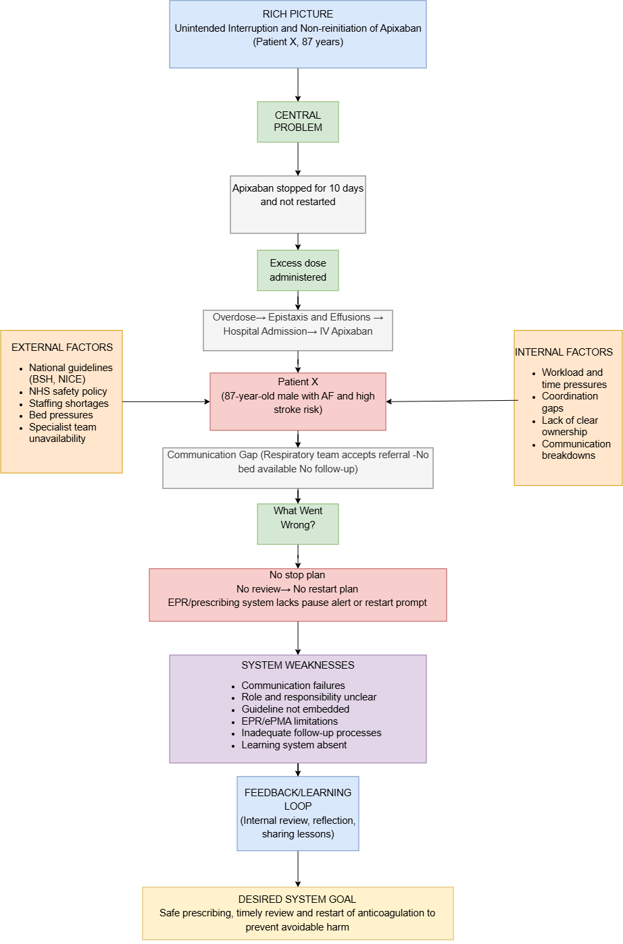
Figure 3: Rich Picture Illustrating the Systemic Factors Contributing to the Medication Safety Incident
(Self-Developed)

2.2 Centralisation or Decentralisation within the Case Study
In this case, the structure can be defined as a combination of centralised and decentralised aspects. The national agencies determined clinical requirements, whereas the Trust managed the resources, policies, IT system and escalation process. The front-line teams were responsible for prescription decisions and clinical priorities. Such a structure provided flexibility, but the responsibility for anticoagulation therapy of Patient X was divided. Centralisation is characterised by a concentration of decision-making and resource management at high levels. Decentralisation is related to decisions made closer to clinical needs and services (Sapkota et al 2023). The European Observatory suggests that centralisation leads to standardisation. Decentralisation is associated with innovation, flexibility, accountability and efficient local resource management. However, it should be noted that recent evidence shows that certain tasks have to be centralised. For example, it is necessary to centralise such issues as the development of health policy and the development of a quality strategy to ensure that patients all over the country can expect the same conditions of access, coverage and service delivery (Euro Health Observatory, 2018).
Some of the organisational controls were centrally coordinated by the Trust, such as workforce planning, specialist staffing, bed capacity, technology infrastructure, and local clinical guidelines. They directly impacted the resources required to manage the care of Patient X. For instance, the Trust had stopped using the specialist pleural nurse position due to budgetary limitations and did not have a pleural administrator. This decreased the respiratory team's ability to manage referrals, track the waiting list, and schedule the procedures. Respiratory beds allocation was also managed via the central patient flow strategy used by the Trust.
It meant that while this approach allowed equal resource distribution, the bed allocation was contingent on capacity rather than on the total drug-related risks posed by the individual. Patient X was clinically stable during the seven-day wait for CT and the additional ten days before the procedure, and only one male respiratory bed was free. It was another reason for which apixaban cessation did not impact bed prioritisation. Matron escalation and patient flow meetings were among the available escalation strategies. However, since Patient X did not deteriorate clinically, the rising risk of thromboembolism was not sufficient to elevate the organisational priority. Conclusion of one review states that ‘one of the problems when devolving the health sector is getting the balance right between decentralized and centralized roles (Ohrling and Brommels, 2021).
The centralised nature of this approach meant that scarce resources such as specialised beds and diagnostics could be allocated through central knowledge of the hospital. Centralisation may enhance consistency and resource allocation within the healthcare environment. But its success depends on whether decisions take into account changes in clinical risks and operational pressure (Ohrling, 2026). In Patient X's case, the inefficiencies were shown in him waiting for seven days for a CT scan and ten days before his procedure. Within this time the risk due to the interruption of apixaban therapy was not taken into consideration in prioritisation decisions. Thus, central control helped coordinate capacity but failed to properly factor in the increasing risk of medication interruption.
The decision-making process regarding the administration of apixaban was decentralized. Consultant doctors from both the ward and the ED were authorized to decide whether to stop, continue or restart the use of the drug depending on the condition of the patient at that time. This facilitated quick decision-making in the event of any active bleeding, and it was concluded that it was appropriate to make the initial decision to stop the use of apixaban. However, decentralization of decision-making raised concerns regarding accountability during the assessment of patients after completion of the procedure. The referral was received by the respiratory consultant but later closed down, while the medical team was still responsible for the patient awaiting specialist advice. It appears that the respiratory consultants lacked an ongoing assessment of referrals unless there was a new referral. Further staffing difficulties added to the distributed accountability issue.
The case study's dual structure helped to act immediately clinically but impeded collaboration once Patient X's condition shifted. Clinicians on the ground level could suspend use of apixaban while actively experiencing epistaxis without consulting the head office. Such decentralization of power was suitable at admission. But the responsibility became decentralized once Patient X needed to undergo a respiratory procedure. The respiratory department accepted the referral but ongoing monitoring was conducted by the general medical ward. In addition, the referral was completed despite the lack of a specialist bed available. Such fragmentation hindered detection of a crisis since delay and anticoagulation risk were handled separately. In addition, staffing stress decreased quality and accountability of decisions.
One consultant and three residents had to cover 28 beds and even sometimes one or two extra patients. A coordinating nurse was available in only one out of six relevant day shifts. Such circumstances restricted senior review, reassessment of medications and follow up. The evidence of staffing helps support such an argument. In 58 hospitals in British Columbia, 59.4% of nurses experienced high levels of burnout (Lasater et al. 2025). In addition, another 66.6% identified insufficient staffing as one of the reasons why they were planning to leave their position. The study concluded that 60.6% gave their hospital poor patient safety grades. Such data do not indicate causation in this case study's hospital. But it demonstrates how staffing stress undermines surveillance, communication and escalation.
The staffing chart presented in Figure 4 demonstrates the problem of the policy–practice gap as well. It stated that the medical-surgical units had a policy of the ratio of four patients per nurse. Several hospitals worked above that ratio, having real ratios equal to seven patients per nurse. Such data demonstrate that the centralized standards could not protect patients from danger unless there is proper staffing. Therefore, the accountability was distributed among ward doctors, respiratory doctors, bed managers, pharmacy and electronic system. Apixaban was suspended for ten days and was never resumed after the procedure. Such structure helped with initial decision but failed to manage the risk.

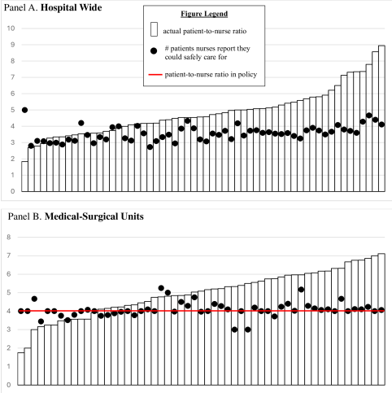
Figure 4: Variation in Patient-to-Nurse Staffing Ratios Across 58 British Columbia Hospitals
(Source: Lasater et al. 2025)

2.3 Leadership Theories and Application to the Case Study
The lack of leadership in Patient X's care did not happen only once or in a singular delayed intervention. There were weaknesses in senior supervision, diffusion of responsibilities, inconsistent guidance, and low specialist capability in several teams. There was leadership in terms of operations but not in coherence with the changes in risks to the patient’s need for anticoagulation. Theories of transformational, transactional, and situational leadership help in analyzing the deficiencies. None of them provides a full explanation of the case or an optimal solution to it. The last systematic review included 12 articles and found that certain leadership styles contribute to higher levels of teamwork, communication, learning, and perceptions of safety. However, the narrative synthesis could not tell which style is more efficient in the specific clinical environment (Althobaiti, 2026).
Transformational leadership involves a shared vision, empowerment of employees, learning, and continuous improvement beyond mere compliance. The leaders should define the common goal for ensuring Patient X's safety in terms of the critical time frame of his anticoagulation therapy. It should unite ward doctors, respiratory specialists, nurses, pharmacists, and managers of digital systems. In reality, senior medical leadership was deficient in the acute general medical ward. One consultant and three resident doctors worked in the department of 28 beds, with one or two additional patients each time. The usual middle-grade doctor was absent most of the time, and the consultant was unable to supervise all of his delegation. The coordinating nurse was there during one day of the six-day shift.
Peer-reviewed research supports transformational leadership. However, there is insufficient proof of causation. For example, Hamdan et al. (2024) surveyed 200 nurses and found that there is a statistically significant association between transformational leadership and patient-safety culture. The coefficient of β was 0.666 and p < 0.001. Transformational leadership also has a direct relationship with nursing safety practices at β = 0.216 and p < 0.001. Patient-safety culture has a stronger relationship with nursing safety practices at β = 0.631 and p < 0.001. It means that leadership positively affects safety through teamwork, communication, learning, and common expectations.
The cross-sectional design of the study does not allow making causation conclusions. However, the transformational leadership approach was relevant but inadequately used in the patient's pathway of care. There were no leaders who brought together the teams in order to formulate an anticoagulation plan taking into account the procedural delay. The respiratory team accepted and concluded the referral, while the clinical care stayed in the scope of the general medical team. Nobody controlled the continued specialist review or questioned the timing of the procedure. In such a way, transformational leadership could have motivated employees to question the unchanged plan and bring to light the growing risks of thrombosis. But, without reliable controls, inspirational leadership would depend greatly on individual memory.
Padauleng et al. (2020) observed 104 hospital nurses and discovered that transactional leadership prevailed in 69.2% of nurse managers. There was a significant association between leadership style and patient safety culture at p < 0.05. This literature is consistent with transactional approaches to use where routine is necessary regarding compliance, workload management, and reporting of incidents. Routine daily anticoagulation checks and electronic alerts could be essential safeguards in Patient X's situation. On the other hand, transactional leadership may become passive where leaders only act when standards are violated. An effective exception alert never happened in 10 days of interruption.
Situational leadership would offer the best explanation for changes in the requirements in this case. According to this theory, leaders must change direction, support, delegation, and supervision depending on the level of risk and skills of their staff members. The leader's directives were justified by serious epistaxis where apixaban had to be interrupted immediately. However, the situation changed after nasal packing and no more bleeding. Leadership should have become more multidisciplinary in reassessing the patient's condition, consulting specialists, and monitoring risks of thrombosis. Such changes did not take place in spite of procedural delays and the previous stroke history of Patient X.
Ghallab and Sallam (2026) conducted a survey among 319 healthcare professionals and showed that situational leadership is a strong predictor of healthcare service quality with β = 0.52 and p < 0.001. Moreover, situational leadership predicts crisis management capacity with β = 0.61 and resource availability with β = 0.47, both of which are statistically significant at p < 0.001. The model accounts for 48% of the variance in healthcare service quality. However, the study is conducted among private hospitals from conflict-stricken Yemen. Therefore, the findings cannot be generalized to the English NHS hospital. Further proof for a dual leadership framework is provided by staff engagement research. Janes et al. (2021) conducted a meta-analysis including 11 studies with 30,490 participants in total. Staff engagement proved to be significantly correlated with patient safety at r = 0.22.
Additionally, four studies with 2,633 participants found a link between greater engagement and reduced error rate and number of adverse events at r = −0.20. For Patient X’s ward, the presence of a coordinating nurse led to better organization and mood among the staff. However, this nurse was present on just one shift out of four, thus reducing communication abilities. In contrast, the management of Patient X demanded a combination of leadership styles rather than the reliance on just one type of leadership.
Transformational leadership style was necessary to achieve a common understanding beyond the realm of professions. Transactional leadership style was necessary for having mandatory review periods, electronic reminders and accountability. Situational leadership was necessary when the bleeding threat diminished while that of a stroke increased. The major problem here was not that of choosing an unsuitable theory at some point in time. It was the inability to adapt leadership behavior to changing situations.

2.4 Improvement and Lessons Learned
The cause of death of Patient X was due to the interactions between distributed decisions within clinical practice and central governance arrangements. The decision to hold apixaban is well justified due to active bleeding during emergency treatment. Nevertheless, the leadership did not amend this decision despite resolution of bleeding issues and delay in procedures. The governance processes failed to recognize that the initial plan became more and more dangerous. Apixaban was held for ten days, and then omission continued after the procedure despite the intent to resume it.
The first missed opportunity related to the ownership of the anticoagulation plan during the admission of Patient X. There was acceptance of the referral by respiratory physicians, but the plan stayed under the responsibility of general medicine team until the transfer. The referral process ended, leaving no regular check-up despite uncertainty about the date of the procedure. No one specified the time limits of pausing, the date of reconsideration, and the person who would start the treatment again.
Pharmacists can help improve this process for older patients taking risky medications. In their 35-study review comprising 22,214 anticoagulant therapy patients, Kefale et al. (2024) found that interventions by pharmacists resulted in increased appropriate medication use by more than threefold with an odds ratio of 3.43. They also resulted in decreased overall bleeding by 25% and hospitalization or readmission by 36%. However, there was no decrease in thromboembolism or mortality. So, the pharmacy review cannot absolve physicians from any responsibility. Daily lists compiled by pharmacists will help to identify pauses in anticoagulation which require immediate revaluation.
The second gap relates to poor governance of the Trust's electronic prescribing system, because the ePMA record of patient X contains information about the pause in his anticoagulation but no warning about the need for reassessment. This record does not mention the duration of the intended pause and the physician responsible for the follow-up care. The post-procedure documentation does not contain any mandatory prompt for reassessment of anticoagulation. The Trust needs to implement time-limited pause orders, escalating alerts, and mandatory re-evaluation decisions after procedures.
Digital security is supported by evidence, but proper implementation is critical. According to Roumeliotis et al. (2019), a 76% reduction in medication errors was achieved with the help of electronic prescribing in 38 hospitals, while adverse drug events decreased by 48%. However, the quality of the evidence is very low. According to Mekonnen et al. (2016), the use of electronic reconciliation led to 45% reduction in medications containing unintended discrepancies in ten studies. However, discrepancy levels at patient level did not decrease. This indicates that the software cannot ensure safety, as there should be workflow, responsible recipients of digital alerts, and response times.
The third missed opportunity had to do with communication during cross-specialty and procedural delays. Only one bed for a male respiratory patient could be offered during day two. None of the beds was offered before the procedure. The patient X waited for 7 days for computed tomography, despite high anticoagulation risks. Daily multidisciplinary huddles should highlight procedures which have been delayed, overdue transfers, and time-critical medications which are on hold.
Structured interdisciplinary communication has shown tangible positive results in equivalent hospital settings. According to O’Leary et al. (2011), there were 3.9 adverse events per 100 patient-days with structured interdisciplinary rounds. Control units at the same period and historically showed 7.2 and 7.7 adverse events, respectively. The number of preventable adverse events was 0.9 per 100 patient-days, while in control units it was 2.8 and 2.1. In another study by Guo et al. (2025), safety huddles decreased adverse events by 12%. The score for communication about errors positively changed from 36% to 64%. However, safety huddles do not show positive results without documented action plans.
The workforce management was another area where opportunities were missed owing to the fact that the number of people available was not sufficient for the workload at the ward. There were a consultant and three resident doctors manning 28 beds, but there could be one to two more patients with them as well. The expected middle-grade doctor was hardly ever present when Patient X was admitted to the ward. A coordinating nurse was present for one out of six-day shifts. Musy et al. (2021) assessed 79,893 inpatients in 55 hospital units. Low RN staffing was linked to 10% greater mortality odds. In turn, high RN staffing was linked to 8.7% lower mortality odds. This does not prove causation of Patient X’s death by staffing.
Nonetheless, it is clear why the workforce capacity needs to act as a patient safety control. The trust management must compare staffing with missed reviews, delayed tasks, workload, and escalation activity. Guideline governance weakness presented another missed opportunity for the Trust. The anticoagulation guideline was hard to find, overdue, and inconsistent in related guidelines. Expertise from pharmacy and haematology has not been utilized in the review process. There should be one guideline with multidisciplinary ownership, version control, and regular comparison with the current evidence. Handovers should highlight stopped medications, pending actions, accountable doctors, and deadlines for their completion. According to Hada and Coyer (2021), handover interventions led to a reduction of medication errors between 11.1% and over 50%. Continuous quality improvement needs accountability that can be measured, rather than promises that come after an investigation is completed.
The Board needs to ensure oversight of reasons for pauses, reviews completed within 24 hours, notifications for late reviews and post-procedure restarting decisions. Further actions needed include delayed specialty reviews, thromboembolic events, bleeding events, and staff escalations. Ivers et al. (2026) examined 292 articles and found audit and feedback increased desired practice performance by 6.2 percentage points. Effective interventions included use of benchmarks, local champions, feedback interaction and action plan. A dashboard should link each variance with the responsible leader, due date and response recorded. In conclusion, while the hybrid organization structure of the hospital was not inherently risky, its safety controls did not align well. The decentralized physicians had the ability to make quick decisions, whereas the transactional controls failed to ensure review and completion of follow-up actions.

3. Recommendations
From the analysis, it can be recommended that,
The results show that organization-wide interventions are necessary to enhance patient safety instead of single remedial measures, since the negative outcome of Patient X was caused by organisational weaknesses in leadership, governance, communication, digital systems and clinical coordination and not by a single mistake made in prescription. Thus, a blended leadership style is recommended in the Trust, which is a mixture of transformational leadership, transactional leadership and situational leadership.
Senior clinical leaders should adopt transformational leadership to define a common vision of patient safety, promote multidisciplinary cooperation and build a culture of employees who do not hesitate to ask about delays in patient care (Alanazi et al. 2026). The standardised medication review process, accountability and adherence to anticoagulation protocols should be supported by transactional leadership (May et al. 2024). Whereas situational leadership should allow the leaders to increase the level of oversight and adjust decision-making in response to changes in patient risk during extended hospitalisation.
There should also be an improvement of governance arrangements by establishing explicit accountability for patients in which anticoagulation has been halted until procedures are done. An identified consultant or multidisciplinary team must continue to review anticoagulation every day until it is safely resumed. Delayed procedures, high-risk medicines that are interrupted and escalation decisions should be reviewed at regular governance meetings with clinical dashboards to make sure that the risks that emerge are recognized before patients suffer injuries (Sloane et al. 2023). Moreover, local anticoagulation policies ought to be revised in accordance with current national guidelines and periodically reviewed to eliminate obsolete clinical practice, as noted in the HSSIB investigation.
There has to be a vast improvement in communication and systems integration. The Trust should improve its ePMA system by adding automatic alerts, requiring reasons for pausing anticoagulants, and reminding staff to review the medication after procedures or before discharge. Referral management, bed allocation, specialist review and medication records should also be digitized and integrated into the digital systems in a manner that real-time information is available to all members of the multidisciplinary team (Tiriteu et al. 2024). Responsibility for high-risk medications should be clearly passed across teams with the help of standardised handover templates and structured multidisciplinary safety huddles to minimize communication failures.
The Trust should expand respiratory services, increase specialist nursing support, and prioritise investigations and procedures based on patient risk rather than bed availability to improve resource use and ensure patients with the greatest clinical need receive timely care. A better approach to workforce planning needs to address the issues of staffing by ensuring enough supervision of the consultants, nurse shift scheduling and time set aside for medication review (Silva et al. 2025). Such measures would minimize unwarranted delays and enhance the quality and safety of care delivery.
Sustainable improvement requires a process of continuous organisational learning and substantial stakeholder engagement. The Trust ought to put regular multidisciplinary morbidity and mortality reviews, simulation-based medication safety training as well as audit programmes on interrupted anticoagulation pathways. ‘Plan-Do-Study-Act’ (PDSA) methodology should be used to incorporate lessons learned into quality improvement cycles (Manandi et al. 2023). They should also involve patients and families by engaging them in shared decision-making, educating them about anticoagulant therapy, and involving them in service redesign efforts. An integrated co-production with clinicians, pharmacists, digital teams, patients and governance staff will create practical, evidence-based care pathways and help prevent future medication safety incidents.

4. Conclusion
This report has assessed the death of Patient X due to apixaban discontinuation for extended periods. This medication was initially suspended because there was active bleeding; however, it remained discontinued for ten days while the planned procedure was postponed. Moreover, apixaban was not restarted even after this procedure. Patient X later suffered a stroke and died. The analysis revealed that this adverse outcome resulted from multiple failures that emerged during admission. Such failures included lack of communication, absence of clear accountability, limited role of specialists, staffing issues, and ineffective electronic controls. Anticoagulation review was inconsistent as patient's status changed over time. The health organisation used a hybrid structure that contained elements of both centralisation and decentralisation. Senior managers were responsible for staffing, policies, digital solutions, specialists, and bed management. Clinicians provided treatment decisions on a daily basis.
This approach allowed rapid response upon patient admission but created gaps in accountability during further management. No clinicians remained accountable for restarting apixaban upon the change of the patient's status. The influence of the leadership on the outcome was significant. Transformational leadership was required for the creation of shared responsibility among various teams. Transactional leadership was needed to ensure that review dates, alerts, and documentation existed. Situational leadership was also important since the balance between risks of bleeding and stroke changed over time. These leadership approaches were not used in combination properly. Systems thinking could be helpful for better understanding of how these failures were linked to each other.
It was possible to notice how such aspects as staffing, referrals, procedure, digital solutions, and clinical responsibility contributed to the final outcome. Therefore, it is important to conduct improvements within the entire system and not just one person. Health organisations need to introduce named accountability, time limitation of medication suspension, electronic review alerts, and multidisciplinary review. Continuous improvement will require audit data, feedback, and monitoring of the results. Leadership and governance play a key role in implementation of the findings into practice.

References
Alanazi, A.K., Traynor, M., McFetridge, L., McKeaveney, C. and Clarke, S.A., 2026. Linking transformational leadership to patient care quality: the role of structural empowerment and registered nurses’ clinical leadership. Journal of Nursing Management, 2026(1), p.7518764. https://doi.org/10.1155/jonm/7518764
Althobaiti, F.M., 2026. The effects of leadership on patient safety culture in health care: a systematic review. BMC nursing, [online] pp.10.1186/s12912–025–04263–7. https://doi.org/10.1186/s12912-025-04263-7
Dresti, S., 2025. Medication not given: anticoagulation before and after a procedure. [online] HSSIB. Available at: https://www.hssib.org.uk/patient-safety-investigations/medication-related-harm/second-investigation-report/ [Accessed 3 Aug. 2026].
Euro Health Observatory., 2018. Centralization and decentralization in health systems. [online] OBS. Available at: https://eurohealthobservatory.who.int/themes/observatory-programmes/governance/centralization---decentralization?utm_source=chatgpt.com [Accessed 3 Aug. 2026].
Ghallab, A. and Sallam, F., 2026. The Effect of Situational Leadership on Healthcare Service Quality Through Crisis Management and Resources Availability: The Moderating Role of Leader Experience. Risk Management and Healthcare Policy, Volume 19, pp.1–23. https://doi.org/10.2147/rmhp.s589078 .
Guo, M., Bayley, M., Ye, X.Y., Dunbar-Yaffe, R., Fortin, C., Go, K., Macedo, A., Matelski, J., Mayo, A., Pelc, J., Robinson, L.R., Rotteau, L., Wolfstadt, J., Cram, P., Linett, L. and Soong, C. (2025). impact of medical safety huddles on patient safety: A stepped-wedge cluster randomised study. BMJ quality & safety, [online] pp.bmjqs-2025–019170. doi:10.1136/bmjqs-2025-019170.
Hada, A. and Coyer, F., 2021. Shift‐to‐shift nursing handover interventions associated with improved inpatient outcomes ‐ Falls, pressure injuries and medication administration errors: An integrative review. Nursing & Health Sciences, [online] 23(2), pp.337–351. doi:10.1111/nhs.12825.
Hamdan, M., Jaaffar, A., Khraisat, O., Issa, M. and Jarrar, M., 2024. The association of transformational leadership on safety practices among nurses: the mediating role of patient safety culture. Risk management and healthcare policy, Volume 17(1), pp.1687–1700. https://doi.org/10.2147/rmhp.s458505
Ivers, N., Yogasingam, S., Lacroix, M., Brown, K.A., Antony, J., Soobiah, C., Simeoni, M., Willis, T.A., Crawshaw, J., Vivi Antonopoulou, Meyer, C., Solbak, N.M., Murray, B.J., Butler, E.-A., Lepage, S., Giltenane, M., Carter, M. D, Fontaine, G., Sykes, M., Halasy, M., Abdalla Bazazo, Seaton, S., Canavan, T., Alderson, S., Reis, C., Linklater, S., Lalor, A., Fletcher, A., Gearon, E., Jenkins, H., Wallis, J.A., Liesl Grobler, Beccaria, L., Cyril, S., Rozbroj, T., Han, J.X., Xu, A.X., Wu, K., Rouleau, G., Shah, M., Konnyu, K., Colquhoun, H., Presseau, J., O’Connor, D., Fabiana Lorencatto and Grimshaw, J.M., 2025. Audit and feedback: effects on professional practice. PubMed, [online] 3(3), pp.CD000259-CD000259. doi:10.1002/14651858.cd000259.pub4.
Janes, G., Mills, T., Budworth, L., Johnson, J. and Lawton, R., 2021. The association between health care staff engagement and patient safety outcomes. Journal of Patient Safety, [online] Publish Ahead of Print(3). https://doi.org/10.1097/PTS.0000000000000807 .
Kefale, B., Peterson, G.M., Mirkazemi, C. and Bezabhe, W.M., 2024. The effect of pharmacist-led interventions on the appropriateness and clinical outcomes of anticoagulant therapy: a systematic review and meta-analysis. European Heart Journal - Quality of Care and Clinical Outcomes. doi:10.1093/ehjqcco/qcae045.
Klinga, C., Lood, Q., Carlström, E. and Barenfeld, E., 2026. Developing person-centred leadership practices: Health and social care leaders’ experiences following an educational programme. PloS one, 21(7), p.e0354356. https://doi.org/10.1371/journal.pone.0354356
Lasater, K.B., Brom, H., Aiken, L.H. and McHugh, M. D., 2025. Are minimum nurse-to-patient staffing ratios needed in hospitals? An observational study in British Columbia, Canada. BMJ Open, 15(7), pp.e099358-e099358. https://doi.org/10.1136/bmjopen-2025-099358
Manandi, D., Tu, Q., Hafiz, N., Raeside, R., Redfern, J. and Hyun, K., 2023. The evaluation of the Plan–Do–Study–Act cycles for a healthcare quality improvement intervention in primary care. Australian Journal of Primary Health, 30(1), p.PY23123. https://doi.org/10.1071/PY23123
May, J.E., Triller, D.M., Inglis, L., Rose, A.E., DiLorenzo‐Agramonte, V., Burnett, A.E., Schumock, G.T., Kaatz, S., Barnes, G.D. and Ansell, J.E., 2024. Securing administrative leadership commitment for anticoagulation stewardship programs. Journal of the American College of Clinical Pharmacy, 7(4), pp.384-394. DOI: 10.1002/jac5.1936
Musy, S.N., Endrich, O., Leichtle, A.B., Griffiths, P., Nakas, C.T. and Simon, M., 2021. The association between nurse staffing and inpatient mortality: A shift-level retrospective longitudinal study. International Journal of Nursing Studies, 120(103950), p.103950. doi:10.1016/j.ijnurstu.2021.103950.
NHS., 2026. Code – Leadership and Management Framework. [online] Leadershipacademy.nhs.uk. Available at: https://lmframework.leadershipacademy.nhs.uk/code/ [Accessed 3 Aug. 2026].
NHS England., 2025. Statistics » quarter 4 2025/26 (january, february, march 2026). [online] England.nhs.uk. Available at: https://www.england.nhs.uk/statistics/statistical-work-areas/patient-safety-data/2025-26/q4/ [Accessed 3 Aug. 2026].
NHS England., 2026. NHS Vacancy Statistics, England, April 2015 - March 2026, Experimental Statistics. [online] GOV.UK. Available at: https://www.gov.uk/government/statistics/nhs-vacancy-statistics-england-april-2015-march-2026-experimental-statistics [Accessed 3 Aug. 2026].
O’Leary, K.J., Buck, R., Fligiel, H.M., Haviley, C., Slade, M.E., Landler, M.P., Kulkarni, N., Hinami, K., Lee, J., Cohen, S.E., Williams, M.V. and Wayne, D.B., 2011. Structured interdisciplinary rounds in a medical teaching unit. Archives of Internal Medicine, 171(7). doi:10.1001/archinternmed.2011.128.
Ohrling, M., 2026. Having and eating the cake? The centralisation paradox in decentralised healthcare governance: a scoping review. BMC Health Services Research, 26(1), p.1020. https://doi.org/10.1186/s12913-026-15162-1
Ohrling, M., Øvretveit, J. and Brommels, M., 2021. Can management decentralisation resolve challenges faced by healthcare service delivery organisations? Findings for managers and researchers from a scoping review. The International Journal of Health Planning and Management, 36(1), pp.30-41.https://doi.org/10.1002/hpm.3058
Padauleng, A.W., Sidin, A.I. and Ansariadi., 2020. The relationship between leadership style and nurse’s work motivation with the implementation of patient safety culture in hospital, Bone regency. Enfermería Clínica, 30(6), pp.161–164. https://doi.org/10.1016/j.enfcli.2020.06.037
Roumeliotis, N., Sniderman, J., Adams-Webber, T., Addo, N., Anand, V., Rochon, P., Taddio, A. and Parshuram, C. (2019). Effect of electronic prescribing strategies on medication error and harm in hospital: a systematic review and meta-analysis. Journal of General Internal Medicine, [online] 34(10), pp.2210–2223. doi:10.1007/s11606-019-05236-8.
Sapkota, S., Dhakal, A., Rushton, S., van Teijlingen, E., Marahatta, S.B., Balen, J. and Lee, A.C., 2023. The impact of decentralisation on health systems: a systematic review of reviews. BMJ Global Health, 8(12), p.e01331.https://doi.org/10.1136/bmjgh-2023-013317
Silva, V., Joaquim, J.J., Desselle, S., Quaye, S. and Matos, C., 2025. Safe staffing standards for pharmacy technicians in hospital settings. Journal of Market Access & Health Policy, 13(3), p.45. https://doi.org/10.3390/jmahp13030045
Singh, A., Yeravdekar, R., and Jadhav, S., 2024. Investigating the influence of selected leadership styles on patient safety and quality of care: a systematic review and meta-analysis. BMJ leader, 8(3), 208–214. https://doi.org/10.1136/leader-2023-000846
Sloane, J.F., Donkin, C., Newell, B.R., Singh, H. and Meyer, A.N., 2023. Managing Interruptions to Improve Diagnostic Decision-Making: Strategies and Recommended Research Agenda: Sloane et al. Journal of General Internal Medicine, 38(6), pp.1526-1531. DOI: 10.1007/s11606-022-08019-w
Tiriteu, S., Cosma, A., Pacuraru, M., Zamfir, A. and Chirvase, S., 2024. Improved healthcare quality through integrated hospital management and digitalization. IBIMA Business Review, 2024. https://doi.org/10.5171/2024.614161
WHO., 2022. world patient safety day 2022. [online] www.who.int. Available at: https://www.who.int/campaigns/world-patient-safety-day/2022 [Accessed 3 Aug. 2026].
WHO., 2022a. Medication without harm. [online] World Health Organization. Available at: https://www.who.int/initiatives/medication-without-harm [Accessed 3 Aug. 2026].
WHO., 2023. Patient safety. [online] Who.int. World Health Organization: WHO. Available at: https://www.who.int/news-room/fact-sheets/detail/patient-safety? [Accessed 3 Aug. 2026].

