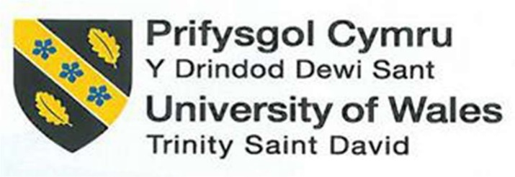

Management and Organisational Behaviour
BMIH5004

Student name: Andrea-Nicoleta Rotaru
Student number: 1912874
Lecturer name: Charlotte Joyner

Executive Summary
The report has shed light on the organisational goals, cultural stances, mission, vision, values and structural developments at Hyatt Group in the United Kingdom. It has focused on the recent changes that have taken place within the organisation while emphasising the positive and negative impacts of such changes. The report has further discussed the relevant theoretical underpinnings and examples from the Hyatt Group with recommendations to mitigate challenges. This has been analysed in terms of understanding their managerial schemes and how they have been able to overcome the challenges imposed by the adversities of the changes initiated within the organisation.
Table of Contents
Introduction 4
Organisation structure, goals and culture 5
Recent change initiatives, their impact and how well these were managed 8
The organisation’s strategic direction and current business performance 11
Conclusion 15
Recommendations 16
Reference List 17

Introduction
Organisational behaviour can be determined as the study of how organisations, individuals and groups influence and interact with one another, especially within the field of business management, driving cultural elements (Khosravi, 2021). Following this, the report will shed light on the organisational framework, vision, mission statement, values, goals and cultural diversification of Hyatt Group. Hyatt is headquartered in the United States, within the hospitality industry, and was established in the year 1957 by Jay Pritzker and Jason Pritzker (Crunchbase, 2024). The report will focus on the change initiatives undertaken within the organisation with an emphasis on how well Hyatt managed to overcome adversities and emerge as one of the best hotels within the hospitality sector of the United Kingdom. With the help of a SWOT analysis and relevant theoretical underpinnings, the report will cover the strategic direction of the organisation while focusing on the current competitive stance of Hyatt Group.

Organisation structure, goals and culture
The organisational chart displayed for Hyatt Group includes 115 main executives serving the business with their skills and qualities (The Official Board, 2024). This indicates that the organisation follows a hybrid framework combining the components of both the functional and divisional organisational structures. Hyatt is established as an alluringly positioned business, owning its transformation to a business model that is asset-light while focusing on luxury segments, concrete growth and marginal improvements (Seeking Alpha, 2023). This indicates that the organisation has been capable of endorsing exclusive structural developments along with effective managerial positions in terms of engaging in the establishment of competitive advantages. For instance, the significant appreciation of share prices at Hyatt limits near-term upside, indicating patience. Backed by actionable commitment and measurable goals, Hyatt Group has been engaged in caring for responsible business, caring for individuals and caring for the planet (Hyatt, 2024a). This can be underpinned by the concept of corporate social responsibility and the Triple Bottom Line Theory.
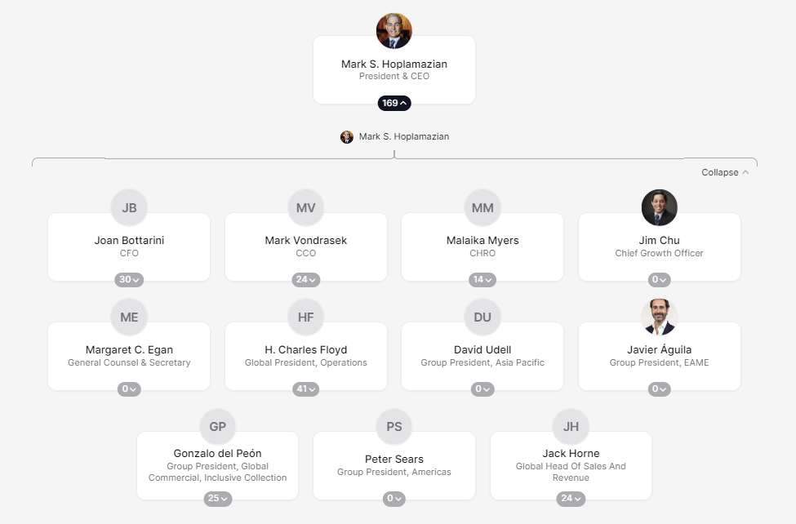
Figure 1: Hyatt’s Organisational Chart
(Source: The Org, 2024)
Corporate social responsibility can be identified as context-specific policies and actions undertaken within an organisation taking into account the expectations of stakeholders along with environmental, economic and social performance (Jeffrey, Rosenberg and McCabe, 2019). This has already been underpinned by the components of the triple bottom line along with the stakeholder theory, which, indicatively have been working out well in Hyatt Group. The Triple Bottomline Theory focuses on organisational dimensions revolving around people, the planet and profit committing concerns regarding sustainable performance (Kouaib, Mhiri and Jarboui, 2020). Hyatt has been following the scheme with an emphasis on involving its stakeholders in sustainable supply chain management as an essential aspect of developing organisational culture. Organisational culture plays a vital role in Hyatt and the organisation believes in every individual to be at his or her best inspiring authentic connection while fostering care for one another and guests at the same time (Hyatt, 2024b).
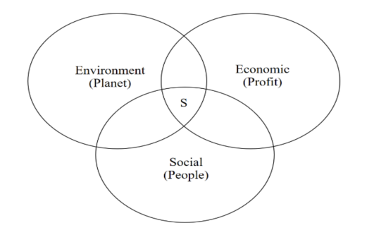
Figure 2: Triple Bottomline Theory
(Source: Shim et al., 2021)
This indicates that the stakeholders of the organisation have been valued over the years and the Stakeholder Theory can work out well in this regard. For instance, the stakeholder theory takes into account any tool that can be utilised by an organisation for internal operations serving to improve sustainability with a multi-stakeholder approach (Diez-Cañamero et al., 2020). This can be aligned with the organisational goals set out by the organisation in the form of its mission statement, vision and values, involving stakeholders. For instance, the mission statement of Hyatt is to deliver an exclusive experience for guests with a vision to create a caring and understanding world, emphasised by its cultural values (Comparably, 2024). The cultural stances of the organisation have been underpinned by Edgar Schein’s Cultural Framework, leveraging the stages of culture with organisational goals. For instance, the model involves dimensions in the form of Artefacts or Symbols, Espoused Value and Underlying or Tacit Assumptions (Tait et al., 2019).
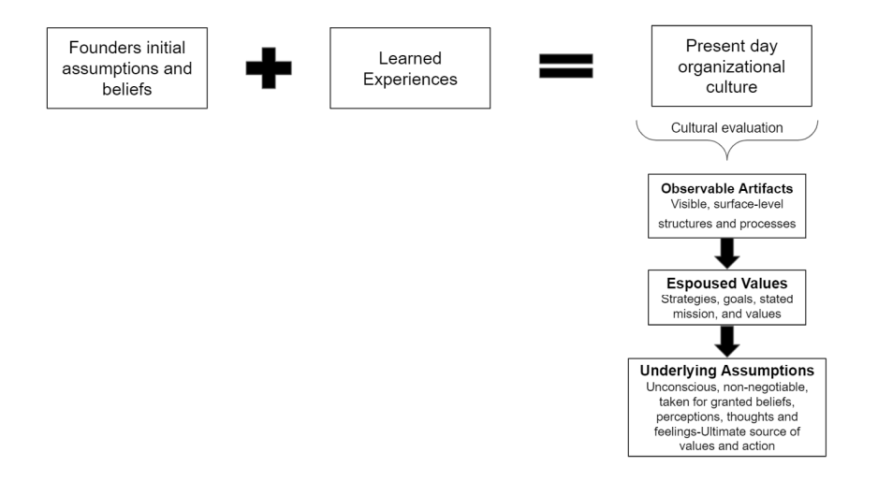
Figure 3: Edgar Schein’s Cultural Framework
(Source: Thompson, 2021)

Recent change initiatives, their impact and how well these were managed
Crainer’s 7 Habits of the new organisation represented a free-flowing workplace environment with an emphasis on non-hierarchical organisational structures (adapted from the module materials). With the benefit of having a hybrid organisational culture, Hyatt is not yet able to enjoy the freedom of a flat organisational framework with a decentralised approach that does not involve bureaucratic or authoritative behaviour. A flat organisational structure determines that an organisation is likely to have a few managerial positions between higher authorities and the workforce, representing a decentralised framework, and not having bureaucracy (Gordon, 2023). This indicates that Hyatt may work out for a change in its hybrid organisational framework and move towards a decentralised structure since it ensures that authority is distributed to all and every staff member feels valued within the organisation. However, lack of trust, blame culture, high employee turnover, lack of morale, excessive stress and negative attitude are prevalent risks of changes that may take place within an organisation (adapted from the module materials).
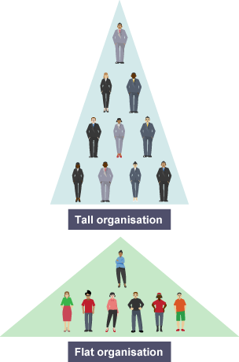
Figure 4: Flat organisational structure
(Source: BBC, 2024)
This can, however, be managed with the help of Lewin’s Change Management Model, and Hyatt has been following such initiatives to keep its workforce satisfied and guests loyal. Lewin’s Change Management Model involves the unfreezing of a prevalent change, the moving or implementation of an innovative change and the refreezing of that new change within an organisation (Burnes, 2020). Hyatt has been able to conduct such approaches and has been efficient in communicating the need for positive changes within the organisation. For instance, Hyatt Group recently announced broadly positive changes to its scheme of “World of Hyatt loyalty programme” for 2024, although complicated, but free of devaluation (Burgess, 2023). Hyatt engaged in the provision of a “Guest of Honor,” a perk available exclusively for the top-tier Globalist members, for 60 nights every year. This allows Globalists members to book for anyone of their choice, providing them with the facility to be treated as a Globalist member themselves, laced with club access, free parking, upgradation to the best available room, guaranteed check-out at 4 p.m. and free breakfast.
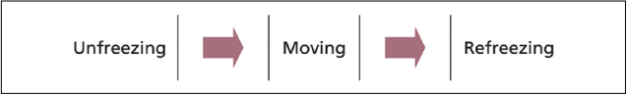
Figure 5: Lewin’s Change Management Model
(Source: Burnes, 2020)
At a point, a change in this scheme was announced where the “Guest of Honor” no longer remained a part of the Globalist perk and was certified as the Milestone Rewards (Burgess, 2023). This became available to every individual and was not only limited to top-tier globalists, and now, every guest planning for a 40-elite night stay at Hyatt can earn one voucher for the “Guest of Honor.” Although this was good news for guests who booked for 40 nights, it adversely impacted the need for a 60-night stay for a globalist at Hyatt. It is even more adverse for globalists who already made large counts of “Guest of Honor” redemption points since there now is a cap relying on the number of certificates being chosen as Milestone Rewards. However, Hyatt managed such adverse impacts by providing valid certificates for an additional 14 months to globalists with individuals with the current Globalist status receiving five “Guest of Honor” certificates.

Figure 6: World of Hyatt
(Source: Burgess, 2023)

The organisation’s strategic direction and current business performance
Strategic management or strategic planning is concerned with undertaking decisions in advance regarding what an organisation needs to perform in the future and prior to any risks that may dismantle the organisational structure (Steiss, 2020). Hyatt has been engaged in strategic planning approaches regarding the development of its organisational goals and culture with an emphasis on its directional practices. This can be underpinned with the help of Handy’s Cultural Model since it may ensure the strategic direction that has already taken place in the organisation focusing on cultural dimensions. Handy’s Model of Organisational Culture involves cultural dimensions in the form of role culture, power culture, task culture and person culture (Mikušová, Klabusayová and Meier, 2023).
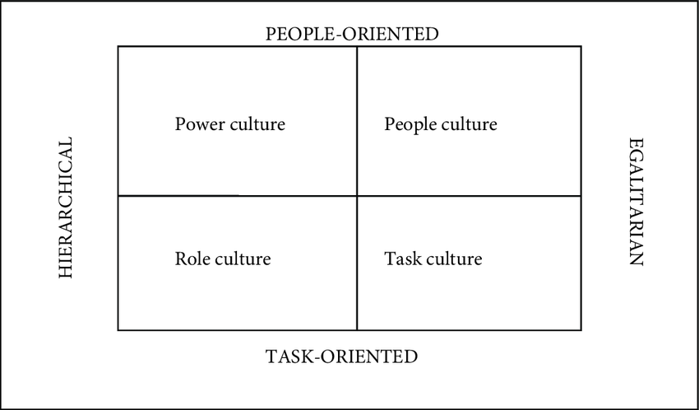
Figure 7: Handy’s Model of Organisational Culture
(Source: Janicijevic, Nikcevic and Vasić, 2018)
Respect, humility, creativity, integrity, empathy and fun are the key components of the strategic direction outlined in Hyatt and the organisation has been fostering environments in terms of making individuals feel valued and welcomed (Hyatt, 2021). Further changes have been decided with strategic implementation in Hyatt with a focus on transforming cultural developments in the form of role, task, power or person. For instance, Hyatt was in the strategic process of transforming the landscape of its hotel operations in Europe (Hyatt, 2020). This was based on planned openings for its new Hyatt-branded hotels in a few desirable destinations all across the globe, focusing on internationalisation.
Competitor Analysis
Competitors | Employees | Revenue
Hyatt Group | 37,000 (Macrotrends, 2024) | $5.89 billion (Statista, 2024)
Marriott International | 148,000 (Global Data, 2024) | $23.7 billion (Global Data, 2024)
Hilton Worldwide Holdings | 178,000 (Global Data, 2024) | $10.2 billion (Global Data, 2024)
InterContinental Hotels Group | 12,886 (Global Data, 2024) | $3.9 billion (Global Data, 2024)
Wyndham Hotels & Resorts | 2,500 (Global Data, 2024) | $1.5 billion (Global Data, 2024)

Table 1: Competitor Analysis
(Source: Created by the learner)
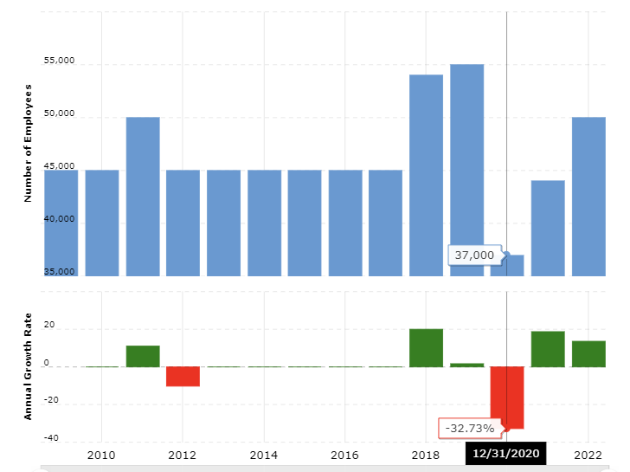
Figure 8: Number of employees at Hyatt
(Source: Macrotrends, 2024)
SWOT Analysis
Strengths | Weaknesses
A restaurant server at Hyatt engages in casual conversation while creating an exclusive experience with the help of their service attributes and styles (Hyatt, 2024c).  Hyatt ensures the inclusion of collaborative leadership since they are the ones owning resources and authority in terms of helping mitigate challenges while deciding the strategic impetus for organisational success. | The advent of the global pandemic imposed a screeching halt on the hospitality industry resulting in almost zero demand within Hyatt overnight while leaders and employees were under immense pressure and unusual stress (Hoplamazian, 2021).  Practising experiments led Hyatt to deal with challenges such as a count of colleagues not being confident about the appreciation they received being at par with their experiences.
Opportunities | Threats
The competitive positioning of Hyatt is likely to develop since its diverse brand portfolio caters to a wide range of market segments (Seeking Alpha, 2023).  With diverse preferences and distinct brands, Hyatt may boost its profitability criteria in the luxury segment in the near future. | Leaders at Hyatt are likely to be monitored by their employees based on their commitment to empathy after acknowledging their biases and ignorance of the workers serving the organisation (Hoplamazian, 2021).  An intensely competitive environment may lead to hyper-competition for Hyatt with the need to develop its pricing strategies.

Table 2: SWOT Analysis
(Source: Created by the learner)

Conclusion
From the above evaluation and analysis, it can be derived that Hyatt has been constantly engaged in developmental activities and strategic changes in terms of developing its competitive stances. This may help in delivering the aspects of both beneficial and adverse influences of the strategic directions that have been implemented by Hyatt Group. For instance, the organisation has been able to implement new changes with success while mitigating a few negative impacts that it had on colleagues. The competitor analysis reveals that Hyatt is not at par with Marriott International or Hilton based on either the count of employees or the revenue generated. However, the revenue generation and the number of employees at Hyatt Group is more than IHG and Wyndham, according to the results stated in Table 1 of the report. With a hybrid organisational structure and a diverse cultural environment, Hyatt has been successfully driving its strategic changes.

Recommendations
- A matrix organisational structure is capable of permitting teams to prioritise key resources and initiatives while allocating them at a rapid pace and responding to changing consumer demands (Logemann, 2023). Hyatt can adapt to a matrix organisational structure where teams can report to multiple leaders, each with its own capabilities.
- Democratic leadership is considered to be an efficient style in terms of leading with decision-making powers being distributed among every member of an organisation while valuing their opinions and contributions (Mansaray, 2019). Hyatt may involve such inputs in its strategic management approach and encourage innovative visionary changes within the organisation.
- Efficient communication skills are essential for leaders within the corporate world in terms of inspiring stakeholders and internal teams while uniting them into cohesive groups (Patel, 2023). Hyatt may take into account the need to improve its organisational performance over the years and focus on team management and cultural dimensions.
- A healthy cultural environment with effective interaction with employees can help them understand how they fit in organisational changes and why are they essential within the scenario of development (Levine, 2018). Hyatt can inform and interact with its employees prior to implementing significant changes within the organisation to involve them.

Reference List
BBC (2024) Tall and flat organisations. Available at: https://www.bbc.co.uk/bitesize/guides/z48y92p/revision/1 (Accessed: 22 February 2024).
Burgess, R. (2023) How do the World of Hyatt changes announced last week work in practice? Available at: https://www.headforpoints.com/2023/12/10/world-of-hyatt-guest-of-honor-changes/ (Accessed: 22 February 2024).
Burnes, B. (2020) The origins of Lewin’s three-step model of change. The Journal of Applied Behavioral Science, 56(1), pp.32-59.
Comparably (2024) Hyatt Mission, Vision & Values. Available at: https://www.comparably.com/companies/hyatt/mission (Accessed: 22 February 2024).
Crunchbase (2024) Hyatt. Available at: https://www.crunchbase.com/organization/hyatt (Accessed: 22 February 2024).
Diez-Cañamero, B., Bishara, T., Otegi-Olaso, J.R., Minguez, R. and Fernández, J.M. (2020) Measurement of corporate social responsibility: A review of corporate sustainability indexes, rankings and ratings. Sustainability, 12(5), p.2153.
Global Data (2024) Hyatt Hotels Corp: Competitors. Available at: https://www.globaldata.com/company-profile/hyatt-hotels-corp/competitors/ (Accessed: 23 February 2024).
Gordon, J. (2023) Flat Organization – Explained. Available at: https://thebusinessprofessor.com/en_US/management-leadership-organizational-behavior/flat-organization-definition (Accessed: 22 February 2024).
Hoplamazian, M. (2021) Hyatt CEO: The pandemic taught us that experimentation is good for business. Available at: https://fortune.com/2021/05/30/business-experimentation-diversity-equity-inclusion-hyatt/ (Accessed: 23 February 2024).
Hyatt (2020) Hyatt Continues Vibrant Brand Growth Journey in Desirable European Locations. Available at: https://newsroom.hyatt.com/european_growth (Accessed: 23 February 2024).
Hyatt (2021) Advancing our Purpose of Care. Available at: https://about.hyatt.com/content/dam/hyatt/woc/2021DEIReport.pdf (Accessed: 23 February 2024).
Hyatt (2024a) About Hyatt. Available at: https://about.hyatt.com/en.html (Accessed: 22 February 2024).
Hyatt (2024b) We Embrace Everyone. Available at: https://about.hyatt.com/en.html#:~:text=Our%20culture%20is%20one%20that,other%20and%20for%20our%20guests. (Accessed: 22 February 2024).
Hyatt (2024c) Working with Hyatt. Available at: https://about.hyatt.com/content/dam/HyattStories/risehy/resources/Playbook2WorkingwithHyatt.pdf (Accessed: 23 February 2024).
Janicijevic, N., Nikcevic, G. and Vasić, V. (2018) The influence of organizational culture on job satisfaction. Economic Annals. 63. 83-114.
Jeffrey, S., Rosenberg, S. and McCabe, B. (2019) Corporate social responsibility behaviours and corporate reputation. Social Responsibility Journal, 15(3), pp.395-408.
Khosravi, B. (2021) How Organizational Behavior Science Can Help Startups Manage New Norm? Available at: https://www.forbes.com/sites/bijankhosravi/2021/06/13/how-organizational-behavior-science-can-help-startups-manage-new-norm/?sh=33db6445b338 (Accessed: 22 February 2024).
Kouaib, A., Mhiri, S. and Jarboui, A. (2020) Board of directors’ effectiveness and sustainable performance: The triple bottom line. The Journal of High Technology Management Research, 31(2), p.100390.
Levine, S. R. (2018) Motivated Employees Are Key To Your Company's Success In The Digital Age. Available at: https://www.forbes.com/sites/forbesinsights/2018/03/12/motivated-employees-are-key-to-your-companys-success-in-the-digital-age/?sh=171e865d2ddc (Accessed: 23 February 2024).
Logemann, R. (2023) Managing For Success In A Matrix Organization. Available at: https://www.forbes.com/sites/forbesbusinesscouncil/2023/09/15/managing-for-success-in-a-matrix-organization/?sh=6d8b8eba2e1f (Accessed: 23 February 2024).
Macrotrends (2024) Hyatt Hotels: Number of Employees. Available at: https://www.macrotrends.net/stocks/charts/H/hyatt-hotels/number-of-employees (Accessed: 23 February 2024).
Mansaray, H.E. (2019) The role of leadership style in organisational change management: a literature review. Journal of Human Resource Management, 7(1), pp.18-31.
Mikušová, M., Klabusayová, N. and Meier, V. (2023) Evaluation of organisational culture dimensions and their change due to the pandemic. Evaluation and Program Planning, 97, p.102246.
Patel, L. (2023) The Power Of Effective Communication In Leadership. Available at: https://www.forbes.com/sites/forbesbusinessdevelopmentcouncil/2023/09/05/the-power-of-effective-communication-in-leadership/?sh=4179f3f46bf4 (Accessed: 23 February 2024).
Seeking Alpha (2023) Hyatt Hotels' Strategy In A Resilient And Evolving Industry. Available at: https://seekingalpha.com/article/4627888-hyatt-hotels-strategy-in-a-resilient-and-evolving-industry (Accessed: 22 February 2024).
Shim, J., Moon, J., Lee, W.S. and Chung, N. (2021) The impact of CSR on the corporate value of restaurant businesses using triple bottom line theory. Sustainability, 13(4), p.2131.
Statista (2024) Revenue of Hyatt Hotels Corporation Worldwide. Available at: https://www.statista.com/statistics/257362/revenue-of-the-hyatt-hotels-corporation/#:~:text=In%202022%2C%20hotel%20giant%20Hyatt,company's%20revenue%20peaked%20in%202022. (Accessed: 23 February 2024).
Steiss, A.W. (2019) Strategic management for public and nonprofit organizations. Routledge.
Tait D., Schein, E., Lloyd B., Trockel, M., Schein, P. and Kirch, D. (2019) Healing the Professional Culture of Medicine. Mayo Clinic Proceedings, 94(8), p.1556-1566, ISSN 0025-6196.
The Official Board (2024) Hyatt. Available at: https://www.theofficialboard.com/org-chart/hyatt (Accessed: 22 February 2024).
The Org (2024) Hyatt. Available at: https://theorg.com/org/hyatt (Accessed: 22 February 2024).
Thompson, S. (2021) Where does culture come from? An investigation of the origination and evolution of one startup’s culture and a test of Schein’s theory of organizational culture formation.

