Ways of Perceiving

3D Recreation of Photos: Contextual Practices

Contextual Studies

Connor Hale: 1701744

The Recreation of Photos for Virtual Reality



The concept for my exhibition is the idea of how photos have a large significance over how we see the past and how it can affect us now. The idea that photos are a huge part of our past and how we see ourselves now and how much we have changed.
That is where my idea for the exhibition came from. The fact that a photo takes a snap shot from a single point in the past and these photos can also hold value, information and even nostalgia for most people. I feel that photos are underrated nowadays since almost everyone has a smart phone in their pockets 90% of the time. But years ago, when photos were harder to procure and create, having a photo taken showed that that moment had a large significance and was worth preserving. Which is why older photos have a larger impact on us nowadays when we look back on them. My plan is to mix newer technology and immersion with old photos and how they influence people.

Exhibition

My exhibition will be largely made up of the VR (Virtual Reality) experience and give people a new founded appreciation for older photos, if they did not already. The plan is to recreate old photos into an actual scene for a person to experience in the VR space. Letting everyone walk around while the scene shows the process of the photo being taken.
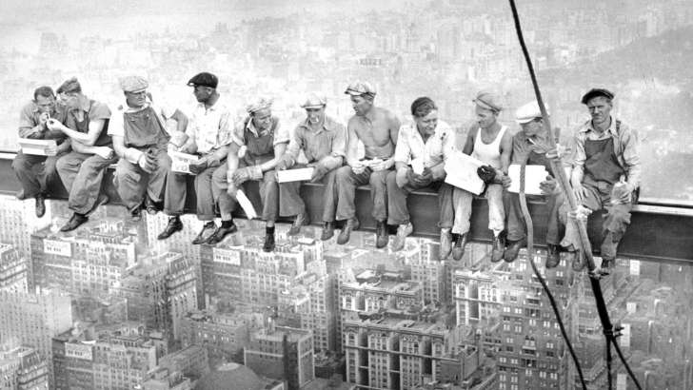

(Lunch atop a skyscraper) [1]

For example, “Lunch atop a skyscraper” would be recreated so the audience would see the men eating their food, the birds flying past, see the photographer taking the photo, the swaying ropes in the wind. All this to give the experience of being in that one moment of time, much like what people take photos attempt to do. This idea mostly applies to why people take photos in the first place, to feel nostalgic and bring them back to the scene they took the photo of. Which I thought would be an even better experience in VR.

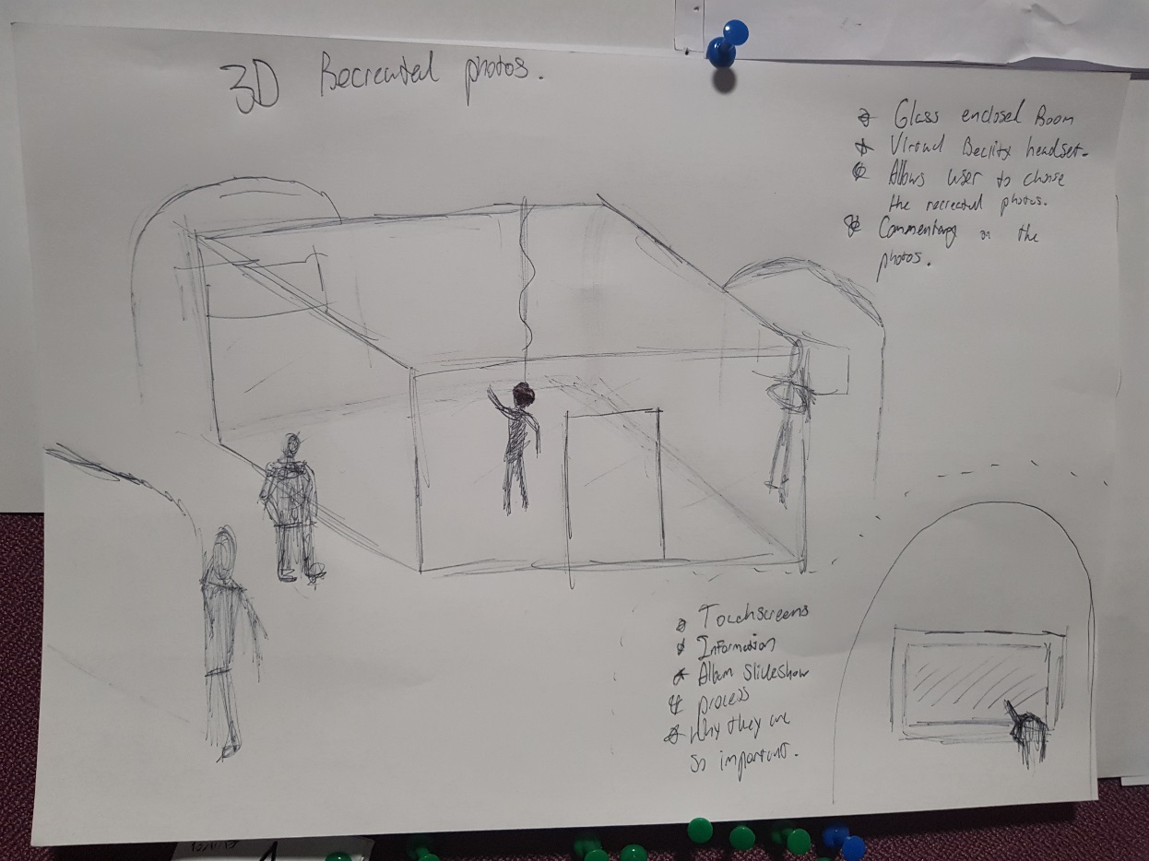

My exhibition will contain the one glass enclosed room with a single VR headset in the centre, which can be worn by anyone visiting the exhibition. The idea is that the user will be able to choose from a selection of recreated photos from our past, which will also include a commentary explaining what is happening in the scene, why its iconic and why the photo is still remembered too this day. Many iconic photographs such as “Lunch atop a skyscraper”, “The Tank Man” and “Pillars of Creation” will be recreated in a moving scene for the audience to wander around and observe in a new unique way. The main message I plan on trying to convey is how photos can take moments in history and preserve them on a canvas. How photos can be used to show its own message and show moments in history that could be forgotten without them. The exhibition will also contain some touchscreen tablets that do not show the scene in a VR sense but a slideshow of all the photos that are being recreated with the same commentary explaining the history of the old photos. They will also show a live feed from the current VR users perspective, so people can see from their point of view.

I will use Time Magazines website “100 Photos, The Most Influential images of All Time” [2], as a source of reference for what images I will put in my exhibition. Since all the photos have enough information on the photo and why they are so influential.

Philosophy behind photography

Joan Fontcuberta’s (An author and conceptual artist) essay of I Photograph Therefore I Am, Page. 2 mentions “the presence of the camera that makes an event historfiable”, [3], which to me tells me that because we can photograph we can preserve history more effectively and a lot can be told about a photograph and the time it was taken just by looking at what is in it.
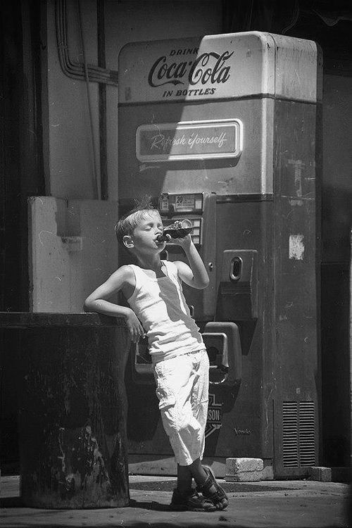

(Vintage Coca Cola ad) [4]

Most photos are taken to keep a memorable moment and because you have taken the photo, it can always be referred too and remembered as a single point in time. Photography became more commercially available at the start of the 20th century. Especially with the introduction of the polaroid in the 1940’s [5]. This allowed people to make their own art with photography and was used in advertisements and became its own medium of art. It became more common to take instant photographs and people would save them, frame them and keep them to look back to for reminiscence.

This philosophy then ties into my exhibition and not only showcases historical moments and events but moments that someone may consider special, so they can look back at that moment captured in history.
Vilém Flusser (philosopher, writer and journalist) says in his book “Towards a philosophy photography” ( 1984, Page. 41) [6],

“Photographs are ubiquitous: in albums, magazines, books, shop windows, on bill-boards, carrier bags, cans. What does this signify?”

Since this book was written before the digital stage of photography, where photographs are now much more common place, he talks about how photos are appearing everywhere and that we are starting towards a cultural revolution, dominated by photographs. Although photos are now used in many different mediums and products they represent many different things dependant on what the photographer is trying to communicate. They can be used in lots of different ways whether its directed towards advertisement or art, they are still the same thing but communicate different things altogether.
This is maybe why photographs are so important and how they managed to start the huge movement towards the “cultural revolution”. How photographs can represent history and events, someone’s way of expression, art, advertisement and many other forms of media.

This fits into my exhibition as I could use this philosophy in the commentary, so people can also get another appreciation for photographs. Using this philosophy to try and give people another perspective on how photographs help the world and other forms of media develop. How photography helped advertisement evolve into the now video advertisements seen on every television and computer. Or how they have now helped catalogue many world events since its inception. Even help people learn, through showing an experiment or how animals live in the wild.

While in Vilém’s book, his philosophy mostly contain arguments like photographs are only colour and made to look like reality when it is not:
“The green of a photographed
field, for example, is an image of the concept 'green', just
as it occurs in chemical theory, and the camera (or rather
the film inserted into it) is programmed to translate this
concept into the image.” – (Page. 43)

It still shows how photography can be used to show emotion and how it affects us as people. Even while in theory it isn’t real and is only a representation of the event that occurred, it is still something that reminds us of the event it came from.

Bibliography

Charles Clyde Ebbets, (1932), Lunch atop a Skyscraper [Online]. Available at: https://upload.wikimedia.org/wikipedia/en/1/13/Lunch-atop-a-skyscraper-c1932.jpg [Accessed 25 April 2018]. [1]

Times 100 Photos. 2018. Times 100 Photos. [Online] Available at: http://100photos.time.com/?view=timeline&position=113. [Accessed 25 April 2018]. [2]

Fontcuberta, Joan, 2018. I Photograph, Therefore I am. I Photograph, Therefore I am, [Online]. 1, 8. Page number 2, Available at: https://moodle.uwtsd.ac.uk/pluginfile.php/70121/mod_resource/content/1/Joan%20Fontcuberta%2C%20I%20Photograph%20Therefore%20I%20Am.pdf [Accessed 25 April 2018]. [3]

(Unknown), (1950), Vintage Coca Cola Ad [Online]. Available at: https://i.pinimg.com/originals/fa/6e/e6/fa6ee620d3f8a43045401b532a1275f8.jpg [Accessed 25 April 2018]. [4]

Shoot Old School. 2015. History of Polaroid. [Online] Available at: http://shootoldschool.com/history-of-polaroid/. [Accessed 25 April 2018]. [5]

Flusser, V., 2000. Towards a Philosophy of Photography. Reaktion Books, Limited. Available at: http://cmuems.com/excap/readings/flusser-towards-a-philosophy-of-photography.pdf [6]

Unused Reference/ Reading List

Hockney, D., 1999. That's the Way I See It. Thames & Hudson.

Foto Mueseum, Walead Beshty. 2012. Walead Beshty Blog. [Online] Available at: https://www.fotomuseum.ch/en/explore/still-searching/authors/26396_walead_beshty.

Metamodernism. 2013. Photography, Imperfection, Education. [Online] Available at: http://www.metamodernism.com/2013/04/11/photography-imperfection-education/.

Vox. (2017). How Obsessive Artists Colorize Old Photos. [Online Video]. 30 May 2017. Available from: https://www.vox.com/videos/2017/5/30/15712820/how-artists-colorize-old-photos.

