Effective-team working and communication

A report on communication within the workplace.

Rahima Akther Khanom (1806290)
Module code: BMSK 4002
Lecturer: Anthony Burns

Executive summary

Effective communication verbal and non-verbal is important for the success of the organization as it is a huge factor and a basic function.

To be able to convey a message clearly depends on how effectively you are able to get it through.

Contents page

- Executive summary
- Introduction
- Main Findings

  - Background of case
  - Groups and Teams
  - Communication
  - Recommendation
  - Conclusion

- Reference list

2.0 Introduction

This written assignment has been set by Anthony Burns in regard to a report on communication within the workplace.

Rahima Akther Khanom has compiled this report.

The 2000-word report has been produced that covers the following points:

1)Effective communication (verbal and non-verbal) is important for the success of the organisation.
2)Importance of two-way communication
3)Effective methods of communication
4)How Tuckman and Belbin can improve teamwork in the organisation.

The submission deadline for this report is the 12th April 2019.

3.0 Main Findings

3.1 Background of case

Michelle Sullivan owns 9 medium sized toy stores, she employs 27 people.
Many of her employees work part-time, the store opening hours are between 8.00am – 10.00pm.

There are no formal teams within the workforce, which leads to a lack of information not shared and a breakdown of communication.

There has been rapid expansion of the business and to enable complete success of the store Michelle requires advice on team structures that can facilitate and enable effective communication amongst the workforce, to prevent problems occurring.

3.2 Groups and Teams

Bruce Tuckman (1965) developed a model for team development, he suggested that there are 4 stages that is used for successful team building.

- Forming – A team that develops a group, who do not know the requirements and are new to each other, they are kind and polite.
- Storming – A group is now challenging each other, and communication is critical
- Norming – Rules are set, trust is built, and communication becomes professional.
- Performing- Sharing the same objective, supporting each other, and striving to complete the task together.
- Adjourning – (added in 1977) The project is completed, and everyone moves on.

Characteristics of a team

- Information is shared
- Feelings are shared
- Objectives are the same
- There is good leadership
- Trust is built
- Support from management
- Roles are clear
- Solving problems as a team

If teams are not performing it may mean there is space for improvement.

Meredith Belbin (1970) suggested that a high performing team contained 9 roles which is

- Plant
- Co-Ordinator
- Resource Investigator
- Shaper
- Team Worker
- Monitor
- Implementor
- Completer finisher
- Specialist

The difference between groups and teams is generalising, a group has different characteristics to a team.

A group of individuals that has no common goal, yet individual objectives, do not trust each other and keep information for themselves, they are the ‘Forming’ team.
For example, a group of people who are waiting to be interviewed will not chat amongst themselves therefore there is no communication.

A team is individuals who share a common purpose, and agreed objectives, with trust and loyalty, they are happy to share information to achieve their shared goal.
For example, if a team were to achieve the target for the end of the month, they are allowed to have a reward, or bonus, therefore every individual within the team will work hard to achieve the target and will have to communicate.

“Team working can give a team member a sense of identity, support, and friendship”.
Bowler and Brass, (2006).

The benefits of effective teams improve the quality of products, services and a
motivating environment to work in.

To build an effective team you must focus your attention on three key areas leadership, ownership and relationships.

Characteristics of groups

- Conflict
- Trust is guarded
- Failure
- Early stage of a team
- No support from seniors
- Individuals work alone and not share ideas
- Amateur

3.3 Communication

Verbal communication

Verbal communication is words that are spoken or written, it is words in the form of languages that makes it easier for people to send messages or talk,
informing others of what we intend to convey, or imparting knowledge to others, or by bringing clarification of missing information and misunderstandings that may arise.

Examples are:

- Making an error and apologising for example,” sorry” is an effective and powerful word that can help you in times of need.
- Creating new relationships by making an effort to converse with other employees will help to enable new relationships, this must be done by verbal communication.
- Persuading a co-worker to work on a new project, is a good verbal communication skill that has to put your co-worker on board.
- The empowerment of employees through upward and downward communication is a sign of increased job satisfaction, for example if the manager listens to employees, they feel empowered.
- Clear communication is the key to success, it removes the hurdles between management and employees while working.
- By boosting motivation and words of support, management can boost the employee’s confidence and in return they help productivity.
- Communication within teams is a two-way flow of ideas that ensures better outcomes.
- Communication of facts and new updates ensures transparency and less absenteeism.

Non-verbal communication
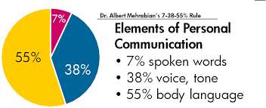

Figure 1
(Source: Google images)

Using body language to communicate with others is non-verbal communication, recognizing these non-verbal communications can help you communicate more effectively.

- Agreement and disagreement while having staff meetings require consent from the audience for example a simple “nod” can imply a “yes” or “no”.
- Listening when there is no eye contact with employees shows they are not paying attention to you but maintaining eye contact ensures the message is conveyed.
- Paralanguage may not convey the audience if the volume or pitch of the voice is too low or too fast.
- Keeping your head in an upright position, maintaining eye contact, knees slightly apart, and arms away from the body indicates confidence.
As a manager you would want to be able to show you have the confidence in what you are doing.
- Detachment shows lack of interest, having a hunched posture and crossed arms.
- Understanding todays culture, diversity in the multicultural environment is important for example different cultures have different meanings and employees could get offended, for example a Muslim woman shaking a male’s hand is not allowed.
- Maintaining space between colleagues must be optimal, not to far or not to close as it can create tension and uneasiness and also differs in different cultures.
- Maintaining relationships makes a huge impact of working within the workplace every day, by smiling or wishing someone a good day can create a different and happy atmosphere.
- Forming impressions, perceptions, the characteristics of an employee can influence the impression of your own personal past experience, sometimes we take some situations too seriously, this can have an impact on the relationship we have with that person for example age, sex, race, culture, accent, appearance and posture.

Two-way communication

Two-way communication is important as messages are transmitted between employers, employees, customers, and suppliers, feedback is required so that the message was received and understood.

Below is Schramm’s model of communication (1954)

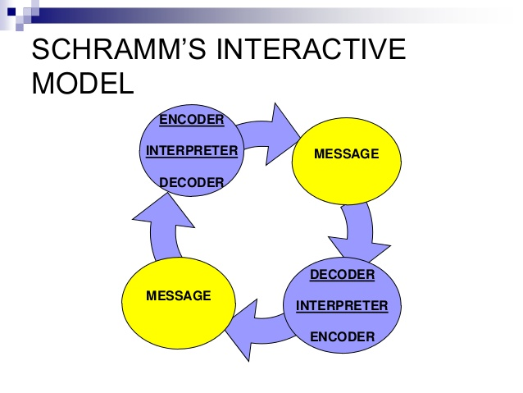
Figure 2
(Source: Google image)

Examples of two-way communication is:
- Phones
- Emergency response personnel
- Police
- Fire
- Public transport
- Aviation
- Building trades

The two-way communication system can range from simple hand-held two-way transceivers to a more complex system in order to share several channels. However, this varies on many factors, for example where the location is, the number of users, the frequency, and the cost of the system.

Two-way communication has one common feature which is to support the network of where you work, for example:

- Asking relevant questions
- Listening
- Treating people equally
- Understanding and keeping employees tuned in
- Speaking the same language
- Using plain, simple, English.

We listen at 5 different levels, listening to co-workers and customers has an impact on the success of a business.

Ignoring – is the lowest level of listening.
Pretend listening – When your facial expressions show there is no interest, but they respond yes, or ok.

Selective hearing – When you listen to the speaker for as long as you are interested in, however as soon as it no longer interests us you ignore them.

Attentive hearing – Carefully paying attention to the speaker yet formulating your response to what the speaker is saying.

Empathetic Listening – the hardest to accomplish, and the top level of listening.

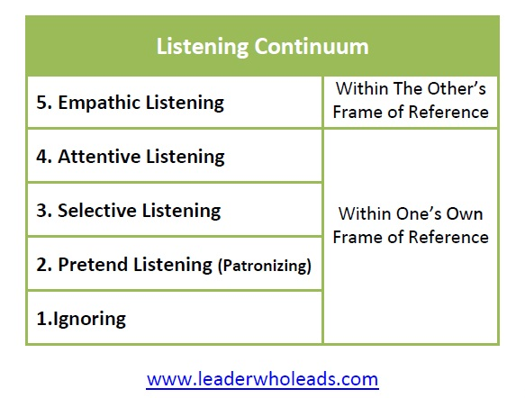
Figure 3
(Source: Google image)

Two-way communication is vital to improving the organisational performance, it is the only complete communication process that happens. Below is the two-way communication that highlights the importance:

- An employer emails the employee highlighting their attendance at work, the employee receives the email, then emails back (feedback) with an excuse or problems that has caused this, he/she then sends (decodes) the message back.

- Two-way communication is most effective when you pause and listen, re-assure and summarise, offer an agreement or solution.

In relation to the case study Michelle can have weekly meetings in order for all employees and managers to discuss relevant information of what is happening, how, why and when anything may occur, this way there is all information passed on to the relevant people and clear clarification to job roles.
Employees can voice opinions without fear and problems can be solved.
Having continues meetings ensures targets are met and everyone can have updated objectives.

For employers it is essential that the skills used for giving feedback is upmost importance to create a supportive and motivating atmosphere. Managers need to make sure they:

- Be specific
- Ensure goals are achieved
- Ensure feedback is understood
- Tailor the message well
- Give clear objectives to employees
- Use open questions
- Explain the facts and impacts of unresolved matters

Managers must ensure they keep a professional appearance and acknowledge what employees are saying.

Asking the right questions in a particular situation can improve your communication skills, managers are able to build on stronger relationships, manage people more effectively, help teach others effectively, and manage people effectively, this is by using the funnel technique, by using open and closed questions, and using questions that begin with what, why, and how, for example in a workplace scenario finding out the managers or employees opinion you could ask “Do you think everyone can adapt if these changes were made?”

The funnel questions start with general questions but then be more specific and involves asking for more details at each level of the funnel.

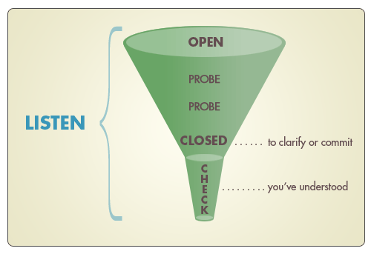
Figure 4
(Source: Google images)

Having effective methods of communication

- Social media
- Verbal communication
- Email
- Written communication
- Meetings
- Visual communication
- Paralanguage
- Body language

Conflict

Having conflict within the workplace is a part of the team development process, when personal characteristics differ, the difference of opinions or two shapers revealing against each other wanting control within a team is caused when information is not shared, which leads to a breakdown of communication.

A ‘team worker’ helps bring the team together and can come to a resolution yet a good Co-Ordinator can resolve difficult conversations.

Employee conflict can arise due to many factors such as:

- Perceptions
- Attitudes
- Interests
- Gender
- Mood
- Expectation
- Assumptions
- Culture

Over time if there is still a breakdown of communication and the issue is still not resolved there maybe conflict that occurs which can decrease productivity, and employee morale. In order for managers to resolve the situation they must:

- Understand the nature of the conflict
- Pro-actively intervene
- Resolve the matter quickly
- Listen by giving both parties a chance to explain, offer them ideas on how to resolve it.
- Train managers to understand how to overcome barriers to communication so they can coach employees in the right minority effective training.
- Have rules and regulations in place
- Give a ‘cool off’ period

3.4 Recommendation

Recommendation | Who is responsible for actioning? | To be completed by (date) | Costs incurred?
Meetings (feedback/updates/questions) | Manager | Every 2 weeks | Free
Staff training (team building exercises) | Manager | Every 3 weeks | £3,000
Reward for targets (canoeing/go karting) | Manager | Every 4 weeks | £300
Figure 5
(Source: Rahima Khanom)

3.5 Conclusion

Communication is a vital to ensure business can succeed, the breakdown of communication creates barriers between employees, employers, customers and suppliers.

Using different theories and applying them to Michelle’s toyshop will enable her to ensure that implementing changes in the way we are and towards our co-workers will make a difference in how to communicate effectively. There are many learning curves with many barriers that may arise however, using the right way and applying theories in those situations any manager will be able to overcome them.

- Reference list

Belonwu, V. (No date).20 ways to communicate effectively with your team. (Available at:
https://smallbiztrends.com/2013/11/20-ways-to-communicate-effectively-in-the-workplace.html Accessed on: (15 March 2019).

Bell, A. (No date). Groups and teams. (Available at: https://ablesim.com/groups-and-teams/ Accessed on: (26 March 2019).

Belludi, N. (2008). Albert Mihranian’s 7-38-55 rule of personal communication. (Available at: https://rightattitudes.com Accessed on: (2 April 2019).

Fenner, S. (No date). Now what is two-way communication? – definition, systems and examples. (Available at:
https://study.com/academy/lesson/what-is-two-way-communication-definition-systems-examples.html Accessed on: (2 April 2019).

No author name. (No date)./Levels of listening(Available at: www.leaderwholeads.com/levels-of-listening.html(Accessed on: (3 April 2019).

No author name. (No date). /Models of communication (Available at:
https://www.slideshare.net/geniusgautams/models-of-communication-23831945
Accessed on: (4 April 2019).

No author name. (No date). Questioning techniques (Available at: https://www.mindtools.com/pages/articles/newTCM_88.htm (Accessed on: (6 April 2019).

Rohn, J. (No date). Different effective methods of communication (Available at:
https://www.educba.com/different-methods-of-communication Accessed on: (7 April 2019).

Reddy, K. (No date). why is verbal and non- verbal communication important at a workplace. (Available at:
https://content.wisestep.com/verbal-nonverbal-communication-important-workplace
Accessed on: (8 April 2019).

No author. (No date). Skill fukk questioning and active listening (Available at:
https://faculty.londondeanery.ac.uk/e-learning/appraisal/skilful-questioning-and-active- listening Accessed on: (9 April 2019).

No author. (No date). What is two-way communication? (Available at:
https://www.google.com.amp/ls/the businesscommunication.com/two-way-communication-and-importance/amp Accessed on: (10 April 2019).

