Changemakers: CREATIVITY AND VALUE CREATION
Assignment 2: E-Portfolio
Digital Degree Apprenticeship
0501251
Craig Oldham
Table of Contents
E-Portfolio 2
Link 2
Screenshot 2
Task 1 2
Screenshot 2
Task 2 3
Screenshot 3
Task 3 3
Screenshot 3

E-Portfolio

Link
The E-Portfolio can be found by using this link: CHANGEMAKERS - Home (weebly.com)

Screenshot
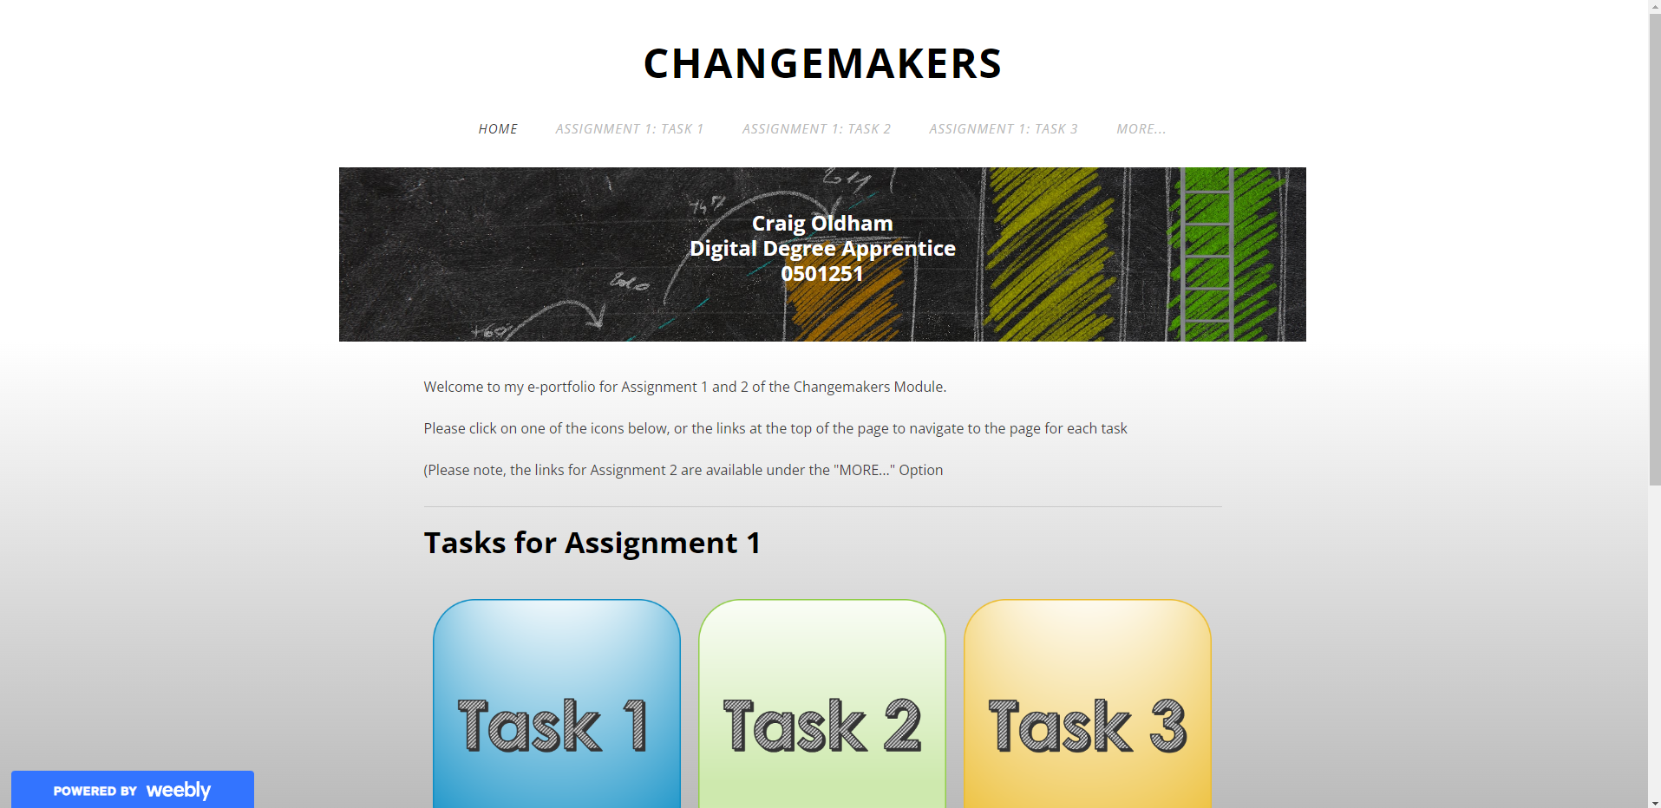

Task 1

In the event the on-page link doesn’t work, the mind map can be accessed by clicking the following link: How Innovation Shapes The World - MindMeister Mind Map

Screenshot
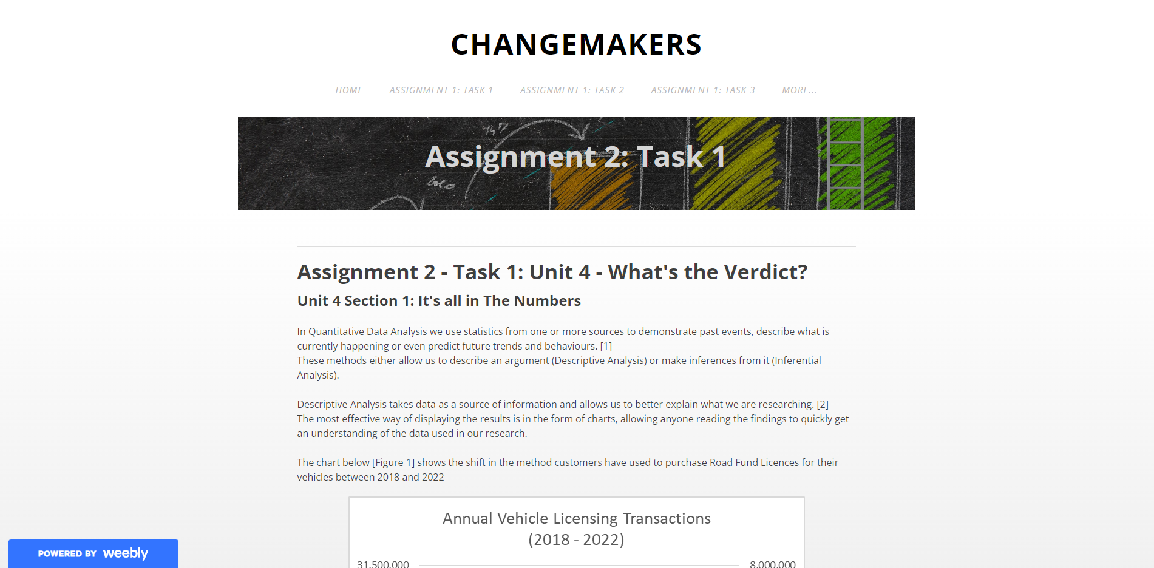

Task 2

Screenshot
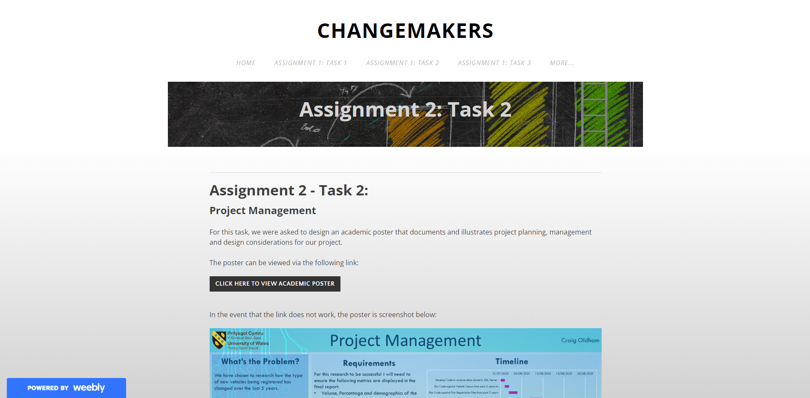

Task 3

Screenshot


