
Student Name: | Ali Miah
Student Number: | 1709388
Module No: | BMSK4001
Module Title: | Academic and employability Skills
Lecturer Name: | Peter Allen
Skills for the Workplace
Module Assignment Submission
Assessment-2

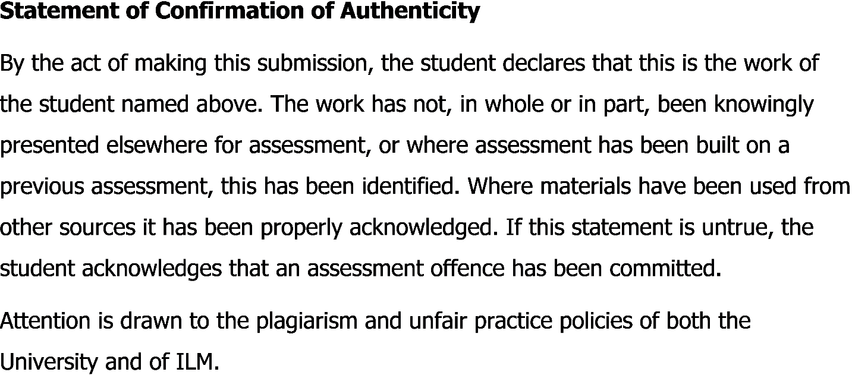
Table of Contents

Introduction 3
Description 3
Feelings 3
Evaluation of my Learning 3
Analysis 5
Conclusion 6
Action Plan 6
References 7

Introduction
This will be a reflective report based on my learning from this module. There were many learning opportunities available for me and I was able to learn a lot from modules. This module helped me to develop both my academic and employability skills. The learnings from my last semester was a great boost for my academic and employability skills and I was able to discover some new insights about me such as my core strengths and weaknesses. I am honoured and happy to get such a learning opportunity early in my university life and all my learning from the module will be reflected in this report. I was able to find out my skill gaps and come out with a proper plan for self-development. To reflect my whole experience I will be using Gibbs model of reflection. The Gibbs reflective cycle was established in 1998, and is about learning by doing and has six steps, which will be discussed below (Gibbs, 1998).

Description
The module was introduced to all of us in the class where we were able to know that it would include learnings about both academic skills and employability skills. The focus on the academic skills such as academic learning, research methods and referencing techniques. In the meantime, I was able to learn several employability skills that will be essential for me when I get a real job in future. In the class, we worked as a group and formed teams among us, which helped with our learning, and we did group studies as well to improve our academic skills and learn about the employability skills. The skilled we focused on improving are the writing skills, research skills, referencing techniques, communication skills, presentation skills, critical thinking and problem solving abilities as these skills will be beneficial for me as a student as well as for me working for an organization (Cottrell, 2010).

Feelings
It was a great feeling of excitement to learn something new in the class. Academic learning was something I was able to learn so easily and something new was also there for learning such as research methods and referencing techniques which was totally new to me and for the rest of us and it gave me a an extra crave for learning from the class. Whenever I needed help, I was able to discuss with the professor and with my classmates and it made things easier and a total teamwork effort was there as everyone helped each other and it felt so good.

Evaluation of my Learning
The learning experience includes both positive and negative experiences although I will provide more percentage on the positive side. The good and positive side of the experience was my learning regarding the academic skills. The most important learning to start with was about the academic writing, which I had not clear idea before. I though academic writing is like any other learning but I learned the correct way of academic writing. I learned how to use a formal tone in academic writing rather than using a casual tone, which was a mistake, I did before. I was able to learning about techniques such as the usage of third person for formal academic writing and the use of first person for reflective writing. I learned about the proper use of word and I try my best to use less word with more meaning on it. The main idea of writing is to make it simple and clear for everyone is short sentences.
Apart from academic writing, I learned about research methods and techniques. Before joining the university, I never thought research could be so easy and fun. With the use of internet, we are able to reach towards any information around the world and this makes research more interesting. I was able to learn about qualitative research methods and quantitative research methods. In qualitative research methods I learned how to ask questions about a given topics and record their different opinions. Whereas the quantitative research method includes the use of numbers.
Moreover, I learned about the Harvard Referencing techniques, which will benefit me through the rest of my life. Whenever I write a proper academic report or publish a writing of my own, I will be able to provide proper references of the authors and internet sites used which is the proper of giving credit to the authors. This learned was little difficult in the beginning but getting used to it every day with proper practice.
I also learned about presentation and proper use of software has to make PowerPoint slides using Microsoft excel which is essential for a university student. This type of learning needed practice and a lot of group work among the classmates and I had to prepare myself for public speaking, which was a fear inside my head. We helped each other out the fear of public speaking vanished after some practice and we learned about being creative with making presentation slides. Apart from that, I learned about effective time management and teamwork and my communication skills improved as well.
However, there were some negative sides of these learning. Some of the classmates were not supportive and they made my learning more ineffective in many cases. I had to take help from my family, friends and professors, it was time consuming, and the whole learning cannot be done within a short period. Although I learned about Harvard referencing but I think I still need to work well regarding this topic. Moreover improving the academic skills does not help much with employability skills in this competitive world. I felt like that the employability skills needs to be improved and more focus should be given here, as the academic skills does not help much to become a competent candidate in the job market.

Analysis
With the overall learning from the semester and the modules, I was able to discover the hidden truth about myself. I learned about the positive and negative sides of me and the skill gaps I have needs a proper plan for improvement. If I analyse my overall learning then I would say I learned about academic skills very well. I had to work with groups and practice my public speaking, which improved my presentation skills as well. I learned techniques to be calm and less nervous during a public speaking and not thinking much about how others are judging me. I learned about my strengths that I am a good team player and good at time management. I am sincere at my work and I stay fully focused and committed towards my learning. Therefore, I learned about my soft skills such as ability of leadership, teamwork, communication skills and creative thinking abilities. I was able to grab some hard skills as well such as computed skills, research abilities, planning and decision-making. However, I found out about my weaknesses, which are the skill gaps that needs improvement.
Some of the skill gaps I found are regarding the employability skills. I need to work more on writing a proper CV to apply for a job. I need to know proper ways to design a CV using different software’s such as Microsoft PowerPoint or Microsoft excel. As a beginner, I can try with designing a one page CV for myself, which can be submitted for any job vacancies, and I lack this skill. Although I learned a little bit from my friends and seniors but still I need to focus more on CV making. Another skill gap I have is regarding my preparation for job interview. Although I have gained good knowledge, regarding public speaking through presentations in class but job interview is different. The recruiters might ask any type of questions and make me feel uncomfortable to need to develop and prepare myself for interviews. I need to learn to answer about questions like what are my weaknesses and strengths and what is my future plan after next five years and I need to consult a career advisor to improve myself. I discovered that I am not much capable enough to make critical decision-making and problem solving in difficult situations. Although in my university, I was assigned with group tasks to solve case studies and present it in class. However, real life employment decision are difficult to make and when I will join an organization then I will need to be able to make quick decisions in difficult situation and solve difficult problem on my own.

Conclusion
Academic and employability skills are essential for every individual. University life is the time to gather mostly the academic skills and slowly it helps to develop the employability skills as well. New skills can be acquired by learning new topics and meeting with new people and working with others in a group. In this generation recruiters look for employees who already possesses both soft skills and hard skills that are essential to perform well in a given job role. To get my dream job I would like to prepare myself as soon as possible by gaining more skills and knowledge so that I can be competent enough to grab a respected position in an organization.

Action Plan
So far, I learned a lot from this module and from my university friends and professors, which helped me to improve both my academic and employability skill in many ways. In my future days, I would like to do things differently to improve myself. I was able to learn about my strengths and weaknesses so far and I want to have an action plan to reduce the skill gaps and focus on improving the strengths as well. An action plan is a detailed plan outlining actions needed to reach one or more goals (Ctbkuedu, 2018). The plan will be to reduce the skill gaps, which I had regarding the employability skills that I need to become a competent candidate in the job market. At first, I will learn more about CV designing and writing techniques using software’s like Microsoft world and PowerPoint and to do that I will self-educate myself using the internet. I will take help from seniors and my classmates who are already skilled in CV making and designing. Another skill gap I had was regarding the interview skills and techniques and this will take some time to improve. I have plans to consult with career advisor and watch different YouTube videos regarding interview techniques and skills so that I can answer the questions that the recruiter would want to know about myself. Finally, I would like to improve some soft skills and hard skills as well. I would try my best to improve my decision-making and problem solving skills by working with different groups in different university projects. I have plans to work with business competitions that are held in different occasions where I would work with a team full of different people and I would like to lead them and make critical decision and solve complex problem whenever needed. If I can take this pressure from the beginning of my university life then I will get used to it and this will help me more when I will start working for an organization. I hope that I would require one more year to improve myself and apply the action plans that I have for myself.

References

- Cottrell, S. (2010) Skills for Success: Personal Development and Employability (Palgrave Study Skills) Hampshire: Palgrave MacMillan
- Cottrell, S. (2011) Critical thinking skills: Developing effective analysis and argument (Palgrave study skills). 2nd edn. Basingstoke: Palgrave Macmillan.
- Ctbkuedu. 2018. Ctbkuedu. [Online]. [15 August 2018]. Available from: https://ctb.ku.edu/en/table-of-contents/structure/strategic-planning/develop-action-plans/main
- Gibbs, G. (1988) Learning by doing: A guide to teaching and learning methods. London: FEU.
- Morgan, P. (2016). The Business Student’s Guide to Study and Employability. Sage Publications
- Maund, A. Schriek, M. and Tinkler, P. (2017). Certificate in Higher Education: Skills for the Workplace Student Yearbook. Sage Publications

