

University of Wales Trinity Saint David
School of Engineering

Vehicle Structures: Past, Current and Future
Automotive Chassis Structure (ACHA5013)

Taylor Winter
Automotive Engineering
1901843

01/04/2021

Table of Contents
1 Introduction iii
2 Structural Development iv
2.1 Developments iv
3 Current Structures vii
3.1 Crash Requirements vii
3.2 Development in Manufacturing Technologies viii
3.3 Development in Materials viii
3.4 Backbone Structure viii
3.5 Triangulated Tube Structure x
3.5.1 Development x
3.6 Pure Monocoque x
3.7 Platform Structure xi
3.8 Birdcage xii
3.9 Unitary Body Structure xiii
4 Future Structures xv
5 Simple Structural Surfaces xvi
6 Improving Rear Access xviii
7 References xix
7.1 Figures xix

Figure 1: Two springs in Parallel. v
Figure 2: Cruciform Bracing Chassis Structure. v
Figure 3: Integral Body Structure. vi
Figure 4: Lotus. viii
Figure 5: TVR. ix
Figure 6: Triangulated Tube Structure Chassis. x
Figure 7: Pure Monocoque Chassis. xi
Figure 8: Platform Structure Chassis. xii
Figure 9: Birdcage Chassis Structure. xii
Figure 10: Unitary Body Structure. xiii
Figure 11: Hillman 10PH. xiv
Figure 12: A Van in Torsion. xvi

1 Introduction

From the first body on chassis structure in the 1920’s, vehicle structures have come a long way. Chassis structures have become tougher and safer over time via the improvement such as:
- Development of material
- Development of manufacturing technologies
- Crash testing

These improvements will be talked about later in the report as well as how these developments have affected the evolution of cars, specifically the chassis structure, over the years.

2 Structural Development

“The first motor vehicles were devised by unhooking a horse from its wagon, then bolting on an engine and a means by which it could turn the wheels. To this rudimentary frame, or "rolling chassis" were eventually added different styles of bodywork” (F. Markus 2020)
In the initial designs of vehicles, the chassis structures started off as ‘body on chassis’ structures. These were designed for the leaf suspension systems, which were commonly used at this time, due to the rigid structure of the chassis.

This structure was very flexible for manufacturers as the same chassis could be used for countless bodies. At the time, the bodies and chassis were manufactured by different people separately and the two parts would then be joined together.

Advantages:
- Cheap to manufacture
- Potentially good bending moment

Disadvantages:
- Poor torsional stiffness
- Heavy

From the advantages and disadvantages, it is clear that the knowledge on how cars move was very poor as tortional stiffness was not even considered in these initial designs.

The next step of the body on chassis design is the bodies. These bodies were built out of wood by carpenters, known as ‘coach built’. The majority of these were open bodies as these were easier to produce in bulk due to the lack of manufacturing technologies at the time. The bodies would be bolted on to the same ladder frames as used before. They were also again manufactured separately from the chassis

The torsional stiffness of these vehicles would be worse than the previous due to the open bodies. It was also apparent that the car body was not at this time load bearing meaning the only things taken into consideration was the original weight of the vehicle as well as being able to deal with the added weight of passengers and luggage.

This means that bending, torsion and the effects of road load on the moving vehicle were not considered. The knowledge of material and how the properties of a certain material could affect the vehicles movement were not yet known.

2.1 Developments

During the 1920’s this design was improved. The bodies became stiffer, steel cad was beginning to be used and rooves were added. From these changes the vehicles began to carry load causing the chassis and body to move apart leading to noticeable rattling between the two parts as well as squeaking and cracking occurring inside of the body.

Due to the design the body and the chassis were reacting like parallel springs resulting in load transfer becoming proportional to stiffness which is represented below in figure one. This is the reason for the movement between the body and the chassis.

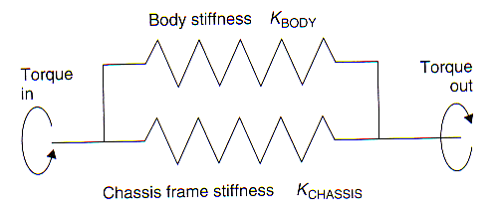
Figure 1: Two springs in Parallel.
From figure 1 it is apparent that the stiffness of both the chassis and the body will affect how the load is carried. If the body is stiffer than the chassis the load would then go through the body. To avoid these problems, they tried to make the body more flexible by adding fabric skins, which shows that’s the knowledge of materials had improved slightly from the initial design. However, manufacturing technologies were still lacking, due to the issue of mass production the fabric on wood bodies was changed to pressed steel as this was immensely easier to mass produce. However, this again causes problems such as load transfer that was not expected again causing squeaking and rattling.

This again led to the same issue of the body and chassis being the same stiffness meaning the body either needed to be softened or the chassis need to be stiffened. To soften the bodies more springs in series would need to be introduced. Making the chassis stiffer was a more feasible solution and therefore was chosen. This was achieved by designing the ‘cruciform bracing’ which had fewer open sections by adding diagonal pieces. This can be seen below in figure 2.
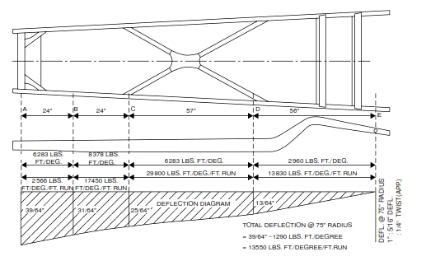
Figure 2: Cruciform Bracing Chassis Structure.
The next step on from this structure is to add more closed sections.

Later in the 1930’s it became apparent that the body was stiffer when experiencing bending and torsion. This led to the design of the ‘integral body’ which reduced the flexibility between the body and the chassis this resulted in a vehicle that represents what a modern-day car would produce, greater torsional stiffness and greater bending stiffness. An example of this can be seen below in figure 3.

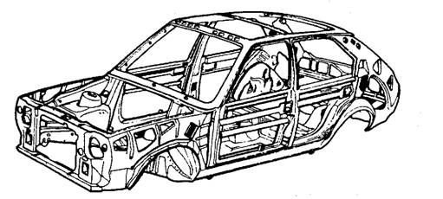
Figure 3: Integral Body Structure.

3 Current Structures

After the design of the previous structures, it became clear that the torsion of the vehicle is proportional to the area enclosed squared.

$$Torsion ∝ {Area Enclosed}^{2}$$

Therefore, to increase the torsion of the vehicle the area enclosed needed to be larger. This was achieved by increasing the depth, which subsequently increased the bending. When this had been discovered, the suspension systems were becoming increasingly better and more affective meaning that the chassis would need to be stiffer to gain better control of the steering. If the chassis were not stiff enough the movement of the wheels would be determined by the bending of the chassis rather than the suspension.

3.1 Crash Requirements

Crash Testing was implemented in 1997 by Euro ncap when almost 90% of all road vehicles in Europe were tested. There are four main test categories, which include:
- Adult occupant
- Child occupant
- Vulnerable road users
- Safety assist

Through these tests the main aim is to develop a safety method that has the most likely chances of survival for all occupants. Adult occupant safety tests are based at the driver’s seat of the car. These tests were originally done to determined which injuries are most likely to be sustained during a crash in the driver’s seat or the passenger seat as well as the survivability of adult occupants.

Child occupant testing came into the lighter at a later date, and these tests were done to see which injuries would be sustained by passengers in the back of the vehicle. At around the same time the testing of road users became a part of a normal crash testing procedure. This is to see not only how people inside of the car may be affected by different crashes but also to investigate the likelihood of a road user surviving a crash. Safety assist testing is the testing of ways to prevent a crash from occurring.

There are six different crash tests carried out for adult occupants, these include:
- Offset-Deformable Barrier
- Full width rigid barrier
- Side mobile barrier
- Side pole
- Whiplash
- Autonomous emergency braking city

For child occupancy these are the tests that are performed:
- Child restraint system performance
- Vehicle provisions
- Child restraint system installation check

The five tests for vulnerable road users are:
- Head impact
- Upper leg impact
- Lower leg impact
- Autonomous emergency braking pedestrian
- Autonomous emergency braking cyclist

And finally, the safety assist crash tests are:
- Electronic stability control
- Seatbelt reminders
- Speed assistance
- Autonomous emergency braking interurban
- Lane support

3.2 Development in Manufacturing Technologies

In the earlier days everything was built by hand, however, through the development of manufacturing technologies, there are a number of new ways to manufacture car parts:
- Smart factories
- Cyber-physical systems
- Additive manufacturing
- Numerical control

3.3 Development in Materials

As the science and knowledge improves, inevitably the development of materials also improves. “Materials development is mostly incremental in the sense that materials used for a certain application evolve in order to adapt to the shifting requirements of that application or materials created for a certain application are appropriated for a different application and progressively modified to satisfy the new requirements.” (C. Duncheon, 2008)

3.4 Backbone Structure

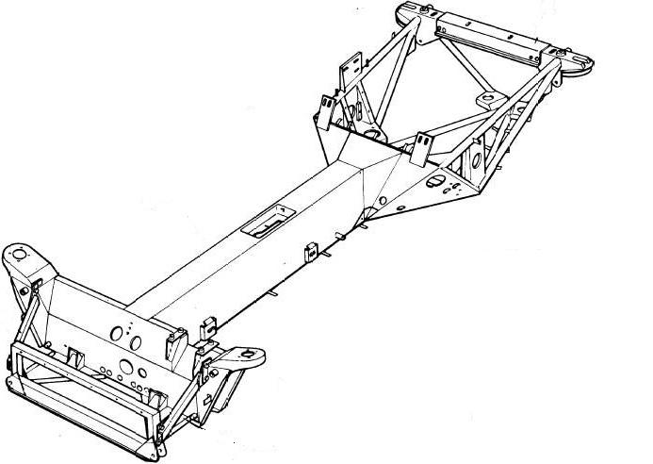
Figure 4: Lotus.
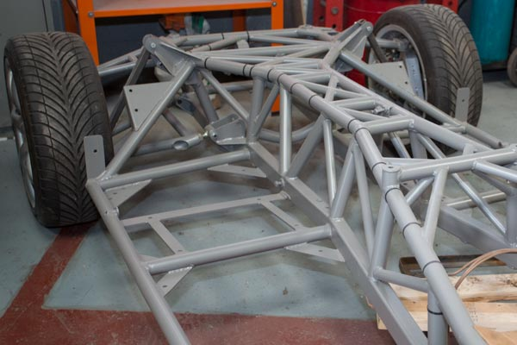
Figure 5: TVR.

The most commonly used back bone structures are ‘Lotus’ and ‘TVR’ which are primarily used on sports cars. These can both be seen above in figure 4 and 5. They are still separate chassis frames meaning that the body stiff provides stiffness. The bending of the lotus structure is controlled by the long tubular centre whereas the TVR design’s bending is controlled by the triangular shape form at the top. The bodies that are used on top of both of these structures are usually made out of glass fibre.

The lotus design is “lightweight spaceframe of bonded anodized extruded aluminium with integral roll over hoop, extruded aluminium impact absorbing structure and steel galvanized rear subframe” (M. Sands, 2018) This was different from previous structures because “instead of a two-dimensional ladder type structure, it consists of a strong tubular backbone (usually rectangular in cross section) that connects the front and rear suspension attachment areas. A body is then placed on this structure.” (Tatra, nd)

The advantages of the lotus design are:
- A standard construction that is able to withstand the torsional twist a wear on the vehicle.
- “The half-axles have better contact with ground when operated off the road.” (Tatra, nd)
- Drive shaft components are concealed from damage by the thick tube.
- The design is able to work for vehicles of various wheelbases.

However, the disadvantages of this design are:
- The cost and complications of manufacturing the structure are higher.
- The structure is heavier therefore has a higher torsional stiffness.

“For higher strength required by high performance sports cars, tubular space frame chassis usually incorporate a strong structure under both doors (see the picture of Lamborghini Countach), hence result in unusually high door sill and difficult access to the cabin.” (M. Wan, nd) therefore the TVR structure is used for race cars however the disadvantages of the design are that it’s “very complex, costly and time consuming to be built. Impossible for robotised production. Besides, it engages a lot of space, raise the door sill and result in difficult access to the cabin.” (M. Wan, nd)

3.5 Triangulated Tube Structure

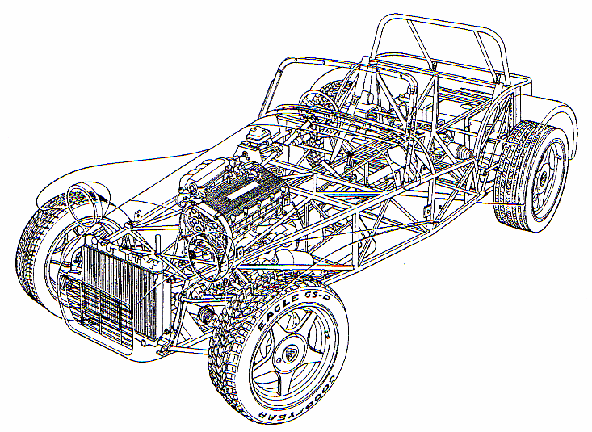
Figure 6: Triangulated Tube Structure Chassis.
In figure 6 above there is an example on a triangulated tube structure chassis. These chassis structures actually surround the body of the vehicle. The width and the depth of this structure is extremely increased when compared to the backbone structure. Therefore, torsional stiffness and bending stiffness will be good.

The advantages of this structure:
- The bodywork connects straight onto the chassis which requires no structure
- Low cost
- Less material is required
- Lightweight
- Strong

However, there are some disadvantages of this, such as:
- A stiffening structure is required to be added in the rear to add stability
- It is difficult to get in and out of the vehicle
- High costs of labour

3.5.1 Development

The next step to improving this design was to incorporate a roll cage. This was in the hopes of improving the torsional stiffness by increasing the enclosed area of the vehicle. This design extended the initial tube design which then allowed for a larger enclosed area.

However, the shape of this can majorly affect the efficiency of the added roll cage, including:
- The angle of the triangular structure of the roll cage itself
- How the roll cage is attached to the rest of the chassis and the car body

For example, if a diagonal tube was added from corner to corner the torsional stiffness would be hugely increased by this small structural change.

3.6 Pure Monocoque

This monocoque chassis structure is more of a closed box structure. “A monocoque chassis is a single piece structure with the body acting as a load-bearing member. It supports the suspension system, steering system, drive system, and other components.” (J. Denny, K. Veale, S. Adali, F. Leverone, 2018) An example of this can be seen below in figure 7:

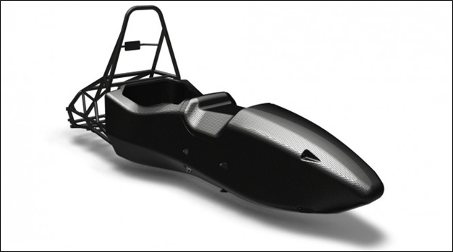
Figure 7: Pure Monocoque Chassis.
This design is weight efficient and used specifically for race cars. It is made up of fully closed tubes forming the shape of the vehicle which is then reinforced by a ‘shell’ which is usually made out of carbon fibre. “Effective chassis performance depends on maintaining rigidity in bending and torsion, providing efficient load absorption and reducing the overall weight of the chassis.” (J. Denny, K. Veale, S. Adali, F. Leverone, 2018)

Advantages of the pure monocoque design:
- Perfect for race cars
- Efficient torsional stiffness and bending
- Torsional stiffness of the chassis itself is upwards of 30,000 Newton Meter per degree

However, the disadvantages of this design are:
- It is not practical for road cars
- Poor visibility
- Difficult to get in and out of
- Outer panels do not handle load

3.7 Platform Structure

A platform structure, also known as punt, has a lot more closed sections than any other chassis structure as the entire floor of the vehicle is closed. Which can be seen below in figure 8:

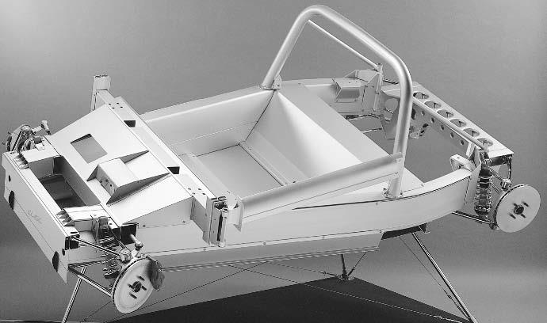
Figure 8: Platform Structure Chassis.
This structure is very similar to a ‘grillage structure’ with improved torsional stiffness and bending stiffness. The bodies that are put onto of these types are not structural, however, very strong joints between the body and the chassis are needed.

3.8 Birdcage

The birdcage structure, also known as the space frame structure, is built out of sections of tubular structure stiffened into ‘ring-beam’ bays. “the space frame can be considered the opposite of a monocoque. Here an internal framework of metal tubes or composite stringers bears most of the load while the exterior bodywork bears very little-like a human skeleton/skin setup.” (F. Markus, 2020) This can be seen in figure 9:

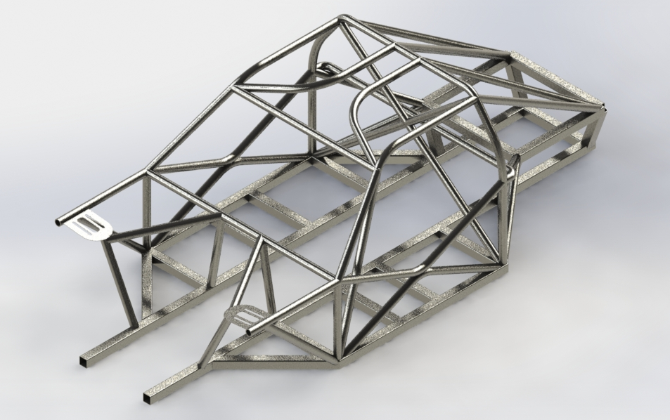
Figure 9: Birdcage Chassis Structure.
If the nodes, that connect the ‘ring-beam’ bays, are not stiff enough loads cannot be transferred between each bay. This would also cause unwanted movement, squeaking and rattling. When the body panels are added to this structure the torsional stiffness is greatly affected meaning that the bodies on these structures does carry loads unlike the platform structure.

3.9 Unitary Body Structure

The most commonly known chassis structure that is currently used is the unitary body structure, also called integral structure. This design was first widely used in 1934. “The body, floorboards, and major chassis structural support and crash-protection elements are welded, bonded, moulded, or somehow joined into a single structural element. This method of construction is more technically complex to engineer and build, but it affords the opportunity for considerable weight savings as compared to constructing a body and then mounting it to a separate structural frame.” (F. Markus, 2020) This design is perfect for mass production because there is no need for a separate chassis as this structure is self-supporting.

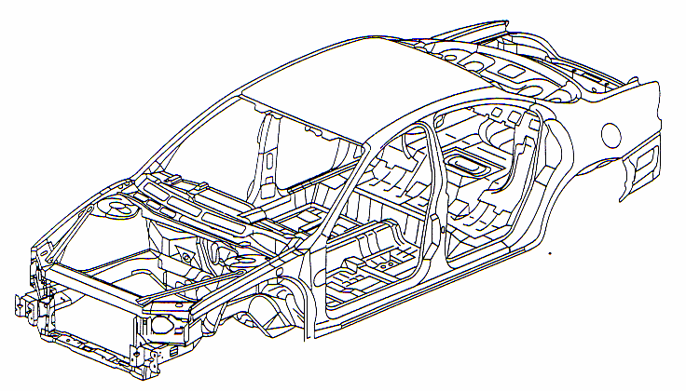
Figure 10: Unitary Body Structure.

Figure 10 above is a modern ‘body in white’. Due to the dramatic increase in the development in materials this vehicle structure is much sturdier, made out of steel sheet metal. However, as steel is very heaving the industry is staring to move away from the use of it and beginning to use carbon fibre as the body material. The most current tendencies with unitary body structures are:
- Hydroforming
- Laser welding/ welded blanks
- Adhesive

A typical torsional stiffness for a normal road car is between 80,000 Newton meters per degree and 10,000 Newton meters per degree. With a more luxurious car the expected values are between 12,000 Newton meters per degree and 15,000 Newton meters per degree.

Hillman 10HP truly shows how far the industry has come. Figure 11 shows the very notable comparison between the ‘body on chassis’ structure and ‘unitary body’ structure.

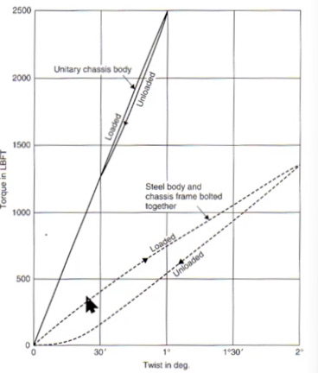
Figure 11: Hillman 10PH.
From this it is clear that the torsional stiffness increased greatly as well as a huge difference in the loading and unloading. As seen above the loading line has increased and the unloading line is much closer, meaning that the hysteresis affect is much lower.

4 Future Structures

From the changes through history, I think in the future we will remain with primarily unitary body structures, or something very similar. The main changes will be the materials which will be used as well as further improvements in technology, therefore further improvements in manufacturing technologies. “It is likely that we have only scratched the surface of Industry 4.0. The breadth and complexity of opportunities in this sector means that robotics, AI and data will probably continue to revolutionise manufacturing.” (TWI, nd)

5 Simple Structural Surfaces
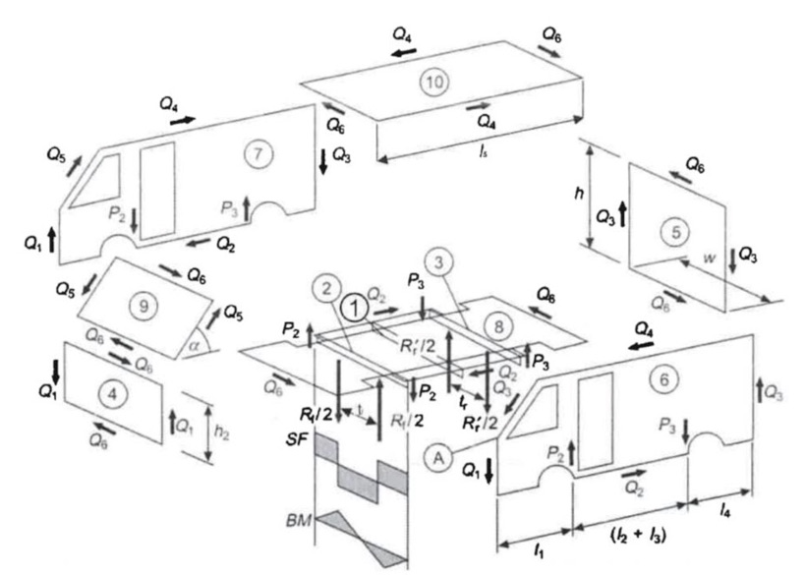
Figure 12: A Van in Torsion.

$$P_{2}=\frac{R_{f} × t_{f}}{2w}$$
$$P_{2}=\frac{5000 ×1.5}{2 × 2}$$
$$P_{2}=1875N$$

$$P_{3}=\frac{R_{r} × t_{r}}{2w}$$
$$P_{3}=\frac{5000 × 1.5}{2 × 2}$$
$$P_{3}=1875N$$

$$Q_{6}=\frac{w\left[P_{3}\left(l_{1}+l_{2}+l_{3}\right)-P_{2}h_{1}\right]}{h_{1}\left(l_{1}+l_{2}+l_{3}+l_{4}\right)+l_{5}\left(h_{1}-h_{2}\right)+h_{2}(l_{1}+l_{2}+l_{3}+l_{4})}$$
$$Q_{6}=\frac{2 \left[1875 \left(2+3\right)-1875 × 2\right]}{2\left(2+3+1\right)+3\left(2-1\right)+1(2+3+1)}$$
$$Q_{6}=535.71N$$

$$Q_{1}=\frac{Q_{6}h_{2}}{w}$$
$$Q_{1}=\frac{535.71 × 1}{2}$$
$$Q_{1}=267.86N$$

$$Q_{2}=\frac{Q_{6}(l_{1}+l_{2}+l_{3}+l_{4})}{w}$$
$$Q_{2}=\frac{535.71(2+3+1)}{2}$$
$$Q_{2}=1607.13N$$

$$Q_{3}=\frac{Q_{6}h_{1}}{w}$$
$$Q_{3}=\frac{535.71 × 2}{2}$$
$$Q_{3}=535.71N$$

$$Q_{4}=\frac{Q_{6}l_{5}}{w}$$
$$Q_{4}=\frac{535.71 × 3}{2}$$
$$Q_{4}=803.57N$$

$$Q_{5}=\frac{Q_{6}(h_{1}-h_{2})}{w\sin{∝}}$$
$$Q_{5}=\frac{535.71(2-1)}{2\sin{45}}$$
$$Q_{5}=378.8N$$

$$T= P_{2}w= P_{3}w$$
$$T=1875 × 2 \\ T=3750Nm$$

6 Improving Rear Access

$$τ=\frac{F}{A}$$
$$τ=\frac{535.71}{4 × 2{×10}^{-3}}$$
$$τ=66963.75 {Nm}^{-2}=0.06694MPa$$

Complex Stress Theory:
$$σ_{1,3}=\frac{1}{2}\left[\left(σ_{x}+σ_{y}\right)±\sqrt{{\left(σ_{x}-σ_{y}\right)}^{2}+4{τ_{xy}}^{2}}\right]$$
$$σ_{1,3}= ±τ_{xy}= ±0.06694MPa$$
Assuming:
$$σ_{2}=0$$

Von Mises stress:
$$σ_{v}= \sqrt{{(σ_{1}-σ_{2})}^{2}+{(σ_{2}-σ_{3})}^{2}+{(σ_{3}-σ_{1})}^{2}}$$
$$σ_{v}= \sqrt{{(0.06694)}^{2}+{(0.06694)}^{2}+{(-0.13388)}^{2}}$$
$$σ_{v}=0.164MPa$$

To improve access to the rear of the van, panel five which can be seen above in figure 12 would no longer be a shear panel. This will result in Q6 no longer existing meaning that shear suspension loads will not be able to be transferred and no force will be applied to the roof. Q4 won’t exist either as it is no longer needed to even out the forces on the roof. Q5 also won’t exist as the side walls are no longer receiving any force. Therefore, all of the torque of the vehicle will go through the floor as it is no longer being applied to any of the shear panels.

7 References

George Wand (March 2017) How automobile bodies evolved through history from wood to carbon Fibre. Available at: https://www.autoblog.com/2017/03/09/evolution-auto-bodies-wood-carbonfiber/ (Accessed 3rd March 2021)

Jason C. Brown, A. John Robertson, Stan T. Serpento (2002) Motor Vehicle Structure: Concepts and Fundamentals. Available at: http://160592857366.free.fr/joe/ebooks/Automative%20engineering%20books/Motor%20Vehicle%20Structures.pdf (Accessed 3rd March 2021)

Tatra (no date) Backbone Chassis. Available at: https://www.tatra.cz/web_en/roura_en.asp/ (Accessed 3rd March 2021)

Michael Sands (January 2018) The Technology of the Lotus Elise 111 Chassis. Available at: http://www.sandsmuseum.com/cars/elise/thecar/technology/technology.html (Accessed 3rd March 2021)

Mark Wan (no date) Different Types of Chassis. Available at: https://www.autozine.org/technical_school/chassis/tech_chassis.htm (Accessed 3rd March 2021)

Jason Denny, Kirsty Veale, Sarp Adali, Fiona Leverone (July 2018) Conceptual design and numerical validation of a composite monocoque solar passenger vehicle chassis. Available at: https://www.sciencedirect.com/science/article/pii/S2215098618300521 (Accessed 20th March 2021)

Frank Marcus (April 2020) Body-on-Frame vs. Unibody vs. Monocoque: What’s the Difference? Available at: https://www.motortrend.com/news/body-on-frame-vs-unibody-vs-monocoque-what-is-the-difference/ (Accessed 20th March 2021)

Peter Fretty (December 2019) 2020: Future of Manufacturing Technologies. Available at: https://www.industryweek.com/technology-and-iiot/article/22028667/2020-future-of-manufacturing-technology (Accessed 22nd March 2021)

Charlie Duncheon (2008) Material Development. Available at: https://www.sciencedirect.com/topics/engineering/material-development (Accessed 22nd March 2021)

TWI (no date) What is Manufacturing Technology? Available at: https://www.twi-global.com/technical-knowledge/faqs/manufacturing-technology (Accessed 22nd March 2021)

7.1 Figures

Figure 1: Two Springs in Parallel (UWTSD, 2021)

Figure 2: Cruciform Bracing Chassis Structure. Available at: https://www.researchgate.net/figure/9-Cruciform-braced-chassis-frame-Booth-1938-by-permission-Council-of-IMechE-2_fig8_313475487 (Accessed on 15th April 2021)

Figure 3: Integral Body Structure. Available at: http://what-when-how.com/automobile/body-work-and-integral-construction-automobile/ (Accessed on 15th April 2021)

Figure 4: Lotus. Available at: https://www.thelotusforums.com/forums/topic/102723-esprit-chassis-ultra-lightweight/ (Accessed on 15th April 2021)

Figure 5: TVR. Available at: https://www.sportmotive.com/tvr-development/tvr-evolution-chassis/ (Accessed on 15th April 2021)

Figure 6: Triangulated Tube Structure Chassis. (UWTSD, 2021)

Figure 7: Pure Monocoque Chassis. Available at: https://pure.sabanciuniv.edu/project/3961/design-analysis-and-manufacturing-race-car-carbon-fiber-monocoque-chassis (Accessed on 15th April 2021)

Figure 8: Platform Structure Chassis. (UWTSD, 2021)

Figure 9: Birdcage Chassis Structure. Available at: https://grabcad.com/library/space-frame-chassis-1 (Accessed on 15th April 2021)

Figure 10: Unitary Body Structure. (UWTSD, 2021)

Figure 11: Hillman 10PH. (UWTSD, 2021)

Figure 12: A Van in Torsion. (UWTSD, 2021)

