AC 1.1 –
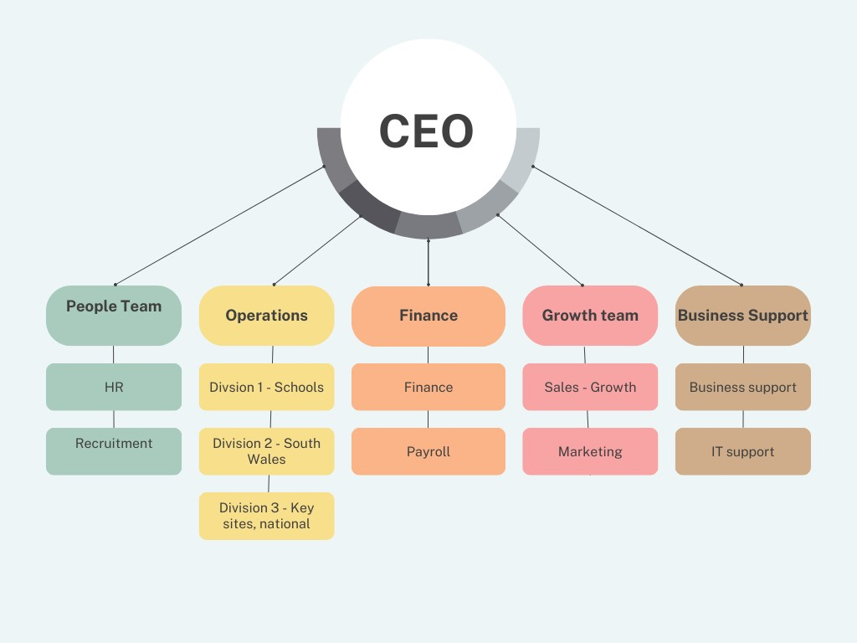

The above diagram illustrates how Mrs. Bucket Cleaning Services is organised using a functional, hierarchical structure. Here, the company's manager or CEO is typically at the top, with all other managers or teams below (Taylor, Woodham, 2022a). One advantage of this organisational structure is that it allows for a large number of managers and employees to have clearly defined roles and responsibilities within the organisation in order to accomplish the strategic goal (Taylor, Woodham, 2022b). There will always be some accountable for a decision. One disadvantage of this structure would be the lack of communication between management and employees, and which could impede decision-making because it isn't always quick to ask for management approval. This could lead to a lack of loyalty and the organisation failing to meet its objectives.
Seren Support work off another organisational structure which is a divisional structure. Here, the organisation is divided into divisions that focus on different products, services and geographical areas (Taylor, Woodham 2022c). Because they have a large number of clients who require individualised attention and a diverse geographical range of departments, Seren Support typically operates under this structure. The services and products are distributed over a larger geographic area, which increases their availability and attracts new customers, making this structure's main benefit. Using this structure in an organisation will also improve the organisations culture. The cost of this structure would be a drawback. Although there might be a benefit to the organisation's overall costs, there would be higher operating costs it also may feel like different divisions are rivals even though they are part of the same organisation (indeed, no date).

AC 1.2 –
There is a strategy in place at Mrs. Bucket Cleaning Services Ltd. which indicates that the plan has been predetermined (Lynch, 2003). A planned strategy does not necessarily mean that it is "fixed," as organisational management teams regularly review and adjust them to account for changes occurring outside the organisation (Taylor, Woodham 2022d). "Challenge the perception of the cleaning industry" is the stated strategy of Mrs. Bucket Ltd (Mrs. Bucket, 2023). This indicates that they want to dispel the misconception that they are just a cleaning company that uses buckets and mops; they want everyone to know that there is much more to what they do, and that cleaning is not just about mops. In a cleaning company, the primary responsibility is to ensure that the sites are cleaned to the highest standards possible in order to maintain a high audit pass rate and satisfy clients with the quality of service they are receiving. The technological world is always changing, and Mrs. Bucket keeps up with it by introducing a variety of robotic equipment that speeds up cleaning, allowing the organisation to have more clients and perform better, more effective cleanings. Some of these robots will complete the tasks themselves, so that the cleaners can focus on other tasks. Mrs Bucket also offers products to the clients who have the cleans and these can be a wide arrange or products within in the cleaning industry. These can be from toilet roll holders to robotic hoovers that the client will keep on their site themselves. Mrs Bucket offers these products so that they do not need to rely on outside distributors and suppliers. The clients want the best cleans with the best equipment for the right price and Mrs Bucket does that.

AC 1.3-
There are several analysis tools that can be used to identify issues and be applied to diagnose organisational issues, these can also be used in day-to-day life. Some of these tools are Porters five forces, Fishbone analysis, Ansoff matric and PESTLE. A PESTLE analysis is the study of key external factors (Political, Economic, Sociological, Technological, Legal and Environmental) that influence an organisation (CIPD, 2023b).
One positive external factor that Mrs Bucket has is that they are very much for helping the environment. They use all Bio Hygiene products in every site that is cleaned. These products replace harmful, non – renewable cleaning chemicals with environmental biotech alternatives that will improve human and environmental health (Biological preparations, 2023). So, the positive for using these products is they are cost effective but helping to save the environment at the same time and these will be an ongoing product. As you can see from below the report that Bio Hygiene put out in 2022.
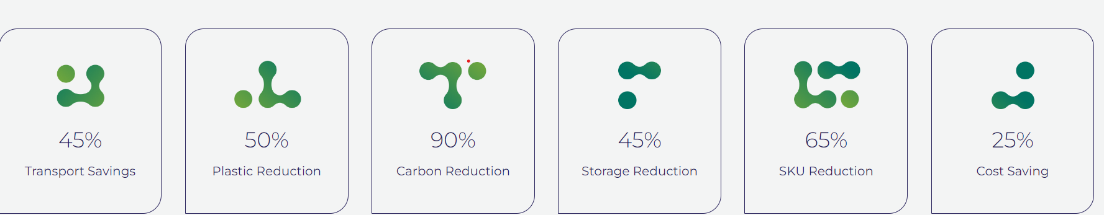

Economic - The cost of living is another external factor that would be advantageous because Mrs. Bucket pays all its cleaners a Real Living Wage, which is now £10.90 per hour and will increase to £12.00 per hour in April 2024. The only wage rate in the UK that is determined by the cost of living is the real living wage. More than 14,000 UK companies voluntarily pay it because they think their employees should be paid enough to cover their basic needs (Livingwage, 2023). Candidates find it more appealing to accept a job offer from an organisation that pays a real living wage because they can see that Mrs. Bucket understands the hardships caused by the COVID-19 pandemic and is committed to helping by increasing the salary annually. Since the pay is higher, more candidates will apply for positions, increasing Mrs. Bucket's pool of potential hires and profits.
Covid 19 is an additional external factor that continues to have an impact on business organisations. Like every other organization, Mrs. Bucket was impacted by COVID, but that was only temporary because there was an enormous demand for cleaners as all the organisations wanted to ensure that their spaces were cleaned to the highest standards possible so that workers could return to their jobs in a secure atmosphere. which increased Mrs. Bucket's clientele and financial gain ongoing.

AC 1.4 –
As a report by CIPD in 2017 states that. Technology plays a major role in the working world, and organisations are utilising the advantages of digital tools to improve their approaches to learning and development. Technology has changed the way organisations run and in which way work is carried out and now this is believed to be an essential part of an organisation.
The utilisation of technology has significantly increased across the board at Mrs. Bucket Cleaning Services Ltd., whether it is in the head office or with the cleaning employees. One significant shift in Mrs. Bucket's use of technology is the way they perform cleaning tasks, which now include robotic equipment and cleaners. The I-mop, one of the robotics they utilise, has the following statistics. According to (Iteam, 2024), "the I-mop family cleans up to 70% faster than traditional wet mopping and up to 30% faster than traditional auto scrubbing." As you can see, implementing a robot to clean gives the cleaners more time to complete other responsibilities within the organisation, which translates into more tasks can be completed, ultimately resulting in greater financial gain for Mrs. Bucket. Using robotics has a drawback, and that is the expense—both for the equipment itself and the training required to operate it.
AI (artificial intelligence) is used in the organisation Flo Gas. They use AI for their performance management system. They accomplish this, among other things, by emailing weekly performance feedback forms. This indicates that they are generated and not staffed by a manager. The following findings from an investigation into AI in performance feedback are presented in a report from CIPD, 2022: -generated performance feedback can be a useful management tool. When compared to human managers, AI-generated feedback improved workers' job performance by 12.9%. One benefit of using AI for performance reviews is that it frees up management time that can be used for other purposes within the organisation. It is possible to generate customised responses. Again, there is a drawback in the form of expense, but AI also makes tailored generation more difficult to audit.

AC 2.1 –
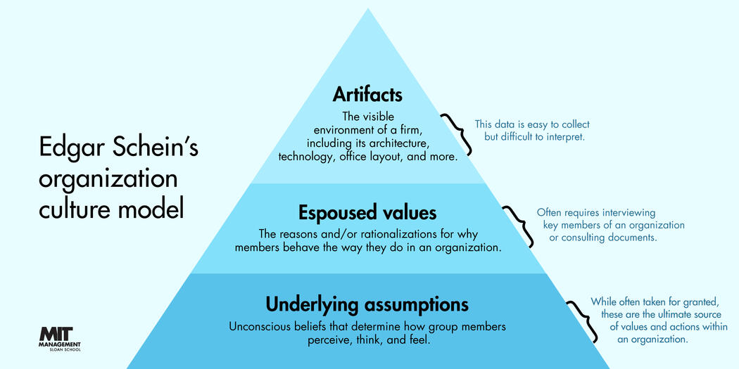
The diagram above explains what Edgar Schein’s organisational culture model it is about and how works. According to Schein's theory, organisational culture is a significant impediment to change, and effective leadership requires an awareness of this factor. Three levels of culture are introduced by his theory: artifacts, espoused values, and underlying assumptions. Though they are visible, artifacts are difficult to understand (Peek, 2023). Understanding the various facets of an organization's culture can be facilitated by using Edgar Schein's organisational culture model. Through an understanding of the interactions between behaviours, espoused values, and underlying assumptions, leaders and managers can effectively manage and shape the culture of their organisation. Organisations can drive change initiatives, attract and retain top talent, and create a positive and productive work environment by using this understanding to help them align culture with strategy. Organisations can develop a robust and flexible culture that fosters long-term success by utilizing Schein's model.
Another model that explains human behaviour is the Expectancy theory. At the Yale School of Management, Victor H. Vroom was a professor of management. He created his own expectancy theory in 1968. An explanation of individual differences in work motivation is provided by Victor Vroom's expectancy theory of motivation, a cognitive philosophy. The expectancy theory describes how people choose a certain course of action from a range of options (Mindtools, no date). According to the expectation theory, the intensity of three expectations determines how motivated we are to act in a specific way: 1. Performance will increase with increased effort 2. Rewards will be given for exceptional performance and lastly, That the outcome – your reward – will be attractive.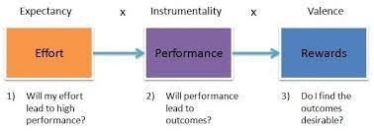
The theory relies on the notion that an employee will be more driven to achieve a goal if they value it more. Their chances of receiving that fulfilling reward increase with the amount of effort they put in to succeed (Channell, 2021). An example of this in an organisation is - An employee's presumption is that they do not have enough time to complete a task effectively, for instance this could be the reason why their efforts are not yielding a satisfactory result. Who would be inspired to put in a lot of effort on something that is bound to fail, after all? Restoring employees' expectations, demonstrating their instrumentality, and/or assisting managers in comprehending the significance of the rewards offered by the company are all possible outcomes of addressing the root cause of the lack of motivation.
AC 2.2 –
A well-established organisational culture enables workers to comprehend their organisation and believe that their opinions count in guiding the organisation toward a shared goal. It is crucial to continuously assess an organisation's culture because a shared set of values will impact employee satisfaction and retention as well as the quality of customer service provided (CIPD, 2023). Majority of employees are aware of the more obvious aspects of people practices, like recruitment, dismissal handling paperwork. Still, there are other customs that influence culture and behaviour, well-being of the employees, pay, training, appraisals are just to name. The organisation Mrs Bucket believes in the following. The foundation of our company is the workforce at Mrs Bucket. The employees at Mrs Buckét are outstanding. In addition to providing all our employees with the training they need to succeed at our Cleaning Academy, we also offer them a fantastic work environment and a plethora of benefits in appreciation for their dedication to Mrs. Buckét and all their hard work. We want their time with us to be enjoyable! Building relationships with each and every one of our employees and treating them with respect are things we take great pride in.
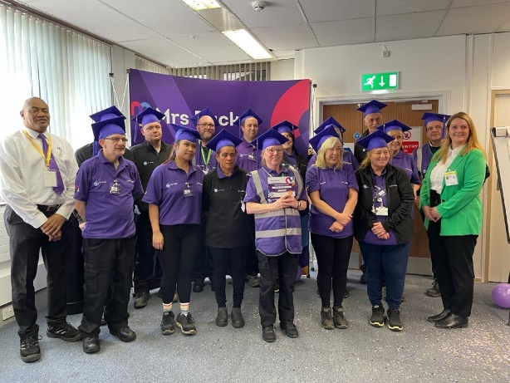 (Mrs Bucket, 2023)
By having a benefits package encourage employees to stick with the organisation and do well. An organisation that provides a competitive salary and benefits package, for instance, is likely to draw in and keep more skilled and driven workers (Satyendra, 2020). People's behaviour patterns generally serve to improve working relationships by achieving organisational, social, and human goals (Armstrong and Taylor, 2020). The implementation of diversity and inclusion policies has a positive impact on this within Mrs Bucket. The goal of these policies is to foster better team dynamics and cooperative methods of performance improvement. It conveys that employees will not face discrimination and that a range of opinions are welcome. (ADD MORE)
AC 2.3 –
Organisations worldwide are faced with the challenge of innovating and adapting to a mixed economic growth environment marked by ongoing change and uncertainty (CIPD, 2015). One model that can be used within organisations to manage change is the Lewins change management Model. In most today, "organisations change management" is a well-known concept. However, the nature of the organisation, the change, and the individuals involved all have a significant impact on how well businesses manage change (mindtools, 2023).
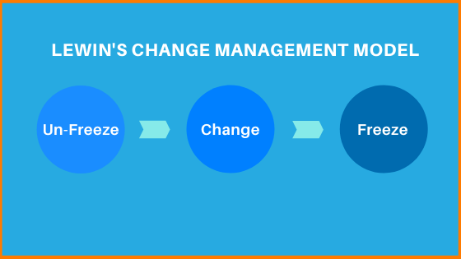
The three-stage change model, which is: unfreeze, change and refreeze. This model demonstrates how people accept change by first responding, pushing back, and adjusting. Most businesses use this model to manage organisational changes (Indeed, 2023). Before an organisation can establish a new way of operating, it must first prepare the organisation to accept that change is required, which entails dismantling the status quo. Creating an effective message that explains why the current course of action is unsustainable is crucial to this. It is most convenient to frame this in terms of observable variables, like diminishing sales numbers, subpar financial outcomes, or unsettling customer satisfaction surveys, for instance. Employees will start to overcome their uncertainty and search for new approaches during the change stage. Individuals begin to act and think in ways that reinforce the new course. The final step, which is sometimes called "refreezing" but is called "refreezing," shows how the change is reinforced. At this point, employees have adjusted, and the workplace returns to normal. The modifications take on a new normal. The managers of the organisation strengthens the change during this time to prevent employees from feeling pressured to go back to their previous ways. They can accomplish this by monitoring the change's advancement to ensure that it is working, comparing the anticipated and actual progress, and rewarding those who uphold the new change (Indeed, 2023). However, there is no step-by-step instructions.

Another theory that is used to manage change within an organisation is called the Maurer 3 Levels of Resistance and Change Model. Because it focuses on the reasons why changes fail, the Maurer 3 Levels of Resistance and Change Model is distinct. Three crucial resistance levels are the focus of this model: I don’t get it; I don’t like it and I don’t like you.
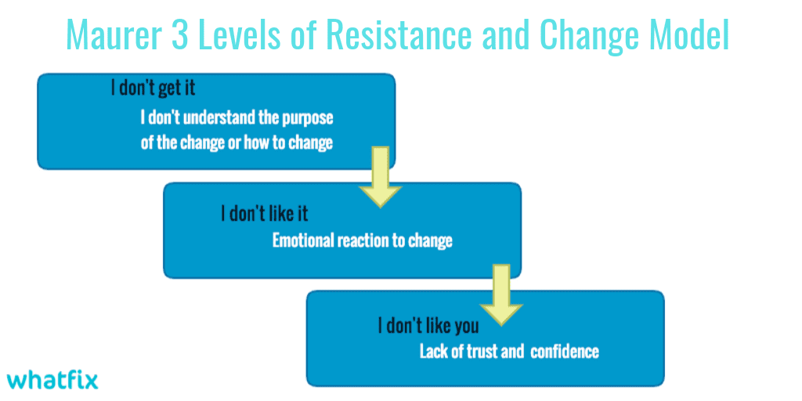(Sharma, 2022a)
I don’t get it - Humans have a tendency to reject things they do not fully comprehend. You've already set yourself up for failure when employees don't understand the change or the need for it. It is imperative that employees earn the knowledge necessary for them to understand why the change is required.
I don’t like it - Adopting change can be severely hampered by emotional responses. Employee resistance is likely to be strong if they are angry about the change or even afraid of it. The secret to implementing the change successfully is anticipating and handling this anticipated roadblock.
I don’t like you - Although you don't have to be best friends with everyone impacted by the change, employees may fight more if they don't trust managements judgment and experience. Employees will be more accommodating if the management team is knowledgeable and confident about the need for change and the steps involved in putting it into practice.
Recognizing and comprehending resistance can be immensely helpful, even though the Maurer 3 Levels of Resistance and Change Model works best when used in conjunction with a detailed manual (Sharma, 2022b)
AC 2.4 –
According to the Kubler-Ross change model that was initially used to explain the grieving process. An organisation may need to go through stages to undergo an overall organisational makeover, whether they are seeking change or are faced with an unavoidable change. These include going through, denial, anger, bargaining, depression, and acceptance, as some examples.
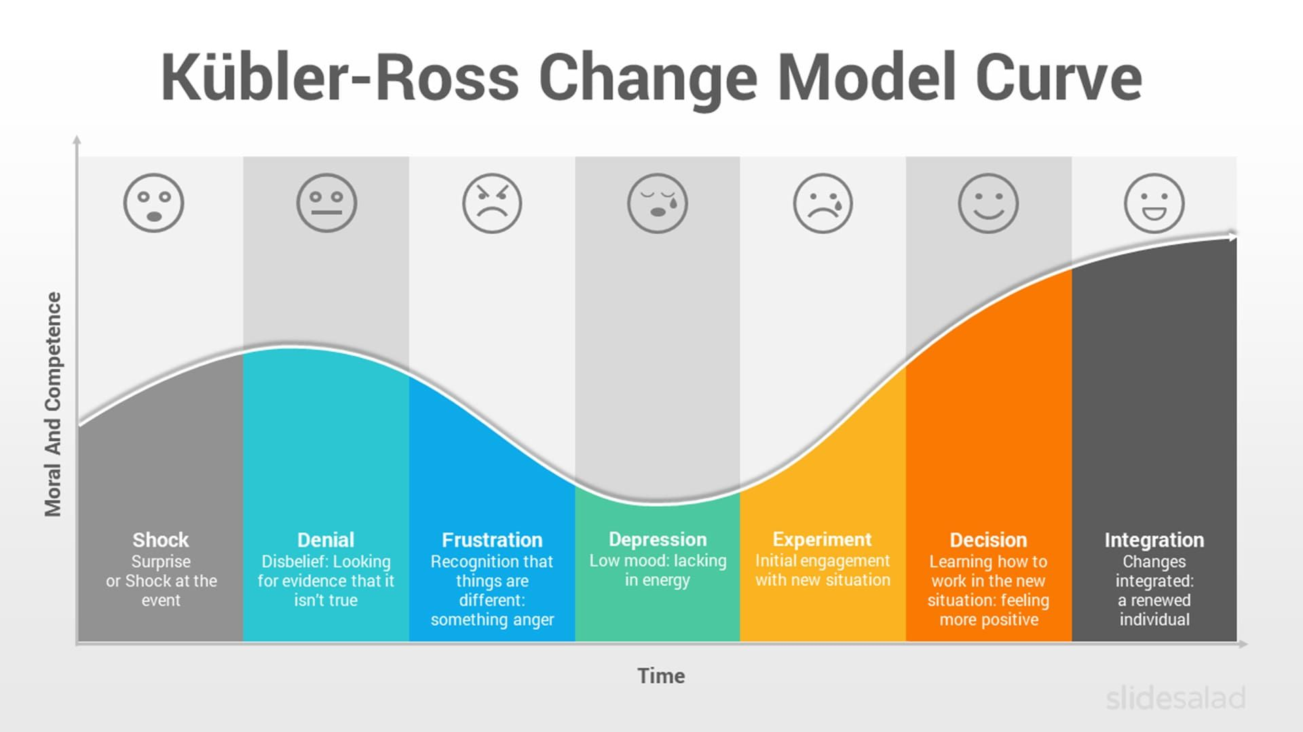(Pinterest, no date)
As the picture above shows the many different stages there are during the model these however do not have to be in any specific order and people will go through different stages at different times. Given the volume and speed of change that organisations are constantly experiencing, it is imperative that people comprehend these stages and the need for them to accept the changes that are occurring around them. Encouraging people to go through each step is crucial to implementing the change and keeping it that way in the future. It cannot be assumed, though, that every employee will move through the change curve at the same rate and in the same manner (CIPD, 2023). A positive for using this model, is by foreseeing potential emotional reactions individuals and organisations making plans appropriately, the model can assist in becoming ready for change (Tahir, 2019) However, Change will not affect everyone in the same way. Individual needs might not be taken into consideration if it is assumed that employees will follow the curve. It works better to comprehend possible employee responses to complicated, large-scale change projects or those that are probably going to have a negative, substantial effect on employees.
AC 2.5-
Promoting employee well-being benefits both the workforce and the organisation. Encouraging well-being can reduce stress and foster productive organisations where employees and businesses can prosper. One of the main factors influencing employee engagement and organisation performance can be one's own health and well-being (Suff, 2023). In particular, line managers have the continuous support required to assist their teams, enabling them to have delicate discussions with individuals and refer them to professionals when necessary. It is important to promote good self-care practices for all employees. Based on the idea that a successful employee wellbeing strategy must encompass much more than several stand-alone projects. The well-being of employees is closely related to their engagement, productivity, and retention. Various factors, including leadership, workload, and relationships with coworkers, can impact the well-being of employees.

CIPD (2023) have identified a few interconnected "domains" of employee wellbeing -
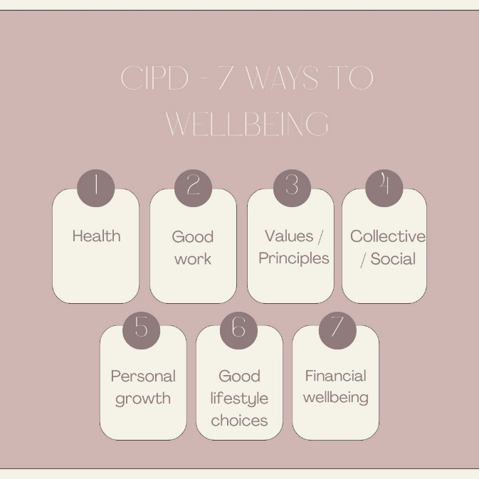

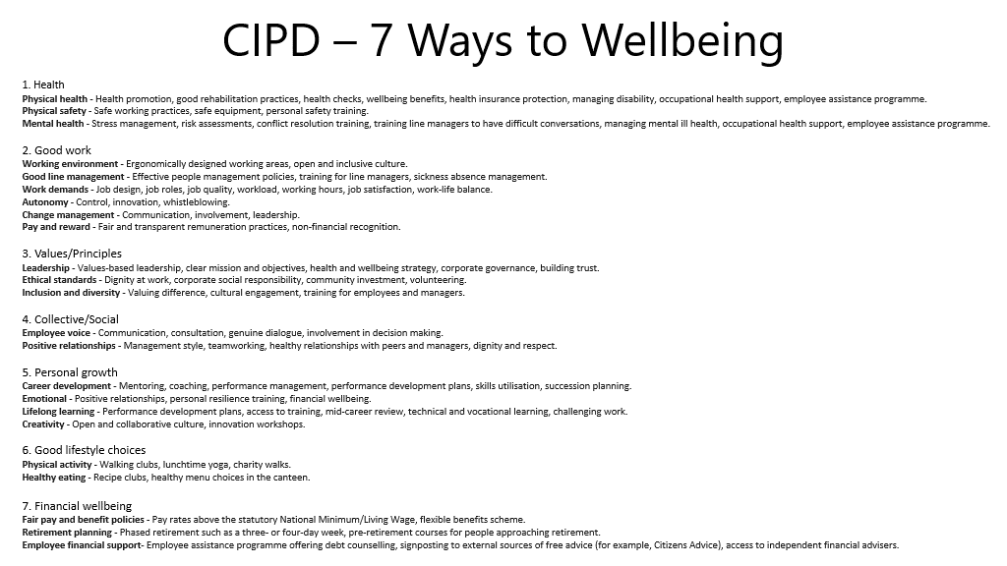

AC 3.1 –
The collection of procedures that workers go through during their employment is known as the "employee life cycle" (Armstrong, 2020).

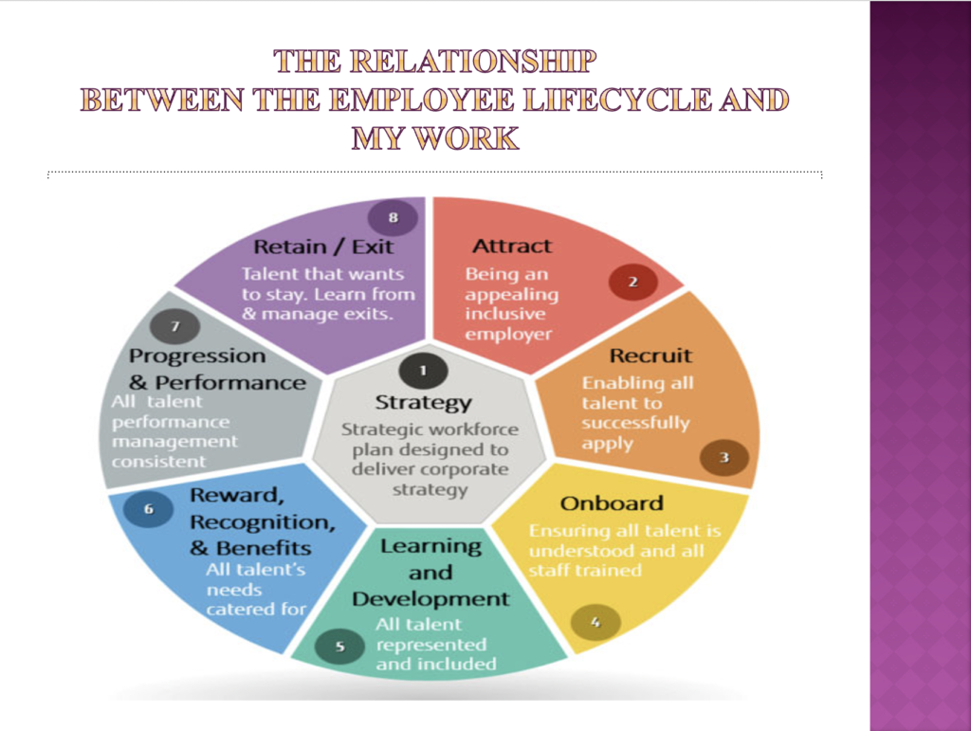
As you can see from the above picture, the employee lifecycle starts with strategy. Strategy ought to be based on the Organisations strategy as a whole. People are a company's greatest asset. A people strategy revolves around identifying the kinds of people and skills needed in the future, as well as where they are needed.
It then moves on to attract. The company's reputation and the information that prospective employees can learn about the organisation are key factors in luring new hires. People team and marketing team would give this information to the recruitment team.
It is imperative that the recruitment process is devoid of prejudice, expresses clear interest in diverse candidates, encourages applications from such candidates, and sets expectations for the recruiting team.
During the onboarding process, new hires have the chance to learn about the expectations, support system, and their opportunities. Diverse candidates should be considered for all development and training programs, and where appropriate, all talent should be given access to special learning and development opportunities.
Benefits for employees should take into account all facets of diversity. It might be necessary to offer some particular extra employment services to particular groups.
Regardless of diversity factors, all employees should have consistent work assignments and performance reviews with their managers. The goal is to make sure that, once assembled, the workforce is highly motivated and willing to give its all at work, and that absences are minimized as much as possible (Taylor, 2021).

Finally, there is the retention or exit. All employees ought to desire to stay in the organisation. People Professionals should implement workplace inclusion initiatives and respond to criticism. Professionals should take note of the exits of diverse employees and stay away from those that aren't inclusive. Retention rates are higher and reputational appeal is increased when workers have a positive experience (Green, Peters and Young 2019).

AC 3.2-
Aligning and supporting broader organisational and people strategies is a crucial function of people practices. To achieve strategic goals, every organisational function, including marketing, sales, finance, and technology will set specific goals. It can accomplish this by examining how potential and current circumstances affect capability versus achievement. These results can be used to both directly and indirectly align every department and worker with the organisation's strategy (Armstrong and Taylor, 2020c).
According to Taylor and Woodhams (2022a), talent management encompasses the strategies and actions taken by an organisation to recruit, onboard, and train personnel, with the ultimate goal of attracting, developing, and maintaining the talent required to meet its objectives. This ensures that the right people are in place to meet the organisation's goals by coordinating these practices with the talent strategy of the company.
Continuous learning in any kind of organisation refers to the development of individuals, teams, and the organisation as a whole via educational experiences and events. A culture of continuous learning can be developed with the help of People Practices. A crucial aspect of the entire learning process involves determining the employees' needs for training and development as well as setting up programs for them.
The idea of vertical integration provides the clearest explanation of the relationship between people practices and broader organizational strategies. This suggests that human resources professionals need to connect their people strategies and practices to the company's strategy. For instance, in the event of an organisation's downsizing, people managers would also need to reorganise the workforce by reducing the number of new employees (Taylor and Woodhams, 2022b).
AC 3.3-
A two-way conversation about a variety of strategic issues impacting the organisation with the workforce is referred to as "information and consultation of employees” (CIPD, 2023c). Organisations have distinct internal customers. Which consist of Senior management and employees on either a short or long-term contract usually make up these bases (Armstrong and Taylor, 2020d). Practitioners can use a variety of techniques to gather information and develop plans to meet the needs of internal customers. These could include, listening groups, pulse surveys, new employee survey or even exit survey/interview. Every approach provides a different chance to hear directly from employees about their experiences working, sometimes in an anonymous manner. It is also possible to confirm whether employee needs are being satisfied by looking at personnel data derived from performance or attendance metrics.
Another way to make sure the internal customer needs are being met is by going digital. The creation of content has become a crucial component of any organisation's marketing plan and has a big impact on employee satisfaction. Internal customers will be more likely to interact favourably and return for more in this digital age if they feel that the content they consume is engaging (Duncan, 2023).
One instance of this at Mrs. Bucket Cleaning Services is their own social media platform, where they regularly post surveys or have a people team member respond to inquiries on a daily basis in addition to conducting weekly polls on workplace developments.

