Module: International Meetings Management for the Hotel Industry
Module Code: BMIH6007
Assignment 2: Event Strategic Planning and Delivery Considerations for an International Meeting
Student Name: Ion Lucian Grigore Maracine
Student ID: 2131338

Table of Contents
Introduction 3
The Event Cycle 5
Event Concept 6
Aim and Objectives of the Event 7
Event Operations 9
Event Budget 10
Industry Trends / Issues / Impacts 11
Cultural and Situational Considerations 14
References 15

Introduction
“Future Tech: Revolutionising Hospitality” is the event being discussed in this report which aims to explore how technology can be integrated in the hospitality sector with a keen focus on the intersection of these two industries. The MICE team carefully curated this event and chose the concept to address emerging trends, pressure, and requirements for these two sectors to collaborate, innovate, and exchange knowledge. The event is to be hosted at Eccleston Square Hotel which is a prestigious hotel situated at London’s Heart, with the promise of offering transformative experiences to its attendees. It includes people attending the event from different backgrounds like interested innovators, policymakers of technology and hospitality, interested investors, and professionals and experts from both industries.
Research shows that the hospitality industry has underwent numerous changes over the years directly fuelled by the advancements made in technological programs, processes, equipment, and so on. From advancements like AI-driven service personalisation to the development of technologically smart hotel infrastructure and supply chain technologies like blockchain solutions, have caused significant transformations and disruptions in this sector (Vinnakota et al., 2023). Technology is not only being used to improve operational efficiency at present but also for meeting sustainability goals across sectors including hospitality and to revolutionise guest experiences. Despite hospitality giants with the knowledge and capabilities to implement such advanced technologies, many businesses fall behind in recognising the potential of technological integration in hospitality services and products. It is why this event is essential.
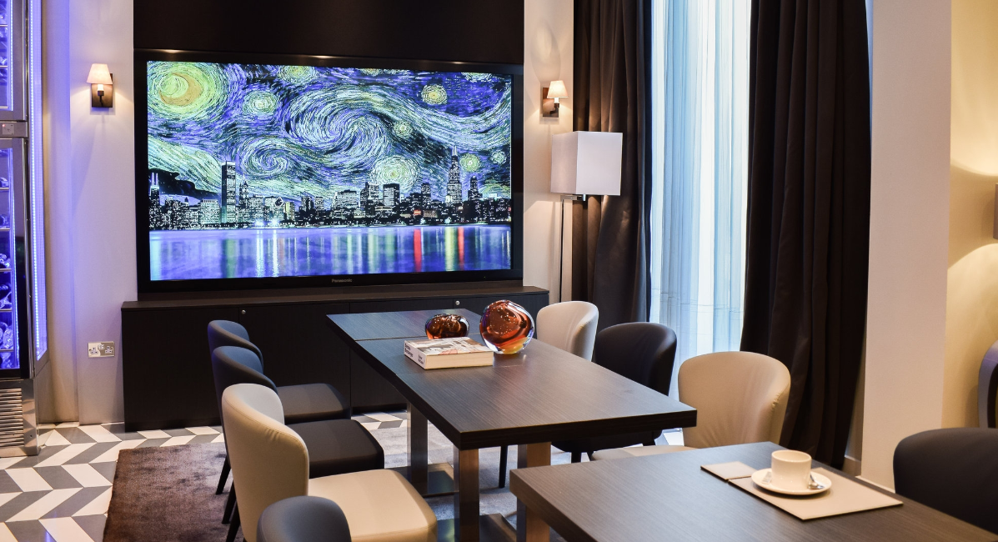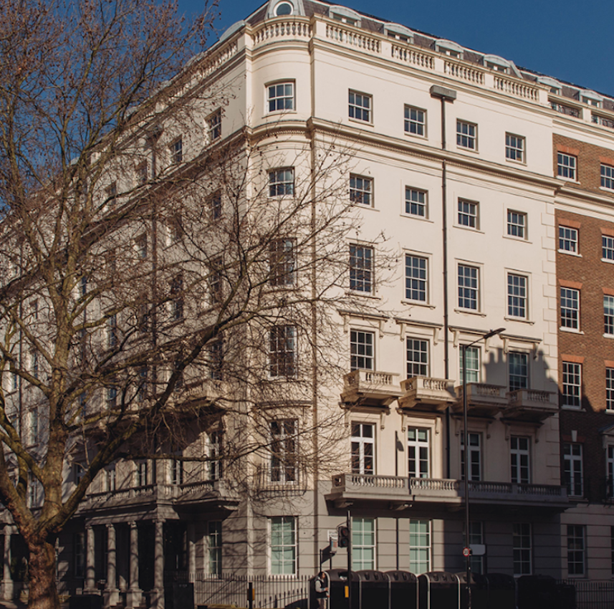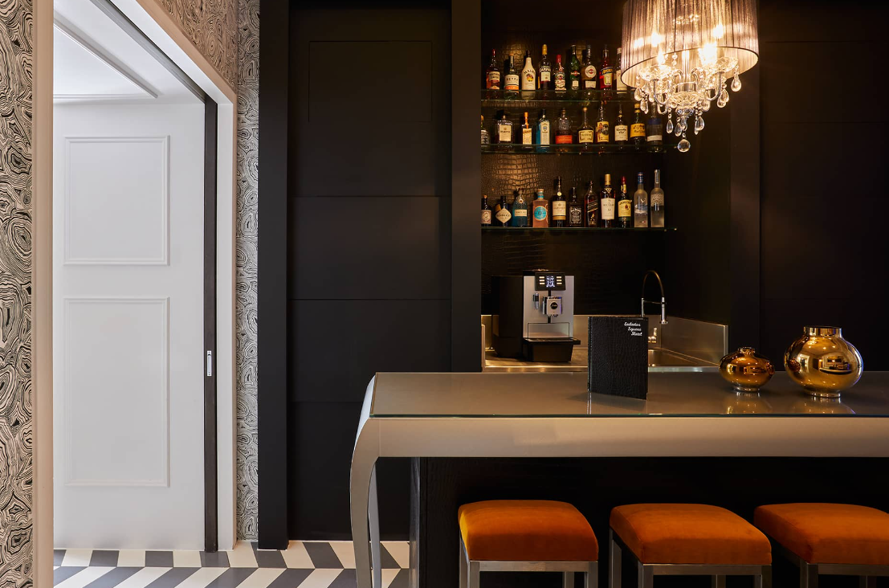
Figure 1: Eccleston Square Hotel
Source: (Ecclestonsquarehotel.com, 2024)
Coming to the choice of Eccleston Square Hotel, the location provides a conducive and sophisticated environment to have productive discussions and conduct networking sessions. The tech-savviness of the hotel is an additional facility that complements this event’s aim and nature (Ecclestonsquarehotel.com, 2024).

The Event Cycle
The understanding of the Event Cycle signifies the sequence of phases that includes the process of planning, organising, implementing and evaluating the meeting and event (Dewey, 2024). The cycle includes different stages that are based on the event.
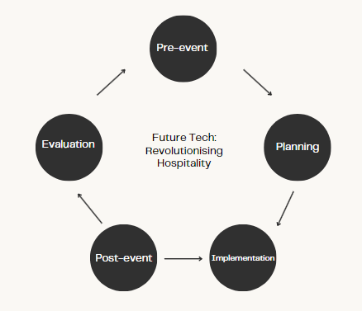
Figure 2: Event Cycle for Future Tech: Revolutionising Hospitality
(Source: Self-created)
Pre-event stage: The stage highlights the event framing, highlighting objectives and market research of the event (Zhang et al., 2021). In this stage, the event planners will understand the target market, theme and stakeholders. In the event of “Future Tech: Revolutionising Hospitality” at Eccleston Square Hotel the stage will help in securing the funding sources and analysing sponsors, integrated technological uses and finding aspects that will enhance the experience of guests.
Planning stage: The stage details the effective planning process where the event organisers develop the plan. Based on the “Future Tech: Revolutionising Hospitality” event, the organisers will plan the process including marketing, logistics, budgeting and other aspects. Agreements on the event at the hotel will be finalised with the vendors, sponsors and exhibitors and an effective layout of the event will be planned. In this stage, effective rules and regulations will be implemented based on the innovation and technological usage by the guests.
Implementation: In this stage, the plans and practices are executed and the event staff organises a venue (Meredith, 2022). Based on the event, the staff decided to plan the event at Eccleston Square Hotel where coordination of technological usage, managing catering, parking facilities and other aspects will also be observed.
Post-event stage: The event organiser of “Future Tech: Revolutionising Hospitality” will conduct meetings with the event shareholders and staff to understand the success and the issues faced during the conduction of the event. In this stage, financial matters and partnering with the sponsors and others will also be discussed by the event organiser at Eccleston Square Hotel.
Evaluation stage: In this stage, the success of the event will be measured by identifying the revenue generated, income sources and the influence caused by the event (Dewey, 2024). The event organiser of the “Future Tech: Revolutionising Hospitality” event will also analyse the lessons that are learned from technological usage for enhancing the guests’ experiences and will also understand the scope for further innovation.

Event Concept
The “Future Tech: Revolutionising Hospitality” event is about enhancing the experiences of the guests within Eccleston Square Hotel through the use of innovation and technologies. The event is about booting the guest's experiences and commuting the day with interactive events, workshops and networking benefits with other shareholders and business delegates within the hospitality sector. The event will focus on the future and enrichment of the hospitality sector and the ways innovation and technologies are integrating the world (Thakur, 2022). The guests at the event at the venue of Eccleston Square Hotel will experience great opportunities for communicating with others and sharing their ideas with an increase of their creativity, technological and knowledge skills. The guests at the venue of the event will experience networking with other delegates from the technological expertise field and the hospitality sector. The process of networking will help the individuals to share thoughts and ideas and enhance their valuable connection with other professionals (Rogers and Wynn-Moylan, 2022). On the day of the event, the guests will also experience the workshop sessions that will create an engagement within the expertise of the hospitality and technological sector. The workshop will effectively include a discussion on technological development focusing on digital transformations and the personalisation scope that will also highlight the experience obtained by the guests on the event day.

Aim and Objectives of the Event
Aim: To explore technology and innovation for future development in the hospitality sector.
Objectives | Specific | Measurable | Attainable | Relevant | Time-bound
To enhance awareness among guests | Offering a guest audience with effective knowledge and potential understanding of the change in technologies in the hospitality sector. | The objective will be measured through the use of wider technologies that will help in the process of digital transformation within the hotel. | The objective can be achieved through using technologies in the check-in system and integrating the mode of AR, VR and other innovations that will help in fostering the experiences of guests. | Technology change creates a development and scope of innovation in the hospitality sector while assessing the fast-paced scope in the sector (Filimonau and Naumova, 2020). | 4 months
To foster engagement of the audience in the event | Creating an interactive guest experience to engage them and enrich their thorough participation in the “Future Tech: Revolutionising Hospitality” event | The event organiser can measure and initiate engaging the guest experience in the hotel venue through implementing the Customer Satisfaction Score and Customer Effort Score that will help in understanding the customer’s participation in workshops. | The objective can be achieved by communicating with the guests so that their demands and requirements regarding technological usage are effectively understood. | Guest’s experiences are positively led in the hospitality engagement that helps them in engaging an indicator of their interactive session through their engagement (Vo et al., 2022). | 6 months
To create networking opportunities within the professionals | Enriching collaboration and networking opportunities with the hospitality industry professionals, shareholders and technological expertise. | Networking with professionals can be measured by identifying the different collaborative activities and obtaining achievements through effective networking. | During the event “Future Tech: Revolutionising Hospitality”, networking can be achieved through scheduling appointments with the professionals discussing technological integration and transformation that are caused due to innovation methods. The event will promote networking through collaborating and fostering the scope of communication with others which will also help in the success of the project. | Networking is relevant in creating collaborative engagement as it helps in creating wider opportunities and enhancing relationships with others (Kapucu and Hu, 2020). Networking in the event will assist in gaining insights and knowledge regarding technological usage that will also enrich the experience of the guests. This will help in staying ahead of the different aspects in the marketplace of the hospitality sector. | 4 months
Table 1: SMART Goals
(Source: Created by the learner)

Event Operations
When preparing to execute the event plan for “Future Tech: Revolutionising Hospitality”, the team must be equipped with appropriately skilled, knowledgeable, and committed staff to understand technology and innovation. At Eccleston Square Hotel, the staff are required to possess proficient skills in using technologies since it has paramount significance for its service delivery and reputation. In addition to the skillsets of the hotel staff, the event management team’s skills are paramount to the success of this event. The MICE team will make sure to include skilled individuals who can not only navigate the operation and utilisation of the latest technologies but also can communicate and demonstrate their benefits or drawbacks. In addition to technological proficiency, the members will be required to possess high-level creativity and presentation skills (Hsu and Tseng, 2022). The most effective skill required for effective and satisfactory experience throughout this 2-day conference will be communication skills since everyone will get the opportunity to participate in networking sessions. The event staff will have to be proficient in utilising innovative systems and technologies like VR, AR, digital check-in systems, and other tools and systems. The key resources required for conducting this event will include the venue, technology and equipment, staff, signage, name badges, networking areas, promotion materials, marketing channels, accommodation arrangements, security personnel, and other essentials.

Event Budget
An event budget is required for the “Future Tech: Revolutionising Hospitality” event as it helps in maintaining the scope of financial planning and allocation of resources within the project. Through the budget, the cost is effectively controlled and financial accountability is thus maintained in the process (Bukh and Svanholt, 2020). Risk management is also effectively implemented through the budget analysis within the event.
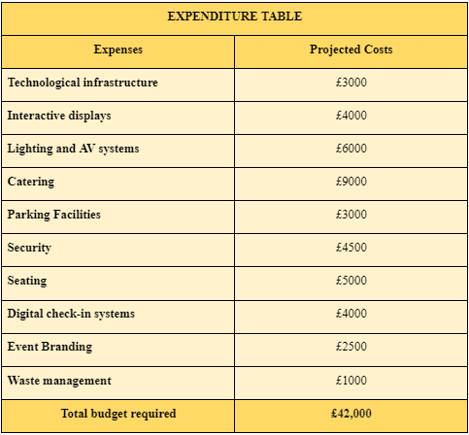
Figure 3: Expenditure for the event
(Source: Self-created)
The “Future Tech: Revolutionising Hospitality” event will require expenditure from different sources which will include expenses on technological infrastructure, event branding, catering, parking facilities, seating, security, lighting and AV systems, digital check-in system, waste management and interactive displays. The total expenses that will be required for the event will be £42,000.
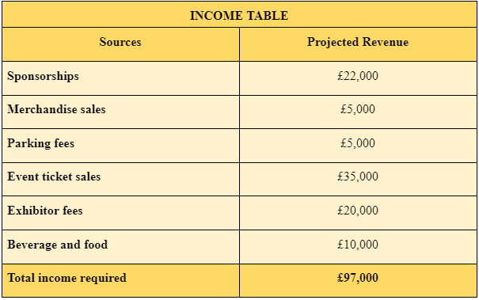
Figure 4: Projected Income from the event
(Source: Self-created)
The event, “Future Tech: Revolutionising Hospitality” at Eccleston Square Hotel will require income so that the process of the event is successful. The event requires income from different sources including sponsorships, parking fees, merchandise sales, exhibitor fees, event ticket sales and beverage and food sales. The total income that will be needed for the event will be 97,000 GBP.
The funding sources for the accomplishment of the event will be through private bank loans. Through this funding source, the event organiser of “Future Tech: Revolutionising Hospitality” at Eccleston Square Hotel will pay cheap rates rather than high-interest loans. The other funding source will be the support of the government that will be offered through tax incentives and other assistance which will help in the success of the event. Additionally, the funding source will also be the angel investors for the event. Angel investors will offer capital and budget for the business and events in return for a share at the event (Botelho et al., 2021). Crowdfunding is the other funding source where capital will be collected through promoting the event on different websites.

Industry Trends / Issues / Impacts
The meetings and events industry (MICE) is evolving at a rapid pace and a variety of trends, external factors, and issues influence it. The main factors can include rapid technological developments, the shift of preferences towards experience-driven events, health and safety concerns, and so on which can be categorised in detail using tools like PESTLE and SWOT analysis.
SWOT analysis
Strengths | Weaknesses
- This event’s strong focus on innovation and technology is well-aligned with the identified industry trends.  - A prestigious venue has been selected, Eccleston Square Hotel, that increases its appeal and credibility.  - It resonates with a diverse audience including both hospitality and technology professionals, investors, innovators, technology experts, and so on.  - The program features activities like keynote presentations, networking sessions, and expert panels. | - The event’s reliance on advanced technological infrastructure might pose a challenge related to technical issues.  - The limited capacity for in-person attendance can also become a weakness of this event which is mostly related to health and safety concerns.
Opportunities | Threats
- There are opportunities to collaborate with sponsors and technology providers to make enhancements to the event offerings.  - It can also expand into hybrid or virtual formats and reach a wider population.  - The event also has the potential to achieve long-term collaborations or partnerships with the stakeholders of the industry. | - Certain uncertainties related to future health and safety regulations might influence the planning of this event and its execution.  - Competition from similar technology or hospitality-related events or alternatives of this event in the virtual form can affect endgame and attendance levels.
Table 2: SWOT analysis of the event
(Source: Created by the learner)
PESTLE analysis
Factors | Influence
Political | The changes in regulations and policies associated with gatherings and events can impact the planning of this event as well as its execution in the decided timeframe (AlWaer and Cooper, 2020). The shits in international relations as well as the level of political stability can also impact the attendance levels of global participants.
Economic | Economic conditions like downturns or recessions can affect the capabilities of sponsorship and opportunities for this event as well as the budgets of attendees (Ormerod and Wood, 2021). The expense capabilities of the event team can also be impacted due to unforeseen exchange rate fluctuations.
Social | Changes in societal trends and demographics are likely to affect the presence and preferences of event attendees. Due to the attitudes influenced by COVID-19, health and safety concerns might arise shaping the behaviour of participants and the event planning process (Templeton, 2021).
Technological | Advancements in technology can enable such event formats as well as allow them to utilise engagement tools. However, higher dependence on technology can also pose a risk of technical issues or malfunction during the event that must be considered carefully (Vinnakota et al., 2023).
Legal | The event processes, decisions and the team must comply with regulations like event safety standards, data protection law, and other similar regulations to legally operate the event (Getz and Page, 2019).
Environmental | The event organisers must consider employing environmental sustainability focusing on the overall impacts of the event. The concerns like waste production, its proper disposal, and so on must be planned carefully with the hotel managers by adopting eco-friendly practices (Tan and Zhu, 2022).
Table 2: PESTLE analysis for the event
(Source: Created by the learner)

Cultural and Situational Considerations
Some key cultural and situational considerations are associated with the execution of the “Future Tech: Revolutionising Hospitality” event which includes cultural diversity, communication and language, dietary restrictions and preferences, and cultural sensitivity. The event will attract attendees from diverse backgrounds which makes recognition and respect for cultural differences essential, especially in terms of preferences, etiquette, and communication styles. Considering these aspects can make the attendees feel welcomed while being involved in an inclusive environment. The diverse audience will also have different communication and language preferences which is why offering interpretation services and multilingual materials will be essential to ensure clear communication. It will also foster engagement among the participants by overcoming linguistic barriers. The professionals from the hospitality industry are highly accustomed to accommodating their guests’ dietary restrictions and preferences (Rahimi et al., 2022). Hence, the event organisers must ensure catering options are prepared carefully to cater a range of dietary needs.

References
AlWaer, H. and Cooper, I., (2020). Changing the focus: viewing design-led events within collaborative planning. Sustainability, 12(8), p.3365.
Botelho, T., Harrison, R. and Mason, C., (2021). Business angel exits: a theory of planned behaviour perspective. Small business economics, 57, pp.583-602.
Bukh, P.N. and Svanholt, A.K., (2020). Empowering middle managers in social services using management control systems. Journal of Public Budgeting, Accounting & Financial Management, 32(2), pp.267-289.
Dewey, E.R., (2024). Cycles: The mysterious forces that trigger events. Harriman House Limited.
Ecclestonsquarehotel.com. (2024). Versatile Corporate Meeting Space | Eccleston Square Hotel London. [online] Available at: https://www.ecclestonsquarehotel.com/corporate [Accessed 25 Apr. 2024].
Filimonau, V. and Naumova, E., (2020). The blockchain technology and the scope of its application in hospitality operations. International Journal of Hospitality Management, 87, p.102383.
Getz, D. and Page, S., (2019) Event studies: theory, research and policy for planned events. 3rd Edition. Routledge: Oxford
Hsu, H. and Tseng, K.F., (2022). Facing the era of smartness: constructing a framework of required technology competencies for hospitality practitioners. Journal of Hospitality and Tourism Technology, 13(3), pp.500-526.
Kapucu, N. and Hu, Q., (2020). Network governance: Concepts, theories, and applications. Routledge.
Meredith, J., (2022) Project management: a managerial approach.
Ormerod, N. and Wood, E.H., (2021). Regional event tourism funding policies: A strategic-relational critique of current practice. Journal of Travel Research, 60(4), pp.860-877.
Rahimi, R., Thelwall, M., Okumus, F. and Bilgihan, A., (2022). Know your guests’ preferences before they arrive at your hotel: evidence from TripAdvisor. Consumer Behavior in Tourism and Hospitality, 17(1), pp.89-106.
Rogers, T. and Wynn-Moylan, P., (2022) Conferences and conventions: a global industry. 4th Edition. Routledge: Oxford.
Tan, Y. and Zhu, Z., (2022). The effect of ESG rating events on corporate green innovation in China: The mediating role of financial constraints and managers' environmental awareness. Technology in Society, 68, p.101906.
Templeton, A., (2021). Future research avenues to facilitate social connectedness and safe collective behavior at organized crowd events. Group Processes & Intergroup Relations, 24(2), pp.216-222.
Thakur, A., (2022). Sensor-based technology in the hospitality industry. In Mobile Computing and Technology Applications in Tourism and Hospitality (pp. 24-43). IGI Global.
Vinnakota, S., Mohan, M.D., Boda, J., Sekuini, J., Mustafa, M. and Madala, H., (2022). Leveraging artificial intelligence in the hospitality industry: opportunities and challenges. Asian Journal of Social Science and Management Technology, 5(3), pp.201-261.
Vo, N.T., Hung, V.V., Tuckova, Z., Pham, N.T. and Nguyen, L.H., (2022). Guest online review: an extraordinary focus on hotel users’ satisfaction, engagement, and loyalty. Journal of Quality Assurance in Hospitality & Tourism, 23(4), pp.913-944.
Zhang, Q., Wang, Z., Ma, S. and Arif, A., (2021). Stochastic pre-event preparation for enhancing resilience of distribution systems. Renewable and Sustainable Energy Reviews, 152, p.111636.

