Student Name: Ffion Morgan
P Number: 2404913
Programme of Study: Graphic Design
Module: ADDA4023 Ways of Perceiving
Task: Curate an exhibition = 848 words

For this assessment, I confirm that I have not used Generative AI to support me in structuring my submission, including creating a draft argument structure, identifying parts and headings. I confirm that I have not used Generative AI to create text for my submission. I confirm that I have not used Generative AI for creative materials, such as images.

Queer Women In Music

This exhibition explores album artwork of queer women and gender non conforming artists to bring visibility for them. Many of the pieces have different subjects, from gender expression,race, freedom to transhumanism, but all share the theme of queerness. Especially in a time where queer women's identities are being weaponized against trans women by non queer people, an exhibition focusing on the two groups is a great way to show solidarity. In an interview with Chloe Wyma for Modern Painters, Mickalene Thomas states “ To see yourself, and for others to see you, is a form of validation. I’m interested in that very mysterious and mystical way we relate to each other in the world” (2012).

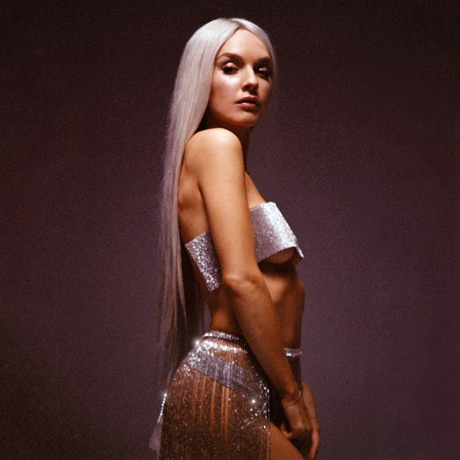
Fig 1 (Hoetzel, Z.M (2018) Sappho)

The first art work featured in the exhibition is the artwork featured on Zolitas E.P called Sappho. As the title of the work suggests, this album explores lesbian love in a deeply personal way, but also features queer identity, feminism and empowerment. Sappho and her poetry has long been important to lesbians and lesbian culture, Sappho is a queer icon. Even though much of her work is fragmented or completely lost, much of it still displays the intensity of relationships between women.

“ He seems to me equal to gods that man
whoever he is who opposite you
sits and listens close
to your sweet speaking

and lovely laughing—oh it
puts the heart in my chest on wings
for when I look at you, even a moment, no speaking
is left in me

no: tongue breaks and thin
fire is racing under skin
and in eyes no sight and drumming
fills ears

and cold sweat holds me and shaking
grips me all, greener than grass
I am and dead—or almost
I seem to me.

But all is to be dared, because even a person of poverty”
(Carson, A, 2003)

The album artwork consists of a moody portrait of Zolita. It's quite minimal, but also intimate, sensual and powerful. Drawing back to the themes of both sapphic love and female empowerment.
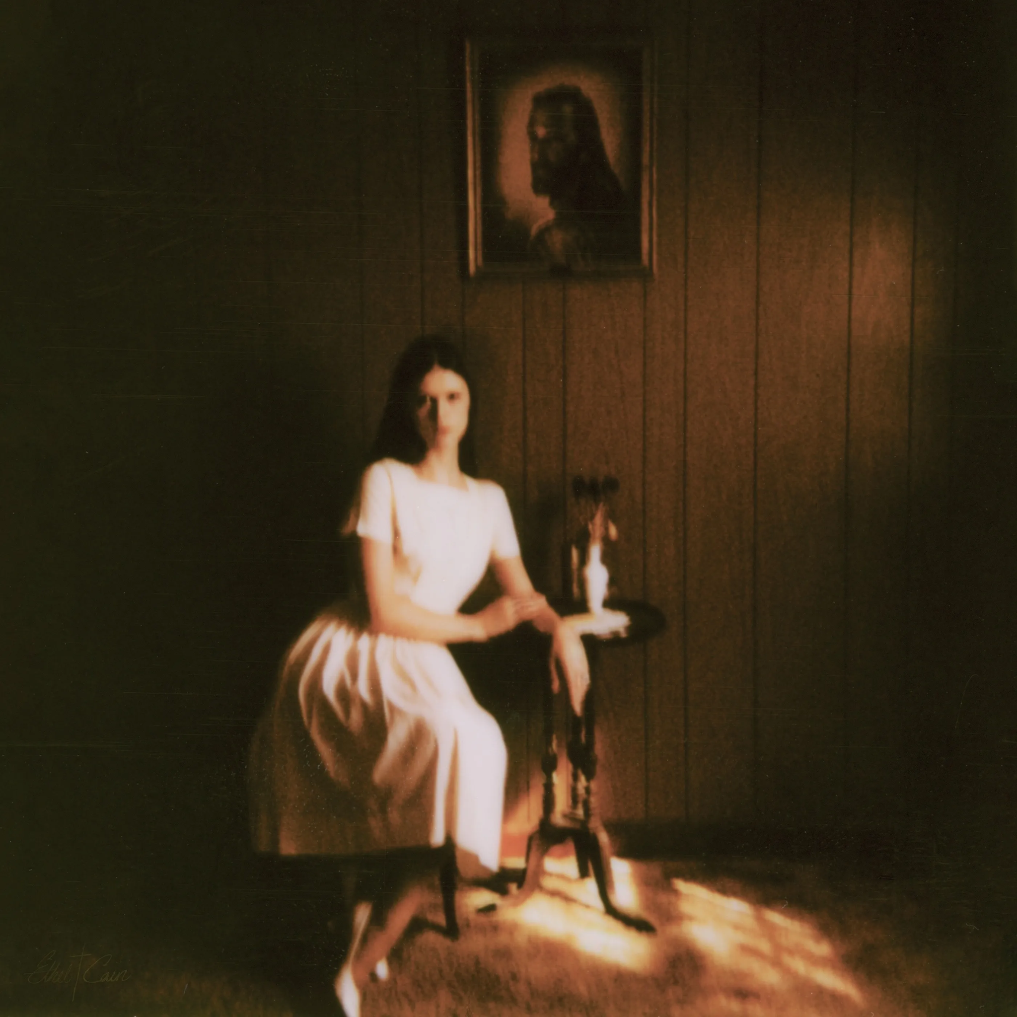
Fig 2 (Anhedönia, H.S. (2022) Preacher’s Daughter)

Ethel Cain’s debut, and concept album Preachers Daughter narrates the story of the fictional Ethel Cain and grapples with themes such as trauma, religion,doomed romance and self destruction, while rich in Americana and Southern Gothic motifs. As defined by Encyclopedia Britannica “Southern gothic, a style of writing practiced by many writers of the American South whose stories set in that region are characterized by grotesque, macabre, or fantastic incidents” (Encyclopedia Britannica, no date) . It also subtly explores Cain’s own transgender identity, who was raised in a southern baptist community.

The album artwork reflects these themes well. The image is haunting, it's out of focus, almost distorted though you can still make out the details. Ethel is sitting in a dimly lit, wood paneled room, wearing a white dress and features a painting of Jesus Christ. The religious iconography hangs above her, symbolising both devotion and oppression. Her white dress represents innocence.

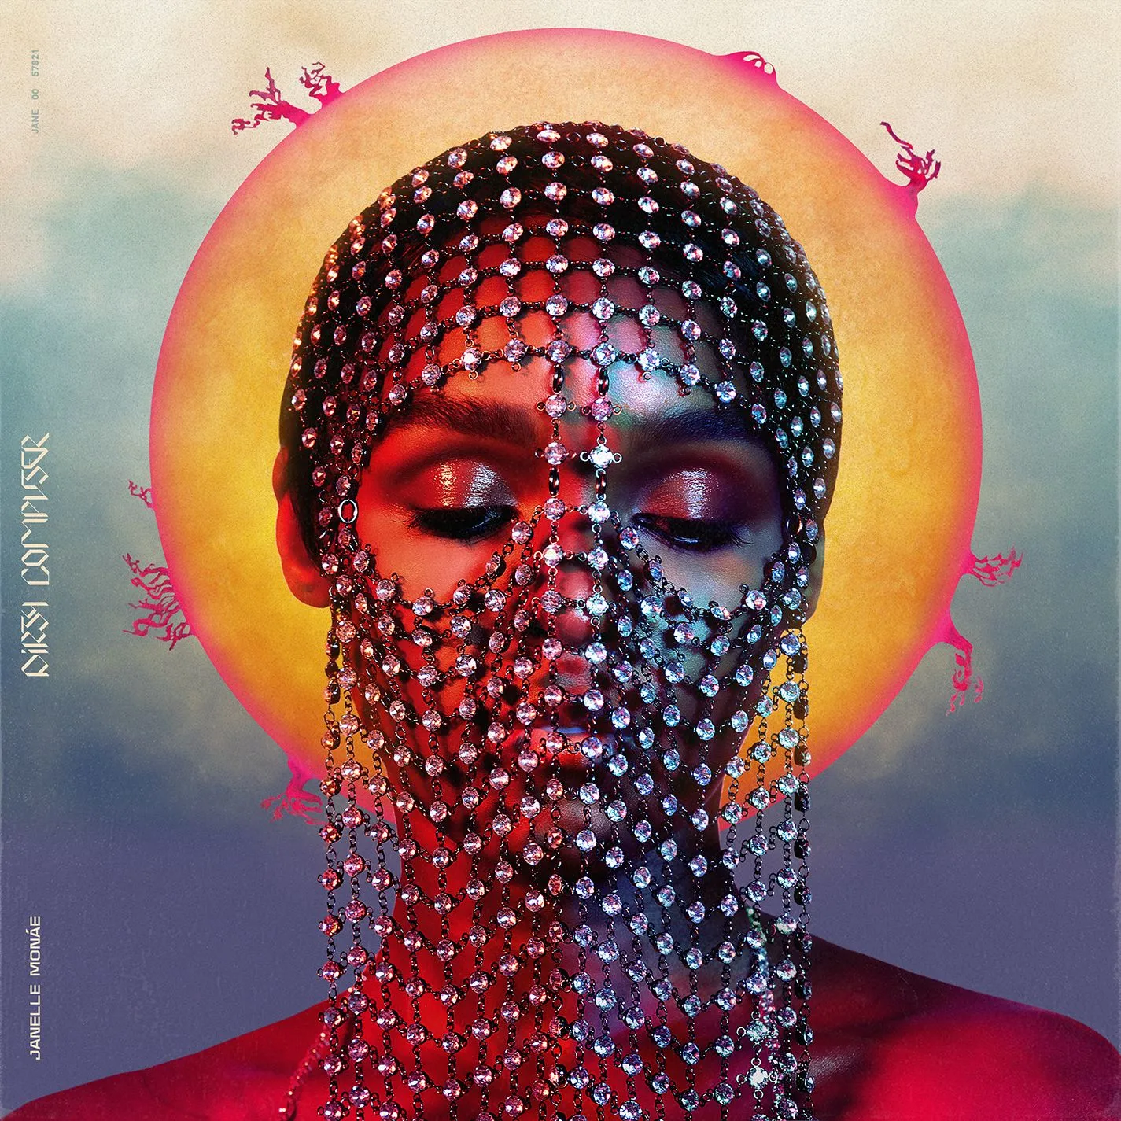
Fig 3 (JUCO, 2018, Dirty Computer)

“They call us dirty ’cause we break all your rules now” (Janelle Monae, 2013).
Janelle Monáe's 2018 album explores themes such as queerness, freedom, sex-positivity, self acceptance and black womanhood, with afrofuturist storytelling. According to the Tate website “Afrofuturism is a cultural aesthetic that combines science-fiction, history and fantasy to explore the African-American experience and aims to connect those from the black diaspora with their forgotten African ancestry” (Tate 2017). Blending genres such as hip-hop, pop, funk and R&B. Monáe uses the phrase “Dirty Computer” to describe those who deviate from what the system expects, and who the system attempts to erase. This album challenges this system, embracing the beauty of those who embrace the beauty of non-conformity and individuality. The album artwork reinforces these themes.

It features Janelle Monáe, donned in a veil I can only describe as opulent, and a golden halo encompassing their head. The halo is of course iconography deeply rooted in many religions where it often features on artwork of figures such as Jesus, saints, and Mary. This represents holiness and divine presence. The album artwork pairs this sacred imagery with modern, digital aesthetics. The vibrant colours, the typography and the futuristic styling of Monáe ties to the afrofuturist themes.

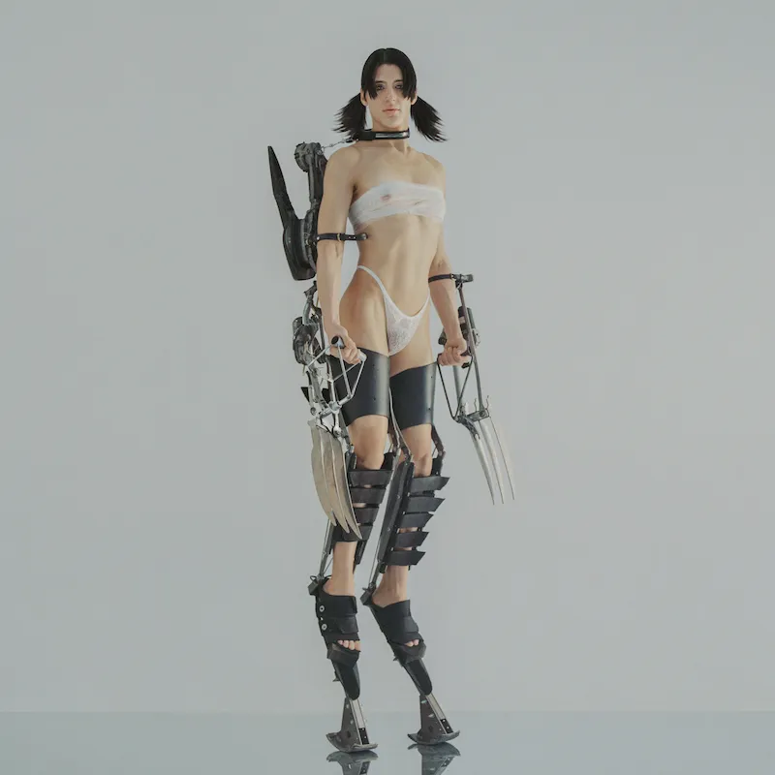
Fig 4: (Guerrero, C (2020) Kick I)

Kick I is Arca's fourth studio album. It's a powerful artistic body of work that celebrates queer rage, queer joy, gender euphoria nonbinary identity and the artwork perfectly embodies these themes. This was also Arca’s first release since coming out as transgender, it almost feels like a rebirth of sorts.

The cover art depicts Arca as a cyborg. Her human body was extended by mechanical limbs and weaponry, her body is bare, yet the robotic features are almost threatening. This reflects the album's tention of vulnerability and empowerment.

Arcas presentation on the album cover is purely androgynous, fully representing her non binary identity and refusal to conform to gendered stereotypes. The industrial and futuristic aesthetic of it perfectly captures Arca's chaotic, glitchy experimentalism.

Bibliography:

Carson, A. (2003) If Not, Winter: Fragments of Sappho. Great Britain: Virago Press

Encyclopedia Britannica. (n.d.). Southern gothic | American literature. [online] Available at: https://www.britannica.com/art/Southern-Gothic

Janelle Monáe Robinson (2013) Q.U.E.E.N. Hollywood. Atlantic Records. Available at: https://genius.com/Janelle-monae-queen-lyrics

Tate (2017). Afrofuturism – Art Term | Tate. [online] Tate. Available at: https://www.tate.org.uk/art/art-terms/a/afrofuturism

List of figures:

Figure 1: Hoetzel, Z.M (2018) Sappho. Available at: https://is1-ssl.mzstatic.com/image/thumb/Music124/v4/12/93/be/1293be75-549c-16fd-5a7e-6e9c19bb469a/SAPPHO_Cover2.jpg/600x600bf-60.jpg

Figure 2: Anhedönia, H.S. (2022) Preacher’s Daughter. Available at: https://media.pitchfork.com/photos/627c0ad088edeb4d342d9258/master/pass/Ethel-Cain-Preachers-Daughter-2022.jpg

Figure 3: JUCO (2018) Dirty Computer.Available at: https://media.pitchfork.com/photos/64b805e39ed6745604d2a147/master/pass/Janelle-Monae-Dirty-Computer.jpg

Figure 4: Guerrero, C (2020) Kick I. Available at:
https://media.pitchfork.com/photos/5efa1273a9d0807aa5684217/1:1/w_800,h_800,c_limit/KiCK%20i_Arca.jpg

