The assignment title: Planning and Delivering an International Meeting/Event

The module title: International Meetings Management for the Hotel Industry
Module code: BMIH6007
Presentation

Student name:Antonina Vasileva Danchova
Student number: 2211877
Lecturer’s name:Chris Wilkin

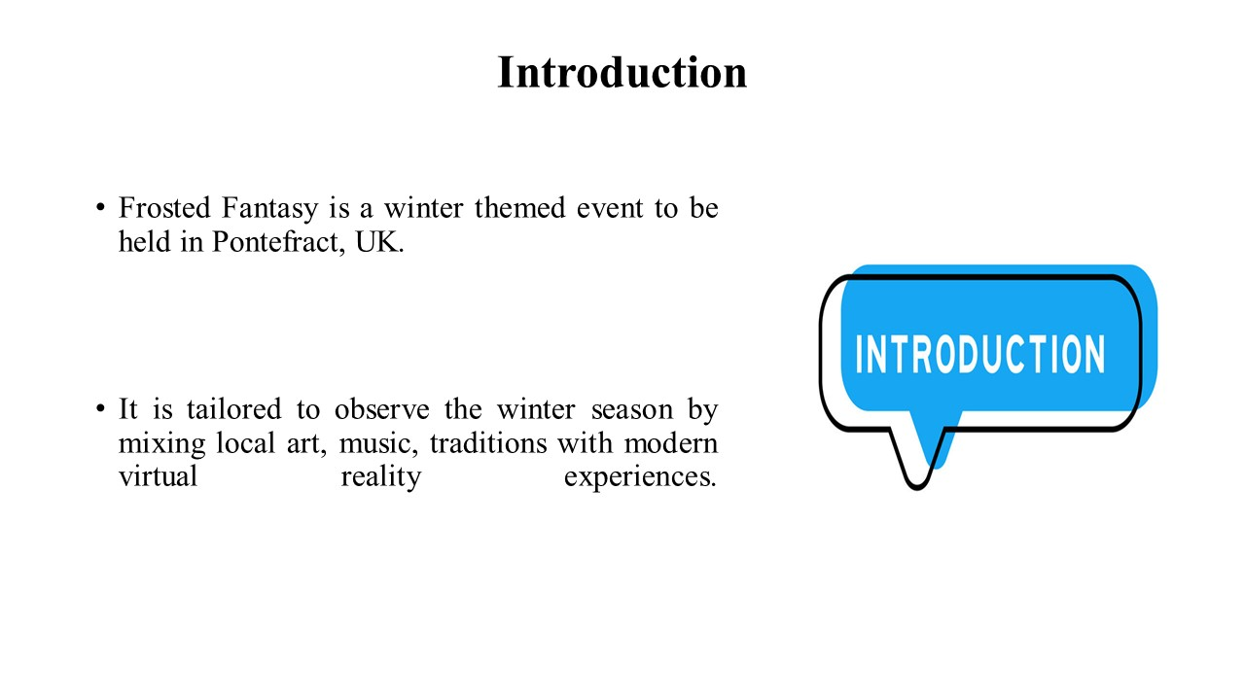

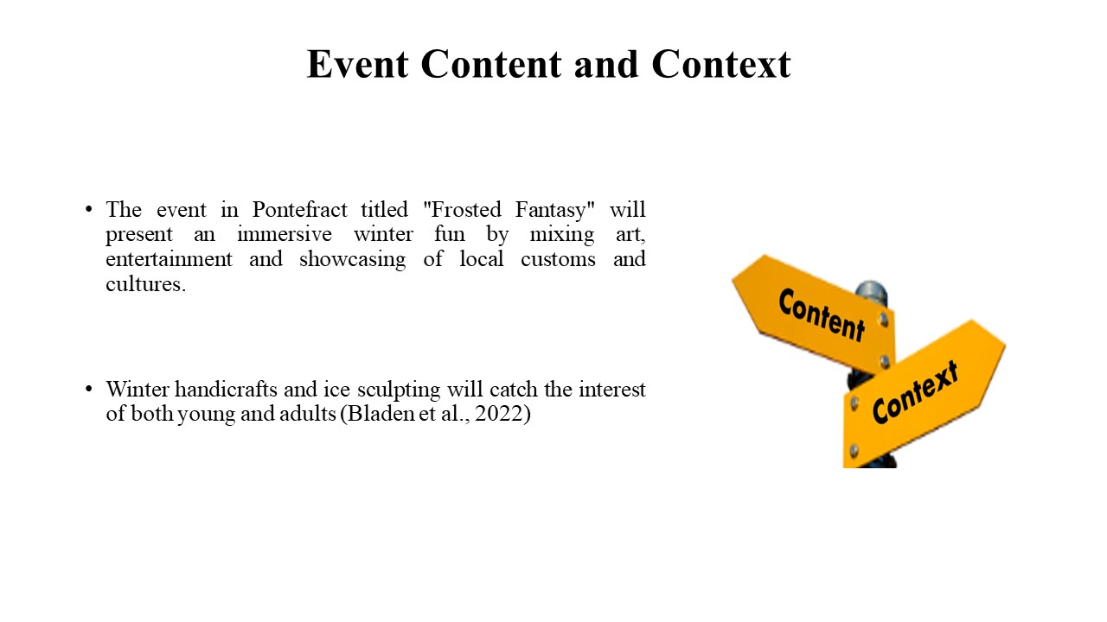

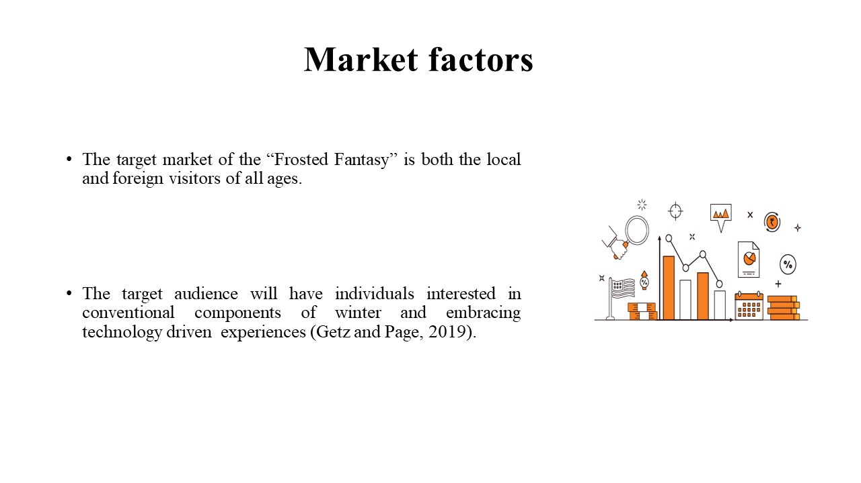

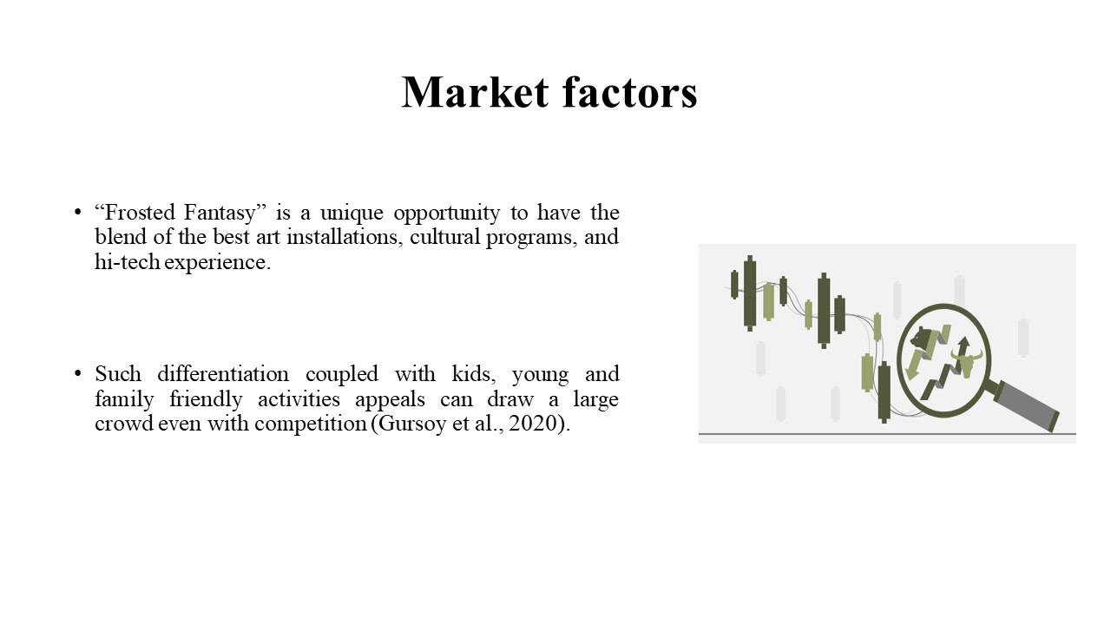

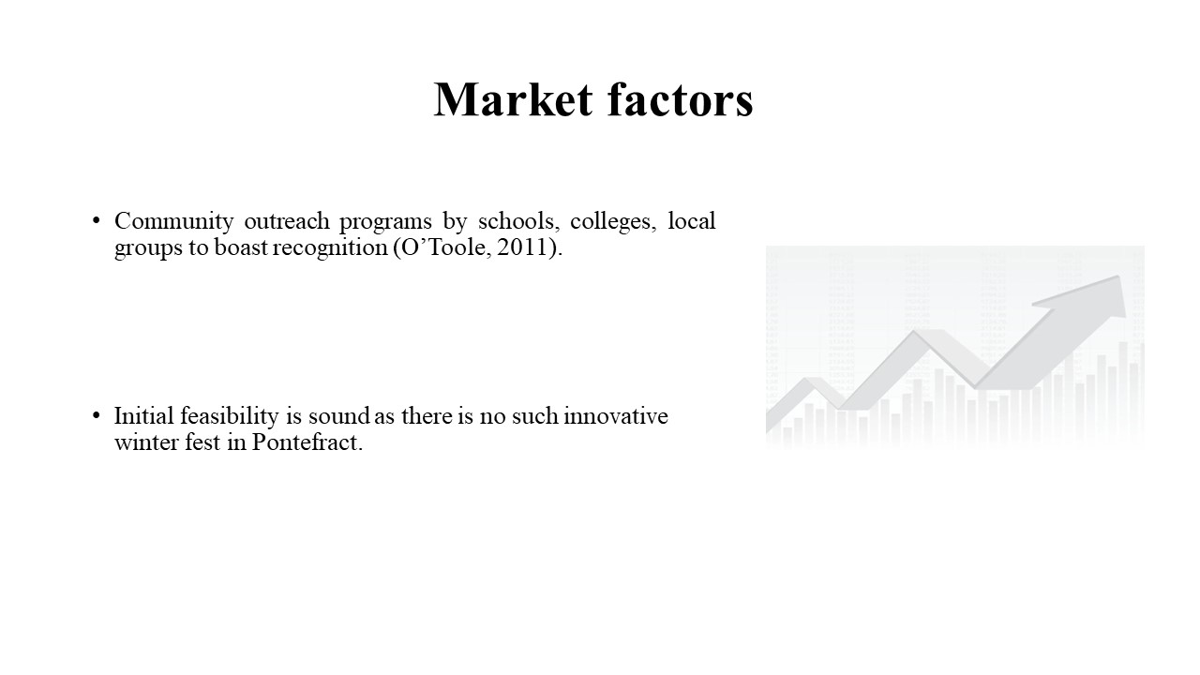

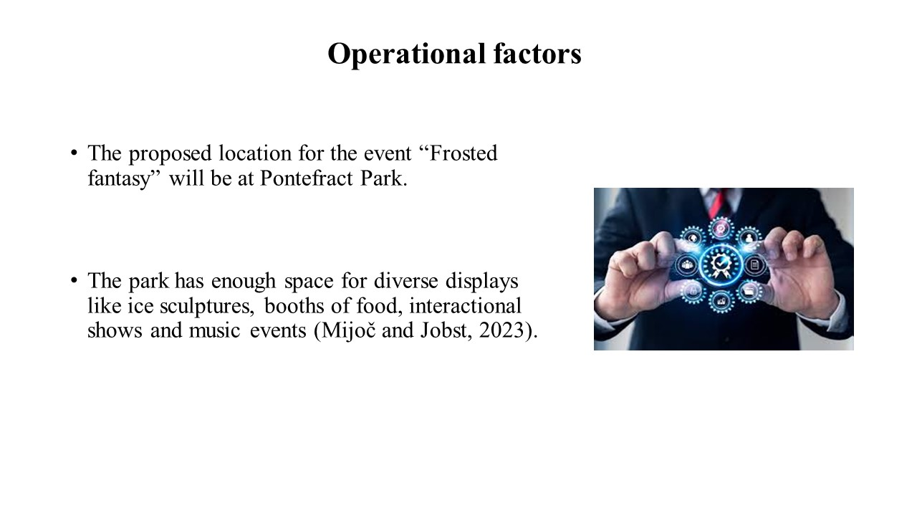

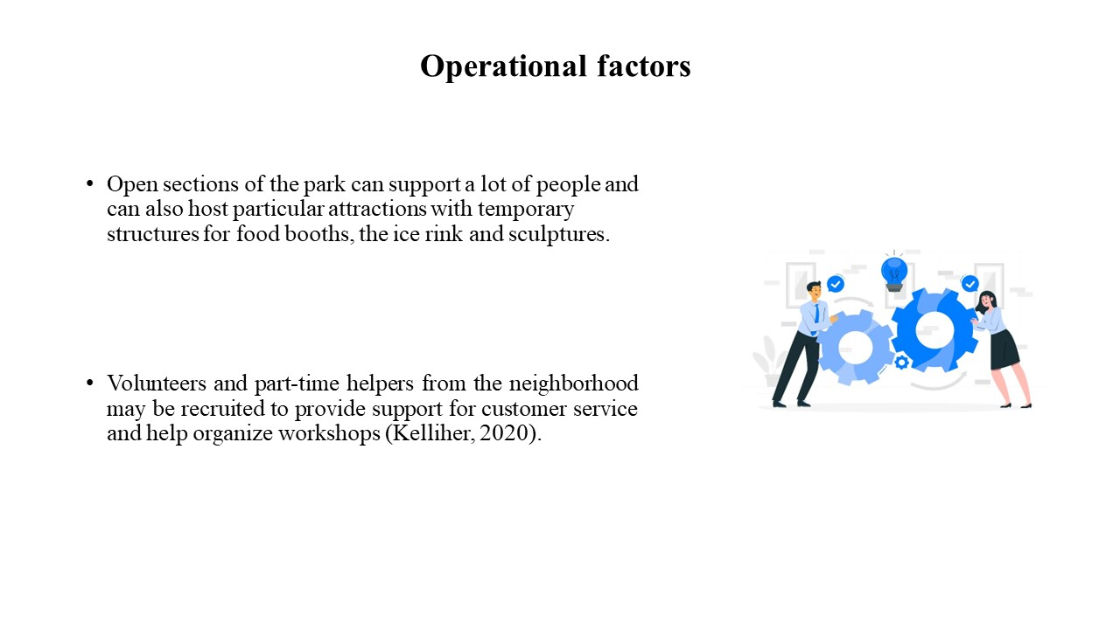

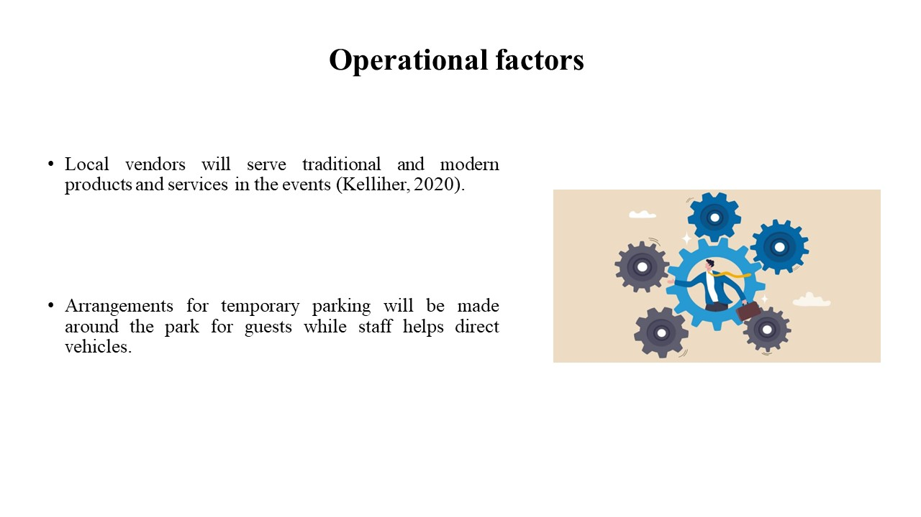

A cost table mentioning different activities and an income table are given below of “Frosted Fantasy” event:

Activities | Cost
Venue lease and permit | £10,000
Ice sculpture and other installations | £14,000
Lighting and sound arrangements | £6,000
Virtual reality instruments and staff | £6,000
Marketing and advertisements | £4,000
Catering and food shops | £5,000
Short term structures and seating arrangements | £4,000
Staff hiring | £10,000
Others | £5,000
Total | £64,000
Table 1: Costs

Activities | Income/ Revenue
Ticket sales (15,000 tickets at £2 per ticket) | £30,000
Vendor charge | £15,000
Sponsorships and local business collaboration | £25,000
Commodities sales (Winter theme products, Frosted fantasy products) | £20,000
Total | £90,000
Table 2: Income Statement
.

Reference List

Fox, D. et al. (2014) Doing events research: from theory to practice. Routledge: Oxford
Getz, D. and Page, S. (2019) Event studies: theory, research and policy for planned events. 3rd Edition. Routledge: Oxford
Meredith, J. (2022) Project management: a managerial approach
O’Toole, W. (2011) Events feasibility and development: from strategy to operations. Elsevier: Oxford
Gursoy, D., Nunkoo, R. and Yolal, M. eds., (2020). Festival and event tourism impacts.
Akhundova, A., (2024). Role of Festivals in Stimulating the Development of Event Tourism. Theoretical And Practical Research In Economic Fields, 15(2), pp.277-287.
Mijoč, J. and Jobst, I., (2023). Research Study on Festival and Events: 4th EU-China International Literary Festival. Andizet-Institute for Scientific and Art Research in Creative Industry.
Kelliher, P.O.J., Acharyya, M., Couper, A., Maguire, E., Nicholas, P., Pang, N., Smerald, C., Stevenson, D., Sullivan, J. and Teggin, P., (2020). Operational risk dependencies. British Actuarial Journal, 25, p.e5.
Olivier, L., Carlson, J., Rahman, S.M. and Rosenberger III, P.J., (2023). Measuring tourist festival experience: development and validation of the PHF-tx model. Journal of Travel Research, 62(7), pp.1530-1549.
Bladen, C., Kennell, J., Abson, E. and Wilde, N., (2022). Events management: An introduction. Routledge.

