MOCK INTERVIEW

STUDENT= SOCORRO ALAM
ID= 2029042

PROFESSIONAL CAREER DEVELOPMENT
( BMSW4005_BIRM )

LECTURER= BETSY JOSE

SOCORRO CALADIAO ALAM

Address= 54 Gray Street, Northampton NN1 3QQ
Email address= socorroalam7@gmail.com

Educational Background:
CERTHE Skills for workplace ( Health and Social Care) level4 2021-2022
Care Certificate Health Education, Skills for care and skills for health 2019
University of Ortanez ( Philippines ) 1980-1986

WORK EXPERIENCE:
Health Care Assistant
Avery healthcare- Moulton, Northampton
August 2019- to present

Support Worker
Consensus- Northampton
November 2018- June 2019

Care assistant (nights)
Midland Care home- Wellingborough
Feb. 2018- Oct. 2019

Care assistant
Four seasons Healthcare Wellingborough
Feb. 2016- Feb. 2018

Care Assistant
Linden Manor residential care home- Wellingborough
Nov. 2015- 2016
Receptionist
Chili’s Takeaway- Burnham on crouch Essex
June 2015- Oct. 2015

Healthcare Assistant
Longfield Healthcare LTD- Maldon Essex
Dec. 2014- May 2015

Live-in- Carer
Loga Care Ltd- Farnham
Oct. 2011- June 2014

Support Carer
Whitmore Vale Housing Association Ltd. Woking Surrey
Nov. 2008- June 2011

Rail Operator
Southwest trains Ascot
July 2004- July 2008

Healthcare Assistant
Heatherwood Hospital Ascot
Jan. 1992- May 2004

Domestic Assistant
Heatherwood Hospital Ascot
Jan. 1991- April 2004

COVER LETTER:

Dear Sir/ Madam,
My name is Socorro Alam. I would like to send my interest for the position HCA (Primary Care) Phlebotomy/ Wound. I had lots of experience in Care settings. My passion is to help others to the best I can. And is willing to learn. I would like to be considered for this position, and if successful is willing to show you some of my skills. I am a team player, Motivated and very reliable.

Many Thanks,
Socorro Alam
Mobile number 07487811147

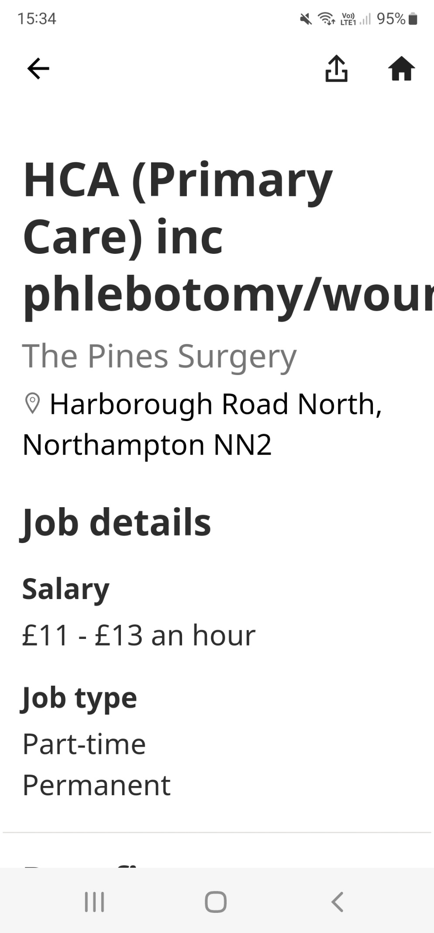
C



