
University of Wales Trinity Saint David
School of Engineering

Powertrain & Control
M5X00404

Engine Cycle Simulation

Jonathan Lloyd-Williams
1805620

BEng Motorcycle Engineering

12/01/2020

Table of Contents
1 Introduction & Aim 1
2 Task 1 Using Real Data 2
2.1 Pressure Against Volume 2
2.2 ΔP Against Crank Angle 3
2.3 Temperature Against Crank Angle 4
2.4 Work Done Against Crank Angle 5
2.5 Polytropic Index ‘n’ Against Crank Angle 6
2.6 Wiebe Function 7
2.7 Log P Against Log V 8
2.8 Finding ‘n’ from Log P / Log V 8
3 Task 2 Simulated Data 10
3.1 Pressure Against Crank Angle Comparison 10
3.2 ΔP / Crank Angle Comparison 11
3.3 Work Done Against Crank Angle Comparison 12
3.4 Temperature Against Crank Angle 13
3.5 Wiebe Function Comparison 14
4 Conclusion 15
5 Bibliography 16

Introduction & Aim
The aims of this assignment were to analyse real engine data provided for a Ford Sigma 1.6L, in order to improve my knowledge and understanding of the various processes involved in the engine combustion cycle and how they interact. This will be achieved by calculating specific variables and expressing them in graph form. By examining the graphs produced, much information can be found that will be useful within the second part of this assignment. Using this better understanding of the variables and their relationships, and the results calculated in the first task; I will then produce a simulation within Microsoft Excel using minimal information from the real Ford Sigma data with the intention of replicating the real data as accurately as possible. Provided the calculations are correct and accurate, I should be able to validate the data calculated within the simulation against the real data.
For both tasks I will be investigating how the changes in the crank angle per degree of the engine cycle affects the various aspects such as the volume and pressure. I will also be examining the thermodynamic properties of the engine throughout the cycle by calculating the average cylinder temperature, as well as the Mass Fraction Burn and Burn rate, and the polytropic index. As mentioned above once all results have been calculated, a comparison will undertaken between the real data provided and the data calculated within the simulation. At this point I will be considering what could be done in order to make the simulation more accurate when compared to the real data, and taking any highlighted steps to improve the simulation.
The aim of this report is to detail some of the methods involved in creating this simulation, as well using graphs produced as a visual aid to explain the processes involved and what conclusions and information can be drawn through the analysis of the various graphs.

Task 1 Using Real Data

Pressure Against Volume
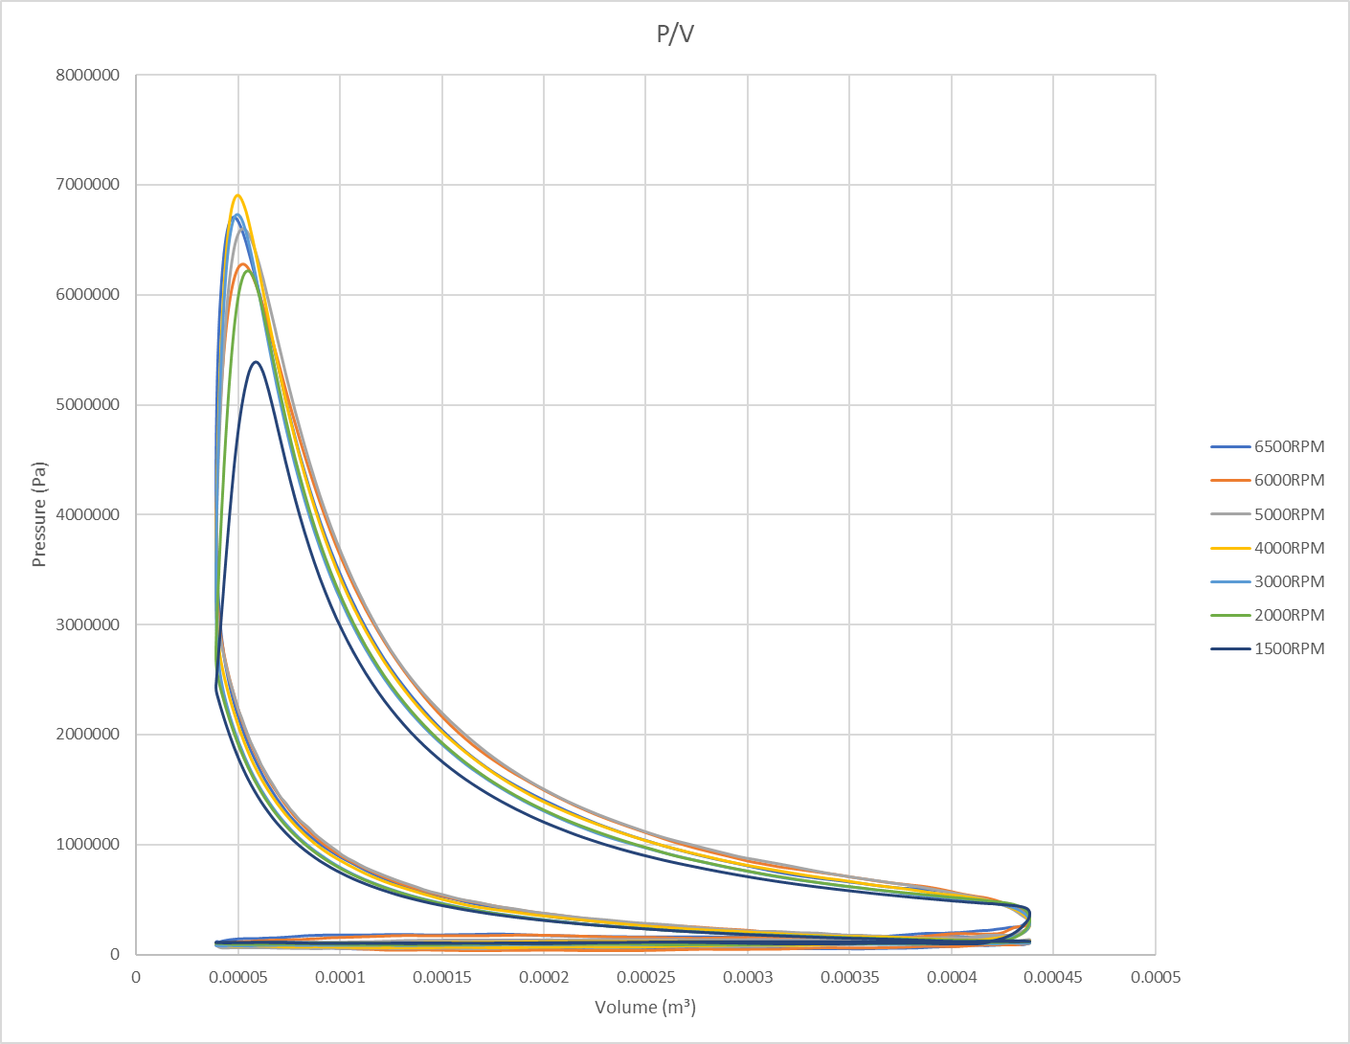
The graph of pressure against volume provides our trace of the Otto cycle, as can be seen below. However, the image below does not take into account the opening and closing of the valves.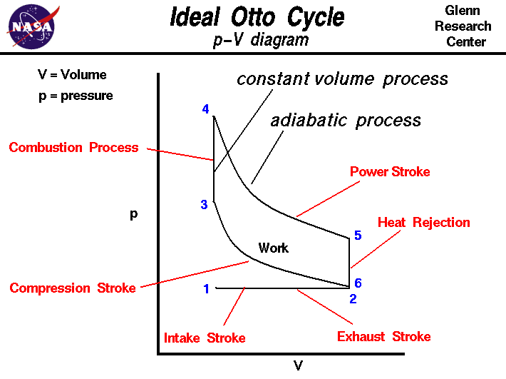
Analysing our graph above we can understand the changes in pressure and volume throughout the cycle. Firstly, the graph demonstrates that the volume is highest at BDC, where we see the lowest pressure, and lowest at TDC where the pressure reaches its peak. We can examine the whole cycle in its various phases through examining different areas of the graph. At BDC the engine is in the induction stroke, as the air fuel mixture is being drawn into the cylinder. The compression stroke is entered as the piston begins to rise towards TDC, this can be seen on the graph as the pressure increasing as the volume decreases. The sharp increase in pressure, despite a no longer decreasing volume indicates the point of ignition. The piston is then forced back down by the expansion of the air fuel mixture, demonstrated through the increasing volume as pressure decreases, highlighting the compression stroke. The exhaust phase can then be seen through the decrease in both pressure and volume. In this phase, the pressure does not increase as the volume decreases due to the opening of the exhaust valve which forces the exhaust gases out of the cylinder instead of increasing the pressure. (Spakovszky, 2002)
As can be seen from the produced graph, the highest pressures are reached during the mid rev ranges, with the peak being at 4000RPM. This is due to the increased piston velocity as the RPM increases and can be used to explain why combustion is more efficient in the mid rev range.
In thermodynamics, an adiabatic process is considered to occur so quickly that no heat transfer is seen (Connor, 2019)

ΔP Against Crank Angle

The rate of change in pressure (ΔP) is calculated through the formula P2-P1= ΔP. This graph can be used to further evidence the conclusion that this engine has been designed to work more efficiently in the mid rev range as the gases are able to expand further in a given time, allowing for more efficient combustion.

Temperature Against Crank Angle
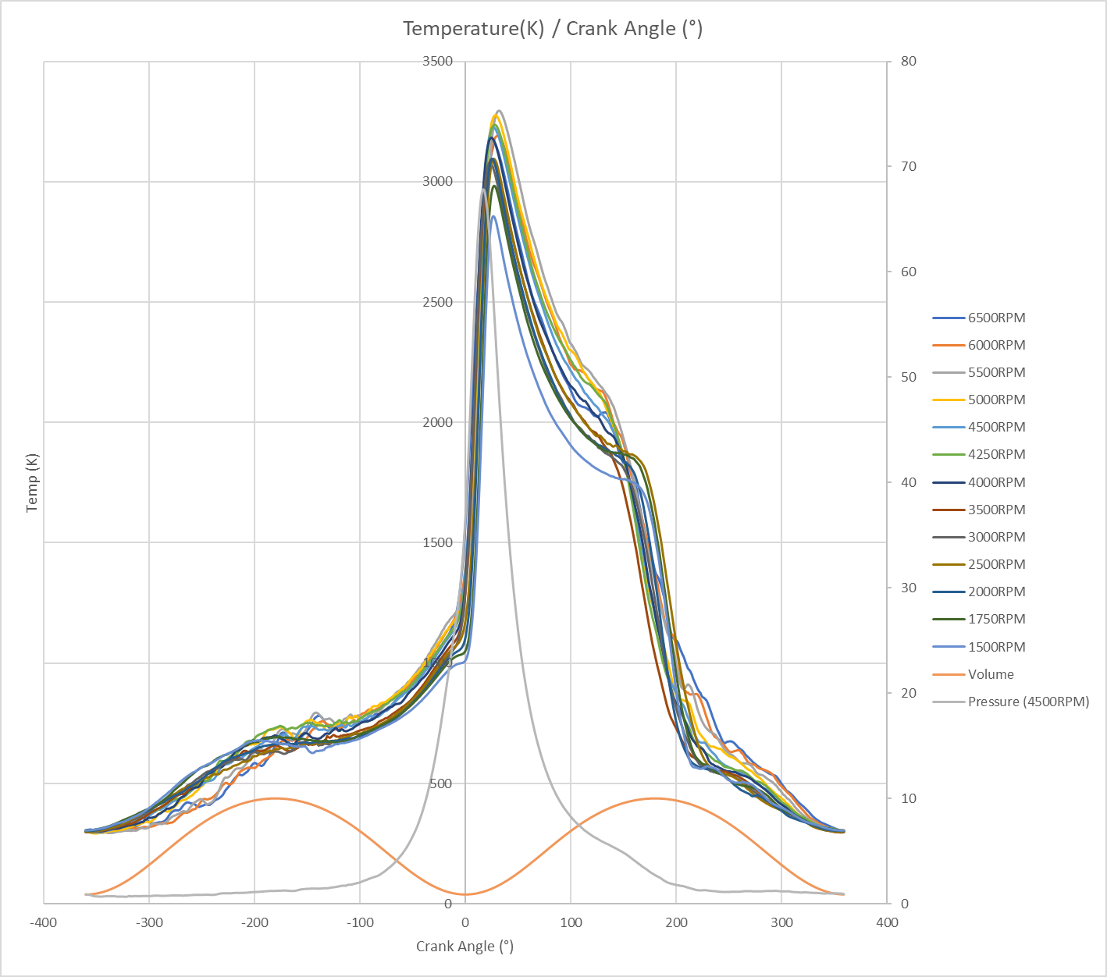
In order to calculate the temperature within the cylinder I used the equation T = ((P.V)/((mf+ma)(GasConstant)))+273
By analysing the temperature against the crank angle we can determine the peak temperatures, and at what point during the cycle these are achieved. As expected, the increase in pressure causes an increase in the temperature within the cylinder, even before ignition. The temperature will begin to rise exponentially at the point of ignition before beginning to fall as the piston returns to BDC and the pressure increases. By including a pressure and volume within the graph we are able to see how the temperature changes with respect to the pressure and volume.
Analysis of the graph confirms that at the start of the cycle the temperature is approximately 300K, a reasonable atmospheric temperature, at this point we pressure can also be considered to be at atmospheric pressure. As the volume increases as we move towards BDC the temperature has increased to approximately 750K. As combustion begins at the point of ignition the temperature increases drastically, to its peak, before beginning to fall during the power stroke. The final sharp decrease in the temperature is caused by the opening of the exhaust valves and the expelling of the hot waste gases to the atmosphere.

Work Done Against Crank Angle

In order to calculate the work done I used the formula (P1(Bar)* ΔV(cc))/10. We can see that the work done on the system (negative) begins in the induction phase at approximately 180°. The work done by the system begins at approximately -20° in the form of heat and kinetic energy (Open Stax College, 2020). The work done then begins to fall as the piston falls and the volume increases during the power stroke.

Polytropic Index ‘n’ Against Crank Angle

By examining the above graph of ‘n’ against crank angle, we can see the point at which ‘n’ begins to fluctuate drastically. Firstly at BDC during the induction stroke when the volume is highest and air fuel mixture is being drawn into the cylinder. A further smaller fluctuation can be seen at TDC due the compression of the air fuel mixture. Before seeing the largest fluctuation as we return to BDC and the highest level of heat transfer occurs.

Wiebe Function
In the Ford Sigma 1.6L data that was provided we were given some of the Mass Fraction Burn (MFB) values at different intervals. In order to make a valid chart I had to estimate the values for the 0% and 100% ranges at various RPMs. These were later revised as the simulation was built and I was able to determine the approximate point of ignition at the various RPM by analysing the point of significant difference between the calculated combustion and non-combustion pressures. This process will be highlighted further in the explanation of the second task. The final values calculated can be seen in the table below, which was then used the produce the Wiebe function graph.
MFB | C.A
MFB | 6000RPM | 5000RPM | 4000RPM | 2000RPM
0.00% | -12 | -8 | -6 | -3
2.00% | -6.066 | -2.328 | -3.566 | 1.664
5.00% | -1.731 | 0.284 | -1.177 | 3.512
10.00% | 1.476 | 2.811 | 1.142 | 5.5
50.00% | 13.911 | 13.235 | 10.511 | 13.876
90.00% | 28.811 | 25.864 | 21.59 | 22.29
100.00% | 45 | 40 | 35 | 34

The point at which the data begins can be taken as the start of combustion, and the point at which 100% MFB occurs gives us the end of combustion. The figures for 100% were also calculated after having the developed the simulation further, and will be explained further on in this report.

Log P Against Log V

By examining the graph of Log P against Log V, we are able to determine an approximate value for the polytropic index.

Finding ‘n’ from Log P / Log V

To approximate the polytopic index, I took data points from the straight line sections of Log P / Log V and redrew straight line graphs for these points. Once the points had been added, trendlines were used to give an equation for the lines in the form of y=mx+c. Once these equations have been produced, the value for the gradient (m) gives us or ‘n’ value. This was done at various RPM’s in order to build the simulation so that when the RPM variable was changed, the given ‘n’ value would also change to the appropriate figure. All figures were found to be within very close range of each other.

Task 2 Simulated Data

Pressure Against Crank Angle Comparison

In order to obtain the combustion pressure for my simulated results I used the formula
P2=(((P1.(V1/V2))^n)+( ΔQr(y-1)/V2)
This was then converted into bar by multiplying by 10^-5.
It was by analysing this graph at various RPM’s I was able to determine the start and duration of combustion. As aforementioned the start point was calculated by determining the point at which the Combustion Pressure and the Non Combustion Pressure begin to diverge. Once this had been achieved at each RPM, and the Wiebe function had been corrected for the start positions, as well as editing the simulation to allow the variable for start combustion to change automatically with RPM by using the IF function in excel; I was able to determine the combustion duration. This was more time consuming and involved varying the variable for combustion duration until the simulated data was as close to the real data as possible for each RPM. By doing this I have ensured that no matter which RPM is as a variable within the simulation, the results will be as accurate as possible. I did this as I noted that if the combustion duration remained the same throughout each RPM, large discrepancies could be found between the real and simulated data. As can be seen form the graph above, which was produced at 6500RPM, the simulated results provide a fairly accurate representation of what we would expect from the real data.

ΔP / Crank Angle Comparison

As can be seen from the graph above the results from the real data and the simulated data can be said to be fairly similar. However, it is clear there are some inconsistencies, as we can see the simulated data gives a much smoother prediction and does not account for any small oscillation. The simulation has also slightly over predicted the values and appears to be off by a couple of degrees either side.

Work Done Against Crank Angle Comparison

In order to calculate the work done I used the formula
WD= (Δv(cc)*P(Bar))/10
As can be seen from the graph above, the simulated data gives a fairly accurate representation of what we would expect from the real engine data. However, it does appear to be slightly under the real values. As can be seen, shortly after TDC, during combustion is where the most energy transfer occurs.

Temperature Against Crank Angle

As can be seen from the above graph, the simulation has given a fairly accurate representation for the expected temperatures. However, once again it appears to have slightly underestimated. It also has not considered the opening of the exhaust valves at which point we see the Real data begin to fall drastically, whereas the simulated data continues onwards. It is possible that this may just be providing the information late, in which case if we were to continue the simulated data past 180°, we may see the point at which the simulation considerers the valve opening. However, without this data to hand I can not confirm whether this is the case. This can be considered to be a clear limitation of the simulation either way, as either it is not taking the exhaust valve opening into account, or is it exceptionally late.

Wiebe Function Comparison

As can be seen from the graph above, the simulated data is predicting the start of combustion to be slightly early when compared to the real data. Both curves are relatively similar in shape and curvature.

Conclusion
To conclude, I am fairly pleased with the results of the simulation and the way in which it has been put together. The assignment has improved my knowledge and understanding of the subject area, and provided an enjoyable method of learning. I would like to further improve upon my simulation in future, and investigate ways in which it could be modified for use with other engines. Some potential limitations have been highlighted above but one that I would like to further note is that by using Microsoft excel some results have been produced fairly inaccurately. It has been noted that calculations such as the MFB give more accurate values in MATlab, and should the process be repeated I would look at doing the simulation in Matlab. However, this is also one of the improvements I would like to make in the future in order to make the simulation more accurate. Despite this Microsoft Excel has provided an accurate enough version for the time being.

Bibliography
Connor, N., 2019. Thermal Engineering. [Online]
Available at: www.thermal-engineering.org/what-is-adiabatic-process-definition
[Accessed 26 01 20].
NASA, 2015. Ideal Otto Cycle. [Online]
Available at: www.grc.nasa.gov/www/k-12/airplane/otto.html
[Accessed 26 01 2020].
Open Stax College, 2020. The First Law of Thermodynamics. [Online]
Available at: https://courses.lumenlearning.com/physics/chapter/15-1-the-first-law-of-thermodynamics/
[Accessed 26 01 2020].
Spakovsky, Z., 2002. Unified: Thermodynamics and Propulsion. [Online]
Available at: https://web.mit.edu/16.unified/www/FALL/thermodynamics/notes/node26.html
[Accessed 26 01 2020].

