Coexistent Perspectives Essay

Coexistent Perspectives (ADCD7001）

Analysis of design thinking at UNIQLO and MUJI
- From process to product

Question 6 - Design thinking - from process to product

Name：Chen Jiahao

Student number:1915389

Submission Date: Tuesday, December 13th, 2022 Word Count: 4755
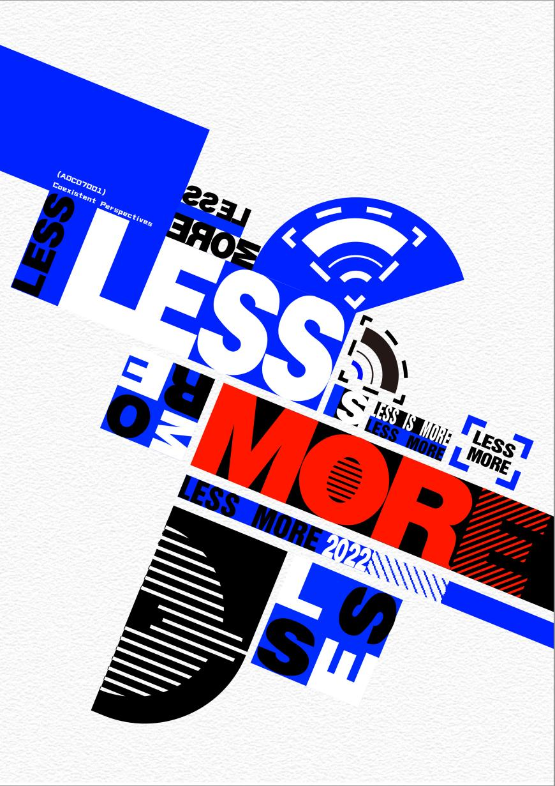
Figure 1. Coexistent Perspectives Poster.

Introduction
This article will explore the design cases of Japanese clothing brand Uniqlo and Japanese grocery brand MUJI. Both brands are committed to the foundations of minimalism and the concept of people-oriented design and how we experience minimalism. both Uniqlo and MUJI delve into our relationship with design cases (visual), the built environment, the spatial context and our personal experiences.
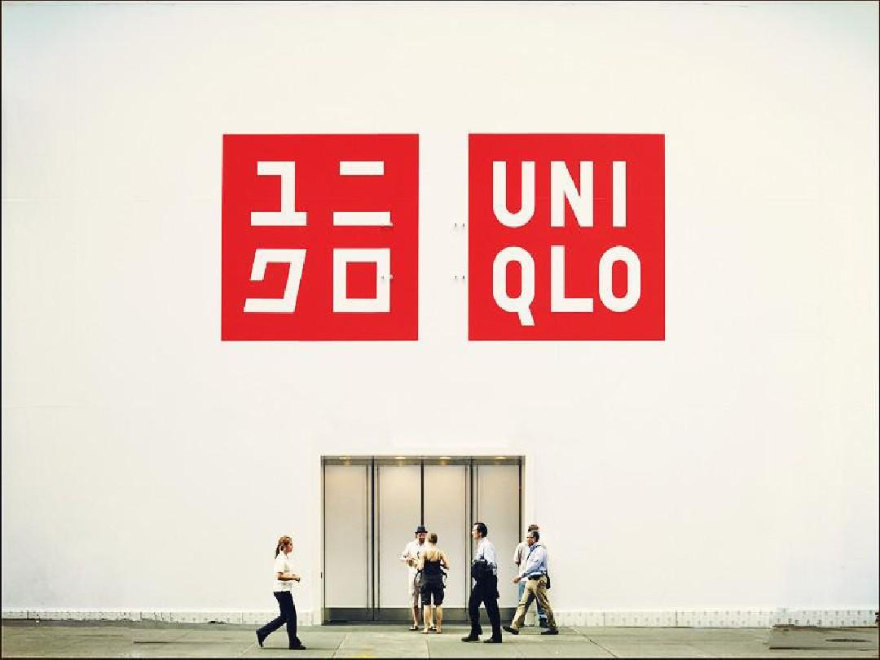
Figure 2Uniqlo Visual Sense
https://www.51wendang.com/doc/420e072bc09e04cf983f97b4

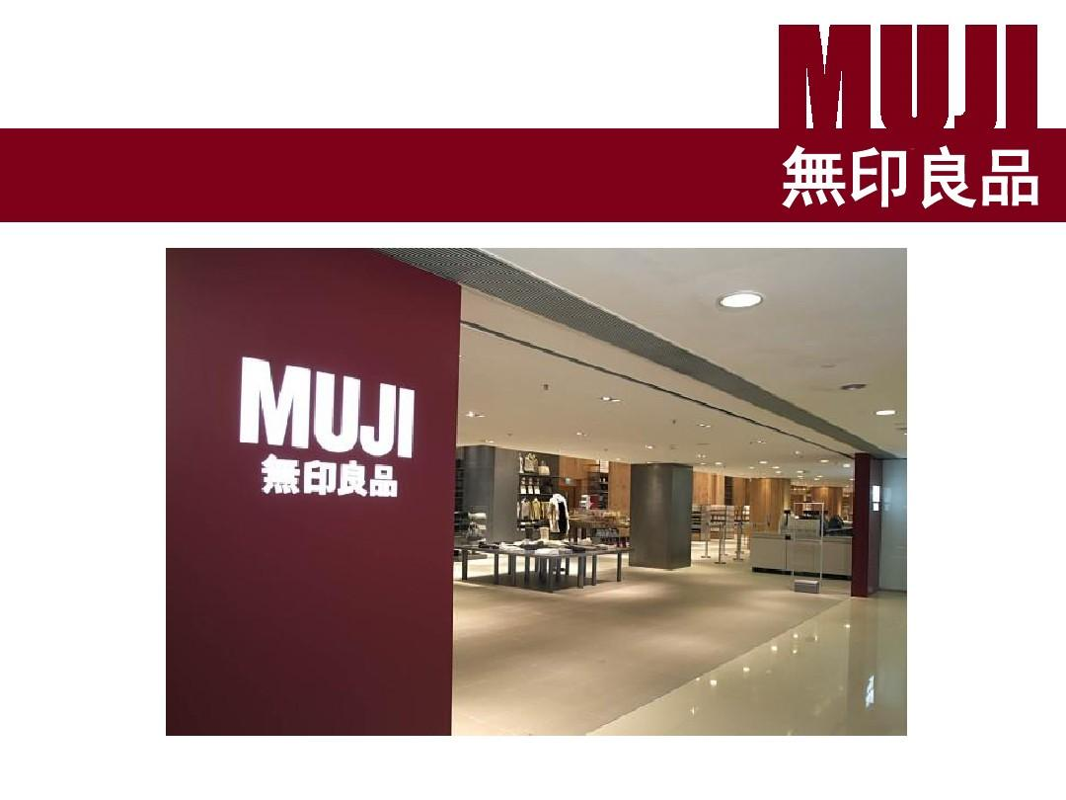
Uniqlo's design style is typically white on red, simple and generous, yet highly communicative and impressive. It was designed by Koshikazu Sato. In designing the UNIQLO brand, Mr Sato created a highly recognisable logo by modifying the Japanese katakana, and developed a corresponding English logo based on the Japanese form of the logo, which is in bright red, and on which all other visual images were developed. UNIQLO is an acronym for Unique Clothing Warehouse, a business concept that provides consumers with "quality products at low prices". The simple monogram design, with a red block background and a strong sense of price promotion, is particularly in keeping with the consumer demand at the time of UNIQLO's creation, which coincided with the economic downturn in Japan, and fits perfectly with UNIQLO's modern, minimalist, high-quality, versatile and basic style.
Figure 3MUJI Style
https://www.51wendang.com/doc/be51197587a86d04f6c395b9/5

The design style of MUJI is based on the ideas of Seiji Tsutsumi and Kenya Hara, with Kazumitsu Tanaka taking full responsibility for the positioning and design of the brand, and in 1980 Tanaka proposed the development of MUJI with the idea of 'the most suitable form to show the essence of the product'. Seiji Tei felt that the market was too colourful and proposed the idea of 'anti-branding' and wanted to create unbranded products. A week before Kazumitsu Tanaka's death, Kenya Hara was appointed as the new head of design for MUJI, and a successor was found for the company. The design style of Kenya Hara is based on the "spirit", "form", "intelligence" and "beauty" of MUJI. In addition to absorbing European and American design culture, he also incorporated Japanese national characteristics, resulting in a design case that combines both cultures.

Theoretical background
Figure 4 Minimalism-Japanese Graphic Design AestheticsWith the continuous development of national cultures and civilisations, the globalisation of the economy is gradually accelerating, and economic globalisation brings with it cultural globalisation. Excellent culture is both national and global, and design, as a way of presenting culture, is receiving more and more attention from all walks of life.

Until the early 1980s, Japan had become one of the world's most important design powers. As Japan's economy entered a period of rapid development, it even gained momentum to rival Europe and the United States. The path of modern Japanese graphic design from imitation to innovation also entered a new turning point: from an emphasis on the reconciliation of East and West to an emphasis on the self-referential nature of national culture and art. This laid the foundation for the future development of Japanese graphic design to maintain its original style throughout.Modern Japanese graphic design, while learning from the West, incorporates a large number of traditional Japanese cultural elements, making its style both international and uniquely Japanese. Among these traditional cultural elements, the influence of painting was particularly profound, even breaking through the boundaries of the country and entering the Western world at the turn of the century, which was then dominant in the field of design and art, setting off an Art Nouveau movement.

As a major design nation, Japan has a unique perspective and philosophy on many designs. During the period of Shogunate rule, Japan studied a great deal of advanced foreign culture and improved upon it, causing Japanese culture to lose its original colour in its development. It is therefore a valuable window of opportunity to study the development of Japanese graphic design in the post-World War II period. Ethnicity is particularly evident in Japanese packaging design, which reflects the cultural and artistic characteristics of Japan, from materials, craftsmanship, logos and patterns to the structure of the packaging. send points (2020, p.26)

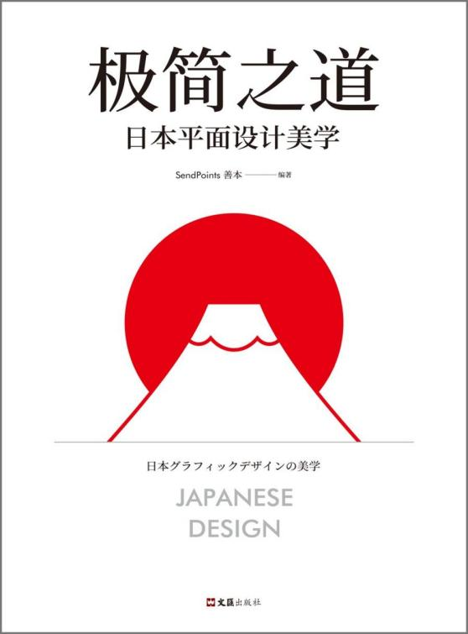
Figure 4 Minimalism-Japanese Graphic Design Aesthetics
https://baike.baidu.com/item/%E6%9E%81%E7%AE%80%E4%B9%8B%E9%81%93%EF%BC%9A%E6%97%A5%E6%9C%AC%E5%B9%B3%E9%9D%A2%E8%AE%BE%E8%AE%A1%E7%BE%8E%E5%AD%A6/56510674

On the other hand, the development of design and the development of human society coexist with each other, and the study of Japanese post-World War II graphic design is not only a study of its expressive form and expressive content, but also a study of history and culture.

The cultural connotations of kendo - a brief analysis of Japanese national culture (Luo Chunyan and Zhang Shuzhen, 2003) reflect that Japanese national culture was influenced by Confucianism and Zen culture in the early days, with a clear hierarchy and the concept of "abiding by one's duty". ", and moreover, a belief in spiritual supremacy. Zhou Wu Zhong (2017, p. 66)

Japan's graphic style is quite recognisable, and it is not just its typography or occasional Japanese motifs that give us away. Steven Heller Seymour Chevast (2020, p. 103) The concept of modern Japanese design is inextricably linked to its own cultural traditions and aesthetic ideas, and the Japanese national aesthetic is most influenced by Shintoism and Zen Buddhism. Zen thought emphasises capriciousness, enlightened clarity of mind, and an intuitive form of feeling the true meaning of the world. Nature, blandness and length are undoubtedly the three key words that best sum up the traditional Japanese aesthetic, as reflected in design. Natural means that the work is filled with infinite affection and beauty for nature, plain means the sedimentary beauty of the passage of time, and long means that the design should stand the test of time.
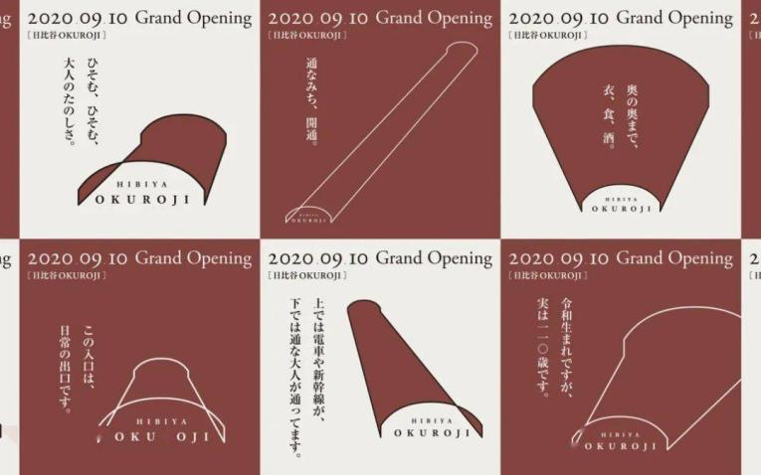
Figure 5 Japanese Graphic Design-Poster
https://www.sohu.com/a/459108452_594400

Yohji Yamamoto once made an impressive statement when he said that he made clothes and was more interested in designing the gap between the clothes and the body so that those who wore his clothes would always feel a breeze when they walked. Chen He (2018, p.132) Japanese design aesthetics and thinking appear to be extraordinarily different, with the distinctive aesthetic concept of minimalism being a distinctive feature in Japanese design. Whether it is Tadao Ando's architectural designs, Naoto Fukasawa's product designs, Yoh Yamamoto's clothing designs or Kenya Hara's graphic designs, one can feel the naturalness, simplicity and rustic design style, as well as the religious beliefs and
traditional aesthetics they pursue in these works.

Interior design
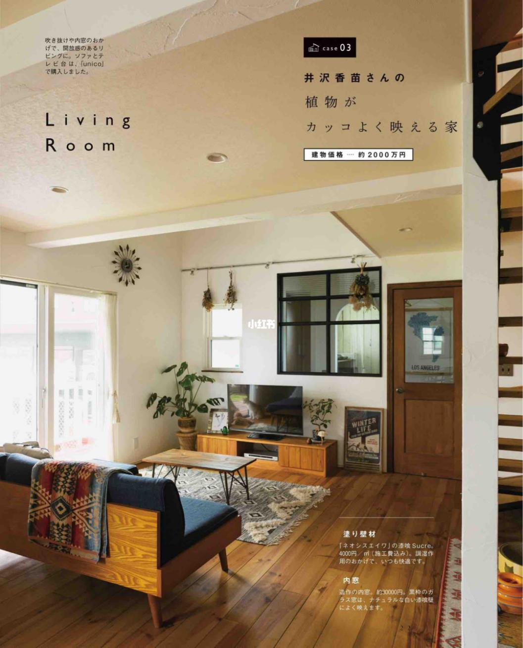
Figure 6 Zen and Interior Design
https://www.xiaohongshu.com/discovery/item/607c24d6000000002103eb7e

Japan is good at absorbing and embracing other cultures in spatial design, gradually forming its own unique cultural connotations, while this idea of inclusion and absorption has led to an extremely diverse range of Japanese interior design styles. The Zen style pursues the beauty of simplicity and elegance, abandoning the cumbersome elements of traditional design and simplifying them to focus on a limited number of design elements to express a rich Zen meaning. It is more about a state of mind and transcendence than the hardness of the Chinese style. Wang Wenzhi (2016, p. 330)

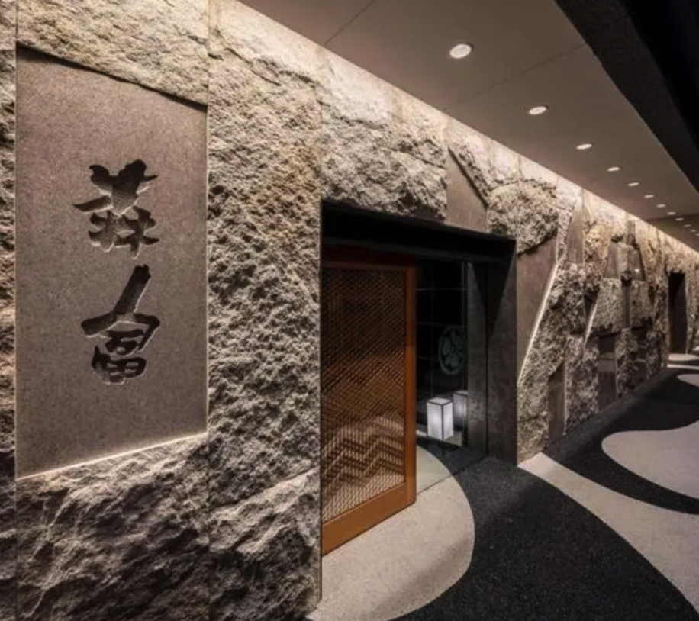
Figure 7 Design and Application of Lighting Atmosphere in Baiju Japanese Restaurant
http://www.guangzhiguo.com/info-1-22-2221.html

The natural style, which first originated in Zen culture, is one of the most popular and distinctive features of recent years. It comes from a distinctive Japanese aesthetic sense, emphasising a simple style that is not dependent on the outside world, and the pursuit of nature without embellishment and straight to the source. In the use of interior materials, the emphasis is also on keeping the materials themselves in their original state. Examples include bare stone, rusted iron, unadorned wood and so on. The natural style expresses a sense of natural flow, where the division of space and the matching of materials flow with an intimate, private emotion, which is essentially different from the cold, rational atmosphere of Western minimalism. Thus, although both styles pursue minimalist shapes and pure finishes, they are two very different styles.

From the Zen culture but interior design works it is easy to see that the simple and minimalist style, the friendly and quiet visual feeling, the control of colours and the pure materials, all these together form a harmonious and natural and rustic and pure atmosphere.

Product Design
Japanese product design, like other designs, has been influenced by the Zen philosophy of the harmonious development of man and nature. This philosophy has not only played a huge role in the form and function of a product's appearance, but has also played a role in indicating the direction of Japanese product design. When beauty is at its best, it is art. All of these are the qualities that make up the "Made in Japan" brand. Peng Xinwu (2021, p. 229)

Japan is a nation that is good at learning. At the beginning of the development of Japanese modern design, it accepted the theories and achievements of European and American modern design and was able to combine them with its own national conditions to develop its own unique design culture by building on its strengths and avoiding its weaknesses.Although influenced by Western design styles, Japanese design has not lost itself, but protects its cultural traditions and insists on the parallel between international style and national tradition.Japanese packaging and product design has also explored a unique and distinctive path, which is different from that of Western countries and other Asian countries. Designers have incorporated the essence of Japanese nationality and tradition into modern design, inheriting and developing national design while meeting international trends.Japanese packaging, especially packaging for traditional products such as confectionery, alcohol and gifts, has very distinctive national characteristics and is loved by the people of this country and the world, making it a typical example of packaging design in the world. Traditional Japanese paintings, patterns, decorative motifs and texts are the source of inspiration for Japanese packaging designers and the basis for the development of their own national design style. For example, Japanese ukiyo-e, which has strong national characteristics, is often used by designers in packaging design. The simplicity of the narrative, the beauty of the form and the freshness of the mood of ukiyo-e works are the most appropriate representatives of the Japanese national art style.

In the field of Japanese product design, Naoto Fukasawa's designs stand out for their Zen thinking. As the designer who first proposed the theory of 'unconscious design', Naoto Fukasawa's products are designed to achieve unconscious actions through conscious design, giving people the feeling of thought. This theory is the essence of Zen thinking. Naoto Fukasawa focuses on the details of life that we have overlooked in relation to the 'unconscious'.
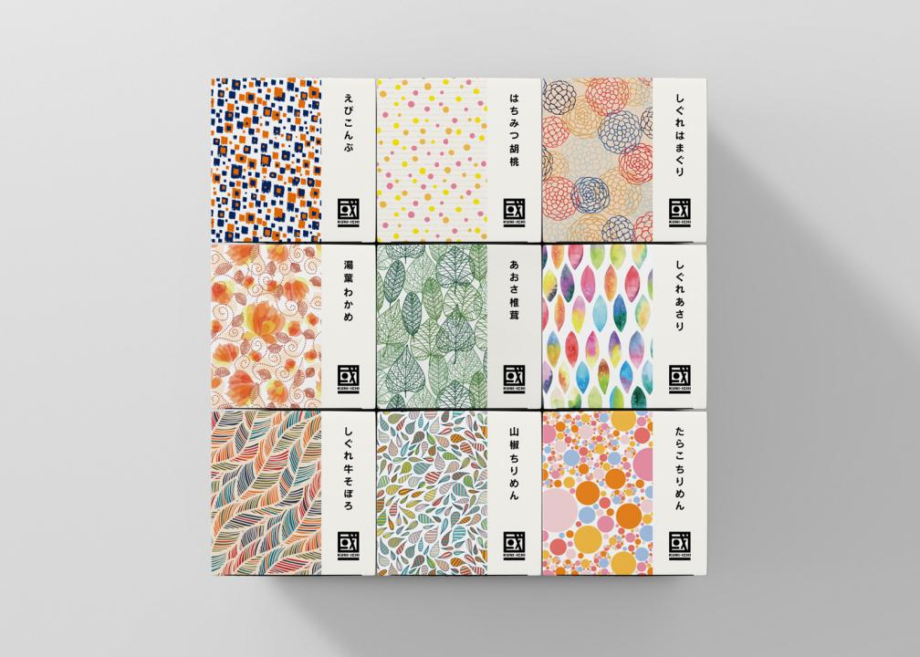
Figure 8 Japanese product packaging
https://www.sj33.cn/article/bzzp/202106/57185.html

The 'Zen' in design represents a spiritual realm. The 'Zen' in Japanese design is a great inspiration to designers, reminding them that when designing, it is the soul and connotation of the work that is important. When a work has a spiritual connotation, it has a life and therefore the message it conveys will take people to a higher realm.

As an integral part of culture, the relationship between design and culture is like "the tree and the soil". Sun Deming (2015, p265)By perceiving design works, people feel the different messages that design brings in their own different social and cultural contexts. Doing the same with people's minds is undoubtedly the most successful, both from a design point of view and from a cultural point of view. Design is a process of re-creation, not a process of making something from nothing. In such a creative process, it is of utmost importance to make people like one's design and understand it. The soul of the design plays a vital role in this process, and that soul is the "Zen" of design.

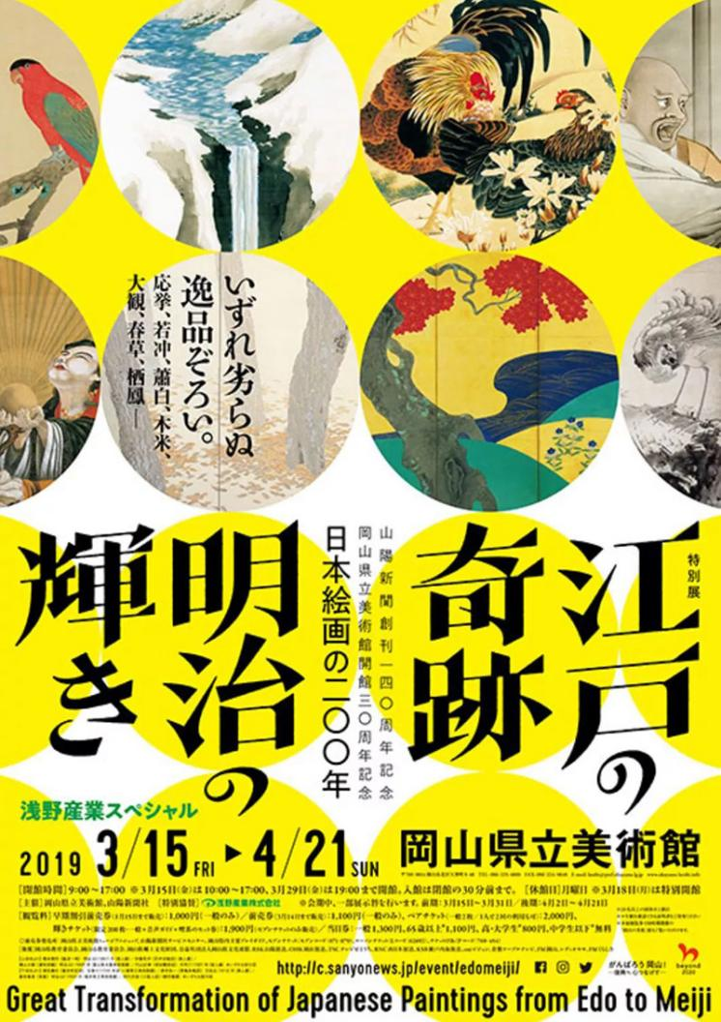
Figure 9 Japanese poster design
https://uiiiuiii.com/inspiration/1616270159.html
MUJI Colour Applications
The MUJI brand has long adhered to the design philosophy of less is more, using the colours closest to nature as the first choice for its products, delivering a simple and clean visual impact to consumers.
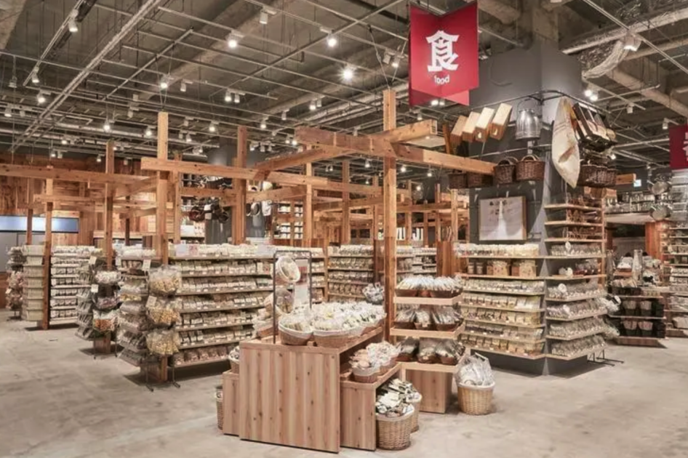
Figure 10 MUJI Color application
http://www.shoppingdesign.com.tw:443/post/view/2747

MUJI's choice of colours takes into account the harmonious relationship between people and their environment, an important feature of Japanese culture that places more emphasis on the relationship between things and their environment than on the objects themselves. In such a noisy and chaotic commercial environment, MUJI's simple and elegant image has attracted many consumers to its products, making them stand out from other colourful products.

MUJI's use of traditional colours is very extensive. In his article 'The Character of Colour Names in Ancient Japanese', Akihiro Satake mentions that Japanese colour names first originated from the four colours white, blue, red and black.

In Japan, one of the key features of the traditional aesthetic concept is the admiration for monochrome and natural colours, which are used extensively in MUJI's visual identity. In its colour system, natural colours such as white, beige, brown and black are used in abundance, and apart from the deep red 'MUJI' on the logo, there are few colours of high purity to be seen.
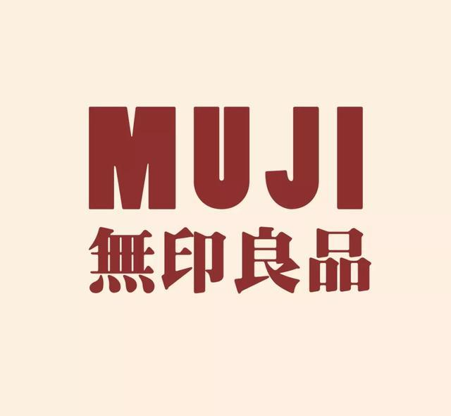
Figure 11 MUJI Logo
https://baijiahao.baidu.com/s?id=1650708785381903543&wfr=spider&for=pc
Each colour gives a different psychological feeling and MUJI's designs are close to nature and unpretentious.

White: purity, brightness and innocence. Grey: elegant, gentle, plain and neutral.

Beige: raw, natural, natural and wholesome. Black: mysterious, silent and deep.

The overall atmosphere created by MUJI reduces the visual fatigue caused by overly bright colours during the shopping process, while increasing the brand's affinity and making it invisible to complete the brand's message about itself. As Kenya Hara, MUJI's art director, says: "The purpose of messaging is not to attract people's attention through strong impact, but to slowly penetrate the five senses. Before people even notice its presence, the sophisticated, hidden, precise and powerful communication is already quietly completed."

Design forms

MUJI's packaging design follows the principle of simplicity, presented in a plain packaging image, as founder Kenya Hara says: "My design concept is to remove the superfluous, without the need for superfluous things to make the design complicated.’’One of the aims of MUJI's product development is to transform the world's established products, changing the original colours, decorations and materials of the products. Akiko Masuda (2019, p. 172) In terms of the design of the shapes, MUJI's packaging is free from any artistic exaggeration or rendering, with colours mostly shown in their original colours and simple forms that are basically regular and commonly used. many of MUJI's everyday items are mostly sold in a uniform way, with their transparent plastic packaging revealing the goods inside directly, and the packaging is typically minimalist in style.

In terms of packaging structure, MUJI reduces the complexity of the packaging structure, allowing the product to be presented to the consumer in an intuitive form, the opposite of the traditional Japanese packaging design with its distinctive detailing. In terms of decoration, MUJI's packaging is 'less', i.e. it has no colourful decoration, no complex and varied design patterns, and no soft and delicate decorative lines; the only decoration is the logo in white on a red background, in Helvetica.

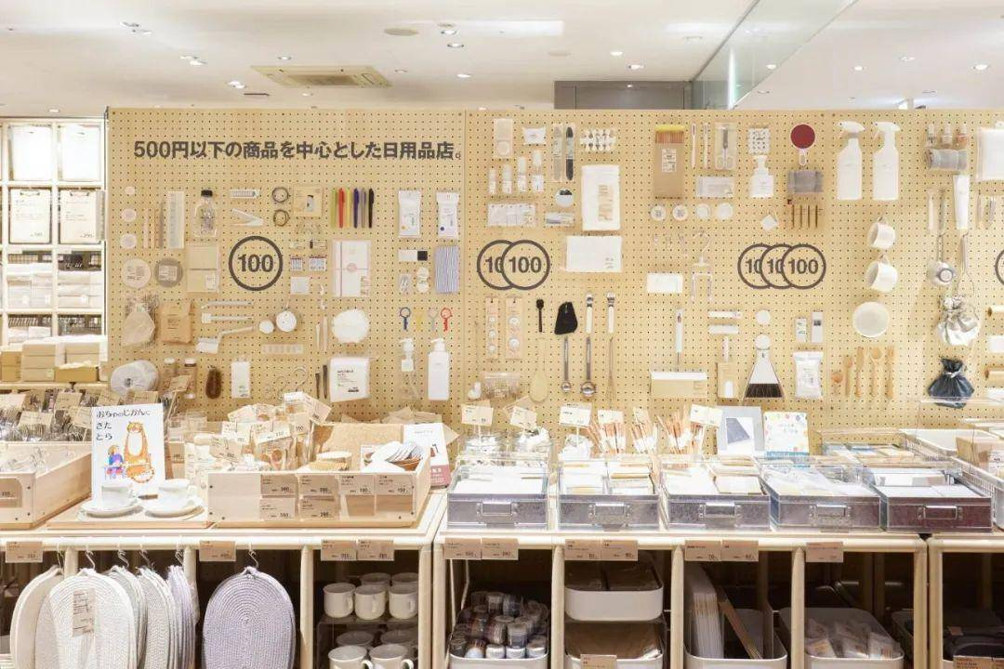
Figure 12 MUJI Design
https://www.sohu.com/a/602680644_568829
This tendency towards 'less' is a reflection of Zen consciousness, and MUJI's pure, minimalist design style, which is close to the heart of the consumer, reveals a quiet, elegant taste of the abyss and allows us to understand the spirit of simple, honest design. Its designs are a metaphor for extremely rich design connotations with a minimum of design elements.

Visual Design

MUJI's overall design philosophy is based on the Japanese culture, which is based on the abandonment of a cluttered style and a return to simplicity, simplicity, simplicity and the pursuit of substance. The logo is an extension of the MUJI style, with the main body of the logo and the standard characters in a low saturation red colour. The logo is designed with the letters 'MUJI', and the logo has been considered and adjusted in terms of font size, style and height.
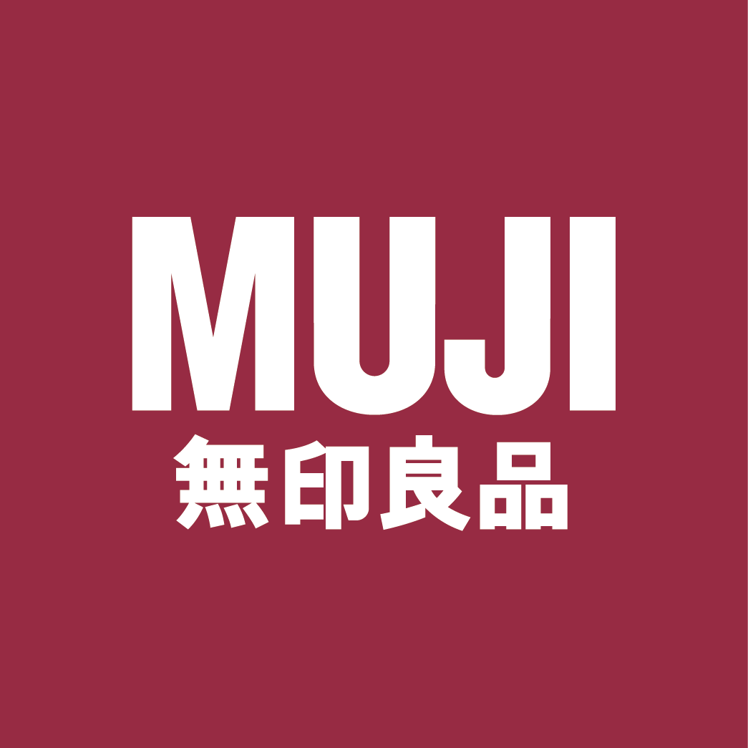
The distance between the letter "M" and the letter "U" and the distance between the letter "J" and the letter "I" are equal, but the distance between the letter "U" and the letter "J" is small in order to give the logo an overall aesthetic appearance due to the large amount of white space above the letter "J".
Figure 13 MUJI Logo
https://cn.japanese-jobs.com/jobs/details/6342

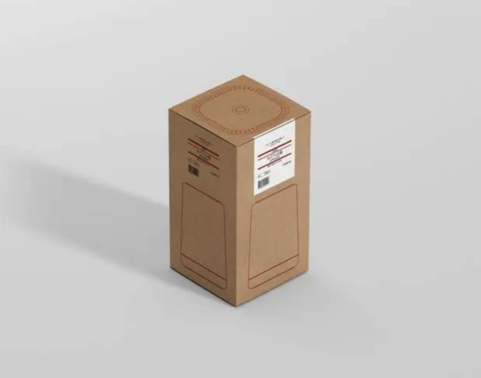
Packaging Form

Figure 14 MUJI Audio Package
https://www.puxiang.com/galleries/9001936892a7781b2d112d1e7d4f1b49

Each piece of MUJI's packaging truly expresses its most essential value, with a simple and elegant form, gentle and unobtrusive, and a simple and direct language of shape that faithfully reflects the function of the product, restoring the essence of the goods with a simple and pure design. Li Yan (2016, p.182-p.183)MUJI's packaging is a green design concept in contrast to the excessive packaging of products in today's society; it does not have bright and exaggerated colours, nor does it have a fashionable and avant-garde personality, but it is its simplicity that impresses consumers who love the environment and nature and are against luxury and waste.
It has been recognised that the future of the planet and of humanity is at stake with regard to the environment. The "clash of civilisations" that pervades the world today shows that there are limits to the pursuit of the benefits that a free economy has provided for so long; one cannot live with the world simply by asserting the uniqueness of one's own culture. In the world of the future, the limited values of niche cultures will be replaced by a rational spirit that looks at the whole picture and suppresses egoism.

Back in the early 1980s, MUJI presented its products as being of understated self-quality and closer to nature. The products follow the principle of simplicity and durability and are packaged on environmentally friendly, unbleached, light brown paper, in stark contrast to the overly packaged look of today's products. Clothing and bedding are made from natural materials such as cotton, linen, wool and silk, and household utensils, whether made of wood, metal or paper, are kept in their natural colours.
MUJI is a fan of plain packaging, which is unadorned and keeps the colours and shapes of the product as they are, and is firmly against extravagant packaging. While half of the packaging for Japanese snacks, for example, is usually elaborate and richly layered, MUJI's packaging has a simple, natural tone, with a selection of ingredients and simple, transparent packaging. Rather than discouraging people from buying, this transparent and translucent packaging design adds a hazy aesthetic that stands out. As a result, MUJI began to enter consumers' minds, gaining recognition for its unique concept and gradually occupying consumers' minds in their pursuit of minimalist living. Xu Hui (2021, p.219-220)

MUJI also includes detailed and specific text on all its packaging to convey the message of why the products are produced. This approach has been embraced by nature-loving environmentalists, as this green philosophy and green packaging design is very beneficial to the sustainability of society and deserves to be embraced by all of us.

MUJI Revelation

The overarching purpose of design is to solve the problems of life, to create for life, a process of removing the glamour and getting to the essence.

MUJI's design is very modest, and its designers are representatives of the minimalist style, where everything is "nothing", no logos, no colours, and the raw materials for its products are all original, green and recyclable. The products are made from raw, green and recyclable materials. MUJI pays great attention to the quality of its products to satisfy people's desire for a high quality of life.After all, MUJI is not just a shop that sells goods, but proposes a way of life to people, so it is necessary to have an in-depth understanding of its source ideas and philosophies. Tadzo Matsui (2018, p. 232) MUJI's visual communication strategies as well as brand philosophy are worthy of study by every designer, through which they can improve their own design.

A good designer needs to be socially sensitive at all times, with the ability to capture the essence of things and the ability to see and respond to the changes of the times. Some designers should draw deep thoughts from the success of MUJI as a brand in order to design even better works in the future.

UNIQLO
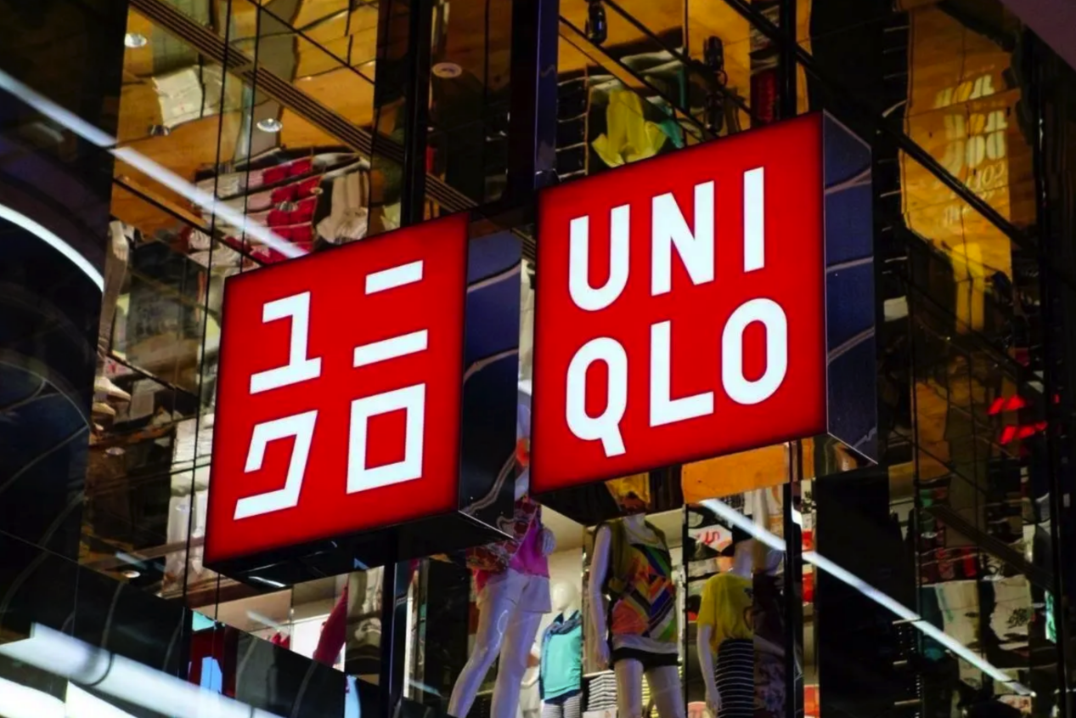
Figure 15 Uniqlo LOGO
http://www.360doc.com/content/17/0706/08/30681898_669235563.shtml

UNIQLO, the Japanese clothing brand, was established in 1963 by the Japanese company Toshinomi as a small clothing shop selling suits, and has become an internationally renowned clothing brand. As a fashion retail giant, UNIQLO has redefined 'comfort'. Very often, instead of Uniqlo it decides what people wear, it accompanies the consumer, together, co-creating and co-existing.

In order to listen precisely to consumers, UNIQLO has set up a unique mechanism called VOC (Voice of the Customer), which collects customers' opinions online every day. This is where the design of the "CORE-T", which will sell well in China in 2019, comes from. Why do people shop? In fact, consumers must identify with the brand, the company and its employees before they buy a product. Viet Kwon Bo (2022, p.278) (UNIQLO: A twenty-year growth miracle during the recession, Wen Hui Press)

The uniqlo logo was designed by the famous Japanese designer Kashiwa Sato, who created his own set of fonts for UNIQLO, called uniqlo, which stands for Unique Clothing Warehouse, a low-cost, high-quality casual wear brand. UNIQLO is an acronym for Unique Clothing Warehouse, and its business philosophy is to provide consumers with "quality products at low prices".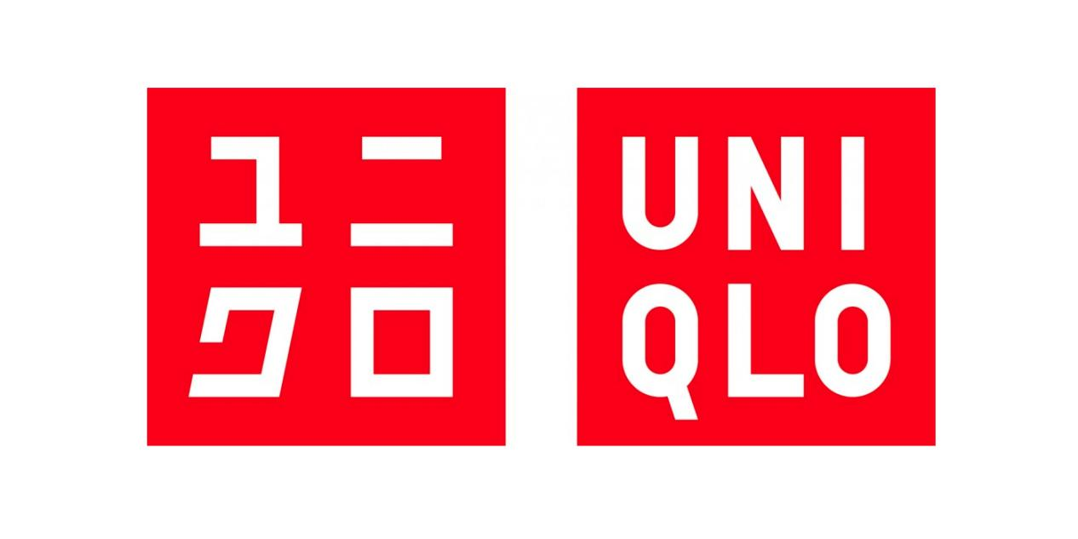
Figue 16 Uniqlo Font
www.vi023.com/newsinfo/330999.html

The Japanese logo text uses the katakana katakana of the Japanese language and the English alphabet, two languages to create a unique logo. Firstly, Japanese is a language that uses kanji, katakana, hiragana and letters. The use of katakana is the conversion of some words introduced from abroad into Japanese. It has been argued that kanji is one of the important sources of katakana. Liu Zhiji (2015, p. 122) (Set of the History of Chinese Character Development, East China Normal University Press) For example, in some major international cities such as New York, London, Shanghai and Paris, even if the meaning of the katakana itself is not understood, it can be seen as a symbol of Japanese popularculture.

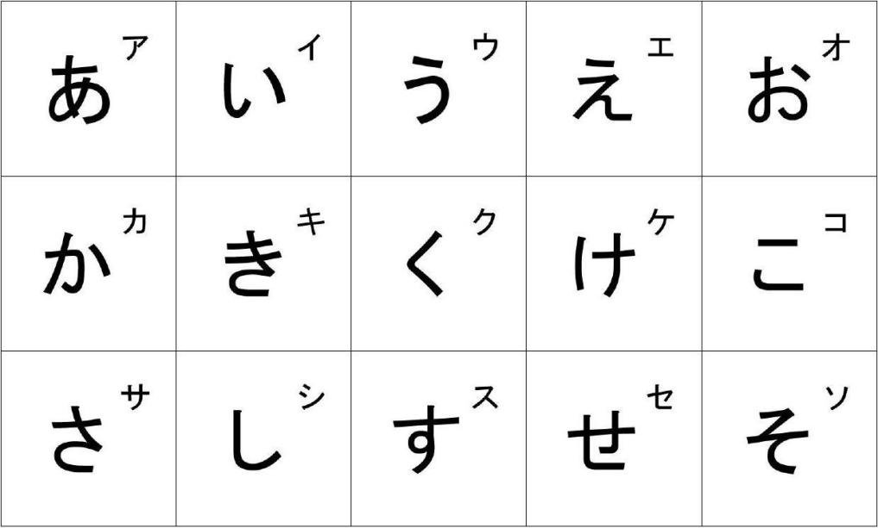
Figure 17 Katakana
http://doc.xuehai.net/b56e2174f349030b168cf4c2e.html

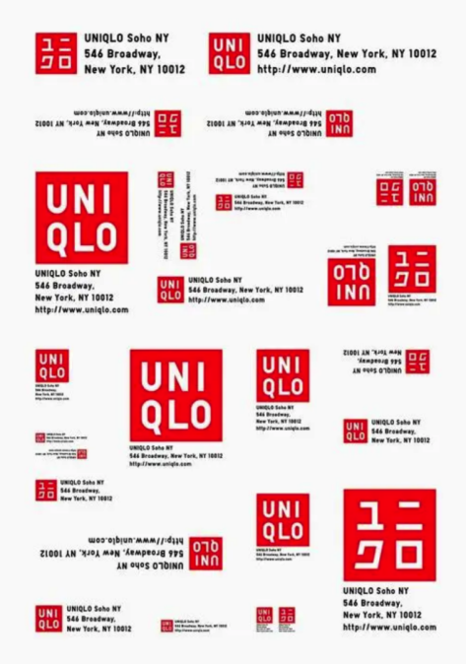
The katakana in Japanese is simply a phonetic symbol, and if you look at the surface of a word there is no way to know exactly what it means. So Uniqlo itself is designed to translate culture from overseas into Japanese style and to promote it worldwide.
Figure 18 Uniqlo Visual Sense Design
http://www.moxiangxu.com/news/page_9_10_1281_5.html

Visual Design
The simple monogram design, in the choice of colour with red backing and white lettering, the contrast between red and white enhances the appeal of the logo, and the red and white has always been an ageless matching colour, just like black and white always so trendy and stylish will not be abandoned by time.The reason for this can be seen first of all in the naming of the Logo. Li Weiwei (2019, p. 264)) The simple, atmospheric letters were a good choice, particularly in line with the popular consumer demand at the time of Uniqlo's beginnings, which coincided with the Japanese economic downturn, and fit perfectly with Uniqlo's modern, minimalist, high-quality, versatile basics style positioning.

Uniqlo is a brand that offers a high quality product at a low price. The concept of the brand cannot be developed if the two diametrically opposed values of high quality and low price are not reasonably acceptable But rationality has the disadvantage of being considered boring under certain conditions. Despite this drawback, the addition of katakana makes it easy to accept. It expresses the idea of daring to do it and highlights Uniqlo's concept of practicality based on having a sense of beauty. Uniqlo as a brand is like a medium that must be something only Uniqlo can do. Wu Chunlei (2017, p. 344)

Design Forms
Aesthetic practicality is the ultimate goal of all design (not limited to print). Based on this philosophy, Uniqlo's logo, interior design and advertising campaigns all exhibit practical and aesthetically pleasing design. Uniqlo sells a variety of clothing, such as polo shirts, slacks and jumpers, and these basic items can be adapted to individual personalities through various combinations Under the Comfort Life brand positioning, Uniqlo sells lifestyle essentials and lifestyle solutions.

This means that clothes for cold and hot days, for work and sports, and for the elderly and children to wear can all be found at Uniqlo. Harvard Business Review (2019, p. 168) Although the items are the same, the different ways of matching them will present different personalities. Such thinking is also reflected in the design of Uniqlo's posters. By repeating the red and white logo combination, it constitutes a rich visual effect that can be promoted and communicated to people through different ways and. By designing the posters in this way, it is intended that people will understand the UNIQLO brand philosophy through the posters.

Space design

First of all, the choice of colours in the shops. Unlike other clothing shops, which only use two monotonous colours of grey and black, Uniqlo has added a variety of bright colours, giving customers the first impression of walking into a sweet shop with their heart beating and excited.
Uniqlo's window displays are always as large as possible, standing in rows from afar and occupying customers' visual points through the formation of group models, and the shops are spacious and tidy to stimulate consumers to enter the shops. The window displays are never very flashy or large props, but basically giant posters as a backdrop, and the effect is achieved through the matching of the shop's clothes and the focus on lighting.

Figure 19 Uniqlo shop design
http://share.enorth.com.cn/share/404.jsp?newsid=030270461

Uniqlo's clothing display area is the visual concentration area for customers upon entering the shop, and is also the main display area for the selling points of the products. In order to stimulate the eye and show an actually majestic visual feeling, Uniqlo tends to fold some basic solid-coloured items together and put them neatly into the storage type display cabinets. The sizes in this area are arranged in order from top to bottom and from small to large, which not only fills the shelves properly but also makes it easy for the shop staff to count them.

The colours and patterns are arranged from light to dark, cool to warm, in a sequence that can be as specific as "red, orange, rice, yellow, green, blue and purple", from the channels backwards in the order of the spectrum. The pattern is also monochromatic, from polka dots to stripes.

Conclusion
The traditional Japanese design culture of clean and cool design aesthetics is still very much alive in contemporary design. It has now been transformed into the wisdom of everyday life.The Japanese aesthetic tradition attaches importance to details, to nature, to simplicity and simplicity, and to the spiritual meaning of aesthetics, and these form the spiritual pillars in Japanese design. Xue Hongyan (2017, p. 98) (History of Industrial Design, People's Post and Telecommunications Publishing House) The prevalence of Zen Buddhism in Japan was motivated by the idea of worshipping nature, which, together with the Japanese people's adherence to a traditional lifestyle of frugality, coincided with the aesthetic interest characterised by simplicity advocated by Zen Buddhism.Zen thinking and aesthetic sensibilities are not only extended to the realm of art, but also intermingled with all aspects of daily life, known to be deeply integrated with the original Japanese national consciousness of life. Li Yan (2016, p. 73) (The chief designer behind the business legend, Chemical Industry Press) Zen Buddhism blends certain ideological elements of Confucianism and Taoism, and as the essence of the culture, rubs dazzlingly with Japanese design art.

Influenced by Zen Buddhism, Japanese graphic design is a minimalist style with few design elements, which emphasises simplicity, simplicity, elegance, antiquity and white space.MUJI and other contemporary Japanese graphic design products are simple, empty and silent, thus forming a freedom and inclusiveness that can accommodate the thoughts of all people, which is in line with the Zen culture that advocates emptiness and freedom, and is an important expression of the Zen aesthetic in Japanese contemporary design philosophy, making Japanese design unique in the world and having its own unique sky. This is the key expression of the Zen aesthetic in Japanese contemporary design, which has enabled Japanese design to be unique in the world. The ultimate expression of Zen aesthetics and the unrelenting pursuit of emptiness, harmony and freedom by Japanese graphic designers has resulted in design products that resonate throughout the world.

References & Bibliography

Send Points（2020，p.26）Minimalism-Japanese Graphic Design Aesthetics，WenHui Publisher：Available at:
https://weread.qq.com/web/bookDetail/c6b32e3071aef261c6b9e7f

ZhouWuzhong（2017，p.66)Oriental Culture and Design Philosophy，Shanghai Jiao Tong University Publisher：Available at:
https://weread.qq.com/web/bookDetail/2d432fd05e0e9d2d46dfc1d

Steven Heller & Seymour Chwast（2020，p.103）Graphic design for 200 years，Wenhui Publisher：Available at:
https://weread.qq.com/web/bookDetail/297329707207de45297cd49

Chen Gen（2018，p.132）Minimalist design from beginner to refined.，Chemical Industry Publisher：Available at:
https://weread.qq.com/web/bookDetail/744329e0715937e3744bb70

Wang Wenzhi（2016，p.330） Classic Home Design and Soft Decoration: Chinese Zen Rhyme，Chemical Industry Publisher：
Available at:
https://weread.qq.com/web/bookDetail/898324105dfe438989fc85b

Peng Xinwu（2021，p.229）Cultural code made in Japan，China Textile Publisher：Available at:
https://weread.qq.com/web/bookDetail/57832260727ac5085785b16

Sun Deming（2015，p265）China Traditional Culture and Contemporary，Design Social science literature Publisher：Available at:
https://weread.qq.com/web/bookDetail/4ee321607166b90b4eeb90b

ZengTian Mingzi（2019，p.172）MUJI式マーケティング MUJI Marketing，ZhongXin Publisher：
Available at:
https://weread.qq.com/web/bookDetail/ac332aa0716d37d3ac31587

LiYan（2016，p.182-p.183）Make a brand with design.，Chemical Industry Publisher：Available at:

https://weread.qq.com/web/bookDetail/3f732700715934703f78b65

XuHui（2021，p.219-220）Open the trend password，Chinese economy Publisher：
Available at:
https://weread.qq.com/web/bookDetail/db43265072a7d94bdb41d3c

Matsui Tazo（2018，p.232）Decrypt MUJI series，New Star Publisher：
Available at:
https://weread.qq.com/web/bookDetail/b1d32d50717c5327b1dc4ba

Yue Quanbo（2022，p.278）Uniqlo: a 20-year growth miracle during the economic recession，WenHui Publisher：

Available at:
https://weread.qq.com/web/bookDetail/56732680813ab6d5cg0113db

Liu Zhiji（2015，p.122) China Character History Suite，East China Normal University Publisher：
Available at:

https://weread.qq.com/web/bookDetail/b473213071a4c6a3b472865

Li Weiwei（2019，p.264）Good design has methods，Engineering Industry Publisher：
Available at:
https://weread.qq.com/web/bookDetail/3d632b70718eb9f93d6bd56

Wu Chunlei（2017，p.344）Business philosophy: the secret of Tadashi Yanai regaining the throne of Japan's richest man, China Federation of Industry and Commerce Publisher：
Available at:
https://weread.qq.com/web/bookDetail/f73320905dffd7f73679b74

Harvard business review（2019，p.168）Insight into new business opportunities in the era of change，Zhejiang publishing group digital media co., ltd
Available at:

https://weread.qq.com/web/bookDetail/88032040718896d788019e6

Xue Hongyan（2017，p.98）History of industrial design，People's Post and Telecommunications Publisher：
Available at:
https://weread.qq.com/web/bookDetail/62532f80718b749d625cb31

Li yan（2016，p.73）Chief designer behind the legend，Chemical Industry Publisher：
Available at:
https://weread.qq.com/web/bookDetail/76e32fd05e4cef76e93c850

Figures

Figure 1.
Coexistent Perspectives Poster.

Figure 2
Uniqlo Visual Sense，Available at：
https://www.51wendang.com/doc/420e072bc09e04cf983f97b4

Figure 3
MUJI Style，Available at：
https://www.51wendang.com/doc/be51197587a86d04f6c395b9/5

Figure 4
Minimalism-Japanese Graphic Design Aesthetics，Available at：
https://baike.baidu.com/item/%E6%9E%81%E7%AE%80%E4%B9%8B%E9%81%93%EF%BC%9A%E6%97%A5%E6%9C%AC%E5%B9%B3%E9%9D%A2%E8%AE%BE%E8%AE%A1%E7%BE%8E%E5%AD%A6/56510674

Figure 5
Japanese Graphic Design-Poster，Available at：
https://www.sohu.com/a/459108452_594400

Figure 6
Zen and Interior Design，Available at：
https://www.xiaohongshu.com/discovery/item/607c24d6000000002103eb7e

Figure 7
Design and Application of Lighting Atmosphere in Baiju Japanese Restaurant，Available at：
http://www.guangzhiguo.com/info-1-22-2221.html

Figure 8
Japanese product packaging，Available at：
https://www.sj33.cn/article/bzzp/202106/57185.html

Figure 9
Japanese poster design，Available at：
https://uiiiuiii.com/inspiration/1616270159.html

Figure 10
MUJI Color application

http://www.shoppingdesign.com.tw:443/post/view/2747

Figure 11
MUJI Logo，Available at：

https://baijiahao.baidu.com/s?id=1650708785381903543&wfr=spider&for=pc

Figure 12
MUJI Design，Available at：
https://www.sohu.com/a/602680644_568829

Figure 13
MUJI Logo，Available at：
https://cn.japanese-jobs.com/jobs/details/6342

Figure 14
MUJI Audio Package，Available at：
https://www.puxiang.com/galleries/9001936892a7781b2d112d1e7d4f1b49

Figure 15
Uniqlo LOGO，Available at：
http://www.360doc.com/content/17/0706/08/30681898_669235563.shtml

Figue 16
Uniqlo Font，Available at：
www.vi023.com/newsinfo/330999.html

Figure 17
Katakana，Available at：
http://doc.xuehai.net/b56e2174f349030b168cf4c2e.html

Figure 18
Uniqlo Visual Sense Design，Available at：
http://www.moxiangxu.com/news/page_9_10_1281_5.html

Figure 19
Uniqlo shop design，Available at：
http://share.enorth.com.cn/share/404.jsp?newsid=030270461

