EARNINGS MANAGEMENT

Contents
Abstract 2
Introduction 3
Earnings management 3
1 Earnings management techniques 4
1.1 The big bath 4
1.2 Cookie jar reserves 4
1.3 Operating activities 4
2 Incentives and forces behind earnings management 5
2.1 Managerial compensation incentives. 5
2.2 Management pressures 6
3 Earnings management with reference to Ted Baker 6
4 Role of UK corporate governance structure in constraining earnings management 7
Conclusion 8
Recommendations 9
References 10

EXECUTIVE SUMMARY

Introduction
The concept of earning management has been studied for decades, yet there are still many different opinions on the concept in the academic community and no consensus has been reached. In recent years, there has been a significant increase in incidents of earnings management. To appear credible and appeal to investors, businesses manipulate their books of accounts. Although this strategy is permitted by accounting standards, overdoing it runs the danger of giving investors a misleading image of the firm (Kjærland et al., 2020). Several businesses have had their books of accounts audited, and it was found that the numbers on those records are false.
This paper will discuss four main issues: The first is the basic definition of earning management and the management techniques that exist. The second is the motivation, both pressure and incentive, for most companies to engage in the management of earnings. The third issue will be the specific analysis of earning management in the case of Ted Baker. We will conclude with a discussion of the role of UK corporate governance structures in constraining earning management.

Earnings management
Making money is always the primary goal of every business, which is always represented in the books of accounts. The books of accounts show how well a business did during a specific financial period. Due to this, business owners make their books of accounts as appealing as they can. Investors and creditors evaluate the books of accounts to decide whether to lend money to the firm or invest in it (Kliestik et al., 2021). To improve the appearance of their financial accounts, the owners creatively employ various accounting strategies. One of the most difficult financial subjects nowadays is earnings management. The perspectives of top management and the economic environment have a key effect in developing organizational norms, which differ greatly from organizational, legislative, and societal norms. Businesses manipulate their profits, with upward manipulation being the most common. Li et al. (2020) Companies in financial distress are found to tend to focus more on accrual-based earnings management. Actual earnings management does not receive much attention. There are numerous reasons for managing earnings. To begin with, businesses utilize earnings management to level out their revenue. Investors invest in businesses that have a trend of constant growth. In actual business, incomes don't follow a smooth trend but include peaks and valleys. Income smoothing leads to window dressing or a company's decision to adorn the financial statements for possible investors and creditors (Kliestik et al., 2020). Making the books of accounts appear as though the firm is doing well is intended to draw in additional investors. A corporation may have to cut its earnings in certain financial periods and enhance them in others to maintain the appearance that it has a lucrative past. The corporation will eventually report the same amount of earnings spread over a certain period, so even if the activity may appear fraudulent, it is not.

1 Earnings management techniques
Earnings management can be done through several techniques.

1.1 The big bath
Under this technique, in years of loss, impairment provisions beyond the normal range are made to change the book value of the company's assets, provided that the GAAP guidelines are consistent, and then the risks accumulated over the years are exposed at once by way of incorrectly attributed accounts such as lower depreciation in future periods. Artificially increasing future income potential.(Muda et al., 2018).

1.2 Cookie jar reserves
When costs are dependent on estimations, this method is employed. The company overestimates the accounting period's costs, which leads them across several fiscal years. Sometimes the projections are greater than the actual costs. However, the estimates are recorded in the books of accounts, and the extra funds are carried forward to pay costs in subsequent financial periods (El Diri et al., 2020).

1.3 Operating activities
Managers use this strategy when they schedule a certain event to take place within specific times. When the earnings are higher, the management could opt to buy equipment. To prevent income spikes in certain months and declines in others, income for the fiscal periods with relatively high profits has to be leveled with earlier periods. Although the earnings are reorganized, the business will still appropriately record the expenses (El Diri et al., 2020).

2 Incentives and forces behind earnings management
The high-profile corporate failure has jeopardized the accuracy of financial reporting. Even though there are a ton of rules and standards controlling the financial reporting process, earnings management methods have accelerated at an alarming rate (HUYNH, 2020). A lack of legal protection against the malpractices and weak regulatory regimes that allows high degrees of manipulation may be to blame for this increasing profit management (Svabova et al., 2020). Internal variables like managerial pressure and incentives are important in managing profitability.

2.1 Managerial compensation incentives.
One of the most prevalent motivations for earnings management is the compensation package for managers. When managers reach specific predefined goals, they sometimes qualify for cash incentives or particular share capital. It is fairly typical for management employment contracts to incorporate accounting-based limitations that control chances for compensation, such as performance reviews, recurrent pay raises, and achieving goals in predetermined compensational contracts (Durana et al., 2021). Managers are encouraged to make strategic discretionary accounting accruals by upper and lower limits on executive bonus packages. Incentives for income-increasing or income-reducing earnings management are provided by compensation contracts that stipulate minimum profits to provide bonuses dependent on the actual profits obtained in a given time. Managers frequently choose income growth accruals as long as earnings stay within the minimum and maximum limits. If profits exceed the maximum level, managers also frequently shift toward income-decreasing accruals. In their study, Rueangsuwan & Jevasuwan (2022) found that If income before accruals is at a lower level than the minimum limit, management decides to increase the discretionary income accruals. If income is above the upper limit, management decides to reduce the discretionary income accrual.
Share issuance gives management a direct incentive to manage earnings. Increased market value, higher share prices, and lower capital costs affect higher profitability. If managers can declare improved earnings without detection, they can enhance the conditions of the public offering. By doing this, the managers benefit not the firm and themselves. According to research by Toumeh and Yahya (2019), managers distort results before initial public offerings and seasoned equity offerings. Due to the informational imbalance between IPO issuers and investors, initial public offerings are particularly vulnerable to earnings management. Managers have the opportunity to falsify results to raise the introduction price of shares in the absence of the previous market price. Issuers with particularly high accruals in the year of their initial public offerings incur subpar stock returns in the following three years. Earnings management during the IPO year is largely to blame for the underwhelming performance of companies after the offering (Israa et al., 2018). Additionally, corporations report extremely high earnings because of unusually high accruals at the time of seasoned equity issues since earnings are managed. However, the company's subsequent-year reports are typically quite subpar.

2.2 Management pressures
One factor that forces management to manage earnings is the management buyout. A downward earnings management is implemented during a management buyout. The managers are under pressure to choose the optimal price for their shareholders in such a scenario (Mangala & Singala, 2021). Prior to the buyout, the managers are under pressure to lower the stated earnings. The company would underestimate its earnings because they are a key factor in the management buyout.
The pressure to meet goals or expectations may also drive managers to manage their earnings. The management tends to announce excessively high earnings when they have not achieved the analyst's projection since they are trying to meet or exceed it as the financial period comes to a close (Shin & Kim, 2018). Additionally, businesses that are susceptible to unfavorable political outcomes, such as antitrust probes or businesses looking for government subsidies, may manipulate their revenues to appear less profitable. In order to be eligible for import relief aid, businesses frequently use income-reducing earnings management (Al Doud, 2018).

3 Earnings management with reference to Ted Baker
Fashion retailer Ted Baker has faced allegations of improper behavior toward employees over the previous few years, as well as profit warnings. It appears that the company had exaggerated the worth of its inventory in the balance sheet by £58 million in the annual report that was published in December 2019. The overstatement was originally thought to be £25 million, but after being corrected by an independent review group, it was found to be £58 million (Shabong, 2020). This overstatement was equal to a stock's book value that was 35% higher.The overstatement of the value of inventory is also an area of high financial concern. There are inflated inventories, inappropriate treatment of inventory impairments and unusual operating costs. They may be due to the inclusion of physical inventory that does not exist, which indicates weaknesses in controls. Alternatively, impairment of inventory is not dealt with in a timely manner or items that should be charged to operating costs continue to be placed in inventory (Taylor, 2020). However, Ted Baker reported these issues in his annual report for the financial year. The overstatement was caused by errors or misstatements due to poor control of inventory locations, including non-existent inventory, inventory figures adjusted in previous calculations, and the risk of potential overstatement of shop assets (McCormick, 2020).
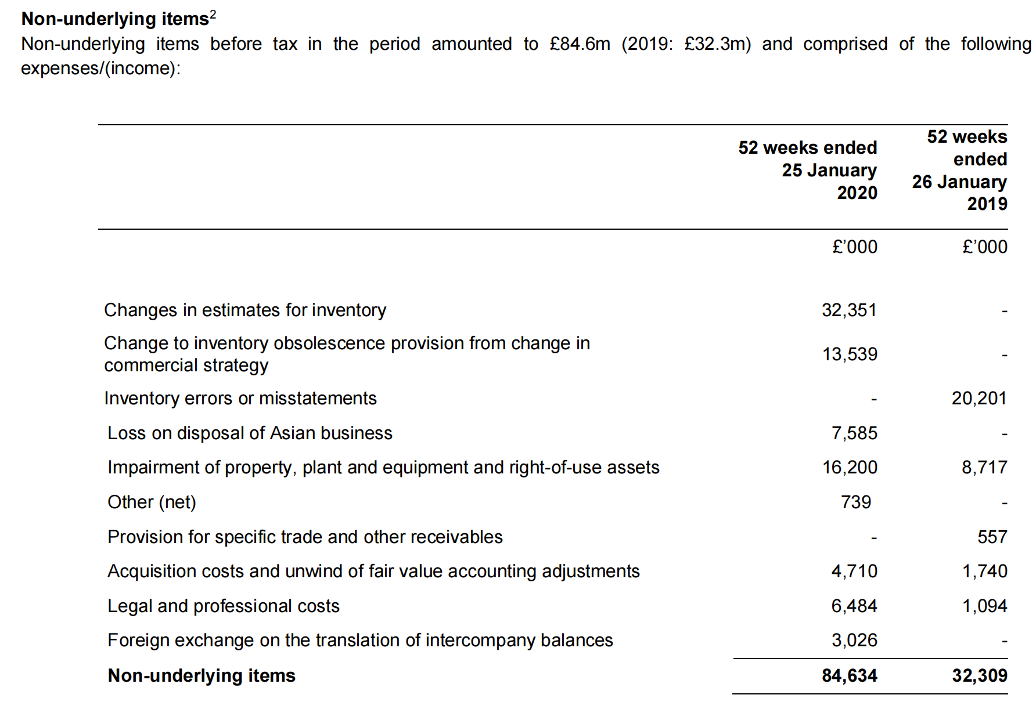

Using the director's expertise and experience in the fashion sector, the minimum cost and net realisable value of the company's inventories are determined by reference to IAS 2 Inventories.The danger of the cost of inventory being higher than the net realizable value is possible since the fashion industry's sales trend has become highly unpredictable and customer behavior and demand closely follow the current trends, which Ted Baker could not have predicted. Inventory stock counts were evaluated, historical trends were examined, and the business sought to discover a means to sell out older season inventory to manage these concerns (Sikka, 2020). However, the management claimed they were unaware of the false statement about improving the presentation. Prior to having to write down such a sum, the company could have been able to recognize the inventory management concerns through the use of more prudent accounting techniques.
According to Ted Baker's financial records, the company's completed product sales rose sharply from £99 million to £216 million between 2016 and 2019. However, according to audit findings based on the turnover ratio, the business replaces inventory as a consequence of sales, and completed products inventory should have climbed to £165 million (Ted Baker Plc, 2020). Concerns are raised by the excess of £51 million, although the corporation has already made adjustments and is employing more responsible accounting practices to produce more precise data.

4 The Effect of Corporate Governance Structures in estricting Earnings Management in the UK
Thanks to the lessons learned from the history of scandals and failures involving large companies in the past, corporate governance has continued to be strengthened. In its broadest sense, corporate governance refers to how directors and shareholders run a business. Some people think of it as a company culture that anticipates economic growth by boosting investor confidence. Another definition of corporate governance is the internal framework of principles, procedures, and personnel that guides and supervises management to serve the interests of shareholders and other stakeholders (Smyth, 2020). An effective corporate governance structure should address two issues: one is to give managers full freedom to manage the business well, without excessive interference from shareholders; the other is to ensure that managers use these freedoms to manage the business in the interests of shareholders, i.e. managers can be effectively motivated and supervised. The former creates the conditions for managers to manage their earnings, while the latter, while reducing the scope for managers to manage their earnings, in a way also stimulates the motivation of managers to manage their earnings.
Firstly, Siekelova et al. (2020) found that the degree of earnings management was negatively related to the proportion of independent directors; the degree of earnings management was lower when the chairman of a listed company was also the managing director. The degree of earnings management was negatively related to the proportion of directors holding shares; the degree of earnings management was positively related to the proportion of the number of board members holding shares; and the degree of earnings management was negatively related to the number of senior managers holding shares.
Therefore, earnings management practices can be monitored by increasing the proportion of independent directors and the number of senior managers holding shares. At the same time, the accounting policies chosen by the company and the changes in accounting policies and the conduct of surplus management should be monitored by independent directors and the audit committee and disclosed to various stakeholders. These measures will strengthen the supervision of the company's managers, discourage opportunistic behaviour of managers and protect the interests of external investors.
In addition, the presence of more than two female directors has a significant impact on limiting surplus management. Because women are less risk-averse, more risk-averse and ethical, and less likely to be overconfident, they are able to correct corporate misinformation through a different perspective and approach, making women directors better at curbing earnings management and thus helping companies to improve their governance efficiency(Bonita & Setiany, 2022). The presence of female directors can, on the one hand, promote gender diversity in the boardroom and reduce information asymmetry at the boardroom level; on the other hand, the presence of female directors can improve the governance effect of the boardroom, curb the level of corporate earnings management and improve the quality of earnings information of listed companies, as female directors are more diligent in enhancing the efficiency of board meetings and have a greater preference for low risk.

Conclusion
A few significant flaws in the corporate governance system have been brought to light by the various scandals. Many investors are becoming more concerned about earnings management as managers frequently manipulate values for their own gain as well as the gain of the company. When actual earnings are lower than projected, managers frequently inflate the values to make it appear as though they are performing. A company's operations are overseen by corporate governance, which also makes sure that the values reported in the books of accounts are accurate. Proper corporate governance should include independent external auditors and external directors with experience in financial planning. By using good corporate governance procedures, earnings management practices could be reduced.

Recommendations
Appropriate corporate governance policies must be implemented in order to decrease the instances and degrees of earnings management. These procedures involve appointing external, independent audit committees and regularly consulting with them. Top Managers should get incentives based on realistic and achievable goals.
To improve the appearance of their financial accounts, the owners creatively employ various accounting strategies. One of the most difficult financial subjects nowadays is earnings management. Therefore, managers are encouraged to make strategic discretionary accounting accruals by upper and lower limits on executive bonus packages.

References
Al Daoud, K. (2018, October). The role of the Audit Committee and the Board of Directors in mitigating the practice of earnings management: Evidence from Jordan. In Proceedings of Business and Management Conferences (No. 6809892). International Institute of Social and Economic Sciences.
Bonita, R., & Setiany, E. (2022). The Effect of Company Size, Profitability, Liquidity, Listing Age, and Public Ownership on Internet Financial Reporting. Journal of Economics, Finance and Accounting Studies, 4(4), 28-41.
DHU, H., & HBP, C. (2019). Corporate governance and earnings management. Iconic Research and Engineering Journals, 2(12), 212–214.
Durana, P., Michalkova, L., Privara, A., Marousek, J., & Tumpach, M. (2021). Does the life cycle affect earnings management and bankruptcy? Oeconomia Copernicana, 12(2), 425-461.
El Diri, M., Lambrinoudakis, C., & Alhadab, M. (2020). Corporate governance and earnings management in concentrated markets. Journal of Business Research, 108, 291-306.
HUYNH, Q. L. (2020). A triple of corporate governance, social responsibility, and earnings management. The Journal of Asian Finance, Economics, and Business, 7(3), 29–40.
Israa, A. M., Kamel, H., & Alashi, M. M. A DIAGNOSTIC FOR EARNINGS MANAGEMENT USING CHANGES IN ASSET TURNOVER AND PROFIT MARGIN: EVIDENCE FROM PALESTINE EXCHANGE. Journal of Economics Finance and Accounting, 8(1), 67-82.
Kjærland, F., Haugdal, A. T., Søndergaard, A., & Vågslid, A. (2020). Corporate governance and earnings management in a Nordic perspective: Evidence from the Oslo stock exchange. Journal of Risk and Financial Management, 13(11), 256.
Kliestik, T., Valaskova, K., Nica, E., Kovacova, M., & Lazaroiu, G. (2020). Advanced methods of earnings management: Monotonic trends and change-points under the spotlight in the Visegrad countries. Oeconomia Copernicana, 11(2), 371-400.
Kliestik, T., Belas, J., Valaskova, K., Nica, E., & Durana, P. (2021). Earnings management in V4 countries: The evidence of earnings smoothing and inflating. Economic Research- Ekonomska Istraživanja, 34(1), 1452-1470.
Li, Y., Li, X., Xiang, E., & Djajadikerta, H. G. (2020). Financial distress, internal control, and earnings management: Evidence from China. Journal of Contemporary Accounting & Economics, 16(3), 100210.
Mangala, D., & Singla, N. (2021). Do corporate governance practices restrain earnings management in the banking industry? Lessons from India. Journal of Financial Reporting and Accounting.
McCormick, M. (2020). Ted Baker warns of £58m writedown on inventory error. The Financial Times. [online] Available at: https://www.ft.com/content/f06051e0-3ce5-11ea-a01a- bae547046735
Muda, I., Maulana, W., Sakti Siregar, H., & Indra, N. (2018). The analysis of effects of good corporate governance on earnings management in Indonesia with panel data approach. Iranian Economic Review, 22(2), 599-625.
Rueangsuwan, S., & Jevasuwan, S. (2022). Earnings management in times of natural disasters. Journal of Financial Reporting and Accounting, (ahead-of-print).
Shabong, Y. (2020). New blow for Ted Baker as accounting scandal doubles in size. Reuters. [online] Available at: https://www.reuters.com/article/uk-ted-baker-accounting- idUKKBN1ZL0NZ
Shin, H., & Kim, S. I. (2018). The effect of corporate governance on earnings quality and market reaction to low-quality earnings: Korean evidence. Sustainability, 11(1), 102.
Siekelova, A., Androniceanu, A., Durana, P., & Frajtova Michalikova, K. (2020). Earnings management (EM), initiatives and company size: An empirical study. Acta Polytechnica Hungarica, 17(9), 41-56.
Sikka, P. (2020). Why didn't auditors spot Ted Baker's overstated inventory? Left foot Forward. [online] Available at: https://leftfootforward.org/2020/01/why-didnt-auditors-spot-ted- bakers-overstated-inventory/
Smyth, L. (2020). 'Adapt or die: Why being a CEO is more challenging than ever. The CEO Magazine. [online] Available at: https://www.theceomagazine.com/business/management- leadership/ceo-turnover/
Svabova, L., Kramarova, K., Chutka, J., & Strakova, L. (2020). Detecting earnings manipulation and fraudulent financial reporting in Slovakia. Oeconomia Copernicana, 11(3), 485-508.
Taylor, M. (2020). Ted Baker admits to £58 hole as stock count error doubles. Accounting web. [online] Available at: https://www.accountingweb.co.uk/business/finance-strategy/ted- baker-admits-to-ps58m-hole-as-stock-count-error-doubles
Ted Baker, (2020). Annual Report and Accounts 2019/20. [online] Available at: https://www.tedbakerplc.com/investor-relations/results-and-reports/2021
Toumeh, A. A., & Yahya, S. (2019). A Review of Earnings Management Techniques: An IFRS Perspective. Global Business & Management Research, 11(3).

