Does technology have an impact on education in primary school?

Bethanney Phillips
(1801687)

Ethical Issues

When starting any kind of research project you must fill out an Ethical form this is to rule out any major risk you might come across, this is done to protect the study, the participants and if there is any sensitive date. As seen below this ethical’s form is signed by the school that the research has taken place, the researchers and the researcher’s university (UCL, 2000).

This study follows the British Educational Research Association (BERA) guidelines. These guidelines are put into place for the researcher to follow as they are legal guidelines and are vital. (BERA, 2017) The anticipated audience for the BERA guidelines is anyone that maybe undertaking educational research. The BERA guidelines are to set out to help the researcher with the aims of ethical review is to protect participants and the researcher themselves (UCL, 2016). During this research project by the researcher going by these guidelines there should not be any problems, but in some cases a problem could develop. This could be that a participation wants to remove themselves out of the researcher project, this is in their right’s to do so as the BERA guidelines state that ‘participation must understand what they are taking part in and have the opportunity to revemove themselves’ (BERA 2017)

APPLICATION FOR ETHICAL APPROVAL

SECTION A: About You (Principal Researcher)
Full Name: |  | Bethanney Phillips
Tick all boxes which apply: |  | Member of staff: | ☐ | Honorary research fellow: | ☐
Undergraduate Student | x | Taught Postgraduate Student | ☐ | Postgraduate Research Student | ☐

Faculty/School/Centre: | Childhood and Education
Campus: | Carmarthen
E-mail address: | 1801687@student.wutsd.ac.uk
Contact Telephone Number: | 07581408056
For students:
Student Number: | 1801687
Programme of Study: | BA Education Studies Primary
Director of Studies/Supervisor: | Lynwen Roberts

SECTION B: Approval for Research Activity
Has the research activity received approval in principle?  (please check the Guidance Notes as to the appropriate approval process for different levels of research by different categories of individual) |  | YES | ☐ | NO | ☐
 |  |  |  | Date
If Yes, please indicate source of approval (and date where known): Approval in principle must be obtained from the relevant source prior to seeking ethical approval | Research Degrees Committee |  | ☐
 | Faculty Research Committee |  | ☐
 | Other (write in)  Lecturer Lynwen Roberts |  | x | 13/12/19

SECTION C: Internal and External Ethical Guidance Materials
Please list the core ethical guidance documents that have been referred to during the completion of this form (including any discipline-specific codes of research ethics, and also any specific ethical guidance relating to the proposed methodology). Please tick to confirm that your research proposal adheres to these codes and guidelines.
UWTSD Research Ethics & Integrity Code of Practice | x
UWTSD Research Data Management Policy | x
BERA GUIDELINES | x

SECTION D: External Collaborative Research Activity
Does the research activity involve collaborators outside of the University? |  | YES |  | NO | x
If Yes, please provide the name of the external organisation and name and contact details for the main contact person and confirmation this person has consented to their personal data being shared.as part of this collaboration.
Institution
Contact person name
Contact person e-mail address

Has this individual consented to sharing their details on this form? |  | YES | ☐ | NO |  |  | x
Are you in receipt of a KESS scholarship? |  | YES | ☐ | NO |  |  | x
Is your research externally funded |  | YES | ☐ | NO |  |  | x
Are you specifically employed to undertake this research in either a paid or voluntary capacity? | Voluntary | YES | ☐ | NO |  | x
 | Employed | YES | ☐ | NO |  | x
Is the research being undertaken within an existing UWTSD Athrofa Professional Learning Partnership (APLP) | If YES then the permission question below does not need to be answered. | YES | ☐ | NO |  |  | x
Permission to undertake the research has been provided by the partner organisation | (If YES attach copy)  If NO the application cannot continue | YES | ☐ | NO |  |  | x

Where research activity is carried out in collaboration with an external organisation
Does this organisation have its own ethics approval system? | YES | ☐ | NO | x
If Yes, please attach a copy of any final approval (or interim approval) from the organisation

SECTION E: Details of Research Activity
Indicative title: | Does technology have an impact on education in primary school?
Proposed start date: | 14/12/19 | Proposed end date: | 29/04/19
Introduction to the Research (maximum 300 words)
Ensure that you write for a Non-Specialist Audience when outlining your response to the three points below:
- Purpose of Research Activity
- Proposed Research Question
- Aims of Research Activity
- Objectives of Research Activity
Demonstrate, briefly, how Existing Research has informed the proposed activity and explain
- What the research activity will add to the body of knowledge
- How it addresses an area of importance.
Purpose of Research Activity

To understand if technology has an impact on education in primary school?

(this box should expand as you type)
Research Question

How does technology have an impact on education in primary school?

(this box should expand as you type)
Aims of Research Activity
To understand how technology has an impact on education in primary school?

(this box should expand as you type)
Objectives of Research Activity

To find out how many times technology is used during the day

(this box should expand as you type)
Proposed methods (maximum 600 words)
Provide a brief summary of all the methods that may be used in the research activity, making it clear what specific techniques may be used. If methods other than those listed in this section are deemed appropriate later, additional ethical approval for those methods will be needed.
(this box should expand as you type)

Location of research activity
Identify all locations where research activity will take place.
(this box should expand as you type)
Research activity outside of the UK
If research activity will take place overseas, you are responsible for ensuring that local ethical considerations are complied with and that the relevant permissions are sought. Specify any local guidelines (e.g. from local professional associations/learned societies/universities) that exist and whether these involve any ethical stipulations beyond those usual in the UK (provide details of any licenses or permissions required). Also specify whether there are any specific ethical issues raised by the local context in which the research activity is taking place, for example, particular cultural and/or legal sensitivities or vulnerabilities of participants.
(this box should expand as you type)
Use of documentation not in the public domain: Are any documents NOT publicly available? | NO | ☐
 | YES | ☐
If Yes, please provide details here of how you will gain access to specific documentation that is not in the public domain and that this is in accordance with prevailing data protection law of the country in question and England and Wales.

(this box should expand as you type)

SECTION F: Scope of Research Activity
Will the research activity include: | YES | NO
Use of a questionnaire or similar research instrument? | ☐ | x
Use of interviews? | ☐ | x
Use of diaries? | x | ☐
Participant observation with their knowledge? | ☐ | x
Participant observation without their knowledge? | ☐ | x
Use of video or audio recording? | ☐ | x
Access to personal or confidential information without the participants’ specific consent? | ☐ | x
Administration of any questions, test stimuli, presentation that may be experienced as physically, mentally or emotionally harmful / offensive? | ☐ | x
Performance of any acts which may cause embarrassment or affect self-esteem? | ☐ | x
Investigation of participants involved in illegal activities? | ☐ | x
Use of procedures that involve deception? | ☐ | x
Administration of any substance, agent or placebo? | ☐ | x
Working with live vertebrate animals? | ☐ | x
Other primary data collection methods, please explain in this box  For example, ‘focus groups’. Please indicate the type of data collection method(s) in this box and tick the accompany box. | ☐ | x
Details of any other primary data collection method:  (this box should expand as you type) | ☐ | x
If NO to every question, then the research activity is (ethically) low risk and may be exempt from some of the following sections (please refer to Guidance Notes).

If YES to any question, then no research activity should be undertaken until full ethical approval has been obtained.

SECTION G: Intended Participants
Who are the intended participants: | YES | NO
Students or staff at the University? | ☐ | x
Adults (over the age of 18 and competent to give consent)? | x | ☐
Vulnerable adults? | ☐ | x
Children and Young People under the age of 18? (Consent from Parent, Carer or Guardian will be required) | x | ☐
Prisoners? | ☐ | x
Young offenders? | ☐ | x
Those who could be considered to have a particularly dependent relationship with the investigator or a gatekeeper? | ☐ | x
People engaged in illegal activities? | ☐ | x
Others (please identify specifically any group who may be unable to give consent) please indicate here and tick the appropriate box. | ☐ | x
Other – please indicate here:  (this box should expand as you type) | ☐ | x

Participant numbers and source
Provide an estimate of the expected number of participants. How will you identify participants and how will they be recruited?
How many participants are expected? | Two Teachers  One Teaching Assistant  Twenty Children  (this box should expand as you type)
Who will the participants be? | Teachers and primary school children  (this box should expand as you type)
How will you identify the participants? | School identified and approached  (this box should expand as you type)

Information for participants: | YES | NO | N/A
Will you describe the main research procedures to participants in advance, so that they are informed about what to expect? | x | ☐ | ☐
Will you tell participants that their participation is voluntary? | x | ☐ | ☐
Will you obtain written consent for participation? | x | ☐ | ☐
Will you explain to participants that refusal to participate in the research will not affect their treatment or education (if relevant)? | x | ☐ | ☐
If the research is observational, will you ask participants for their consent to being observed? | x | ☐ | ☐
Will you tell participants that they may withdraw from the research at any time and for any reason? | x | ☐ | ☐
With questionnaires, will you give participants the option of omitting questions they do not want to answer? | ☐ | ☐ | x
Will you tell participants that their data will be treated with full confidentiality and that, if published, it will not be identifiable as theirs? | x | ☐ | ☐
Will you debrief participants at the end of their participation, in a way appropriate to the type of research undertaken? | x | ☐ | ☐
If NO to any of above questions, please give an explanation
(this box should expand as you type)

Information for participants: | YES | NO | N/A
Will participants be paid? | ☐ | x | ☐
Is specialist electrical or other equipment to be used with participants? | ☐ | x | ☐
Are there any financial or other interests to the investigator or University arising from this study? | ☐ | x | ☐
Will the research activity involve deliberately misleading participants in any way, or the partial or full concealment of the specific study aims? | ☐ | x | ☐
If YES to any question, please provide full details
(this box should expand as you type)

SECTION H: Anticipated Risks

Outline any anticipated risks that may adversely affect any of the participants, the researchers and/or the University, and the steps that will be taken to address them.

If you have completed a full risk assessment (for example as required by a laboratory, or external research collaborator) you may append that to this form.
Full risk assessment completed and appended? |  | Yes | ☐
 |  | No | x
Risks to participants
For example: emotional distress, financial disclosure, physical harm, transfer of personal data, sensitive organisational information
Risk to Participant:  The risk to the participants is minimal. However, their time is precious and some anxiety could development if they have insufficient time to take part in the investigation  (this box should expand as you type) | How will you mitigate the Risk to Participant  I will explain to the participants that their participants is voluntary and they may withdraw at any time  (this box should expand as you type)
If research activity may include sensitive, embarrassing or upsetting topics (e.g. sexual activity, drug use) or issues likely to disclose information requiring further action (e.g. criminal activity), give details of the procedures to deal with these issues, including any support/advice (e.g. helpline numbers) to be offered to participants. Note that where applicable, consent procedures should make it clear that if something potentially or actually illegal is discovered in the course of a project, it may need to be disclosed to the proper authorities
(this box should expand as you type)
Risks to investigator
For example: personal safety, physical harm, emotional distress, risk of accusation of harm/impropriety, conflict of interest
Risk to Investigator:  As I am researching with a family member, I am aware that there is a possibility of conflict of interest in my study  (this box should expand as you type) | How will you mitigate the Risk to Investigator:  I will discuss this with participant and ensure that my research is valid and reliable and without bias. The participant may withdraw their consent at any time  (this box should expand as you type)
University/institutional risks
For example: adverse publicity, financial loss, data protection
Risk to University:  This research is being carried out in the name of University. If ethical guideline is not followed the University's reputation could be at risk.  (this box should expand as you type) | How will you mitigate the Risk to University:  I will ensure that I follow ethical guidelines and the advice of my lectures  (this box should expand as you type)

Disclosure and Barring Service
If the research activity involves children or vulnerable adults, a Disclosure and Barring Service (DBS) certificate must be obtained before any contact with such participants. | YES | NO | N/A
Does your research require you to hold a current DBS Certificate? | x | ☐ | ☐

SECTION I: Feedback, Consent and Confidentiality
Feedback
What de-briefing and feedback will be provided to participants, how will this be done and when?
Verbal feedback will be provided at the end of placement. The participant will be offered a copy of the research finding

(this box should expand as you type)
Informed consent
Describe the arrangements to inform potential participants, before providing consent, of what is involved in participating. Describe the arrangements for participants to provide full consent before data collection begins. If gaining consent in this way is inappropriate, explain how consent will be obtained and recorded in accordance with prevailing data protection legislation.
Consent form and information sheet provided for participants

(this box should expand as you type)
Confidentiality / Anonymity
Set out how anonymity of participants and confidentiality will be ensured in any outputs. If anonymity is not being offered, explain why this is the case.
No names of participants will be used, or the setting

(this box should expand as you type)

SECTION J: Data Protection and Storage
In completing this section refer to the University’s Research Data Management Policy and the extensive resources on the University’s Research Data Management web pages (http://uwtsd.ac.uk/library/research-data-management/).
Does the research activity involve personal data (as defined by the General Data Protection Regulation 2016 “GDPR” and the Data Protection Act 2018 “DPA”)? | YES | NO
“Personal data” means any information relating to an identified or identifiable natural person (‘data subject’). An identifiable natural person is one who can be identified, directly or indirectly, in particular by reference to an identifier such as a name, an identification number, location data, an online identifier or to one or more factors specific to the physical, physiological, genetic, mental, economic, cultural or social identity of that natural person. | ☐ | x
If YES, provide a description of the data and explain why this data needs to be collected:
(this box should expand as you type)
Does it involve special category data (as defined by the GDPR)? | YES | NO
“Special category data” means sensitive personal data consisting of information as to the data subjects’ –  (a) racial or ethnic origin,  (b) political opinions,  (c ) religious beliefs or other beliefs of a similar nature,  (d) membership of a trade union (within the meaning of the Trade Union and Labour Relations (Consolidation) Act 1992),  (e) physical or mental health or condition,  (f) sexual life,  (g) genetics,  (h) biometric data (as used for ID purposes), | ☐ | x
If YES, provide a description of the special category data and explain why this data needs to be collected:
(this box should expand as you type)
Will the research activity involve storing personal data and/or special category data on one of the following: | YES | NO
Manual files (i.e. in paper form)? | ☐ | x
University computers? | ☐ | x
Private company computers? | ☐ | x
Home or other personal computers? | ☐ | x
Laptop computers/ CDs/ Portable disk-drives/ memory sticks? | ☐ | x
“Cloud” storage or websites? | ☐ | x
Other – specify: | ☐ | x
For all stored data, explain the measures in place to ensure the security of the data collected, data confidentiality, including details of password protection, encryption, anonymisation and pseudonymisation:
(this box should expand as you type)
All Data Storage
Will the research activity involve any of the following activities: | YES | NO
Electronic transfer of data in any form? | ☐ | x
Sharing of data with others at the University? | x | ☐
Sharing of data with other organisations? | ☐ | x
Export of data outside the European Union or importing of data from outside the UK? | ☐ | x
Use of personal addresses, postcodes, faxes, emails or telephone numbers? | ☐ | x
Publication of data that might allow identification of individuals? | ☐ | x
Use of data management system? | ☐ | x
Data archiving? | ☐ | x
If YES to any question, please provide full details, explaining how this will be conducted in accordance with the GDPR and DPA (and/or any international equivalent):
The date will be shared only with the module lectures

(this box should expand as you type)
List all who will have access to the data generated by the research activity:
The investigator
The module lectures

(this box should expand as you type)
List who will have control of, and act as custodian(s) for, data generated by the research activity:
The investigator
The module lectures

(this box should expand as you type)
Give details of data storage arrangements, including security measures in place to protect the data, where data will be stored, how long for, and in what form. Will data be archived – if so how and if not why not.
The investigator
The module lectures

(this box should expand as you type)
Please indicate if your data will be stored in the UWTSD Research Data Repository (see https://researchdata.uwtsd.ac.uk/ ). If so please explain. (Most relevant to academic staff)
All date will be stored on their password protected computer

(this box should expand as you type)
Confirm that you have read the UWTSD guidance on data management (see https://www.uwtsd.ac.uk/library/research-data-management/) | YES | x
 | NO | ☐
Confirm that you are aware that you need to keep all data until after your research has completed or the end of your funding | YES | x
 | NO | ☐

SECTION K: Declaration
The information which I have provided is correct and complete to the best of my knowledge. I have attempted to identify any risks and issues related to the research activity and acknowledge my obligations and the rights of the participants.

In submitting this application I hereby confirm that I undertake to ensure that the above named research activity will meet the University’s Research Ethics and Integrity Code of Practice
Signature of applicant: |  | Date:

For STUDENT Submissions:
Director of Studies/Supervisor: | Bethanney Jade Phillips | Date: 13.12.19
Signature: | BJPhillips | Date: 13.12.19

For STAFF Submissions:
Head of School/Assistant Dean: | Helen Amanda Dark | Date: 13.12.19
Signature: | HADark | Date: 13.12.19

Checklist: Please complete the checklist below to ensure that you have completed the form according to the guidelines and attached any required documentation:
x | I have read the guidance notes supplied before completing the form.
x | I have completed ALL RELEVANT sections of the form in full.
x | I confirm that the research activity has received approval in principle
x | I have attached a copy of final/interim approval from external organisation (where appropriate)
x | I have attached a full risk assessment (and have NOT completed Section H of this form) (where appropriate) ONLY TICK IF YOU HAVE ATTACHED A FULL RISK ASSESSMENT
x | I understand that it is my responsibility to ensure that the above named research activity will meet the University’s Research Ethics and Integrity Code of Practice.
x | I understand that before commencing data collection all documents aimed at respondents (including information sheets, consent forms, questionnaires, interview schedules etc.) must be confirmed by the DoS/Supervisor, module tutor or Head of School.
x | I have deleted the guidance notes before submitting the PG2 for consideration

RESEARCH STUDENTS AND STAFF ONLY
All communications relating to this application during its processing must be in writing and emailed to pgresearch@uwtsd.ac.uk , with the title ‘Ethical Approval’ followed by your name.
You will be informed of the outcome of your claim by email; therefore it is important that you check your University and personal email accounts regularly.

STUDENTS ON UNDERGRADUATE OR TAUGHT MASTERS PROGRAMMES should submit this form (and receive the outcome) via systems explained to you by the supervisor/module leader.

This form is available electronically from the Academic Office web pages: http://www.uwtsd.ac.uk/academic-office/

Application Process

All staff research projects and all research students must submit the Ethical Approval Form to the University Ethics Committee via the Academic Office (pgresearch@uwtsd.ac.uk). Staff research directly in relation to personal study for taught undergraduate or Masters programmes should be submitted via the Faculty procedures explained below.

Taught masters and taught undergraduate research Ethical Approval Forms are considered within Faculties. Faculties will provide details of the specific processes for this. Where the Ethical issues within any single ethical application are of particular concern the Faculty will refer these to the University Ethics Committee. Any student activity that involves the collection of primary data needs to undergo Ethical approval, this includes assignment work as well as dissertations.

Notes for guidance in completion of this form

Section A: About You
Please complete all relevant sections

Section B: Approval for research activity
Research proposals must be approved in principle before applying for Ethical Approval. The proposal approval only becomes final when the ethical approval is received.

The process for proposal approval varies according the individual and programme of study:
- Research students, by application on form PG1 to the Research Degrees Committee
- Taught students by review of research proposal within Faculties (Faculties provide specific details of these processes)
- Staff, by agreement by the Head of School/Assistant Dean

Section C: External Ethical Guidance materials
Many discipline areas are required to operate with the discipline specific codes of research ethics (for example health, psychology, education etc.), any such codes must be listed and you must tick to confirm that you have consulted with these.

Section D: External Collaborative Research Activity
Provide details of the external collaborative partners, where appropriate you might want to submit a copy of the external collaboration agreement with the Ethical Approval Form. If the partner requires the research to be subject to its own internal Ethical approval process then please provide details of that process and a copy of any final (or interim) approvals received from the organisation.

Section E: Details of Research Activity
Remember that the individuals reviewing this Ethical Approval Form may not have seen your research proposal, and also may not be experts in the specific area of your research. The information provided should therefore be jargon free and clearly stated.
Indicative Title: please use the same title as used on the research proposal.
Purpose: the Ethical approval process will want to ensure that the methods you propose are adequate and appropriate to address the research aims and objectives. Excessive additional data collection can be seen as unethical.
Proposed Methods: the Ethical approval process seeks to ensure that you understand the methods that are intended, and that the implementation of those methods will be appropriate and without unnecessary impact on respondents. This section must explain how the methods described will lead to the collection of necessary and sufficient data, but not excessive data. Please be specific.
Location: this needs to mention geographical location and also local situation (for example, within Local Authority Offices in Cardiff, using a private room but close to other individuals). If you are collecting data within an organisational setting then you need to explain the permissions that you have obtained to do this.
Research Activity outside of the UK: please complete this section in detail, and note any guidance you have received. Also describe your own familiarity (or not) with the location that you will be utilising.

Section F: Scope of Research Activity
Please tick ALL of the research activities that might be undertaken. If any additional types of activity are intended then please add an extra box and describe these.
If you have answered no to all questions in F then sections G and J do not need to be completed. Section H should be considered, and may be completed. Signatures are still required in section K.

Section G: Intended Participants
Please tick all categories that might apply.
Numbers & Source: if you are using a series of different methods or research activities please list numbers for each stage/phase. Be clear about how you will find respondents. Will you use intermediaries, and if so how? How will you ensure compliance with your sampling strategy?
Information for participants: all participants should be appropriately informed about the research, what is expected of them and what will happen to the information that they provide. The Ethical review process does not ask to see this documentation, but requires this to be reviewed and approved by the Director of Studies in the case of research students, the supervisor/module tutor in relation to students on taught programmes and the Head of School/Assistant Dean in relation to staff research.

Section H: Anticipate Risks
All research carries some level of risk. The answers you provide to questions in this section will be reviewed to ensure that you have an appropriate understanding of the type of risks involved and how you can mitigate against these risks. If you have completed a full risk assessment, as required for example for laboratory work, field work, clinical tests, diving operations, or by a collaborative partner, you may append that to this form. In that case, please tick the box indicating this has been provided. You will not then be required to complete Section H.
Risk to participants Think very carefully about how your actions/questions/discussions might affect the people you are involving as participants. You might identify the risk as small but it would still be a risk. Many types of question have the potential to make respondents less content with their life / job; you need to recognise and try to ameliorate any such effects
If these are business owners, time with you may reduce profit.
In some locations physical risk is very real to both participants and yourself, please consider this.
Risk to you, the researcher Think about where you will meet people, if there are any dangers involved in the location. If you are meeting people as individuals think about using a public place. In general do not visit people in their own homes or remote locations. If you are talking to individuals about certain issues think about how their responses might affect you emotionally. What about the risk of collecting insufficient data?
Risk to the University When undertaking your research, you are acting as a member of the University (student or staff). Professionalism is important, so it is important to be well organised and well prepared. Punctuality, clarity etc. are all part of this. What will you do to ensure this? You must ensure you do not harm the good name of the University in any way and do nothing to undermine the reputation of the research it conducts and sponsors. Upholding high standards of conduct and integrity are vital in this regard. You must also conduct the research in such a way to minimise the potential for claims of negligence made against the University, its researchers and any collaborating individual or organisation. In this respect you should always comply with ethical, legal and professional frameworks, obligations and standards as required by statutory and regulatory authorities, as well as the university’s Research Integrity and Ethics Code of Practice. Research misconduct in this respect can take many forms, including:
- fabrication: making up results or other outputs (eg, artefacts) and presenting them as if they were real
- falsification: manipulating research processes or changing or omitting data without good cause
- plagiarism: using other people’s material without giving proper credit
- failure to meet ethical, legal and professional obligations: for example failure to declare competing interests; misrepresentation of involvement or authorship; misrepresentation of interests; breach of confidentiality; lack of informed consent; misuse of personal data; and abuse of research subjects or material
- improper dealing with allegations of misconduct: failing to address possible infringements such as attempts to cover up misconduct and reprisals against whistle-blowers

Adverse Outcomes. Think carefully about the possibilities, and cover here

Section I: Feedback, Consent and Confidentiality
Feedback to participants: outline your approach. Will interview transcripts be shared with respondents to check accuracy? Will summaries of questionnaire analysis be made available to respondents in some way? Will an overview report be provided? How and when?
Informed consent: Draft letter / e-mail / or heading (or footer) section of questionnaire must be approved by DoS/supervisor (if research student), supervisor/module tutor if taught student, or Head of School / Assistant Dean if a member of staff.
Confidentiality/Anonymity. Explain clearly how you will ensure confidentiality and anonymity.

Section J: Data Protection and Storage
Before completing this section it is necessary to read the University’s Research Data Management information. The questions that follow are designed to ensure compliance with the Data Protection Act as well as established research protocols.

Many research activities will involve electronic transfer of data and use of data management systems in the summarisation and analysis of data. You will need to explain these in relation to compliance with the Data Protection Act.
Think carefully about who will have access to your data, this will include supervisors and examiners. Also that a thesis will be made available via the University library and the British Library system. If you are seeking an access bar for a period of time after completion then mention it here. If you will provide a copy of your findings, or intend to give a presentation, to a facilitating/ supporting/accessing organisation then explain that in this section. But also think about the general principle of data sharing, as explained in the Research Data Management information.
In terms of storage of data please ensure security, and also mitigate against loss of data.

Section K: Declaration
Ensure the appropriate countersignatures have been provided
Look carefully at the checklist and ensure that you comply with and tick all that are relevant to your research.

In every school they need to have written policies and procedures, this is vital that all staff in the school follows them. Policies and procedures are not only to protect the staff and children in the school but they are also legal requirement, these are put into place in every school to be followed and to stick to the legal responsibilities that schools have (GOV.UK, 2018).

Safeguarding Policy

Ysgol fach â chalon fawr.......A small school with a big heart.

The safeguarding officer in School A is the Head teacher but the deputy designated person is Key Stage 2 teacher.

Schools have a vital role in children and young people’s life’s (GOV.UK, 2018). While children and young people are growing up teachers are one of the biggest role models as children and young people spend more of their day in school (NHS, 2016). School A states in their Safeguarding policy that it promotes the welfare of children refers to the process of protecting children from abuse or neglect, preventing the impairment of their health or development, ensuring that children grow up in circumstances consistent with the provision of safe and effective and nurturing care and undertaking that role so as to enable those children to have optimum life chances and to enter adulthood successfully (HM Goverment, 2007).
During placement in School A, the safeguarding was taken very seriously. As there is a pupil in the school that they have concerns about and it has been reported but that pupil was not in school and they did not get a phone call of the parents so Key Stage 2 teacher went to phone to see if everything was alright. This pupil is often late to school so Key Stage 2 teacher has to have a meeting with that pupils parent.

Child Protection

All schools must have a member of staff to coordinate child protection arrangements and this person is named in this policy guidance. In school A the designated adult for Child Protection is the Head teacher but as she is a head teach of two primary schools when she is not in School A then the Key Stage 2 Teacher (School A, 2017). The deputy designated person is appropriately trained and, in the absence of the designated person, carries out those functions necessary to ensure the ongoing safety and protection of children. In the event of the long-term absence of the designated person, the deputy will assume all of the functions above (School A, 2017).

In school A these are the principal aims and objectives:
- Provide a happy, secure and welcoming learning environment for every child.
- Nurture an enjoyment of learning by building and developing the strengths and talents of all our pupils.
- Enable every pupil to develop the skills, knowledge and understanding to be successful and confident learners.
- Sustain our high expectations in our pupils’ standards of achievement as well as the skills and professional development of all our staff.
- Develop the skills, knowledge and attitude essential for our pupils to become responsible, purposeful and effective citizens in our local as well as in the wider community.
- Ensure effective co-operation, trust and support amongst all members of our school’s community for the well-being and development of our pupils. (School A, 2017)

E-safety Policy

School A asked both children’s parents and the staff to both read and sign their E-safety policy. The internet and online technology gives the children and young people new opportunities to learn and grow, but it can also expose them to new types of risks (NSPCC, 2020).
The letter for the children’s parents explain what type of equipment they could be using and that they will be safety using technology in school.

ICT including the internet, email, laptops, digital cameras etc. has become an important part of learning in our school. We expect all children to be safe and responsible when using any ICT.

- I will only use ICT in school for school purposes.
- I will only use my class email address.
- I will make sure that all ICT contacts with other children and adults are responsible.
- I will not deliberately look for, save or send anything that could be unpleasant or nasty. If I accidentally find anything like this I will turn off my monitor and tell my teacher immediately.
- I will not send to children or adults anything that could be considered unpleasant or nasty.
- I will not give out my own details such as my name, phone number or home address.
- I will not arrange to meet someone unless this is part of a school project approved by my teacher and a responsible adult comes with me.
- I will be responsible for my behaviour when using ICT because I know that these rules are to keep me safe.
- I know that my use of ICT can be checked and that my parent/ carer contacted if a member of school staff is concerned about my e-Safety. (School A, 2012)

Topic Based Information

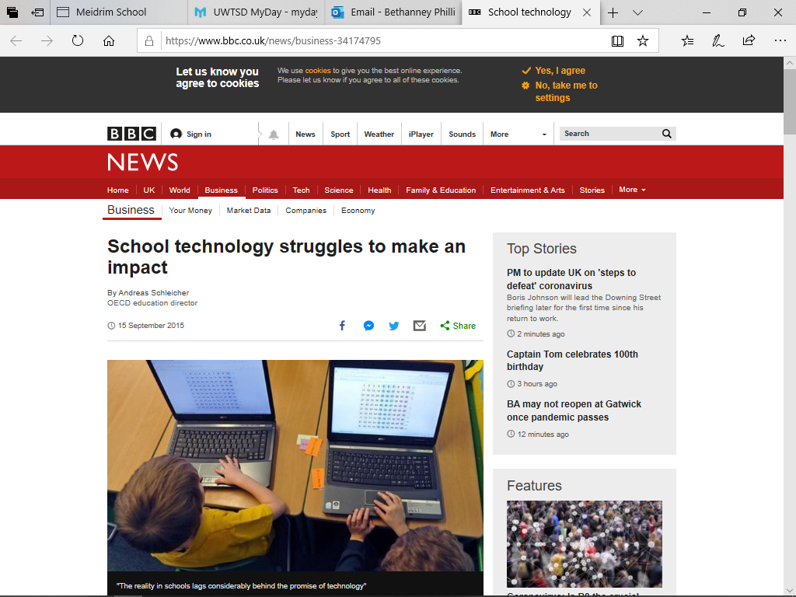

I chose this article as not all pupils understand or know how to use technology.
In this article is explains that that children that spend more than six hours online per weekday outside of school are at risk of reporting that they feel lonely in school, and that they arrive or skip a day off school.

This shows that technology can affect children in many ways not just in their work but missing out on being with their friends as they are on the computer.



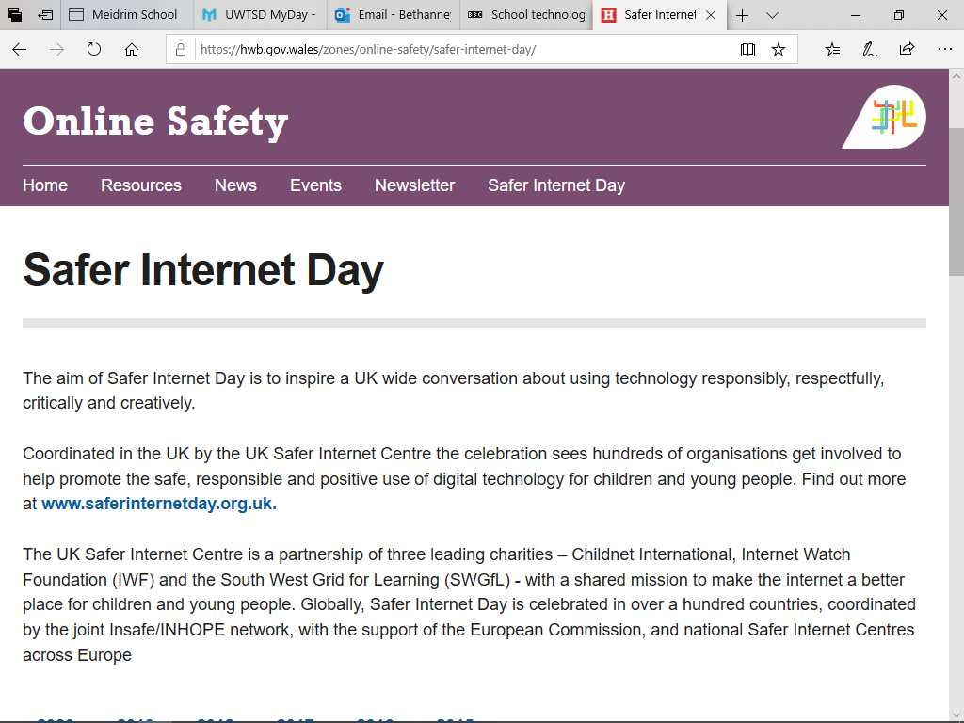

I used this article on the HWB website as when I went on placement Key stage 2 from year three to six the children did this competition in class. One of my days in placement was Safer Internet Day, teaching the children all about technology and the dangers that the internet can have and cause. This was a good opportunity for me to ask the children what technology they had or used at home.

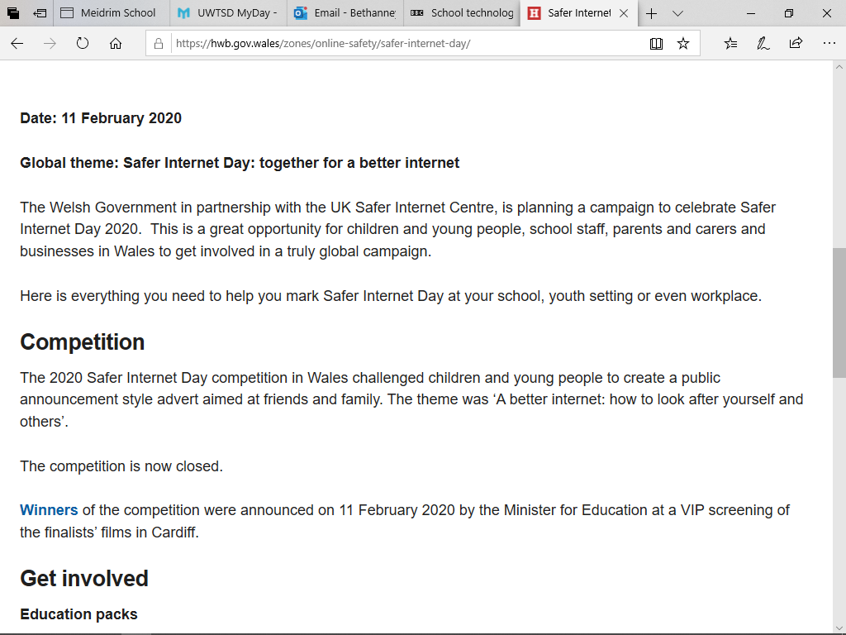

This is one of the children posters they made in Class for the Safer Internet day.



ESTYN Report School A 2016

Pupils in key stage 2 do not develop their ICT skills in terms of handling data or modelling across other subjects or within the subject itself (ESTYN, 2016).However, the school does not plan effectively enough to develop pupils’ numeracy or ICT skills across the curriculum(ESTYN, 2016).
During my time in placement the teacher was always planning her lessons and bringing in ICT into them.

As a result, there are very few opportunities for pupils to apply their numeracy skills across the curriculum. ICT provision does not give pupils opportunities to develop their data handing or modelling skills However, tasks do not challenge pupils of higher ability consistently enough (ESTYN, 2016). Teachers offer pupils very few opportunities to use their numeracy skills and the full range of ICT skills across the curriculum. (ESTYN, 2016).
Even though with this problem the pupils in the school still have a positive attitudes to learning despite the lack of technology.

Successful Futures

During the next two years the Welsh Government will be putting in place a new Curriculum called Successful Futures; this is designed by Graham Donaldson (2015). One of the main aims that the New Curriculum wants is that the digital competence to be cross-curricular within all of the other six areas of learning and experiences. Cross-curricular means that it needs to be integrated in every lesson the teacher prepares for the children.
The Digital Competence Framework has been developed to be inclusive of all learners aged 3 to 16-plus. It covers the development of skills from the earliest stages that very young children need to learn. For learners with additional learning needs this incorporates ‘Routes for Learning’ skills, which are the skills that form the foundation for other, higher skills to be developed ( Welsh Government, 2018).
Donaldson wants the new curriculum to inclusive so every child, and young people to have the same opportunity to achieve the same outcomes (Welsh Government, 2018).
Under the United Nations Convention on the Rights of the Child (UNCRC) and Welsh Government’s overarching strategy document Children and Young People: Rights to Action (2004), all children and young people must be provided with an education that develops their personality and talents to the full. The UNCRC was made law in 2011 which places a duty on Welsh Government to have due regard to the UNCRC when making decisions.

Before starting the whole research in the school the researcher had to get the head teacher or the deputy head teacher to read and sign the consent forms to say that the researcher can take place in the school observing the children. Due to confidentiality the researcher had to blank out the deputy head teacher’s name and signature, this is for their safety and as point four explains that their name will not appear in any reports, articles or presentations.

  FFURFLEN GANIATÂD CYFRANOGIAD | PARTICIPATION CONSENT FORM
Teitl Y Prosiect: / Project Title: Does technology have an impact on education in primary school
Enw'r Ymchwilydd / Name of Researcher: Bethanney Phillips

1 | Cadarnhaf fy mod wedi darllen a deall y daflen wybodaeth dyddiedig 13/12/19 ar gyfer yr astudiaeth uchod. Rwyf wedi cael y cyfle i ystyried y wybodaeth, gofyn cwestiynau, ac rwyf wedi cael ateb boddhaol i’r rhain. |  | I confirm that I have read and understand the information sheet dated 13/12/19 for the above study. I have had the opportunity to consider the information, ask questions and have had these answered satisfactorily.
2 | Deallaf fy mod yn cymryd rhan o’m gwirfodd a bod croeso i mi dynnu’n ôl ar unrhyw adeg, heb roi rheswm. |  | I understand that my participation is voluntary and that I am free to withdraw at any time, without giving any reason.
3 | Deallaf y gellir defnyddio unrhyw wybodaeth a roddir gennyf mewn adroddiadau, erthyglau neu gyflwyniadau gan y tîm ymchwil. |  | I understand that any information given by me may be used in future reports, articles or presentations by the research team.
4 | Deallaf na fydd fy enw’n ymddangos mewn unrhyw adroddiadau, erthyglau neu gyflwyniadau. |  | I understand that my name will not appear in any reports, articles or presentations.
5 | Cytunaf i gymryd rhan yn yr astudiaeth uchod. |  | I agree to take part in the above study.
Enw’r Cyfranogwr Name of Participant |  | Helen Amanda Dark |  | Llofnodwyd  Signature  HADark
Ymchwilydd  Researcher |  | Bethanney Phillips |  | Llofnodwyd  Signature:  BJPhillips
FFURFLEN GANIATÂD CYFRANOGIAD | PARTICIPANT INFORMATION SHEET
Teitl Y Prosiect: / Project Title: Does technology have an impact on education in primary school?

Dear Participant:
My name is Bethanney Phillips and I am studying in the School of Childhood and Education
I would like to invite you to participate in my research project. This project will study and aims to find out how technology has an impact on education in primary school.
All observation/ interview answers will be kept strictly confidential to the researchers involved and at NO time will individual observation/ interview answers be released to the general public. Your participation in this study is completely voluntary so you can withdraw from the observation/ interview answers at any stage.
Our interview should take about 20 minutes to complete, but there is no time constraint. There are also no right or wrong answers. Attached to this letter is a consent form. We understand that your time is at a premium, but your opinions are very valuable to us.
After careful and precise analysis of the data obtained from the observation/ interview I will be happy to provide you with a copy of the findings at your request. The results of this observation/interview will hopefully enhance my understanding of how the curriculum promotes ICT and will be stored on my password protected computer. The results of the research will be fed back to my lecturers at UWTSD and an external examiner.
We thank you in advance for your time and participation. If any questions do arise, feel free to contact me at your convenience.
ENW A CHYFEIRIAD YR YMCHWILYDD | Bethanney Phillips  UWSTD  College Road  Carmarthen  SA31 3EP  1801687@student.uwstd.ac.uk

Methodological

Reflective practice is thinking or reflecting on what you do as an individual. It allows the individual to learn from their experiences in what they think about, what has or could happen and what they could do or think about doing differently the next time (University of Cambridge, 2020). By using Kolb’s experiential learning cycle he wants to see what children have already experienced in life and his theory is based on what people learn and the concept of their understanding their development the real like experiences (University of Cambridge, 2020). These are Kolb’s four stages of this experiential learning cycle
- Concrete experience
- Reflective observation
- Abstract conceptualization
- Active experimentation
This model makes the researcher start with someone that they or the children have already experiences or something that they are new too. This is to make us understand even if we have done it before we can still reflect on the experience as the children could have learn something new. When this happened as researchers we start to develop a new idea on the results of the new experience. E.g. when something that we didn’t think would have happens we as researchers try and find out why this might have happened. In the final stage of Kolb’s cycle he suggests that we apply the new ideas to different situations so that the researcher can see if the results are the same in different situations and environment (Leeds Beckett University, 2019).

Action Plan

Action plan is the first stage of Kolb’s experiential learning cycles this is vital for the researcher as they understand what the objective of the research is before starting it. It gives the researcher a structure to follow so they do not go off tract (University of Leicester, 2020).

This is the Action plan for the study:
Objective | Date | Status
Show placement DBS | 14/1/20 | This was handed to the Deputy Head on my first day then the Head Teacher on my second day.
Find out who the child Protection Officer is in the school | 14/1/20 | The Deputy Head is the child protection officer. There were pictures of her and her responsibilities as a child protection officer on the walls around the school, also on the visitor’s badge I wore.
Check timetable with school | 14/1/20 | Head teacher told me I would be going back and for, from Foundation Phase to Key Stage 2 doing my observations.
Discuss with the teacher if I can take notes | 16/1/20 | Both Teachers agreed that note taking was acceptable but no names would be put in the note book, and that the notes would not be shared in anyone.
Observe the class | 14-24/1/20 | DONE
Get all form signed | 14/1/20 | As the head teacher was not in the first day the deputy head signed the forms.

Placement notes

In school A there are twenty children, one teaching assistant and two class teachers.
During this study the research would take place in both classes the Foundation Phase and Key Stage 2.
During morning register both class teachers would use the computer to register all children into school. This is Carmarthen County Council rule that all teachers have to register children in before a certain time in the morning and after dinner, this is to ensure all children are safe.
During the day the teacher’s would all start with an explanation of lesson and what they want the children to learn and do, this is all done on the computer and presented to the children.
In school PowerPoint’s are a vital way that the teacher can show and teach the children exactly what they would like them to do.
In the Foundation Phase the children would not really use a lot of the computer do complete their work they would be doing work sheets and learning how to use their fine motor skills by learning how to use a pencil,
The Key Stage 2 teacher would want all children to complete their work hand write first before allowing them to complete it on the computer.
The teacher would encourage them to use the computer as much as possible as the New Curriculum states that Digital Competence will have to be integrated into every lesson possible.
One day we went on a trip to Pizza Express, when we got back into school the class teacher wanted them to write a recount on the computer about their day and how they felt about the whole day.
One of the children in Key Stage 2 did a 3D picture of a Pizza on JIT, this is a program on the computer that the children could use to make 3D pictures.
As the school is a very small school, they do not have the best equipment for the children to use as some of the computers do not work probably or do not have the right programmes on for the children to use.

The second stage of Kolb’s experiential learning cycle is for the researcher to take time out and reflecting on how they felt before this whole study started. Before I went into placement I was scared and nervous about the whole experience even though I had been in a school environment before, this time felt very different as I had to do a research project in the school. The teachers and teaching assistant were all very welcoming and made me feel very settled very fast. I was very interested in how much technology the school used or had as they were a very small village school, this interested me as the New Curriculum is coming into force this year and Donaldson (2020) wants Technology to be integrated as a cross-curriculum into every lesson that teacher teach (Successful Futures, 2020.)
The Head teacher was not there on my first day so the Key Stage 2 teacher shows me around and I explained to her exactly what I need to do. I was very nervous but excited to meet all the children in the school and wanted to see their reaction when they saw a new face around the school. When I was observing the classes both class teachers would also ask me if I needed any help or if I did not understand something to just to ask and do not be shy. I soon settled and become familiar with all the children. The class teachers would also give me time in a corner to right up my notes about what I saw. During my time in Key Stage 2 even though the class teacher was intergraded technology into her lessons there were not enough computers that were working or had the right programmes on that the children needed to use.
The third stage of Kolb’s experiential learning cycle he would want the researcher to think what went well about their observation if they saw how technology has an impact on children education. He also wanted the researcher go on what they saw, listen to and learned during observe in the classes (University of Leicester, 2020).
During this time the researcher can think about how the the observation went. They can also think about what worked well? What didn’t work? How do you account for the successes or failures of this experience? What shaped your activities or contribution to the experience? (University of Cambridge, 2020).
The fourth and final stage of Kolb’s experiential learning cycle is that the researcher needs to put what they have learnt into practice. Kolb’s explains that you would come up with a plan on how you would do thing differently if you could do the whole experience again. This for the researcher that may not have got the outcomes or answers they wanted during their study (University of Cambridge, 2020).

During this study the researcher has learnt while trying to find out if technology has an impact of children education, that observation is the best way to observe and get or not get the answer they are looking for. The researcher also found out that in smaller village schools they do not get the same amount of funding as the larger schools do. This as an affect on what the school can get in terms of equipments like computers and iPads. While the researcher was talking to the class teacher she explained that teachers do not get enough course and knowledge on technology and how to use some of the newer programmes.

Reference list

BBC (2015) School technology struggles to make an impact
Available at: https://www.bbc.co.uk/news/business-34174795 (Accessed 20th April 2020)

British Educational Research Association [BERA] (2018) Ethical Guidelines for Educational Research. . Available at:
https://www.bera.ac.uk/researchers-resources/publications/ethicalguidelines-for-educational-research-2018 (Accessed 20th April 2020)

GOV.UK (2018) Health and safety: responsibilities and duties for schools. Available at:
https://www.gov.uk/government/publications/health-and-safety-advice-for-schools/responsibilities-and-duties-for-schools (Accessed 20th April 2020)

Gov.UK (2020) Data protection
Available at: https://www.gov.uk/data-protection (Accessed 20th April 2020)

HM Government (2007) Working Together to Safeguard Children. Available at:
https://dera.ioe.ac.uk/11265/1/Working%20Together%20to%20Safeguard%20ChildrenV2.pdf (Accessed 20th April 2020)

HWB (2020) Online Safety Available at:
https://hwb.gov.wales/zones/online-safety/ (Accessed 15th April 2020)

IN BRIEF (2016) Curriculum reform: The Digital Competence Framework
Available at: https://seneddresearch.blog/2016/09/16/curriculum-reform-the-digital-competence-framework/ (Accessed 15th April 2020)

Leeds Beckett University (2019) Kolb’s Cycle of Reflective Practice. Available at:
https://www.leedsscp.org.uk/LSCB/media/Images/pdfs/Kolb-learning-cycle.pdf(Accessed 20th April 2020)

Meirdrim (2018) Croeso i Ysgol Meidrim. Available at: http://www.meidrim.amdro.org.uk/cartref (Accessed 21st April 2020)

UCL Research Ethics Committee (2000) Guidelines on Completing the Application Form Available at: https://ethics.grad.ucl.ac.uk/forms/guidelines.pdf(Accessed 21st April 2020)

University of Cambridge (2020) Models of revelation. Available at https://libguides.cam.ac.uk/reflectivepracticetoolkit/models (Accessed 21st April 2020)

University of Leicester (2020) David Kolb Available at https://www2.le.ac.uk/departments/doctoralcollege/training/eresources/teaching/theories/kolb (Accessed 21st April 2020)

