

An Integrated Strategic Analysis of BYD: Evaluating Competitive Advantage in a Geopolitically Dynamic Electric Vehicle Industry

Student Name:
Student ID:
Table of contents:
Section 1: Integrated Strategic Analysis of BYD 4
1. Organisational Context: Strategic Foundations of BYD 4
1.1 Strategic Evolution and Capability Reconfiguration 4
1.2 Business Model and Resource-Based Advantage 4
1.3 Industry Context and Strategic Positioning 5
2. External Environment Analysis 5
2.1 Macro Environment: PESTEL 5
2.1.1 Political 5
2.1.2 Economic 6
2.1.3 Social 6
2.1.4 Technological 6
2.1.5 Environmental 7
2.1.6 Legal 7
2.2 Industry Analysis: Porter’s Five Forces 7
2.2.1 Rivalry 7
2.2.2 Supplier Power 7
2.2.3 Buyer Power 8
2.2.4 Threat of Substitutes 8
2.2.5 Barriers to Entry 8
3. Internal Environment Analysis 9
3.1 Resources and Capabilities 9
3.2 VRIO Analysis 9
3.2.1 Value 9
3.2.2 Rarity 10
3.2.3 Imitability 10
3.2.4 Organisation 11
3.3 Dynamic Capabilities 11
4. CSR and Sustainability Strategy 12
5. Balanced Scorecard Analysis 13
5.1 Financial Perspective 13
5.2 Customer Perspective 14
5.3 Internal Processes Perspective 14
5.4 Learning and Growth Perspective 14
6. Strategic Choices and Implementation 15
6.1 Business-Level Strategy 15
6.2 Corporate-Level Strategy 15
6.3 Change Management and Implementation 16
7. Strategic Evaluation and Recommendations 16
Section 2: Critical Reflective Analysis 18
1.1 Description 18
1.2 Feelings 18
1.3 Evaluation 18
1.4 Analysis 19
1.5 Conclusion 20
1.6 Action Plan 20
References: 22
Appendices 1: Strategic Alignment Between External Pressures and Internal Capabilities 27
Appendices 2: Strategic Tension and Trade-Off Analysis 28

Section 1: Integrated Strategic Analysis of BYD

1. Organisational Context: Strategic Foundations of BYD

1.1 Strategic Evolution and Capability Reconfiguration
BYD has reinvented itself as an electric vehicle manufacturer with vertical integration, and a rechargeable battery maker by reconfiguring its capabilities, and not expansion (Kim, Paek and Lee, 2022). The management perceived the Chinese environmental regulation and industrial policy as long-term and structural changes that provide an example of the sensing dynamic capabilities by Chen, Li and Zhang (2022). The move to manufacture automobiles was an act of taking behaviour, and it aims to use the expertise of battery intensity to internalise the propulsion systems and decrease the reliance on suppliers. Instead of opportunistic diversification, BYD was able to transfer manufacturing expertise to nearby technological areas due to path-dependent capability development. This evolution shows that there is adaptive renewal, and at the same time, the technology remains coherent. But dynamic capability theory also brings out the risk: it is next to impossible to achieve rapid scaling without creating rigidity by making routines domestically fixed, hindering responsiveness in the heterogeneous international market.

1.2 Business Model and Resource-Based Advantage
The resource orchestration exhibited in the vertically integrated structure of BYD, i.e., battery production, semiconductor fabrication, and vehicle assembly, is in line with the Resource-Based View provided by Dixon and Wei (2025). The ability to control the vital inputs helps in cost effectiveness and reduces the supplier bargaining power, which is consistent with the value chain logic of Porter (Ayuningtias et al., 2025). Battery intellectual property and scale of manufacturing capacity possess value and relative scarcity, whereas cumulative learning effects reinforce tacit knowledge that is inimitable. Centralised governance and financing by the state assist in bringing organisational alignment, which enables efficient deployment of resources. However, the RBV also suggests that it is vulnerable: asset specificity can be a restriction to flexibility in constantly changing technological settings. Therefore, integration enhances efficiency and, in the process, creates a risk of structural inertia.

1.3 Industry Context and Strategic Positioning
There is accelerated regulation, convergence in technologies, and increased rivalry in the global EV industry. Other competitors like Tesla focus on differentiation through brand and software ecosystems, but BYD blends structural cost leadership and selective technological differentiation (Basile, 2025). Although this ambivalent positioning undermines the caution about the middle ground (stuck-in) issue, there is a conflict between the dominance of domestic scale and international brand-building, especially when geopolitical questioning is on the agenda.

2. External Environment Analysis

2.1 Macro Environment: PESTEL

2.1.1 Political
The existence of state intervention is a structural circumstance that defines the course of competitiveness of BYD. The industrial policy of China has focused subsidies and assistance in procurement and preferential financing to producers of new energy vehicles, which alleviated the capital restrictions and increased the speed of scale formation. This institutional support reduces the risk in the initial stages and supports the expansion of aggressive capacity. Nevertheless, the institutional theory suggests that the companies that are entrenched in the state-backed systems can become reliant on a consistency of regulations (Semanne, 2025). The domestic advantage of BYD is thus somewhat dependent on the stability of its policies. At the same time, the US and EU tariffs on Chinese EV imports change the opportunity structures to make exports more expensive and legitimacy more closely questioned (Bown, 2024). The benefit of politics, therefore, exists next to the weakness of geopolitics that limits the autonomy of the world and strengthens national power.

2.1.2 Economic
Given that the demand for electric vehicles is considered economically cyclical, it is determined by income expectations, fuel prices, and government incentives. The level of price elasticity is high in the emerging markets, which contributes to the positioning of BYD as cost-effective in times of crunches. Margin uncertainty is due to the volatility of the raw material, especially lithium and nickel. Vertical integration of the battery will reduce but not eradicate exposure to commodity fluctuations. The key point is the logic of economies of scale: when large volumes of production are involved, unit cost decreases, which promotes pricing resilience (Shafiei, Seifi and Hagh, 2025). However, the scale needs to be sustained in its demand in order to warrant capital intensity. Cost leadership is thus substantiated by economic forces, with the issue of profitability being subject to macroeconomic shrinkage.

2.1.3 Social
The increase in environmental awareness enhances the demand for mobility with low emissions. Sustainability is becoming more strongly linked to corporate legitimacy by consumers, which perfectly fits the electrification orientation of BYD. Nevertheless, the perception of the brand outside of China is still subject to the effect of the geopolitical narratives and stereotypes of quality. The social acceptance is thus different between markets. Sustainability enlarges demand on a structural level, whereas reputational restrictions might restrict premium positioning in the foreign market, which requires conscious brand-building policies (Adewole, 2022).

2.1.4 Technological
The EV industry is destabilised by technological innovation, which also facilitates it. The Blade battery offered by BYD enhances cost efficiency and safety, and the differentiation is engineering-based (Atkinson, 2024). The learning curve effect implies that cumulative production decreases the costs as time goes by, supporting the benefit. Nonetheless, the speed of innovation diffusion encourages imitation more especially among state-backed competitors. Technological leadership generates competitive rents that are temporary except when they are sustained. The continued elevated level of R&D becomes strategic (Woods, 2025).

2.1.5 Environmental
EVs are institutionalised through the decarbonisation promises and the regulation of emissions (Rimpas et al., 2025). In China and Europe, regulatory requirements incorporate the dimension of demand into policy frameworks, making uncertainty less pronounced and long-term electrification infrastructure investment legitimate.

2.1.6 Legal
Antidumping inquiries and trade examinations increase legal risk in the West. Prospective quotas or tariffs have a direct impact on the profitability of exports (Guo, Liang and Yang, 2025). Legal pressures, therefore, provide incentives to the adaptive internationalisation practices such as localised production to reduce exposure to protectionism.

2.2 Industry Analysis: Porter’s Five Forces

2.2.1 Rivalry
The competitive landscape in the international EV industry is heating up as both the current players and newcomers are increasing their speed to electrify and carry out technological specialisation, respectively. Tesla has to compete in terms of brand equity and software integration, and it aims to differentiate itself based on ecosystem control. BYD focuses on vertical integration as a way of structural cost leadership. The surplus production in China has caused price slumps, which increased the competition (Gotoh and Vic Li, 2026). High fixed costs put pressure on keeping output, and the competition intensifies. Although the cost base allows BYD to be flexible in pricing, long-term competition poses a threat to the compression of the industry margin.

2.2.2 Supplier Power
Traditionally, the power of suppliers is concentrated among battery cell and semiconductor suppliers. The in-house battery and chip production of BYD seriously undermines the upstream leverage, as this corresponds to the value chain logic suggested by Porter of controlling the strategic inputs (Gaertner, 2025). Nevertheless, full insulation against commodity volatility is curtailed by reliance on raw materials that are externally obtained. The power of suppliers is thus lower compared to the less integrated competitor, but not zero.

2.2.3 Buyer Power
There is moderate buyer power and increasing power. An increase in model diversity and open pricing increases consumer switching power. Demand is pooled to negotiate power when fleet buyers and government procurement departments make purchases. The price expectations are limited by the cost efficiency of BYD, which might have neutralised the buyer's power to some extent (Jia et al., 2024). Nevertheless, in the international setting, there is a low degree of brand differentiation, which lowers the bargaining power to receive higher prices. The power of buyers thus threatens constant innovation and brand funding.

2.2.4 Threat of Substitutes
The alternatives are hybrid cars, hydrogen engines, and better internal combustion technologies. Tightening regulations make combustion less attractive, which makes EVs structurally favourable (Mohanty et al., 2023). Transportation development is an indirect competition in the city market. Although a momentum in policy is reducing the chances of substitution, the presence of technological innovations in alternative energy systems might cause a competitive imbalance.

2.2.5 Barriers to Entry
The barriers to entry are high because of the capital intensity, technological complexity, and compliance with regulations. New entrants are also discouraged by established brands and distribution networks. The structural barriers are supported by the accrued manufacturing scale and battery technology of BYD. However, the example of state-supported companies in China shows that institutional backing can partially compensate for the lack of capital, and it is more likely to enter the local market than an international one.
All in all, institutional strength, technological dynamism, and increasing competition are present in the external environment of BYD, which presents structural opportunity and strategic vulnerability (Shou and Li, 2024).
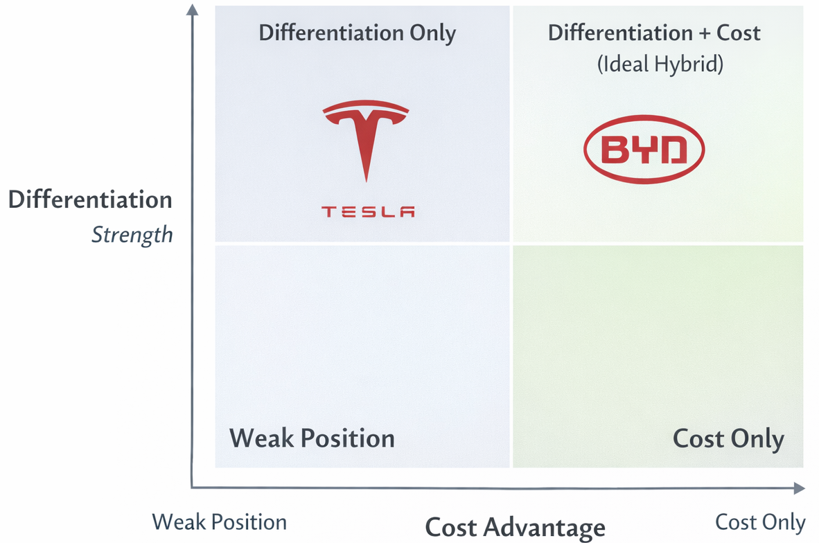
Figure 1: Competitive Positioning Matrix of BYD and Tesla Based on Cost Advantage and Differentiation Strength
Source: Adapted from Basile (2025), Liu (2025) and Chen & Hou (2025).

3. Internal Environment Analysis

3.1 Resources and Capabilities
In the Resource-Based View (RBV) approach, competitive advantage is not only a result of market positioning but a result of the firm-specific resources that can be valued, rare, inimitable, and embedded in an organisation (Nayak, 2022). The physical resource base of BYD lies in the giant manufacturing facility involving battery manufacturing, semiconductor fabrication, and vehicle assembly. These capital-intensive plants provide cost efficiencies in the form of scale economies, production standardisation, and strengthening structural cost advantages as compared to less integrated competitors. Nevertheless, sheer size will not be a long-term benefit unless it is coupled with process know-how.
Intangible assets are more strategically decisive. BYD battery intellectual property, especially the lithium iron phosphate battery, is a type of knowledge-based asset that has been generated through years of R&D investment (Wong, 2024). This level of technology minimizes reliance on outside suppliers and underlines product differentiation based on safety and cost effectiveness. Also important are relational assets, which are entrenched in domestic institutional networks, e.g., policy support and financing. These connections, which are externally located, are strategic resources to the extent that they enable expansion and lessen uncertainty.
Human capital also enhances the development of capabilities. Continuous incremental innovation is assisted by engineering talent that is focused on battery chemistry, electronics, and optimization of processes. Specialised technical skill increases problem-solving and adaptive response, as opposed to commodified manufacturing labour (Zago, 2026). The overall portfolio of resources that BYD has is more of a coherent accumulation as opposed to unrelated diversification, and this is in line with the focus of RBV on internally generated competitive advantage.

3.2 VRIO Analysis

3.2.1 Value
The value-adding aspect of the BYD production system is cost structure optimization, which is generated by a vertically integrated system. The domestic generation of batteries and semiconductors decreases the transaction costs, lessens the supply interruption, and facilitates closer value chain coordination (Rajaeifar et al., 2022). Such efficiencies give the industry a direct competitive pricing flexibility that is characterised by price competition and high fixed costs. In addition, the integration increases the reliability of the products as there would be fewer interface failures between components. Nevertheless, the value creation has to be estimated in terms of the environmental situation: in the case of the rapid technological paradigm change, the large asset specificity could decrease the adaptability. Therefore, though it is evident that current cost leadership is a value-enhancing strategy, it proves to be sustainable only in the case of technological alignment.

3.2.2 Rarity
Despite the presence of many EV manufacturers in the world, not many of them have the same level of battery cell production alongside autonomy in semiconductors (Abro et al., 2023). The majority of competitors use third-party suppliers of key components, and this makes them susceptible to supply bottlenecks. The fact that BYD has adopted upstream capabilities is not very popular with large-scale automakers, giving it a structural differentiation. Rarity, however, is not fixed; it is dynamic. This uniqueness could be destroyed as competitors move towards a strategy of backward integration or obtaining strategic alliances. Thus, rarity is currently a solid competitive positioning factor but is not yet permanent in a quickly converging industry.

3.2.3 Imitability
The barriers to imitation are caused by path dependency, causal ambiguity, and cumulative learning effects. Battery skills at BYD have been formed through decades of experience, such that tacit knowledge is incorporated into engineering practices. According to the learning curve theory (Mohr and Jan, 2024), cost reduction is not only scale-driven, but experience-driven, i.e., new entrants cannot immediately copy the accrued efficiencies. The fact that it is causally ambiguous only deepens imitation: the exact level of interaction between optimization of design, supplier relationships, and control over processes will be hard to externalize. However, the risk of imitation is greater where technological standards are disclosed or where competitors with such standards have access to equal or greater capital intensity, supported by state aid. Therefore, the cost and time requirements of replication are great, but not so huge that inimitability is strong but not absolute.

3.2.4 Organisation
It is the organisational alignment that helps to identify whether the valuable, rare, and inimitable resources are exploited or not. The centralised form of governance in BYD ensures all decisions made in the battery, semiconductor, and vehicle businesses are made in coordination (Zhao and Luethje, 2025). The availability of state-consistent funding promotes strategic flexibility, which facilitates the long-term use of capital. Centralisation can, however, limit responsiveness in diversified international markets. The organisational effectiveness is then strong within the domestic boundaries, but it may be subject to international complexity.
Conclusion: BYD now has a high, but not indisputable, foundation of a sustainable competitive advantage, provided that it is constantly renewed and has an institutional base.

3.3 Dynamic Capabilities
According to Zahra, Petricevic and Luo (2022), dynamic capabilities: the ability to perceive opportunity, grab it by investing in it, and reorganize the assets, are essential in generating sustainable advantage in volatile environments. The strategic path of BYD indicates a successful ability to sense the electrification move in the world. The environmental regulation, urban pollution issues, and battery cost decrease were perceived by the management as structural indicators and not cyclical oscillations, and they were early committed to electric mobility when competitors were still heavily invested in combustion technologies.
The acquisition was done by capacity building through aggressiveness and vertical integration. Instead of contracting to develop batteries, BYD in-sourced production and turned technological aptitude into commercial magnitude. It is a strategic commitment that involves calculated risk-taking with domestic policy incentives. Another factor that shows how deployment of seized opportunities is practiced is the high pace at which several EV models have been introduced in the market at various price points (Tiwari and Farag, 2022).
The reconfiguration has been witnessed through the continued combination of semiconductor fabrication and optimization of battery structure in the firm (Ma, Wang and Zhang, 2025). Reorganizing internal operations according to electrification, BYD minimized the reliance on the old automotive supply chains. Nevertheless, global adaptability is also focused on by dynamic capability theory. The question arises whether or not the base of capabilities developed by BYD is transferable enough to leave the institutional environment in which it was developed. The high dependency levels on domestic policy assistance can hinder the perception of the situation in foreign markets with other regulatory logics and consumer expectations.
This means that although BYD can be shown to exhibit high dynamic capabilities in the domestic setting, whether these capabilities can be redeployed elsewhere in geopolitically diverse settings remains to be known.
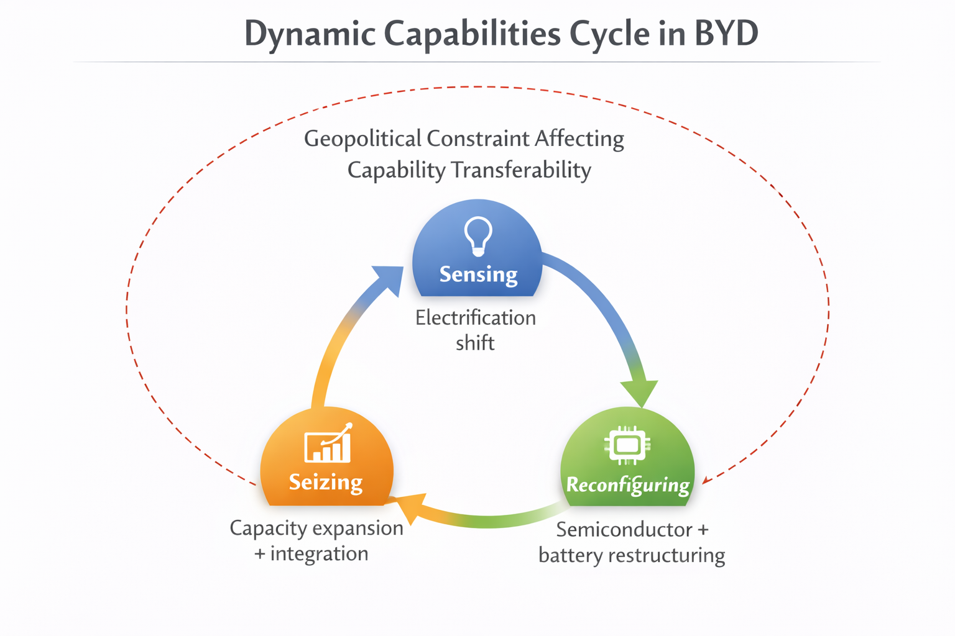
Figure 2: Dynamic Capabilities Cycle Illustrating BYD’s Sensing, Seizing and Reconfiguring Processes under Geopolitical Constraints
Source: Adapted from Zahra, Petricevic and Luo (2022); Dixon and Wei (2025); Shou and Li (2024).

4. CSR and Sustainability Strategy
The concept of sustainability is at the core of the strategic positioning of BYD, but its motivating factors are to be considered critically. Using the pyramid of CSR, BYD fulfills the economic responsibility of producing electric vehicles in a commercially viable way and complies with the law as stipulated by law in reference to environmental regulation (Dathe, Volker Müller and Helmold, 2023). Ethical obligations are manifested in the emission reduction goals and battery development, and philanthropic involvement seems to be less important than business activity (Ng et al., 2025). Nonetheless, the hierarchy used by Carroll suggests that true CSR is beyond compliance. The question to be answered in the course of analysis is whether the sustainability agenda adopted by BYD is an intrinsic strategic orientation or a reflection of state-directed incentives.
In terms of ESG integration, the environmental goals do not take the form of marginal programs attached to the main operations. An example of operational integration of sustainability and competitive advantage is the development of battery technology and the infrastructure of electrification. The Shared Value concept introduced by Porter and Kramer supports this explanation: increasing the access of affordable EVs at the same time encourages decarbonisation of society and the increase of firms (Basile, 2025). It seems that environmental strategy is economically sound, but symbolically, reputation-wise.
However, institutional embeddedness makes evaluation more difficult. The Chinese industrial policy greatly encourages the concept of green mobility, indicating that it will use regulatory arrangements to some extent (Fan et al., 2025). Competitive logic is not transformed in compliance-driven CSR, which reduces risk, but in strategically embedded CSR, which will change competitive logic. The technological commitment of BYD suggests a shift towards the latter; however, the sustainability of this trend can only be determined by continuing to lead in the field even without subsidy frameworks, especially in the markets that lack the belief in the state-sponsored benefit.

5. Balanced Scorecard Analysis
The Balanced Scorecard connects the strategic intent and quantifiable performance in the financial and non-financial aspects (Agarkova et al., 2024). When applied to BYD, it allows us to assess whether performance indicators facilitate competitiveness on a global scale in the long term or focus on consolidating domestic leadership on a large scale.

5.1 Financial Perspective
On the financial front, BYD focuses on increasing its revenues by expanding its production and increasing its exports. The growing sales rates indicate successful scaling, but the shrinking margin in the Chinese EV sector indicates the existence of more price competition. Capital intensity is also elevated because of the battery plants, semiconductor plants, and foreign operations. Financially, the KPIs should be cost leadership in terms of balancing the growth of volumes with the profit of the invested capital (Oualid and Rachid ZAMMAR, 2024). The economies of scale will lower the cost per unit, although there is the threat of an overall decline in profitability due to continuous price wars in the industry. As such, it becomes important to track operating margins, stability of cash flow, and asset turnover. Excess focus on the market share without profitability discipline might compromise long-term sustainability, especially when the international markets fail to counter domestic competitive pressures.

5.2 Customer Perspective
Customer objectives target the market share consolidation of the domestic market and the enhancement of the international brand legitimacy. Affordability in China supports the accessibility of the mass market. Nevertheless, the international customers consider technological credibility and brand trust in addition to price. The rivals like Tesla use brand differentiation to charge premiums, which reflects a comparative reputational deficit of BYD in the foreign market (Liu, 2025). Based on this, KPIs must include customer satisfaction indexes, brand equity measurements, and retention rates instead of sales volume only. The largely price-focused strategy can limit the increase into higher-margin segments. Customer metrics are therefore an indicator of success in moving the competitive advantage beyond the cost efficiency to wider international acceptance.

5.3 Internal Processes Perspective
There is operational integration and battery autonomy that constitute key internal goals. Structural cost advantages are directly supported by efficiency measures, production cycle time, cost per kilowatt-hour, and defect rates. Vertical integration lowers the reliance on suppliers and increases the resilience of the supply chain. Also, the technological renewal capacity can be indicated by such metrics of innovation pipeline as the level of patent output or the speed of development. But process optimisation based on scale can lead to a lack of flexibility in heterogeneous regulatory and consumer environments. The indicators of localisation and cross-border coordination would be a more accurate way of aligning internal processes and the international strategy without inadvertently supporting domestic orientation (Linde and Broman, 2025).

5.4 Learning and Growth Perspective
Constant ability growth is important for sustainable benefit. Incubation of a battery through innovation and improved digital systems through R&D, and development of talent via talent development programs, maintains engineering competence. The use of artificial intelligence in the manufacturing process enhances productivity and quality (Molina, Teti and Alvir, 2023). However, international growth requires more than merely technical expertise, such as regulatory expertise and cross-cultural management. In case the learning metrics are still domestically focused, the adaptive capacity in the foreign country could be destroyed.
Critical Evaluation: Although the current scorecard priorities enhance focus on cost efficiency and the dominance of domestic scales, re-aligning KPI with the focus on the global brand development and international managerial competence is necessary to maintain the competitive advantage in the long term.
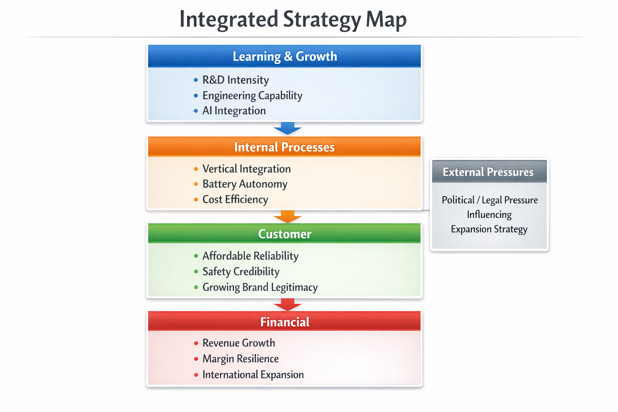
Figure 3: Integrated Strategy Map Linking Capabilities, Customer Value and Financial Outcomes in a Geopolitically Dynamic EV Industry
Source: Selfmade, Adapted from Agarkova et al. (2024); Zahra, Petricevic and Luo (2022); Fan et al. (2025).

6. Strategic Choices and Implementation

6.1 Business-Level Strategy
On the business level, BYD seems to pursue structural cost leadership, but on further analysis, it seems to be an orchestrated hybrid strategy. The strategy of cost leadership and differentiation, Porter cautions, should not be combined as this causes strategic incoherence. However, BYD is cost-efficient because of the structural advantages (not price) achieved through vertically integrated production of batteries and semiconductors. This inbuilt efficacy lowers the unit costs and promotes flexibility of prices. At the same time, a selective technological difference is created through proprietary battery architecture and safety performance. These attributes are also based on internal capabilities, unlike superficial enhancement of features, which is in line with the value chain logic of Porter.
Tesla, conversely, focuses on brand equity and software ecosystem distinction, and it is able to price its vehicles based on its perceived innovativeness (Chen and Hou, 2025). The hybrid orientation of BYD is therefore more focused on operational profundity than symbolic branding. The strategic risk is in the international markets where differentiation is highly applied in consumer preferences. When brand legitimacy falls behind cost advantage, international positioning might fail to price competition in spite of technological strength.

6.2 Corporate-Level Strategy
On the corporate level, the first growth mechanism is international expansion. Using the market development strategy of Ansoff, BYD aims to apply the existing EV platforms in European and emerging markets (Chen and Chen, 2023). Mandatory European electrification regulations open up regulatory avenues without increasing tariff and anti-subsidy examination. The new economies have a greater correspondence with the affordability strength of BYD. Nevertheless, there are political risks, which are increased by geopolitical tensions. As a way of reducing exposure, localisation by way of joint venture or regional production plants becomes very prudent in strategy. This kind of embedded foreign investment enhances immunity to tariffs and transmits long-term commitment, while balancing expansion goals and institutional sensitiveness.

6.3 Change Management and Implementation
The implementation can be viewed through the dynamic capabilities perspective. BYD has proven to be able to reorganize assets quickly and mass-produce effectively. But internationalisation needs decentralised accommodation as opposed to centralised control domestically. In the absence of culturally responsive management structures, global integration can face regulatory and market friction. Long-term success thus lies in making reconfiguration possibilities go beyond the institutional familiarity of home.

7. Strategic Evaluation and Recommendations
The overall analysis that combines SWOT logic suggests that the main strength of BYD is its vertically integrated battery, which generates a cost advantage that was proved by VRIO analysis and addresses supplier power that was detected in Five Forces analysis. But due to subjective global brand equity, it is unable to differentiate outside of China. The opportunities exist due to the regulatory-based electrification requirements (PESTEL political and environmental aspects), and the threat can be represented by the tariff increase and increasing competition.
With the market development approach of Ansoff, the strategy of geographic expansion needs to be narrowed down. The first recommendation is that BYD ought to enhance brand differentiation in Europe by leading in safety and reporting of sustainability. This lowers buyer power because competition will no longer be price-centered, but perception of value.
Second, geopolitical exposure must be limited through localised manufacturing partners. The scenario analysis posits the idea that the increase of protectionism may erode the reliance on exports; hedging tariff risk in regions may not impair the process efficiencies.
Third, building proprietary software systems would augment differentiation and raise switching costs to attenuate rivalry strain and bolster resource inimitability.
These recommendations put the internal strengths in line with the external constraints, in order to enhance the global sustainable competitive advantage.

Section 2: Critical Reflective Analysis

1.1 Description
This evaluation included a thorough strategic evaluation of BYD in the electric vehicle market worldwide. The report has been organized in accordance with the module learning outcomes, both in the external and internal analytical perspectives. Some of the frameworks utilized were PESTEL and Porter's Five Forces in order to evaluate the environment, and the Resource-Based View, VRIO analysis, and Dynamic Capabilities in order to evaluate internal strategic positioning. The Balanced Scorecard, developed by Kaplan and Norton, was used to relate strategic intent and operational performance indicators. The discussion was backed by the work with about twenty scholarly materials, both classic literature on strategic management and recent studies. It was constructed in such a way as to be theoretically coherent, critically evaluated, and synthesised systematically instead of being descriptively commented.

1.2 Feelings
First, I did not realize the complexity in matching the analysis of internal capabilities with external institutional forces. Although I approached the task with a positive attitude towards applying the accepted frameworks of analysis, like the PESTEL and the RBV, there were some ambiguities in the analysis posed by the geopolitical aspects of the Chinese industrial policy. State support and competitive legitimacy played with one another in a more subtle way than expected. I became aware of the multi-layered nature of strategic management, which involves the aspects of macroeconomic structures, specific resources of a firm, and international politics at the same time. It was not a matter of explaining theories, but the intellectual task was to put them together in a coherent way to make them build up to defensible arguments. This procedure solidified the significance of critical analysis as opposed to the utilization of the mechanical frameworks.

1.3 Evaluation
One of the strong points of my work was that the integration of theory was planned and not used in sequence. Rather than considering the PESTEL, VRIO, and Five Forces as separate instruments, I instead tried to show their interdependence of institutional pressures to resource configuration and competitive positioning. This inter-structure synthesis increased analysis and was in line with expectations of postgraduate level. Moreover, all the arguments were always backed up with scholarly materials, which made them evidence-based instead of assertive.
But transport restrictions were also apparent. Only publicly available disclosures were provided as a means of access to internal organisational data, and this might not be a comprehensive measure of strategic intent or operational complexity. In turn, some of the conclusions had to be made carefully. Furthermore, a lot of the Western literature consumed in strategic management was often Western, and as a result, it may have created an interpretive bias in examining a Chinese firm that is embedded in a different institutional setting. Although I have tried to respond to this by including institutional theory, I have realised that more depth of work on this topic through region-specific scholarship would assist in achieving analytical balance. It is this critical consciousness that has pointed out areas in which methodology can be refined.

1.4 Analysis
The biggest learning outcome came from the realisation of how theoretical lenses influence managerial sense. Before I conducted this analysis, I linked competitive advantage mainly with market positioning. The application of the Resource-Based View helped me to change my point of view to focus on the internal capability accumulation as the key reason behind sustained advantage. The VRIO analysis revealed that cost leadership is not necessarily better; the structural peculiarity of the resources, as well as their organisational correspondence, can be advantageous.
The institutional theory also helped to reform my perception of the role of the state. At the beginning, the idea of government support seemed to be unambiguously beneficial. Nevertheless, the study of geopolitical risks showed that institutional embeddedness is a source of dependency and legitimacy issues. This two-sidedness demonstrates that strategy has to be assessed in larger socio-political ecologies as opposed to the financial values.
The generic strategies provided by Porter gave a clear understanding of the competitive positioning, but I also came to find that their use was limited to modern digital-industrial ecosystems. The difference between cost leadership and differentiation is less dichotomous when technological integration makes efficiency-based differentiation possible. This understanding made me use frameworks as guidebooks and not strict categories.
Finally, I gained a level of appreciation for the dynamic aspect of strategy. According to the dynamic capabilities theory, competitive advantage is dynamic and requires reconfiguration on an ongoing basis. The truth about strategic judgement is therefore the necessity of balancing structural efficiency with adaptive flexibility. This critical thinking experience has enhanced my ability to consider organisations as a whole and not in distinct theoretical contexts.

1.5 Conclusion
The reflection has strengthened the fact that strategic management is a complex process that necessitates a combination of macro-environment analysis with firm capability level analysis. I have already formed a more advanced understanding of how institutional, economic, and technological drivers arise together to determine the result of competition. The exercise brought out strategic ambiguity in the emerging markets, where government intervention not only boosts growth but also brings about geopolitical vulnerability. I also realised that frameworks are to be interpreted critically and not mechanically. Strategic formulation requires the synthesis of different viewpoints of analysis and recognizing their weaknesses. On the whole, the given assignment has helped to enhance my skills in measuring competitive advantage in volatile and highly sensitive industries, showing cognitive development of the method of descriptive analysis and critical strategic thinking.

1.6 Action Plan
In order to improve their strategic analysis in the future, I will expand the scope of my research by engaging in more systematic data triangulation, by including industry reports, policy documents, and region-specific academic scholarship. In the process of analyzing companies that operate in different regulatory regimes, it will be necessary to develop a greater degree of geopolitical literacy. The skill of critical synthesis will be improved, as well, with the help of the practise of the application of comparative frameworks: theoretical tools will not be assumed true, but interrogated. Enhancing the level of quantitative literacy, especially in the process of decoding financial and operational indicators, will enhance the accuracy of analysis. In my professional practice, I would expect to utilize this method of organized strategic thinking in the managerial setting, relying on the integrated frameworks to make informed, evidence-based decisions. The ongoing intellectual growth will be assisted by the constant interaction with modern strategy research and will equip me with the leadership positions when I am expected to make judgments in uncertain situations.

References:
Abro, G.E.M., Zulkifli, S.A.B.M., Kumar, K., El Ouanjli, N., Asirvadam, V.S. and Mossa, M.A. (2023). Comprehensive Review of Recent Advancements in Battery Technology, Propulsion, Power Interfaces, and Vehicle Network Systems for Intelligent Autonomous and Connected Electric Vehicles. Energies, [online] 16(6), p.2925. Available at: https://www.mdpi.com/1996-1073/16/6/2925.
Adewole, O. (2022). CSR–brand relationship, brand positioning, and investment risks driven towards climate change mitigation and next perspectives emerging from: ‘Litigation, projections, pathway, and models’. SN Business & Economics, 3(1). doi:https://doi.org/10.1007/s43546-022-00374-4.
Agarkova, L., Anisimova, S., Anisimova, E., Puchkova, E. and Tomaily, A. (2024). The Balanced Scorecard: Integration into the non-financial Reporting System. Lecture Notes in Networks and Systems, pp.501–513. doi:https://doi.org/10.1007/978-3-031-70673-8_52.
Atkinson, R. (2024). CHINA IS RAPIDLY BECOMING A LEADING INNOVATOR IN ADVANCED INDUSTRIES. [online] Available at: https://www2.itif.org/2024-chinese-innovation-full-report.pdf.
Ayuningtias, J., Marimin, M., Buono, A. and Suroso, A.I. (2025). An Integrated DEA–Porter Decision Support Framework for Enhancing Supply Chain Competitiveness in the Muslim Fashion Industry: Evidence from Indonesia. Logistics, 9(3), p.129. doi:https://doi.org/10.3390/logistics9030129.
Basile, V. (2025). Strategy and Competitive Advantages. Future of Business and Finance, pp.5–81. doi:https://doi.org/10.1007/978-3-032-02766-5_2.
Bown, C.P. (2024). Trade Policy, Industrial Policy, and the Economic Security of the European Union. Social Science Research Network. [online] doi:https://doi.org/10.2139/ssrn.4834530.
Chen, S.-L. and Chen, K.-L. (2023). Exploring the Impact of Technological Innovation on the Development of Electric Vehicles on the Bibliometric Perspective of Innovation Types. World Electric Vehicle Journal, [online] 14(7), pp.191–191. doi:https://doi.org/10.3390/wevj14070191.
Chen, Y. and Hou, Y. (2025). Impacts of design aesthetics, brand equity, and trust on electric vehicle purchase intention: an empirical study. Journal of Brand Management. doi:https://doi.org/10.1057/s41262-025-00408-w.
Chen, Y., Li, J. and Zhang, J. (2022). Digitalisation, data-driven dynamic capabilities and responsible innovation: An empirical study of SMEs in China. doi:https://doi.org/10.1007/s10490-022-09845-6.
Dathe, T., Volker Müller and Helmold, M. (2023). Business Opportunities and Risks in China. Management for professionals. doi:https://doi.org/10.1007/978-3-031-31933-4.
Dixon, T.D. and Wei, J. (2025). Business ecosystem transformation: embedded resources and their impact on automotive industry value chain transformation. Asian Journal of Technology Innovation, pp.1–28. doi:https://doi.org/10.1080/19761597.2025.2603911.
Fan, H., Li, Z., Duan, Y. and Wang, B. (2025). Incentive policy formulation for China’s electric vehicle market: Navigating pathways to sustainable mobility with a green premium analytical model. Energy Policy, 202, p.114610. doi:https://doi.org/10.1016/j.enpol.2025.114610.
Gaertner, L. (2025). How German automakers must adapt to stay competitive against BYDs strategic approach across the automotive value chain - upstream strategies. [online] Run.unl.pt. Available at: https://run.unl.pt/entities/publication/c37b602d-75c6-4570-8c31-68ae4479986d.
Gotoh, F. and Vic Li, Y. (2026). Chinese and Japanese Capitalisms: A Comparative Analysis of Co-ordination Problems in Vehicle Electrification Paths. Journal of Contemporary Asia, pp.1–30. doi:https://doi.org/10.1080/00472336.2025.2605303.
Guo, Z., Liang, Y. and Yang, R. (2025). Tariffs, Geopolitical Risks, and Location Choices of Multinational Enterprises. Systems, [online] 13(12), p.1086. doi:https://doi.org/10.3390/systems13121086.
Jia, S., Gao, Y., Guo, Y., Ma, H., Li, Y. and Yu, H. (2024). Energy-saving and CO2 reduction strategies for new energy vehicles based on the integration approach of voluntary advocacy and system dynamics. Environmental science and pollution research international, 31(10), pp.14804–14819. doi:https://doi.org/10.1007/s11356-024-32172-w.
Kim, J., Paek, B. and Lee, H. (2022). Exploring Innovation Ecosystem of Incumbents in the Face of Technological Discontinuities: Automobile Firms. Sustainability, 14(3), p.1606.
Linde, J. and Broman, R. (2025). Global Strategy, Local Words: Navigating Interpretation and Implementation in Decentralized MNCs. [online] Lub.lu.se. Available at: https://lup.lub.lu.se/student-papers/search/publication/9198761.
Liu, Y. (2025). BYD’s Pricing Strategy in the EV Market: Comparative Analysis with Tesla and Strategic Recommendations for Sustainable Development. Finance & Economics, [online] 1(6). doi:https://doi.org/10.61173/jwzch613.
Ma, T., Wang, T. and Zhang, J. (2025). Optimisation of China’s Semiconductor Industry Layout. SpringerBriefs in Economics, pp.133–158. doi:https://doi.org/10.1007/978-981-95-3332-9_7.
Mohanty, A.K., Vivekanandhan, S., Tripathi, N., Roy, P., Snowdon, M.R., Drzal, L.T. and Misra, M. (2023). Sustainable composites for lightweight and flame retardant parts for electric vehicles to boost climate benefits: A perspective. Composites Part C: Open Access, [online] 12, p.100380. doi:https://doi.org/10.1016/j.jcomc.2023.100380.
Mohr, F. and Jan (2024). Learning curves for decision making in supervised machine learning: a survey. Machine Learning, 113(11-12), pp.8371–8425. doi:https://doi.org/10.1007/s10994-024-06619-7.
Molina, L.M., Teti, R. and Alvir, E.M.R. (2023). Quality, efficiency and sustainability improvement in machining processes using Artificial Intelligence. Procedia CIRP, [online] 118, pp.501–506. doi:https://doi.org/10.1016/j.procir.2023.06.086.
Nayak, B. (2022). Integrating the dialectic perspectives of resource-based view and industrial organization theory for competitive advantage – a review and research agenda. Journal of Business & Industrial Marketing, 38(3). doi:https://doi.org/10.1108/jbim-06-2021-0306.
Ng, L., Wang, X., Yu, J. and Zaiats, N. (2025). Ethical Leadership in Climate Action: Navigating National Government Intervention, Financial Constraints, and Corporate Decarbonization. Journal of Business Ethics. doi:https://doi.org/10.1007/s10551-025-06195-3.
Oualid, M. and Rachid ZAMMAR (2024). Evaluating Commercial Performance: The Role of Growth, Market Shares & Evolution Index. International Journal of Accounting Finance Auditing Management and Economics, [online] 5(9), pp.422–436. Available at: https://revue.ijafame.com/index.php/home/article/view/1519.
Rajaeifar, M.A., Ghadimi, P., Raugei, M., Wu, Y. and Heidrich, O. (2022). Challenges and Recent Developments in Supply and Value Chains of Electric Vehicle batteries: a Sustainability Perspective. Resources, Conservation and Recycling, 180(106144), p.106144. doi:https://doi.org/10.1016/j.resconrec.2021.106144.
Rimpas, D., Barkas, D.E., Orfanos, V.A. and Christakis, I. (2025). Decarbonizing the Transportation Sector: A Review on the Role of Electric Vehicles Towards the European Green Deal for the New Emission Standards. Air, 3(2), p.10. doi:https://doi.org/10.3390/air3020010.
Semanne, A. (2025). Small businesses under siege: Austrian perspectives on COVID-19 regulations and their impact on SMEs in France. The Review of Austrian Economics. doi:https://doi.org/10.1007/s11138-025-00694-2.
Shafiei, K., Seifi, A. and Hagh, M.T. (2025). A novel multi-objective optimization approach for resilience enhancement considering integrated energy systems with renewable energy, energy storage, energy sharing, and demand-side management. Journal of Energy Storage, 115, p.115966. doi:https://doi.org/10.1016/j.est.2025.115966.
Shou, S. and Li, Y. (2024). Exploring the collaborative innovation operational model of government-industry-education synergy: a case study of BYD in China. Asian journal of technology innovation, pp.1–36. doi:https://doi.org/10.1080/19761597.2024.2366883.
Tiwari, A. and Farag, H. (2022). Analysis and Modeling of Value Creation Opportunities and Governing Factors for Electric Vehicle Proliferation. Energies, 16(1), p.438. doi:https://doi.org/10.3390/en16010438.
Wong, S. (2024). Developing electric vehicles in China and the United States: Revisiting debates on industrial strategy. Development Policy Review, 43(1). doi:https://doi.org/10.1111/dpr.12815.
Woods, D. (2025). A Stackelberg Model of China’s Rare Earths Strategic Lead. Journal of Chinese Political Science. doi:https://doi.org/10.1007/s11366-025-09921-w.
Zago, M. (2026). Setting the Stage: Unlocking Future Skills in the Performing Arts Sector. Social Indicators Research Series, pp.111–121. doi:https://doi.org/10.1007/978-3-032-09731-6_7.
Zahra, S.A., Petricevic, O. and Luo, Y. (2022). Toward an action-based view of dynamic capabilities for international business. Journal of International Business Studies, [online] 53, pp.583–600. doi:https://doi.org/10.1057/s41267-021-00487-2.
Zhao, W. and Luethje, B. (2025). Manufacturing Competency from Local Clusters: Roots of the Competitive Advantage of the Chinese Electric Vehicle Battery Industry. World Electric Vehicle Journal, [online] 16(6), p.319. doi:https://doi.org/10.3390/wevj16060319.

Appendices 1: Strategic Alignment Between External Pressures and Internal Capabilities
External Pressure | Strategic Risk/Opportunity | Relevant Internal Capability | Sustainability of Advantage | Strategic Implication
Geopolitical tariffs (Political/Legal) | Export cost escalation | Vertical integration & cost efficiency | Moderate (policy-dependent) | Localised production required to hedge risk
Price rivalry in China (Five Forces) | Margin compression | Economies of scale & process efficiency | High (experience curve reinforced) | Cost discipline must remain primary anchor
Raw material volatility (Economic) | Input cost instability | Partial battery supply control | Moderate | Upstream sourcing diversification needed
Brand legitimacy concerns (Social) | Limited premium positioning | Engineering reliability & safety innovation | Developing | Strategic brand investment essential
Technological convergence | Rapid imitation risk | Battery IP & tacit manufacturing knowledge | Strong but time-bound | Continuous R&D renewal critical

Appendices 2: Strategic Tension and Trade-Off Analysis
Strategic Dimension | Advantage Generated | Associated Risk | Long-Term Sustainability Assessment
Vertical Integration | Cost control, supplier power reduction | Reduced flexibility, capital intensity | Sustainable if technological alignment maintained
State Alignment | Domestic scale acceleration | Geopolitical dependency | Vulnerable in protectionist scenario
Hybrid Strategy | Price competitiveness + selective differentiation | Potential brand dilution internationally | Sustainable if differentiation deepens
Rapid Scaling | Market share dominance | Industry-wide margin compression | Risk of overcapacity
Cost Leadership Focus | Emerging market penetration | Weak premium positioning | Requires parallel brand development

