Reflection on Study Skills

Daniel Cowen

10/1/2024

Contents
1 Contents 2
2 Table of figures 2
3 List of Tables 2
4 Section one - Presentation review 3
5 Section Two - Evaluating Skills 4
5.1 Smart targets 5
5.1.1 Complete the OME level 4 HNC. 5
5.1.2 Pass all assignments. 5
5.1.3 Achieving smaller competencies at work 5
5.1.4 Become a competent Trials conducting officer (TCO). 5
6 Section Three – Application 5
6.1 Subsection A – Looking after your data 5
6.2 Subsection B – Time management and self-organisation 6
6.3 Subsection C – Independent study on Torp Ex 6
7 Section Four – Conclusion 7
8 Section Five – Appendix 8
9 References 13

Table of figures
Figure 1- First slide titled Home Life 8
Figure 2- Second slide titled Work life 8
Figure 3- Third slide titled Trials Conducting Officer 9
Figure 4- Fourth slide titled My Interests 9
Figure 5- personality quiz questions [2] 10
Figure 6- results of the personality quiz [2] 10
Figure 7- Careers quiz results [3] 10
Figure 8- organised calendar 11
Figure 9- Personal development plan 11
Figure 10- training record 11
Figure 11- Proof of research for Torpex, book on explosive properties 12

List of Tables
Table 1- Explosive properties of Torpex [5] 12

Section one - Presentation review
This section will include a brief overview of who the report writer is, his life story and their path to joining the OME course. This will be presented within class and will include a review on the work by analysing the strengths and weaknesses when presenting and to conclude will include a section on the key points learnt.
The presentation starts with a section on current home life (figure 1). when delivering this presentation, the presenter spoke about the place of birth and current living conditions. On this slide he talks about Reading Fc a local team and watching them whilst growing up. The speaker also talks about living at home with his parents and siblings and has a section on current relationship status using images to add a humorous side to it. For the second slide (figure 2) the presenter talks about past and current careers, which in this instance contained working behind a bar for a local golf club and how a massive change in career lead to joining AWE which stands for Atomic Weapons Establishment. The speaker also went on to talk about the career path that led to the OME level 4 course. On the third slide (figure 3) the speaker goes into more depth with the current job role and what it entails. for this the presenter talks about trials he has been involved in and work friends made along the way. The use of pictures here really allows the audience to get an idea of NX modelling which many of the listeners may have never seen before. The fourth slide (figure 4) contains some of the interests that the presenter wanted to talk about, these interests include going to the pub with family and friends, playing pool which, the presenter does often and an image of the Chelsea fc badge. The speaker then elaborated on the images and explained a love for football and playing computer games.
On completion of this task the strengths found were that the posture and body language was very open when performing in front of the class therefore allowing engagement with everyone that was watching the presentation. Another strength identified was the humorous side of the presentation which gave it a somewhat relaxed feel for the audience. Finally, a skill that was found very useful was the addition of pictures. This meant that those who are visual learners stayed interested in the information being presented as they could get a further understanding and stay focused on the information being taught. On the other hand, the weaknesses found were due to the humour within the presentation sometimes the feeling was too relaxed causing the focus of the audience to be taken away from the presenter and the presentation. On completion of the presentation feedback was provided from the audience and some of the comments made were about the slight lack of confidence when presenting for example at times there was key information missed and at points it was hard to hear due to the volume of the class and the speaker not projecting his voice loud enough, the reason for this was a lack of practise in speaking in front of an audience. Other feedback given on the presentation stated that although it was informative there may have been too many words on some of the slides which in some instances took away from the pictures.
Overall, the key points learnt when producing and delivering a presentation are that presentations are an interesting way to deliver information to large groups of people in a slightly more relaxed tone and exciting way. Another key point identified was to ensure that the slide show was not too word heavy and that there should be plenty of pictures, this is to allow the presenter to elaborate on these images and allows for a slightly less formal however informative presentation. To conclude, the most important point recognized was time management. This can be crucial to a presentation as spending too much time on certain slides can lead to a lack of concentration or an overload of information for the audience. On the other hand, spending too little time on the slides meant that sometimes key information can be missed, and it can seem like a lack of professionalism if the presenter is rushing through the slides and doesn’t meet the expected time frame.

Section Two - Evaluating Skills
This subsection will include an explanation the key skills that are required for learning education at a much higher level and how these ideas can be applied in an educational environment. I will also go over the desired skills employers are looking for. Furthermore, it will also include a section on developing knowledge about the report writer from strengths and weaknesses to behaviour and personality types with the goal of creating action plans in the S.M.A.R.T. format.
The Key skills required when learning at a higher level are academic writing, this is important as writing in a formal, informative and professional way is key to completing assignments and essays. Not only is it an extremely important skill within education it is also transferrable to work when writing large, detailed reports and is a desirable skill that employers look for within candidates. A further key skill for higher education is critical thinking. Critical thinking is the ability to be able ask questions and challenge others ideas whilst coming up with counter arguments or further knowledge to support ideas [1]. Critical thinking is also a desired skill for employers as being able to challenge ideas leads to adaptations and changes to the way a job may be carried out. Another key skill could be the ability to adapt to learning new skills, an example of this could be leading a presentation or learning a new software system. Due to the constant change in technology and work in general, being able to constantly adapt is a desirable skill.
After completing numerous questionnaires on personality types (figure 5 and 6) [2] some of the strengths identified are that the report writer is a very practical learner and finds that on-the-job training is a much easier way to learn and understand skills. Another strength identified was an ability to work well in pressured situation this is important for meeting deadlines at both university and work. Another strength found was a self-conscious personality, this can be important as it allows for a success-driven and perfectionist mindset ensuring all work is completed to the highest standard possible. On the other hand, the weakness’ identified were a lack of confidence when dealing with large social situations this was shown during the presentation task in section one. Another weakness found was a lack of self-control in serious situation, this can sometimes come across as a lack of professionalism and is something to be worked on with further career progression. On completion of the personality questionnaire the results came back with “Virtuoso” (figure 6) [2]. Virtuoso means “innovative and practical experimenter” (figure 6) [2]. After reviewing these results, the report writer agrees with the outcome of this questionnaire. After reading all the evidence provided the best method of learning for the report writer is on-the-job hands-on learning.
Some of the short-term goals set out are, to ensure each assignment is completed to the highest standard possible and all deadlines are meant, work towards smaller quicker competencies within work and Ensure all revision is done and all upcoming assessments are passed.
Some of the longer-term goals are, to complete the OME level four HNC with either a pass or distinction. Work towards becoming a trial conducting officer and getting a licence for the explosive chambers at work by continuously working alongside other trials conducting officers.

S.M.A.R.T targets

Complete the OME level 4 HNC.
Specific- complete OME level four HNC
Measurable– ensure all modules are passed.
Attainable- all classes are attended.
Relevant- will help further career development.
Time bound- when the course finishes in two and a half years.

Pass all assignments.
Specific- pass all assignments that have been set.
Measurable- a minimum pass grade on assignments.
Attainable- ensure deadlines are met.
Relevant- will ensure the whole course is passed which will help with the target of passing the OME HNC.
Time bound- each assignment will have its own time frame and deadline which shall be met.

Achieving smaller competencies at work
Specific- work towards being competent in high explosive builds.
Measurable- ensure continuous professional development log is updated with any builds completed under supervision.
Attainable- help with any builds that are happening.
Relevant- will help with further development within the role.
Time bound- over the next six months to a year.

Become a competent Trials conducting officer (TCO).
Specific- become a qualified trials conducting officer and get a licence for the explosive chamber.
Measurable- gain other competencies that are needed to become a TCO.
Attainable- help with as many trials as per trial plan.
Relevant- further development within role.
Time bound- over the next one to three years.

Section Three – Application

Subsection A – Looking after your data.
This subsection will include ways to protect your data and how that applies to university and office work.
There are many reasons why you should back up data. These are to prevent files being lost through; software or hardware malfunctions which cause data to be erased, yourself accidentally deleting it by mistake, leaving the device somewhere or most importantly being hacked or having a virus within your electronic device. Another reason why damage to the device through accidental errors an example of this could be not securing it in a bag and having it fall out and be severely damaged, leaving it in the rain accidentally or spilling liquids on it. Finally, another important reason could be the device is stolen. Due to most electronics being high priced they are susceptible and easy to be stolen. There are many ways to prevent these issues from happening such as the 3-2-1 method. The 3-2-1 backup rule states that you should have one main document and two copies on two different storage devices kept either on your person, at work or at university and a further storage device kept offsite in case of an emergency [4]. The reason why this rule is so effective is that due to there being so many copies in different places it provides a much higher level of security and prevents a lot of the issues raised during the beginning of this writing. This rule has been recommended for most to use “in a US-CERT (united states computer emergency readiness team) paper [4]” due to its level of security. Overall, it is a very good rule and one that will be applied during university and whilst at work.

Subsection B – Time management and self-organisation
This subsection will include an explanation on the steps taken to increase productivity, improve organisation and reduce stress.
The steps that have been taken to increase productivity are ensuring any distraction such as phones or televisions are off in a separate room and that when completing any work it is done in a well-lit quiet space to maximise concentration. Another way of increasing productivity is by setting small achievable goals with enough time for them to be completed in, this is effective as it stops the writer being overwhelmed by large amounts of work and it feels rewarding when each smaller target is met. A further way to increase productivity is by taken short but frequent breaks as sometimes it’s hard to concentrate for long periods of time and by giving the mind a few minutes to rest not only does it help increase concentration, but it gives the mind time to go over any ideas and thoughts. A calendar is a good way to organise work as it allows the writer to balance university work with any other work that may be happening (figure 8). Creating a structured plan of what is needed to be completed during the elected time is another good way utilise the calendar as it allows for a more efficient process and eliminates time wasting.
Furthermore, the most important way to self-manage is by creating a personal development plan (figure 9). This PDP contains goals related to university for example the completion of assignments and meeting deadlines and the full picture which includes the completion of the OME level four course. It also includes areas of personal development with on-the-job training and competencies to help further a career and build a pathway of guidance to help achieve the goals. By setting time frames it allows the writer to gain a rough idea on when these targets should be met. Finally, another way to keep track of progress is through an updated training record (figure 10) this is important as it shows all training that has been complete and any further training that is required.

Subsection C – Independent study on Torp Ex
This subsection will be a literature review on Torp Ex outlining the details to why it is so commonly used and its effectiveness.
Torp Ex is a mixture between aluminium powder, RDX and TNT. The Ratio for this depends on the desired outcome for example for Torpex 1 is RDX/TNT/Al in a ratio of 45/37/18 (table 1) [5]. The reason for this formation is due to RDX being effective because of its structural stability which allows for the safe handling and production however yielding a high velocity of detonation and detonation pressure. The use for TNT with RDX is due to its low sensitivity and high chemical stability. TNT is a well-known and commonly used explosive. By mixing TNT with RDX it allows for an even safer filling. Research has found that during the explosive’s detonation part of the explosive effects are transferred to the air and lost resulting in a less explosive power, this is where aluminium powder becomes most effective [6]. Due to aluminium’s endothermic properties, it can absorb the detonation heat and react with it to create a quicker and more effective release in energy when detonated [6]. Torpex is widely used for multiple areas within the military for example due to its insensitivity to shock and penetrating properties it can be used for destroying heavily built up and armoured vehicles such as warships and submarines. This makes it an important explosive within torpedoes and is used across the navy. Not only is it used for torpedoes it is also useful as a filler for “underwater depth bombs [7].” The main reason it is used as a filler for most underwater missiles and “depth bombs [7]” is due to its insensitivity to high pressures and bullets. It is also super effective as it yields a large number of shockwaves when submerged deep within the sea.

Section Four – Conclusion
To conclude section one the report writer found that when delivering power point presentations, it is important to have an equal balance not only between visual images but also word content. This is because too many visual images can lead to the audience focusing too much on the images instead of the content being taught whereas too much word content can cause people to lose focus and interest within the presentation. On reflection the report writer feels more confident in leading a presentation which will be a key skill for upcoming modules within the OME HNC.
In conclusion, when completing the personal evaluation in section two the writer discovered many new helpful skills that will lead to a deeper understanding of how the report writer learns which can be transferred into a work-related environment and useful for development during the HNC. Within section two the writer also came up with S.M.A.R.T targets to help with further career development over the next six months to a year. By setting these goals the writer now has a manageable way to measure achievements and track progression.
In section three subsection A the report writer discovered ways to protect data. During research the most effective method found was the 3-2-1 method which involved keeping one main document in 3 different places 2 on you on site and 1 in an offsite location. This method was found most effective as if one of the copies was lost, damaged or stolen there are two more copies in different places that can be retrieved if necessary. This is a method that will be used over the HNC course and transferred to a work environment.
In Subsection B the report writer investigated methods of time management and organisation. The outstanding methods identified were setting small goals with short time frames. This meant that it was easier to stick too and allowed for better concentration when completing the smaller tasks. Another method discovered was ensuring an up-to-date calendar this helped when planning assignment work around the day-to-day work onsite.
Subsection C included a short review on the properties of Torp Ex and underwater explosive. Torp Ex consists of RDX, TNT and aluminium powder. Due to the properties of these it allows for a very effective filling for torpedoes and underwater mines.
Overall, this assignment has taught the report writer many different skills from: how to design and give presentations, personal evaluations, ways to manage data and how to manage workloads by organising work and managing time.

Section Five – Appendix
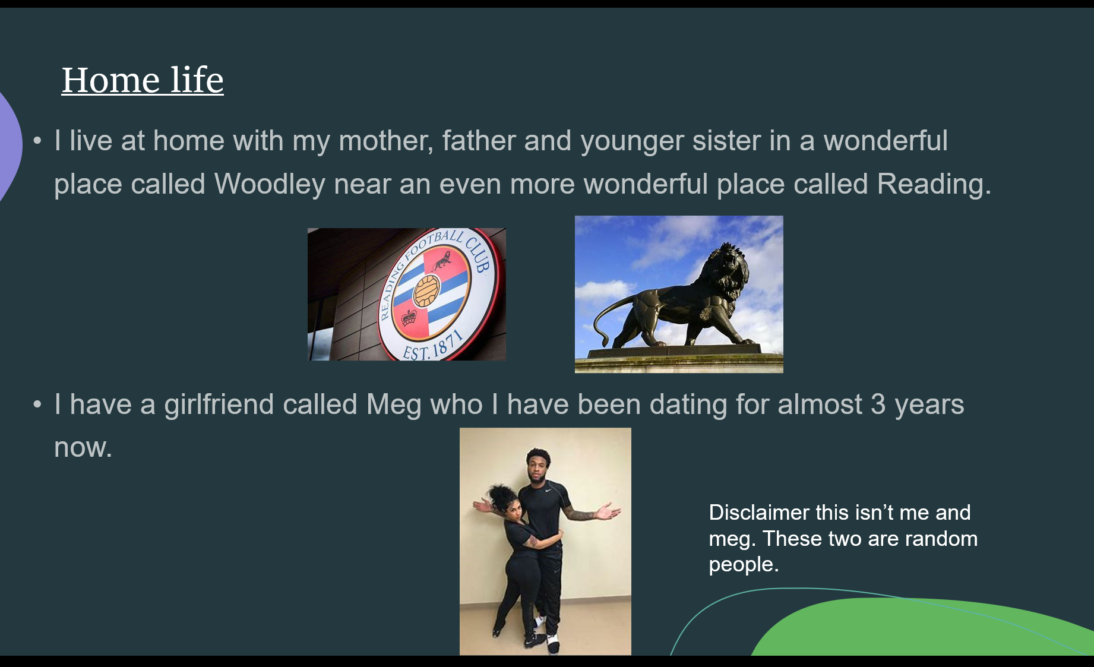
Figure 1- First slide titled Home Life
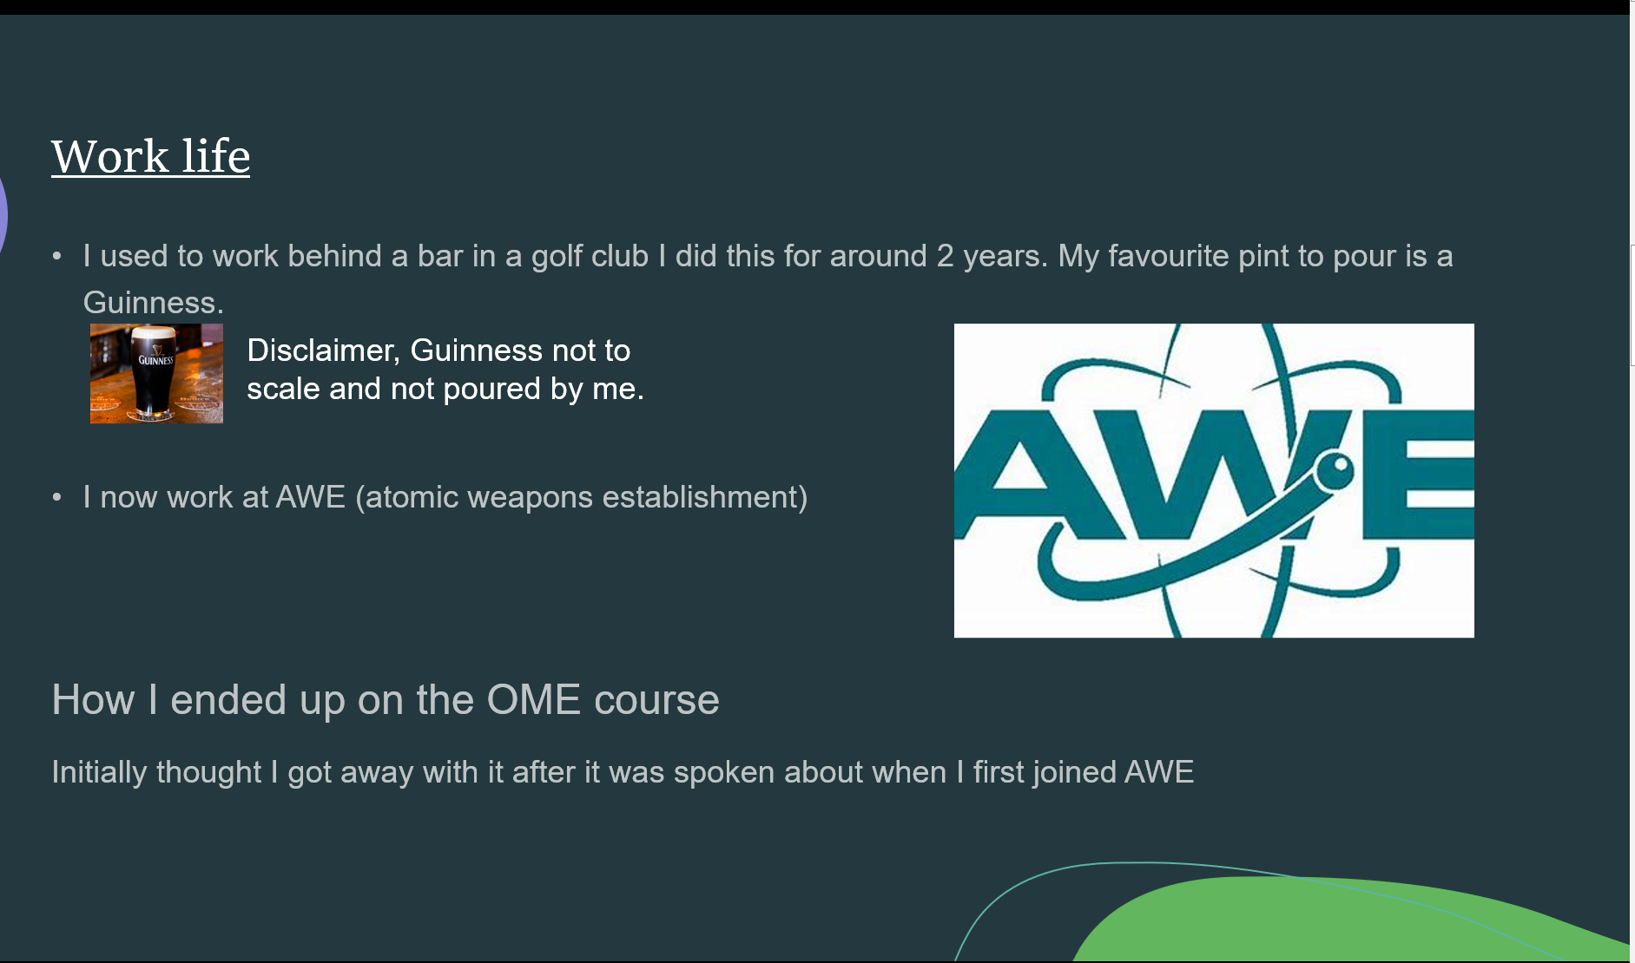
Figure 2- Second slide titled Work life
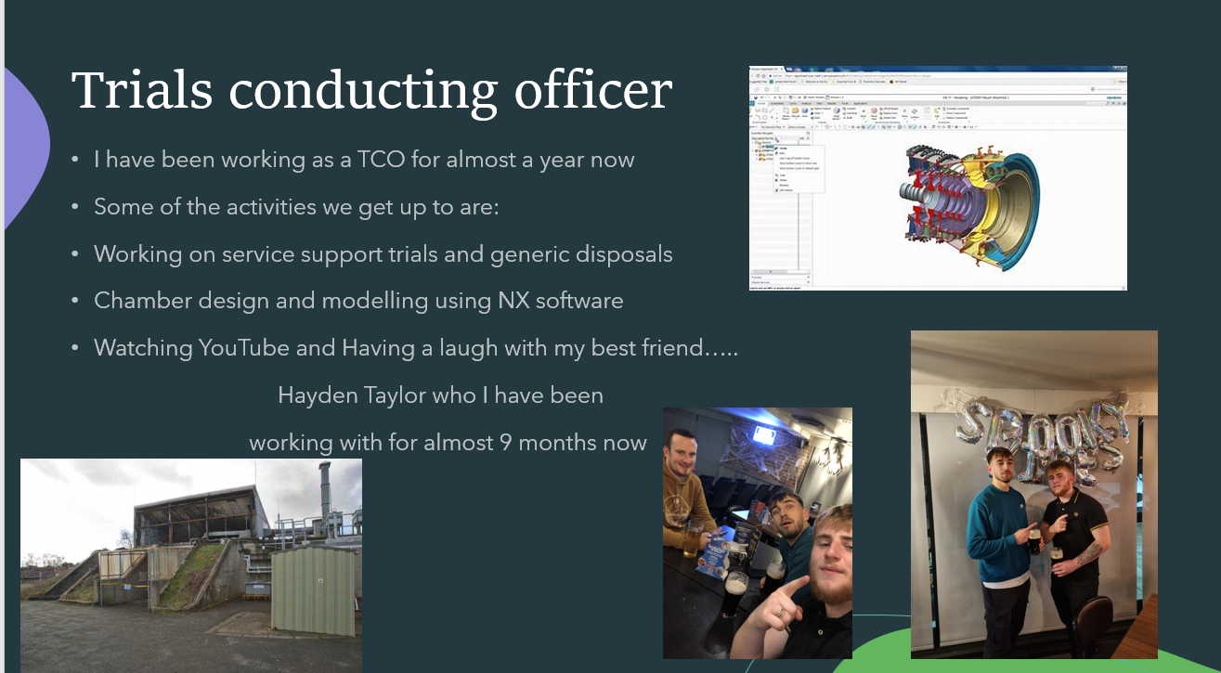
Figure 3- Third slide titled Trials Conducting Officer
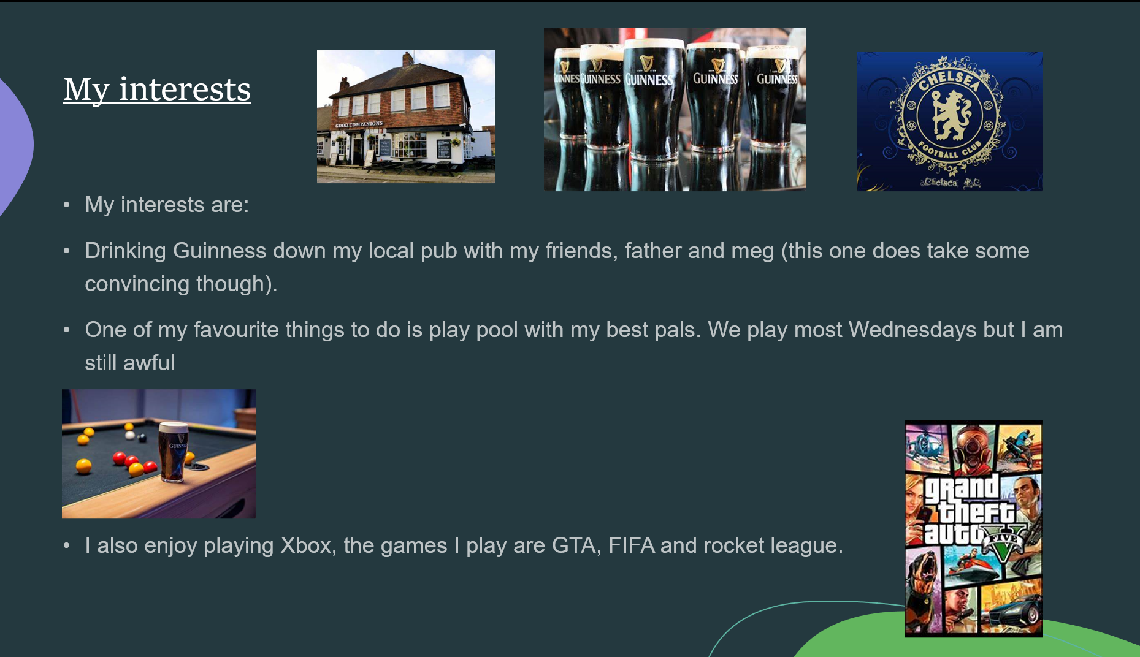
Figure 4- Fourth slide titled My Interests

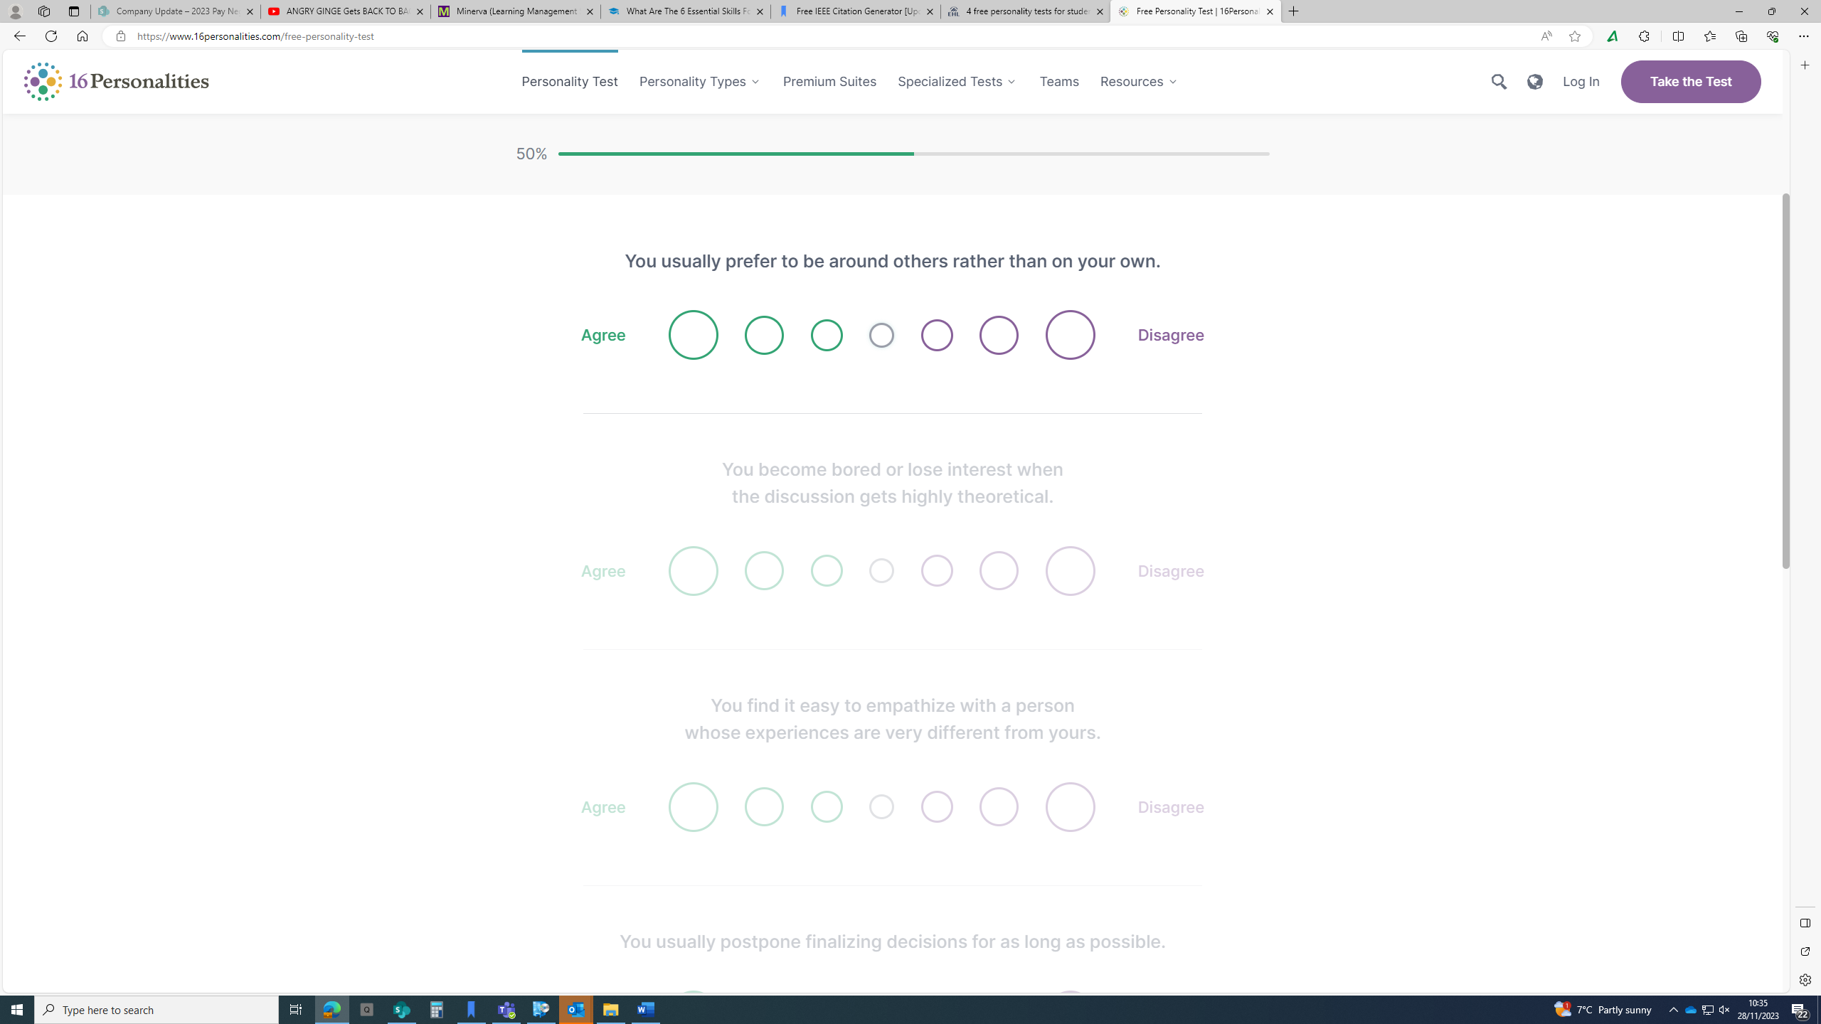
Figure 5- personality quiz questions [2]
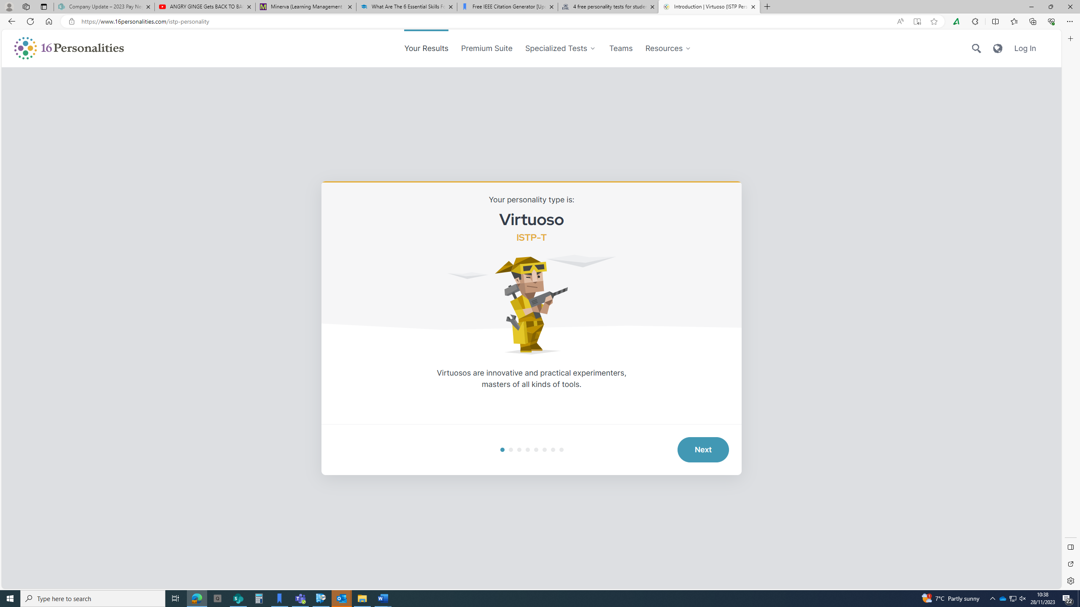
Figure 6- results of the personality quiz [2]

Figure 7- Careers quiz results [3]
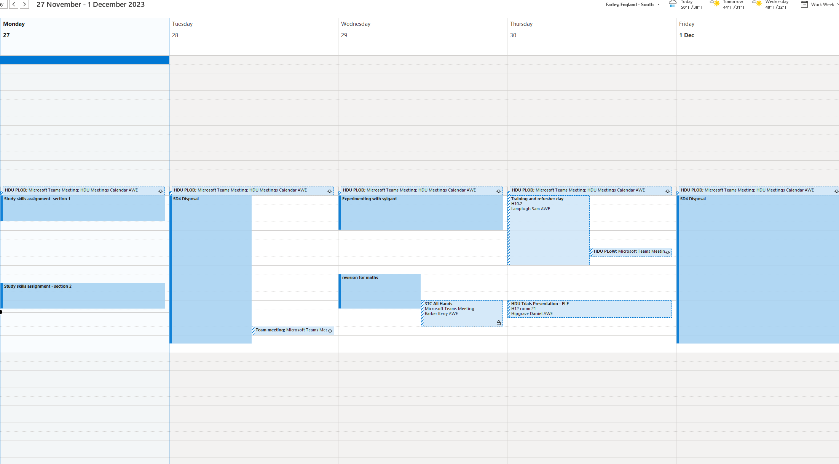
Figure 8- organised calendar
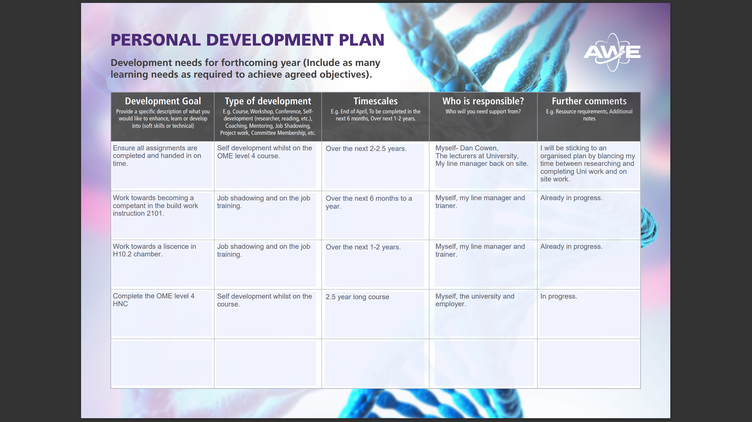
Figure 9- Personal development plan
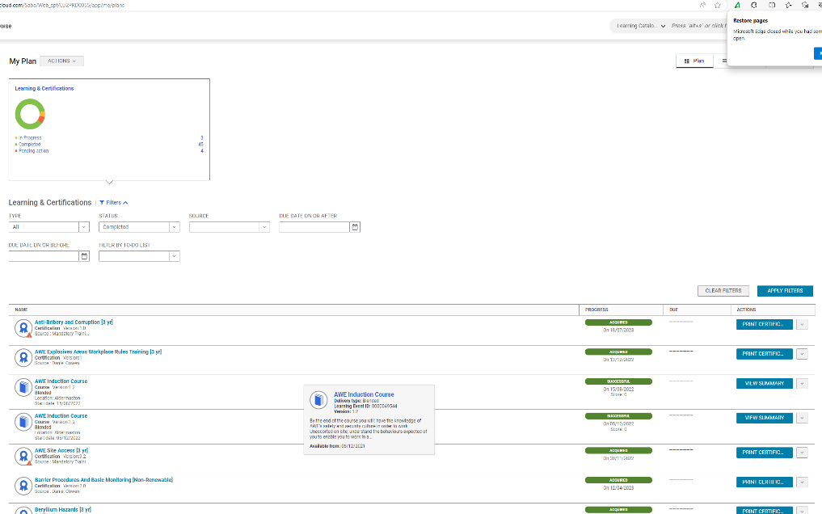
Figure 10- training record

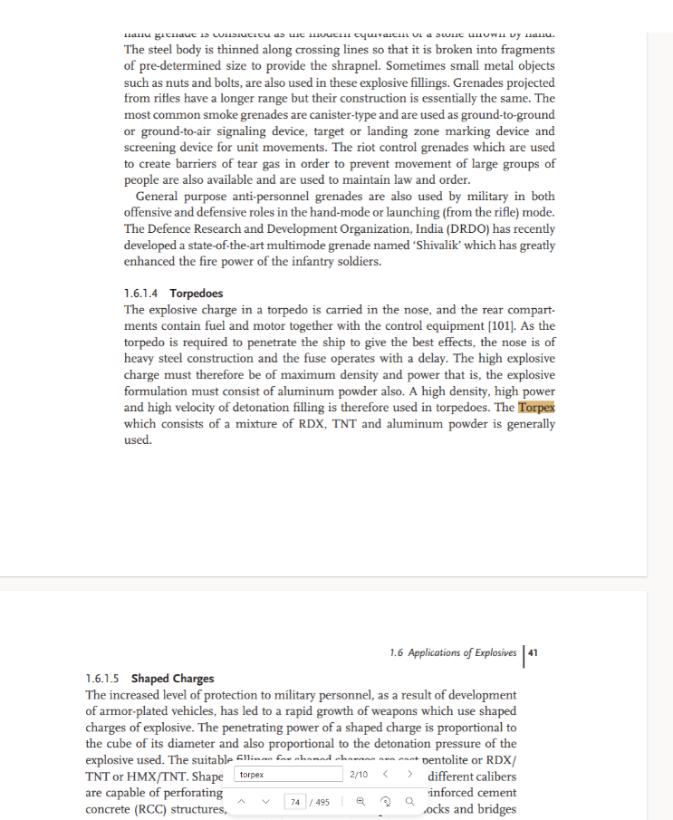
Figure 11- Proof of research for Torpex, book on explosive properties
Notes on Torpex for section 3 subsection C.
- Torpex is a mixture of RDX, TNT and aluminium Powder.
- Used to defeat heavy armour on ships or vessels.
- Very insensitive deep bomb and torpedo filler.
- Al powder helps to increase the explosive power.
- Castable mixture in the ratio of 45/37/18.
- There are different variants and formulations of Torpex.

Explosive | Formulation | Density/ g cm-3 | Velocity of Detonation / m s -1
Torpex 1 | RDX/TNT/Al  45/37/18 | 1.78 | 7440
Torpex 2 | RDX/TNT/Al  42/40/18 | 1.85 | 7360
Torpex 2B | RDX/TNT/Al  42/40/18 +5.5% de-sensitiser | 1.77 | -
Torpex 5 | RDX/TNT/Al  30/50/20 +2% C black | 1.78 | 6990
Table 1- Explosive properties of Torpex [5]

References
[1] R. Needleman, “What are the 6 essential skills for university students?,” UniAdmissions, https://www.uniadmissions.co.uk/application-guides/6-essential-skills-for-university-students/ (accessed Nov. 27, 2023).

[2] Free personality test, type descriptions, relationship and career advice (no date a) 16Personalities. Available at: https://www.16personalities.com/ (Accessed: 27 November 2023).

[3] “Careers quiz,” UCAS, https://www.ucas.com/careers-quiz (accessed Nov. 27, 2023).

[4] M. Campbell, “Why 3-2-1 backup sucks,” Unitrends, https://www.unitrends.com/blog/3-2-1-backup-sucks#:~:text=The%203%2D2%2D1%20backup%20strategy%20simply%20states%20that%20you (accessed Nov. 28, 2023).

[5] J. P. Agrawal, High Energy Materials: Propellants, Explosives and Pyrotechnics. Weinheim: Wiley-VCH, 2012.

[6] J. Dong et al., “Effects of nano aluminum powder on the mechanical sensitivity of RDX-based explosives,” Nanomaterials, vol. 11, no. 9, p. 2182, 2021. doi:10.3390/nano11092182

[7] D. Dougall, “TERMINAL BALLISTICS A REPORT PREPARED FOR THE AAF SCIEN’rIFIC ADVISORY GROUP,” 1946. Accessed: Nov. 27, 2023. [Online]. Available: https://www.governmentattic.org/vonK/ExplosivesTerminalBallistics_VKarman_V10.pdf

