PROGRAM: Certificate in Higher Education Business Skills for the Workplace
MODULE NAME: Understanding and Engaging Stakeholders
MODULE CODE: LCLM5001
LECTURER NAME: Kazeem Oseni
GROUP: 1
STUDENT NAME: Md Maynul Hasan Sumon
STUDENT ID: 2417454

Executive Summary
In this report, I have assessed the significance of stakeholder involvement in the effective initiation and successful implementation of a 6-month project to initiate a new wearable health device at Fitbit UK. The report comes out as the appointed project manager and examines the role of internal and external stakeholders on the project outcomes in a highly regulated setting with sensitive information in the healthcare system. Such strategic tools as SWOT, PESTLE, and SMART objectives are used in the evaluation of organisational preparedness and external forces. The major stakeholders are identified, and their roles, benefits, and challenges are analysed with the help of the known engagement frameworks like the PowerInterest Matrix, RACI model, and 4Cs approach. The report proves that successful stakeholder engagement improves project delivery, compliance with regulations, innovation, and long-term business performance.

Contents
1. Introduction 5
2. Strategic Analysis of Fitbit UK 6
2.1 SWOT Analysis 6
2.2 PESTLE Analysis of Fitbit UK 7
2.3 SMART Objectives 9
3. Identification of Stakeholders 10
3.1 Internal Stakeholders 11
3.2 External Stakeholders 11
3.3 Stakeholder Classification. 11
4. Roles, Responsibilities, Benefits, and Challenges of Stakeholders 12
4.1 Internal Stakeholders 12
4.2 External Stakeholders 13
5. Engagement Frameworks, Models, and Theories 13
5.1 Stakeholder Power Interests Matrix (Mendelow) 14
5.2 Stakeholder Engagement Plan. 15
5.3 Communication Plan 15
5.4 RACI Matrix 16
5.5 Theoretical Foundations 17
6. Stakeholder Engagement Process and Conflict Management 18
6.1 Stakeholder Engagement Process. 18
6.2 Managing Conflicts: the 4Cs Model. 19
6.3 Role of the Project Manager 20
7. Impact of Stakeholder Engagement on Business Performance and Recommendations 20
7.1 Effect on Business Performance. 21
7.2 Future Stakeholder Engagement Strategic Recommendations. 22
8. Conclusion 23
9. References 25

Introduction
Fitbit UK is a subsidiary of Google and one of the leaders in the provision of wearable health technology in the United Kingdom. It is a medium-to-large company that employs a few hundred people who are engaged in product development, data analytics, marketing, and regulatory compliance. Having a strong market share, an established reputation in terms of innovation and development in the area of health monitoring devices, Fitbit designs and sells smartwatches and fitness trackers capable of tracking heart rate, oxygen level, sleep patterns, and physical activity (Kohl, 2023). The company has its headquarters in London and operates in the UK and serving individual consumers and enterprise health partners. By 2025, the wearable technology market in the UK is estimated to reach USD 5.89 billion, and it is estimated that it will grow at 15.73% in the period between 2025 and 2030 (MordorIntel, 2025), which places Fitbit UK in a position to be a principal player in the industry.
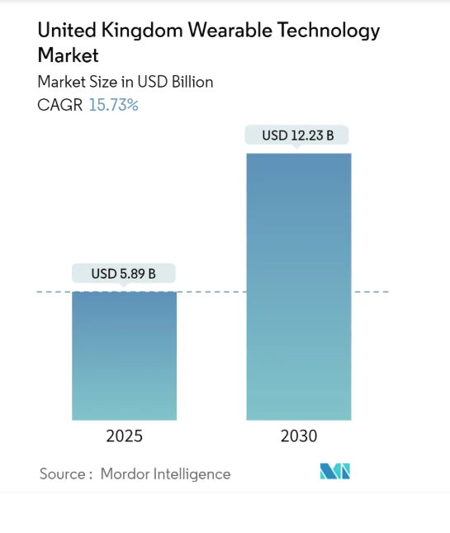
Figure 1UK Wearable Technology Market Growth Projection (2025–2030) (MordorIntel, 2025)
This report discusses stakeholder engagement approaches that are essential in the launch of a new wearable health device, Fitbit UK, in six months. Being the designated project manager, it will be necessary to locate and involve the internal and external stakeholders. Using strategic tools and theoretical concepts, the report is expected to show how effective stakeholder engagement can contribute to project success and business sustainability.

Strategic Analysis of Fitbit UK
Fitbit UK competes in a very competitive and strictly controlled market of wearable health technology. The proposed six-month introduction of a wearable product is in line with the increasing demand for digital health and preventive care in the UK (Leung et al., 2021). But success in projects goes beyond internal capacity and management of the external environment pressure and stakeholder expectations. Thus, SWOT, PESTLE, and SMART objectives are used in this section to achieve a stakeholder-based strategic background to make informed decisions, manage risks and control conflicts.

SWOT Analysis
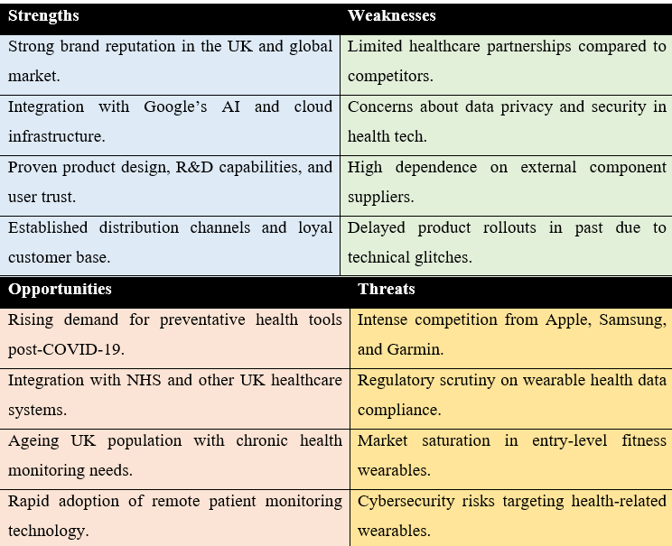
Figure 2 SWOT Analysis of FITBIT (UK) (Leung et al. 2021; Ferreira et al. 2021; Brönneke et al. 2021)
According to the SWOT analysis, the project is supported by strong technological capabilities and brand reputation, and the internal risks involve data privacy issues and reliance on suppliers. Outside, preventative healthcare opportunities are balanced by regulatory scrutiny and intense competition, and stakeholder-based planning is necessary (Lee, 2025).

PESTLE Analysis of Fitbit UK
The six-month wearable health device launch and stakeholder engagement approach of Fitbit UK are assessed using the PESTLE framework (Vilas Belsare, 2025).
Political factors
The UK government is proactive in promoting digital health innovation and remote patient monitoring to ease the burden on the public healthcare services. This opens up partnerships with NHS stakeholders. Nevertheless, the creation of health data governance is politically sensitive and must closely interact with regulators to promote social trust and policy compliance during the project lifecycle (Arora et al., 2021).
Economic factors
Economic unpredictability and cost increases in technology components affect project budgets, pricing, and relationships with suppliers. The internal stakeholders, finance and procurement teams have to balance the cost control with the innovation, and the external partners might pressure the timelines and margins, which involves open communication with the stakeholders (Yue, 2022).
Social factors
The rising popularity of health, wellbeing and preventive care has led to the rise in the demand for wearable health technologies. Consumers and healthcare professionals are high-interest stakeholders due to an ageing population and health awareness post-pandemic. Their demands in terms of usability, accessibility, and ethical data processing should be met to guarantee adoption and the end-lasting involvement (Ferreira et al., 2021).
Technological factors
The emerging rapid artificial intelligence, data analytics, and cloud infrastructure offer Fitbit UK a competitive edge by integrating with Google. Nevertheless, rapid technological evolution puts more pressure on product development teams and suppliers to offer sophisticated functionality in a short period, which poses more issues in coordination and cybersecurity (Khan et al., 2025).
Legal factors
The project will be under stringent legal criteria, such as UK GDPR, medical devices, and MHRA approval. High-power stakeholders such as regulatory bodies should be involved early to prevent delays in compliance, legal fines, or negative publicity that may harm the project (Quigley et al., 2023).
Environmental factors
Corporate responsibility relates to the perception of the stakeholders and environmental sustainability. Consumer, regulatory and investor pressure forces Fitbit UK to involve suppliers in sustainable sourcing, energy efficiency, and e-waste minimisation to ensure environmental appropriateness of the project (Góes et al., 2023).

SMART Objectives
The SMART analysis is employed to evaluate the internal strengths and weaknesses of Fitbit UK as well as external opportunities and threats that refer to the wearable health device project (Ramy, 2017).
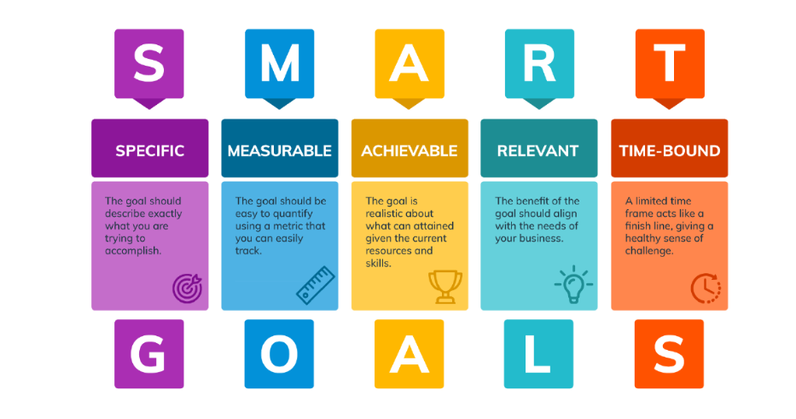
Figure 3SMART Objectives Diagram (Ramy, 2017).
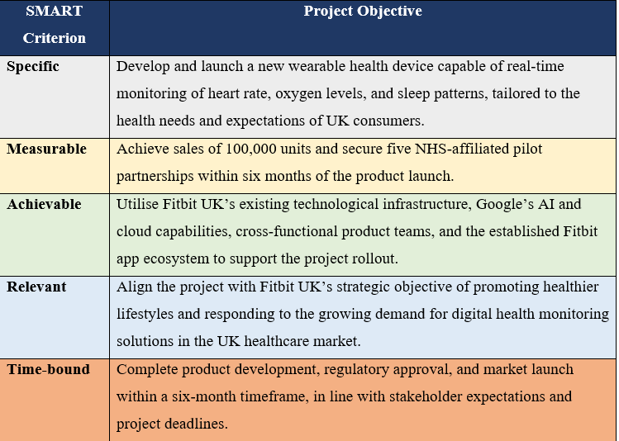
Figure 4SMART Objectives for FITBIT (UK)
SWOT, PESTLE and SMART objectives are used to create a clear strategy by harmonising internal resources, external forces and stakeholder demands to facilitate effective project implementation.

Identification of Stakeholders
One of the most important stages in planning the introduction of a new wearable health device in Fitbit UK is the identification of stakeholders because they directly affect the decisions, schedules and the results of a project. Effective stakeholder identification allows the project manager to balance expectations, assign roles, and develop appropriate engagement plans over the six-month project life cycle. To simplify and manage, the stakeholders are classified as internal and external groups according to their participation and degree of influence in the project (Sanyaolu et al., 2023).

Internal Stakeholders
Internal stakeholders are departments and personalities in Fitbit UK directly engaged in project delivery. The design, testing, and integration of the health-monitoring features are the duties of the product development team, which must be performed with the necessary technical quality and adherence to the standards. Their work has a direct impact on the product preparation and launch schedules (Nazir et al., 2025).
The marketing department assists with pre-launch parts like branding, awareness, and market positioning. Sales staff involves making pricing decisions and working with distribution partners, whereas the finance department controls budgets, costs, and financial risk. All these functions should work in harmony to prevent delays and miscommunication.
The top management or executives are a high-power internal stakeholder group. They offer strategic direction, make key decisions and ensure that the project fits in organisational objectives. Internal stakeholders also include the customer service team, which handles feedback and customer satisfaction after the launch to assist in the long-term improvement and retention (Ferede et al., 2024).

External Stakeholders
External stakeholders are those outside Fitbit UK that are critical to the success of the project. The major stakeholders are consumers because their adoption, feedback, and follow-up directly determine market performance. NHS partners and healthcare professionals make the products more credible and facilitate them in remote health monitoring systems (Maqbool et al., 2022).
Retailers, including Boots and Amazon, are market entrants and distributors. Approving the device and making sure that it meets the UK regulations on health and safety is done by regulatory bodies, especially the MHRA. Suppliers such as cloud technology and hardware providers also determine product quality, cost, and delivery schedules.

Stakeholder Classification.
The Power-Interest Matrix is also used to categorise stakeholders. Close engagement is needed with high-power, high-interest stakeholders, such as executive leadership, MHRA, and NHS partners. High-interest but low-power stakeholders, including internal teams and consumers, need frequent communication and engagement. This classification guides engagement and communication strategies that are in the following section.

Roles, Responsibilities, Benefits, and Challenges of Stakeholders
It is necessary to know the roles, responsibilities, benefits, and challenges of the essential stakeholders to make the project of providing a wearable health device by Fitbit UK effective. Stakeholders offer knowledge, resources, and legitimacy that are helpful in project objectives, in addition to posing risks that should be well addressed by the project manager. This section analyses the role of both external and internal stakeholders and the impact of their involvement on project outcomes.

Internal Stakeholders
Designing, testing and delivering a wearable device that satisfies the user expectations and regulatory requirements are the roles of the product development team. Their technical knowledge promotes innovation and proper health-tracking capabilities, including heart rate and sleep. The main problem that this team deals with is connected to the strict development schedules and the necessity to coordinate the work with the other departments, which can influence the delivery schedules without sufficient care (Brönneke et al., 2021).
The marketing and sales departments are at the heart of branding, market positioning, pricing, and distribution planning. Their participation assists in creating demand and product supply via the physical and online stores. Nevertheless, difficulties can occur when marketing campaigns are not synchronised with the readiness of the products, and it might come with reputational risks or failing to meet customer expectations (Shaffer and Okundaye, 2025).
The finance department is in charge of budgetary allocation, cost management, and financial risk. Their position will see the project stand on its own feet and also ensure efficient use of resources. One of the possible obstacles is a lack of financial flexibility, because high budgets or slow funding approvals can slow down the work on a project or limit innovation (Chukwuma-Eke et al., 2021).
Executive leadership offers strategy, endorses big decisions, and facilitates alignment with organisational goals. They increase the credibility of the project and enable access to resources. Nevertheless, the lack of participation in the day-to-day project processes can lead to a lack of awareness of operational difficulties, which would demand the project manager to be a good communicator (Adepoju et al., 2023).

External Stakeholders
Consumers are vital external stakeholders because product adoption, satisfaction and feedback directly influence market success. Their feedback helps create new products better, but handling the diversity of users and data privacy issues is always a challenge (Latip et al., 2022).
The NHS and other healthcare partners can contribute a lot by providing a higher degree of credibility and facilitating connections with remote health monitoring systems. Nevertheless, project complexity could be heightened by administrative procedures and the existence of rigid data management standards (Issa et al., 2021).
The suppliers and retail partners provide availability of components and market access. Although they help in timely performance, disruptions in the supply chain or contracting difficulties can cause delays (Tsai et al., 2022).
Lastly, regulatory actors, especially the MHRA, play the role of making sure that health and safety standards are adhered to. Their consent is mandatory for the market introduction, but they can influence project schedule changes due to new regulations.

Engagement Frameworks, Models, and Theories
Stakeholder engagement needs well-developed frameworks that will aid the communication process, decision-making, and clarity of roles during the project life cycle. In the case of the Fitbit UK wearable health device launch, the known engagement models are used to determine the influence of stakeholders and assign responsibilities and develop trust among both internal and external stakeholders (Mukhtar and Bahormoz, 2021).

Stakeholder Power Interests Matrix (Mendelow)
The Power-Interest Matrix developed by Mendelow is employed in order to categorise the stakeholders based on the degree of influence and interest in the project (Mendelow, 1991). As indicated in the table, executive leadership, the MHRA, and the NHS partners are classified as high-power and high-interest parties and therefore should be handled with a lot of care by ensuring that they engage in regular interactions and participation in strategic decision-making. The stakeholders who are of high power yet have low interest, like the finance team and key suppliers, should be kept satisfied with specific updates. Highly interested and less powerful stakeholders, such as the consumers and the internal project teams, should be kept informed to ensure engagement and support.
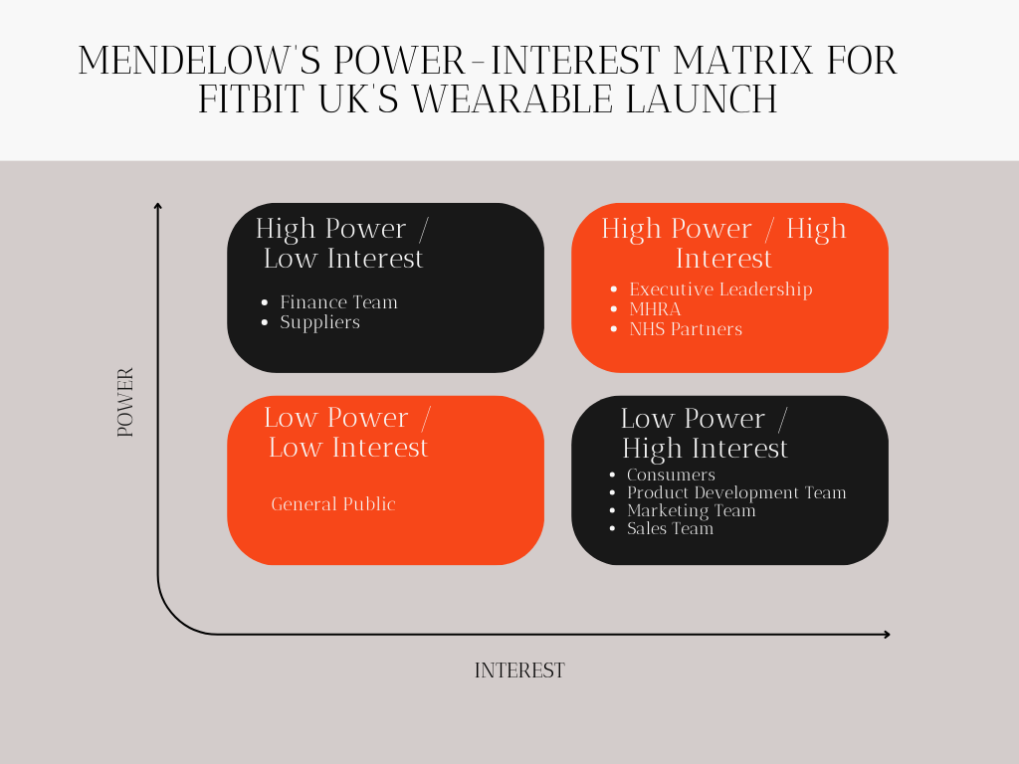
Figure 5Mendelow's Matrix for FITBIT (UK)(Mendelow, 1991)

Stakeholder Engagement Plan.
A stakeholder engagement plan determines the mode and timing of the engagement of various stakeholder groups at the different stages of the project. The stakeholders with high priorities, like the MHRA, are involved earlier in the compliance phase, and the retail partners are involved near the distribution and launch phase. Such a gradual process facilitates making decisions in time and lessening uncertainty (Khin et al., 2021).

Communication Plan
A communication plan defines how, when, and why to communicate with the stakeholders. As an illustration, the executive leadership is provided with the periodic progress and risk reporting, and suppliers are able to know about the technical demands and delivery schedules. Bidirectional communication is also stressed, especially to consumers and healthcare partners who can provide feedback which can inform the design changes and engagement strategies (DeFosset et al., 2023).

RACI Matrix
The RACI matrix defines responsibility and accountability in project activities of the key project activities. It guarantees that the ownership of regulatory compliance, stakeholders' coordination and product delivery is well laid out, eliminating role ambiguity and the chances of delays during the implementation process (McGrath and Whitty, 2018).
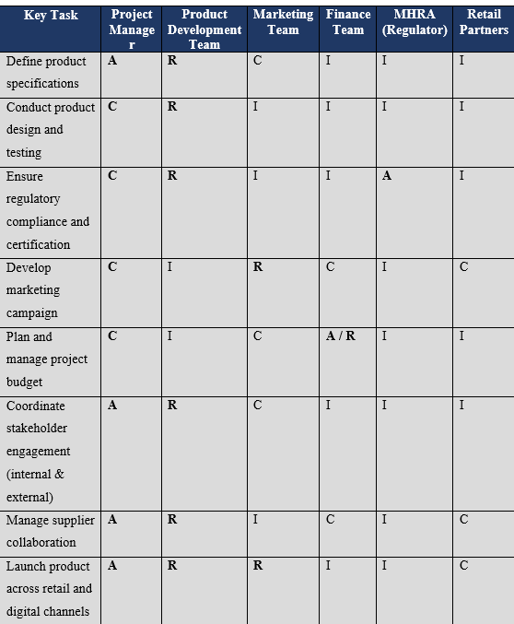
Figure 6RACI Framework

Theoretical Foundations
The use of Stakeholder Theory (Freeman) is the rationale behind prioritising the interests of several stakeholder groups instead of the interests of shareholders when undertaking such a project, especially in the case of healthcare technology. Moreover, the relational lens of Ashcroft facilitates building long-term and trustful stakeholder relations, enhancing ethical involvement and long-term cooperation (Freeman, 2010).

Stakeholder Engagement Process and Conflict Management
To manage expectations, build trust, and successfully deliver complex projects like the six-month launch of Fitbit UK as a wearable health device, effective stakeholder engagement is necessary. Due to the highly sensitive data and regulation of healthcare technology, stakeholder interests do not always align, and sometimes they conflict. The project manager thus needs to develop a formal, participatory, inclusive, and transparent engagement process that takes into account the stakeholder power, interest and expectations across the lifecycle of the project. This part details the stakeholder engagement process used for the project and also assesses conflict management through the 4 Cs model: Communication, Coordination, Cooperation, and Collaboration.

Stakeholder Engagement Process.
The stakeholder engagement cycle starts at the project start and proceeds to development, launch, and post-launch assessment. The initial step is stakeholder mapping via the Power-Interest Matrix (developed by Mendelow) to define the stakeholders who need close attention, including executive leadership, the MHRA, and the NHS partners. Early identification helps the project manager to focus on engagement efforts and resource allocation (Bourne, 2016).
At the planning and development stage, specific stakeholder group engagement plans are developed. Early involvement of regulatory stakeholders, and especially the MHRA, is done to ensure that medical devices and the UK GDPR comply with the requirements. Early involvement in regulations will minimise the chances of high costs and late launches in the project. Meanwhile, internal stakeholders like the product development, finance and marketing teams are involved in routinely coordinating the meetings to harmonise technical progress, budget limits and launch schedules (Quigley et al., 2023).
The level of engagement is high in the testing and pre-launch stage. Pilot testing is done with selected users and healthcare partners to help product development teams develop product usability and clinical relevance. Promotional activities should not precede regulatory approval, as marketing and retail partners are contacted only after the product is ready. Through the RACI matrix, the project manager clarifies roles and accountability and avoids role overlap and decision ambiguity (Raber-Johnson et al., 2021).
The stakeholders are engaged after the market launch with post-launch reviews, customer feedback analysis, and performance reporting to the executive leadership. This continual interaction helps in the constant improvement, builds stakeholder confidence, and helps to inform subsequent product development.

Managing Conflicts: The 4Cs Model.
Projects that involve numerous stakeholders with conflicting priorities are bound to have conflicts. The 4Cs model offers a realistic guide to addressing such conflicts effectively.
Communication
Conflict prevention is mainly based on clear, transparent and timely communication. In the Fitbit UK project, poor communication may create confusion over the regulatory requirements or the launch preparation. Indicatively, the failure to communicate on MHRA feedback in time might lead to marketing campaigns being arranged at an early stage. The project manager addresses this risk by ensuring that he/she report the progress to the executive leadership regularly, carry out compliance reporting with the law to the regulators, and maintain open communication with the consumers and healthcare partners. Open communication minimises the possibilities of uncertainty and instils confidence among stakeholders (Kerzner, 2025).
Coordination
Coordination is aimed at aligning the work, schedule, and dependencies of stakeholder groups. A major coordination risk on this project is a mismatch between product development and marketing schedules. Unless delays in development are properly communicated, marketing campaigns can be run before the product is ready. The project manager is the focal point of coordination, and the tools used to coordinate activities and mitigate supply chain disruption between suppliers and retail partners include shared dashboards and milestone reviews (Moura et al., 2021).
Cooperation
Cooperation is an aspect of the willingness of the stakeholders to collaborate with each other, regardless of their dissimilar interests. Financial constraints can lead to strain, where a finance team can make budget cuts, which can influence product features. By collaboratively working together, the project manager will enable a discussion between finance and product teams to focus on key features and remain financially disciplined. This would not harm project purposes but promote compromise (Sentanu et al., 2021).
Collaboration
Collaboration is the most advanced form of engagement, whereby stakeholders are involved in the decision-making process. The latter is of special concern when it comes to involving NHS partners and healthcare professionals. By increasing product relevance, acceptance, and long-term adoption, collaborative workshops and focus groups enable these stakeholders to make contributions to design decisions and data governance deliberations. Also, teamwork improves trust, which is essential in health IT projects (MacDonald et al., 2022).

Role of the Project Manager
The project manager is at the centre of the implementation of the engagement process and conflict resolution based on the 4Cs model. The responsibilities involve designing and implementing engagement and communication plans, defining accountability based on the RACI matrix, leading cross-functional collaboration, and mediating conflicting stakeholder interests when they clash. The project manager needs to strike a balance between innovation, compliance, cost management, and ethical issues, especially the health data privacy and user trust.

Impact of Stakeholder Engagement on Business Performance and Recommendations
Stakeholder involvement is a challenging aspect in organisational performance, especially in high-stakes and highly regulated projects like the development and release of a wearable health device by Fitbit UK. An efficient engagement will help in ensuring that the stakeholder expectations are proactively handled, risks mitigated, and values are created both operationally and at financial, reputational and strategic levels (Vrečko et al., 2023). This section assesses both tangible and intangible consequences of stakeholder engagement on the business performance of Fitbit UK and provides strategic suggestions to enhance stakeholder relationships.

Effect on Business Performance.
Timely Project Delivery and Operational Performance
Early and ongoing stakeholder involvement helps a lot in improving the efficiency of the operations and also minimising delays. Tight liaison with influential stakeholders like MHRA makes sure regulatory requirements are made clear at an earlier stage so that the product development team can take into account compliance requirements without needless redesigns. This proactive interaction minimises approval channels and helps to ensure the delivery of projects on time. On the inside, formal interactions among the product development, marketing, sales, and finance departments enhance alignment and coordination of schedules. Consequently, promotions will be done according to the product readiness, minimising the chances of late product launch and overruns (Bird et al., 2021).
Quality of products, Innovation, and Usability
Involving consumers, healthcare professionals, and NHS partners in the design and testing stage leads to the direct contribution of product quality and innovation. The feedback during pilot testing, surveys, and usability testing helps Fitbit UK to improve functionality, accuracy of health monitoring features, and overall user experience. Engagement of suppliers and technology partners in co-design discussions also promotes innovation through the use of external knowledge. This cooperative method will decrease the chances of technical problems after the launch and raise the topicality of the product in the healthcare ecosystem (Boateng and Danquah, 2025).
Reduction in Financial Performance and Risk
Stakeholder engagement is a factor that enhances financial performance by eliminating rework, compliance risks and resource optimality. The initial involvement in regulation will reduce the risk of fines, penalties or recall of products, which can be expensive and reputational. Moreover, finance and operations teams work together to make sure that budget restrictions do not jeopardise key product features. Stakeholder engagement fosters cost control and increases the payoff of a project by minimising uncertainty and expanding predictability (Okeke et al., 2024).
Trust, Brand Loyalty and Reputation
Trust is a very important factor of success in the health-technology industry. Open communication with the consumer on the privacy of their data, the safety of such information and the ethical use of such health information increases the credibility of the brand. Association with a reliable health organisation like the NHS also helps to boost the trust of the population towards the device. Such trust will result in high brand loyalty, good user advocacy, and retention of customers in the long term, which will give Fitbit UK a competitive edge over its many competitors (Dowthwaite et al., 2021).
Organisational Relationship Capital and Learning
Learning and building relationships provide long-term organisational benefits, as well as being generated by stakeholder engagement. Cross-functional teamwork enhances internal knowledge exchange and an inclusive organisational culture. On the outside, long-term involvement creates relational capital, in the form of partnerships, networks and trust that can be used on future projects and strategic initiatives. These intangible resources help in resilience and long-term development of organisations.

Future Stakeholder Engagement Strategic Recommendations.
To continue the stakeholder engagement and improve the business performance, Fitbit UK can take into consideration the following strategic options:
1. Install a Centralised Stakeholder Engagement Dashboard.
The introduction of a centralised digital dashboard, which provides real-time information about project milestones, risks, and regulatory status, should be introduced. The tool would promote transparency, better coordination among groups of stakeholders and a faster decision-making process (Adekunle et al., 2024).
2. Institutionalise Continuous Feedback Loops of Stakeholders.
There should also be formal feedback arrangements for the consumers, healthcare partners, and suppliers during and after the launch of the product. Frequent feedback analysis will aid in the continuous improvement and guide the development of future products.
3. Enhance NHS Cooperation at Joint Pilot Programmes.
Fitbit UK ought to increase its partnership with NHS partners in shared pilot studies in order to prove clinical significance and data integration functionality. These would increase product credibility and promote their broader use in the public healthcare systems.
4. Invest in Stakeholder Training and Alignment Sessions.
Frequent workshops and strategy fit sessions among internal teams as well as prominent external stakeholders are necessary to explain the goals, expectations, and address the emergent conflict. Such an investment would enhance collaboration and minimise misalignment in project stages (Twum-Darko et al., 2023).
5. Integrate Moral Stakeholder Interaction Practices.
Fitbit UK needs to institutionalise ethical engagement policies, especially when it comes to data privacy, health equity, and compliance with regulation, among others. Ethical leadership will help build stakeholder confidence and preserve organisational reputation.

Conclusion
The effective implementation of a new wearable health device by Fitbit UK will heavily depend on strategic stakeholder engagement during the project lifecycle. The report has shown that defining internal and external stakeholders, their roles, interests, and power, and implementing effective engagement models are the key to successful project delivery in a highly regulated and data-sensitive healthcare technology context. The RACI model, tools like the Power/Interest Matrix, and the 4Cs framework can be used systematically to assist the project manager in controlling complexity, managing stakeholder expectations, and mitigating uncertainty.

The analysis also points out that initial interaction with powerful stakeholders, especially the executive leadership, the regulatory agencies like the MHRA, and healthcare providers like the NHS, among others, is crucial to ensuring regulatory compliance, timely decision-making, and strategic direction. Simultaneously, regular communication with internal teams and end users can help to coordinate, innovate, and operate with greater efficiency. The use of the 4Cs model also demonstrates how well-organised communication, coordination, cooperation and collaboration may be employed to foresee and address conflicts caused due to competing priorities, resource constraints and regulatory demands.
Stakeholder engagement helps not only enhance project performance, but it also leads to broader organisational gains. These are improved product quality, customer loyalty, brand loyalty, and long-term relational capital. The strategic suggestions outlined in this report, including enhancing the NHS partnership, institutionalising the feedback channels, and integrating the centralised engagement solutions, offer Fitbit UK a feasible guide in maintaining the stakeholder relationship after the project is finalised.
On the whole, stakeholder engagement cannot be regarded as a single-time practice but as a dynamic process that supports the short-term project success and long-term organisational performance. Fitbit UK can reinforce its position in the UK wearable health technology market and enable sustainable innovation by integrating stakeholder-centred practices into its project management strategies.

References
Adekunle, B.I. et al. (2024) ‘Optimising internal control systems through blockchain-based financial reporting: Opportunities and risks’, International Journal of Management and Organisational Research, 3(1), pp. 213–222. doi:10.54660/ijmor.2024.3.1.213-222.
Adepoju, A.H. et al. (2023) ‘Developing strategic roadmaps for data-driven organizations: A model for aligning projects with business goals’, International Journal of Multidisciplinary Research and Growth Evaluation, 4(6), pp. 1128–1140. doi:10.54660/.ijmrge.2023.4.6.1128-1140.
Arora, A. et al. (2021) ‘Innovation pathways in the NHS: An introductory review’, Therapeutic Innovation andamp; Regulatory Science, 55(5), pp. 1045–1058. doi:10.1007/s43441-021-00304-w.
Bird, M. et al. (2021) ‘A generative co-design framework for Healthcare Innovation: Development and application of an end-user engagement framework’, Research Involvement and Engagement, 7(1). doi:10.1186/s40900-021-00252-7.
Boateng, W.K. and Danquah, J.A. (2025) ‘The impact of stakeholder involvement on project delays’, Asian Journal of Economics, Business and Accounting, 25(4), pp. 249–257. doi:10.9734/ajeba/2025/v25i41746.
Bourne, L. (2016) Stakeholder Relationship Management [Preprint]. doi:10.4324/9781315610573.
Brönneke, J.B. et al. (2021) ‘Regulatory, legal, and market aspects of smart wearables for cardiac monitoring’, Sensors, 21(14), p. 4937. doi:10.3390/s21144937.
Chukwuma-Eke, E.C., Ogunsola, O.Y. and Isibor, N.J. (2021) ‘A conceptual framework for financial optimization and Budget Management in large-scale energy projects’, International Journal of Multidisciplinary Research and Growth Evaluation., 2(1), pp. 823–834. doi:10.54660/.ijmrge.2021.2.1.823-834.
DeFosset, A.R. et al. (2023) ‘Building bi-directional referral and communication pathways across the community-clinic divide: Experiences from a systems-informed Innovation Project in Los Angeles’, Healthcare, 11(1), p. 100671. doi:10.1016/j.hjdsi.2022.100671.
Dowthwaite, L. et al. (2021) ‘Public adoption of and trust in the NHS covid-19 contact tracing app in the United Kingdom: Quantitative Online Survey Study’, Journal of Medical Internet Research, 23(9). doi:10.2196/29085.
Ferede, W.L., Endawoke, Y. and Tessema, G. (2024) ‘Change management through strategic leadership: The mediating effect of Knowledge Management in public organizations, Ethiopia’, Future Business Journal, 10(1). doi:10.1186/s43093-024-00363-z.
Ferreira, J.J. et al. (2021) ‘Wearable Technology and consumer interaction: A systematic review and Research Agenda’, Computers in Human Behavior, 118, p. 106710. doi:10.1016/j.chb.2021.106710.
Freeman, R.E. (2010) Strategic management [Preprint]. doi:10.1017/cbo9781139192675.
Góes, H.A. et al. (2023) ‘Managing for stakeholders towards Corporate Environmental Sustainability’, Corporate Social Responsibility and Environmental Management, 30(4), pp. 1561–1572. doi:10.1002/csr.2448.
Issa, H., Townsend, W. and Harris, M. (2021) ‘Benefiting the NHS through innovation: How to ensure International Health Partnerships are genuinely reciprocal’, BMJ Global Health, 6(Suppl 6). doi:10.1136/bmjgh-2021-004936.
Kerzner, H. (2025) Project Management: A systems approach to planning, scheduling, and controlling. Hoboken, NJ: John Wiley and Sons, Inc.
Khan, N. et al. (2025) ‘A review of AI-based health prediction using Apple Watch and Fitbit Data’, Discover Applied Sciences, 7(10). doi:10.1007/s42452-025-07783-8.
Khin, N.A. et al. (2021) ‘Tackling challenging data integrity topics in 2020: Update on good clinical practice perspectives from the US FDA and MHRA UK’, Clinical Pharmacology andamp; Therapeutics, 112(1), pp. 31–43. doi:10.1002/cpt.2386.
Kohl, U. (2023) ‘Fitbit Health Data, Apple’s geodata and google searches: Cross-border law enforcement and the territoriality principle’, Transformations in Criminal Jurisdiction, pp. 191–218. doi:10.5040/9781509954254.ch-008.
Latip, M. et al. (2022) ‘The impact of external stakeholders’ pressures on the intention to adopt environmental management practices and the moderating effects of firm size’, Journal of Small Business Strategy, 32(3). doi:10.53703/001c.35342.
Lee, S.B. (2025) Transforming healthcare through negotiation [Preprint]. doi:10.4324/9781003336013.
Leung, W. et al. (2021) ‘A meta-analysis of Fitbit Devices: Same Company, different models, different validity evidence’, Journal of Medical Engineering andamp; Technology, 46(2), pp. 102–115. doi:10.1080/03091902.2021.2006350.
MacDonald, A., Clarke, A. and Huang, L. (2022) ‘Multi-stakeholder partnerships for sustainability: Designing decision-making processes for partnership capacity’, Business and the Ethical Implications of Technology, pp. 103–120. doi:10.1007/978-3-031-18794-0_7.
Maqbool, R., Rashid, Y. and Ashfaq, S. (2022) ‘Renewable energy project SUCCESS: Internal versus external stakeholders’ satisfaction and influences of power‐interest matrix’, Sustainable Development, 30(6), pp. 1542–1561. doi:10.1002/sd.2327.
McGrath, S.K. and Whitty, S.J. (2018) ‘Accountability and responsibility defined’, International Journal of Managing Projects in Business, 11(3), pp. 687–707. doi:10.1108/ijmpb-06-2017-0058.
Mendelow, A.L. (1991) Environmental scanning--the impact of the stakeholder concept, AIS Electronic Library (AISeL). Available at: https://aisel.aisnet.org/icis1981/20/ (Accessed: 11 December 2025).
MordorIntel (2025) UK wearable technology market - size,Share and Industry Analysis, Mordor Intelligence. Available at: https://www.mordorintelligence.com/industry-reports/united-kingdom-wearable-technology-market (Accessed: 11 December 2025).
Moura, R.L., Carneiro, T.C. and Dias, T.L. (2021) ‘Effects of standardization-based coordination mechanisms in Project Performance’, Gestão andamp; Produção, 28(3). doi:10.1590/1806-9649-2021v28e5257.
Mukhtar, S.-M. and Bahormoz, A. (2021) ‘An integrative framework for stakeholder engagement: Reconciling and integrating stakeholders’ conflicting CSR priorities in management decision-making’, Journal of Decision Systems, 31(4), pp. 407–432. doi:10.1080/12460125.2021.1950115.
Nazir, Abubakar et al. (2025) ‘Wearable Technology and its potential role in Cardiovascular Health Monitoring and disease management’, Health Science Reports, 8(11). doi:10.1002/hsr2.71486.
Okeke, N.I., Bakare, O.A. and Achumie, G.O. (2024) ‘Forecasting financial stability in smes: A comprehensive analysis of strategic budgeting and Revenue Management’, Open Access Research Journal of Multidisciplinary Studies, 8(1), pp. 139–149. doi:10.53022/oarjms.2024.8.1.0055.
Quigley, M. et al. (2023) ‘The shape of medical devices regulation in the United Kingdom? Brexit and beyond’, Law, Technology and Humans, 5(2), pp. 21–42. doi:10.5204/lthj.3102.
Quigley, M. et al. (2023) ‘The shape of medical devices regulation in the United Kingdom? Brexit and beyond’, Law, Technology and Humans, 5(2), pp. 21–42. doi:10.5204/lthj.3102.
Raber-Johnson, M.L. et al. (2021) ‘Key steps toward a promotional communications strategy: Collaboration best practices for teams creating promotional materials and regulatory colleagues’, Therapeutic Innovation andamp; Regulatory Science, 55(4), pp. 696–704. doi:10.1007/s43441-021-00272-1.
Ramy, A. (2017) (PDF) smart objectives: A strategic approach to achieving business success. Available at: https://www.researchgate.net/publication/387976768_SMART_Objectives_A_Strategic_Approach_to_Achieving_Business_Success (Accessed: 11 December 2025).
Sanyaolu, T.O. et al. (2023) ‘Stakeholder management in IT development projects: Balancing Expectations and Deliverables’, International Journal of Management andamp; Entrepreneurship Research, 5(12), pp. 1239–1255. doi:10.51594/ijmer.v5i12.1535.
Sentanu, I.G. et al. (2021) ‘Stakeholder collaboration model for ecotourism development in Indonesia: Case study from Batu City East Java province’, Journal of Government and Civil Society, 5(2), p. 214. doi:10.31000/jgcs.v5i2.4420.
Shaffer, M. and Okundaye, I.O. (2025) ‘Marketing, sales, and Distribution’, Innovation in Nephrology, pp. 381–397. doi:10.1016/b978-0-323-95680-2.00035-1.
Tsai, P.-H., Tang, J.-W. and Chen, C.-J. (2022) ‘Partnerships that go places: How to successfully market products from vendor partners at retail stores from the vendors’ perspective’, Journal of Retailing and Consumer Services, 64, p. 102806. doi:10.1016/j.jretconser.2021.102806.
Twum-Darko, M., Ncede, N. and Tengeh, R. (2023) ‘Stakeholder engagement: A service delivery-based strategy formulation process in the public sector of South Africa’, International Journal of Research in Business and Social Science (2147- 4478), 12(3), pp. 109–121. doi:10.20525/ijrbs.v12i3.2361.
Vilas Belsare, H. (2025) ‘Pestle analysis’, International Journal of Advanced Research, 13(02), pp. 608–612. doi:10.21474/ijar01/20411.
Vrečko, I., Tominc, P. and Širec, K. (2023) ‘Enhancing the performance of high-growth small- and medium-sized enterprises through effective project-management processes and stakeholder engagement: A systems perspective’, Systems, 11(10), p. 511. doi:10.3390/systems11100511.
Yue, O. (2022) ‘Conceptual model for effects of the buyer supplier relationship, purchasing process, and measures of performance in supply chains’, Journal of Enterprise and Business Intelligence, pp. 142–152. doi:10.53759/5181/jebi202202015.

