Cerys Bishop

Student number: 2418645
Module code: ECEY4001

I have not used AI.

Components:
- Component one: Infograph
- Component two: The concept of holistic child development
- Component three: Maslow’s significance in understanding child development

Word count for component one: 904
Word count for component two: 937
Word count for component 3: 877
Overall word count: 2718
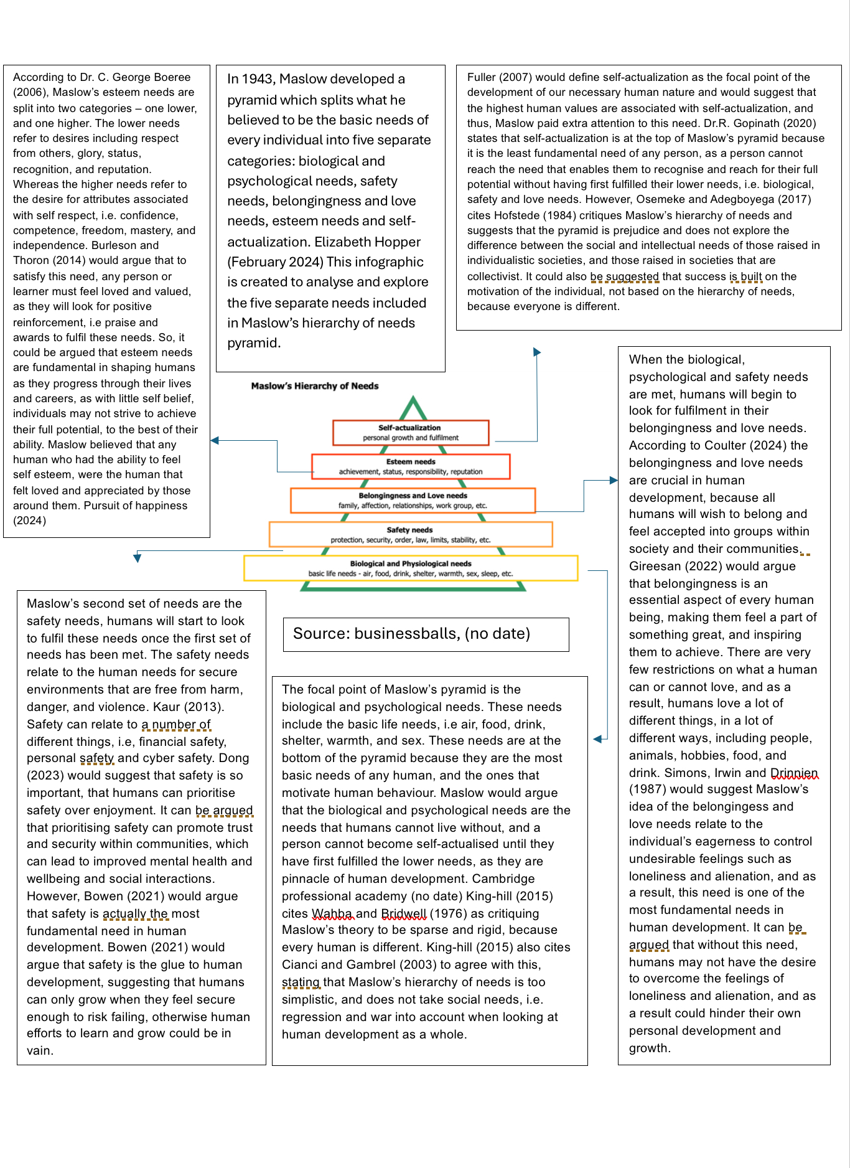
Reference list

Boeree, Dr. C (2006) ABRAHAM MASLOW [ 1908 – 1970] personality theories available at: http://capacity-resource.middletownautism.com/wp-content/uploads/sites/6/2017/03/abraham-maslow.pdf [accessed on: 25.11.2024]

Bowen, B. (2021) the matrix of needs: reframing Maslow’s hierarchy available at: https://www.scirp.org/journal/paperinformation?paperid=109226 [accessed on: 26.11.2024]

Burleson, S. E and Thoron, A. C (2014) Maslow’s Hierarchy of Needs and Its Relation to Learning and Achievement available at: https://journals.flvc.org/edis/article/download/131587/135186/236583 [accessed on: 25.11.2024]

Businessballs (no date) Motivational Model: Maslow’s Hierarchy of needs available at:
https://www.businessballs.com/improving-workplace-performance/motivational-model-maslows-hierarchy-of-needs/ [accessed on: 23.11.2024]

Cambridge professional academy (no date) marketing theories - Maslow’s Hierarchy of Needs available at: https://www.professionalacademy.com/blogs/marketing-theories-maslows-hierarchy-of-needs/ [accessed on: 26.11.2024]

Coulton, J. (2024) the power of belonging available at: https://journals.lww.com/professionalcasemanagementjournal/citation/2024/11000/the_power_of_belonging.7.aspx?context=latestarticles [accessed on: 26.11.2024]

Dong, P. (2023) is safety more of a priority than fun? Available at: https://www.scholarlyreview.org/api/v1/articles/121767-is-safety-more-of-a-priority-than-fun.pdf [accessed on 26.11.2024]

Fuller, A.R (2007) psychology and religion : classical theorists and contemporary developments available at: https://books.google.co.uk/books?hl=en&lr=&id=900CEQAAQBAJ&oi=fnd&pg=PA127&dq=abraham+maslow+self+actualization&ots=d6tHhqaPgF&sig=XpEH7taD4_k1-BZ3kJXasjakx1E&redir_esc=y#v=onepage&q&f=false [accessed on 24.11.2024]

Gireesan, A. (2022). Evolution of Belongingness: Its Past, Present, and Future available at: https://link.springer.com/chapter/10.1007/978-981-16-8263-6_5 [accessed on: 26.11.2024]

Gopinath, Dr. R (2020) prominence of self-actualization in Organisation available at : https://www.researchgate.net/profile/Dr-Gopinath-R/publication/343375897_Prominence_of_Self-Actualization_in_Organization/links/5f25b506299bf134049a336d/Prominence-of-Self-Actualization-in-Organization.pdf [accessed on 24.11.2024]

Hopper, E (February 2020) Maslow’s Hierarchy of Needs Explained available at: https://www.christianworldmedia.com/client/docs/603_1585079540_17.pdf [accessed on: 24.11.2024]

Kaur, A. (2013) Maslow’s need hierarchy theory: applications and criticisms available at: https://d1wqtxts1xzle7.cloudfront.net/56316711/Maslows_Hierarchy.docx2-libre.pdf?1523706445=&response-content-disposition=inline%3B+filename%3DMaslows_Need_Hierarchy_Theory_Applicatio.pdf&Expires=1732656628&Signature=ZiFNGMMXo~f1VXbSgcweQ9R5YoKFHZr~RDmIsD1ieHPGiO4q2GQlINBvxFiK8LpHWSpYHODtWpbXkggZb5P39enNZPhXchGCC3oCw0KEbpapzWQLPMDq0sDGFmIKqfoqga3r65jX3mLcIDPCSauiZaxvOjJNnkZrbvxTEvMWf8urvyJ1WsjtEcseiBZAG~mlTdf3cPOavDAzxJMkszmJXX4656ki-c9GgJwCkQQLEsVMmNy1u3WM8NPlm9WBmcb4xcmK-yGpFPC42ZDjonCDiJ8XAaqypjaph6UB4pWQm3l-DUMtcv9UDTem62IGo5YfmsvxoTb6pVYFEhnjFf9diA__&Key-Pair-Id=APKAJLOHF5GGSLRBV4ZA [accessed on: 26.11.2024]

King-Hill, S. (2015) Critical analysis of Maslow’s hierarchy of needs. Available at https://insight.cumbria.ac.uk/id/eprint/2942/1/KingHill_CriticalAnalysisOfMaslows.pdf [accessed on: 26.11.2024]

Monday Osmeke, PHD and Samuel Adegboyega (2017) Critical Review and Comparism between Maslow, Herzberg and McClelland's Theory of Needs. Available at:https://fujabf.org/wp-content/uploads/2018/01/Critical-Review-and-Comparism-between-Maslow-Herzberg-and-McClellands-Theory-of-Needs.pdf [accessed on 24.11.2024]

Janet A. Simons, Donald B. Irwin and Beverly A. Drinnien (1987) Maslow’s hierarchy of needs available at: https://www.andrews.edu/~ggifford/Copy%20of%20EDAL520SU05/Need%20Hierarchy%20Theory.doc [accessed on 26.11.2024]

The concept of holistic child development.
Queen Margaret University (2023) would define holistic childhood development as the concept of looking at the child as a whole and emphasises that the interconnectedness of several aspects of a child’s growth, i.e, the biological, cognitive, and social development of the child plays a crucial part in the child’s development.
The aim of this essay is to analyse and explore multiple concepts associated within the holistic development of a child in detail. According to the Collins dictionary (no date), the word concept originates from the Latin word ‘conceptus’ and is a principle or idea. Some concepts of holistic development include safety, relationships, and play.
When exploring the concept of holistic child development, practitioners must consider the concept of safety within the early years. Practitioners have a duty to ensure the child feels safe and happy within their care. Safeguarding is everyone’s responsibility and is the right of every child to be protected from harm NSPCC (2024). The Office for National Statistics (2024) would argue that children are most vulnerable during their early years. Children are dependant on adults to recognise the signs and act when something does not seem right and there should be proper measures put into place in early years settings to support this, examples of this may include having a safeguarding lead at the setting, and numerous posters around the setting with referral numbers and information on different type of abuse, ensuring practitioners know how and where to make a referral, should they feel the need to do so. NSPCC learning (2024) states that practitioners must have the knowledge and skills expected of a competent safeguarding professional as safeguarding is one of the most serious and important matters involved in the early years sector. Practitioners can attend regular safeguarding training to continuously broaden their knowledge and understanding of what safeguarding is, and how best to safeguard the children in their care.
Relationships are also a crucial aspect of a child’s holistic development. It is suggested that the most crucial relationship during a child’s early years, is the relationship between the child and their parents. Bronfenbenner (1991) created an ecological systems theory, in which he discussed how the quality and context of a child’s environment contributes to their holistic development. In this theory, Bronfenbenner (1991) proposed that “every child needs at least one adult who is irrationally crazy about him or her” to develop holistically, supporting the theory that the most important relationship during the early years, is the one between the child and their parents Brendtro (2006). According to UNICEF (no date) a positive relationship between a child and their parents can prompt children to become happy adults who are resilient, independent and can take criticism and setbacks and overcome challenges, which further supports the idea of this relationship being the most crucial during a child’s development. Bowlby (1997) supports this and argued that children can form positive attachments with multiple adults, but the relationship between a child and their parents is more important than any other positive attachment within the early years of their holistic development. Bowlby (1997) argues that any potential disturbance or hinderance to the formation of positive attachments can have a negative impact on the child’s development, potentially putting a strain on the child’s psychological and emotional development NSPCC (2021). It is also important that the child creates a strong bond with their key worker. The Early Years Foundation Stage Statutory Framework would state that every child must be assigned a key person, this is someone who will ensure the child’s rights are being met, their learning and care is being tailored to their individual needs, they will help the child with the transition into the early years setting, and will develop developmental plans that best support the child Aston University (2022). The Department for Education (2022) states that key worker is responsible for providing a strong and special relationship with the child and their families. This includes determining the child’s likes, dislikes and interests and using them to support the child, i.e if the child is struggling to settle, a practitioner may use their likes to set up provocations that interest the child and can help make the transition period a little bit easier for them.
Practitioners should also consider play as one of the key concepts of a child’s holistic development as most of what children learn through play cannot be taught. Vygotsky (1987) would argue that imaginative play encourages the development of abstract thinking and self-regulation Smolucha and Smolucha (2021). The Victorian Government (2023) states that self regulation is an important part of the child’s development because it enables them to become more independent, understand what is happening around them, and how to manage their interactions, behaviours, and reactions. The National Library of Medicine (2017) would support this, referring to self regulation as “an early life marker for later life successes”. This suggests that if humans can independently self regulate during their childhood, they will benefit from this in later life and will become independent and understanding as they grow into adulthood. UNICEF (no date) would also support the idea of play being a vital part of a child’s development, stating that “children who play regularly with their parents are less likely to develop anxiety, depression and sleep problems.” UNICEF (no date) also states that play helps children to learn about the world around them and allows them to develop their confidence. This suggests that there are several benefits to play, and play contributes to the child’s holistic development in several ways, including emotionally, socially, and intellectually.

Reference list
Aston University (2022) key person policy available at https://www.aston.ac.uk/sites/default/files/Key%20Person%20Policy.pdf [accessed on: 28.11.2024]

Brendtro, L. K. (2006) The vision of Urie Bronfenbrenner: Adults who are crazy about kids." Reclaiming children and youth available at: https://www.researchgate.net/profile/Larry-Brendtro/publication/234721190_The_Vision_of_Urie_Bronfenbrenner_Adults_Who_Are_Crazy_about_Kids/links/5e20b793299bf1e1fab7f40e/The-Vision-of-Urie-Bronfenbrenner-Adults-Who-Are-Crazy-about-Kids.pdf [accessed on: 29.11.2024]

Collins Dictionary (no date) ‘definition of concept’ available at: https://www.collinsdictionary.com/dictionary/english/concept [accessed on: 30.11.2024]

Department for Education (2022) Relationships. Building solid relationships helps children to develop trust and to thrive in your setting. Available at: https://help-for-early-years-providers.education.gov.uk/personal-social-and-emotional-development/relationships [accessed on: 29.11.2024]

National Library of Medicine (2017) the development of self regulation across Early Childhood. Available at: https://pmc.ncbi.nlm.nih.gov/articles/PMC5123795/ [accessed on: 30.11.2024]

NSPCC (2024) safeguarding and child protection available at: https://learning.nspcc.org.uk/safeguarding-child-protection [accessed on 28.11.2024]

NSPCC learning (2021) Attachment and child development available at: https://learning.nspcc.org.uk/child-health-development/attachment-early-years [accessed on: 29.11.2024]

Office for National Statistics (2024) Homicide in England and Wales year ending: March 2023 available at: https://www.ons.gov.uk/peoplepopulationandcommunity/crimeandjustice/articles/homicideinenglandandwales/yearendingmarch2023#variations-in-homicide-victimisation-by-personal-characteristics [accessed 28.11.2024]

Queen Margaret University (2023) nurturing holistic development in early childhood available at: https://online.qmu.ac.uk/blogs/nurturing-holistic-development-in-early-childhood/ [accessed on:28.11.2024]

Smolucha, L and Smolucha, F (2021) Vygotsky’s theory in-play: early childhood education. Available at: https://www.tandfonline.com/doi/full/10.1080/03004430.2020.1843451#:~:text=Extensive%20research%20in%20neurology%2C%20psychology,abstract%20thinking%20and%20self%2Dregulation. [accessed on: 30.11.2024]

UNICEF (no date) how play strengthens your child’s mental health available at: https://www.unicef.org/parenting/child-development/how-play-strengthens-your-childs-mental-health#:~:text=Play%20helps%20to%20strengthen%20the%20bond%20between%20you%20and%20your%20child&text=By%20providing%20your%20child%20with,health%20and%20future%20well%2Dbeing. [accessed on: 30.11.2024]

UNICEF (no date) what you need to know about parent-child attachment. Available at: https://www.unicef.org/parenting/child-care/what-you-need-know-about-parent-child-attachment#:~:text=A%20positive%20early%20bond%20lays,challenges%20and%20recover%20from%20setbacks. [accessed on: 29.11.2024]

Victorian Government (2023) how to help children self regulate. Available at: https://www.schools.vic.gov.au/includedoshc/safe-environments/how-help-children-self-regulate [accessed on: 30.11.2024]

Maslow’s significance in understanding child development.
The aim of this essay is to analyse the significance of Maslow’s hierarchy of needs in understanding child development while looking at three examples of early years practice. Maslow’s hierarchy of needs is both extremely popular, and heavily criticised. Trivedi (2019) would argue that some of the main criticisms of Maslow’s hierarchy of needs include that every individual is different so the pyramid of needs may not be suitable for everyone’s specific needs, Maslow’s writings are more philosophical than scientific, and these needs are oversimplified.
Practitioners are responsible for being vigilant and recognising the needs of each child. An example of this could include the basic need of a child needing a nappy change. Care Inspectorate Wales (2023) states that early year's settings must have appropriate nappy changing facilities, i.e a clean, safe, and appropriate environment that encourages privacy and dignity. It is vital that practitioners use best practice and change nappies often and efficiently because if a child’s nappy is left unchanged for a while the child could suffer from nappy rash, ulcers, and pain and discomfort NHS (2024). Careers Wales (no date) would suggest that successful practitioners are those who are compassionate, patient, respectful to the rights of each person, and those who treat each person as equal regardless of any difference in physical and emotional needs. So, if a child is left in a nappy that is soiled or wet, the practitioner is not using best practice within their job role and as a result, are also breaking one of the general principles of the UNCRC. Article number 3 is ‘the best interest of the child’ and being in a dirty, wet nappy that causes pain and discomfort, is not in the best interest of the child UNICEF (no date). This basic life need would place at the bottom of Maslow’s pyramid and would fall into the biological and psychological category as this is a basic need of any child. Maslow argued that any person who’s biological and psychological needs are not being met cannot be expected to become adults who achieve a great level of higher thinking Willingham (2023). Thus, children who’s most basic needs were not met during childhood, will reap the repercussions of this in later life.
A safe and stable environment is a key element of a child’s development. Maslow would place the environment in category two, the safety needs. Hanscom (2024) would suggest that every being has the desire to feel safe within their environment, and environments that feel unsafe, chaotic, and dangerous prompt an uneasy upbringing of children. Harvard University may disagree and argue that safety should be considered as one of the most fundamental needs, because exposures to certain environments can affect their development, health, and well-being. Early years practitioners can create a safe and stable environment by carrying out regular risk assessments to ensure the setting is at the best standard and free from any potentials risks that could harm the children. The steering leaders and owners have a legal duty to keep the environment safe and this must be done in line with the health and safety act 1974, Jackson (2023). Schoolhouse day care (no date) would argue that feeling safe is crucial in the child’s development because they learn best when they do not feel any fear, this is because they will feel able to be fully engaged with the activities and experiences available to them. When children feel safe and secure in their environment, they will feel prepared to take risks and sometimes fail, without the fear of what any potential consequence could be.
Promoting independence in a child’s early years is important for them to grow up into confident and indecent adults. Independence falls at the top of Maslow’s hierarchy of needs pyramid, in the self-acutalization category. Maslow placed this at the top of his pyramid because he believed a person could not reach this without having first successfully meeting the goals of the other categories of the pyramids. Practitioners can promote independence by encouraging children to prepare their own snack, pour their own drinks, dressing themselves, washing their hands, and making decisions, Kids play (no date). Making decision and choices is also a great way to promote independence in a child’s early years because it encourages children to think critically, voice their opinions and could open their eyes to bad decision making. The Pennsylvania state university (no date) would argue that giving children choices enables them to feel as though they have some control over what they do and could prevent children from becoming angry because they cannot choose for themselves.
To conclude, Maslow’s hierarchy of needs is significant to the early years practice because it enables practitioners to understand the needs of children and how best to support them. However, every child is different, so it is impossible to place each child into a category that depends on the criteria they are yet to meet, or the criteria they have already met. All children develop at their own pace so may not fulfil the needs in each category as fast as others and we should also take in to account any contributing factors in the child’s life, i.e the environment they are raised in.

Reference list
Care inspectorate Wales (2023) Nappy Changing for early learning and childcare settings (excluding childminders) available at: https://www.careinspectorate.com/images/documents/Nappy_changing_guidance_2023.pdf [accessed on: 30.11.24]

Careers Wales (no date) Skills and Qualities. Available at: https://careerswales.gov.wales/job-information/care-assistant-children/skills-and-qualities [accessed on: 30.11.2024]

Hanscom, D. (2024) Our need to feel safe. Available at: https://www.psychologytoday.com/gb/blog/anxiety-another-name-for-pain/202404/our-need-to-feel-safe [accessed on: 30.11.2024]

Harvard university (2023) place matters: the environment we create shapes the foundations of healthy development available at: https://developingchild.harvard.edu/place-matters-the-environment-we-create-shapes-the-foundations-of-healthy-development/ [accessed on: 30.11.2024]

Jackson, L. (2023) Health and Safety in early years: is your nursery compliant? Available at: https://blossomeducational.com/blog/eyfs-health-and-safety-is-your-nursery-setting-compliant/ [accessed on: 30.11.2024]

Kids play (no date) Supporting children’s independence. Available at: https://www.kidsplaychildcare.co.uk/nurseries/2020/12/09/children-independence/ [accessed on: 30.11.2024]

NHS (2024) How to change your baby’s nappy available at: https://www.nhs.uk/conditions/baby/caring-for-a-newborn/how-to-change-your-babys-nappy/#:~:text=Babies%20need%20frequent%20nappy%20changes,will%20help%20prevent%20nappy%20rash. [accessed on: 30.11.2024]

Pennsylvania state university (no date) giving children choices. Available at: https://extension.psu.edu/programs/betterkidcare/early-care/tip-pages/all/giving-children-choices [accessed on: 30.11.2024]

Schoolhouse day care (no date) why it is important for a child to feel safe? Available at: https://schoolhouse-daycare.co.uk/blog/why-is-it-important-to-make-a-child-feel-safe/#:~:text=Feeling%20safe%20and%20valued%20is,and%20the%20embrace%20of%20challenges. [accessed on: 30.11.2024]

Trivedi, A. (2019) Maslow’s Hierarchy of Needs - Theory of Human Motivation available at: https://www.raijmr.com/ijrsml/wp-content/uploads/2020/01/IJRSML_2019_vol07_issue_06_Eng_09.pdf [accessed on: 30.11.2024]

UNICEF (no date) how we protect children’s rights. Available at: https://www.unicef.org.uk/what-we-do/un-convention-child-rights/ [accessed on: 30.11.2024]

