University Of Wales Trinity Saint David

Motorsport Engineering

ACHA5010

Alternate Vehicle Propulsion

Kinetic Energy Recovery

2219871

William Hare

Introduction
In the relentless pursuit of sustainable and efficient automotive technologies, the integration of Kinetic Energy Recovery Systems (KERS) has emerged as a pivotal strategy to enhance fuel economy and reduce environmental impact (Prototype Powertrain in Motorsport Endurance Racing: An SAE Technical Paper ... - Google Books, n.d.). This was first seen in Formula 1 in 2009 and was used as a driver aid to help with overtaking and defending (Yadav, n.d.) This report delves into the impressive automotive innovation, specifically investigating the effects of introducing a KERS system in the iconic Mazda RX-7 FD. Focused within the rigorous framework of the Worldwide Harmonized Light Vehicles Test Procedure (WLTP), our study aims to dissect the intricate relationship between the revolutionary KERS technology and the traditional high-performance characteristics of the Mazda RX-7 FD.




Ingram, A. (2023). Mazda RX7

The vehicle chosen for this analysis is the Mazda FDRX7. This vehicle has mainly been chosen due to its twin rotary engine however the RX7 also boasts a near 50/50 weight distribution which is one of many factors of its impressive ability and record as a track car. The rotary engine of the RX7 produces an impressive 255HP stock (Specifications for Mazda RX-7 1.3 Manual, 256hp, 1994, n.d.). However, the rotary engine isn’t known for being the most efficient engine. It is precisely this reason for the choice to explore the effects of a KERS system on the RX7.

Dynamic Characteristics
Dynamic characteristics of a vehicle refer to the aspects that define its motion, handling, and overall performance while in motion. These elements encompass a wide range of factors, including the responsiveness of the engine, the distribution of weight, the efficiency of the braking system, and the aerodynamics of the vehicle. This report will look at the following:
- Test Mass.
- Frontal area.
- Rolling resistance coefficient.
- Aerodynamic drag coefficient.
The test mass is the unladen vehicle mass plus mass of vehicle options (WLTP-DTP-08-04e.Ppt, n.d.). In the automotive industry, the test mass is often standardized to ensure consistency in testing procedures and comparisons between different vehicles.
The vehicle frontal area is the total area of the front-facing surface of a vehicle as seen from the front. It is an important parameter in aerodynamics and fuel efficiency calculations and is typically measured in square meters or square feet (Xu & Gao, 2022).
Rolling resistance is often defined as the force needed to keep a free-rolling tire at a constant speed, to assure force equilibrium (Hall & Moreland, 2001). It quantifies the force resisting the tire's motion and is influenced by various factors, including the tire construction, tread design, tire pressure, and the characteristics of the road surface.
Finally, the drag coefficient is a measure of how efficiently an object moves through the air, and it depends on the object's shape, size, and the smoothness of its surfaces. It is an important factor in assessing the overall aerodynamic efficiency of a vehicle or object and having a lower drag coefficient indicates better aerodynamic performance. The exact values used can be found in the appendices below.

Test Procedure
The RX7 has been placed in the 3b class. This is due to it being a road vehicle and it having a power of 188kW and a curb weight of 1300kg it puts it in class 3b (Mazda RX 7 FD Twin Turbo Specs, Dimensions, n.d). The Worldwide Harmonized Light Vehicles Test Procedure (WLTP) 3b is a sophisticated testing protocol designed to evaluate the fuel consumption, emissions, and overall energy efficiency of vehicles in a more realistic and diverse manner compared to its predecessor, the New European Driving Cycle (NEDC). Comprising various driving scenarios, the WLTP 3b is structured into distinct speed zones to comprehensively mimic real-world conditions. This includes the Low Speed Zone, replicating urban settings with frequent stops and starts; the Medium Speed Zone, simulating suburban environments with moderate speeds and acceleration patterns; the High Speed Zone, representing highway or motorway driving with sustained higher speeds; and the Extra High Speed Zone which covers anything above (Demuynck et al., 2012). Each speed zone is meticulously crafted to reflect the dynamic nature of contemporary driving experiences, providing a more accurate and nuanced assessment of a vehicle's performance across different speed ranges.

Data
In order to find where the breaking energy can be saved, the resistive forces acting on the vehicle need to be realised. These forces include:
Acceleration (m/s²) * Mass (kg) Rolling resistance coefficient * Weight (N) ½ * Drag coefficient * Density (kg/m³) * Velocity² (m/s)
- Acceleration forces.
- Rolling resistance force.
- Drag resistance force.
- Total of combined forces.
The equations used to find the values of the forces. These values were then used to create the graphs shown below.
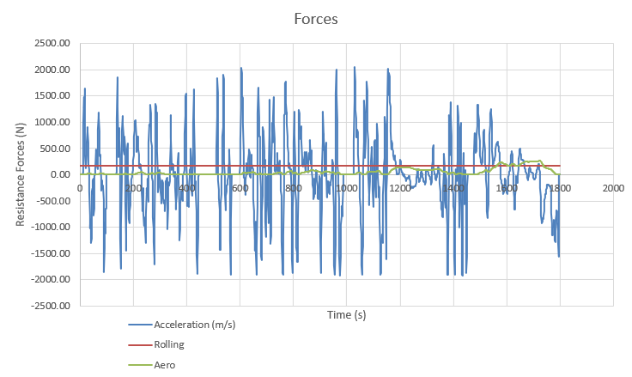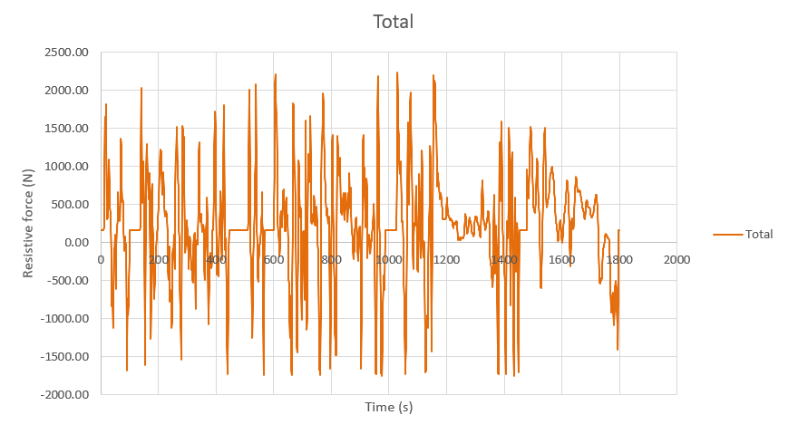
The graph above shows the individual values of the resistive forces against the time in seconds. These forces include the acceleration, rolling and aero drag forces. The acceleration and deceleration have different signs because they represent changes in velocity in opposite directions. When an object is speeding up or increasing its velocity in a certain direction, the acceleration is considered positive. Deceleration is sometimes referred to as "negative acceleration," and occurs when an object is slowing down or decreasing its velocity. In this case, the acceleration is considered negative.
The rolling resistance force shown in the graph is a constant. This is because of the tyre compound and the road surface material and condition remain the same. In the context of a time graph, this means that the rolling resistive force experienced by the vehicle does not change throughout the observed period. Therefore, it is assumed the tyre pressure, and all conditions listed above remain the same throughout the duration of the test.
The aero drag resistance also remains relatively unchanged through the duration of the test. As seen in the graph above, there are spikes in the positive side which show a larger resistive force. The larger force is because of an increase in velocity of the velocity which can be seen on the velocity graph below. If the vehicle's speed is not constant and experiences minor fluctuations, these speed changes can influence aerodynamic drag. Small accelerations or decelerations can result in brief increases in drag resistance.
In addition to this, the orange graph shows the total resistance of the combined three forces. It shows no direct correlation and experiences negative values because of the forces acting on the vehicle from different directions.
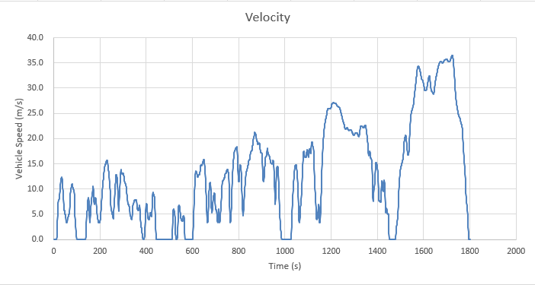
The graph above shows the variations of the velocity of the vehicle over the 1800 seconds it was recorded for. The resulting graph reveals no discernible correlation between these two variables. Despite variations in time, the vehicle velocity data appears scattered with no clear trend. Several factors may contribute to this lack of correlation, including external variables such as wind conditions or road surface variations. The points on the line graph where the velocity is zero at 589s, 1022s, 1466s and 1800s are the end points of the speed zones. The WLTP test cycle is divided into different speed zones, each representing a specific range of speeds and driving conditions. These speed zones are designed to mimic real-world driving scenarios.
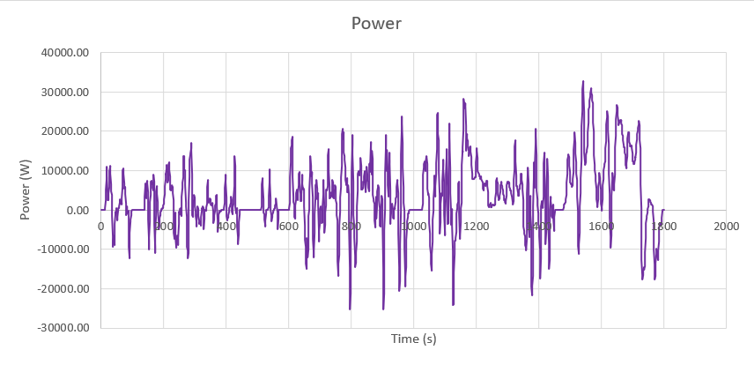
The graph between power and time is shown above. The power has been calculated using the equation Velocity (m/s) * Total Resistive Force (N). The power generated by the vehicle is used to overcome these resistive forces and maintain a certain velocity. If the driving force is greater than the resistive forces, the vehicle will accelerate; if it is equal, the vehicle will move at a constant velocity; and if it is less, the vehicle will decelerate.

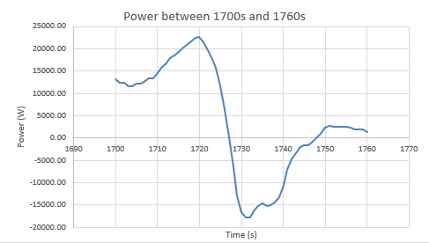
Above, the graph shows a section of the power graph between the time 1700s and 1760s. It shows a sharp decrease in the power between 1720s and 1732s due to a large decrease in acceleration as the vehicle decelerates. This deceleration period is where we can find the energy produced during breaking. Focussing on that same area, a graph showing the energy produced is shown below as well as the values.
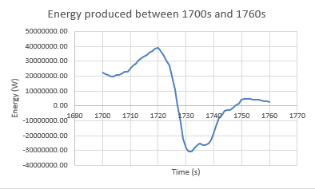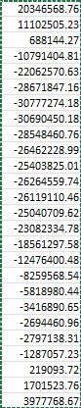
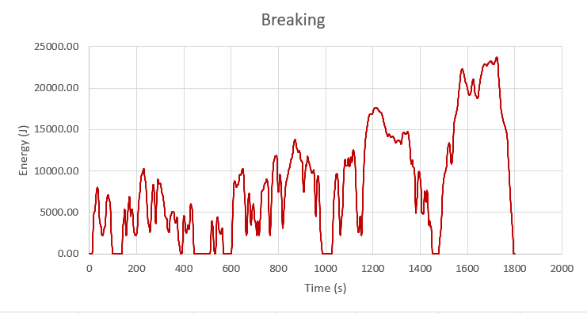
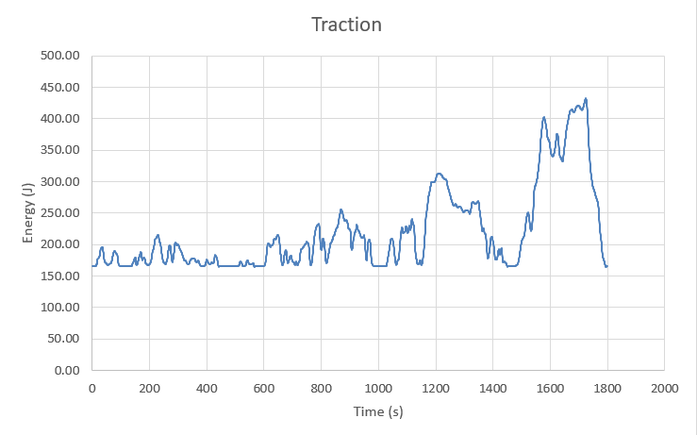
As you can see the graph takes the same shape as the power graph shown above. The values on the right are the Time in seconds and the Energy produced at each second. Using the values found from this, the type of KERS system can be found.

The graphs above show the energy produced by the tractive forces and the breaking forces during the time that the vehicle was measured for.

Types of KERS
There are several types of Kinetic Energy Recovery Systems (KERS), each utilizing different technologies to recover and store energy during braking or deceleration. The main types of KERS systems include:
- Electric Motor.
- Flywheel Based.
- Hydraulic.
- Mechanical.
There are a variety of uses for each of the above types of KERS systems. The electric motor and the hydraulic have not been considered for the vehicle chosen as the electric motor is used in an electric vehicle and the hydraulic KERS is used in larger vehicles like busses or trucks both of which the chosen vehicle is not.
The flywheel-based KERS system is what is used on Formula one cars and works by storing energy in a rotating flywheel during braking. The flywheel is connected to the drivetrain and spins at high speeds, storing kinetic energy. When acceleration is required, the flywheel releases its stored energy back into the drivetrain (Kinetic Energy Recovery Systems for Racing Cars - Alberto Boretti - Google Books, n.d.). This is a possibility due to the rotary engine in the RX7 being small there packaging is not a problem. However, as a road car, the flywheel-based KERS system may not be the most beneficial due to the weight, complexity, and the maintenance that it would require.
The one most suited to the vehicle chosen would be the Mechanical KERS system. This works by using mechanical devices like springs or rotating masses to store and release energy. During braking, the energy is stored in the mechanical system, and when needed, the stored energy is released to assist acceleration. Benefits of this include the simplicity and reliability, a lightweight design, and its ability to store and release energy (Bottiglione et al., 2013).
There are many components required to set up a KERS mechanical flywheel system on a road vehicle. The components are:
- Flywheel.
- Housing and bearings for flywheel.
- Transmission mechanism to connect flywheel to drivetrain.
- Clutch system to engage and disengage the KERS system.
- Breaking system integration to harness the kinetic energy.
- Control electronics and storage management system.
- ECU and monitoring system.
Altogether there are a lot of components to ensure the success of the KERS system allowing it to harness, store and distribute the energy to the drivetrain. According to (Kapoor et al., n.d), the mechanical flywheel is the most efficient with an efficiency of 60%. However, modern flywheels made from advanced materials, such as carbon fibre, with high rotational speeds can achieve high levels of efficiency, often exceeding 90%. From the power graph above, the maximum power shown is about 23kW of power produced. Therefore, with a storage efficiency, the useful power output becomes 13.6kW. The useful power output is then what is used by the vehicle during acceleration when the KERS is activated.

Recovered Energy
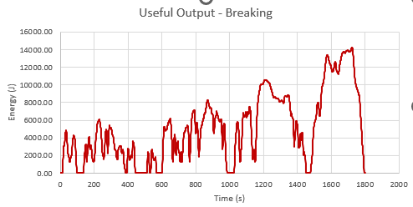
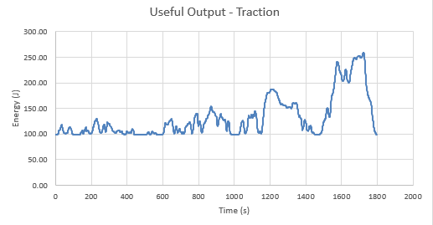
The graphs below show the recovered energy that can be returned to the traction point to enable a boost of power during acceleration.

In the analysis of the KERS performance, two key graphs depict the system's useful power output during both traction and braking phases. The first graph illustrates the traction energy, showcasing the power delivered by the KERS system to enhance vehicle acceleration. This graph captures the dynamic interplay between the KERS system and the drivetrain, highlighting the moments when additional power is seamlessly integrated, resulting in improved traction and acceleration. On the other hand, the second graph focuses on braking energy, illustrating the power generated and stored by the KERS system during deceleration. The braking energy graph provides insights into how efficiently the KERS system recovers and stores kinetic energy during braking events.

Operation
A Kinetic Energy Recovery System (KERS) is a technology used in various applications, including automotive and motorsports, to recover and store kinetic energy that is typically lost during braking. Mechanical KERS systems operate by converting the kinetic energy of a moving vehicle into another form, such as mechanical energy, which can then be stored and later reused to enhance the vehicle's performance. Firstly, when a vehicle equipped with a mechanical KERS system brake, the kinetic energy of the moving vehicle is converted into rotational mechanical energy. Next, the rotational energy is transferred to a flywheel or a similar mechanical energy storage device. The mechanical energy is stored in the flywheel, which spins at a high speed (Sampurno Arief Abdurrakhman Herry Sufyan Hadi, 2015). The high rotational speed helps store a significant amount of energy in a compact space. The energy is stored so that when additional power is needed, such as during acceleration or to assist the engine, the stored energy in the flywheel is released. The released energy is transferred back into the drivetrain to provide additional power to the vehicle (Tess et al., n.d.). This can be achieved through a mechanical linkage or other means, depending on the specific design. By reusing the recovered energy during acceleration, the mechanical KERS system can improve overall vehicle performance and fuel efficiency.
In motorsports, KERS systems are often used with Formula 1 being the most notable. It provides vehicles from racing series a temporary boost in power, enhancing overtaking opportunities and overall performance. The specific implementation and components of a mechanical KERS system can vary depending on the manufacturer and application.
Some assumptions that have been made include the amount of energy lost due to friction and heat within the system. Mechanical systems, including flywheels, have inherent losses due to mechanical resistance and aerodynamic drag. In addition to this, the storage medium such as the type of material used for the flywheel, its size, and its ability to store and release energy efficiently. Assumptions might also be made about the safety measures in place to prevent failure. Lastly, the size and weight of the mechanical KERS system play a crucial role in its integration into a vehicle. Assumptions are made about the acceptable weight and size constraints, as well as the impact on the vehicle's overall performance.
One of the most noticeable differences is the potential for enhanced acceleration. When the KERS system releases stored energy during acceleration, it provides an additional power boost. This can result in quicker acceleration and improved overall performance. During braking, the mechanical KERS system captures and stores kinetic energy that would otherwise be lost as heat through conventional friction brakes. This may lead to a different feel during braking, potentially providing smoother and more controlled deceleration.

Conclusion
In conclusion, the integration of a mechanical KERS in the Mazda RX-7 brings a significant increase to its performance dynamics. The mechanical KERS system significantly enhances the vehicle's acceleration capabilities, providing an additional power boost during moments of increased demand. This innovative technology not only improves the overall driving experience by delivering seamless acceleration but also contributes to the vehicle's efficiency by efficiently capturing and storing braking energy.

References
Bottiglione, F., Carbone, G., De Novellis, L., Mangialardi, L., & Mantriota, G. (2013). Mechanical hybrid KERS based on toroidal traction drives: An example of smart tribological design to improve terrestrial vehicle performance. Advances in Tribology. https://doi.org/10.1155/2013/918387
Demuynck, J., Bosteels, D., De Paepe, M., Favre, C., May, J., & Verhelst, S. (2012). Recommendations for the new WLTP cycle based on an analysis of vehicle emission measurements on NEDC and CADC. Energy Policy, 49, 234–242. https://doi.org/10.1016/J.ENPOL.2012.05.081
Hall, D. E., & Moreland, J. C. (2001). Fundamentals of rolling resistance. Rubber Chemistry and Technology, 74(3), 525–539. https://doi.org/10.5254/1.3547650
Ingram, A. (2023) Our classics: 1994 Mazda RX7. Available at https://www.hagerty.co.uk/articles/our-classics-1994-mazda-rx-7/
Kapoor, R., on, C. P.-P. of the W. C., & 2013, undefined. (n.d.). Comparative study on various KERS. Iaeng.Org. Retrieved January 14, 2024, from http://www.iaeng.org/publication/WCE2013/WCE2013_pp1969-1973.pdf
Kinetic Energy Recovery Systems for Racing Cars - Alberto Boretti - Google Books. (n.d.). Retrieved January 14, 2024, from https://books.google.co.uk/books?hl=en&lr=&id=iXd0EAAAQBAJ&oi=fnd&pg=PR5&dq=formula+one+kers&ots=mNvmcOttw7&sig=CDuPu3wRh7mvYBK6b7mqViVpI-8&redir_esc=y#v=onepage&q=formula%20one%20kers&f=false
Mazda RX 7 FD Twin Turbo specs, dimensions. (n.d.). Retrieved January 12, 2024, from https://www.ultimatespecs.com/car-specs/Mazda/7613/Mazda-RX-7-FD-Twin-Turbo.html
Prototype Powertrain in Motorsport Endurance Racing: An SAE Technical Paper ... - Google Books. (n.d.). Retrieved January 12, 2024, from https://books.google.co.uk/books?hl=en&lr=&id=PXh0EAAAQBAJ&oi=fnd&pg=PA149&dq=kers+fuel+economy&ots=8yK3-8xaQT&sig=pXS22j8IA3At4IiJ_oAAvSYQ00o&redir_esc=y#v=onepage&q=kers%20fuel%20economy&f=false
Sampurno Arief Abdurrakhman Herry Sufyan Hadi, B. (2015). Development of Electrical Kinetic Energy Recovery System (KERS) on Motorcyle. 15–17.
Specifications for Mazda RX-7 1.3 Manual, 256hp, 1994. (n.d.). Retrieved January 12, 2024, from https://www.car.info/en-se/mazda/rx-7/rx-7-13-m5-1994-6317908/specs
Tess, by, Dong-Yang Gao, K., & Liu, H.-G. (n.d.). Kinetic energy recovery systems in motor vehicles You may also like Correcting Stellar Flare Frequency Distributions Detected. https://doi.org/10.1088/1757-899X/148/1/012056
WLTP-DTP-08-04e.ppt. (n.d.). Retrieved January 12, 2024, from https://view.officeapps.live.com/op/view.aspx?src=https%3A%2F%2Funece.org%2FDAM%2Ftrans%2Fdoc%2F2012%2Fwp29grpe%2FWLTP-DTP-08-04e.ppt&wdOrigin=BROWSELINK
Xu, F., & Gao, Z. (2022). Frontal area index: A review of calculation methods and application in the urban environment. Building and Environment, 224, 109588. https://doi.org/10.1016/J.BUILDENV.2022.109588
Yadav, Y. (n.d.). Phase Shift in Formula One with KERS. International Journal of Research In Mechanical Engineering, 3(2), 38–44. Retrieved January 12, 2024, from www.iaster.com

Appendices
- The values used in the equations.


