

Module Code: BMMB7026
Module Name: Managing Marketing Change

Assignment Title: Future Developments in the Field of Marketing

Module Leader: Gwyneth Jones

Student Name: SHAHIN HOWLADER
Student ID: 2438319
Date: 07.01.2026
Executive Summary
The current report assesses the marketing undertakings of Unilever, appraising particularly its measurement and evaluation framework as a way of managing marketing change. The discussion of the correspondence between Unilever’s marketing strategy and environmental forces, target markets, marketing mix, and performance measurement systems is analysed. The evidence shows a good move by Unilever to consider data-based analytics, brand equity metrics, and ESG metrics in marketing assessment. However, there are still difficulties with the standardisation of measurements in the global markets and the association of the long-term brand value with the short-term performance indicators. The report ends with feasible suggestions on how to enhance accountability, consistency and strategic decision-making when it comes to marketing evaluation. While the organisation is demonstrating strong digital, data driven and purpose-led marketing capabilities, there are shortcomings in campaign level attribution; cross market comparability and link between ESG outcomes and commercial returns. To fix these hindrances, the report advises by improving multi-touch attribution models, standardising global KPIs with local flexibility, balancing short- and long-term metrics, and improving tying sustainability performance behaviour with marketing ROI, Unilever will be able to accomplish long-term success.
Table of Contents
Introduction 4
Task 1: Critical Evaluation of Unilever’s Marketing Activity 5
1.1 The Concept and Strategic Importance of Marketing at Unilever 5
1.2 Macro and Micro-Marketing Environment Influencing Measurement 6
1.2.1 Macro Environment (PESTLE Analysis) 6
1.2.2 Micro Environment (VRIO Analysis) 9
1.3 Target Markets and Marketing Strategy Alignment 11
1.4 Marketing Mix and Communication Channels 13
1.5 Measurement and Evaluation Framework at Unilever 15
1.6 Evaluating Marketing Effectiveness and Control Mechanisms 17
Task 2: Conclusion addressing the shortcomings 18
Task 3: Recommended Measures 19
References 21

List of Figures
Figure 1: Unilever 4
Figure 2: Financial Performance of Unilever 5
Figure 3: Real GDP Growth in the UK 7
Figure 4: Total Number of People Use Internet Globally 8
Figure 5: VRIO Model 9
Figure 6: Company Ranking of 2025 10
Figure 7: STP Model 12
Figure 8: Sales Growth and Group Turnover 12
Figure 9: 4P Marketing Mix 13
Figure 10: Revenue of Unilever in 2024 14
Figure 11: Underlying Sales Growth of Unilever 16

Introduction
Measurement and evaluation of marketing is a vital part of modern marketing practices, particularly in multinational organisations that are dynamic. Efficient measurement systems empower companies to evaluate the efficiency of marketing operations, make decisions, and show the responsibility of resource utilisation (Morgan et al. 2022). Strategic responsiveness and long-term value creation can be lessened by strong evaluation systems both during the time of swift technological change and consumer behaviour evolution related to specific company industries. This report analyses the measurement and evaluation model of Unilever, a multinational consumer goods company, in an attempt to know how this firm is measuring the efficiency of its marketing operations in the dynamic environment. Unilever has more than 400 brands in various markets all over the world, providing service to billions of consumers (Unilever, 2026). Its marketing is a purpose-led, digitally and data-driven approach to consumer connection and sustainable growth. Such a complicated solution requires sophisticated measurement tools that combine brand performance, digital analytics, consumer insights, and financial returns.


Figure 1: Unilever
(Source: Unilever, 2025a)
The emphasis on measuring is supported by the Unilever strategic digital transformation, which uses data and technology to optimise operations and the organisation of campaigns. To illustrate, digital-based tools and insights delivery tools facilitate agile decision-making and provision of real-time data in markets (Unilever, 2025a). This report will critically assess the present measurement and evaluation system at Unilever and find the main weaknesses to improve its marketing performance with concrete suggestions. The outline is based on three activities, including a critical analysis of the marketing activity of Unilever and an overall summary of strategic failures and how these may be resolved.

Task 1: Critical Evaluation of Unilever’s Marketing Activity

1.1 The Concept and Strategic Importance of Marketing at Unilever
Marketing is a central aspect of the corporate strategy of Unilever that enables growth, affirmation of brand relevancy and long-term consumer engagement. Unilever is one of the largest consumer goods companies in the world, functioning in over 190 countries with a wide range of “Power Brands” which have over 75% of its turnover (Unilever, 2024a). The company has recorded a brand and marketing investment level of 15.5% of the total turnover in 2024, which was the highest mark in more than a decade (Unilever, 2024a). This indicates how marketing and brand building have been placed in the strategic mode of the entire business model. A key point in the strategy of Unilever is the fusion of digital transformation and data analytics with marketing. The company has been progressively investing on new technologies to aid in the process of marketing decision-making, which includes huge data-based infrastructure, artificial intelligence applications, and web-based shopping portals.
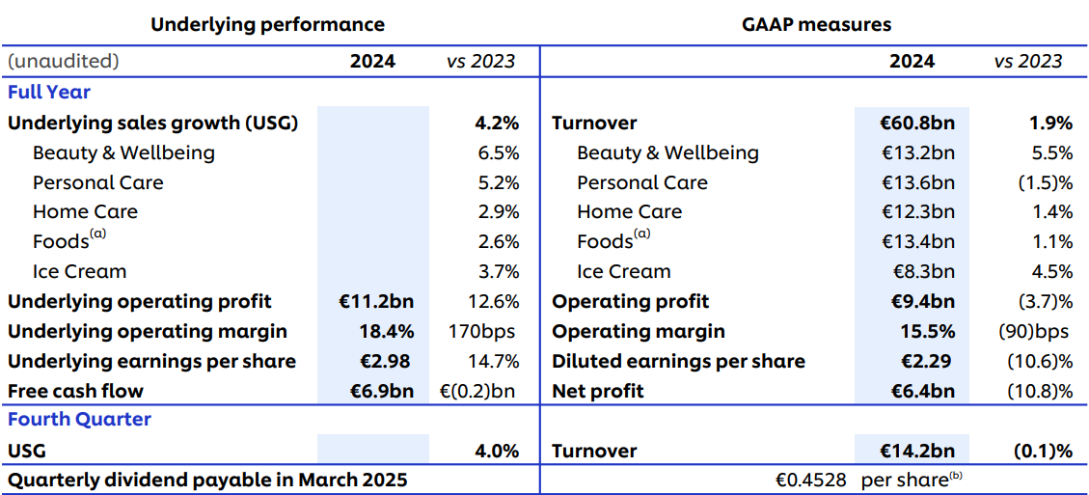

Figure 2: Financial Performance of Unilever
(Source: Unilever, 2024a)
Unilever enterprise data systems handle tremendous volumes of data every day, facilitating increased targeting, tracking performance and real-time campaign optimisation (Unilever, 2025a). This innovative approach will allow Unilever to make communications more personal, addressing the changing behaviour of consumers, and track the impact of the campaign more accurately. In addition, its purpose-driven marketing correlates brand stories with social and environmental causes that matter. Dove and Lifebuoy are brands that incorporate basic values in their interactions with consumers, enhancing the presence provided to the society, as well as reinforcing business performance over the competition (Sheridan, 2024). The use of significant resources devoted to marketing and analytics increases the accountability of the performance outcomes. By basing marketing investment on data and metrics, Unilever relates marketing activity to business results enhancing the transparency and making wise decisions regarding the operation in the complexity of changing world markets.

1.2 Macro and Micro-Marketing Environment Influencing Measurement

1.2.1 Macro Environment (PESTLE Analysis)
Political Factor
Political risk in the global scope is also high and armed conflict was found to be the greatest risk of 2025 according to more than 900 specialists in the World Economic Forum Global Risks Report. Almost 23% of the interviewees mentioned this threat, as it raises the level of geopolitical tensions and their effects on purchasing and interstate collaboration (Martinuzzi, 2025). On the other hand, 67% of consumers prioritise sustainability in purchasing. Business confidence and access to the market are an issue for multinational companies such as Unilever due to such instability.
Economic Factor
The UK economy momentum was also not strong, as the real GDP grew only by 0.1% in the third quarter of 2025 (ONS, 2025a). In the same time, the inflation was addressed to approximately 3.2% whilst the unemployment stood at 5.1%, illustrating the persisting outside economic stress. The IMF also predicts a world GDP growth of 3.1–3.2% in 2025–26, with growth having slowed in advanced economies compared to emerging markets (ONS, 2025a). These tendencies affect the demand and investment choices of consumers in markets.
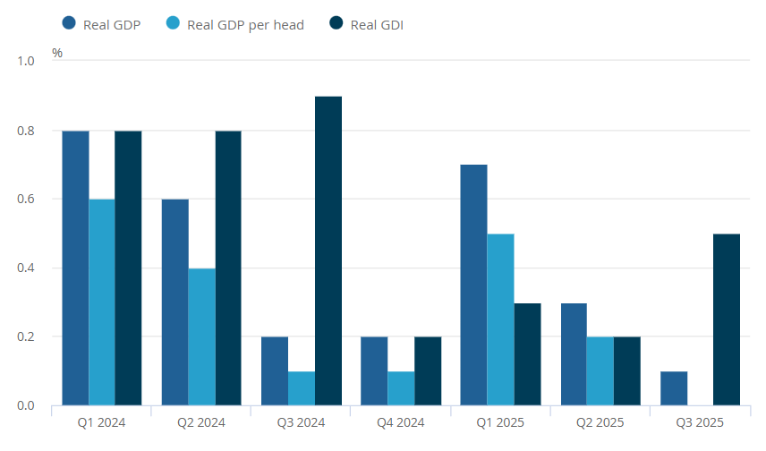

Figure 3: Real GDP Growth in the UK
(Source: ONS, 2025a)
Social Factor
Demand patterns are determined by consumer behaviour and demographics. Discretionary spending in the UK is decelerating because of concerns about the cost of living and high prices that mean people spend cautiously. Digital interaction and social media also will continue to play an important role (Inman, 2025). On the social platforms, a massive number of people have active accounts globally, which shapes the brand activity and digital marketing trends.
Technological Factor
Change in the world of technology is fast and leads to innovation in marketing analytics, artificial intelligence (AI), automation, and online advertising. In 2025, the world population of people using the internet amounted to more than 5.56 billion (AIPRM, 2025). Digital tools are popular, and the majority of companies are implementing digital activities and implementing modern technology in the performance measurement and consumer insights of markets.
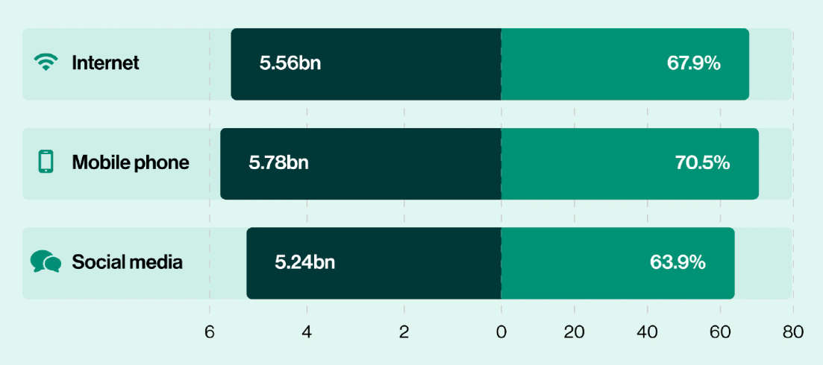

Figure 4: Total Number of People Use Internet Globally
(Source: AIPRM, 2025)
Legal Factor
The dynamic nature of global regulation is making it more complex for firms such as Unilever. The standards of data privacy, such as GDPR, and the product safety standards differ across jurisdictions and thus have to be approached with great care (Wolford, 2025). The enhancement of intellectual property and quality aspects of regulations also influence the ways of marketing and securing the products on the international level, which requires the use of strong legal regulation in marketing, distribution, and internet interaction.
Environmental Factor
The macro factors include environmental issues, and climate change and sustainability risks have been observed to be among the top in the global risk measure. The UK has gone further in environmental accounting and metrics, which takes his climate and natural capital progress by covering GDP (ONS, 2025b). Moreover, Droughts and flooding disrupt crops. In response to this, Unilever must invest in sustainable sourcing and circular economy models.

1.2.2 Micro Environment (VRIO Analysis)
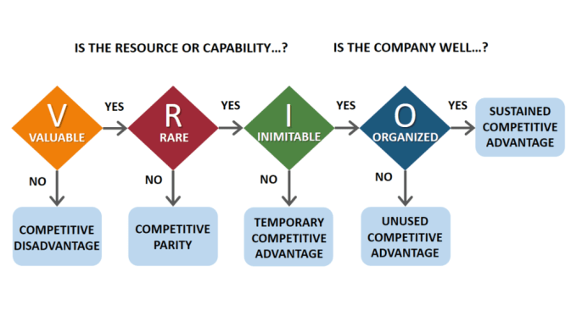

Figure 5: VRIO Model
(Source: Lecture Notes)
Valuable
Unilever has an FMCG industry that is highly competitive in the world market against competitors like Procter & Gamble (P&G), Nestlé and L’Oréal. Unilever received 89.7 marks in the Future Readiness Index and was competitively rated among the large consumer goods companies in 2025 (Yu et al. 2025). It was marginally above P&G at 86.9 and Nestlé at 85.4, still under the industry leaders like coca-cola and L'Oréal (Yu et al. 2025). The fact that power Brands were instrumental in aiding the market share maintenance and growth in key areas, proving the strength of the marketing and operational strengths at Unilever (Unilever, 2025b).
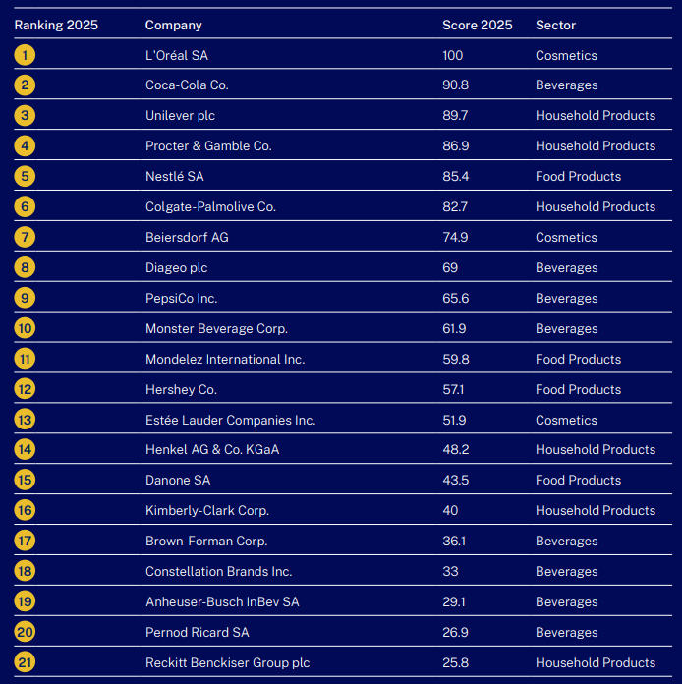

Figure 6: Company Ranking of 2025
(Source: Yu et al. 2025)
Rare
The integration of massive data analytics with purpose-driven brands is not very common in competitors of the FMCG industry, which is why Unilever has this capacity. Consumer engagement data demonstrate that approximately 50% of consumers learn about brands via social media, and one out of every five buys each month as a result of influencer content (Unilever PLC, 2025a). This indicates a high level of social-first marketing by Unilever. The strong focus on real-life brand stories and cultural suitability enhances customer trust and loyalty, a skill achieved by only a handful of rivals across the international market segment.
Inimitable
The internal organisational capabilities of Unilever are hard to imitate because of the integration and size of its systems. The company uses a digital infrastructure on an enterprise-wide basis to process more than 240 terabytes of data each week, handling 3 billion transactions (Unilever, 2025a). Moreover, more than 23,000 employees trained in AI in 2024 form a source of knowledge and organisational learning that competitors can scarcely replicate in the operating period (Unilever, 2025a).
Organised
Unilever is well structured to leverage these resources. It has well-organised investment in analytics, innovation and human capital that can make decisions fast and respond to marketing. It is this organisational similarity that enables Unilever to transform valuable, rare and inimitable resources into sustainable competitive advantage in an incredibly competitive global FMCG market.

1.3 Target Markets and Marketing Strategy Alignment
Segmentation
Unilever has demographic, geographic and behavioural variables in its market segmentation in order to cater to varied consumer needs of its 400+ brands that sell in 190 countries. The company divides its market on the geographical grounds, namely North America, Europe, and Asia (Unilever, 2025b). It also divides its customers into income groups like mass, mid-market and premium and category behaviour including personal care, nutrition and home care. As an example, Vaseline targets a wide audience, whereas such a brand as Hourglass targets more affluent groups and gathers everyone interested in luxury and wellness (Unilever, 2025b). Moreover, since 85% of consumers favour brands that align with their values and take sustainability into account before making purchases, Unilever must be transparent and genuine. The multi-segment strategy allows Unilever to offer products and position the brand messages to specific consumer segments worldwide.
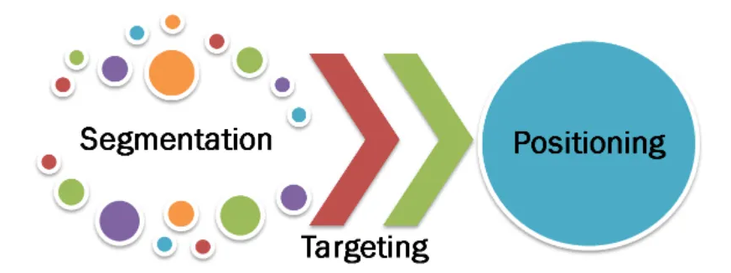

Figure 7: STP Model
(Source: Deshmukh, 2022)
Targeting
Unilever employs differentiated targeting, where various segments of consumers are chosen and a different strategy is developed. The company targets core consumer segments of value-seeking households in emerging markets and premium health/wellbeing customers in developed markets. As an example, the Personal Care division of Unilever, contributing 22% of turnover, serves consumers who value science-led superior products in deodorants, skin and oral care (Unilever PLC, 2024). Equally, its wellness products such as Liquid I.V. are geared towards health-conscious customers internationally with international expansion efforts. Differentiated targeting will enable Unilever to have a balance between the wide coverage and the narrow messages.
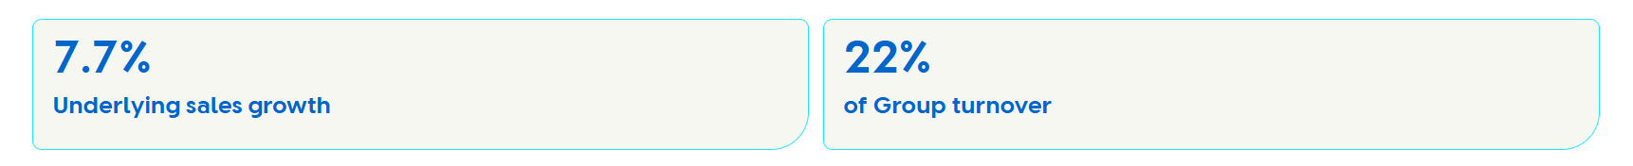

Figure 8: Sales Growth and Group Turnover
(Source: Unilever PLC, 2024)
Positioning
Unilever based its brands on the concept of unmissable superiority whereby the products focus on particular consumer needs and values (Unilever, 2025b). The Power Brands like Dove and Knorr are being promoted based on functional performance, emotional relevance, and sustainability (Unilever, 2025b). This plan involves such innovations as products with science-linked skincare and eco-friendly stories, which appeal to the new generation of consumers. Moreover, social-first demand sailing and data-driven thinking by Unilever contribute to brand relevance in the digital platforms, which makes sure that the positioning matches changing consumer expectations in the competitive markets.

1.4 Marketing Mix and Communication Channels
This part discusses the Unilever Product, Price, Place and Promotion strategies and the way the aspects interact with other parts of its marketing efforts.
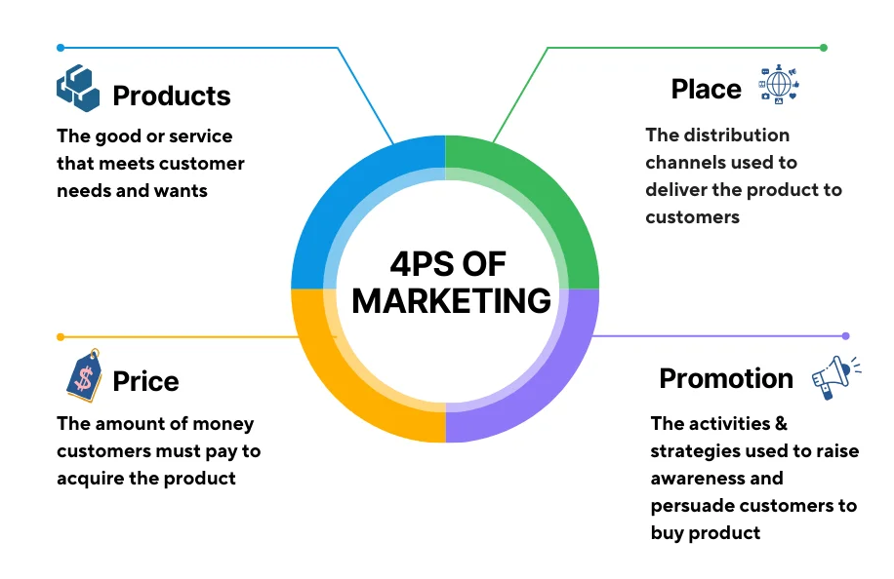

Figure 9: 4P Marketing Mix
(Source: Nguyen, 2024)
Product
Unilever has a large portfolio of primary products that serve the daily consumers in a wide variety of products. In 2024, it achieved a turnover of €60.8 billion, of which more than three-quarters of the turnover was on its Power Brands (Watty, 2025). They are Dove, Comfort, Knorr and Magnum, market leaders (Unilever, 2024b). These products, such as the Personal Care, Home Care, foods, and ice cream, centre on high performance, sustainability, and consumer preference with strong R&D and innovation. This broad and narrow product range helps Unilever to adapt to the different needs of consumers all over the globe and foment development using flagship products.
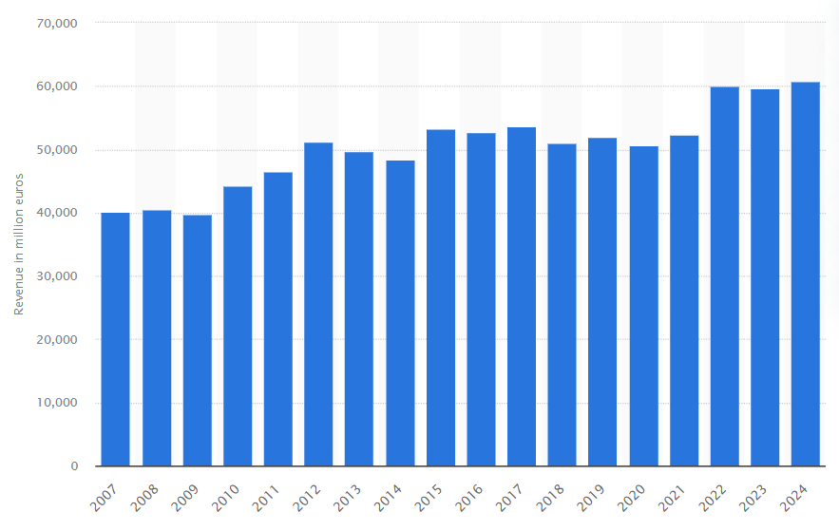

Figure 10: Revenue of Unilever in 2024
(Source: Watty, 2025)
Price
Unilever employs a mixed pricing strategy which indicates the level of competition to the price as well as the value differentiation in various markets. Prices fluctuate depending on product type and location or use premium pricing on differentiated products and penetration or competitive pricing on highly price-sensitive products. In 2024, overall sales performance is moderately associated with moderate global price advancement by 1.3% in contrast to consumer demand and cost pressure (Unilever, 2024b). This dynamic pricing strategy enables Unilever to survive in the emerging markets as well as cushion the margins in the developed markets.
Place
Unilever has one of the largest distribution channels in the FMCG industry globally, serving more than 190 countries. The company has large-scale traditional retail channels and online-based channels and online stores. Unilever invests in cloud-based B2B ecommerce to support 1.5 million micro-retailers, who are expected to bring in more than €4 billion annually, improving product access and on-demand availability (Brohan, 2025). The hybrid distribution model enhances market penetration in rural and urban regions, availing products to the market via supermarkets, small-scale stores, pharmacies, and online market frames.
Promotion
Unilever is continuing to enjoy a high level of promotion with brand and marketing expenditure becoming 15.5% of turnover in 2024 (The Malketeer, 2025). This is the highest percentage in more than a decade, signifying more money spent in brand building and media participation. The promotion expenditure of the company is moving more towards the social-first and the digital platform. It will dedicate approximately half of the advertisement budget to social media and influencer initiatives to boost importance and interaction among the various markets (Jones, 2025). Unilever now runs purpose-driven campaigns with measurable social impact. Conventional media, including TV and sponsorships, still complements the mass reach, whereas data-based online campaigns enhance effectiveness of control and targeting.

1.5 Measurement and Evaluation Framework at Unilever
Current KPIs and Performance Metrics
Unilever monitors a set of KPIs related to the company’s financial performance as well as marketing results. Brand and marketing investment grew to 15.5% of turnover, the highest in more than a decade, as marketing effectiveness and measurement of return on investment were priorities (Unilever PLC, 2025b). The underlying sales growth of 4.2% and volume growth of 2.9% represent that such investments are associated with business performance and will provide executives with the performance metrics they can measure (Unilever PLC, 2025b). A lot of these measures, including underlying operating margin and increase in volumes, are the proxies of success of the marketing activities in regions and categories.
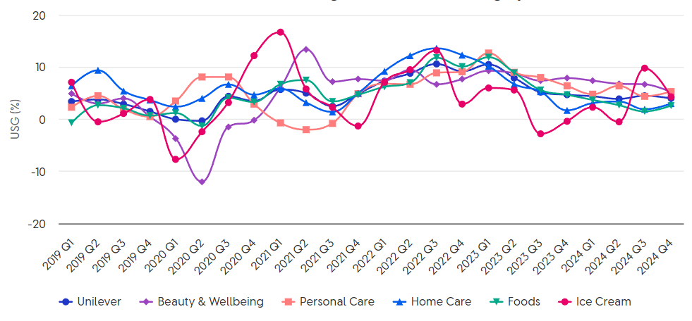

Figure 11: Underlying Sales Growth of Unilever
(Source: Unilever PLC, 2025b)
Brand Equity, Brand Purpose and ESG Measurement
Unilever incorporates brand equity and purpose-led performance as two components of its extended assessment approach. The Sustainability Progress Index (SPI) of the company measures the company’s progress of the four sustainability pillars, such as climate, nature, plastic, and livelihoods. Unilever also announced that by 2024 it would have reduced Scope 1&2 emissions by 76 percent since 2015 and achieved more progress in regenerative agriculture, plastic decrease, and living-wage sourcing (Schumacher and Fernandez, 2025). These ESG KPIs are also becoming more closely correlated with salaries and executive reviews and making sustainability a part of the performance measurement. Additionally, Unilever has developed new quantitative tools to measure the consumer desirability of its Power Brands at a global level, which is a switch to data-driven quantification of brand strength, as opposed to awareness or reach indicators (Storyboard18, 2024).
Digital Analytics and Campaign Evaluation
Unilever applies to digital marketing platforms advanced analytics, AI and multi-touch models of attribution that assess marketing effectiveness. The activities of digital transformation include working with large volumes of data, and the systems are supplied with approximately 240 terabytes of data per week and over 3 billion transactions (Unilever, 2025a). This enhances instantaneous information on campaign execution, buyer conduct, and buy conversion. These systems enhance accuracy of digital campaign assessment as well as complement channel optimisation decision-making.
Use of Dashboards, Data Integration and Reporting Systems
Unilever marketing activities are increasingly using performance dashboards that combine several data sources to deliver cross-channel perspectives of campaign performance, audience interaction and KPI trends. The need to develop dashboards that combine the insights of agencies, media, and consumers to make strategic decisions and define the measurement practice is highlighted in such roles as Associate Manager of Audience Measurement.
Strengths and Weaknesses of Unilever’s Framework
The main advantage of the Unilever framework is that it combines ESG performance with financial and brand metrics, which facilitates purpose-based expansion and stakeholder responsibility in the long run. Advanced analytics and AI are used, thereby increasing the level of responsiveness and the quality of insights (Olayinka, 2021). Nevertheless, there are still problems with measuring globally cross-market and cross-channel and quantifying the financial effect on particular campaigns, particularly within multi-touch online settings. The lack of these points supports the necessity of constant improvement of cross-media measurement models and digital attribution approaches.

1.6 Evaluating Marketing Effectiveness and Control Mechanisms
Unilever measures marketing performance through the performance measurements based on the underlying sales improvement and market share of its Power Brands, which comprised, say, about 75% of its turnover over the past few years. New quantitative methodology has been integrated into core brands to gauge consumer appeal, define performance gaps and determine strategic choices to increase competitiveness (AFAQS, 2024). This is a systematic approach which assists in comparing markets and channels in order to determine the level of effectiveness. Unilever has been able to strike a balance between short-term performance and long-term brand value.
Short-term metrics deal with sales development and trends in volume and promotion return, whereas long-term evaluation is concerned with sustainable consumer demand and brand excellence (AFAQS, 2024). This two-fold concentration acknowledges the lack of immediate outcomes that may solely reflect the influence of investments that develop brand preference in the long run. Unilever performance management has feedback loops and corrective action in the form of regular checkups and cross-functional assessment of campaign performance. Quantitative brand assessment gives insights on how to plan and optimise, making corrective action when performance falls below expectations and reallocating resources to activities with more impact (Unilever, 2024c). All in all, the Unilever marketing effectiveness model unites the commercial and brand measures that allow aligning the strategy and improving continuously.

Task 2: Conclusion addressing the shortcomings
Over-dependence on Aggregate Performance Metrics
A major weakness in the Unilever marketing strategy is the excessive use of high-level and aggregated performance indicators such as underlying sales growth, volume growth and operating margins. While these metrics are useful to prove the overall health of the business, it is a secondary measuring stick to marketing effectiveness rather than campaign-specific or channel-level insight. In a portfolio of more than 400 brands operating across diverse markets, this makes it hard for Unilever to be specific about the allocation of financial returns of individual marketing activities, which can be an even more complex situation within complex multi-touch digital environments.
Issues in cross-channel and cross-market measurement
Irrespective of the presence of AI-driven data infrastructure, different issues encompassing performance measurement and media channels are encountered. Variances in regulatory aspects, data quality, and customer preferences also make the overall performance across different regions less reliable. This undermines the capacity of this organisation to standardise evaluation frameworks and hampers the transferability of best practices across regions, impacting strategically on the organisation's responsiveness to change in a rapidly changing global environment.
Complexity of Attribution in Digital Marketing
Unilever's progression towards social-first, influencer-led and digitally driven promotion has boosted engagement levels and made attribution issues even more acute. The complexity of the procedures also gets augmented by the presence of multiple touchpoints for different customers across the overall customer journey. The enactment of short-term performance indicators for engagement makes the marketing decisions volatile, and therefore, the overall brand visibility and profitability are hindered.
Enactment of Purpose and commercial outcomes
While the combination of ESG and brand purpose measures reinforces Unilever's positioning for the long-term, connecting sustainability results to marketing return on investment is underdeveloped. Purpose-led performance is robustly measured at a corporate level, but less clearly quantified as to its direct contribution to brand growth and consumer purchasing behaviour, leaving gaps in accountability for performance.
Therefore, it can be observed that although the marketing activities of Unilever are diverse and multifaceted, different hindrances encompassing cross-market volatility makes their profitability and long-term success to be hampered. It is necessary to eradicate these challenges so that the value creation for the customers becomes long-term, and a purpose-led marketing approach is sustained.

Task 3: Recommended Measures
a) Unilever should improve the current analytics functionality by building on the existing unified, multi-touch attribution models that connect individual campaigns with channels and customer touchpoints to ultimate financial outcomes. While this is an organisation that already deployed advanced AI and data dashboards, more focus should be given to integrating marketing mix modelling (MMM) with real-time digital attribution (Daryanto, Dewanti and Farras, 2020). This would enable Unilever to go beyond aggregate performance measures and measure incremental ROI at the brand and campaign level. Given Unilever's existing investment in enterprise data systems and AI training, this recommendation is feasible without having to spend on significant additional infrastructure.
b) In order to overcome inconsistencies in cross-market evaluation, Unilever needs to make a global marketing measurement framework with a set of standardised KPIs to be used across regions, and local indicators which are flexible in nature. This hybrid approach would increase comparability and keep the market relevant (Shaikh, Solangi and Raza, 2022). Central governance of measurement standards backed by regional analytics teams would help drive better knowledge transfer and enable better benchmarking of campaign performance across geographies, in line with the current organisational structure of Unilever.
c) Unilever should further institutionalise the separation between short-term activation metrics and long-term brand-building metrics in its performance dashboards. By applying more apparent weighting to branding equity, consumer desirability and lifetime value measures in addition to sales and volume gains, decision-making will not be overly short-term biased (Hajarath and Vummadi, 2025). This would support Unilever's strategic intent of sustainable purpose-led growth, while not compromising commercial accountability.
d) Finally, Unilever should better align measures of ESG and brand purpose with commercial performance measures. Developing analytical links between sustainability initiatives, consumer trust and purchasing behaviour would enhance accountability and make this investment in purpose-led campaigns worth the cost (Chiedu, Long and Ashar, 2024). Given the already existing link between ESG metrics and executive performance reviews, it will be both practical and strategically aligned to reach from the former to the latter through marketing ROI.

References
AFAQS (2024). Unilever to roll out quantitative methodology to measure brands’ consumer appeal. Available at: https://www.afaqs.com/news/mktg/unilever-to-roll-out-quantitative-methodology-to-measure-brands-consumer-appeal (Accessed: 3 January 2026).
AIPRM (2025). 100+ Technology Statistics 2025. Available at: https://www.aiprm.com/technology-statistics/ (Accessed: 3 January 2026).
Brohan, M. (2025). Unilever expands its digital platform for B2C and B2B ecommerce. Available at: https://www.digitalcommerce360.com/2025/04/28/unilever-expands-digital-platform-b2c-b2b-ecommerce/ (Accessed: 3 January 2026).
Chiedu, C.K., Long, C.S. and Ashar, H.B. (2024). Examining the Interplay between Job Satisfaction, Organizational Commitment, and Employee Turnover at Unilever Corporation in Nigeria. IZA Journal of Labor Policy, 14. https://scholar.archive.org/work/vzeojo5h4jhppkgm3m6qts54wm/access/wayback/https://laborwide.com/files/articles/ijlp_v14_i1/chiedu.pdf
Daryanto, W.M., Dewanti, R.W. and Farras, R. (2020). Financial ratio analysis of PT Unilever Indonesia Tbk to measure financial performance. International Journal of Business, Economics and Law, 23(1), pp.93-100. https://www.ijbel.com/wp-content/uploads/2020/11/IJBEL23-232.pdf
Deshmukh, K. (2022). STP Analysis of ‘Maggi’. Available at: https://medium.com/@kishorgdeshmukh3/stp-analysis-of-maggi-802f85cb217e (Accessed: 3 January 2026).
Hajarath, K.C.R. and Vummadi, J.R. (2025). Rebuilding trust in global supply chains: Strategic supplier collaboration in a post-covid world. ES, 19(1), pp.43-49. https://www.researchgate.net/profile/Krishna-Chaitanya-Raja-Hajarath/publication/392458479_Rebuilding_Trust_in_Global_Supply_Chains_Strategic_Supplier_Collaboration_in_a_Post-COVID_World/links/6864d308b991270ef300e351/Rebuilding-Trust-in-Global-Supply-Chains-Strategic-Supplier-Collaboration-in-a-Post-COVID-World.pdf
Inman, P. (2025). UK consumers still reluctant to spend going into 2026, KPMG survey finds | The Guardian. Available at: https://www.theguardian.com/business/2025/dec/30/uk-consumers-reluctant-spend-going-into-2026-survey (Accessed: 3 January 2026).
Jones, M. (2025). Unilever invests half of its budget on an ‘influencer-first’ strategy. Available at: https://www.emarketer.com/content/unilever-invests-half-of-its-budget-on-influencer-first-strategy (Accessed: 3 January 2026).
Martinuzzi, E. (2025). Wars top global risk as Davos elite gathers in shadow of fragmented world | Reuters. Available at: https://www.reuters.com/world/wars-top-global-risk-davos-elite-gathers-shadow-fragmented-world-2025-01-15/ (Accessed: 3 January 2026).
Morgan, N.A., Jayachandran, S., Hulland, J., Kumar, B., Katsikeas, C. and Somosi, A. (2022). Marketing performance assessment and accountability: Process and outcomes. International Journal of Research in Marketing, 39(2), pp.462-481. https://doi.org/10.1016/j.ijresmar.2021.10.008
Nguyen, S. (2024). 4 Ps Of Marketing. Available at: https://www.mageplaza.com/blog/4-ps-of-marketing.html (Accessed: 3 January 2026).
Olayinka, O.H. (2021). Big data integration and real-time analytics for enhancing operational efficiency and market responsiveness. Int J Sci Res Arch, 4(1), pp.280-96. https://doi.org/10.30574/ijsra.2021.4.1.0179
ONS (2025a). Quarterly economic commentary. Available at: https://www.ons.gov.uk/economy/nationalaccounts/uksectoraccounts/articles/quarterlyeconomiccommentary/julytoseptember2025 (Accessed: 3 January 2026).
ONS (2025b). Beyond GDP insights – environment, climate and nature, UK. Available at: https://www.ons.gov.uk/economy/environmentalaccounts/articles/beyondgdpinsightsenvironmentclimateandnatureuk/2025 (Accessed: 3 January 2026).
Schumacher, H. and Fernandez, F. (2025). FY 2024 Results. Available at: https://www.unilever.com/files/ir-q4-2024-results-presentation.pdf (Accessed: 3 January 2026).
Shaikh, A.U.H., Solangi, A. and Raza, A. (2022). An In-Depth Comparative Analysis of Financial Statement Metrics: A Study of Unilever and P&G. Journal of Development and Social Sciences, 3(3), pp.594-609. https://ojs.jdss.org.pk/journal/article/view/467
Sheridan, N. (2024). Unilever Marketing Strategy 2024: A Case Study – Latterly.org. Available at: https://www.latterly.org/unilever-marketing-strategy/ (Accessed: 3 January 2026).
Storyboard18 (2024). Unilever to roll out quantitative methodology to measure brands’ consumer appeal. Available at: https://www.storyboard18.com/quantum-brief/unilever-to-roll-out-quantitative-methodology-to-measure-brands-consumer-appeal-22702.htm (Accessed: 3 January 2026).
The Malketeer (2025). Unilever Increases Brand and Marketing Investment to 15.5% of Turnover in 2024 | MARKETING Magazine Asia. Available at: https://marketingmagazine.com.my/unilever-increases-brand-and-marketing-investment-to-15-5-of-turnover-in-2024/ (Accessed: 3 January 2026).
Unilever (2024a). Q4 and Full Year 2024 full announcement. Available at: https://www.unilever.com/files/ir-q4-2024-full-announcement.pdf (Accessed: 3 January 2026).
Unilever (2024b). Unilever Annual Report and Accounts 2024. Available at: https://www.unilever.com/files/unilever-annual-report-and-accounts-2024.pdf-13 (Accessed: 3 January 2026).
Unilever (2024c). Implementing Growth Action Plan at pace. Available at: https://www.unilever.com/news/press-and-media/press-releases/2024/implementing-growth-action-plan-at-pace/ (Accessed: 3 January 2026).
Unilever (2025a). How Unilever’s digital transformation is driving operational excellence | Unilever. Available at: https://www.unilever.com/news/news-search/2025/how-unilevers-digital-transformation-is-driving-operational-excellence/ (Accessed: 3 January 2026).
Unilever (2025b). Improved Performance Led by Volume Growth and Gross Margin Expansion | Unilever. Available at: https://www.unilever.com/news/press-and-media/press-releases/2025/improved-performance-led-by-volume-growth-and-gross-margin-expansion/ (Accessed: 3 January 2026).
Unilever (2026). Unilever at a Glance | Unilever. Available at: https://www.unilever.com/our-company/at-a-glance/ (Accessed: 3 January 2026).
Unilever PLC (2024). What’s behind Unilever’s full-year results? Available at: https://www.unilever.com/news/news-search/2024/whats-behind-unilevers-fullyear-results/ (Accessed: 3 January 2026).
Unilever PLC (2025a). Leveraging social insights and technology to meet changing consumer behaviours | Unilever. Available at: https://www.unilever.com/news/news-search/2025/leveraging-social-insights-and-technology-to-meet-changing-consumer-behaviours/ (Accessed: 3 January 2026).
Unilever PLC (2025b). Full Year 2024 Results Overview. Available at: https://www.unilever.com/investors/results-events/results-events-webcasts/overview-q4-2024/ (Accessed: 3 January 2026).
Watty, F. (2025). Revenue of Unilever from 2007 to 2024 | Statista. Available at: https://www.statista.com/statistics/269190/global-revenue-of-the-unilever-group-since-2007/ (Accessed: 3 January 2026).
Wolford, B. (2025). What is GDPR, the eu’s new data protection law? Available at: https://gdpr.eu/what-is-gdpr/ (Accessed: 3 January 2026).
Yu, H., Shan, J., Sonderegger, A., Tempel, L. and Maslova, Y. (2025). Future Readiness in the Era of Adaptability A report by the IMD Future Readiness Center. Available at: https://www.imd.org/wp-content/uploads/2025/12/FINAL-FR-Report-2025.pdf (Accessed: 3 January 2026).

