Materials Science – The Brittle Fracture of Liberty Ships

David Tolhurst | 2222916 | Level 6 | Materials Science | Dr Phil Holden

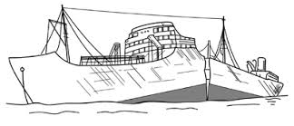

List of Contents
List of Figures 2
Abstract 3
Introduction 4
Fracture Mechanisms 5
Embrittlement 5
Stress Concentrations 9
Welded Structure 10
Steel Impurities 10
Historic Preventative Measures Taken 11
Rounding Sharp Corners 11
Riveted Crack Arrestors 12
Suggested Corrective Action 12
Manganese Alloying 12
Conclusion 12
References 13

List of Figures
Figure 1 - SS Schenectady [3] 4
Figure 2 - Constance Tipper [5] 5
Figure 3 - Charpy Impact Test Setup [6] 6
Figure 4 - Ductile to Brittle Transition Temperature (DBTT) Graph [8] 7
Figure 5 - Ductile & Brittle Fracture Surfaces [7] 8
Figure 6 - Toughness - Stress & Strain Relation Graph [10] 8
Figure 7 - Replica Liberty Ship Model [12] 9
Figure 8 - Stress Concentration [15] 10
Figure 9 - Hot Cracking [17] 11
Figure 10 - Riveted Crack Arrestor 12

Abstract
This report will outline both the Liberty ship’s importance during World War II and its key areas of material and design failures which led to thousands of severe fractures occurring across the entire fleet. Various fracture mechanisms will be analysed, and the main contributing mechanism will be concluded upon at the end of the report along with some preventative measures.

Introduction
The Liberty ships were produced in mass during World War II. Over 2700 Liberty ships were made with the primary objective of transporting troops, equipment and supplies across the North Atlantic to support the ongoing war efforts. These ships were designed to be built fast and cost-efficiently to replace the ones that German U-boats had sunk. Relatively new ship building techniques at the time such as welding were used to decrease build times and lower labour costs. However, this speed of production came with significant problems. The Liberty ships quickly became well known for their structural integrity issues. At least 1500 reports of severe fractures in a ship’s structure were reported and a further 12 cases of a ship’s hull completely splitting in two occurred during the war. One of the most famous incidents that occurred involved the T2 Tanker SS Schenectady which completely split in two only one day after been put into service during calm weather conditions whilst docked in Portland, Oregon. This event highlights that there were clearly huge design flaws that was plaguing the Liberty ship fleet. [1] [2]

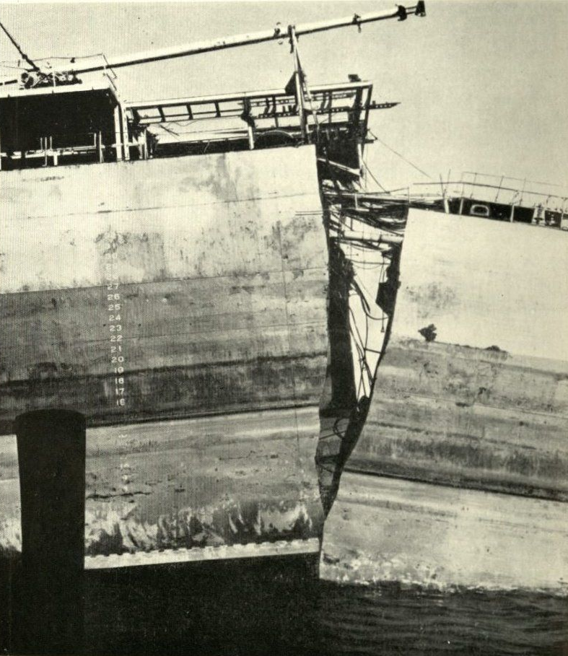
Figure 1 - SS Schenectady [3]
This report will analyse the primary mechanisms which contributed to these catastrophic failures. It will also outline the sequence of events that led to embrittlement, stress concentrations and how cracks easily propagated through the ships structure which ultimately led to complete structural failures in many cases.

Fracture Mechanisms

Embrittlement
When the Liberty ships first started suffering from these mysterious fractures, initial suspicions pointed towards poor welding practises and low-quality workmanship due to the high demand caused by the war. However, this turned out not to be the root cause of these fractures. An engineer by the name Constance Tipper and her team from the University of Cambridge discovered that most of the severe fractures that occurred on the liberty ships happened during the cold winter months. This caused Tipper and her team start to perform a series of mechanical and metallurgical tests that would produce findings which would go onto revolutionise materials science and shipbuilding standards. [4]


Figure 2 - Constance Tipper [5]
One of the first tests that Tipper and her team conducted was the ‘Charpy’ impact test. This test is designed to determine a materials toughness by measuring how much energy is absorbed by a material when it is fractured by a swinging pendulum. The steel samples used were subjected to a range of temperatures so that the conditions of the North Atlantic could be simulated. The average temperature of the North Atlantic typically ranged from -2°C to 5°C. The results from the Charpy tests showed that the steel acted as expected at higher room temperatures with standard levels of plastic deformation being observed. When the temperatures were reduced to close to freezing, the amount of energy absorbed drastically. This was indicative that the steel had become brittle when subjected to these temperatures. Figure 3 below shows how Charpy tests are setup and carried out.
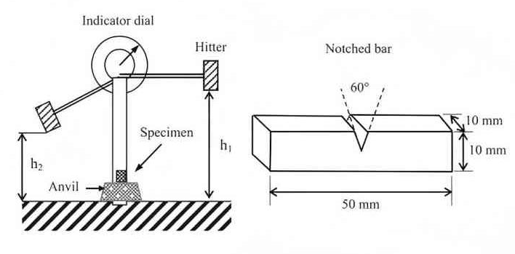
Figure 3 - Charpy Impact Test Setup [6]
During Tippers research, she developed her own testing method which is known as the ‘Tipper Test’ and still used to date. The Tipper test was like the Charpy test but instead of using high-speed impact from a swinging pendulum it used a machine that could gradually apply higher levels of tensile stress. This allowed Tipper to more accurately simulate the conditions on the Liberty ships. [4]
Tipper’s testing showed that steel was becoming brittle in the cold temperatures because it was a low alloy mild steel. This meant that it had a relatively high Ductile to Brittle Transition Temperature (DBTT). The DBTT for the steel used in the construction of the Liberty ships was close to or just above 0°C. This meant that the ships were regularly operating in water temperatures which were near to, or at the DBTT. When steel is subjected to temperatures above its DBTT, it stays tough and can withstand much higher levels of stress. It can do this as it is still able to deform plastically which means cracks were less likely to propagate and caused significant fractures. However, when steel is subjected to temperatures at, or below its DBTT, the steel loses its ability to deform plastically. This leaves it in a state of brittleness which makes it behave similarly to glass. In this state, cracks can spread rapidly and lead to a sudden catastrophic failure as seen with the SS Schenectady. [7]
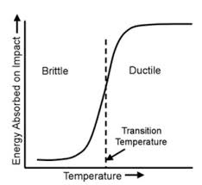
Figure 4 - Ductile to Brittle Transition Temperature (DBTT) Graph [8]
The elastic and plastic deformation of steel refers to the point in which the deformation observed shifts from temporary to permanent. Elastic deformation occurs when a load is applied but the stress values do not exceed the yield strength. This allows the material to return to its original shape. During elastic deformation only small slips or dislocations occur within the materials crystal lattice. Plastic deformation on the other hand takes place immediately after the yield strength is exceeded. This deformation is permanent, and the material is unable to return to its original shape. This is due to the much bigger slips between grain boundaries within the crystal lattice. [9]
The main differences between the ductile and brittle behaviours observed lies in the steel’s microstructure. At higher temperatures, the steel can be stretched under stress which helps resist crack formation. At lower temperatures, dislocation movement becomes restricted which makes plastic deformation almost impossible. Because of this, cracks begin to form along grain boundaries as they are an easy pathway to follow. This leads to uncontrollable crack propagation. An example of a ductile and a brittle fracture can be seen in figure 5 below.
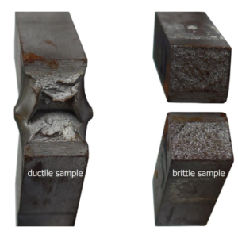
Figure 5 - Ductile & Brittle Fracture Surfaces [7]
In figure 5 above we can see a clear example that highlights the key differences between a ductile and brittle fracture. The left sample shows that a lot of energy has been absorbed and prevented a complete fracture which is indicative of plastic deformation. This is shown by the stretching and rougher surface finish left by the fracture. The right sample shows that much less energy has been absorbed by the material and little plastic deformation has taken place. This sample has a more uniform, granular fracture surface which is symptomatic of a brittle material.
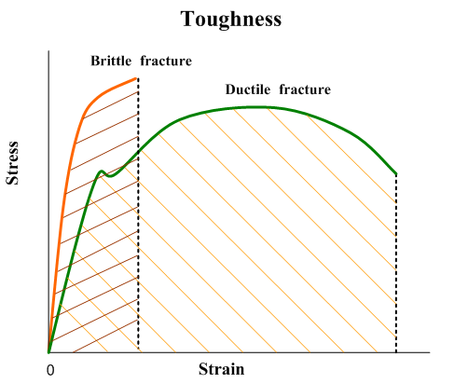
Figure 6 - Toughness - Stress & Strain Relation Graph [10]
Figure 6 above presents this information on a tensile test graph. The ductile material shown in green starts by deforming elastically before a clear yield strength is reached, at which, the material starts to deform plastically before it reaches its Ultimate Tensile Strength (UTS) and then its breaking point further along the strain axis.
The brittle material shown in orange also starts by deforming elastically but shows no clear transition point before it reaches its breaking point. This makes the concept of yield strength irrelevant. We can calculate the difference in the amount of energy absorbed between the ductile and brittle materials by finding the areas under the curve for each line. This is done by using a method called definite integration. [11]

Stress Concentrations
The earlier produced Liberty ship designs featured large square cargo hatches. This was extremely problematic as it introduced numerous areas with sharp corners that weakened the ships structural integrity. Introducing sharp corners to anything that will be subjected to high levels of cyclic loading will cause stress concentrations. These areas of stress concentration amplify the local stress during cyclic loading. Over time, these areas can initiate cracks and weaken the ships integrity further.
The large square cargo hatches were located near the midsection of the ship and were the most common sites for crack initiation. These cracks would often lead to a ship requiring substantial repairs or being removed from service due to the severity and speed of propagation of the cracks. Due to the lack of historical photographs available, an image of a replica Liberty ship model has been used to help illustrate the location of the problem cargo hatches. This can be seen in figure 7 below.
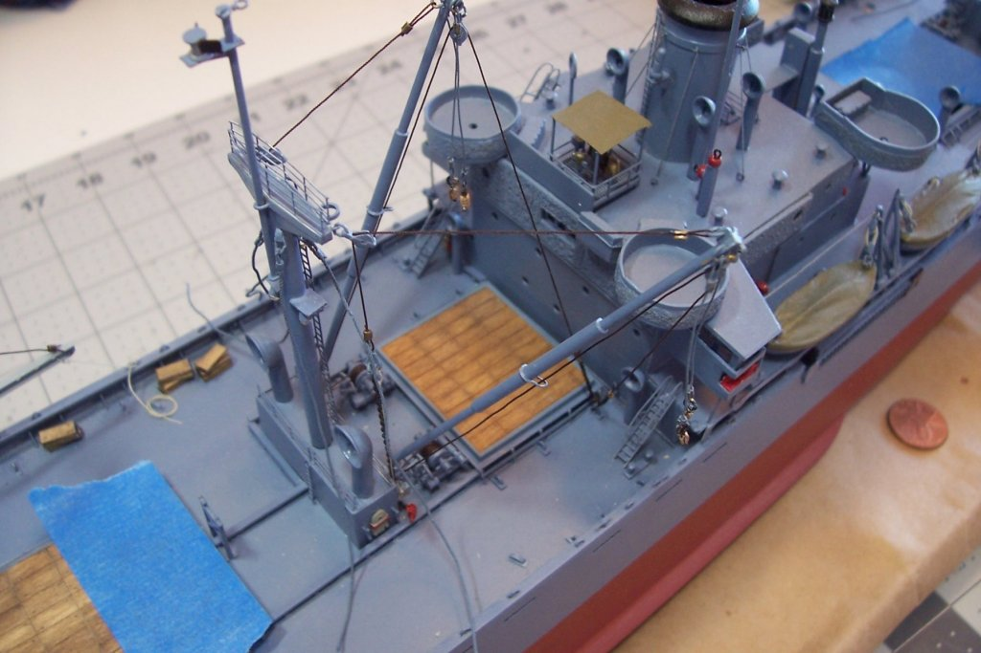
Figure 7 - Replica Liberty Ship Model [12]
To understand how the stress concentrations are formed, firstly we must understand how the ships underwent cyclic loading whilst at sea. As a ship passes over a wave, the bow is lifted upwards creating a large, localised area of stress which travels towards the rear of the ship. This motion induces stresses that cause the ship to undergo elastic deformation. This is known as sagging and hogging. Sagging is where the ship bends downwards at the centre as it approaches the waves crest. Hogging is where the ship bends upwards at the centre as it passes through the crest of the wave. [13]
These cyclic forces create varying levels of stress across the hull of the ship. Stress patterns can be visualised through isostatic lines or stress trajectories, which indicate the direction of the maximum principal stress within a material. When these trajectories meet sharp corners, they are forced to change direction abruptly which causes them to bunch up. These areas of concentrated stress trajectories cause the local stress levels to be amplified. This greatly increases the likelihood of crack formation. Figure 8 below shows how concentrations are formed. [14]

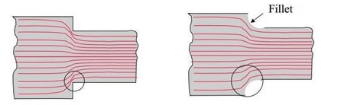
Figure 8 - Stress Concentration [15]

Welded Structure
The liberty ships were welded together instead of riveted to allow them to be constructed faster. Not only did this allow them to be built faster but it eliminated the need for highly skilled riveters which were in high demand during the war. Welding was taught to labourers quickly and in huge numbers. Welding also had a few other benefits in comparison to riveting, for example the ships overall weight could be reduced due to the lack of overlapping plates and rivets, which in turn, reduced the overall amount of steel required to construct the ship. This weight loss also allowed for the Liberty ships to carry more cargo.
Unfortunately, the decision to weld prefabricated sections together came at a huge cost. When something is welded together it creates a homogenised and uninterrupted load path. This means that there were no barriers to resist cracks propagating throughout the ships structure. When ships are riveted in construction, the structure will have individual plates which are then connected but are not homogenised as such. The riveted structure will still have plate boundaries and rivet holes which act as crack resistors. Even if cracks were to form on a riveted structure, it would most likely stop propagating once it had travelled through the entirety of the plate it was initiated on. [1]

Steel Impurities
The Liberty ships were constructed using American Standard for Testing Materials A7 (ASTM A7) which is a low-alloy mild carbon steel. Due to the high demand for steel during the war, steel manufacturing standards dropped, and the steel produced contained high levels of impurities such as phosphorus, sulphur and oxygen. [16]
High sulphur content in steel is a major problem as it forms an iron-sulphide (FeS) film at the grain boundaries which has a significantly lower melting temperature than regular steel. This is especially problematic when introduced to a welded structure because it significantly increases the risk of hot cracking during the welding process. Hot cracking is when cracks are formed in the welded metal as it cools. As the weld cools it solidifies and begins to shrink. This applies a significant amount of tensile stress which the brittle iron-sulphide film cannot withstand, causing the weld to crack. An example of this form of crack initiation can be seen below in figure 9.
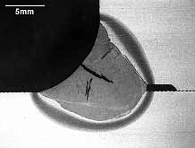
Figure 9 - Hot Cracking [17]
Phosphorus content can be beneficial as it strengthens through a process known as solid solution strengthening. This is where the larger phosphorus atoms mix within the iron crystal lattice which reduces the likelihood of dislocation. This can increase overall yield strength, but when levels are too high it causes embrittlement within the steel.
Similarly to sulphur, excessive levels of oxygen (O) content in steel can cause embrittlement as it forms brittle compounds such as iron-oxides (FeO) within the crystal lattice. Oxygen also has the tendency to form inclusions within steel and acts as a stress concentrator which promotes both crack initiation and propagation. During the manufacturing of steel, as the liquid steel cools, oxygen reacts with the carbon molecules to form carbon monoxide (CO) bubbles. These bubbles usually end up being trapped during the solidification process and result in internal defects. This creates a weakened material that is highly prone to suffer from stress concentrations. [3] [18]

Historic Preventative Measures Taken

Rounding Sharp Corners
Design changes were introduced towards the later period of the war. The main design change being to round off all cargo hatch corners to reduce levels of stress concentrations. Rounding off the cargo hatch corners meant that during cyclic loading, isostatic lines were not congesting at sharp corners anymore. They were able to wrap round the corners more freely with a less abrupt change in direction. This reduced the levels of local stress at the hatch corners which therefore reduced the likelihood of crack initiation. However, design change was only incorporated whilst a ship was undergoing repairs, this meant there was an entire fleet of Liberty ships still out there that were essentially ticking time bombs. Although rounding off the hatch corners significantly reduced the number of fracture failures occurring to the ships the changes had been made to, much more work had to be done as the number of ships suffering from severe structural fractures was still unacceptable.

Riveted Crack Arrestors
Approximately 1000 Liberty ships were fitted with riveted crack arrestors whilst undergoing repairs. These riveted strips were fitted strategically along the ships hull and near known stress concentrations points such as the large cargo hatches. Fitting crack arrestors near these known problem areas did prove to be somewhat effective as the number of fractures reported on the retrofitted ships did fall again significantly. An example of how a crack arrestor would be fitted to a ships hull can be seen below in figure 10. [19]
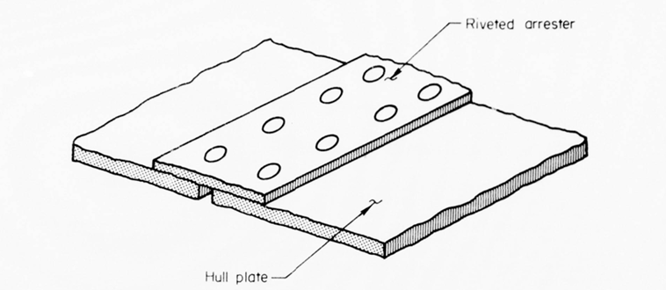
Figure 10 - Riveted Crack Arrestor [20]

Suggested Corrective Action

Manganese Alloying
The most effective way that the Liberty ships could have been saved from disaster is to add manganese to the steel used for construction. Higher manganese content improves steel’s microstructure by refining the grain size within its crystal lattice. This makes it harder for cracks to propagate which intrinsically improves the steel’s ability to deform plastically at the cold temperatures present in the North Atlantic. When steel containing higher manganese contents is subjected to low temperatures, manganese atoms undergo a process known as ‘solid solution softening’. This process results in increased grain boundaries mobility and easier dislocations which helps increase the likelihood of plastic deformation and reduce the likelihood of brittle fracture. In essence, manganese reduces the steel’s DBTT. This alloying process would have allowed it to cope with the low water temperatures in the North Atlantic, especially during winter months.
Introducing higher levels of manganese also helps reduce the amount of sulphur in steel which is undesirable as it forms brittle compounds which congregate at grain boundaries, therefore, weakening the material. It does this by reacting with any sulphur present within the steel to form manganese-sulphides which are much less harmful and less brittle than the previously mentioned iron-sulphides due to their welding implications. [21]

Conclusion
In conclusion, the main contributing fracture mechanism was the embrittlement of the steel. The lower quality, low-alloy steel used for constructing the Liberty ships was unable to cope with the low temperatures that the North Atlantic subjected it to. The effects of the embrittlement were then accelerated by additional stress concentrations caused by poor ship design. This fatal combination was then accelerated further by the ships welded structure which did not allow for any chance of halting crack propagation.

References

[1] | J. Lancaster, Engineering Catastrophes (Third Edition) Chapter 4, 2005.
[2] | A. Mital, Product Development (Second Edition) Chapter 3, 2014.
[3] | J. E. Moore, “Brittle Fracture: When Ships Split in Two,” The mariners' museum and park, 28 January 2021. [Online]. Available: https://www.marinersmuseum.org/2021/01/brittle-fracture-when-ships-split-in-two/. [Accessed 08 January 2026].
[4] | K. Zappas, “Constance Tipper Cracks the Case of the Liberty Ships,” The Minerals, Metals & Materials Society , 2015. [Online]. Available: https://link.springer.com/content/pdf/10.1007/s11837-015-1697-9.pdf. [Accessed 08 January 2026].
[5] | University of Cambridge , “Constance Tipper,” [Online]. Available: https://www-g.eng.cam.ac.uk/millennium/1925-1950/tipper.html. [Accessed 08 January 2026].
[6] | Sinospecialmetal, “Charpy Impact Test: Principles, Equipment, Procedures, and Applications,” SSM, 26 February 2025. [Online]. Available: https://ssmalloys.com/charpy-impact-test/. [Accessed 08 January 2026].
[7] | SASSDA, “Could stainless steel have saved the liberty ships during WW2?,” 2023. [Online]. Available: https://sassda.co.za/news-home/stainless-steel-magazine/stainless-steel-magazine-issue-1-2023/case-study/. [Accessed 08 January 2026].
[8] | E. Majarmovic, “Testing the impact energy and determination of the brittleness temperature of the welded joint of steel A516 Gr.70,” Univeristy of Bihac, 2023. [Online]. Available: https://www.researchgate.net/publication/376730976_Testing_the_impact_energy_and_determination_of_the_brittleness_temperature_of_the_welded_joint_of_steel_A516_Gr70. [Accessed 08 January 2026].
[9] | Iowa State University - Centre for Nondestructive Evaluation, “Elastic/Plastic Deformation,” [Online]. Available: https://www.nde-ed.org/Physics/Materials/Structure/deformation.xhtml. [Accessed 08 January 2026].
[10] | D. D. Kopeliovich, “Fracture toughness,” Substech.com, [Online]. Available: https://www.substech.com/dokuwiki/doku.php?id=fracture_toughness. [Accessed 08 January 2026].
[11] | Newcastle Univeristy, “Definite Integration,” [Online]. Available: https://www.mas.ncl.ac.uk/ask/numeracy-maths-statistics/core-mathematics/calculus/definite-integration.html. [Accessed 09 January 2026].
[12] | Model Ship World, 15 May 2016. [Online]. Available: https://modelshipworld.com/topic/13443-ss-stephen-hopkins-by-schooner-finished-bluejacket-shipcrafters-liberty-ship/page/7/. [Accessed 09 January 2026].
[13] | “Hogging and Sagging,” Heisenberg Shipping, 18 March 2024. [Online]. Available: https://heisenbergshipping.com/ship-hogging-and-sagging/. [Accessed 09 January 2026].
[14] | “Stress Trajectories,” Ramsay Maunder Associates, [Online]. Available: https://www.ramsay-maunder.co.uk/downloads/rma_aa_002.pdf. [Accessed 09 January 2026].
[15] | “Why do stress concentrations really occur?,” Stack Engineering, March 2019. [Online]. Available: https://i.sstatic.net/0lfOo.jpg. [Accessed 09 January 2026].
[16] | “ASTM A7,” Gang Steel, [Online]. Available: https://gangsteel.net/News/astm-a7-historical-standard.html. [Accessed 09 January 2026].
[17] | The Welding Institute, “What is hot cracking (solidification cracking)?,” [Online]. Available: https://www.twi-global.com/technical-knowledge/faqs/faq-what-is-hot-cracking-solidification-cracking. [Accessed 09 January 2026].
[18] | “Effects of sulphur and phosphorus on weld metal solidification cracking,” pp. 2, 8, 333-338, 1970.
[19] | “Liberty Ship Failures,” 15 December 2015. [Online]. Available: https://nuleren.be/edocumenten/materialen_Liberty_Ship_Failures___Metallurgy___Materials_Engineering.pdf. [Accessed 09 January 2026].
[20] | S. S. Commitee, “A Study of Ship Hull Crack Arrester Systems,” 1977.
[21] | M. Tanaka, “Effects of Ni and Mn on brittle-to-ductile transition in ultralow-carbon steels,” Science Direct , 25 November 2016. [Online]. Available: https://www.sciencedirect.com/science/article/abs/pii/S0921509316313995#:~:text=rights%20and%20content-,Abstract,decreasing%20a%20martensite%2Dstart%20temperature.. [Accessed 09 January 2026].

