

Child sexual exploitation/Child criminal exploitation within Serious Organised Crime – How do police offer support to those in need to tackle Child sexual exploitation/Child criminal exploitation within Serious Organised Crime?

__________________________________________________________________________________
Connor Dumayne-Davis
2132139
BSc (Hons) Policing and Criminology

Declaration
This work has not previously been accepted in substance for any degree and is not being concurrently submitted in candidature for any degree.

Signed: C.Dumayne-Davis

Date: 3rd January 2025

Statement 1
This dissertation is being submitted in partial fulfilment of the requirements for the degree of BA.

Signed: C.Dumayne-Davis

Date: 3rd January 2025

Statement 2
This dissertation is the result of my own independent work/investigation, except where otherwise stated.
Other sources are acknowledged by footnotes giving explicit references. A bibliography is appended.

Signed: C.Dumayne-Davis

Date: 3rd January 2025

Statement 3
I hereby give consent for my dissertation, if accepted, to be available for photocopying and for interlibrary loan, and for the title and summary to be made available to outside organisations.

Signed: C.Dumayne-Davis

Date: 3rd January 2025

Statement 4
I hereby give consent for my dissertation, if accepted, to be available on the university’s IT system to those who have consent to use the system.

Signed: C.Dumayne-Davis

Date: 3rd January 2025

Table of Contents

Chapter One – Introduction
  - Introduction ………………………………………………………………………………………………………………… 7
  - Background and Rational …………………………………………………………………………………………….. 7
  - Aims and Objectives ……………………………………………………………………………………………………. 7
  - Research Structure ……………………………………………………………………………………………………… 8
  - Conclusion ………………………………………………………………………………………………………………….. 8

Chapter Two – Literature Review
2.0 Introduction …………………………………………………………………………………………………………………. 9 2.1 Child Sexual Exploitation, Child Criminal Exploitation and Serious Organised Crime …….. 9 2.2 County Lines in the Modern Era …………………………………………………………………………………… 11 2.3 The role of the Police dealing with these incidences ……………………………………………………. 13 2.4 Conclusion …………………………………………………………………………………………………………………… 14

Chapter Three - Methodology
3.0 Introduction ………………………………………………………………………………………………………………… 16 3.1 The Research/Data Analysis Spiral ……………………………………………………………………………… 16 3.1.1 Managing and Organizing Data ………………………………………………………………………………... 17 3.1.2 Reading and Memoing Emergent Ideas ……………………………………………………………………. 17 3.1.3 Developing and Assessing Interpretations ……………………………………………………………….. 18 3.1.4 Representing and Visualizing the Data …………………………………………………………………….. 18 3.2 Reliability and Validity ………………………………………………………………………………………………… 18 3.3 Ethical Considerations ………………………………………………………………………………………………… 18 3.4 Conclusion ………………………………………………………………………………………………………………….. 18

Chapter Four – Data Analysis
4.0 Introduction ………………………………………………………………………………………………………………… 19 4.1 Participants …………………………………………………………………………………………………………………. 19 4.2 Attending incidences involving Child Criminal Exploitation and Child Sexual Exploitation within Serious Organised Crime ………………………………………………………………………………………… 19 4.3 Training regarding Child Criminal Exploitation and Child Sexual Exploitation within Serious Organised Crime ……………………………………………………………………………………………………. 20 4.4 Protection outcomes to support those exploited by Child Criminal Exploitation and Child Sexual Exploitation ……………………………………………………………………………………………………………. 20 4.5 Conclusion …………………………………………………………………………………………………………………… 21

Chapter Five – Findings and Conclusion
5.0 Introduction …………………………………………………………………………………………………………………… 22 5.1 Findings ………………………………………………………………………………………………………………………….. 22 5.2 Future Research …………………………………………………………………………………………………………….. 23 5.3 Recommendations …………………………………………………………………………………………………………. 23 5.4 Conclusion ……………………………………………………………………………………………………………………… 24

Chapter Six - Appendix
6.0 Copy of Questionnaire …………………………………………………………………………………………………… 25 6.1 Ethics Form ……………………………………………………………………………………………………………………. 31 6.2 Questionnaire Answers – Question 1 to 9 ……………………………………………………………………… 43 6.3 Questionnaire Answers – Question 10 to 17 …………………………………………………………………. 47 6.4 Bibliography ………………………………………………………………………………………………………………….. 50

Acknowledgments
I would like to thank Samantha Wilson for their time and support that was provided throughout the course of this dissertation process.
I would also like to thank my family, specifically my fiancé and friends for the continuous encouragement throughout the course of completing this degree. The time and understanding you have provided throughout the last three years to help my succeed is something I will never forget and will always be grateful for.

Abstract
The aim of this dissertation was to investigate how and why many children are being exploited within the modern day era. The researcher carried out an in-depth critical analysis of relevant and existing academic literature surrounding the topic of Child Sexual Exploitation and Child Criminal Exploitation and how police identify and deal with these incidences.
To assist in understanding these further, expert questionnaires were completed by officers within the Gwent Police organisation to better understand if the training provided to help police identify these incidences and deal with them.
The findings of the project support a substantial amount of literature analysed in chapter two. Following the completion of key milestones throughout the project, the dissertation achieved its aim by answering the main question. The answer will be in accordance with the views of current police officers and staff within Gwent Police as well as existing academic literature.

List of Abbreviations
CAWNS - Child Abduction Warning Notices
CCE - Child Criminal Exploitation
CSC - Children’s Social Care
CSE - Child Sexual Exploitation
NCA - Nation Crime Agency
NDTMS - The National Drug Treatment Monitoring systems
OCG - Organised Crime Group
PPN - Public Protection Notification
SRU - Safeguarding Referral Unit
UK - United Kingdom

Chapter 1 – Introduction

1.0 Introduction
The purpose of this chapter is to present the study's background and justification. It will give the dissertation's structure and provide an outline and explanation of the study's goals and objectives. The purpose of this study is to examine the definitions of child sexual exploitation and child criminal exploitation as well as the ways in which police officers respond to victims of these crimes in the course of their daily work.

1.1 Background and Rationale
Exploitation defined by Cambridge Dictionary (2024) is where someone uses someone or something unfairly for their own advantage. Examples of exploitation, that will be researched and analysed within the dissertation is Child Sexual Exploitation and Child Criminal Exploitation.
Home Office (2018) has highlighted that those being exploited , get used within a ‘county lines’ system. Those being exploited within this system, are responsible to export illegal drugs into one or more areas within the UK.
College of Policing (2021) identifies that when officers deal with an incident involving a child being exploited, each incident will be dealt differently based on the circumstances. It is the Police responsibility to respond to children where a concern has been raised and work with third party agencies such as social services to prevent the exploitation in the best format possible.

1.2 Aims and Objectives
Investigating and critically assessing how officers and staff handle cases of child sexual exploitation and child criminal exploitation, as well as how police assist in preventing the exploitation and if the training provided assist those dealing with these incidences, is the goal of this dissertation.

Objective 1
To critically research and analyse previous and current academic literature and research to understand the surrounding of Child sexual exploitation/Child criminal exploitation within Serious Organised Crime, and the role the police have to prevent the exploitation.
Objective 2
To decide on a suitable research strategy in order to investigate the first goal.
Objective 3
To examine the data gathered from the primary goal.
Objective 4
To offer recommendations regarding how police officers and staff can prevent those being exploited, as well as how force training helps address cases of child exploitation.

1.3 Research Structure
To fulfil the objectives of this research project, the dissertation will be divided into five chapters.
The background information presented in Chapter 1 explains the purpose, goals, and rationale behind the research. A questionnaire with closed-ended questions will be used to collect primary and secondary data for the study.
The literature review, which is based on studies on child sexual and criminal exploitation as well as the role that police play in providing aid to those in need, will be presented in Chapter 2. Understanding how officers and staff handle incidents will be made easier with the aid of the literature review.

  - Conclusion
The research was introduced in Chapter 1, along with the purpose and goals of the dissertation and the reasons why it is useful in determining how police handle cases involving children who are being exploited.

Chapter 2 – Literature Review

2.0 Introduction
This Chapter of the dissertation is to provide an analysis of relevant, key and academically valued sources of literature regarding the topic of Child sexual exploitation/Child criminal exploitation within Serious Organised Crime and the role police has in an environment where serious organised crime is evolving.
Furthermore, the purpose of this chapter is to achieve objective two of the dissertation. Objective two is for reference: To critically research and analyse previous and current academic literature and research to understand the surrounding of Child sexual exploitation/Child criminal exploitation within Serious Organised Crime, and the role the police have to prevent the exploitation.
To make sure that I can meet the previous stated objective, general research information surrounding Child sexual exploitation/Child criminal exploitation within Serious Organised Crime and other developments such as County Lines will be analysed and reviewed throughout the dissertation. This will also be analysed and reviewed as it is an insight on how Serious organised Crime groups identify and target those children to get them involved with crime, making them a victim of Child criminal exploitation without even knowing they are a victim.
Such terms used to assist to obtain such information involving the topic will include: ‘’ Child sexual exploitation’’, ‘’ Child criminal exploitation’’, ‘’Serious Organised Crime’’, ‘’vulnerability’’, ‘’county lines’’, and ‘’role of police to prevent child exploitation’’.

2.1 Child Sexual Exploitation, Child Criminal Exploitation and Serious Organised Crime

Sexual abuse includes the practice of child sexual exploitation (CSE). It occurs when a child under the age of eighteen is forced, tricked, or misled into engaging in sexual activity in return for gifts, drugs, cash, or other items they may need or desire. For the purpose of sexual exploitation, people under the age of 18 may be trafficked into or through the UK. A Serious Organised Crime group is made up of people who force others to engage in sexual activities and abuse them sexually (NSPCC, 2022).
When a child under the age of 18 is coerced, urged, or expected to engage in an activity that is illegal under British law, this is known as child criminal exploitation, or CCE. Numerous activities fall under this category, including "County Lines’’ (as explained below), shoplifting, cannabis farming, supplying Class A and/or Class B drugs, and a host of other illegal activities (Norman, 2024).
In a criminal exploitation system known as "County Lines," young people and children are coerced, manipulated, or forced by urban gangs to store drugs and cash and/or transport them to suburban areas, market towns, and coastal towns (GOV.UK, 2018). Serious Organised Crime Groups, also known as county lines gangs, are extremely well-organized criminal networks that groom young people under the age of eighteen through the use of complex and constantly changing tactics. Section 45(6) of the Serious Crime Act (SCA) 2015 defines a Serious Organised Crime Group (OCG). An OCG is defined as a group that has at least three members and engages in criminal activity as one of its goals (Brylczak, 2024).
To increase profits and dissociate themselves from the illegal activity of physically distributing drugs, Serious Organized Crime Groups exploit minors under the age of eighteen (National Crime Agency, 2019). They are removing themselves from the action's front lines by doing this, making it difficult to see them actively engaging in criminal activity.
Child trafficking cases have increased since the Modern Slavery Act of 2015 was passed, and as of 2021, 43% of all referrals through the National Referral Mechanism were related to child trafficking. The increase is explained by criminal exploitation, mainly of children in Britain. Even though there has been a rise in awareness of child criminal exploitation in general and county lines in particular in recent years, serious organized crime groups still exploit children on a daily basis (Human Trafficking Foundation, 2022).
Due to the ongoing increase of CCE and CSE within serious organised crime, the National Crime Agency had identified that there was potential that approximately 10,613 are victims of exploitation that have not actually been reported. With this figure being announced part of the 2021 National Strategic Assessment of Serious Organised Crime, it has also been identified that due to the ongoing increase of Serious Organised Crime, there is a minimum of 6,000-8,000 offender that are involved in the exploitation within the UK alone (National Crime Agency, 2021). This figure involves in those recruiting those children to exploit them, moving them to where is required, controlling them making sure they do what is required from them being exploited, and finally monetising the services of those victims.
The research above clearly identifies the rapid increase if today’s society where children are becoming a main target for Serious Organised Crime. Due to modern technology, the amounts that are being targeted are only increasing. With the increase of children being exploited by the Serious Organised Crime groups, the importance of police and partner agencies to step in and act upon the exploitation is crucial. This is because due to the cost-of-living crisis within the UK, children are more open to assisting with Serious Organised Crime without identifying the risk to themselves. They are doing this because the cost of living has risen in the UK and across the world since 2022. In the UK, prices of consumer goods and services rose by 9.6% in the year to October 2022 – the fastest rate in four decades with inflation still at a rise of 4.2% in January 2024 (ONS, 2024).
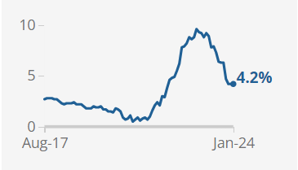
ONS, 2024

Therefore, children who are living in poverty and are being seriously impacted by this are openly getting involved with Serious Organised Crime groups just so they have a financial gain to afford basics. According to (GOV, 2011), organised crime will always have a direct correlation with poverty. People who live in underprivileged areas, are already engaged in low-level criminal activity, or have familial or other connections may be more likely to become involved in organised crime in the UK. To maintain themselves or their family, some people are drawn to engaging in activities that help organised crime groups, either directly or indirectly. Even though there is a sizable budget for international aid and development, poverty remains a key worldwide motivator. With the cost-of-living crises still increasing, it is inedible that those children being exploited will only increase unless police and partner agencies make a positive impact to tackle CCE and CSE.

2.2 County Lines in the Modern Era
According to the 2018 Home Office Serious Crime Strategy, gangs and organised criminal networks that use dedicated cell phone lines or other types of "deal lines" to export illegal drugs into one or more importing areas [within the UK] are referred to as "county lines" by the NPCC. They frequently use coercion, intimidation, violence, including sexual violence, and weapons. They are likely to take advantage of children and vulnerable adults in order to move and store the drugs and money (National Crime Agency, 2018).
The National Crime Agency reports that 88% of police areas in England and Wales have either an established or emerging County Lines problem in their area, with an estimated 46 053 aged 10–18 years in England in a gang ran by a Serious Organised Crime group that is highlighted by the National Crime Agency. Cities, towns and rural areas across the UK are supplied with drugs by multiple county line gangs. The National Crime Agency also states that within January 2019, that approximately 15% of the county ling gangs are covered within the Metropolitan Police Service area. This result is the greatest percentage of county lines within the UK (National Crime Agency, 2019).
Over the past several years the evolution of UK drug markets has gathered national attention of everyone within the UK due to media etc. The recent review of Drugs by Dame Carol Black (Black, 2020) shows that the UK drug market is worth approximately £9.4 billion a year. This is because of the development of drug distribution and supply networks from the urban areas to the smaller town areas. This is where the children are exploited within the county lines system. According to Hay and colleagues (2019), 313,971 people in England between the ages of 15 and 64 who used opiates and/or crack cocaine in 2016–17. According to estimates from the National Drug Treatment Monitoring Systems (NDTMS), 279,793 people received structured treatment in 2016–17.
Furthermore, the study (Black,2020) also found that 86% of the drug-related costs to individuals and society are concentrated in the markets for heroin and crack cocaine. (Black,2020) also highlights that county lines are always profitable; an individual line's potential earnings is estimated to be over £800k annually. A significant contributing factor to the rise in drug-related violence in the UK appears to be the county lines business model, along with the expansion of the crack cocaine market and the growing involvement of youth in the drug supply chain. Children (ages 11 to 15) who use drugs are more likely to be involved in the supply of drugs as a result of the trend of young people getting involved in drug use. Since 2014, this has increased by 40%. This phenomenon is observed in a diverse array of substances.
These exploited children are transported throughout the United Kingdom to distribute drugs to other cities and towns. Trains are primarily used by the kids who are being used as props to transport drugs throughout the United Kingdom. The train use within county lines is used at a total amount of 40%. Compared to a taxi which is used at a total of 1%. The reasoning behind this is because a train is the most direct use of transport therefore utilising those exploited efficiently and making the most amount of money as quickly as they can.
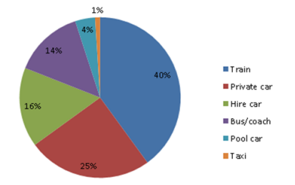
Method of transport associated to County Lines (NCA, 2019)

The above highlights just how significant county lines is within the UK. Black (2020) and the above research clearly identifies that children involved within county lines activities are only increasing. With the increase in percentages over the years on those involved with the drugs and running the county lines, it’s clear the children need stronger safeguarding against Serious Organised Crime and those targeting them to exploit them within a county lines system. By conducting a questionnaire with those linked to police organisation, it will assist to highlight how police in a pacific area of the UK indicates how drugs are used, instead of the UK as a whole. Therefore, by exploring this issue via a questionnaire I can gain a more direct answer to compare it to the above research.

2.3 The role of the Police dealing with these incidences.
The Police has the role and responsibility to respond to children when there is a raised concern. Although, each response will be dealt with differently based on the circumstances. This is because, (College of Policing) indicates that CSE and CCE is not a specific criminal offence. It encompasses a range of different forms of serious criminal conduct and a number of individual offences. Therefore, police who are responding have to identify the risks and concerns correctly so that the concerns are dealt with correctly. (College of Policing, 2021), highlights that ‘’CSE and CCE investigations require a proactive approach to explore the nature and patterns of exploitation locally, and to share information with partner agencies about those at risk and potential offenders’’. When attending police officers respond to these calls, if the officer attending highlights a possible vulnerability, the officer will submit a Public Protection Notification (PPN). When an officer discovers a "Child at Risk" while performing their duties, they complete a PPN and submit it electronically to the Safeguarding Referral Unit (SRU). After reviewing and evaluating PPNs, the SRU officers forward them to the local authority's children services department for consideration of a safeguarding investigation (Dorset Police, 2015).
Upon research, College of Policing, 2021 has highlighted that the guidance for police has been written following a series of high-profile cases. These being, ‘’ Operation Span, Operation Retriever and Operation Bullfinch’’. Although this guidance was written in 2012/2013. Even though it does highlight the need of a continuous approach to identify the risks of exploitation, with the guidance being provided over ten years ago and how fast each incident is developing, an updated guidance may be required as those serious organised crime groups exploiting the vulnerable, will always find new ways on how to do so to actively avoid the police as much as they can. Following this, even though it is only eleven years ago, policing since then has had a dramatic change as a whole. This indicates that the training provided to police may be outdated to assist with police identifying those being exploited. Throughout my own personal research via a questionnaire, the training to active police constable with be questioned in identifying if the guidance provided is outdated to modern day policing.
Preventing victims from being exploited requires identifying and stopping those who engage in county lines exploitation. Similar to this, bringing up safeguarding issues with the police or other relevant organizations like social services can help impede investigations and disruptions of Serious Organized Crime. Police can apply civil orders to deter those responsible for serious organized crime once they have gathered sufficient evidence against them. Telecommunication Restriction Orders for Drug Dealing and non-statutory instruments like Child Abduction Warning Notices (CAWNS) are examples of this (Home Office, 2023).
Effectively CAWN’s are warning letters to those that are believed to be involved in harbouring children. In recent years CAWN’s have become a valuable tool in the fight against CSE. Now, they are also being used in some cases of CCE and are normally served upon members of county lines and Serious Organised Crime networks to prevent children being harboured. Several individuals from the police and partner agencies should be involved when deciding whether a CAWN should be served on someone suspected of harbouring a child. Usually, CAWN’s will be considered in a case where the child is already known to or is an open case to Children’s Social Care (CSC). Therefore, generally CAWN’s will be part of a wider discussion at either a missing or sexual exploitation strategy meeting relating to the child at risk. Although CAWN’s are not covered by any legislative statute. Therefore, the actual breach of the notice is not a criminal offence (Safeguarding Hub, 2018).
Therefore, this indicates a clear grey area on how the police can help protect a vulnerable child that is at risk of CSE and/or CCE. This is because if a subject is to breach that CAWN, without it being a criminal offence it allows that subject to breach it freely without being criminalised. With those being issued CAWN’s being involved with serious crime as it is, a CAWN being placed on them will not stop them from continue targeting vulnerable children to exploit. Within the questionnaire, issues regarding CAWN will be explored on just how effective it is to protect those at risk.

2.4 Conclusion
This chapter has now achieved objective one: To provide an analysis of relevant, key and academically valued sources of literature regarding the topic of Child sexual exploitation/Child criminal exploitation within Serious Organised Crime and the role police has in an environment where serious organised crime is evolving. A full Resource Matrix breakdown can be viewed in Appendix A of the dissertation.
To conclude, under this section of the dissertation, the literature review has informed and made clear that the risk of which children are at of CCE and CSE is only increasing day by day. Following this, responding police constables need further training regarding on how to identify CCE and CSE early so that those at risk can be assisted to be kept safe from Serious Organised Crime groups. Therefore, showing that there is still a clear grey area regards to the academic input surrounding the precise training and inputs regarding how to tackle CCE, CSE and Serious Organised Crime groups. Furthermore, it has become evident by both personal research observations whilst reading, but also by authors such as Black (2020) that there is only an increase in activity regarding CCE and CSE, with county lines being the leading impact for children being exploited on a day-to-day basis.
The methodology that I believe will be most appropriate and suitable to conduct primary research regarding the gaps that were noted in the literature review will be the subject of the next chapter of this dissertation.

Chapter 3 – Methodology

3.0 Introduction
The previous chapter of the dissertation achieved objective one of this study after analysing key existing literature investing the topic of Child Criminal Exploitation/ Child Sexual Exploitation within Serious Organised Crime. This chapter of the dissertation seeks to achieve objective two of the dissertation which is: To identify the most suitable research approach required to appropriately conduct the research project and the sensitive topic of Child Criminal Exploitation/ Child Sexual Exploitation within Serious Organised Crime.
Research is defined as a punctilious and systematic enquiry process designed to explore and unravel specific subjects or issues with accurateness. This methodical approach encompasses the thorough collection, accurate analysis, and insightful meaning of information, aiming to consider deep into the nuances of a chosen field of study. By adhering to established research methodologies, investigators can draw significant conclusions, fostering a remote understanding that contributes importantly to the existing knowledge base (Alam, 2023). Therefore, throughout this chapter I will be using two main forms of research. This being primary and secondary research. Primary research described by (Gratton & Jones, 2010) as research that has involved the collection of original data specific to a particular research project and gathers information first-hand rather than relying on available information in databases and other publications. Therefore, I will be able to gain primary data from sources such as Questionnaires.

Whereas secondary research is defined by (Bouchrika, 2021) as involving the summary or subtraction of data and literature that has been organised and published by others. When doing secondary research, researchers use and analyse data from primary research sources. Therefore, due to the academic gap surrounding the specific research question of Child Criminal Exploitation/ Child Sexual Exploitation within Serious Organised Crime, secondary research will prove vital throughout. The secondary sources that will be used throughout will be sources such as, textbooks, specialist books, and web pages.

As identified in chapter two, primary research will be needed to support in answering the project's question. To determine better understanding of the research process, this chapter will now clearly identify the intended methodology of this research project.

3.1 The Research/Data Analysis Spiral
When looking at specific research techniques regarding the route to collecting primary data, one of the many used methods used in academic writing is followed using ‘’The Research Spiral’’ or also commonly known as ‘’The Data Analysis Spiral’’ created by Creswell and Porth (et al., 2018)
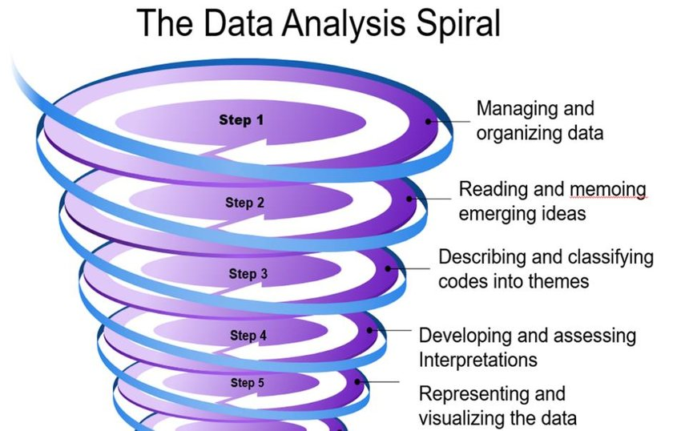
Figure 3.1 – The Data Analysis Spiral – The Research Spiral (Source: Creswell and Porth et al., 2018)

3.1.1 Managing and Organizing Data
The first step in the data analysis is managing and organising the data. To assist with the first step the research strategies as previous explained above regarding primary and secondary resources will assist to gain data. By conducting this, it allows for the data researched to be placed into a form of questions within a survey format.
By managing and organising data during the first stage, it assists to conduct and effective survey. This is because after reviewing and managing data that has been researched, it will determine who will participate within the survey.
3.1.2 Reading and Memoing Emergent Ideas
Once the data is managed and organised, step two and reading and emergent the ideas will assist to design the survey questions to identify the information within the gaps in the academic research.

3.1.3 Developing and Assessing Interpretations
A survey consisting of pre-written questions was sent to participants in order to collect data regarding the qualitative interviews due to time constraints and individual circumstances.
Survey research (McCombes, 2023) entails asking a group of people questions in order to gather information about them and then analysing the answers from those survey questionnaires to assist in filling in the gaps through academic research.

3.1.4 Representing and Visualizing the Data
The final step in the Data Analysis Spiral involves representing and visualizing the data. During this final step, I will be completing a visual representation such as graphs to show my findings throughout.

3.2 Reliability and Validity
Validity and reliability are means of illustrating and conveying the thoroughness of research procedures and the reliability of research results. Research must not mislead its users if it is to be beneficial. According to Murphy and Dingwall (2003), following protocols by themselves is insufficient to yield reliable results. The reliability and validity of research should be taken into account from the beginning when reading published research.
3.3 Ethical Considerations
Ethical considerations are crucial when conducting such a delicate research project, which is why a comprehensive ethics form was completed before the project began to guarantee that every aspect of the project was approved. As per the to the UWTSD-approved ethics form, participation was entirely voluntary, and participants retained the option to decline or withdraw at any time during the project. So, although qualitative surveys facilitate a more candid conversation between the participant and the researcher, participants' right to remain anonymous was upheld to protect the privacy of those who volunteered their time to help with the project.
3.4 Conclusion
This chapter has accomplished the second goal of the project by successfully identifying the form of methodology to identify the most suitable research approach required to appropriately conduct the research project and the sensitive topic of Child Criminal Exploitation/ Child Sexual Exploitation within Serious Organised Crime. The data gathered during the research project's collection phase will be presented and analysed in the dissertation's following chapter.

Chapter 4 - Data Analysis

4.0 Introduction
To identify themes regarding police officers' and staff's involvement in incidents involving child sexual exploitation and child criminal exploitation, whether the training provided is adequate, and whether the results to protect those from being exploited have been successful, this chapter of the dissertation will compare the responses to the questionnaire that was submitted and can be found in the appendix ‘6.2’ and ‘6.3’. This chapter will address the primary goals of this dissertation and examine the responses provided by the participants in the questionnaire. A separate unanswered questionnaire can be located on appendix ‘6.0’.

4.1 Participants
A total of 25 Participants took part in the questionnaire that was made available to Gwent Police officers and staff by the Gwent Police Intranet. This was available for a period of three weeks. Of the 25 participants 13% of those were aged between 18-24, 25% aged between 25-34, 17% aged between 31-40 33% aged between 35-44, 13% aged between 45-54. With 64% of those being a Police constable, 12% of those being a police Sargent, 4% of those being a Police Community support officer, 8% of those being police staff and 12% considering themselves as other. The length of service in participants within the police force was that 60% participants had less than 5 years’ experience, where 40% of participants had more than 5 years’ experience. These figures identify the amount of service within the force is not important when dealing with Child Criminal Exploitation and Child Sexual Exploitation incidences and as the literature review highlights the rapid increase in exploitation, the likely of officers and others involved in the police organisation dealing with these incidences are also at an increase to what they may have been in previous years.
Most responses to the questionnaire came from response officers. This being with response being first responders before the incident being dealt with by other specialised units such as CID and PPU.

4.2 Attending incidences involving Child Criminal Exploitation and Child Sexual Exploitation within Serious Organised Crime
Of the 25 Participants, 20% had responded that they always attend incidences involving CCE/CSE, 16% have often involvement within these incidences, 36% sometimes have an involvement, 20% rarely have an involvement and 8% never have an involvement.
Also of the 25 participants, 20% has responded that they always deal with serious organised crime, 12% often deal with Serious organised crime, 20% sometimes having an involvement, 40% rarely dealing with organised crime and 8% never dealing with serious organised crime.
Also of the 25 participants, 20% has responded that they always deal with County lines incidences, 8% often deal with County lines, 28% sometimes having an involvement, 28% rarely dealing with County lines and 16% never dealing with County lines incidences.
The literate review highlights that the majority of children being exploited criminally and sexually are linked to serious organised crime groups and ‘county lines’, however these results highlight that not all those being exploited are linked to serious organised crime and are being exploited by others not linked to serious organised crime.

4.3 Training regarding Child Criminal Exploitation and Child Sexual Exploitation within Serious Organised Crime
24% of participants have highlighted that they strongly disagree that they receive regular training inputs of how to identify with CCE/CSE, 32% disagree that the receive regular inputs, 20% neither agree or disagree with receiving regular training, 20% agree that they receive regular training and 4% strongly agree that they receive regular training regarding CCE/CSE.
Even though training is provided to all officers, 16% of participants have highlighted that they strongly disagree that they have confidence regarding the CCE/CSE training, 28% that they disagree in having confidence regarding the CCE/CSE training, 32% neither agree or disagree with the confidence of the training, 20% agree that they have confidence regarding the CCE/CSE training and 4% strongly agree that they have confidence regarding the CCE/CSE training.
24% of participants have highlighted that they strongly disagree that they receive regular training inputs on how to identify Serious Organised Crime and County Lines, 48% disagree that the receive regular inputs, 12% neither agree or disagree with receiving regular training, 8% agree that they receive regular training and 8% strongly agree that they receive regular training inputs on how to identify Serious Organised Crime and County Lines.
These figures highlight that the guidance written in 2012/2013 which is highlighted within the literature review may be outdated and further regular inputs are required for officers with every day-to-day policing changing all the time and the guidance provided may not be as suited as thought and the guidance needs further work to suit modern day policing.

4.4 Protection outcomes to support those exploited by Child Criminal Exploitation and Child Sexual Exploitation
39% of participants have stated that they have never had to use a CAWN to protect those vulnerable to exploitation. 26% of those have stated that they have had to use it on 1-2 times, 26% have used a CAWN 3-6 times, 4% of those used it 7-10 times and 4% of those have used it more than ten times.
For those who have participated, 44% of those have answered ‘yes’ to a CAWN being effective when it comes to safeguarding those vulnerable and 56% of those answered ‘No’ to a CAWN being effective when it comes to safeguarding those vulnerable.
These figures mainly agree with the literature review as the literature review highlights that due to a CAWN not being covered by any legislative, if anyone is to breach a CAWN, there is no criminal offence within breaching the CAWN and therefore does not stop them persons from breaching it.

4.5 Conclusion
During this chapter, the objectives set forth have been met, by comparing the participants answers on the questionnaire to the research found in previous chapters. It is found that officers and staff do deal with those children being exploited criminally and sexually within day-to-day policing no matter the role. Although they are dealing with this within a day-to-day role, the regular training provided is not where it is required to assist those dealing with the incidences. Also, those investigating the incidences and use a tool such as CAWN to protect them, is not as effectively as they hoped and resulting to those still possibly being exploited.

Chapter 5 - Findings and Conclusion

5.0 Introduction
The introduction, literature review, research chapter, and analysis have all been covered in the earlier chapters. In order to conclude the dissertation with a suggestion for additional research, this chapter compares the results of the literature review and analysis from the earlier chapters. Additionally, to offer a logical conclusion. Along with summarising the primary research goals, this chapter will also highlight any constraints encountered during the dissertation's completion.

5.1 Findings
The main question of research within the literature review was ‘’To critically research and analyse previous and current academic literature and research to understand the surrounding of Child sexual exploitation/Child criminal exploitation within Serious Organised Crime, and the role the police have to prevent the exploitation.’’ Throughout the literature review, this was answered. This was answered by conducting research the identify the definition of Child Sexual Exploitation and Child Criminal Exploitation. Also identifying the definition of Serious Organised Crime and how all three are linked within County Lines. Within the dissertation questionnaire, only 8% of the participants have confirmed that they have never attended an incident linked to a person being exploited criminally and/or sexually.
The second question put within the dissertation, ‘’How do police officers deal with these incidences and the role the police have to prevent the exploitation’’ was answered within the dissertation. 44% of participants believed that when dealing with an incident with a person’s being exploited, when trying to safeguard that exploited person, a CAWN to be an effective safeguarding measure.
The main themes found within the research was that officers and staff highlighted that those believe further training is required to help identify those being exploited and more regular training may assist this. This is highlighted within the questionnaire where 56% of participants highlighted that the training regarding Child Criminal/Sexual Exploitation needs to be conducted more regularly to assist them in their day-to-day role and that only 24% of participants had agreed and/or strongly agreed to have confidence in the training that is provided to them over Child Sexual Exploitation and Child Criminal Exploitation. Also, those who have provided training has indicated that regular training over the matter does not happen, this has been identified within the questionnaire where 64% of participants have stated it has been over one year since they have had a training input on Child Criminal Exploitation and Child Sexual Exploitation with 40% of participants are either extremely dissatisfied or somewhat dissatisfied. It was also identified that those who had participated on the questionnaire, 50% of the participants had stated that an attachment with a specialised units such as the Public Protection Unit (PPU) who specialised in safeguarding children from crime.

5.2 Future Research
From the literature review and questionnaire, it is still unclear if there is an actual effective safety measurement in place to protect those children being exploited criminally and sexually. Although this dissertation identifies what is Child Sexual Exploitation and Child Criminal Exploitation, and how police deals with the incidences. Further research can be done to identify other solutions on how police support and safeguard those being exploited and other tactical methods used to prevent those being exploited again in the near future.
The further research can aim to identify as highlighted within the literature review and this dissertation questionnaire, ‘’How do police officers deal with these incidences and the role the police have to prevent the exploitation’’ The dissertation has also provided an opened research opportunities into how the police continue to support those that had been exploited after the investigation has completed. This is because the questionnaire present, has identified that a CAWN to safeguard those has only been 44% effective, therefore further support will be required further down the line of the investigation.

5.3 Recommendations
The recommendations provided within this dissertation are based on a comparison of the literature reviewed and the responses provided in the dissertation questionnaire, rather than being solicited from any experts.
From the literature review, and the answers received within the questionnaire, it is evidential that the training provided within Gwent Police is outdated and needs updating to provide suitable training to the officers dealing with these incidences. College of Policing (2021) has identified that the training provided to police was completed and written in 2012/2013 following a series of high-profile cases. The problem with the training being outdated is identified within the questionnaire, where 48% of the participants have stated they disagree or strongly disagree that they have confidence in the training provided, with 32% neither agreeing nor disagreeing. Therefore, identifies that the training is provided to police regarding Child Sexual Exploitation and Child Criminal Exploitation is not as beneficial as the force believes it to be and those being provided the training is not confident for that training to assist them whilst dealing with real-life incidences.
Another recommendation would be that another form of protecting those children from being exploited needs to be identified and applied. This is because, from the literature review and the answered gained from the questionnaire, Home Office (2023) has identified that a Child Abduction Warning Notice (CAWN) is a warning letter to those believed to be involved in harbouring children, and as of this has become a valuable tool in the fight against CSE and CSE. Although, those who have participated within the questionnaire, 56% of those participants have identified that when using a CAWN to protect one being exploited, it hasn’t actually been effective. Therefore, to assist those being exploited and to protect them, it is vital for a new tool to be identified to protect those. This wont only help those being exploited, but also gain a more positive experience for those being exploited and close ones having a positive mindset on the police as they will believe we are making a difference and protecting the public.
A final recommendation would be that police officers and staff that deal with those being exploited, should have a period of time on the specialised departments where they are only dealing with those being exploited. By doing this, officers who may only deal with those children being exploited from time to time, will have more experience dealing with them incidences and have an overall more confidence when dealing with the incident within the first response. This is because they will be able to learn and gain knowledge of other officers who always deal with these incidences and their knowledge may be more beneficial than classroom training as the officers knowledge will be more updated then the classroom training that’s provided.

5.4 Conclusion
This dissertation has provided insights around the issues of the training provided to police officers and staff to identify and deal with an incident involving those being exploited. The project objectives have all been answered herein. The main goal was to identify the following objective, ‘’Child sexual exploitation/Child criminal exploitation within Serious Organised Crime – How do police offer support to those in need to tackle Child sexual exploitation/Child criminal exploitation within Serious Organised Crime?’’ The main objectives throughout the dissertation have been answered throughout.
The conclusion of the dissertation is that whilst the second question was answered by participants answering a survey, has found that police officers and staff feel that the training provided to them to assist them in dealing with child criminal/sexual exploitation with serious organised crime was not significant enough to deal with the incidents within modern day policing. This was answered through the dissertation whereby participants were asked to comply within a questionnaire to see how those who deal with these incidences feel regarding the training provided and how if it is beneficial to assist them with those incidences.
To conclude, the longer a police officer length of service, the more outdated the training for Child Criminal/Sexual Exploitation is becoming, however even though the training provided is based on a series of high-profile cases, the training may need further updating based on modern day high-profile cases which suits the modern-day policing era. This clearly highlights the importance of regular updated training to be provided to modern day police officers so that all police officers are prepared to deal with any incident they are presented with and are able to deal with that incident with confidence and knowledge.
Chapter 6 – Appendix

6.0 Copy of Questionnaire
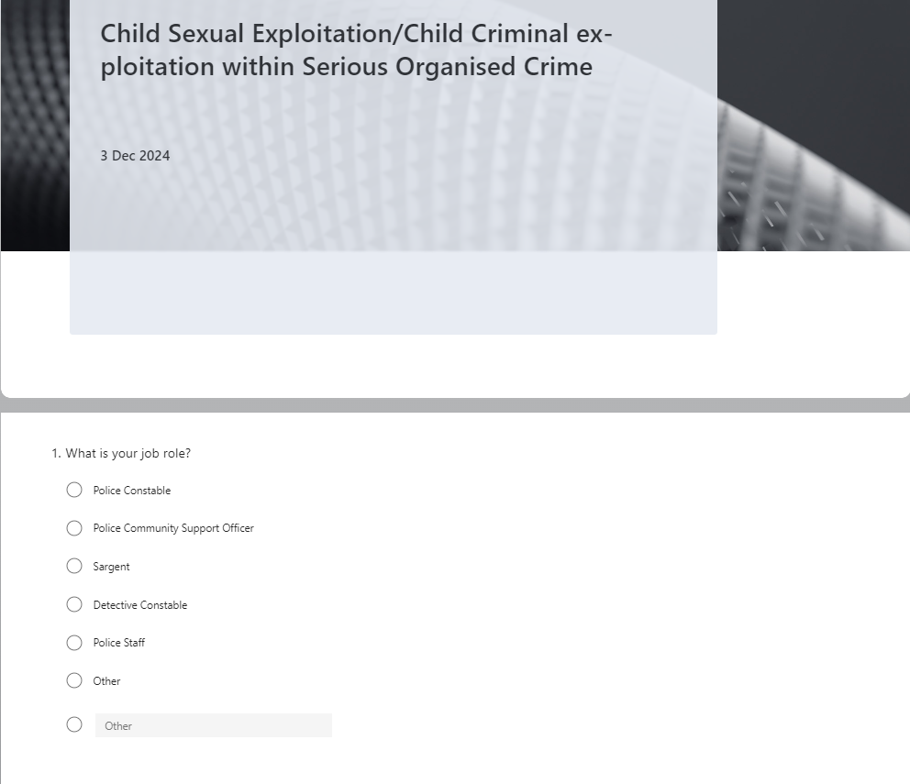



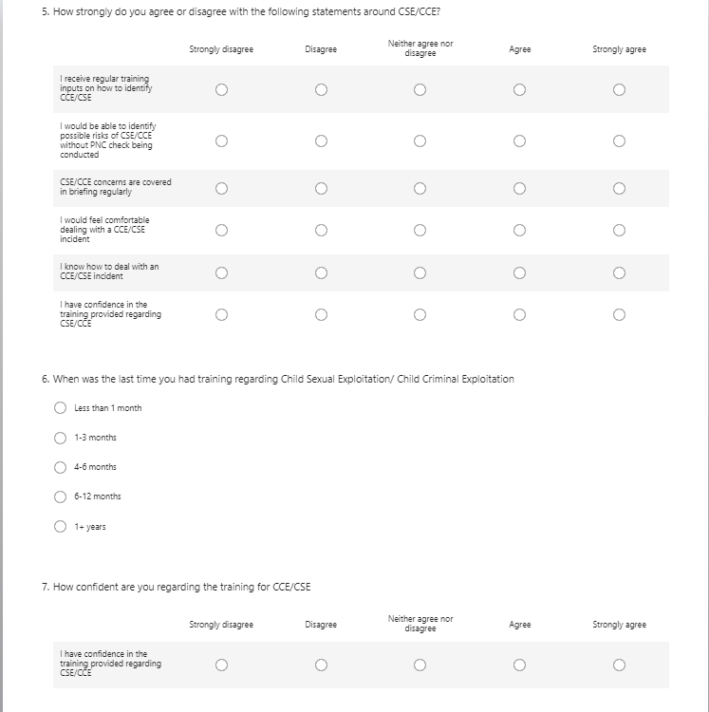

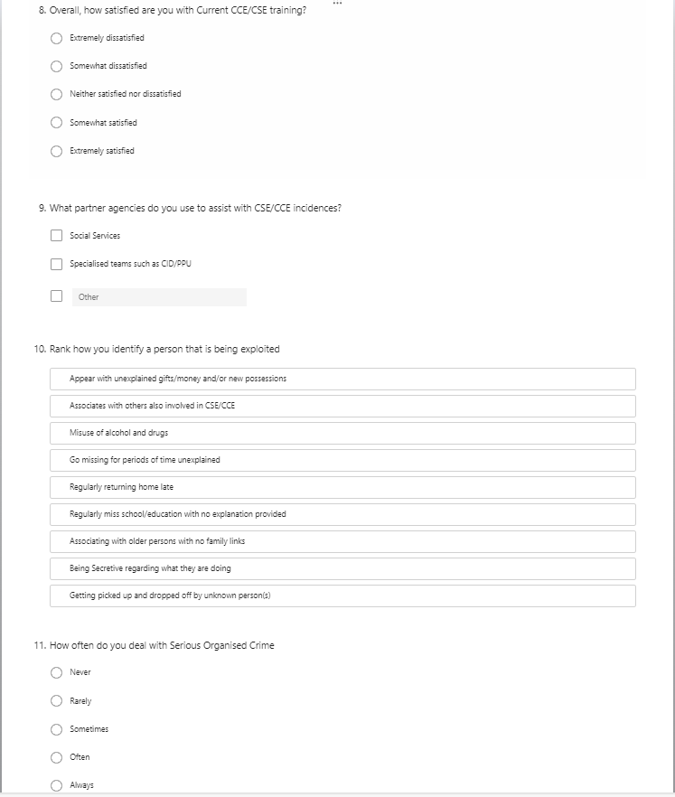

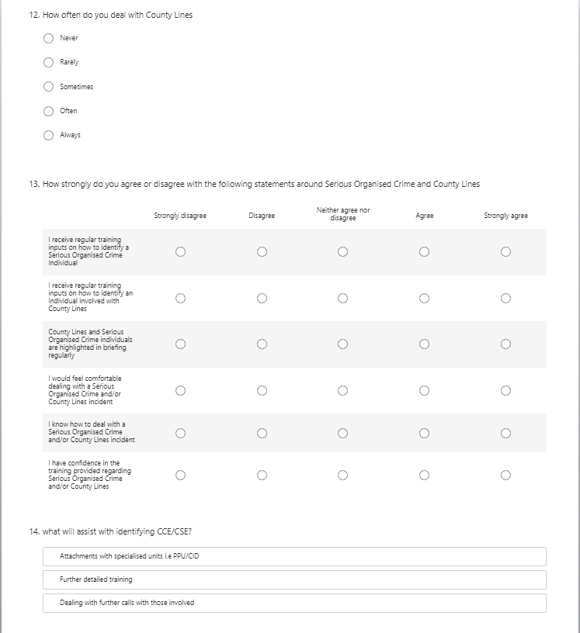
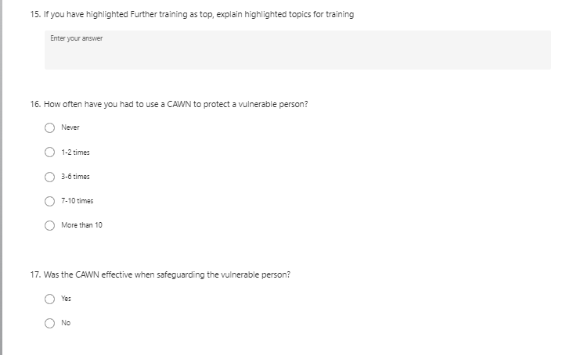

6.1 Ethics Form


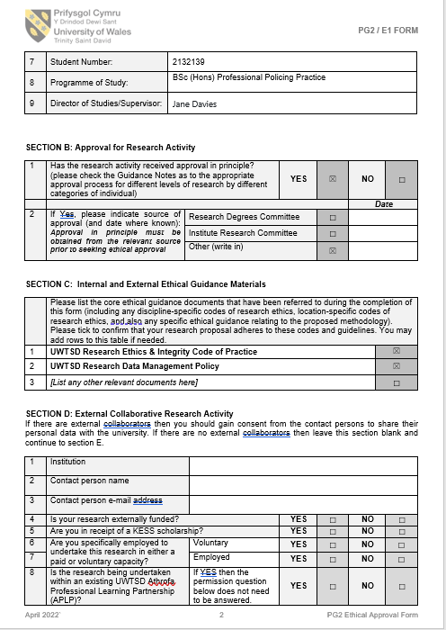
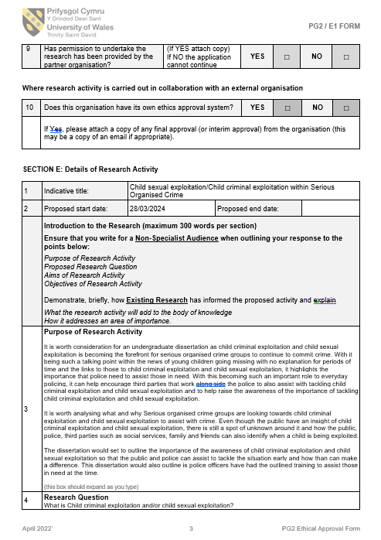
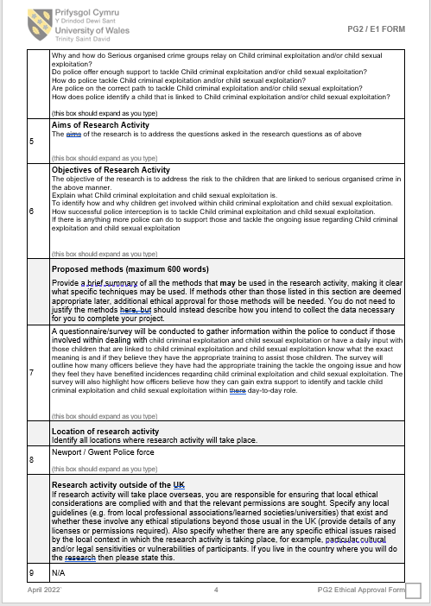
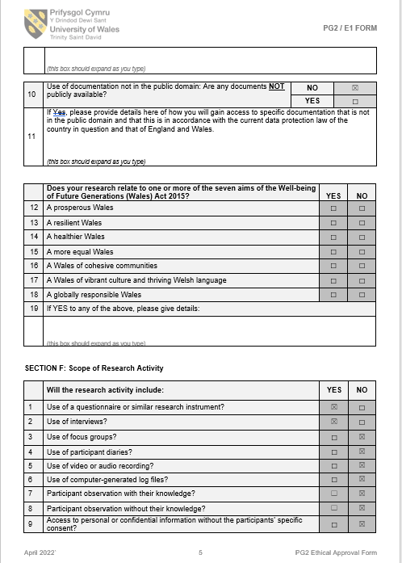
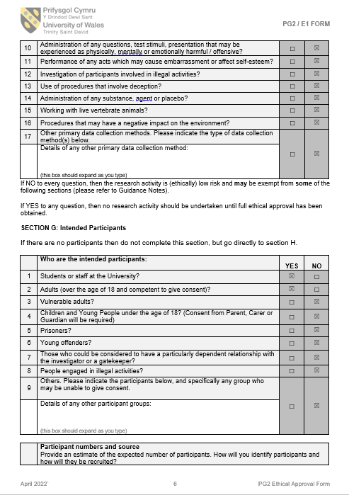

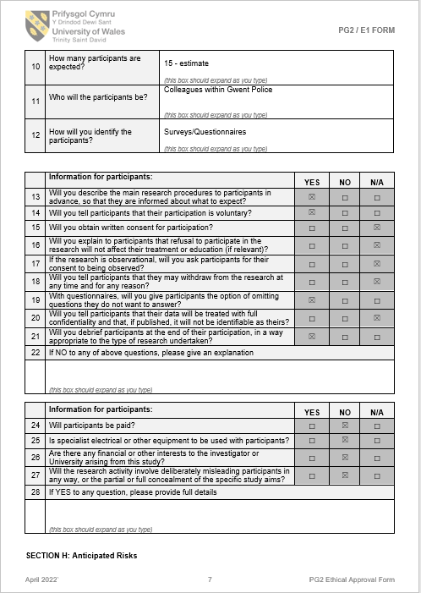
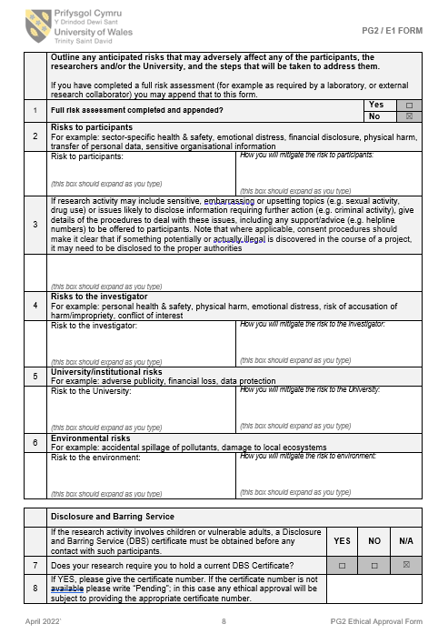
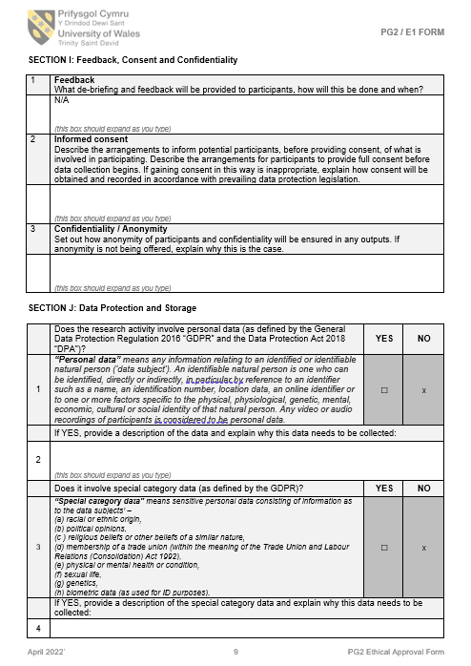
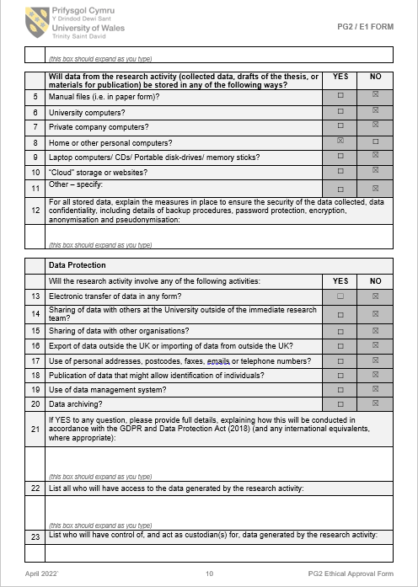
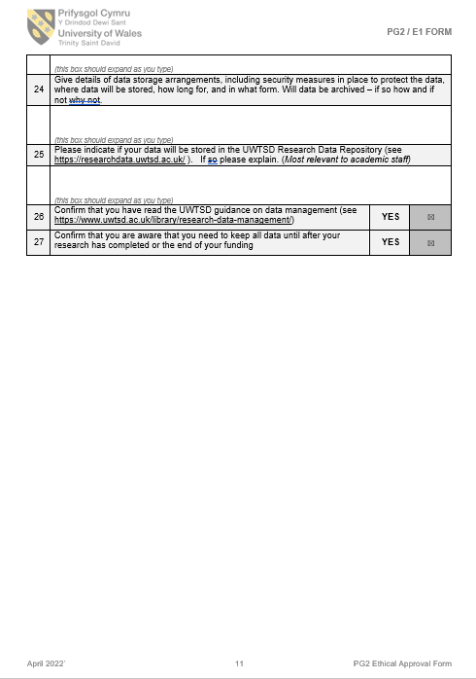
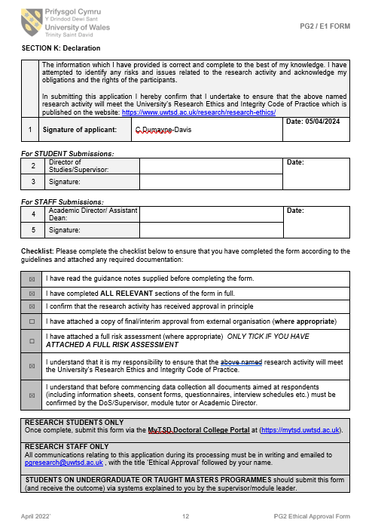

6.2 Questionnaire Answers – Question 1 to 9

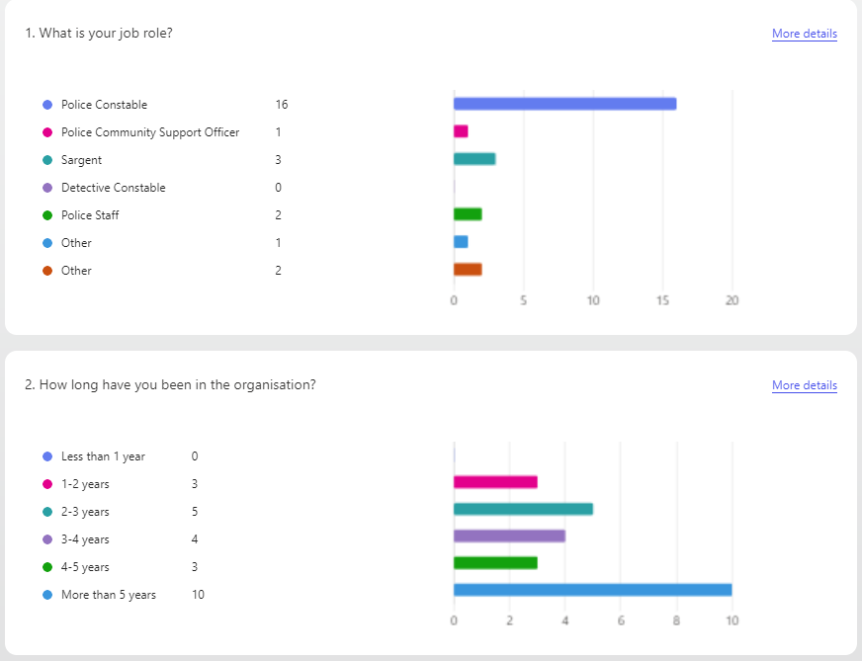
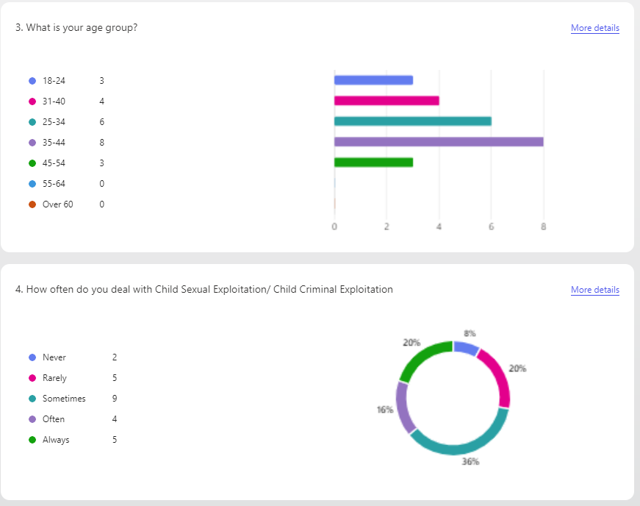
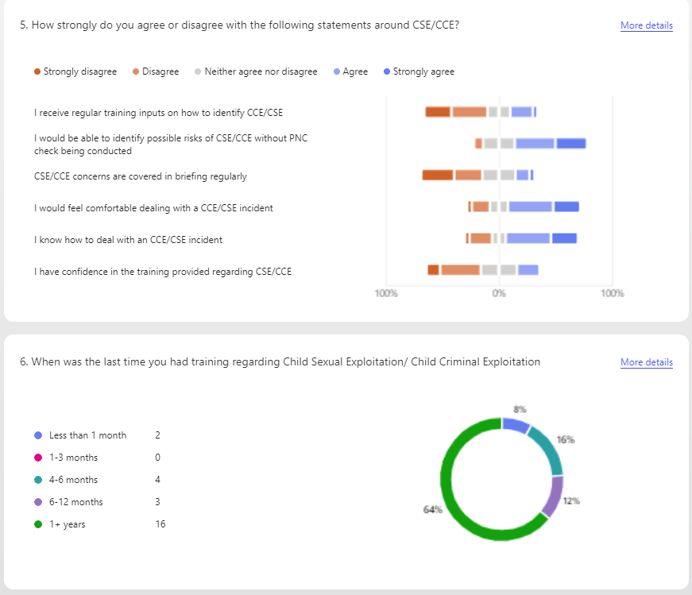
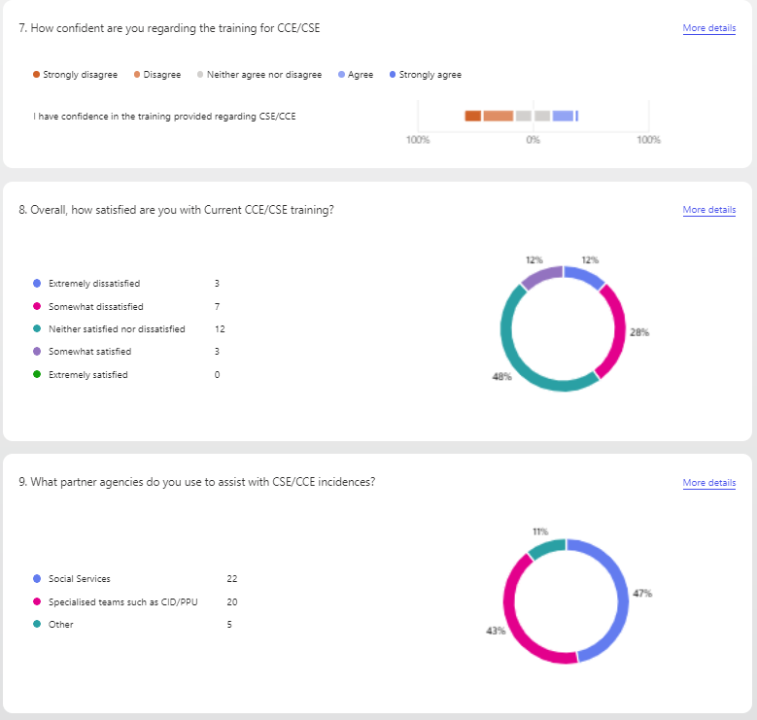

6.3 Questionnaire Answers – Question 10 to 17
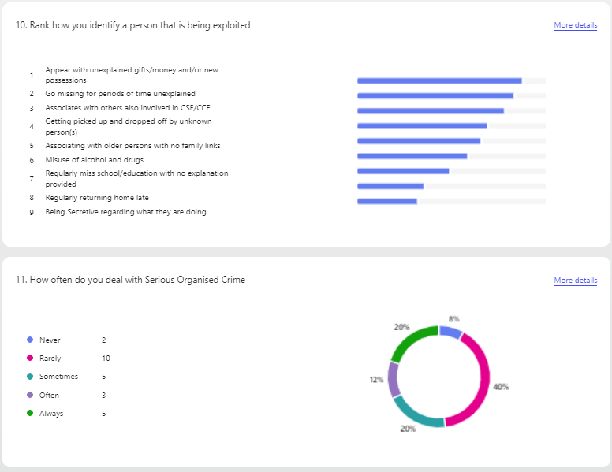
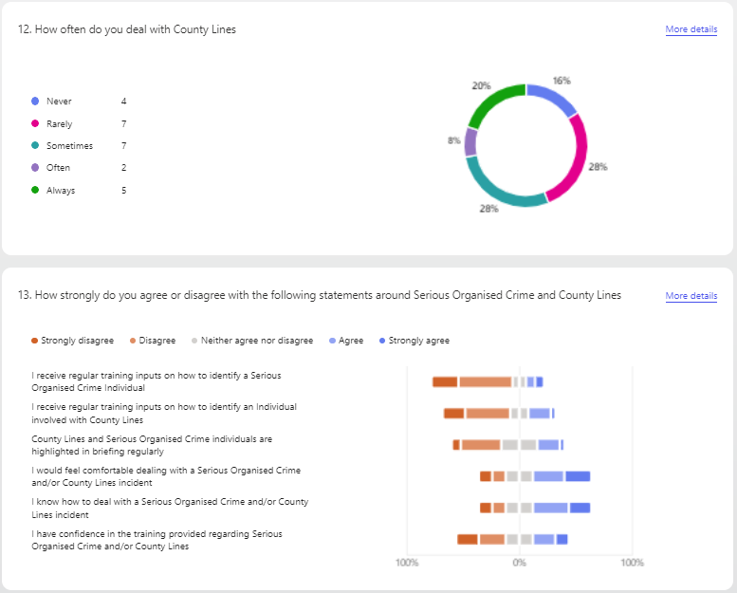
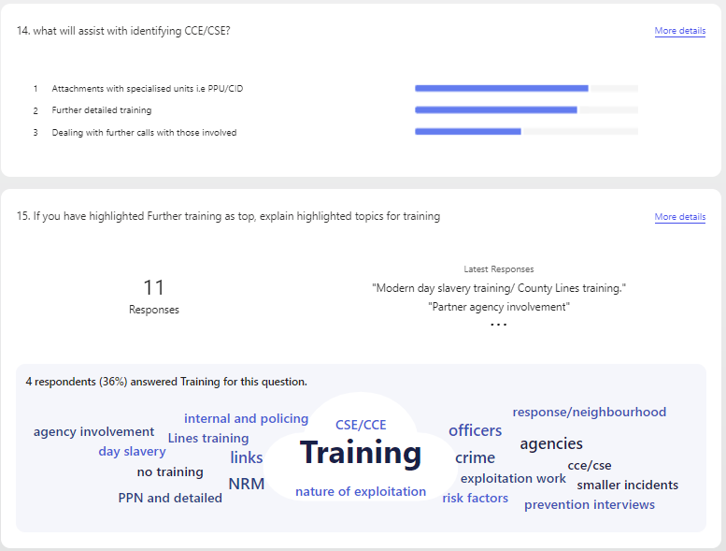

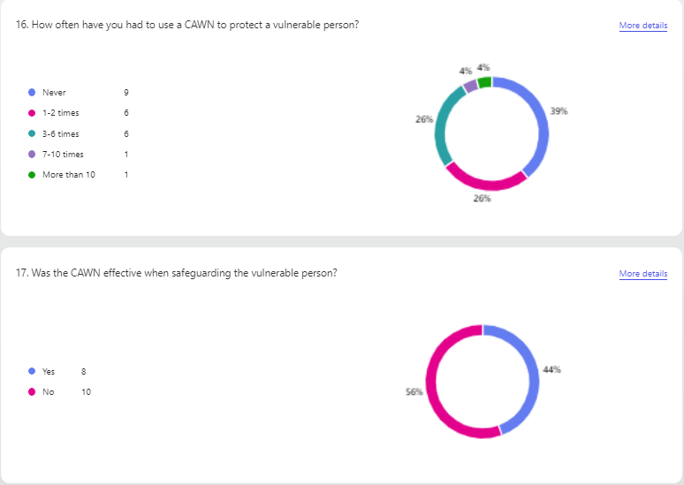
6.4 Bibliography

Alam, M. (2023). What is Research? Definition, Types, Methods and Process. [online] Available at: https://ideascale.com/blog/what-is-research/#toc_What_is_Research. (Accessed: 24th July 2024)

Black, C. (2020) Review of Drugs, Executive Summary. [online] Available at: https://assets.publishing.service.gov.uk/government/uploads/system/uploads/attachment_data/file/868438/2SummaryPhaseOne+foreword200219.pdf (Accessed: 26th June 2024)

Bouchrika, I. (2021). Primary Research vs Secondary Research: Definitions, Differences, and Examples. [online] Available at: https://research.com/research/primary-research-vs-secondary-research#secondary. (Accessed: 24th July 2024)

Brylczak, C. (2024). What is an Organised Crime Group? [online] Available at: https://www.olliers.com/news/what-is-an-organised-crime-group/#:~:text=An%20Organised%20Crime%20Group%20%28OCG%29%20is%20defined%20under (Accessed: 15th June 2024)

Cambridge Dictionary (2021). exploit. [online] Available at: https://dictionary.cambridge.org/us/dictionary/english/exploit. (Accessed: 3rd December 2024)

‌Child Criminal Exploitation and The Need for Consistency Report produced by the Human Trafficking Foundation. (2022). Available at: https://core.ac.uk/download/565836392.pdf. (Accessed: 15th June 2024)

College of Policing (2021). Responding to child sexual exploitation. [online] College of Policing. Available at: https://www.college.police.uk/app/major-investigation-and-public-protection/responding-child-sexual-exploitation/responding-child-sexual-exploitation. (Accessed: 26th June 2024)

Dorset Police Public Protection Notice. (2019) PPN. [online] Available at: https://www.bcpsafeguardingadultsboard.com/uploads/7/4/8/9/74891967/appendix_2_-_changes_in_dorset_police_since_completion_of_the_sar_dhr.pdf. (Accessed: 26th June 2024)

Gratton, C., & Jones, I. (2010). Research methods for sports studies (2nd ed.) [online] Available at: https://repository.stkipgetsempena.ac.id/bitstream/575/1/Research_Methods_for_Sports_Studies.pdf (Accessed: 24th July 2024)

GOV.UK. (2023). County Lines Programme. [online] Available at: https://www.gov.uk/government/publications/county-lines-programme. (Accessed: 15th June 2024)

Hay, G., Rael dos Santos, A., Reed, H. and Hope, V. (2019) ‘Estimates of the prevalence of opiate use and/or crack cocaine use, 2016/17: Sweep 13 report’, Available at: https://bdoc.ofdt.fr/index.php?lvl=publisher_see&id=4445 (Accessed: 26th June 2024)

Home Office (2023). Criminal Exploitation of children, Young People and Vulnerable Adults County Lines. [online] Available at: https://assets.publishing.service.gov.uk/media/65322ad1e839fd001486720d/2023_FOR_PUBLICATION_-_Criminal_exploitation_of_children_young_people_and_vulnerable_adults_county_lines1.pdf. (Accessed: 5th July 2024)

Local to Global. (2011) Reducing the Risk from Organised Crime 2 Local to Global: Reducing the Risk from Organised Crime. (n.d.). Available at: https://assets.publishing.service.gov.uk/media/5a79a478ed915d07d35b70a3/organised-crime-strategy.pdf. (Accessed: 3rd October 2024)

McCombes, S. (2023). Doing Survey Research | A Step-by-Step Guide. [online] Available at: https://www.scribbr.com/methodology/survey-research/. (Accessed: 14th August 2024)

National Crime Agency (2018). County Lines - National Crime Agency. [online] Available at: https://nationalcrimeagency.gov.uk/what-we-do/crime-threats/drug-trafficking/county-lines. (Accessed: 26th June 2024)

National Crime Agency (2019). County Lines Drug Supply, Vulnerability and Harm 2018. [online] Available at: https://www.nationalcrimeagency.gov.uk/who-we-are/publications/257-county-lines-drug-supply-vulnerability-and-harm-2018/file. (Accessed: 15th June 2024)

National Crime Agency (2021). National Strategic Assessment of Serious and Organised Crime. [online] Available at: https://www.nationalcrimeagency.gov.uk/who-we-are/publications/533-national-strategic-assessment-of-serious-and-organised-crime-2021/file. (Accessed: 5th July 2024)
‌
Norman, J. (2024). Criminal Exploitation, Child Criminal Exploitation and County Lines. Available at: https://doi.org/10.1007/978-3-031-48319-6_5. (Accessed: 15th June 2024)

NSPCC (2022). Child sexual exploitation. [online] NSPCC. Available at: https://www.nspcc.org.uk/what-is-child-abuse/types-of-abuse/child-sexual-exploitation/#what. (Accessed: 15th June 2024)

ONS (2024). Cost of Living Latest Insights . [online] ONS Available at: https://www.ons.gov.uk/economy/inflationandpriceindices/articles/costofliving/latestinsights. (Accessed: 5th July 2024)

Safeguarding Hub (2018). Child Abduction Warning Notices (CAWN’s). [online] Safeguarding Hub. Available at: https://safeguardinghub.co.uk/child-abduction-warning-notices-cawns/. (Accessed: 5th July 2024)

‌

‌

‌

