

Reflections on SHEIN’s Marketing

Module：
Marketing Management (BMMB7012)
Name：Niu Chenchong
ID: 2106311
E-mail：2106311@student.uwtsd.ac.uk
Tutor：Davina Wyn Evans
Completion time：25-6-2022

Completion time

1 Introduction
1.1 The purpose of the report
By investigating the marketing issues within the process of development of SHEIN, this report tries to identify whether marketing activities within SHEIN were effective, and give sound justification for decisions.

1.2 Introduction of SHEIN
According to BT Finance(2022) and Burriter Business Review(2022), SHEIN is a cross-border e-commerce independent site, that is now a cross-border e-commerce unicorn valued at $100 billion in China. It is similar to the famous Business to Customer(B2C) online shopping platform JD, which is mainly self-operated and also allows third-party platforms to be stationed. Its main marketing strategy is to quickly capture the market with its low price advantage. Headquartered in Nanjing, with a marketing center in Guangdong, the company is invisible in the domestic market. Its main audience is young girls, which can be interpreted as an "online low-cost version of ZARA"(Li y., Zeng N.,2022)

Through an environmental audit, the corporate social responsibility (CSR) is the main issue faced by the corporate. That is defined in figure 1 below.
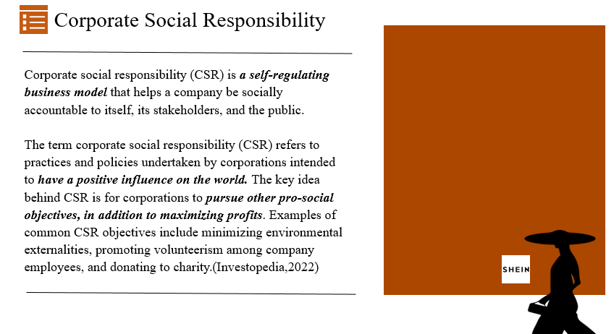
Figure 1 The dIfinaton of CSR
2 Main Findings
2.1 The Marketing Concept
Roland, Christine and Gaurav(2020) have rethought marketing, illustrating that companies can now interact directly with customers, they must radically reorganize to put cultivating relationships ahead of building brands. They attached much importance to “Building Relationships”, viewing customer relationships in B2C organisations as evolving over time, and they may hand off customers to different parts
of the organization selling different brands as their needs change. Firstly, it has a poor risk assessment for SHEIN of after-sales customer service because of a lot of time, money spent to reduce own costs. Secondly, in new markets in Brazil and India, Influenced by political and cultural factors,it also has problems to cope with the relationships with customers. Thirdly, resulted by the characteristics of the fast fashion industry and suppliers,there is negative public opinion about the use of low-cost labor and the lack of protection of human rights of SHEIN.
Report from McKinsey&Company(2020) confirmed the online sales boom, Growth in customers’ purchasing category of apparel increases 19% from June 15 to June 21, 2020. Therefore, the way of marketing also needs to be changed, Millennials and high-income earners are in the lead when it comes to shopping online. The crisis has prompted a surge of new activity, with an astounding 75% of U.S. consumers trying new shopping behaviors in response to economic pressures, store closures and shifting priorities. These changes argue for SHEIN to ensure strong availability while also delivering value, which places more stringent demands on SHEIN's upstream suppliers.

2.2 The Macro & Micro environments
2.2.1 The Macro Environment
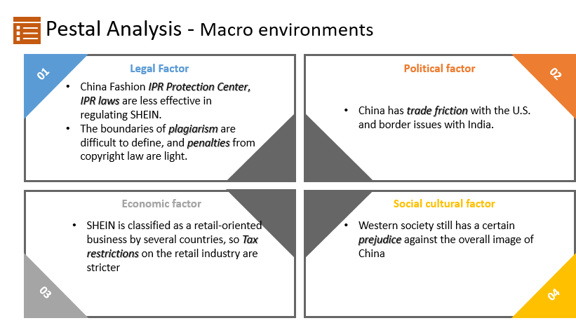
Figure 2 PESTEL Analysis of macro environments
As what is shown on the Figure 2, We can see four different factors both in the macro environment and micro environment in the SHEIN’s development.

- Legal Factor
China Fashion IPR Protection Center, IPR laws are less effective in regulating SHEIN，which has its entire business overseas. The basic legal research of intellectual property rights in China is still in the stage of advancement, and relevant laws and regulations such as patent law, trademark law, copyright law, anti-monopoly law, science and technology progress law, and e-commerce law are yet to be revised and improved. Strengthening legislation in the fields of geographical indications and trade secrets, and introducing regulations on trade secret protection is the next step of development. (CCTV News,2022)

The boundaries of plagiarism are difficult to define, and penalties from copyright law in western world are a drop in the bucket before the huge profits of the fast fashion industry. The special nature of the fashion industry has led to relatively broad and vague laws, and the laxity of the legal provisions has given the absence of CSR of some fashion industry practitioners

- Political factor
China has trade friction with the U.S. and border issues with India. Which has laid a bad brand image on the SHEIN. Local websites may be flooded with government regulations on Chinese brands, eroding consumer trust in the brand.

- Economic factor
SHEIN is classified as a retail-oriented business by several countries, and the tax restrictions on the retail industry are stricter in various countries compared to high-tech businesses. Excessive tax pressure has forced SHEIN to cut back on its expenses in terms of product costs, etc. Once the quality of the product itself is affected, the brand's reputation and social image will also be greatly diminished.

- Social cultural factor
Western society still has a certain prejudice against the overall image of China, especially Chinese products, giving them an inherent impression of cheap and low quality. Different cultures have different views of human nature, man's relationship with nature, relationship with others, and view of time and space. Once multinational companies do not localize well, it is likely to lead to negative people relationship(PR) events, resulted in the absence of CSR. (Kluckhohn &Strodtbeck,1976)

2.2.2 The Micro environment
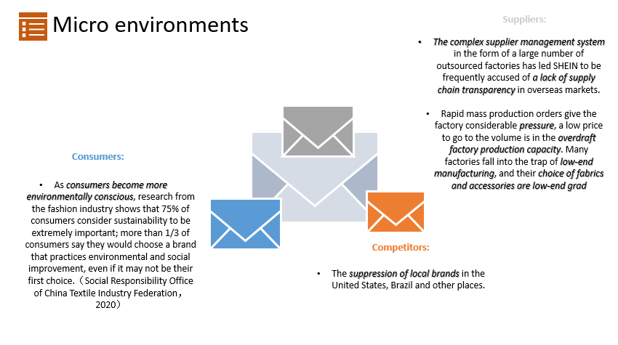
Figure 3 PESTEL Analysis of micro environments
- Suppliers
The complex supplier management system in the form of a large number of outsourced factories has led SHEIN to be frequently accused of a lack of supply chain transparency in overseas markets.
Rapid mass production orders give the factory considerable pressure, a low price to go to the volume is in the overdraft factory production capacity. Many factories fall into the trap of low-end manufacturing, and their choice of fabrics and accessories are low-end grade.

- Competitors
The suppression of local brands in the United States, Brazil and other places.

- Consumers
As consumers become more environmentally conscious, research from the fashion industry shows that 75% of consumers consider sustainability to be extremely important; more than 1/3 of consumers say they would choose a brand that practices environmental and social improvement, even if it may not be their first choice.（Social Responsibility Office of China Textile Industry Federation，2020）

2.3 The Target Market
2.3.1 Segmentation
The segmentation concept was first developed by Smith (1957) and is concerned with grouping consumers in terms of their needs, habits, that can be addressed through marketing activities.
SHEIN’s segmentation is Generation Z consumers demographic, mainly in European and American moving down-market. From the perspective of the layout of the client, the main customer group of fast fashion apparel is young consumers aged between 18 and 35 with high fashion sensitivity, which is consistent with the main consumer group of cross-border e-commerce.(Bloomberg, 2022)
This customer group is generally students or women who have just started working. They have a low level of income but a high sensitivity of fashion trends. Because they often update their wardrobes, their requirements on clothing quality is not so high.
So SHEIN used in vogue, low price promotion strategy to achieve an average of 2,000 models per day on the new.

2.3.2 – Targeting
SHEIN products are very inexpensive, as what is shown on Figure 4. A new design trendy dress is only sold for as little as $ 10. Almost all of the clothes cost no more than $20, to this against female consumers in developed countries, which help SHEIN to sit in the upper hand with the same category of offline fast fashion international women brands such as Zara, H&M (dresses for similar categories are about $40-50).
Gen Zers have some features, Across APAC, higher than millennials (22 percent) and Gen Xers (10percent), almost a third of Gen Zers spend six hours or longer a day on their phones. They rely on social media, but have a good idea of how to engage with it. Gen Zers tends to spend more time on their phones than other generations, and they prefer brands that show their personality and uniqueness.
Responding to these features, SHEIN needs to put more energy on social media and diverse marketing issues. (Buck, 2022)

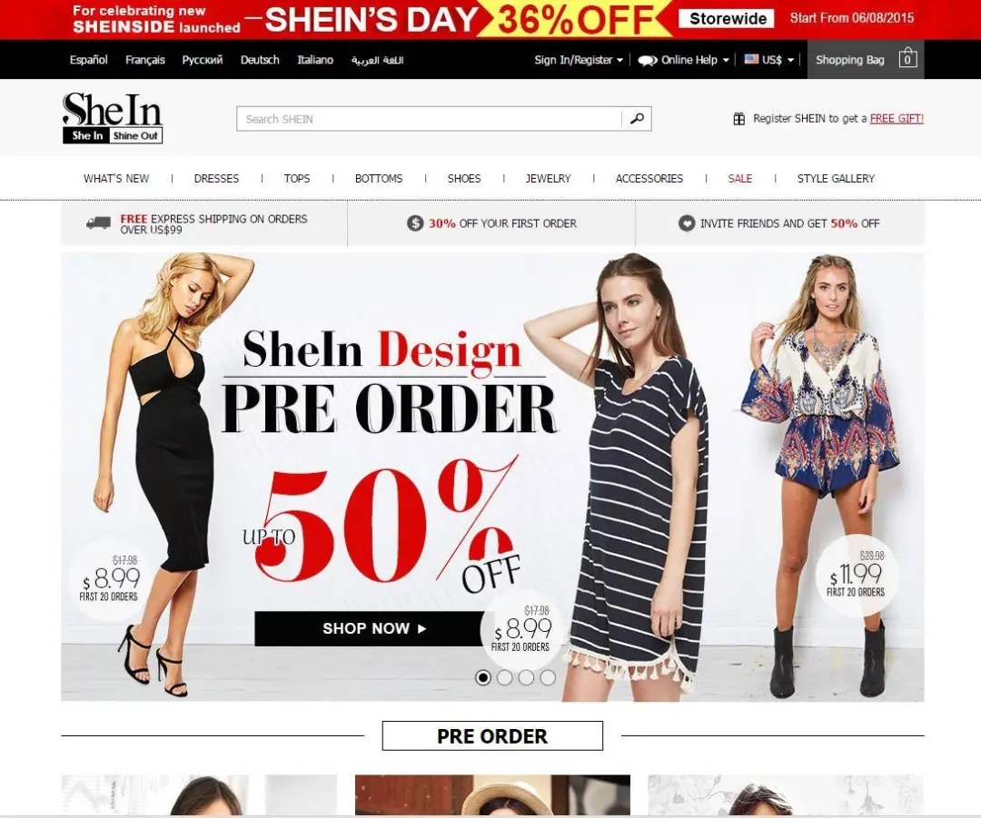
Figure 4 Offical website of SHEIN with varible discounts and clear volume

2.3.3 Positioning
SHEIN is China's first truly cross-border fast-fashion women's apparel e-commerce company, backed by China's developed industry chain, focusing on cross-border apparel, shoes and hats e-commerce B2C operations. The marketing strategy of SHEIN coincides with Trout's "positioning" theory(1969) , attempt toing create an image or identity for their product, brand or organization in the target market. It is the "relative competitive comparison" that the target market perceives their product to occupy in a given market. SHEIN's vision is to "create a world-class fast fashion brand platform", and the product is to "focus on fast fashion and create fashionable products for young people". The product positioning of "fashionable products" has apparently allowed SHEIN to remove the category limitation in the process of expanding its scale. Compared with Zara, H&M and other old fast fashion brands in Europe and America in Figure 5, SHEIN wins with faster update speed and cheaper price, but the process of expansion from women's wear to full category, from focus to comprehensive, is also the risk of losing focus.
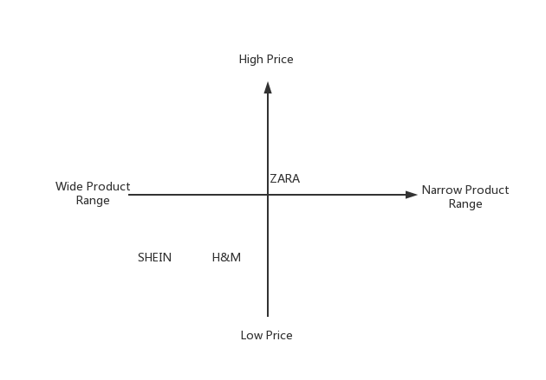
Figure 5 Posioning Map
2.4 The Marketing Mix
- Product
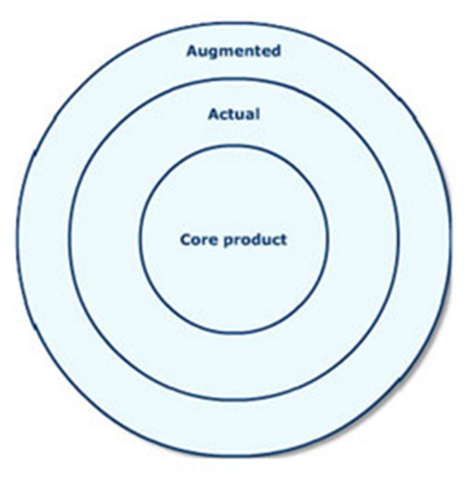
Figure 6 Three different levels to view a product

The core product of SHEIN is fast-changing fashion derivatives, what can also be called the designs of in vogue. Then is apparel itself, like dress, T-shirts, swimming suits. The last one is the is the additional value by chasing the fashion trend, the feeling of confidence, delight and freshness.

- Pricing Strategy
SHEIN has adopted an economy price strategy, which is deliberate to set low price. Compared to Zara in 2022 midyear sales season, SHEIN can achieve a half of the price advantage, what is shown in the Figure 7&8.
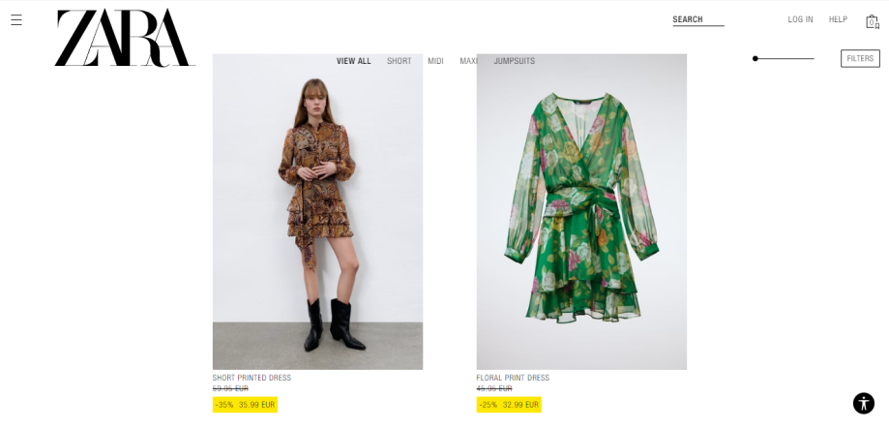
Figure 7 Zara offical website of 2022 summer discount
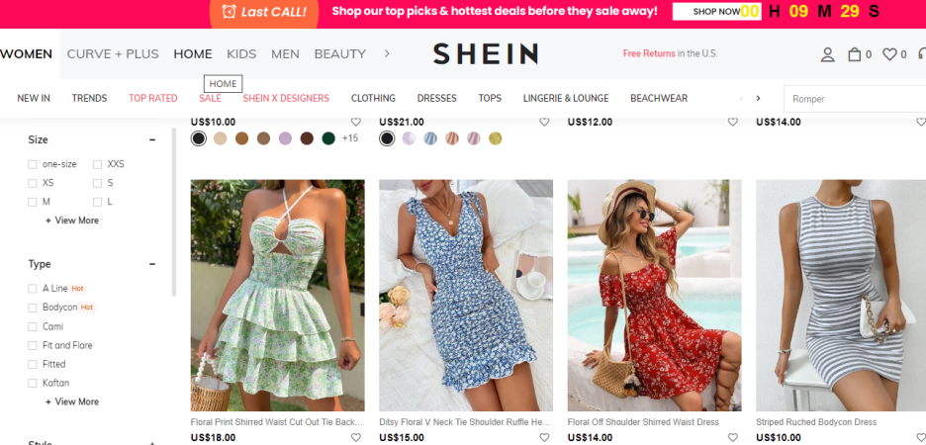
Figure 8 SHEIN offical website of 2022 summer discount
- Place
According to Financial(2021), in terms of quantity of flow of SHEIN in May 2021, the main sales regions are North America and Europe, of which the US/Canada accounted for 40%/6% and France/Italy accounted for 8%/6% respectively. In addition, the company is actively expanding its market and has business layout in South America, Middle East and Southeast Asia.
However, SHIEN didn’t land in Chinese market, which is caused by Chinese local retail-oriented shopping sites TAOBAO, Buy Together and itself has been more developed related to the wholesale shopping site 1688. The absence in the domestic market makes SHEIN lose its voice in many PR events, which is not conducive to its social image
- Distribution
SHEIN has chosen a direct distribution way to deliver its product. SHEIN adopts a DTC business model, the essence of which is to "remove the middleman, remove the price difference"(How to Make the DTC Model Work for You, 2022), reduce the flow costs of channels and intermediate goods, compress profit margins, and at the same time, by collecting feedback from front-line customers, directly reflecting to the supply demand, to create a faster and stronger flexible supply chain.
- Promotion
SHEIN only adopts only online sales, and its discount information always occupies the most prominent position on the website. Sales Promotion is SHEIN’s the most important promotion way.

2.5 Marketing Media
SHEIN took the advantage of the YouTube influencer and Instagram influencer bonus. (Han,2022) As early as 2012, it used a large number of cooperation with various types of weblebrities, mainly fashion/style/beauty/makeup type. As far as the communication content, there are real fitting, real reviews, rather than nakedly to emphasize the product selling points mainly. The model of SHEIN'S social media marketing is like Figure 9.

Small influencers: Traffic and external links,
Central influencers: Recommend goods
The head influencers: Brand communication.

Figure 9 The model of SHEIN'S social media marketing

2.6 Measuring the Success of SHEIN
The marketing strategies have helped SHEIN develop into a unicorn quickly, but also bring many problems, especially corporate social responsibility issues.
Firstly, promotion leaves the pressure of inventory to itself to reduce the pressure of suppliers, but also puts forward higher requirements for suppliers, such as "delivery within 40 hours of stock, delivery within 5 days of stock availability", etc. SHEIN learns Zara's strategy in design, shipping and category expansion, but unlike Zara, SHEIN is basically faster than ZARA in every aspect because it has no stores and relies entirely on online sales.
SHEIN's e-commerce operation model is "self-operated", not an open trading platform like TAOBAO, so the pressure of inventory and cash flow is on SHEIN itself, but it is such a "heavy" supply chain model that gives it complete control over all aspects of the brand. Another problem with this "self-managed" model is that as the category expands, the pressure on inventory, cash flow and sales capacity will increase.
Secondly, the communication has the authenticity, the traffic has a long-term influence. Product evaluation and recommendation link bring the real traffic of constant influx, injecting vitality for the platform. But along with the bonus of product fittings, a large number of accusations about the quality of SHEIN's products continue to appear on social media, which undoubtedly solidifies the Western society's prejudice against China's overall image, especially Chinese products, giving them an impression of cheap and low quality.

3 Conclusion
From an overall perspective, SHEIN’s marketing in western and mideast market has achieved a success. High integration of supply chain, low product price and social media marketing, there are common issues in the fast fashion industry - production environmental protection, labor human rights, forcing suppliers, design plagiarism and so on.
At the same time, Shein also has some other issues, such as poor online after-sales service, insufficient cross-border localization, negative opinion of the founders, cross-border policy risks, high expectations of capital and so on.
From the perspective of marketing, I summarize it as the absence of CSR. To solve this problems, SHEIN need to take measures which targeted at Gen Zers. While not harming the existing perceptions in the positioning map of consumers, SHEIN must transfer the brand image into a green, good-quality, responsible one.

4 Recommendations(using SOSTAC recommendation model)
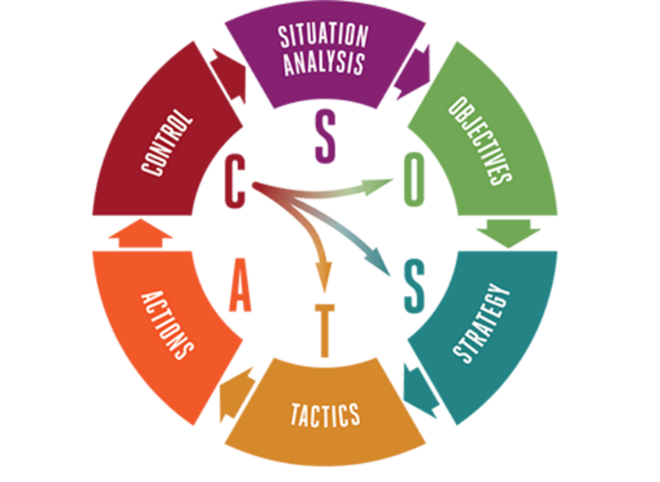
In this section, a SOSTAC recommendation model will be used to illustrate what SHEIN needs to do in the following process to solve the CSR problems.

•Situation
Now, SHEIN is faced up with the social corporate responsibility issues. Some blames are published on the social medias, criticizing production environmental protection, labor human rights, forcing suppliers, design plagiarism of SHEIN, which harm the corporate image of SHEIN.
•Objectives
The objective for SHEIN is to shoulder the corporate social responsibility, remodeling its corporate image in public is the primary issue.
•Strategy
The first step is to build an corporate transformation awareness for leaders. Secondly, it is important to establish an effective PR system, who can develop a unified outreach strategy for SHEIN.The third step is to build a helpful customer Service System, which can not only serve shopping advice, but also after-sales service advice.
•Tactics
Restructuring of the company structure at the level of business managers, with emphasis on the user research department, marketing department, and public relations department.
Establish a rapid response PR mechanism to respond to negative information on social media and other channels in a timely manner.
Recognize the differences in language environment, cultural customs, political and legal differences between China and different countries, as well as the differences in business management with overseas enterprises, so as to adapt to the local situation. For different countries specialize in forming integrated teams with Chinese and foreign managers.
Clarify the specific business of the customer service team, plan a general business direction for the team, and the different work contents directly determine the configuration of the positions and the development of related processes at a later stage. Refine the job requirements and responsibilities of the customer service team. With the general business framework already determined, the next thing to do is to determine the internal organizational structure of the team, including the development of positions and responsibilities, etc. Overseas customer service staff, because of the language requirements, actually have a relatively low chance of finding the right person, and very often need to make timely adjustments to recruitment. Through various methods, maintaining the stability of team personnel saves a lot of energy and financial resources for the company and the team.
•Actions
Social media referrals is helpful to SHEIN's sales tremendously, so the PR department should pay attention to maintaining relationships with these people, for example, by creating a community to collect feedback from these adults and sending them experience packages during the holidays.
SHEIN can also set up its own multi-platform media accounts and add some gamification elements to enrich the account content.
For some of the criticism against it is not environmentally friendly, shein can take the initiative to post some activities and interactions about environmental protection on social media, such as eco-friendly fabric clothing graffiti, old clothes recycling, etc.
As far as the establishment of overseas customer service system is concerned, staff instability is a big threat factor, shein can increase staff care, use HR department to set up staff training and growth mechanism, give bonuses, learning opportunities, vacations and other benefits.

•Control
Set up a performance appraisal system for the relevant departments of the company, and provide for appraisal and salary payment.
Set up a system of responsibility for major events, and regularly evaluate the effectiveness of the public relations department and the marketing department in responding to public opinion events that occur in social media and traditional media, and record the effective means and hold the relevant personnel accountable for any shortcomings in a timely manner.
Regular training for employees by department leaders to learn from the best practices of other companies in CSR.

Reference Lists
- Li y., Zeng N.2022. How did SHEIN, a $100 billion unicorn, come to be?. [online] Available at: <https://baijiahao.baidu.com/s?id=1731404338077821536&wfr=spider&for=pc> [Accessed 18 June 2022].
- Han.(2022).Why can SHEIN become another Pinduoduo.Financial BT [online], 5 May. Available from: https://baijiahao.baidu.com/s?id=1731900370759580617&wfr=spider&for=pc [accessed 10 May, 2022]
- Rust, R. Moorman, C. and Bhalla, G., 2022. Rethinking Ma. SPOTLIGHT ON REINVENTION, January–February, pp.94-102.
- Social Responsibility Office of China Textile Industry Federation(2020).Circular fashion: China's new textile economic outlook.Available at:https://www.lenzing.com/(Accessed: 22 May 2022)
- Trout, J. (1969) “”Positioning” is a game people play in today’s me-too market place”, Industrial Marketing, Vol.54, No.6, (June 1969), pp.51-55.
- Sina Finance. 2022. The secret of China's fast fashion "invisible champion" SHEIN: a record $15 billion valuation, the first symptoms of "unconventional". [online] Available at: <https://baijiahao.baidu.com/s?id=1709684158806702772&wfr=spider&for=pc> [Accessed 19 June 2022].
- Optimoroute.com. 2022. How to Make the DTC Model Work for You. [online] Available at: <https://optimoroute.com/direct-to-consumer-model/#what-is-the> [Accessed 19 June 2022].
- Buck, R.2022. Perspectives on retail and consumer goods. McKinsey & Company.
- CCTV News. 2021. "The 14th Five-Year Plan for the Protection and Use of National Intellectual Property Rights: Full Establishment and Implementation of a Punitive Damages System for Intellectual Property Rights Infringement. [online] Available at: <https://www.cnipa.gov.cn/art/2021/10/29/art_2769_171058.html> [Accessed 25 June 2022].
- Kluckhohn, F. and Strodtbeck, F.（1976） Variations in value orientations. Westport, Conn.: Greenwood Press.
- Bloomberg.com. （2022) Bloomberg.[online] Available at: <https://www.bloomberg.com/news/articles/2022-04-04/shein-s-100-billion-valuation-would-top-h-m-and-zara-combined> [Accessed 25 June 2022].
- Lv D.(2021) China's Shein is popular in Europe and America, except China.Observer network [online], 1 October. Available from: https://mp.weixin.qq.com/s/oCWZuEOLUAFgbqQWlobW2Q [accessed 15 May, 2022]
- Juny.(2022) After surpassing tiktok to win the national download list, Shein with Chinese gene has become another phenomenal application.Silicon star man[online], 14 May. Available from: https://mp.weixin.qq.com/s/_gc_6GNktl2EE4FXyEwXYA [accessed 15 May, 2022]
- Jiao Ying Wu.(2022).Shein, is it worth $100 billion?.I dark horse[online], 8 May. Available from: https://mp.weixin.qq.com/s/Vy_zoyqCwQUojF9-DZTHew [accessed 15 May, 2022]
- Rui Zhang.(2022).Mysterious Xu Yangtian: the imperfect B-side deep network of 100 billion e-commerce sheen.Shenzhen Tencent News[online],10 May. Available from: https://mp.weixin.qq.com/s/Y2g31iNbL047VhpyT8n81w [accessed 15 May, 2022]
- Le Tian.(2022).Fashion retailer Shein is exposed to be stranded in listing in the United States: Founder Xu Yangtian suspects changing nationality.Leidi network[online] 27 February.Available from: https://mp.weixin.qq.com/s/757H6zHHoNutzAfotVIeOQ [accessed 15 May, 2022]
- Yiguan analysis and reporting group.(2022) Using recycled polyester to make clothes, shein launched a new production line evolushein.Blue ocean yiguan.com[online], 12 May.Available from: https://mp.weixin.qq.com/s/UmaRUYMxnh-iPU65kW3DIg [accessed 15 May, 2022]
- E-commerce headlines.(2021).Side a and side B of shein. E-commerce headlines[online],8 August.Available from: https://mp.weixin.qq.com/s/MJdpnWeTIdULo-GYY0Y8pA [accessed 15 May, 2022]
- Cross border e-commerce disclosure specialist.(2021).Side B of shein, a mysterious US $10 billion company in China: the siege dilemma of clothing suppliers[online], 21 May.Available from: https://mp.weixin.qq.com/s/b7FNxMTxI06ToOL5u_TMHQ [accessed 15 May, 2022]
- Lu Caijing.(2022). Without a small factory in Panyu, Shein is nothing. Know[online],21 April. Available from: https://zhuanlan.zhihu.com/p/502683026 [accessed 15 May, 2022]
- xu2miss.(2022).In the next 20 years, will shein and Zara have a reciprocal relationship?. Know[online], 30 April. Available from:https://www.zhihu.com/question/530248308/answer/2463098788 [accessed 15 May, 2022]
- Uncle Boyi.(2022).Shein: Why did Xu Yangtian go to Brazil?. Know[online]​,4 March. Available from: https://zhuanlan.zhihu.com/p/475981911 [accessed 18 May, 2022]
- Huang Shan.(2021).In the face of environmental protection and labor disputes, shein is opening up. Interface news[online],22 December. Available from: https://baijiahao.baidu.com/s?id=1719802317965442806&wfr=spider&for=pc [accessed 18 May, 2022]
- Dong Lv.(2021).Cross border e-commerce giant Shein is popular in Europe and America. Can it fade the background of China?.Observer network[online], 1 October.Available from: https://baijiahao.baidu.com/s?id=1712403314293593830&wfr=spider&for=pc [accessed 18 May, 2022]
- Yibang power.(2022).Urgent! Shein supplier: lost in a game of "Eagle catching chicken".Baidu[online],27 April. Available from: https://baijiahao.baidu.com/s?id=1731257248164515116&wfr=spider&for=pc [accessed 18 May, 2022]
- Zheng Yang.(2022).Shein was pointed out by the British government that the labor supervision system is not well informed.Overseadia[online],1 March.Available from: https://chuhaiyi.baidu.com/news/detail/23917832 [accessed 18 May, 2022]
- Pride, W.M., and Ferrell, O.C. (2016), Marketing: Concepts and Strategies, 7th ed, Houghton Mifflin
- Jobber, D., and Ellis-Chadwick, F., (2016) Principles and Practice of Marketing 7th revised edition, Berkshire: McGraw-Hill
- Aaker, D. (2015) Brand personalities are like snowflakes, Marketing News, 49(7), pp. 20-21. Full text available at: EBSCOhost Business Source Complete
- Kotler P and Chernev, A. (2014) Strategic Marketing Management, 8th edition, Cerebellum Press

