3
Callum Jones
2306025@Student.uwtsd.ac.uk

Surveying PROBLEMS
ACBA4002

Surveying problems

Question 1
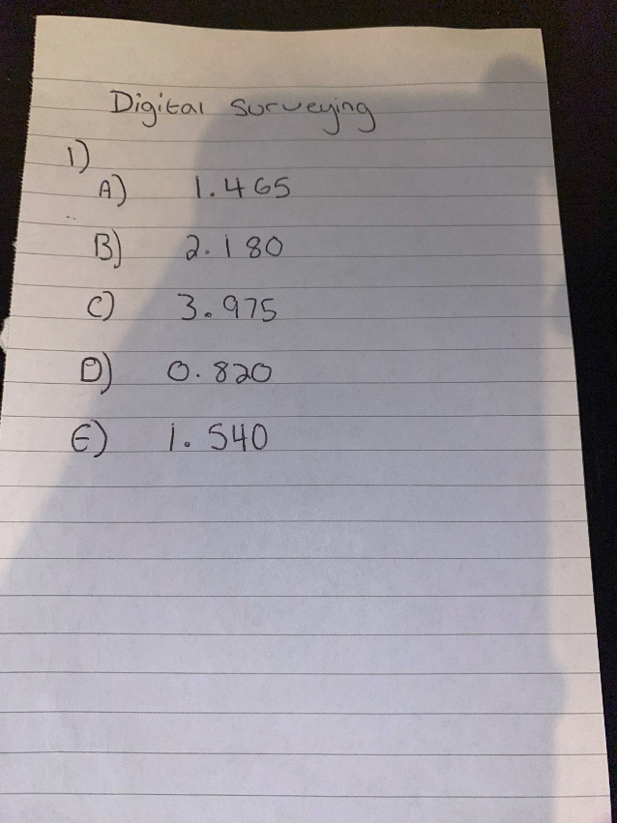

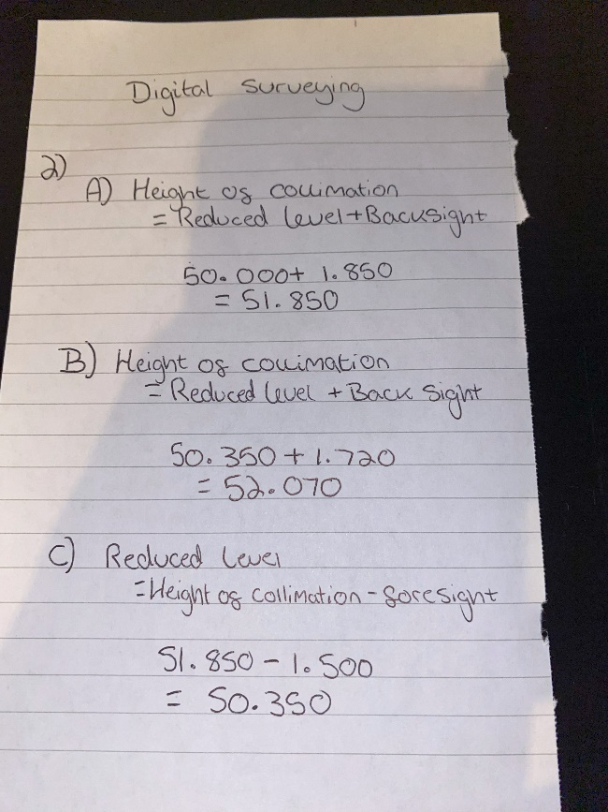
Question 2

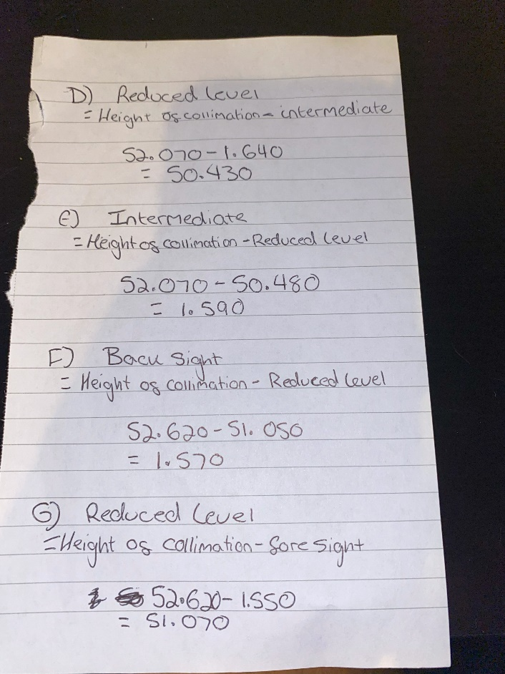

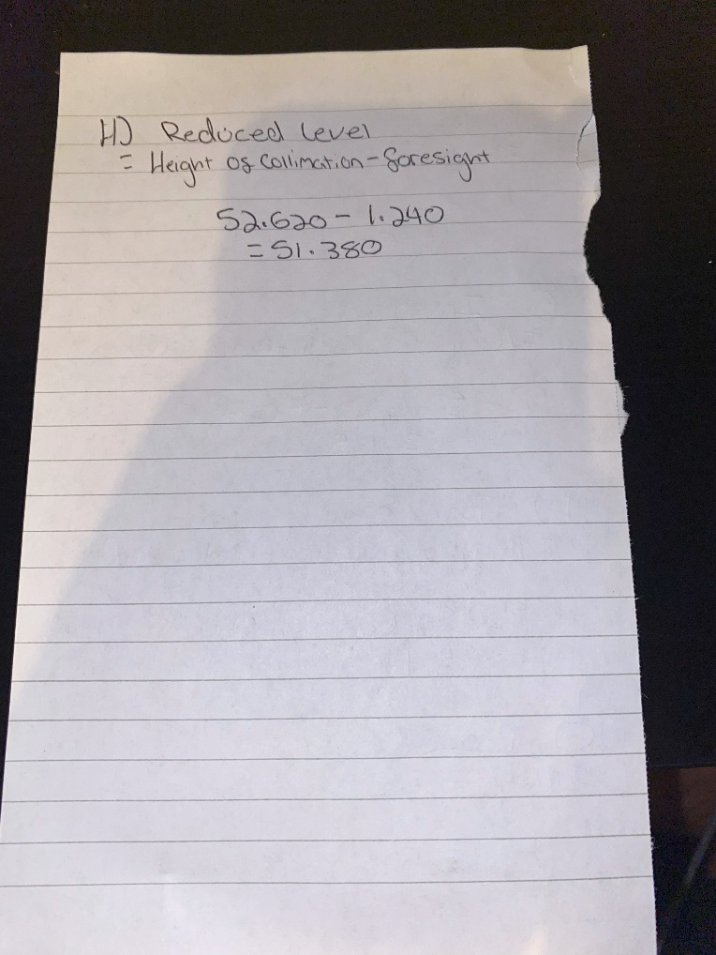

Question 3
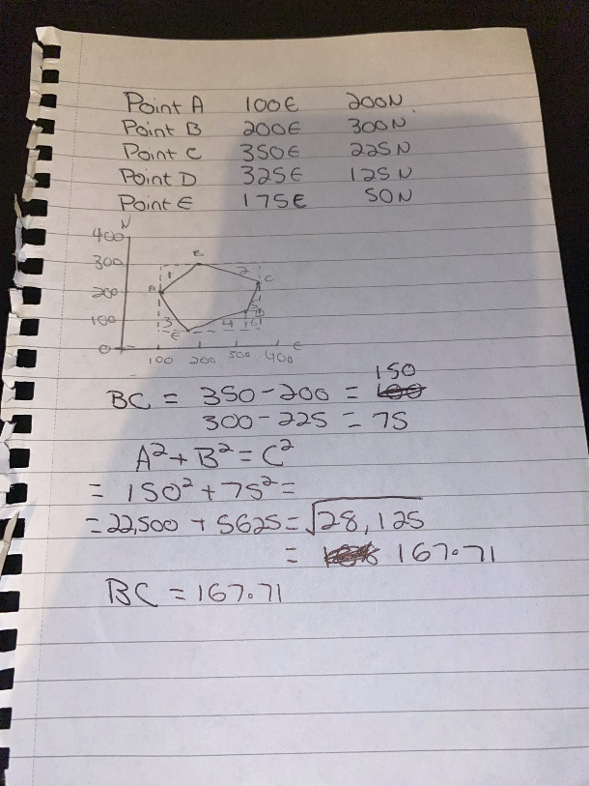

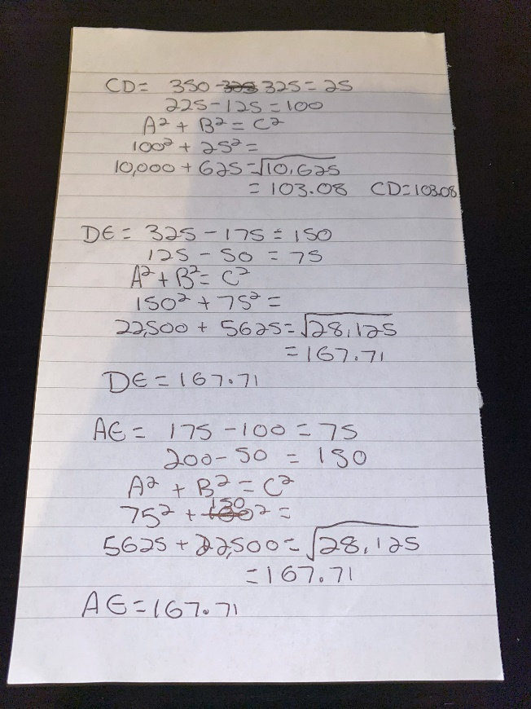

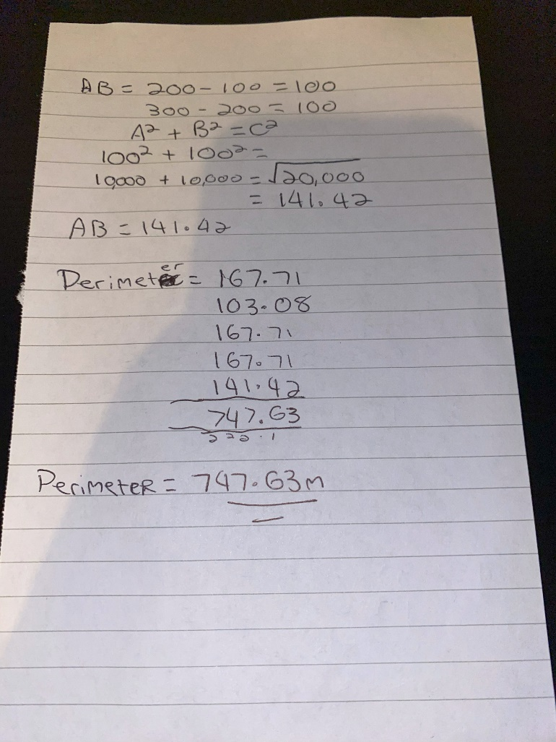
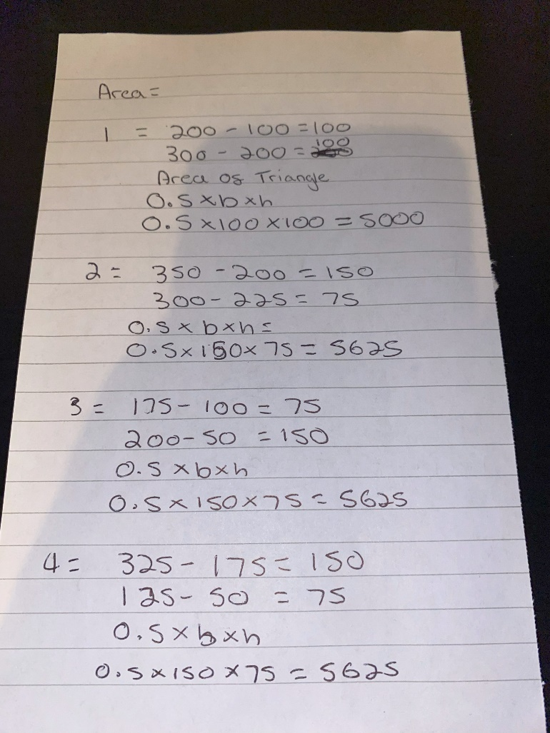
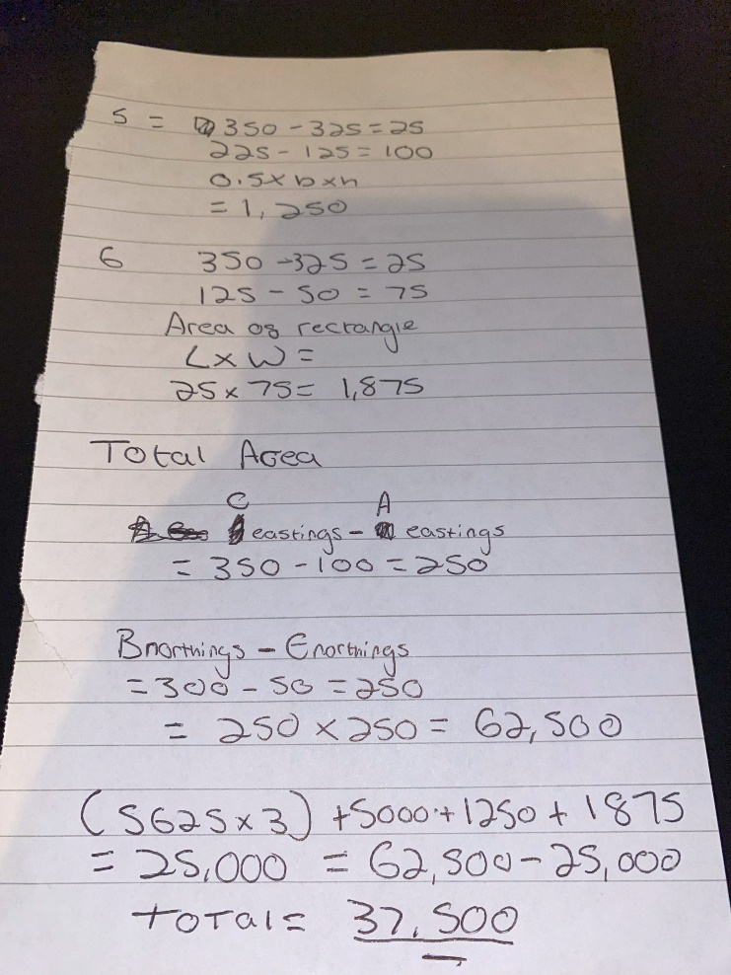

Question 4

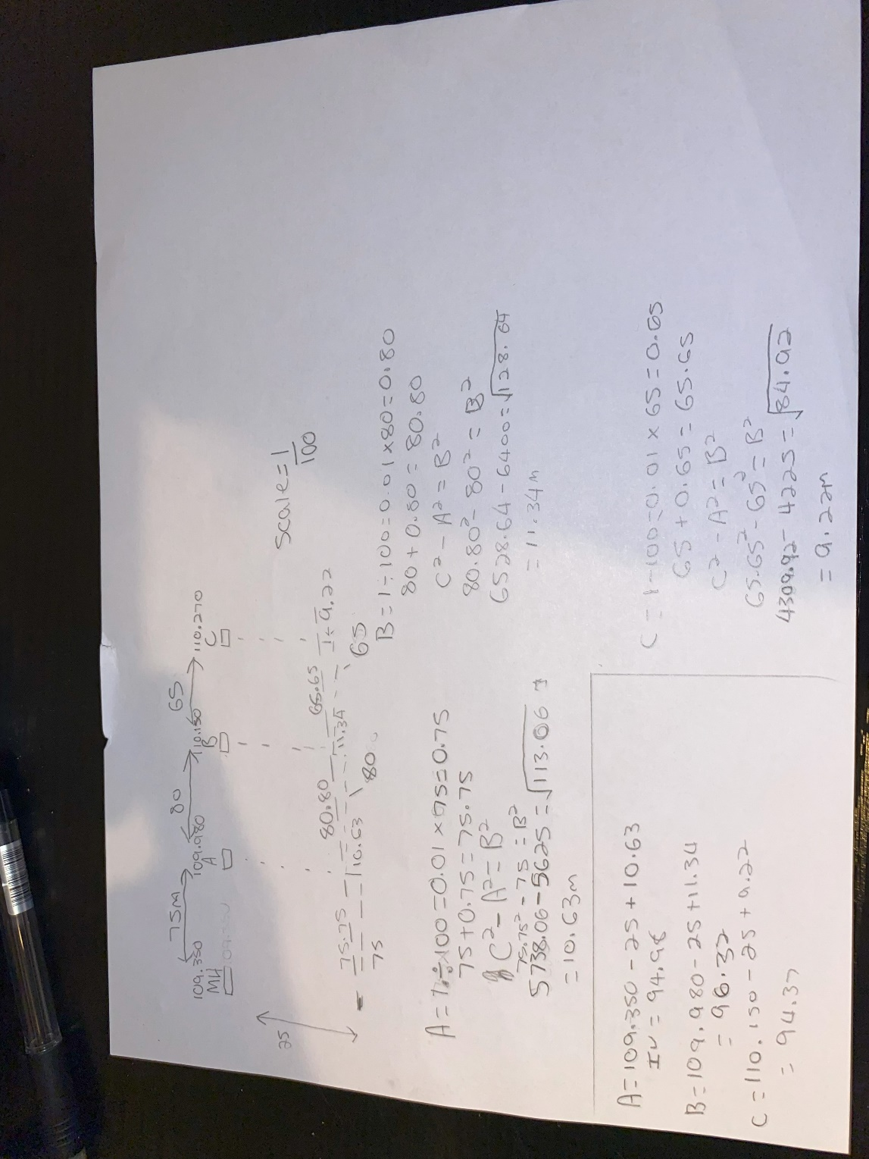

Question 5

Total station

What is a total station? What is it used for?
A total station is a piece of surveying equipment that has a whole array of capabilities. Some of these are electronic distance measuring, electronic theodolite. This piece of equipment often comes with a screen that can be used to visualise collected data.
The main purpose of the total station is to measure angles as well as distances most commonly in the construction industry. This piece of equipment is primarily used by land surveyors as well as Civil engineers. It would be used to complete tasks such as topographic mapping.
The total station is a commonly used tool within the modern construction industry and has proven its usefulness many times over providing accurate and a more efficient way of data collection.

