Requirements Specification

Ben Archer | Project | 28/11/2017

Contents
Project Initiation Document 2
Objectives 2
Scope 2
Constraints 2
Authority 3
Resources 3
Description of the Existing System 3
Organisation and users 3
current system evaluation 3
Independent Catch Up Service Diagrams 4
Channel 4 Catch Up Service Diagrams 5
Evaluation of Current Systems 6
Software Methodology adoption 7
Development Tools 7
System Requirements 8
Operational requirements 8
Information Requirements 9
Who for? 9
How recent? 9
Purpose 9
How comprehensive? 9
How concise? 9
Accuracy 9
Medium 10
Frequency 10
General System Requirements 10
Plan 12
Plan Notes 14
References 14
Bibliography 14
Appendix 15

Project Initiation Document

Objectives
The main objectives surrounding the project in question chiefly revolve around producing an easy to navigate and informative website wherein users can catch up on news from sources they trust, around topics they desire. Moreover, the main objective the website should achieve is for the information presented on the website to up to date, informative, and impartial. The website should be built from the ground up to remove the ability for administrators to manipulate or remove news stories that they deem not worthy for display. Finally, sufficient scope should be allowed while building the website to allow for additions later in the websites lifespan.

Scope
The scope the project will exist within will be within the field of a website, the scope of the project will not delve into fields such as mobile apps or desktop applications. Moreover, as the project will affectively serve as a ‘middle-man’ between the user and information they deem desirable, the information present on the app will not contain any bias from the website administrator or users.✓

Constraints
The main constrains that this project will face are mainly products of the writers own technological experience, the chosen technologies pitfalls, and the information sources limitations. For example, the writer (at the time of writing) only has a year of experience in the chosen language being used to build the project, this may lead to inefficient techniques being used within the source code of the project, in addition to outdated or depreciated methods of building websites using the chosen technology. However, the main constraint could be argued to be the limitations of the information source being used to collate the information. E.G. it may be impossible to achieve a completely impartial information dataset, if the dataset itself is subject to bias. Fair point

Authority
Authority members that would influence the project’s final outcome, would undoubtedly be the governing bodies that determine the acceptable methods of building websites. For example, the W3C’s WCAG 2.0 Guidelines.

Resources
Resources that are available to the writer when building the project would be, not limiting to, the following:
- DBMS documentation
- Backend language documentation
- Frontend language documentation
- API documentation

Description of the Existing System

Organisation and users
There are a number of organisations that provide users with some sort of ‘news catch-up’ service, however it should be noted that none of them, to the writer’s knowledge, are within the same scope as the writer’s proposed system. Two of the systems that provide a catch-up service are the Independent’s catch-up service [1] and Channel 4’s news program catch up service [2]. The Independents catch up service consists of a single page containing news stories written by a single writer at the Independent. It can be assumed that this writer is a dedicated “Catch-Up” writer for the Independent. At the time of writing, this page consists of 36 news stories. These stories mainly revolve around the topics of politics and society. Channel 4’s news catch up service consists of a page that allows users to select a date within the last 7 days. After clicking on a date, the user is able to view videos detailing the top news reports of that day. The current system’s users would be individuals who are aiming to catch up on news from their preferred news source, over a broad range of topics. It should be noted that although these providers allow users to catch up on news stories, the stories that are available to users are solely from the news organizations that provide the catch up service. ✓

current system evaluation
In this section the writer aims to provide readers with an understanding of the current method for news catch up through the medium of SSADM [3] diagrams. Since the two news catch up services detailed above are simplistic in nature, the writer will detail both services separately, then form an analysis afterwards. The diagrams chosen by the writer consist of an ERD (Entity Relationship Diagram) and a Level 1 Data Flow Diagram.

Independent Catch Up Service Diagrams
At the time of writing, the Independents Catch Up service’s articles cease on the 5th of May 2016, however due to the sparse nature of news catch up services, the writer will detail how the system worked for arguments sake.

Entity Relationship Diagram
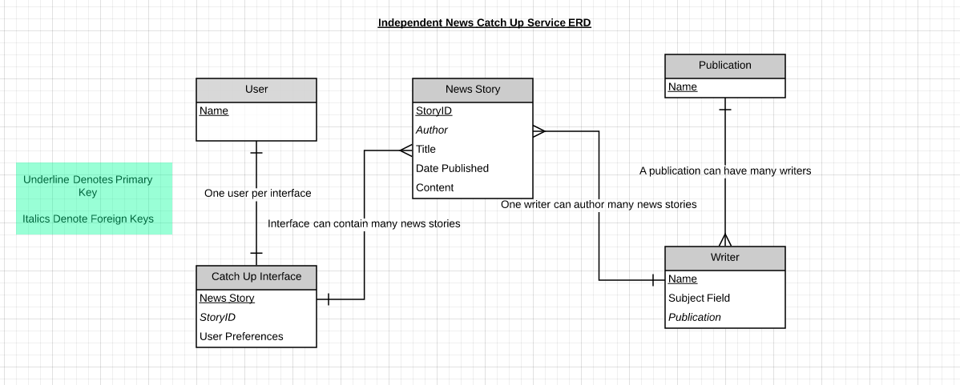

Data Flow Diagram
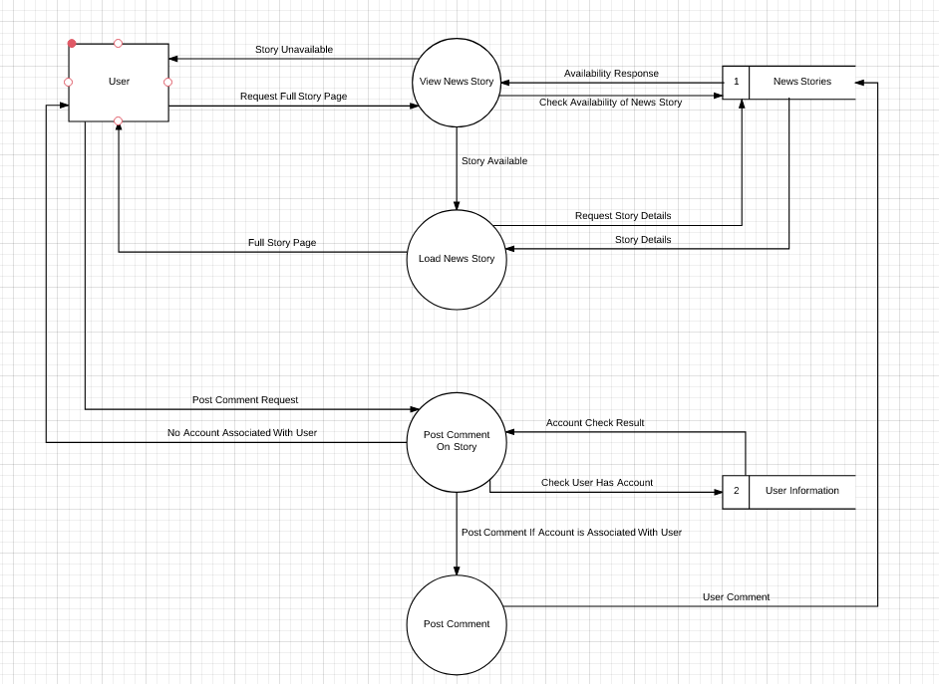

Channel 4 Catch Up Service Diagrams
At the time of writing, Channel 4’s Catch Up service, compared to the Independents, is far more robust. The premise of the service revolves around video snippets of Channel 4’s news program that are deemed noteworthy. These snippets are arranged by day; the user has the ability to cycle through the previous seven days’ worth of video snippets through the use of a carousel. ✓

Entity Relationship Diagram
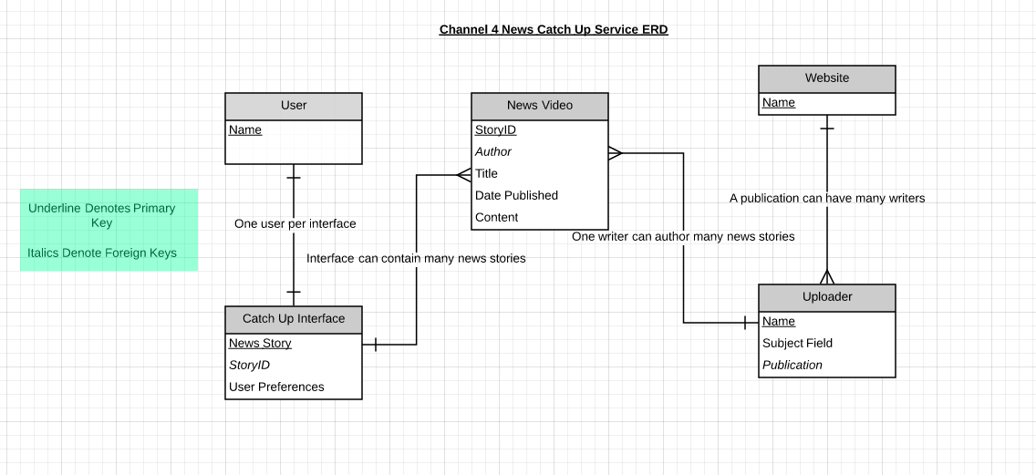

Data Flow Diagram
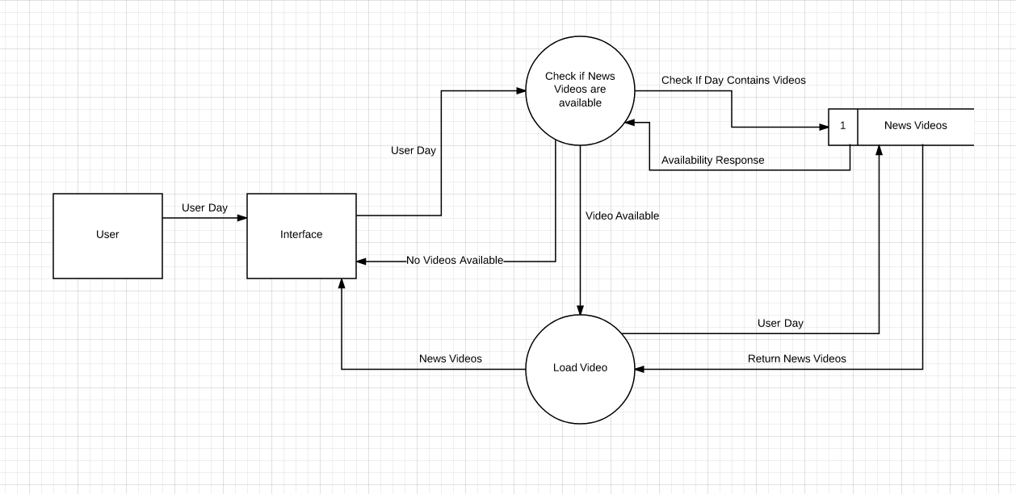

Evaluation of Current Systems
After reviewing both the Independent’s and Channel 4’s catch up services, it is clear that the superior service is Channel 4’s catch up service. This is chiefly because the Independents catch up service, at the time of writing, has not been updated for over a year, as well as the fact that the service only covers a small segment of world news. Moreover, the Independent’s catch up service was written by a single person, allowing writer bias to influence how the news stories are written. When looking at Channel 4’s catch up service, it becomes clear how superior this service is compared to the Independent’s. However, it could be argued that due to the fact that Channel 4’s catch up content is solely made up of videos, the service cuts off or shuts out many users who may not be able to watch video content in their country, or due to data restriction may not be able to afford to watch videos. ✓

Software Methodology adoption
There are several software methodologies that could be adopted for the project in question. Due to the time constraints afforded to the writer, as well as the nature of the project, the writer has chosen to adopt the Agile method of software development. The writer has chosen this development methodology due to a number of factors, chief among which is the time afforded to the writer within the build process of the project. As seen in a segment of the writers Gantt plan (Appendix: (1)), the amount of time dedicated to solely to testing within the build process is three days, between the 27/04/2017 and the 30/04/2017. Due to this fact, the adoption of such methodologies such as the Waterfall Method would not be suitable as, in order for the writer to fully adhere to the methodology, “Each phase must be 100% complete before moving on” [4]. Following the waterfall method would drastically increase the chances of a “blocker” bug [5] as no testing would take place throughout the projects development. Due to the nature of the problem discussed above, the best alternative methodology wise for the writer’s project would be an Agile development methodology, specifically the Scrum [6] methodology. Using this methodology allows the writer to continually test and assess the progress of the project while building (Appendix: (2)) reducing the amount of dedicated testing time needed at the end of the project. The writer believes that using this methodology allows for more emphasis to be placed on the design process and initial features of the project. ✓

Development Tools
The premise of the project relies on users being able to interact with a front-end interface that in turn interacts with a back-end database to provide the desired information. When thinking about tools, i.e. development languages, database tools, styling languages, two main candidates appear. The first candidate for the project would be a HTML and CSS driven front-end using PHP to interact with a MySQL server in the back-end. The pros of this method would undoubtedly be PHP’s syntax “familiar to the myriad of programmers that know any other C based language”, as well as its “Large community” and “online manual…regarded to the be best of any programming language”. [7]. In addition to these points, when relating PHP to the writer’s own time constraints, developers are able to build applications very quickly using PHP. However one of the main problems with PHP is that it lacks the ability to be debugged as easily as the other candidate for the writers application. This becomes even more prevalent when taking the writers experience within PHP into account, as due to the writer’s relatively basic understanding of the language, the opportunity for critical bugs to occur is drastically increased. When factoring in the time lost due to working out bugs within the application, PHP may not be as suitable as other languages when it comes to rapid app development. The second candidate for the project would be the use of ASP.NET MVC as the front-end and back-end interaction language interacting with an SQL Server database back-end. At the time of writing, the writer has been working with ASP.NET MVC for nearly 1 year within a software development company. When factoring in the increased experience the writer has of MVC, one could argue that the opportunity for the occurrence of critical bugs is reduced somewhat. Some of the pros of using MVC as a development language include the ability to increase the scope of applications easily, the maintainability of MVC code is far greater than that of PHP code, finally, the tools available within MVC (Entity Framework for instance) vastly increase the ease in which database interaction can be handled. After reviewing both technologies, it is clear that due to the writer’s circumstances, ASP.NET MVC would be the superior language to use over PHP as the writer has significantly more experience within the technology and, due to this fact, would be able to rapidly develop an application to and above the standards required. ✓

System Requirements

Operational requirements
For each user:
- Allow the selection of preferences regarding desired news story categories and sources
- To allow the selection of a time frame from within to fetch these desired news articles.
- Allow users to create an account within the application to save and manipulate these preferences.
- To generate an easy to read, responsive, and aesthetically pleasing list of news stories that are of interest to the user.
- To allow users to view these news stories “in-site” within a modal popup instead of being redirected to another page.
- To use SEO friendly URL’s by using IIS rewrite techniques on the hosting server.
- Allow users to sign up to ‘mailing lists’ containing news stories that may be of importance to them.
- Allow users to reset passwords or change usernames through email confirmation.
For each administrator
- All basic site functionality is accessible via an administrator login (see list above).
- The ability to maintain users.
- Regulate news stories appearing on the site.

Information Requirements

Who for?
The information (news stories) that are present within the application will be catered to the current user browsing the page.

How recent?
The information available for users to interact with should be as up to date as possible, due to the fact that users will be browsing news stories, the writer aims for the information to be no later than a few hours old. This will be achieved using an importer that is run via task scheduler on the server in which the application is hosted. Users also have the ability to browse news stories up to 3 months old.

Purpose
The purpose of the information (news stories) is to simply inform the user of current events and happenings that are of significance to them. The information garnered may be used for whatever purpose the user desires.

How comprehensive?
The comprehensiveness of the information that will be presented to the user will allow them to form a basic understanding of the news story being presented to them, the user will then have the ability to gain close to a full understanding of the information by viewing the story within an in-site redirect to the full story. When referencing the information on the page, without in-site redirects, the information will consist of a picture that sums up the story to the user, the news source in which the story comes from, the author (if applicable), the date in which the story was published (if applicable) and a blurb explaining the ‘gist’ of the story. All of this information will be pulled from the back-end database that is populated by pulling data from an independent, third party API.✓

How concise?
The information on the page should be concise enough that a user can garner the ‘gist’ of a story by skimming over the blurb, however when prompted by the user, the full details of the story should be able to be viewed.

Accuracy
The main talking points regarding accuracy when referencing news stories, particularly on the writers application, should be as follows:
- The news source reporting the article should be correct.
- The author writing the article should be correct.
- The link provided to the user to view the full story should be correct. i.e. the link should take the user to the exact story that is being reported within the writers application.
- The date of publication for the news story should be accurate to the nearest day.

Medium
The medium in which the information should be presented should be via a computer display, no physical representation of the information should be present. Regarding enquiries into the information, there are two main functions that should be available to the user.
- The ability to view the full story by clicking the full story link present on the article and viewing the full story in-site.
- The ability to change the preferences or filter the existing information.
If the user aims to accomplish these functions, an immediate response to that input should be present within the application.

Frequency
The frequency in which the information should be updated is down to two factors:
- How often the articles are updated in the database
- How often a user refreshes the information significant to them.

General System Requirements
In terms of the accuracy of input regarding user input into the application, the application aims to eliminate all user input that isn’t already approved by the application. For example, when choosing news article preferences, the user can only choose from categories and sources that are already known to the application, eliminating the possibility for an unknown input. The main area, to the writers knowledge, that could be susceptible to user error is account creation. For example if users enter invalid email inputs or invalid password characters. Due to the nature of the technology being used within the application, it is relatively easy for input checks to be set up for email and password inputs, whether that be input sanitation on the server side or RegEx client side validation. In reference to system controls and audit trails, the application should have input confirmation checks that make sure that the user understands if an input has been successful or not. These confirmation checks could take the form of email confirmation of a successful password change, custom 404 page errors, custom error handling if a database call fails, or client side script that allows users to restore previous inputs if they have failed. User account security should be of the upmost importance when thinking about the system requirements of the application. The application should not save any sensitive user information as plain text within the database, nor save any personal information in-session. When saving user information to the database, all sensitive information should be hashed using a significantly powerful hashing algorithm such as scrypt or bcrypt as well as salting these passwords to prevent rainbow table attacks. Finally, the program should allow sufficient scope for additional features or adaptations later on in the applications lifespan.✓

Plan
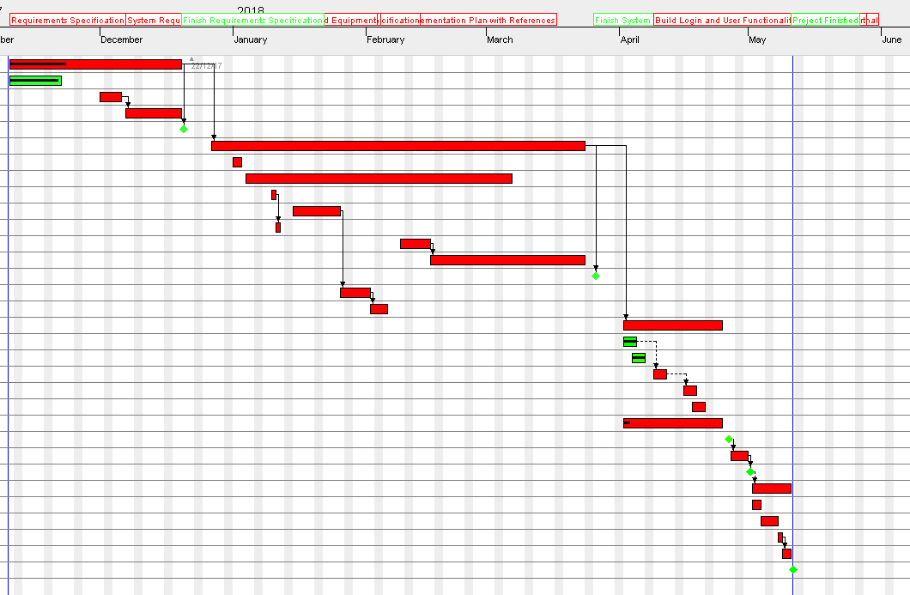
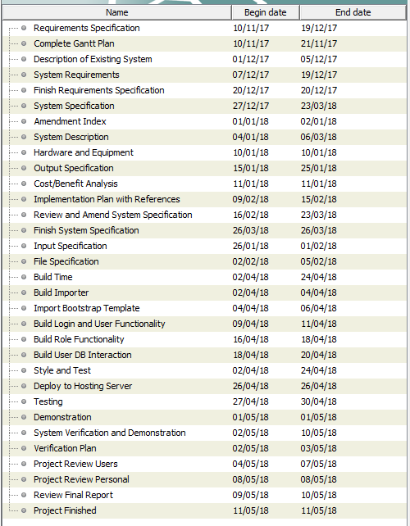

Plan Notes
After creating a plan, it is clear that, difficulty wise, time constraints are undoubtedly the most prevalent factor in regard to the difficulty in which the plan can be implemented. Due to the fact that the writer not only has to keep up with the process the plan outlines, they must also complete and sit other assignments and exams throughout their final year. As referenced earlier, the nature of these time constraints has led to the adoption of a development technique that minimizes the need for block testing time at the end of development. The writer believes that by minimizing the time spent solely on testing, more emphasis can be placed on the quality of the application, as well as the standard to which the application is delivered.✓

References

- Independent (2017) Catch-Up, Available at: http://www.independent.co.uk/topic/catch-up(Accessed: 28/11/2017).
- Channel 4 (2014) Catch up, Available at: https://www.channel4.com/news/programmes/2017/11/27/1900 (Accessed: 28/11/2017).
- Margaret Rouse (2017) SSADM (Structured Systems Analysis & Design Method), Available at: http://searchsoftwarequality.techtarget.com/definition/SSADM (Accessed: 12/12/2017).
- Tyler Hubbell (2017) Top 4 Software Development Methodologies, Available at: https://blog.blackducksoftware.com/top-4-software-development-methodologies(Accessed: 12/12/2017).
- documentfoundation.org (2017) Release Criteria, Available at: https://wiki.documentfoundation.org/Release_Criteria (Accessed: 12/12/2017).
- Scrum.org (2017) Release Criteria, Available at: https://www.scrum.org/resources/what-is-scrum (Accessed: 12/12/2017).
- C2.com (2014) Php Pros And Cons, Available at: http://wiki.c2.com/?PhpProsAndCons(Accessed: 12/12/2017).

Bibliography
- David Mburu (2017) What are the pros and cons of the MVC pattern?, Available at: https://www.quora.com/What-are-the-pros-and-cons-of-the-MVC-pattern (Accessed: 12/12/2017).
- lucaskauffman (2013) About Secure Password Hashing, Available at: http://security.blogoverflow.com/2013/09/about-secure-password-hashing/ (Accessed: 12/12/2017).
- Vilx- (2009) What exactly is a rainbow attack?, Available at: https://stackoverflow.com/questions/1012724/what-exactly-is-a-rainbow-attack(Accessed: 12/12/2017).
- W3C (2017) Web Content Accessibility Guidelines (WCAG) , Available at: https://www.w3.org/WAI/intro/wcag (Accessed: 08/01/2017).

Appendix
(1).
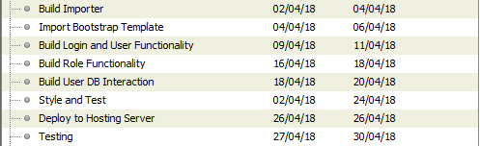

(2)


