
University of Wales Trinity Saint David
School of Engineering

ACMA6013
Major Project

Steffan Rhys Lloyd
2220589
01/06/2026

Table of Contents
Table of Contents 2
Table of figures 3
List of tables 3
1. Abstract 4
Declaration of authenticity 5
2. Introduction 6
3. Aims and Objectives 8
4. Timing Plan 10
4.1 Project Planning and Scheduling Approach 10
5. Literature Review 12
5.1 Cost Estimation in Manufacturing 12
5.1.1 Analogy-Based Estimation 13
5.1.2 Parametric Costing 13
5.1.3 Process-Based Estimation 14
5.1.4 Activity-Based Costing (ABC) 14
5.2 Tooling Life and Cost Impact 16
5.2.1 Cost of tooling 16
5.2.2 Commercial (Stock or Sourced) 17
5.2.3 Tooling type 17
5.2.4 Design and manufacturability of parts 18
5.2.5 Material spec 18
5.2.6 Production environment 18
5.2.7 Cutting Conditions 19
5.3 Subcontractor and Supply Chain Risk 19
5.4 Data-Driven Decision Making in Engineering 21
5.5 Engineering Decision-Making in Quotation Processes 22
6. Work Carried out 23
6.1 Research Approach & Methodology 23
6.2 Existing RFQ Process Analysis 25
6.3 Data Analysis 28
6.4 Development of a Structured RFQ Framework 29
6.4.1 RFQ Intake and Initial Review 30
6.4.2 Data Structuring and Bill of Materials (BOM) Creation 30
6.4.3 Cost Input and Process Estimation 30
6.4.4 Tooling Assessment 30
6.4.5 Subcontractor Evaluation 31
6.4.6 Quote Compilation and Review 31
6.4.7 Post-Process Validation 31
6.5 Implementation of RFQ Tracking and Analysis Tools 31
6.6 Validation of the Improved RFQ Process 35
7. Results 37
7.1 RFQ Variance Analysis Results 37
7.2 Tooling Performance Results 39
7.3 Subcontractor Cost and Delivery Performance Results 41
7.4 Machining Time and Process Estimation Results 43
7.5 Overall RFQ Framework Performance Results 44
8. Discussion and Conclusions 46
8.1 Discussion 46
8.2 Conclusion 48
9. Recommended Further Work 50
10. References 52

Table of figures
Figure 1: Activity base costing flow chart (Principles of Accounting, 2016). 15
Figure 2: Natural view compared to zoomed in of tooling wear Company (H.P. 2018). 17
Figure 3: Wear examples on a tool’s life (Immerman, G. 2025). 19
Figure 4:Supply chain and subcontractor management risk diagram (M, M. 2025). 20
Figure 5: Qualitative Vs Quantitative Comparison Path (Turner, 2026). 24
Figure 6: Current RFQ process within Llanelec. 27
Figure 7: Structured RFQ framework incorporating technical, operational, and commercial evaluation stages. 29
Figure 8: New RFQ Tracker Spread Sheet at Llanelec precision engineering. 32
Figure 9: Subcontractor Tracker at Llanelec precision engineering. 33
Figure 10: Tooling Costing Tracker at Llanelec precision engineering. 34
Figure 11: Operator Measurement sheet at Llanelec precision engineering. 36
Figure 12: Live Data Comparison Spread Sheet at llanelec precision engineering. 38
Figure 13: Tooling Performance Spread Sheet at Llanelec precision engineering. 40

List of tables
Table 1: Gantt chart of projects timing plan. 11
Table 2: Traditional techniques of cost estimation. 12
Table 3: Each tracking tool purpose data. 33
Table 4: Project Objectives vs Outcomes. 48

Abstract
The accuracy of the RFQ (Request for Quotation) processes within precision engineering environments has a significant impact on manufacturing profitability, process reliability and operational planning. Inaccurate quotations can lead to cost overruns, reduced profitability, production delay and increased manufacturing risk. This project investigates the factors contributing to quotation inaccuracies within Llanelec Precision Engineering and develops a structured RFQ framework aimed at improving quotation consistency and manufacturing cost visibility.
The study adopts a practical, data driven methodology using both historical and live manufacturing data collected from real production activities. Quantitative analysis was used to compare estimated and actual manufacturing costs, machining times, tooling expenditure and supply chain risk in subcontracting across multiple projects. Qualitative evaluation was also undertaken to assess workflow structure, engineering decision-making and process consistency within the existing quotation system.
The investigation identified tooling variation, machining time estimation, subcontractor performance and inconsistent workflow control as the primary contributors to quotation inaccuracy. To address these issues, a revised RFQ framework was developed using a staged process approach incorporating structured tooling assessment, machining estimation, subcontractor evaluation, variance analysis and post process validation.
Supporting tracking tools and analysis spreadsheets were implemented to improve visibility of manufacturing cost drivers and enable continuous comparison between quoted and actual production performance. Validation of the revised framework demonstrated improvements in quotation consistency, process traceability, manufacturing visibility, and overall RFQ reliability. The results showed that implementing of historical manufacturing data and structured workflow validation reduced reliance on assumptions and improved engineering decision-making throughout quotation preparation.
The project concludes that implementation of a structured and data-driven RFQ process can significantly improve quotation accuracy and manufacturing cost control within a precision engineering environment. The revised framework also establishes a foundation for future process development, continuous improvement, and further integration of manufacturing data into quotation preparation activities.

Declaration of authenticity
This thesis is the result of the author's original research. It has been composed by the author and has not been previously submitted for examination which has led to the award of a degree.
Signed: Steffan Lloyd Date: 01/06/2026

Introduction
In precision engineering, the fundamental start of a business profit and loss comes from the Bid stage within the company. The Bidding stage is critical to both commercial and financial success of the company as well as a key figure in the operational side of the business day to day running. Within industries such as defence and aerospace, it is often overlooked as being a stage that is not as important as for example the actual manufacturing of the components. But due to the complexity of the work as well as the value and time involved, it is a process than if not done correctly can have detrimental impacts of the company’s future.
Producing accurate quotations requires several factors, including material identification, machining times, labour in all aspects not just machining, correct tooling identification and subcontracted processes. This process can be influenced by uncertainty at the start of a project, factors such as material deliveries, tooling wear, subcontracting performance all will differ from project to project. The difficulty comes in predicting all relevant factors when estimating the true cost of a project before production begins. Although estimators aim to account for all possible issues, unforeseen events often arise throughout the life of the projects, leading to discrepancies between the estimated costs and actual costs.
In addition to the technical issues surrounding the RFQ process, the organisational factors of the stage also influence quotation accuracy and consistency. In engineering environments, quotation process typically develop over time, ranging from simple paper based systems that rely on individuals knowledge and memory, to fully operational ERP systems that captures every small detail to complete a project. In the case of Llanelec precision engineering the company is currently operating with more of a functional process rather than a systematic and structured approach.
The opportunity to improve consistency, reduce variability as well as save on time taken along with enhancing its decision making will benefit the organisation greatly. Recent advances in engineering management suggest that greater use of data driven decision making and process standardisation will improve the accuracy, consistency and knowledge of RFQ processes, not only for its current but for any future employees.

The aim of this project is to explore a more structured approach to the RFQ process within Llanelec in order to improve accuracy and reliability within the field. Focus will be on areas such as tooling life and performance, engineering and process data in cost estimation, and the impact of subcontracted operations over the project’s lifespan. The study aims to offer a detailed insight on how technical, operational, and supply chain considerations can be more effectively managed and integrated into the RFQ process.

Aims and Objectives
The aim of the project is to develop and improve the RFQ process within Llanelec Precision Engineering by introducing and developing a more structured, data driven approach throughout each stage of the bid. The focus will be on several steps such as, the variation of estimated to actual manufacturing costs, tooling performance data, engineering process data and subcontracted process involved throughout a project’s life.

Objectives
To achieve this aim, the following objectives have been defined:
- Review RFQ cost methods, tooling life and management, and subcontracted procedures or parts risk within precision engineering as well as within the company.
- Analyse historical and live project data to see if there are any occurring issues or discrepancies between the estimated quoted costs to the actual costs of the job.
- To evaluate tooling life and its performance, checking live data to back up any findings.
- Compare the Pricing, quality and delivery dependability of all subcontractors.
- See if or how engineering and process data can be captured, then used to assist in more precise and consistent cost estimation.
- Develop a framework that progresses visibility, reliability, consistency and decision-making during the Bid process.
- The use of real live projects that have been completed in the past to compare results.
- Gather evidence and provide recommendations for improving the RFQ process.

From the objectives listed above, a focused examination of how the early stages costing discrepancies are affecting the final stage of the RFQ process. By using a more data driven methodology, the project will aim to pinpoint and reduce reliance on estimation or personal judgement and more on evidence-based costing for the final bid.
A look at how digital tolls will improve the data and management of the RFQ process, increasing the traceability, accessibility and effective use of historical costing information. This will support more accurate estimations, facilitating continuous improvement for future RFQ’s and enable greater standardisation across the bidding team. Collectively, these improvements will help establish more consistent workings and reduce variation in final RFQ submissions between the team.

4. Timing Plan

4.1 Project Planning and Scheduling Approach
To start the project, a project plan and time frame are created to help organise a structured approach in writing the project. This structured approach is key in organising and progressing the project in a logical and controlled manner, this will ensure that nothing is missed and the project flows smoothly from start to finish. Project scheduling methods, such as Gantt charts, are commonly used in engineering and project management to visualise task dependencies, timelines, and critical paths (Institute, P. M. (2021).
Advantages of project management Planning: -
- Improve predictability
- Complete each stage at the right time and in the correct manner
- Resolve any issues on source
- Allow for better writing flow
- Ensure that any research that is required is done before hand
- Avoid delays in starting the project and reduce workload pressures closer to the projects deadlines.
The schedule plan is designed to balance the workload as well as allowing some flexibility in the projects schedule. This is done by allocating realistic timeframes that are easily achievable, so that any delays that occur can be managed more efficiently. Research has shown that introducing a project plan will improve reliability and reduces the risk of delays later in the project (Institute, P. M. (2021).
Therefore, as shown in table 1, the project was structured in to key phases : initial planning, literature review, data collection, analysis, framework development, and report writing. This approach aligns with common methods used throughout engineering where projects are broken down in to stages to improve efficiency and clarity throughout the project (Ullman, 2010).

Task | Time Frame Planned | Time Taken | Oct | Nov | Dec | Jan | Feb |  | Mar | Apr | May | Jun
Project Proposal & Planning | 3-5 weeks (Oct) | 5 weeks | ✔ | ✔
Literature Review | 6–8 weeks (Nov–Jan) | 6 weeks |  | ✔ | ✔
Data Collection | 16–20 weeks (Nov–Mar) | 17 weeks |  | ✔ | ✔ | ✔ | ✔ | ✔
Report Writing | 24–26 weeks (Feb–May) | 25 weeks |  |  | ✔ | ✔ | ✔ | ✔ |  | ✔ | ✔
RFQ Framework Development | 6–8 weeks (Dec–Feb) | 6 weeks |  |  |  | ✔ | ✔
Data Analysis | 8–10 weeks (Jan–Mar) | 14 weeks |  |  | ✔ | ✔ | ✔ | ✔
Implementation (Tools/Models) | 8–12 weeks (Jan–Mar) | 12 weeks |  |  |  | ✔ | ✔ | ✔ |  | ✔
Results Compilation | 3–4 weeks (Feb–Mar) | 8 weeks |  |  |  |  | ✔ | ✔ |  | ✔
Discussion | 3–4 weeks (Mar–Apr) | 4 weeks |  |  |  |  |  | ✔ |  | ✔ | ✔
Review & Editing | 3–4 weeks (Apr–May) | 9 weeks |  |  |  |  |  | ✔ |  | ✔ | ✔
Submission | 1 week (June) | 1 Week |  |  |  |  |  |  |  |  |  | ✔

Table 1: Gantt chart of projects timing plan.

5. Literature Review

5.1 Cost Estimation in Manufacturing
One of the key, if not the key, components in the RFQ process within engineering is the cost estimation of the required parts. This is a crucial stage in the defence and aerospace industry due to the complexity and tolerances required by most jobs. The process relies on the person’s ability to accurately estimate the time it will take to complete a project or part, with any inaccurate estimating leading to reduced profitability and increased financial risk (NIST, 2022).
At Llanelec precision engineering the process is mainly reliant on the opinions and experience of team members. This method places the company behind other manufacturing businesses as well as leaving the company at risk if a member of the team leaves mid process. Traditionally, techniques for cost estimation in manufacturing exist of parametric costing, analogy-based estimation, process based costing and activity-based costing (Ning et al., 2020).
Method | Speed | Accuracy | Cost Driver Visibility | Data Requirement | Suitability for RFQ
Analogy-Based Estimation | Minutes | Low | None | Low | Done at early-stage estimates where not as much information is available.
Parametric Costing | Minutes / Hours | Medium | Limited | Medium | Standardised components with historical data relationships.
Process-Based Estimation | Hours | High | Full | High | Used for two detailed RFQs requiring accurate cost breakdown.
Activity-Based Costing (ABC) | Hours / Days | High | Very High | Very High | Main use is for complex projects requiring detailed costing.

Table 2: Traditional techniques of cost estimation.

As can be seen in table 2 there is a difference in multiple factors most notably the speed and accuracy that each process requires. The quicker processes such parametric and analogy-based costing, although quicker and cheaper to do as the amount of time spent on these is considerably lower, are less suitable for high-precision applications due to their lack of precise cost visibility. Whereas process-based estimating and activity-based costing take a lot more time and resources they do provide far better accuracy and insight into cost drivers.

5.1.1 Analogy-Based Estimation
Analogy-Based Estimation is a way to predict the cost, duration, or effort of a new project by using previous projects that are like the new one and drawing on experience from them to give an estimated value from that without doing extensive research.
This process is useful when you don’t have all the information on hand, but the RFQ needs to be submitted at short notice. The goal isn’t perfection but rather to give a realistic starting point from actual experience rather than relying on pure guessing (Monday Team, 2022).

5.1.2 Parametric Costing
‍Parametric costing works by estimating based on the identification, examination, and validation of one or more connections between programmatic, technical, and cost characteristics. It's the most used technique and one that is currently used most within the company to quote a job.
‍Key concepts of parametric estimating include:
- The variable of dependent costs
- Cost driver
- Cost estimating relationship (CER)
- Sensitivity analysis
- Regression analysis” (Whiltshire, M. 2024).

‍Parametric cost estimating techniques can be simple or complicated. The simple model uses one cost driver, such as hours that is likely to be taken to complete a job. Complex models use more than one cost driver with multiple different drivers, a technique, often a formula or model, that is used to estimate the project's cost based on historical data and similar projects where the comparison comes using data such as weight, power, or size (Whiltshire, M. 2024).

5.1.3 Process-Based Estimation
Process-Based Estimation (PBE) is an in-depth, logical method of cost and schedule forecasting, that divides a project into its unique processes and tasks. Different to the top-down model of estimation, it looks at the main processes that drive the cost, these are raw materials, machine hours, and tolerances, leading to improved accuracy and frequently holding errors around 7% (Ning, 2022).
It also has an impact on the planning of the project where “Process planning is defined as the activity of deciding which manufacturing processes and machines should be used to perform the various operations necessary to produce a component, and the sequence that the processes should follow” (Bagge, M., 2014).

5.1.4 Activity-Based Costing (ABC)
This method is used to get the more accurate estimate of what each project or even parts that make up the project would cost. This process consists of examining what parts, materials, set ups, processes, etc are necessary to produce each unit, because all processes or consumables have had a cost attached. This is the basis of activity-based costing (ABC).
The ABC process is as follows:
- Split fixed overheads into activities. These are called cost pools.
- For each cost pool identify what causes that cost. In ABC terminology, this is the ‘cost driver’, but it might be better to think of it as the ‘cost causer’.
- Calculate a cost per unit of cost driver.
- Assign costs to the RFQ based on how much the product uses of the cost driver (ACCA, 2025).
The (ABC) process makes cost factors like machining time, labour input, and tooling utilisation more visible, this can all be seen in figure 1 below. However, the execution of ABC is the most time-consuming process from the above four, and its accuracy relies on consistent and accurate tracking of past and present manufacturing techniques or operations (ACCA, 2025).
Although the idea and process of these techniques seem strong, challenges remain in achieving regular accuracy. Manufacturing environments are never the same, and the performance is dependable on different factors such as machine performance, operator skill, and material behaviour. These can lead to differences between estimated and actual costs, when the estimation is done at the quotation stage and the machining is done in real time (NIST, 2022).
Highlighting the importance of data-driven approaches in improving cost estimation accuracy. In looking at historical production data, companies can look for patterns in cost variation and implement the findings into estimation models over time. This approach is the same as the approach used in this project, where eventually real company data is used to compare and improve the consistency of the RFQ process (Ning et al., 2020)
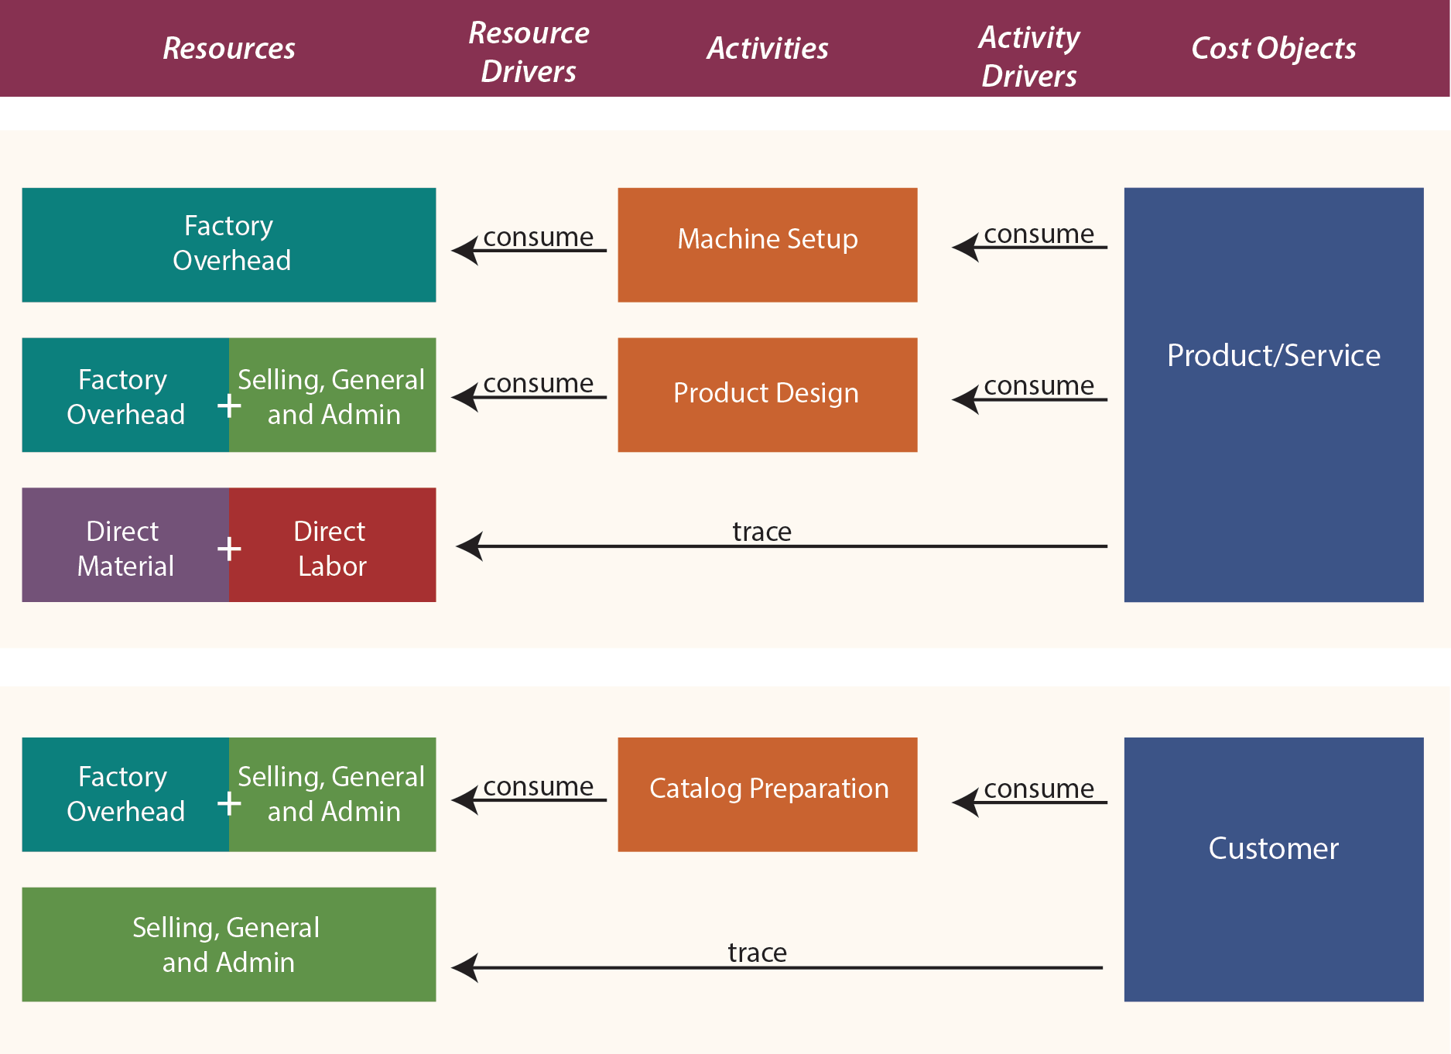
Figure 1: Activity base costing flow chart (Principles of Accounting, 2016).

5.2 Tooling Life and Cost Impact
Tooling life and performance is a critical factor in machining capabilities and part manufacturing processes, this also is a huge component in cycle times and part scrappage percentage, this all contributes to tooling being a critical factor when completing the RFQ process.
Key factors of tooling at RFQ stage: -
- Cost of tooling
- Commercial (Stock or Sourced)
- Tooling Type
- Design for Manufacturability
- Material Specification
- Production Environment
Tooling is a critical part of the manufacturing process within a precision engineering company, especially when dealing with tight tolerance parts that need to be manufactured. Tooling used can range from several factors such as, work holding, machining capabilities, material and inspecting. All these factors make getting a data driven approach when doing an RFQ key to the accuracy of the estimation when submitting the bid.

5.2.1 Cost of tooling
The cost of tooling is not necessary an occurring cost when it comes to the quote process and will often change from project to project, but it is a critical part of the RFQ process as in machining tool wear and replacement tooling are unavoidable. There are multiple factors that can reduce the tool wear or need for new tooling but considering the nature of precision engineering where tight tolerances need to be maintained, the requirement for the tooling to be consistent is key.
A common mistake for precision engineering companies is trying to use old tools that are still within the business, as tool wear is a gradual degradation caused by stresses during machining operations, directly influencing tool life and cost (Hosseinkhani and Ng, 2020). Although these may look good but often when put back into machining they often fail or leave a finish that is not acceptable to the drawing causing parts to be scrapped this can be seen in Fig 2 & 3 below. This is why tooling needs to almost always be considered into the quotation stage as any inaccurate estimation of tooling with almost certainly lead to reduced profitability.
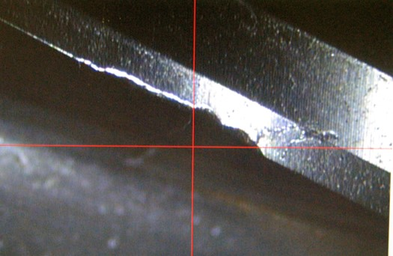
Figure 2: Natural view compared to zoomed in of tooling wear Company (H.P. 2018).

5.2.2 Commercial (Stock or Sourced)
The commercial availability and if it is a stocked part not only effects the price it also has a part to play in the lead time that needs to be assigned to the RFQ. If tooling essentially is stocked on site this still needs to have a cost to it within the quote as these tools were purchased at some point or if in the case of Llanelec there is a tooling vending machine, where tooling is stored at the premises and only paid for when they are removed from the vend. The sourced tooling is different where not only the cost of this is important, but the lead time also effects the quote.

5.2.3 Tooling type
Tooling selection also needs to be considered in determining machining performance, cost, and efficiency. Different tooling options such as single-point tools, multi-edge tools, and coated inserts, all have specific strengths and weaknesses making it crucial to choose the correct tooling for the job (H.P. 2018). The selection of tooling must therefore balance cost and performance, as specialised tooling may improve efficiency but increase upfront expenditure. Incorrect tooling selection can result in reduced tool life, poor surface finish, and increased machining time, all of which negatively impact cost estimation within the quotation process (Hosseinkhani and Ng, 2020).

5.2.4 Design and manufacturability of parts
The design and complexity of the part have a big influence on not only the tooling involved but also the work holding and machine that needs to be used to manufacture the desired part, “The choices made during the design phase ripple through every subsequent manufacturing step. A seemingly minor design decision like specifying an unnecessary fillet or choosing an overly tight tolerance can transform a straightforward CNC machining operation into a complex, time intensive process that delays product launch by weeks” (Engineer, P. 2025).

5.2.5 Material spec
Material properties are the most influential aspect when choosing tooling and estimating an RFQ. The type of material drastically affects the tooling required ranging from what type of cutting tool is used and its material it is made from to the work holding required for the job and even the machine choice will be affected by the material that is required to be machined all contribute to the performance and tool life. Tougher more abrasive materials increase cutting loads leading to quicker tool wear, reduced tool life and increasing tooling cost (Wang, P, 2016). In contrast, materials with higher machinability allow for longer tool life and improved efficiency. There is also a factor that some material materials may undergo work hardening during machining, this has not only a huge effect on the tool but also can cause the properties in the material to change so much it needs to be scrapped (Holton, S. 2023).

5.2.6 Production environment
Tooling performance is greatly influenced by the production environment, which includes machine condition, cutting parameters, and process stability. Although the main causes of tool wear are cutting speed, feed rate, material and temperature (Darwish, 2021). Furthermore, machining instability and vibration can lead to tool failure and poor surface quality, having the correct machine, coolant, air temperature all play roles in keeping tool wear to a minimum, along with keeping the finish and tolerance of the part in keeping with the drawing.

5.2.7 Cutting Conditions
Correct cutting compounds and pressure will also determine a tools life; this will also affect the materials condition after machining. “There are cases where it may be an environmental and cost perspective benefit to machine without coolant (dry machining). However, many applications require machining with coolant for tolerance, surface quality and machinability. If coolant is required, it should be optimized to maximize its true potential” (Coromant, S. 2022). Without the correct cutting fluids and work holding the tools life will be subject to a few different wear patters that can be seen in Fig 3 below.

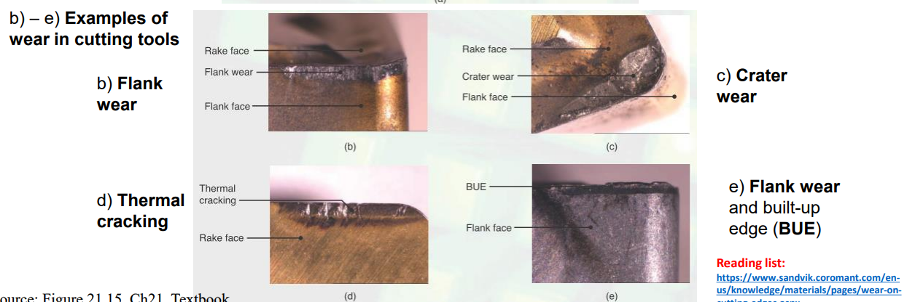
Figure 3: Wear examples on a tool’s life (Immerman, G. 2025).

5.3 Subcontractor and Supply Chain Risk
Subcontracting is a key and common part of the engineering and manufacturing industry, there is a range of different types of subcontracted work, whether it be precision machining, treatments, testing, painting or coatings that are required for the project that either the company does not have the capacity or facilities to complete the operation, or alternatively it could be that the company can manufacture the part but has more profitable work on machines that would be required to manufacture the part so subcontracting the part out will allow you to meet delivery times promised on the RFQ. Supply chain research highlights that external sourcing increases uncertainty due to factors such as supplier reliability and delivery performance, there are simple steps that can be taken to eliminate the risk in the best way possible (Christopher, 2016).
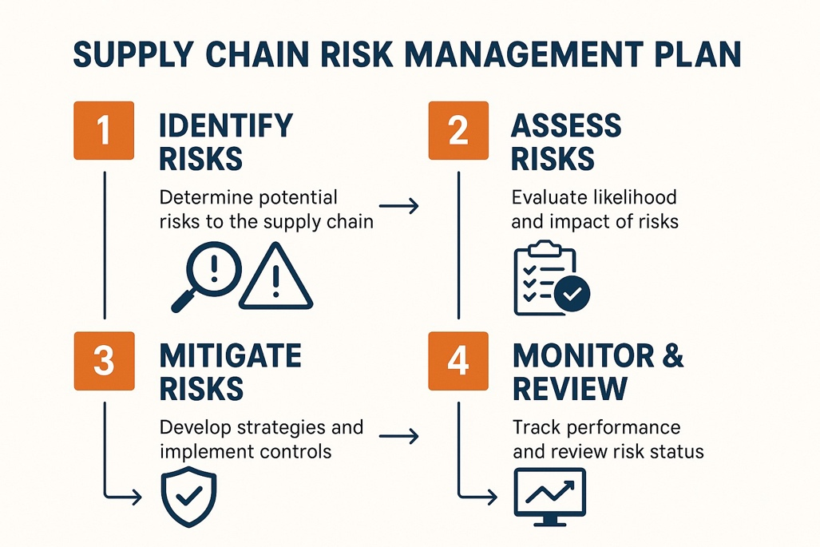
Figure 4:Supply chain and subcontractor management risk diagram (M, M. 2025).
Pricing variability is one of the more persistent challenges in subcontracting. Costs are subject to change based on several different factors these include supplier demand, material availability, lead times, and production capacity. This causes difficulties in producing consistent and accurate quotations, especially when estimates are taken from outdated supplier data or where visibility across the supply chain is limited (NIST, 2022). When subcontractor pricing is not consistent therefore is unreliable, it can have a knock-on effect on the overall, leading to an increased gap between what was quoted and what the work ends up costing. Lead times are a similar issue. Schedules slip, projects take longer than expected, and indirect costs start to increase when subcontractors don't deliver on time. It is easy to understand why supply chain literature continually identifies supplier reliability as a key factor influencing operational performance. Machines lying idle, the expense and disturbance of rescheduling work, and hurrying jobs through to make up lost time are just a few of the repercussions that delays frequently cause (Christopher, 2016).
The standard of work returned is also another risk that should not be overlooked. When subcontracted work or processes are not consistent or to the standard required, the consequences tend to surface as rework, scrap, or the need for additional inspection all of which add cost to the production process. In a precision-based engineering company this becomes an issue given the tight tolerance and surface finishing needed to comply with the drawings (Christopher, 2016). There is a real danger that costs can spiral if this is not factored in the quotation stage, this will affect both profits of the company and the relationship between the customer and Llanelec.
In trying to eliminate these risks, organizations have moved towards data-driven approaches to supplier evaluation and performance tracking. Studying historical subcontractor data such as pricing trends, lead times, and quality performance gives a company a better understanding of where profit is lost or gained. The adoption of this displays a broader understanding that subcontractor performance is not a marginal concern, but something that sits at the heart of delivering projects successfully and profitably (Bao, G. and Vitliemov, P. 2024).
Taking all the knowledge of the effects of this into account leads to this area is key to the project where subcontractor performance is something that needs addressing and a data driven approach needs to be implemented into the company to help with a more consistent and accurate RFQ submission. The integration of subcontractor performance analysis therefore supports the development of a more robust and reliable quotation framework (Ersahin, N, 2024).

5.4 Data-Driven Decision Making in Engineering
In modern manufacturing settings, where multiple processes are done and operational data is produced during the production process, data driven decision making has grown in importance. Data driven is a process where it uses historical or current evidence to support more accurate and consistent decision making instead of relying on experience or personal judgment. This is particularly essential in the RFQ processes, where non consistent cost estimation can lead to loss in profit or demands not met for the customer (Ersahin, N., 2024).
In manufacturing engineering, these methods tend to be applied to areas like machining performance, tooling usage, subcontractor and supply chain and cost variation. Looking at historical data gives a better chance of spotting mistakes or discrepancies that would likely be missed through personal estimation alone, which in turn helps with forecasting and keeps profits within the company (Ersahin, N, 2024).

5.5 Engineering Decision-Making in Quotation Processes
At the quotation stage engineering decision making is critical to the quotation processes, where technical and commercial decisions must often be made within limited timeframes and lack of important information. Making estimations and decisions involving tooling selection, machining strategy, material specification, subcontractor usage, and production all have an impact on the quote and the accuracy of it (Bao, G. and Vitliemov, P. 2024)
The traditional estimation method which is done from engineering experience and personal judgement rather than data can be key for decision making and estimation when a time frame is tight for a RFQ return but this can cause inaccuracies or specific information being missed. This can lead to variation in quotation accuracy and reduce confidence in cost estimation outcomes.
The increasing availability of date driven quotation methods should be adopted where possible as these improve visibility of cost drivers and allow estimated values to be compared against actual production performance. This enables organisations to perfect estimation methods over time (Wittig, C., Hemmerich, J. and Matthiesen, S. 2025).
Accuracy and efficiency must be balanced while making engineering decisions for RFQ preparation. While simplified approaches boost speed but decrease the visibility of manufacturing risk, detailed estimation methods can increase quotation reliability but may also increase preparation time. Companies must strive to establish a quotation process that provides enough technical detail while remaining practical within commercial timescales.
This is where currently Llanelec can improve and reduce the inconsistencies in the RFQ process and identify any issues affecting cost accuracy and process reliability. Therefore, the project's goal is to improve consistency and reduce estimation uncertainty in the quotation process by developing a more structured and data-driven RFQ framework that would validate engineering decision making (Wittig, C., Hemmerich, J. and Matthiesen, S. 2025).

6. Work Carried out

6.1 Research Approach & Methodology
A practical, data-driven approach has been chosen to explore and improve the accuracy and consistency of the RFQ process within Llanelec Precision engineering. This is because currently the process that is in place at the company does not meet expectations of modern precision engineering companies, the “RFQs facilitate communication between project stakeholders and suppliers, ensuring that materials, equipment, and services are sourced professionally and efficiently. Larger scale projects in these sectors are complex, the need for accurate and timely quotations has become increasingly pivotal. However, traditional RFQ methods, often reliant on manual workflows, struggle to keep up with the demands of modern infrastructure projects” (Ezeanochie, (2023).
Both historical data and live data will be the focus through the project, this combined approach will allow identification what is working and what is failing in the current system that is in place.
The data will be gathered from the company as it had on going jobs that have been historically manufactured as well as have future orders from new RFQ that were submitted. This data will allow a real understanding on if the current process is effective or if the new process is more efficient and accurate. This delivers a representative basis for the study, as it is production-based data rather than theoretical.
Both quantitative and qualitative techniques will both be used. “Quantitative data refers to any information that can be quantified that is, numbers. If it can be counted or measured, and given a numerical value, it's quantitative in nature. Think of it as a measuring stick” ‌(Fullstory, 2024). The ever-growing need for the predictions that quantitative data can create has made it increasingly essential in engineering.
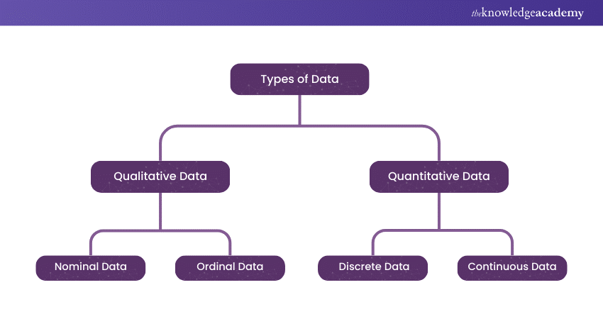
Figure 5: Qualitative Vs Quantitative Comparison Path (Turner, 2026).

Where quantitative analysis will be mainly used: -
- Estimated versus actual costs
- Forecast machining times versus actual machining times
- Tooling usage, including tool life and replacement frequency.
- Subcontractor pricing and associated cost variations.
Estimated and actual values form the basis of variance analysis; this can be used to measure the discrepancy among predicted and real outcomes. This is usually measured in a percentage form, as this allows a clearer indication on the results as well as allowing a universal measurement across different projects (Burger, 2024). While analysing the difference across a range of projects, any recurring over or under estimation can be identified.
Analysis of machining time compares how accurate process planning assumptions are. Differences between projected and actual machining times will be highlighted showing if the estimation was done well or not, there could be several factors that contribute to a gap in the estimation and actual time taken like operator variability, or inefficient process planning. Similarly, tooling data makes it possible to assess how overall cost is affected by tool wear, breakage, and replacement frequency. As tooling performance plays a big role in precision engineering as both cost and product quality is involved, this is especially crucial (H.P. 2018).
Subcontractor pricing data is also analysed quantitatively to assess cost variation and consistency across external suppliers. By comparing quoted subcontractor costs against performance and quality, as well as comparing between suppliers for similar processes, it is possible to recognise areas of risk and potential cost instability within the supply chain.
Therefore, this project's use of quantitative approaches makes it possible to find quantifiable differences in the quote process. The study can go beyond subjective evaluation and offer evidence-based insights into the major elements influencing quotation accuracy by methodically evaluating numerical data (Ning et al., 2020).
In parallel, qualitative evaluation examines process workflows, decision-making practices, and the role of experience-based judgement in quotation preparation. When combined, these techniques offer a more thorough comprehension of the causes and mechanisms of errors. The methodology makes it possible to examine the major factors affecting quotation accuracy by combining these. These include supply chain issues like subcontractor dependability, operational factors like data availability and process consistency, and technical variables like tooling performance and machining efficiency (Ersahin, N, 2024). The combination of these components facilitates the creation of a methodical and repeatable quoting process that aims to lower uncertainty, increase consistency, and improve overall cost estimating accuracy.

6.2 Existing RFQ Process Analysis
Analysing Llanelec Precision Engineering's present RFQ procedure was the first step in the practical inquiry. This was done to find areas where quote errors were occurring during the estimation process, as well as weaknesses and inconsistencies. The inquiry concentrated on the creation of quotations, the data available for estimation, and the engineering choices taken during the quotation preparation process. It was identified that the company’s quotation process solely depended on engineering experience and previous project knowledge to estimate a cost, rather than structured analysis or standardised workflows. While this approach allowed quotations to be produced quickly which with it only being a single person doing this at the time this was a positive and almost the only real way all RFQ’s could be completed by the deadline dates, however inconsistencies were identified between estimated and actual manufacturing costs across several completed projects. Experience-based estimating can induce variability and inconsistency in manufacturing quotation processes, according to research on machining quotation systems. (García-Crespo et al., 2009).
A review of historical RFQs identified that information used during quotation preparation was not always centrally recorded or validated against actual manufacturing performance.
On more than one occasion assumptions were made or even missed on key areas such as, tooling assumptions, machining strategies, and subcontractor costs where these were even done from estimations based on previous similar jobs without formal comparison to historical production data. The lack of systematic validation and historical analysis can greatly lower quotation reliability and increase cost volatility, according to studies on manufacturing estimating systems. (RIT, 2017).
Research also identified variation in how quotations were prepared between different projects and personnel. Inconsistencies occurred throughout the quotation process due to, accessible supporting data, and estimation techniques. This demonstrated the absence of a completely organised RFQ process and confirmed the need of a more data-driven method for the RFQ process.
To better understand the process, the RFQ workflow was broken down into a sequence of stages, beginning with receipt of customer requirements and ending with final quotation approval. Weaknesses, inefficiencies and missing information can be highlighted thanks to this process mapping exercise. Process mapping and structured workflow analysis enhance the visibility of operational inefficiencies and facilitate more consistent engineering decisions, according to research on manufacturing decision-making frameworks. (Jeavons, 2018).
The research served as the basis for the creation of the enhanced RFQ framework that was later in the project. The analysis clarified where process enhancements may be applied to enhance quotation accuracy and overall process dependability by identifying the primary causes of variability and inconsistency within the current system.

Step 1 | RFQ Received | Customer RFQ documentation received. No formal intake checklist or structured review in place.
▼
Step 2 | Engineering Review | Single engineer reviews the drawing from memory and experience. No standard checklist, no data lookup, no formal complexity assessment.
▼
Step 3 | Experience-Based Estimation | ⚠ Key risk area. Tooling, machining times and subcontractor costs all estimated from memory and prior experience. No historical data validation. Primary source of quotation inaccuracy.
▼
Step 4 | Quote Created | Quote compiled from estimated figures. No formal review stage, no sign-off process, and no cross-check against historical performance data before submission.
▼
Step 5 | Submitted | Quote submitted to customer. No post-project validation cycle in place to compare actual costs against quoted values for future improvement.

Figure 6: Current RFQ process within Llanelec.

6.3 Data Analysis
To find patterns, inconsistencies, and recurrent sources of quotation inaccuracy within the current RFQ process, a thorough study was conducted after historical and current production data was gathered. Identifying where cost variation was occurring and which factors had the biggest impact on quotation reliability, the investigation concentrated on comparing estimated quotation values against actual production outputs.
Variance between projected and actual costs was a crucial component of the inquiry. Examining machining times, tooling costs, subcontractor prices, and total production expenses across several finished tasks were all part of this. Variance analysis is frequently used in manufacturing cost estimation to find differences between projected and actual performance, allowing for a more thorough evaluation of quoting system flaws.
To evaluate the connection between tooling life, replacement frequency, and production efficiency, tooling performance data were examined. The effects of tooling wear on machining consistency, downtime, and total manufacturing cost were particularly examined. Tooling variability is a primary source of uncertainty in machining cost estimation and has been found to have a considerable impact on production performance (Wang, Wang and Gao, 2015).
Aswell as tooling life and performance, an evaluation of lead time performance and subcontractor cost. Inconsistencies between vendors for comparable production processes and variations in external pricing were found by comparing quoted subcontractor costs and final invoiced values. Delays within subcontracted operations were shown to impact total production scheduling and project cost, therefore delivery performance and process dependability were also examined.
The analysis focused on finding more general trends and recurrent patterns across several projects rather than concentrating on specific instances. This made it easier to identify typical sources of quotation errors and made it easier to see where process improvements were needed. The enhanced RFQ framework that was later presented inside the project was developed based on the analysis's conclusions.

6.4 Development of a Structured RFQ Framework

In the development of improving the accuracy of the RFQ process a step-by-step framework was created, this was based on the concept of workflow process. This method is like purchasing or transactional workflows, where each step must be finished before moving on to the next. Applying this to the RFQ process made sure that all technical, operational and commercial requirements are reviewed via the date driven process rather than relying on opinion and experience. Process sequencing and stage validation can greatly increase consistency and lower operational variability, according to research on structured manufacturing workflows (Jeavons, 2018).
The base was developed using findings established throughout the earlier stages of the project’s investigation and process analysis. Most focus was done on addressing recurring issues that were found, such as machining timing, tooling estimation, subcontractor management and process validation The completed framework introduced a more controlled and traceable quotation system, improving visibility of key cost drivers throughout RFQ preparation.
Figure 7: Structured RFQ framework incorporating technical, operational, and commercial evaluation stages.

6.4.1 RFQ Intake and Initial Review
Receiving and reviewing customer RFQ documentation, which includes technical drawings, specifications and customer requirements such as qty and time frame, is the first step in the framework. Before preparing a quote, this step focuses on determining the manufacturing complexity, technical viability, material requirements and any information that is missing that will affect the quote being completed. Early detection of technological issues, weather it may be missing dimensions on a drawing or a material spec that is superseded needs to be either questioned or a concession being requested on the quote.

6.4.2 Data Structuring and Bill of Materials (BOM) Creation
Once the initial review is done, all requirements need to be produced on a data sheet this will include creation of a Bill of Materials (BOM). A BOM is a sheet that has all identification of raw materials, required machining operations, component quantities, and any additional manufacturing processes. Early project data structuring facilitates more uniform quotation preparation and enhances manufacturing requirements visibility.

6.4.3 Cost Input and Process Estimation
The next stage is cost input and process estimation, this is done by using data and previous manufacturing statistics, the next step focuses on estimating labour requirements, machining times, production routing, and operating costs. Instead of depending solely on conjecture, prior project records and production data are utilised when appropriate to enable more evidence-based estimation. Structured estimating techniques increase dependability and decrease quotation variation, according to research on manufacturing quotation systems (García-Crespo et al., 2011).

6.4.4 Tooling Assessment

The assessment of tooling which includes tooling selection, estimated tool life, replacement frequency if applicable and tooling capability are all considering when processing the RFQ. This stage was included due to tooling-related cost variation being identified as a significant contributor to quotation inaccuracies during earlier project analysis.

6.4.5 Subcontractor Evaluation
Subcontractors are evaluated according to cost, lead time, dependability and process capacity. When available, historical supplier performance data is examined to promote more uniform supplier selection and reduce uncertainty in subcontracted processes. This phase seeks to reduce external cost variation and boost confidence in quotation estimates relating to subcontractors. A simple point scoring system was implemented in tracking all the key areas that determine that if a subcontractor is meeting standards required or failing (Ersahin, N, 2024).

6.4.6 Quote Compilation and Review
Individual cost components are combined into a final quotation after all cost inputs have been finished. Before submitting a quotation, a review of the quote is conducted to confirm tooling assumptions, machining estimates, subcontractor prices and overall manufacturing feasibility is all accounted for. RFQ process control systems frequently follow this step-by-step process to increase consistency and lower process error (GAO, 2020).

6.4.7 Post-Process Validation
Once the project has been completed, a review is processed to see the actual machining costs and how they compare to the original price quoted. Any variance is then compared to see what the differences are between the quote and the actual cost to complete the project. This approach supports any long-term commitment and development of a more accurate RFQ process, giving the company full confidence that when a Quote is submitted every step has been taken to ensure it is as accurate as can be.

6.5 Implementation of RFQ Tracking and Analysis Tools

To support the implementation of the revised RFQ framework several tracking and analytical tools were created to enhance the organization, monitoring, and assessment of quotation data throughout the project to facilitate the implementation of the updated RFQ framework. These tools were created to make important cost drivers more visible and to offer a better organised method for preparing quotes and reviewing completed projects.
Spreadsheet-based tracking systems were developed to record and compare estimated quotation values against actual manufacturing outcomes. The tracking tools included data relating to machining times, tooling usage, subcontractor costs and labour estimate. By combining this information, it became possible to monitor cost variations and see any trends over multiple projects more effectively.
The focus and a key function of the tracking system was the tracking the differences of actual costs of the project in comparison to quoted estimations. Percentage-based comparisons were used to measure the scale discrepancies within tooling costs, machining times, and subcontractor expenditure. This made it easier to see persistent overestimations and underestimations and gave quantifiable proof of where the RFQ process needed to be improved. The significance of structured data monitoring in enhancing forecasting accuracy and promoting ongoing process improvement is shown by research on industrial estimate systems (GAO, 2020).
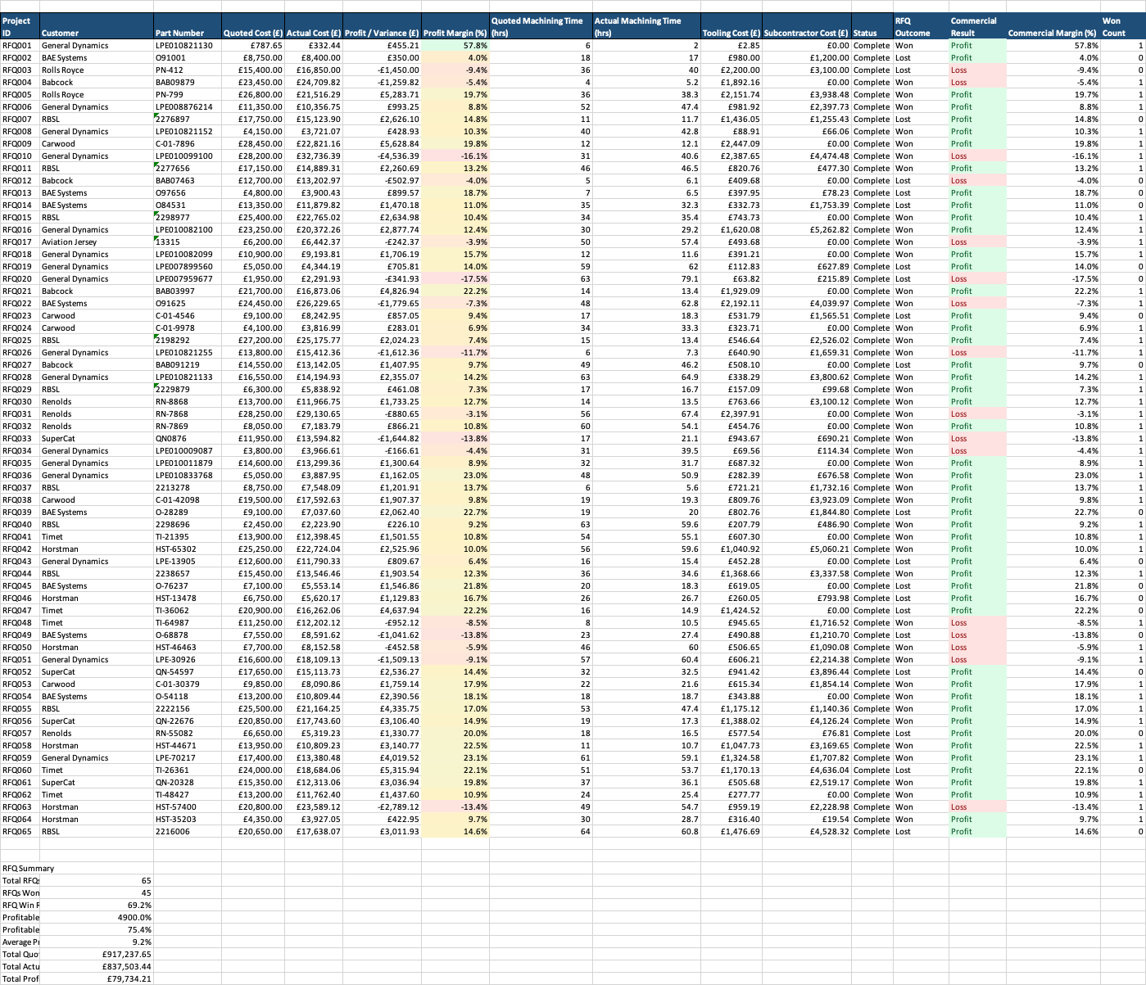
Figure 8: New RFQ Tracker Spread Sheet at Llanelec precision engineering.

Subcontractor tracking was also incorporated into the system as can be seen in figure 5 to monitor supplier pricing, lead times, and delivery reliability. This improved understanding of external manufacturing risks and supported more informed supplier selection during future quotation preparation, it also gives the company a smaller selection of subcontractors that are preferred to use, this then installing confidence that if any of the ones you have choice from you know they perform well consistently enabling you to give more accurate lead times.

Tool | Purpose | Benefit
RFQ Tracker | Compare quoted vs actual | Variance visibility
Tooling Tracker | Monitor tooling spend | Improve tooling estimation
Subcontractor Tracker | Monitor supplier performance | Reduce supply chain risk
Live Data Tracker | Compare active jobs | Improve forecasting

Table 3: Each tracking tool purpose data.

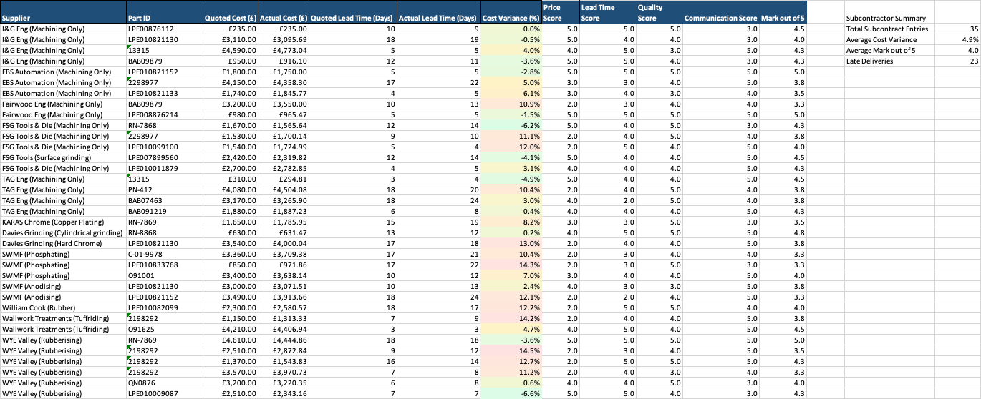

Figure 9: Subcontractor Tracker at Llanelec precision engineering.
In addition to increase consistency in the development of quotations, process monitoring tools were created in addition to cost tracking. To guarantee that crucial sections like tooling assessment, machining estimation, and subcontractor evaluation were consistently accomplished throughout each RFQ, structured checklists and review stages were created. According to research on workflow standardisation, organised process monitoring enhances operational consistency and lowers process variability in manufacturing settings (RIT, 2017).
Compared to the company's prior system, the use of these tracking tools allowed for a more structured and data-driven approach to RFQ preparation. All this contributed to the ongoing improvement of quotation accuracy by improving visibility of manufacturing performance and showing constant comparison between estimated and actual project outcomes.

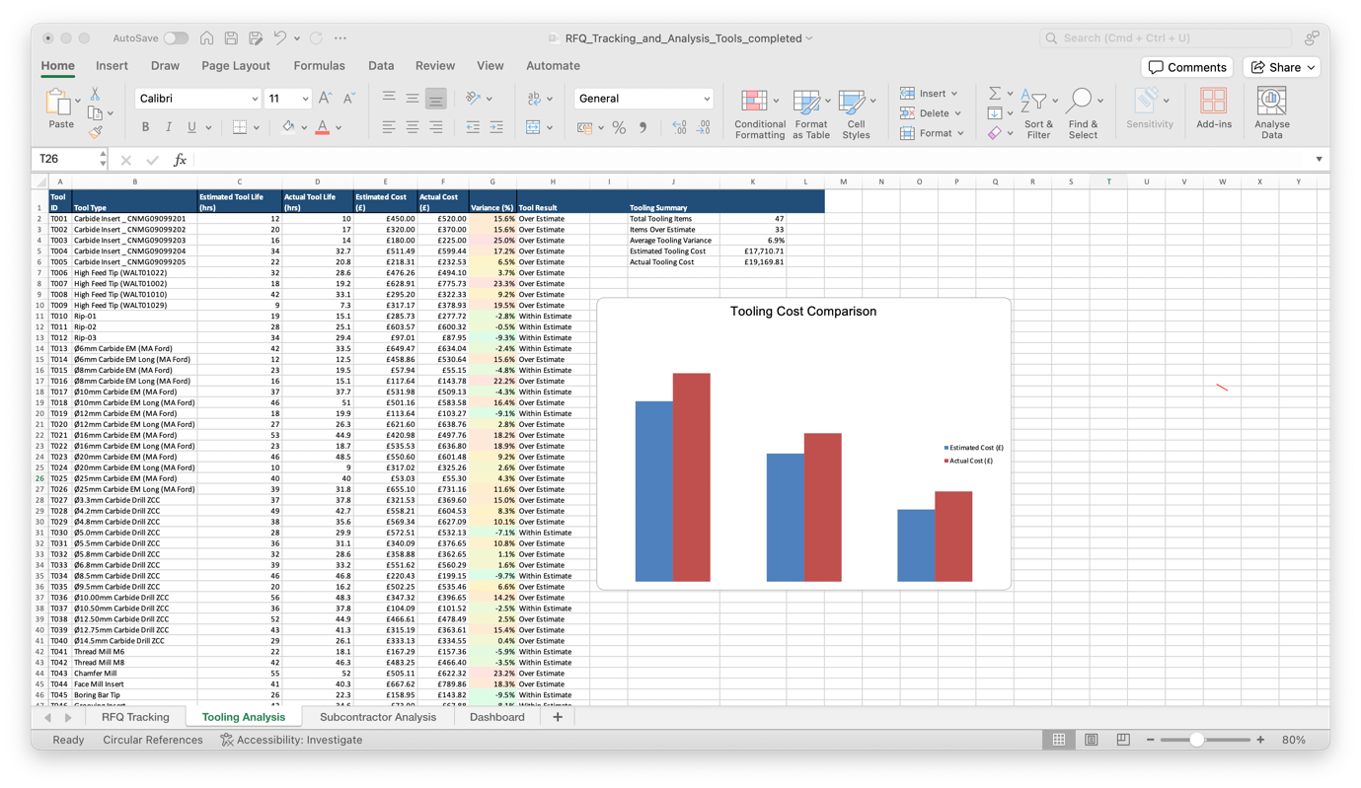
Figure 10: Tooling Costing Tracker at Llanelec precision engineering.

6.6 Validation of the Improved RFQ Process
Following implementation of the revised RFQ framework and supporting tracking tools, validation activities were carried out to assess the effectiveness of the proposed improvements. This was carried out to establish if the new process increased manufacturing risk visibility, decreased cost fluctuation, and enhanced quotation consistency.
Estimated quotation values were compared to actual manufacturing results across a selection of projects and active RFQs to undertake validation. Tooling costs, machining times, subcontractor pricing, and total production spending were given special attention because these factors have previously been found to be significant causes of quotation errors. The performance of the updated framework might be quantitatively assessed by measuring the discrepancies between quoted and actual values using variance analysis.
It was established that the structured RFQ workflow improved consistency within the RFQ process by ensuring that all highlighted steps were improved. The new structure reduced the likelihood of missing information and improved traceability throughout the quotation process. This is backed up by research into manufacturing estimation systems used in other companies or industries showing that structured validation and workflow control improve process reliability and reduce operational variability (GAO, 2020).
The tracking of historical data into the quotation process also improved visibility of recurring cost trends and supporting the estimations and engineering decisions. Estimates of tooling utilisation, machining time, and subcontractor expense might be more accurately determined than under the prior approach by comparing current RFQs with past project performance. This increased trust in the estimation process and decreased reliance on assumptions. An implementation of an Operator Tooling and measurement sheet was also implemented to assist in reducing the scrappage of work, this allowed operators to check where possible the part while it was still in the machine, an example can be seen below in Figure 8.

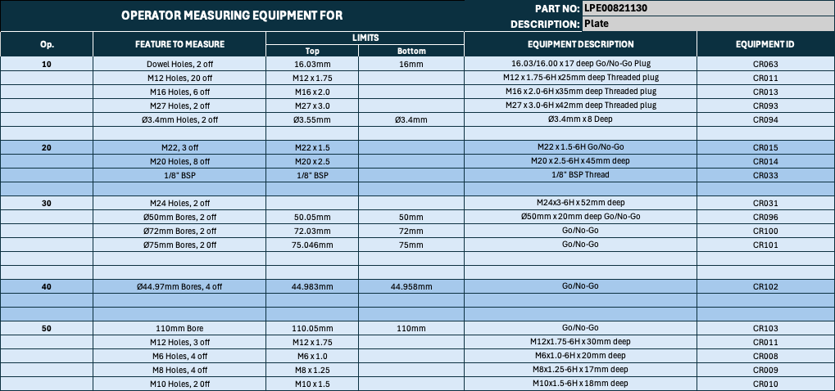

Figure 11: Operator Measurement sheet at Llanelec precision engineering.

Feedback gathered throughout the process suggested that the new process improved organisation and consistency during quotation preparation. The staged process structure ensured that quotation activities followed a more repeatable workflow, reducing variation between projects and improving overall process control.
Therefore, the validation stage demonstrated that the revised RFQ process and framework provided improvements in quotation structure, consistency, and manufacturing cost visibility. While further improvements will be made in the future, the results indicated that a more structured and data-driven approach will improve the whole RFQ process for Llanelec Precision engineering.

7. Results

7.1 RFQ Variance Analysis Results
Once all the work had been done on the new systems, research was done to evaluate quoted manufacturing estimates versus actual production outcomes across finished and ongoing projects following the revision of the RFQ framework and related tracking systems. This was carried out with the view of finding out whether the new RFQ framework had improved consistency in the quoting and reduce any cost deficits.
The old quoting procedure frequently resulted in discrepancies between estimated and actual manufacturing costs, according to variance analysis. The areas with the most variation were subcontractor pricing, machining time estimation and tooling expenditure. These results verified the conclusions drawn in previous process research, which found that dependence on experience-based estimation and a lack of historical validation were significant causes of quotation inaccuracy.
Improvements in the quotation structure and visibility of manufacturing cost factors were noted once the redesigned RFQ process was put into place. The consistency of labour estimation, tooling assessment and subcontractor appraisal throughout RFQ preparation was enhanced by the utilisation of historical production data and organised review stages. Repetitive over evaluations and under estimations across several projects could be more easily discovered thanks to percentage-based variation tracking.

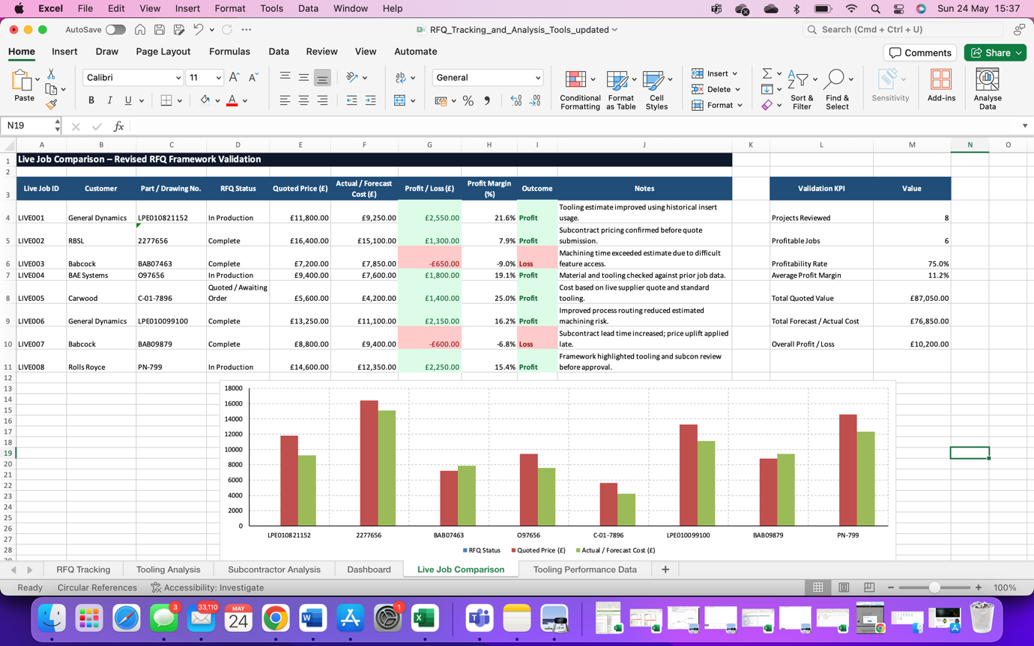

Figure 12: Live Data Comparison Spread Sheet at llanelec precision engineering.

It can be seen on the RFQ tracking sheet that roughly 75% of reviewed projects remained within acceptable profitability following implementation of the revised framework. Projects showing lower profitability were typically linked to external factors such as subcontractor delays, material cost fluctuations or unexpected tooling wear, although this can never be accurately estimated as there are so many factors that contribute to tooling wear or snap page. However, the revised process improved visibility of these risks during quotation preparation and allowed mitigation strategies to be considered at an earlier stage.
Measurable gains in quotation consistency were also revealed by analysis of machining time estimation. Projects prepared utilising the structured RFQ framework produced lower variation levels than projects estimated using the previous approach, according to a comparison between anticipated and actual machining times. Better use of past machining data encouraged more evidence-based process planning and decreased reliance on conjecture (Ersahin, N, 2024).
The results also highlighted the value of constant post process validation within the new process. In comparing completed project performance against original quotation estimates, recurring errors can be identified used to refine future RFQ processes. This created a continuous improvement cycle within the revised framework and installed more confidence in future RFQ submissions.
Overall, the new RFQ process demonstrated that implementation of a structured and data-driven quotation process improved knowledge of manufacturing risks, reduced estimation inconsistency and enhanced overall quotation reliability within Llanelec Engineering.

7.2 Tooling Performance Results
The relationship between tooling utilisation, tooling cost variance and machining performance across specific manufacturing projects was assessed by tooling performance analysis. Tooling life, replacement frequency, tooling-related downtime and the effect of tooling wear on quotation accuracy were all highlighted (Wang, P, 2016).
The study revealed that tooling costs represented one of the most variable elements within the original RFQ process. Under the previous estimation method, tooling assumptions relied heavily on engineering judgement and experience rather than on measurable, data-driven performance metrics. This led to recurring discrepancies between projected tooling costs and actual tooling consumption observed during production.
Following the implementation of the revised RFQ framework, tooling utilisation was monitored through structured tracking spreadsheet and comparative performance records. Estimated tooling life was systematically benchmarked against real-world tooling performance throughout the production cycle, facilitating a more precise and reliable assessment of tooling-related manufacturing costs.
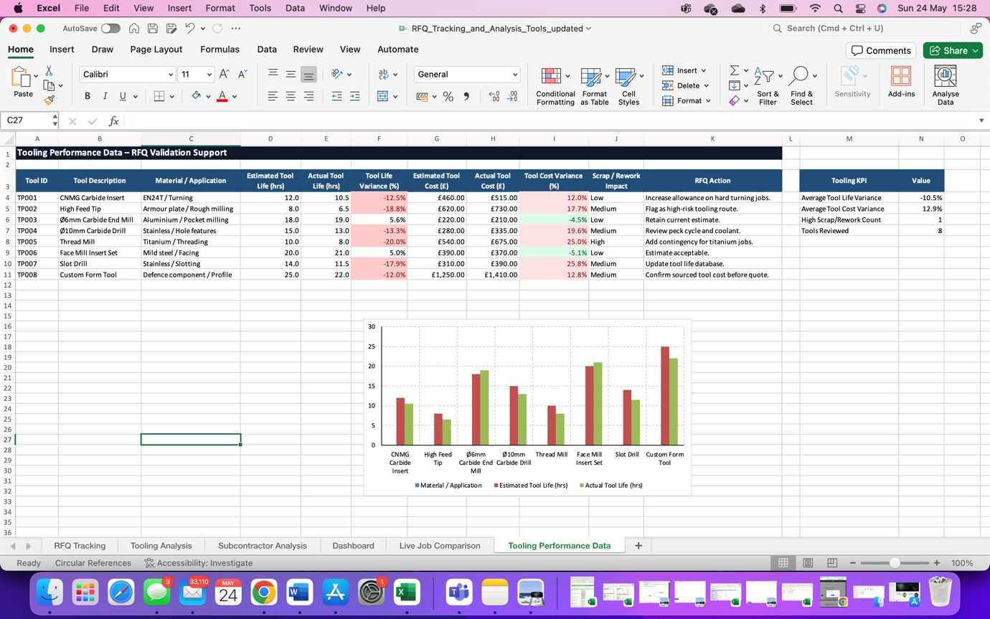

Figure 13: Tooling Performance Spread Sheet at Llanelec precision engineering.

The tooling performance tracker revealed that excessive tooling wear and unplanned tool replacement were significant drivers of machining cost increases, particularly on complex components and difficult to cut materials. Components requiring tight tolerances, aggressive cutting parameters, or abrasive workpiece materials exhibited the greatest degree of tooling variability. These findings aligned closely with conclusions drawn from the literature review, where tooling wear was widely acknowledged as a primary contributor to manufacturing cost instability (Krajnik et al., 2016).

The revised tooling tracking process enhanced visibility of tooling-related cost risks during quotation preparation. The availability of historical tooling performance data enabled more realistic and defensible tooling allowances to be embedded within RFQ estimates, thereby reducing the risk of systematic underestimation of tooling expenditure. The introduction of structured tooling review stages within the RFQ framework further improved consistency in tooling selection and mitigated the risk of inappropriate tooling assumptions at the estimation stage.
Beyond cost-related improvements, tooling performance monitoring yielded measurable benefits in manufacturing consistency and process control. Greater visibility of tooling condition and replacement intervals reduced the incidence of dimensional variation, surface finish degradation, and tooling-induced scrap during production (Teti et al., 2010). The introduction of operator tooling and measurement sheets provided additional process assurance through in-process dimensional verification at key stages of machining operations.
Overall, the tooling performance analysis demonstrated that integrating tooling monitoring and historical performance data into the RFQ process significantly improved tooling cost visibility, reduced estimation uncertainty, and supported more reliable and consistent quotation preparation within the manufacturing environment.

7.3 Subcontractor Cost and Delivery Performance Results
Subcontractor A subcontractor performance analysis was carried out to assess how external manufacturing operations affected quotation accuracy, production scheduling, and overall project profitability. The analysis focused on three core areas, pricing consistency, lead-time reliability and the gap between quoted and actual external manufacturing costs.
What became clear quickly was that subcontractor-related expenditure had been one of the more unpredictable elements of the original RFQ process. Previously, supplier selection tended to lean on established relationships and rough pricing estimates rather than any structured review of how those suppliers had performed over time. Unsurprisingly, this occasionally led to notable differences between what had been quoted and what was eventually invoiced a problem that is well recognised in procurement practice, where the absence of consistent performance tracking leaves organisations exposed to cost variances that could have been anticipated (Gainfront, 2026).
The revised RFQ framework addressed this by introducing a more disciplined approach to subcontractor evaluation. Before any supplier was selected, lead times process costs, delivery reliability, and pricing history were all reviewed and compared against structured records. This gave the quotation team a much clearer picture of where the risks lay and reduced the degree of uncertainty that had previously crept into subcontractor cost estimates.
The data gathered through this process reinforced something that might seem intuitive but is often overlooked in practice suppliers with stable pricing and reliable delivery records produced far more predictable quotation outcomes than those with erratic histories. The tracking system also made it easier to flag higher risked operations early, meaning contingency allowances and backup supplier options could be built into the RFQ before costs became a problem rather than after. Without consistent tracking, organisations risk gaps in procurement compliance as underperforming suppliers continue operating outside agreed terms a pattern the revised framework was specifically designed to prevent (Ivalua, 2026).
Delivery performance analysis added another layer to the findings. Subcontractor delays did not simply affect delivery dates they had a knock-on effect on production sequencing and, in some cases, pushed up manufacturing costs through the need for expedited operations. The revised framework gave the team better visibility of these risks ahead of time, allowing supplier selection to be made on more informed grounds.
Subcontractor analysis showed that embedding supplier performance tracking within the RFQ process led to genuine improvements better external cost visibility, less uncertainty at the quotation stage, and more reliable project planning overall.

7.4 Machining Time and Process Estimation Results
To compare projected machining times with actual production times for a subset of projects and manufacturing procedures, machining time analysis was performed. The goal was to assess the accuracy of process planning assumptions and find recurring sources of machining time variation within the RFQ process.
The results showed that estimations of the machining times in the previous RFQ process heavily relied on experience and engineering judgment, this was done without any formal validation against any historical data. While this was a quick process, it was inconsistent with what actual machining operations took compared to estimated machining times.
The most significant levels of machining time variation were recorded on components with complex geometries, tight tolerances, multi-stage operations and tougher materials. On several occasions additional setup requirements, tooling adjustments or the need to reduce cutting parameters resulted in actual production durations that effected the time allowances built into the original quotation. This is consistent with wider manufacturing literature, which recognises that part complexity and tight tolerance requirements are among the most influential drivers of machining cycle time variability (Lécrivain et al., 2021).
The introduction of the revised RFQ framework brought a more structured and evidence-based approach to machining time estimation. Rather than relying on just judgement, the quotation preparation is supported by historical production records, tooling performance data and documented operational information. This shift gave a more reliable foundation from which to assess production times, particularly on higher complexity components where the margin for error had previously been the main issue.
The results were encouraging. Quotations produced under the revised framework showed noticeably lower levels of machining time variance when compared against those generated through the previous process. Better visibility of machining complexity, combined with a clearer understanding of tooling-related challenges, allowed more realistic production allowances to be built into estimates from the outset rather than having to be reconciled after the fact, this can all been seen in the data spread sheets in figure 10.
Verifying machining assumptions before quotation sign off reduced the chances of operational requirements being overlooked and helped maintain greater consistency between projects something that had been difficult to achieve reliably under the original approach.
In summary, the machining time analysis demonstrated that bringing historical manufacturing data and structured workflow controls into the quotation process led to meaningful improvements in estimation accuracy and reduced the uncertainty that had previously characterised this area of RFQ preparation.

7.5 Overall RFQ Framework Performance Results
The overall results of the project demonstrated that the application of a structured and data-driven RFQ framework improved quotation consistency, manufacturing visibility and process control within Llanelec Precision Engineering. The new structure gives a more strategic and data driver approach to estimation and quotation preparation while fixing several of the outstanding issues that were current in the old RFQ process.
The addition of historical manufacturing data, tooling analysis, subcontractor evaluation and structured process validation stages all combined to improved visibility of the key cost areas that influence RFQ preparation. Rather than relying on assumptions or experience-based judgement alone, the revised framework gave the team a more solid, evidence-based foundation of which engineering and commercial decisions can now be made with greater confidence. This change to data informed estimation is well supported in manufacturing, where structured process controls and historical data have consistently been shown to reduce variability and strengthen decision making all of which are they key factors in moving to the new RFQ system (Bao, G. and Vitliemov, P. 2024).
The workflow structure also consistency in quotation preparation, ensuring that all critical manufacturing considerations were reviewed before the quotation was approved this with process traceability all but eliminated missing information, allowing quotations to have a more repeatable workflow across multiple projects. The results demonstrated that the revised framework provided more accurate quotations although considering that there is still some uncertainty such as material price, the variability of subcontractors and tooling wear (Bao, G. and Vitliemov, P. 2024). With better risk visibility and better management in quotation preparation the post process validation and the continuous comparison between quoted and actual manufacturing performance provided a basis for long-term process improvement, with historical manufacturing feedback used to adjust future RFQs, improve tooling estimation and predict machining time over time. In general, the project results showed that a structured RFQ framework assisted by manufacturability evaluation facilitated the development of a more accurate quotation, with remaining uncertainty such as material price, the variability of subcontractors and tooling wear, but with better risk visibility and better management in quotation preparation, and provided a basis for long-term process improvement, with historical manufacturing feedback used to adjust future RFQs, improve tooling estimation and predict machining time over time.

8. Discussion and Conclusions

8.1 Discussion
The aim of this project was to look at how to improve the current RFQ process within Llanelec Precision Engineering. From the project it was discovered that the existing quotation process had several weak points especially when it came to estimating tooling costs, predicting machining times and accounting for subcontractor expenses. None of this was entirely surprising.
The ability to respond quickly and accurately to requests for quotation is a genuine source of competitive advantage for manufacturing companies yet achieving that accuracy is far from straightforward. The findings from this project closely support the arguments made by Veeramani and Joshi (1997), who identified accurate RFQ response as a genuine source of competitive advantage in manufacturing. This project at Llanelec showed how relying solely on experience immediately undercut that advantage not because the engineers lacked expertise, but rather because inconsistency was nearly inevitable in the absence of organised data to support their decisions. Real evidence of that gap was provided by the study's live project data, which grounded the thesis in actual production performance at a precision engineering company and moved it beyond theory (Veeramani and Joshi, 1997).
The completion of a structured RFQ workflow improved process control and traceability throughout quotation preparation. By dividing the RFQ process into stages, critical manufacturing factors were reviewed more prior to quotation approval. This reduced the risk of missing information and improved overall workflow repeatability between projects. The staged framework additionally increased visibility of manufacture risks earlier within the quotation process, allowing strategy to be put in place prior to releasing the project.
When it came to tooling, it became clear that wear rates, replacement frequency, and tooling-related downtime were all contributing to cost variation in ways that hadn't been well tracked. Before the revised process was introduced, estimates were largely left to engineering judgement, with little hard data to validate them against. Being able to estimate tool wear in precision machining is critical to reducing processing costs and improving manufacturing efficiency yet remains difficult without structured data capture. Introducing tooling performance tracking addressed this directly allowances within quotations could then be grounded in historical evidence rather than assumption, improving overall cost accuracy (Han et al. 2022). Although cost visibility was enhanced by tooling performance tracking, there were still restrictions. Wear on the tools and the speed of this was still hard to forecast with complete confidence on complicated parts and abrasive materials, and the system's dependability depended on consistent operator data entering.
Inconsistency in subcontractor lead times and pricing caused problems both for scheduling and for keeping projects profitable. This kind of variability is well recognised as a supply chain risk; lead time especially was a cause for concern as this was putting the company’s reputation at risk with its customers due to delivery dates being missed. This also would have an impact on profit due to the fact there is a late fee charge on parts by our customer. Clear variations in supplier performance were identified by the rating method, especially regarding pricing consistency and delivery dependability. Stable suppliers yielded more consistent quotation results, providing the team with an evidence-based basis for selection instead of depending just on familiarity. Confidence in the subcontractor cost allowances included in RFQ submissions was immediately increased as a result.
Overall, the project reaffirms that the implementation of a data driven RFQ process will significantly improve quotation consistency, manufacturing visibility and engineering decision-making within the company’s environment. The projects findings also highlight the importance of continuous validation and manufacturing feedback in contributing to the long term RFQ process being more successful for the company. There are a few restrictions to be aware of. The projects conclusions cannot be immediately transferred to different contexts without additional validation because it is based on a single organization and a small number of projects. Additionally, the time the new process has been in place is not long enough to give a 100% accurate showing of its effects.
Several limitations were identified in the project. The study was done within one precision engineering company, limiting the ability to generalise the findings. The validation period was short and therefore did not record long-term performance trends. In addition, some historical data sets were incomplete, restricting the ability to perform quantitative analyse. Using a larger project sample size in the future would provide greater confidence in the findings.
Project Objective | Method Used | Outcome Achieved | Evidence
Improve quotation accuracy | Variance analysis of quoted vs actual costs | Improved cost visibility and reduced estimation errors | RFQ Tracking Dashboard
Improve tooling cost estimation | Tooling performance tracking and historical tooling data | Better tooling cost prediction and identification of wear trends | Tooling Performance Tracker
Improve subcontractor selection | Supplier performance and cost tracking | Improved visibility of supplier reliability and pricing consistency | Subcontractor Analysis Results
Develop a structured RFQ process | Seven-stage RFQ framework | Improved workflow consistency and traceability | RFQ Framework Development
Increase use of manufacturing data | Historical and live project comparisons | Reduced reliance on assumptions and experience-based estimation | Live Job Comparison Data
Support continuous improvement | Post-project validation process | Ongoing refinement of future quotations | Validation and Results Analysis

Table 4: Project Objectives vs Outcomes.

8.2 Conclusion
This project set out to improve the RFQ process within Llanelec precision engineering. By using both historical and live manufacturing data, It became evident that the discrepancy between quoted and real costs wasn't coincidental and might be linked to several distinct issues, including tooling costs, machining time estimates, subcontractor pricing, and a lack of overall process consistency.
The issue was that the existing RFQ process depended on individual experience and personal estimations. Although this was quick and accurate to a point, it was not always consistent and had no structured data to back it up, Leaving the process at risk to inconsistency and made it difficult to build real confidence in the figures being quoted.
The revised RFQ process was created to change that. By bringing tooling assessment, machining estimation, subcontractor evaluation and variance analysis into a single staged workflow, the quotation process became far more controlled and repeatable. Alongside it, tracking tools and supporting spreadsheets were created to increase the visibility of cost drivers and provide the company with a basis for continuous improvement rather than a one-time solution.

Testing the revised framework showed genuine progress not just in the numbers, but in how decisions were being made. Reliance on assumption reduced, traceability improved and manufacturing risks were being picked up earlier in the process, before they had the chance to affect production.
Although it had many positive impacts there are still limitations. Manufacturing variability and external supply chain pressures aren't going away, and no framework eliminates those entirely, although with the new scoring system and tracking a hold on the supply chain risk can be reduced and managed a lot better than it ever was before. Everything being considered the project demonstrated clearly that a more structured, data-driven approach makes a meaningful difference to RFQ reliability in a precision engineering setting and at Llanelec specifically, that improvement is now built into the process.

9. Recommended Further Work
Even though the updated RFQ framework showed quantifiable gains in manufacturing visibility, process control, and quotation uniformity, there are still several areas that might be improved. increasing integration between engineering and manufacturing operations, better production planning and increasing quotation accuracy would all be supported by ongoing system improvement.
Increasing the automation of data analysis and quotation preparation is one area that needs more work. Spreadsheet based tracking systems and manually designed workflows are the main components of the current framework. Throughout the quotation process, integration with ERP software or enterprise manufacturing systems could increase data accessibility, decrease the need for human input, and offer real-time production cost awareness.
A big plus point in the project was the use of historical data compared to live projects, developing this area would also be beneficial to the RFQ process. The use of machine learning or predictive modelling techniques could additionally support more advanced estimation methods within future quotation systems.
Future work should also consider broader supplier performance analysis and supply chain integration. Concentrating on the development of the scoring systems and subcontractor benchmarking may further improve subcontractor selection leading to reducing external manufacturing variability within the RFQ process.
Comparison between low-volume, high-complexity manufacturing and higher-volume production environments may provide further insight into how RFQ systems can be adapted to suit different operational requirements, also giving a better understanding on what section best suits LLanelec.

Finally, continued long term monitoring of quotation performance will only benefit the company in providing additional validation of the revised framework and support continuous improvement activities within Llanelec Precision Engineering. Ongoing modification of manufacturing data collection, process standardisation and variance analysis would further strengthen quotation reliability and support future operational development.

10. References
ACCA (2025). Activity-based Costing | F5 Performance Management | ACCA Qualification | Students | ACCA Global. [online] www.accaglobal.com. Available at: https://www.accaglobal.com/gb/en/student/exam-support-resources/fundamentals-exams-study-resources/f5/technical-articles/ABC.html [Accessed 1 April 2026].
Bagge, M. (2014). Process planning for precision manufacturing An approach based on methodological studies Mats Bagge. [online] Process planning for precision manufacturing. DIVA Portal. Available at: https://www.diva-portal.org/smash/get/diva2:718386/FULLTEXT01.pdf [Accessed 2026].
Bao, G. and Vitliemov, P. (2024) An approach to building a smart decision-making process in a manufacturing organization in terms of profitability, MDPI. Available at: https://www.mdpi.com/2673-4591/70/1/35 (Accessed: 01 May 2026).
Boothroyd, D. (2026). Manufacturing Cost Estimation: Methods, Tools & How to Get It Right. [online] https://www.dfma.com/resources/manufacturing-cost-estimation.asp. Available at: https://www.dfma.com/resources/manufacturing-cost-estimation.asp [Accessed 2 May 2026].
Burger, R. (2024, September 23). What is variance analysis? types, examples and Formula Guide. OneStream Software. https://www.onestream.com/blog/variance-analysis/
Christopher, M. (2016) Logistics and Supply Chain Management. 5th edn. Harlow: Pearson. Available at: https://www.pearson.com/en-gb/subject-catalog/p/logistics-supply-chain-management/P200000003320 [Accessed 01 May 2026].
Chukwuemeka Ezeanochie et al. (2023) ‘A Data-Driven Model for Automating RFQ Processes in Power Distribution and Data Center Infrastructure’, International Journal of Multidisciplinary Research and Growth Evaluation, 04(01), pp. 961–966. Available at: https://doi.org/10.54660/.IJMRGE.2023.4.1.961-966.
Company, H.P. (2018). Necked Tooling - In the Loupe Machinist Blog. [online] Harvey Performance Company. Available at: https://www.harveyperformance.com/in-the-loupe/tag/necked-tooling/ [Accessed 4 April 2026].
Coromant, S. (2022). Coolant aspects – machining with coolant. [online] Sandvik Coromant. Available at: https://www.sandvik.coromant.com/en-gb/knowledge/machine-tooling-solutions/tooling-considerations/machining-with-coolant [Accessed 1 May 2026].
Engineer, P. (2025). Design for Manufacturability: CNC Machined Metal Parts - Complete Engineering Guide. [online] Modusadvanced.com. Available at: https://www.modusadvanced.com/resources/blog/design-for-manufacturability-cnc-machined-metal-parts-complete-engineering-guide.
Ersahin, N. (2024) Supply Chain Risk: Changes in supplier composition and vertical integration - sciencedirect. Available at: https://www.sciencedirect.com/science/article/pii/S002219962300140X (Accessed: 08 May 2026).
‌Fullstory (2024) Qualitative vs. Quantitative Data: What’s the Difference? and Why They’re so Valuable | FullStory, www.fullstory.com. Available at: https://www.fullstory.com/blog/qualitative-vs-quantitative-data/.
Gainfront (2026). How supplier performance directly impacts procurement costs in 2026. Available at: https://www.gainfront.com/blog/how-supplier-performance-directly-impacts-procurement-costs-in-2026 [Accessed April 2026].
GAO, (2020) Technology Readiness Assessment Guide: Best Practices for Evaluating the Readiness of Technology for Use in Acquisition Programs and Projects. GAO-20-48G. Washington, DC: U.S. Government Accountability Office. Available at: https://www.gao.gov/products/gao-20-48g [Accessed 17 April 2026].
García-Crespo, Á. et al. (2009) 'A review of conventional and knowledge-based systems for machining price quotation', Journal of Intelligent Manufacturing, 22(6), pp. 823–841.
‌Han, S. (2022) 'Sensor selection and tool wear prediction with data-driven models for precision machining', Journal of Advanced Manufacturing and Processing, 4(4), e10143. Available at: https://doi.org/10.1002/amp2.10143
Holton, S. (2023). Understanding the Impact of Material Machinability. [online] eMachineShop. Available at: https://www.emachineshop.com/understanding-material-machinability/ [Accessed 2026].
Hosseinkhani, K. (2020). A Unique Methodology for Tool Life Prediction in Machining. Journal of Manufacturing and Materials Processing, [online] 4(1), p.16. doi:https://doi.org/10.3390/jmmp4010016.
Immerman, G. (2025) What is tool life? how to optimize tooling with Machine Data, MachineMetrics. Available at: https://www.machinemetrics.com/blog/tool-life (Accessed: 01 May 2026).
Institute, P. M. (2021). Guide to the Project Management Body of Knowledge (Guide to the Project Management. https://trainupinstitute.com/wp-content/uploads/2022/03/Project-Management-Institute-A-Guide-to-the-Project-Management-Body-of-Knowledge-PMBOK%C2%AE-Guide%E2%80%93Sixth-Edition-Project-Management-Institute-2017.pdf
Ivalua (2026). Ultimate guide to supplier performance management. Available at: https://www.ivalua.com/blog/supplier-performance-management/ [Accessed Feb 2026].
Jeavons, C. (2018). A cost-based decision framework for advanced manufacturing research. [online] C at: https://etheses.whiterose.ac.uk/id/eprint/25255/1/A%20cost-based%20decision%20framework%20for%20advanced%20manufacturing%20research.pdf [Accessed May 2026].
Krajnik, P., Drazumeric, R., Badger, J. and Kopac, J. (2016). Tool wear and process optimisation in grinding. Journal of Manufacturing Processes, 24, Available at: https://www.sciencedirect.com/science/article/pii/S1526612516300573 [Accessed April 2026].
M, M. (2025). Supply Chain Risk Management Plan: A Detailed Guide. [online] Project Templates. Available at: https://www.projectmanagertemplate.com/post/supply-chain-risk-management-plan-a-detailed-guide [Accessed 2026].
Monday Team (2022). How to use analogous estimating for better budgeting. [online] monday.com Blog. Available at: https://monday.com/blog/project-management/analogous-estimating/ [Accessed 2 Apr. 2026].
Ning, F., Shi, Y., Cai, M. and Xu, W. (2020) 'Manufacturing cost estimation based on a deep-learning method', Journal of Manufacturing Systems, 54, pp. 186–195. Available at: https://doi.org/10.1016/j.jmsy.2019.07.005
NIST (2022) Standards development for standards development for. Available at: https://www.nist.gov/system/files/documents/el/isd/ks/NISTRobotCommStdsPresentation.pdf (Accessed: 01 April 2026).
Principles of Accounting (2016) Activity-Based Costing - principlesofaccounting.com, principlesofaccounting.com. Available at: https://www.principlesofaccounting.com/chapter-20/activity-based-costing/.
RIT (2017). Estimating Systems Research. [online] Available at: https://s3.cad.rit.edu/cadgallery_production/storage/media/uploads/projects/1742/documents/339/rit-estimating-systems-research-final_report-2-3-1.pdf [Accessed 9 May 2026].
Teti, R. (2010). Advanced monitoring of machining operations. CIRP Annals, Available at: https://www.sciencedirect.com/science/article/pii/S0007850610001964 [Accessed Feb 2026].
Turner, lily. (2026, February 25). Types of data in statistics: An ultimate guide. Types of Data in Statistics: Explained with Examples. https://www.theknowledgeacademy.com/blog/types-of-data-in-statistics/
Ullman, D.G. (2010) The Mechanical Design Process. 4th edn. New York: McGraw-Hill.
VEERAMANI, D. and JOSHI, P. (1997) ‘Methodologies for rapid and effective response to requests for quotation (RFQs)’, IIE Transactions, 29(10), pp. 825–838. Available at: https://doi.org/10.1080/07408179708966405.
Wang, P. (2016). Stochastic Tool Wear Prediction for Sustainable Manufacturing. Procedia CIRP, [online] 48, pp.236–241. doi:https://doi.org/10.1016/j.procir.2016.03.101.
Whiltshire, M. (2024). What is Parametric Cost Estimation? | Unison. [online] Unisonglobal.com. Available at: https://www.unisonglobal.com/blog-posts/what-is-parametric-cost-estimation [Accessed 2 Jan 2026].
Wittig, C., Hemmerich, J. and Matthiesen, S. (2025) Exploring decision-making in manufacturing process selection: An interview study: Proceedings of the design society, Cambridge Core. Available at: https://www.cambridge.org/core/journals/proceedings-of-the-design-society/article/exploring-decisionmaking-in-manufacturing-process-selection-an-interview-study/1F70C38C2AA7859429267FBE7B2B44ED (Accessed: 08 May 2026).

