

LOCATION: Swansea | LLEOLIAD: abertawe
LEVEL 5 | LEFEL 5
EXAMINATION PERIOD | CYFNOD ARHOLIADAU
MAY 2023 | MAI 2023

MODULE CODE: ACDA5001
Electrical Engineering

TIME: 2 HOURS
answer Any 5 questions

Equipment or materials required – Calculator
Adnoddau neu ddefnyddiau sydd eu hangen - Cyfrifiannell

ANSWER ANY 5 QUESTIONS

Question 1 [20 marks]
- A supply voltage of $V_{1}=15V$ is given to the circuit shown in fig:1. Determine the following
- The load current, [7 marks]
- Value of load resistor, when maximum power is transferred across the load,
[2 marks]
- Simplified circuit diagram for the circuit shown in fig.1 [3 marks]
- The maximum power transferred across the load ($P_{L})$. [3 marks]
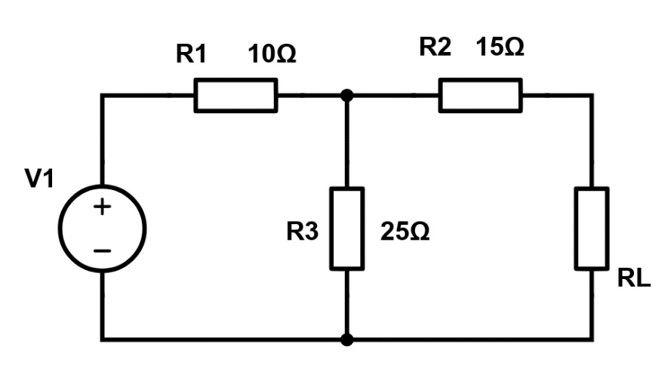
Fig:10
Solution:
- The Load Current,
Voltage across 25$Ω$ resistor,
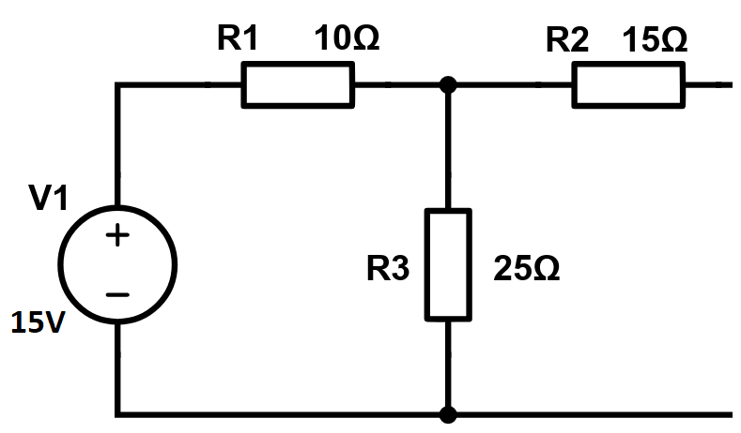
To find current in the loop,$I=\frac{15}{35}=0.4286A$
$V_{25Ω}=0.4286×25=10.715V=V_{th}$ [3 marks]
To Find $R_{th}$
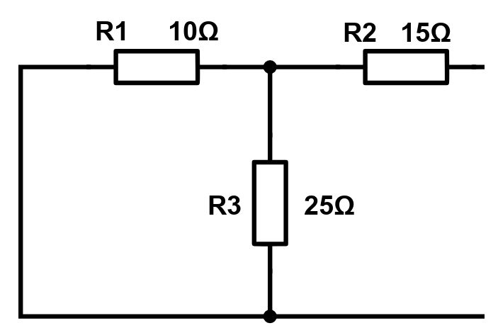
$R_{1}$ parallel to $R_{3}$=7.143Ω
7.143Ω series with $R_{2}$=22.143 Ω
$R_{th}=22.143Ω$ [2 marks]
$I_{L}=\frac{V_{th}}{R_{th}+R_{L}}=\frac{10.715}{22.143+22.143}=0.242A$ [2 marks]
- Value of load resistor, when maximum power is transferred across the load,
According to Maximum power transfer theorem, maximum power will be transferred across the load, when the Load resistor is equal to internal resistance. Hence Internal resistance is $22.143 Ω$ [2 marks]
- Simplified circuit diagram for the circuit shown in fig.1
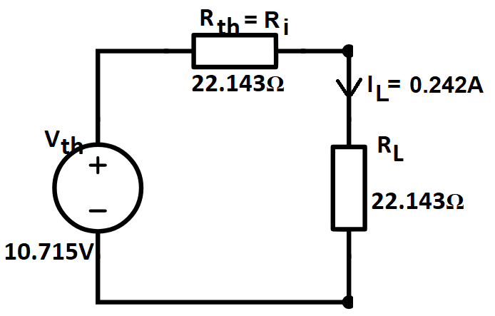 [3 marks]
- The maximum power transferred across the load ($P_{L})$.
$P_{L}=I_{L}^{2}R_{L}={0.242}^{2}×22.143=1.2968W$ [3 marks]
$This is the maximum power transfered across the load$.
- Define Norton’s Theorem, with the aid of its equivalent Circuit.
Solution:
Norton’s Theorem states that, Any two terminals of an network consisting of active and passive elements can be replaced by an equivalent current source and an equivalent parallel resistor. The magnitude of the current is equal to the short circuit current and the equivalent parallel resistor is the equivalent resistance. [2 marks]
Equivalent Circuit
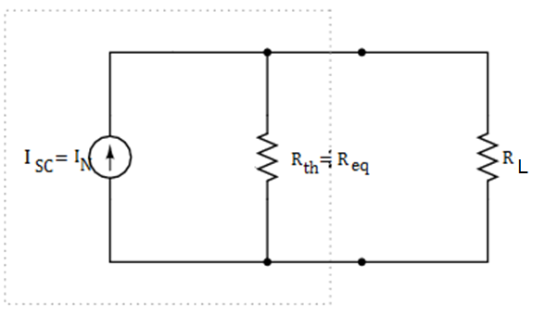 [1 mark]
- Calculate the voltage $V_{DC}$ across the open circuited terminal of the circuit shown in fig:2.
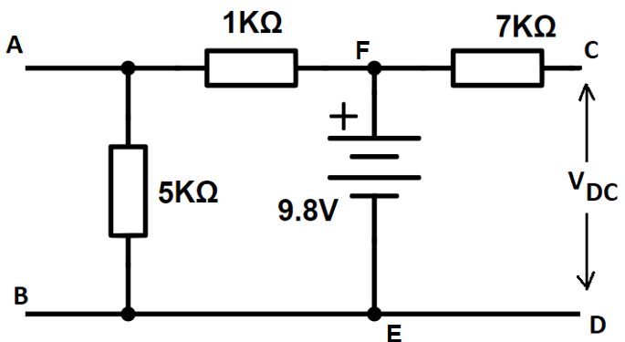
Fig:2
Solution:
The Voltage across $V_{DC}$ is 9.8V as DC is Open circuited, the voltage across EF will be the voltage DC [2 marks]
Question 2 [20 marks]
- A coil of inductance of $0.1H$ and resistance of $5Ω$ is switched on to a$230V$ supply. Calculate the steady state value of the circuit and the rate of rise of current at t=0 and at $t=2τ,$ where $τ=L/R$ .
Solution:
To Find rate of Rise of current at t=0
The rise in Current is given by
$i=I_{0}\left(1-e^{-t/τ}\right)$
$i=\frac{V}{R}\left(1-e^{-{Rt}/L}\right)$
$i=\frac{230}{5}\left(1-e^{-{5t}/{0.1}}\right)$
$i=46\left(1-e^{-50t}\right)$
$i=46-46e^{-50t}$ [1 mark] The rate of change of Current with respect to time can be determined by differentiating the above equation with respect to t.
$\frac{di}{dt}=0-46(-50)e^{-50t}$ [1 mark]
$\frac{di}{dt}=2300e^{-50t}$
At t=0
$\frac{di}{dt}=2300e^{-50×0}$
$\frac{di}{dt}=2300e^{0}$
$\frac{di}{dt}=2300 A/Sec$
At t=0, the rate of change of Current is 2300A/Sec [2 marks]
At t=$2τ$
$\frac{di}{dt}=2300e^{-50×2τ}$
$\frac{di}{dt}=2300e^{-50×2\frac{L}{R}}$
$\frac{di}{dt}=2300e^{-50×2\frac{0.1}{5}}$
$\frac{di}{dt}=2300e^{-2}$
$\frac{di}{dt}=2300×0.135$
$\frac{di}{dt}=310A/Sec$ [2 marks]
At t=$2τ$, the rate of change of Current is 310A/Sec
The Steady state current $I_{0}=\frac{V}{R}=\frac{230}{5}=46A$ [2 marks]
- A Capacitor of Value $1μF$ and a resistor of 5.45M$Ω$ are connected in series across a $220V$ power supply through a switch. Calculate the time by which the capacitor will be charged to $60$percentage of the supply voltage.
Solution:
When the Capacitor is charging
$V_{C}=V(1-e^{-\frac{t}{τ}})$ [1 mark]
$V_{C}=V(1-e^{-\frac{t}{RC}})$
$V_{C}=V(1-e^{-\frac{t}{5×{10}^{6}×1×{10}^{-9}}})$
As the capacitor will be discharging to 60% of the Voltage
$\frac{220}{100}×60=220(1-e^{-\frac{t}{5.45}})$ [2 mark]
$132=220(1-e^{-\frac{t}{5.45}})$
$\frac{132}{220}=(1-e^{-\frac{t}{5.45}})$
$0.6=(1-e^{-\frac{t}{5.45}})$
$e^{-\frac{t}{5.45}}=1-0.6$
$e^{-\frac{t}{5.45}}=0.4$ [2 mark]
Taking natural ln on both the side
$-\frac{t}{5.45}=\ln\left(0.4\right)$ [1 mark]
$-\frac{t}{5.45}=-0.916$
$t=0.916×5.45$
$t=4.99 Sec$ [2 marks]
The Time taken by the capacitor to charge to 60% of the supply voltage is 4.99Sec.
- A voltage of 100sinwt is applied to a 10Ω resistor. Calculate the current and the instantaneous power.
Solution:
V=100sinwt, R=10Ω
$I=\frac{V}{R}=\frac{100sinwt}{10}$ =10sinwt [2 marks]
P=VI =100sinwt ×10sinwt =$1000\sin^{2}ωt$ [2 marks]
Question 3 [20 marks]
- A Coil of inductance $318.3mH$ is connected in series with a $200 Ω$ resistor to a $240V, 50Hz$ supply. Calculate the following.
- Inductive reactance of the coil [2 marks]
- Impedance of the circuit [2 marks]
- Current in the circuit [2 marks]
- Potential difference across each components [4 marks]
- Circuit phase angle [2 marks]
Solution:
- Inductive reactance of the coil
Inductive Reactance $X_{L}=2πfL$=2$π×50×0.3183=100Ω$ [2 marks]
- Impedance of the circuit
$Z=\sqrt{R^{2}+X_{L}^{2}}=\sqrt{{200}^{2}+{100}^{2}}=223.6Ω$ [2 marks]
- Current in the circuit
$I=\frac{V}{Z}=\frac{240}{223.6}=1.073A$ [2 marks]
- Potential difference across each components
Potential difference across the coil,
$V_{L}=IX_{L}=1.073×100=107.3V$ [2 marks]
Potential difference across the resistor,
$V_{R}=IR=1.073×200=214.6V$ [2 marks]
- Circuit phase angle
Φ=$\tan^{-1}\left(\frac{X_{L}}{R}\right)=\tan^{-1}\left(\frac{100}{200}\right)={26.57}^{0}$ [2 marks]
- Find the RMS value and Phase of the current, $I=25+j40 A$
Solution:
$r=I_{rms}=\sqrt{X^{2}+Y^{2}}=\sqrt{{25}^{2}+{40}^{2}}=47.17A$ [2 marks]
$ϕ=\tan^{-1}\left(\frac{Y}{X}\right)=\tan^{-1}\left(\frac{40}{25}\right)={58}^{0}$ [2 marks]
- Differentiate Active power, Reactive power and Apparent power [ minimum of two differences
Solution:
 | Active power | Reactive power | Apparent Power
Definition | The actual power consumed by a circuits due to the resistive load is called real power. | The portion of the apparent power observed by the reactive elements ($X_{L} or X_{C}$) in a circuit is called reactive power. | It is the amount of power delivered to a circuit.
Formula | P=$VI Cos∅$ | Q=$VI Sin∅$ | S=$VI$
[Each Point 2 marks Maximum of 4 marks]
Question 4 [20 marks]
- The voltage and current of a RC circuit is given by $V=120sin(314t)$ and $I=10sin(314t+π/6)$. Determine the following.
- Value of Resistance and Capacitance [6 marks]
- Power consumed by the circuit [2 marks]
- Phasor diagram [2 marks]
Solution:
- Value of Resistance and Capacitance
$V_{m}=120V$, $ω=314$, $ω=2πf$, $f=50Hz$
$V=\frac{V_{m}}{\sqrt{2}}=\frac{120}{\sqrt{2}}=84.85V$ [1 mark]
Also, $I_{m}=10$, $ϕ=\frac{π}{6}={30}^{o}$
$I=\frac{I_{m}}{\sqrt{2}}=\frac{10}{\sqrt{2}}=7.07A$ [1 mark]
$Z=\frac{V}{I}=\frac{84.85}{7.07}=12Ω$ [1 mark]
As current leads voltage by ${30}^{o},$ the circuit is RC series Circuit, Capacitive in nature., So ϕ is negative.
$Z=12∠-{30}^{o}$
$Z=12\cos\left(-{30}^{o}\right)+j12\sin\left(-{30}^{o}\right)$
$Z=12\cos\left({30}^{o}\right)-j12\sin\left({30}^{o}\right)$
$Z=10.392-j6Ω$ [1 mark]
Comparing with $Z=R-jX_{C}$
$R=10.393 Ω and X_{C}=6Ω$ [1 mark]
$X_{C}=\frac{1}{2πfc}$
$6=\frac{1}{2π×50×C}$
$C=530.45μF$ [1 mark]
- Power consumed by the circuit
$P=VICosϕ=84.85×7.07×\cos\left({30}^{o}\right)=519.52W$ [2 marks]
- Phasor diagram
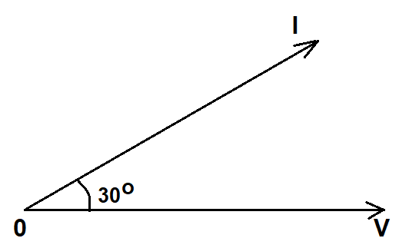 [2 marks]
- A coil of inductance 0.20H and Resistance 60$Ω$ is connected in parallel with a 20μF capacitor across 20V, variable frequency supply. Calculate
- the resonance frequency [4 marks]
- the dynamic resistance [2 marks]
- the current at resonance [2 marks]
- the circuit Q-factor at resonance [2 marks]
Solution:
- the resonance frequency
$f_{r}=\frac{1}{2π}\sqrt{\left(\frac{1}{LC}-\frac{R^{2}}{L^{2}}\right)}$ [1 mark]
$$f_{r}=\frac{1}{2π}\sqrt{\left(\frac{1}{\left(0,20\right)\left(20×{10}^{-6}\right)}-\frac{{\left(60\right)}^{2}}{{\left(0.2\right)}^{2}}\right)}$$
$f_{r}=\frac{1}{2π}\sqrt{160000}$ [1 mark]
$f_{r}=\frac{1}{2π}\left(400\right)=63.66Hz$ [2 marks]
- the dynamic resistance
$R_{D}=\frac{L}{RC}=\frac{0.20}{(60)(20×{10}^{-6})}=166.7Ω$ [2 marks]
- the current at resonance
$I_{r}=\frac{V}{R_{D}}=\frac{20}{166.7}=0.12A$ [2 marks]
- the circuit Q-factor at resonance
Q-Factor at resonance = $\frac{2πf_{r}L}{R}=\frac{2π(63.66)(0.2)}{60}=1.33$ [2 marks]
(Or)
Q-Factor at resonance =$\frac{I_{C}}{I_{r}}$
$I_{C}=\frac{V}{X_{C}}=\frac{V}{1/{2πf_{r}C}}=2πf_{r}CV$
$=2π(63.66)(20×{10}^{-6})(20)$=0.16A
$$Q-factor= \frac{I_{C}}{I_{r}}=\frac{0.16}{0.12}=1.33$$
Question 5 [20 marks]
- A $400V$, three phase star connected alternator supplies a delta – connected load as shown in fig: 3, each phase of which a resistance of $30Ω$ and inductive reactance $40Ω$. Calculate the following, neglecting the losses in line between the alternator and the load.
- the current supplied by the alternator, [7 marks]
- the output power, [6 marks]
- the kVA of the alternator. [3 marks]
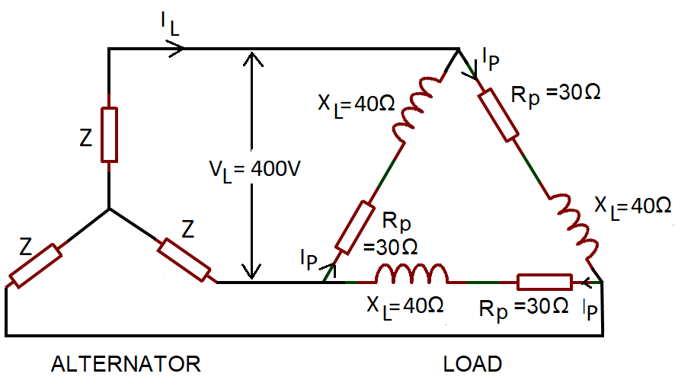
Fig: 3
Solutions
- the current supplied by the alternator,
Consider the Load: Phase Current =$I_{p}=\frac{V_{p}}{Z_{p}}$ [1mark]
$V_{p}=V_{L}$ for delta connection. Hence $V_{p}=400V$
Phase impedance, $Z_{p}=\sqrt{{(R}_{p}^{2}+X_{L}^{2})}=\sqrt{{30}^{2}+{40}^{2}}=50Ω$ [2 marks]
Hence, $I_{p}=\frac{V_{p}}{Z_{p}}=\frac{400}{50}=8A$ [2 marks]
For delta connection line current, $I_{L}=\sqrt{3}I_{p}=\sqrt{3}×8=13.86A$ [2 marks]
13.86A is the current supplied by the alternator.
- the output power of the alternator,
Alternator output power is equal to the power dissipated by the load .
$P=\sqrt{3}V_{L}I_{L}Cosϕ$ [1 Mark]
Where $cosϕ=\frac{R_{P}}{Z_{p}}=\frac{30}{50}=0.6$ [2 Marks]
Hence, $P=\sqrt{3}×400×13.86×0.6=5.76KW$ [3 marks]
- the kVA of the alternator.
Alternator Output kVA, S=$\sqrt{3}V_{L}I_{L}=\sqrt{3}(400)(13.86)=9.60kVA$ [3 marks]
- A transformer has a rated output of 200kVA at a power factor of0.8. Determine the rated power output and the corresponding reactive power . .
Solution:
Rated Power output =$VICosϕ=200×{10}^{3}×$0.8 = 160KW [2 marks]
Reactive Power output =$VISinϕ$
We know that power factor =$Cosϕ=0.8$
$ϕ=\cos^{-1}0.8$= ${36.87}^{o}$
Reactive Power output =$VISinϕ=200×{10}^{3}sin\left({36.87}^{o}\right)=120KVA$ [2 marks]
Question 6
- List the types of DC Generators. Describe any two types of DC generator with the aid of necessary diagrams. [15 marks]
Solutions:
Types of DC Generators
- Separately Excited DC Generators – Field coils excited by some external source
- Self-Excited DC Generators – Field coils excited by the generator itself
  - Series Wound Generators
  - Shunt Wound Generators
  - Compound Wound Generators [5 Marks]

Series Wound Generator
In these type of generators, the field windings are connected in series with armature conductors, as shown in the figure below.
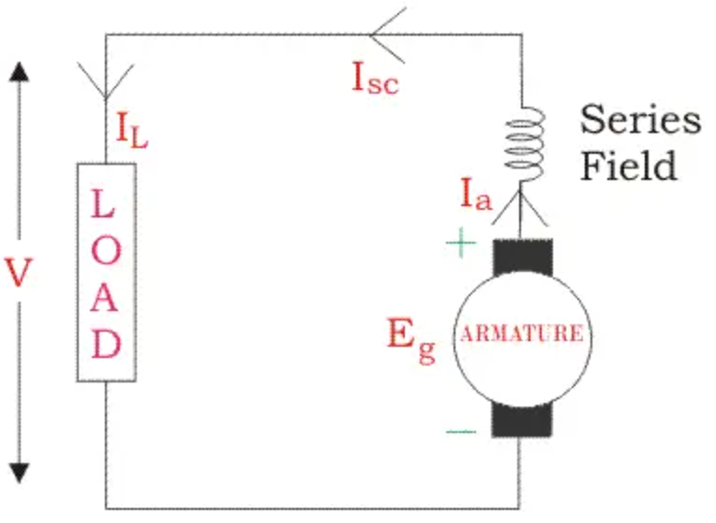
All the currents flows through the field coils as well as the load. As series field winding carries full load current it is designed with relatively few turns of thick wire. The electrical resistance of series field winding is therefore very low (nearly 0.5Ω ).
- R_{sc} = Series winding resistance
- I_{sc} = Current flowing through the series field
- R_{a} = Armature resistance
- I_{a} = Armature current
- I_{L} = Load current
- V = Terminal voltage
- E_{g} = Generated EMF

Then,
$$I_{a}=I_{SC}=I_{L}=I$$

Voltage across the load is equal to,
$$V=E_{g}-I(I_{a}{×R}_{a)}$$
Power generated is equal to,
$$P_{g}=E_{g}×I$$
Power delivered to the load is equal to,
$$P_{L}=V×I$$
[5 Marks]

Shunt Wound DC Generators
In these type of DC generators, the field windings are connected in parallel with armature conductors, as shown in the figure below. The voltage in the field winding is same as the voltage across the terminal.
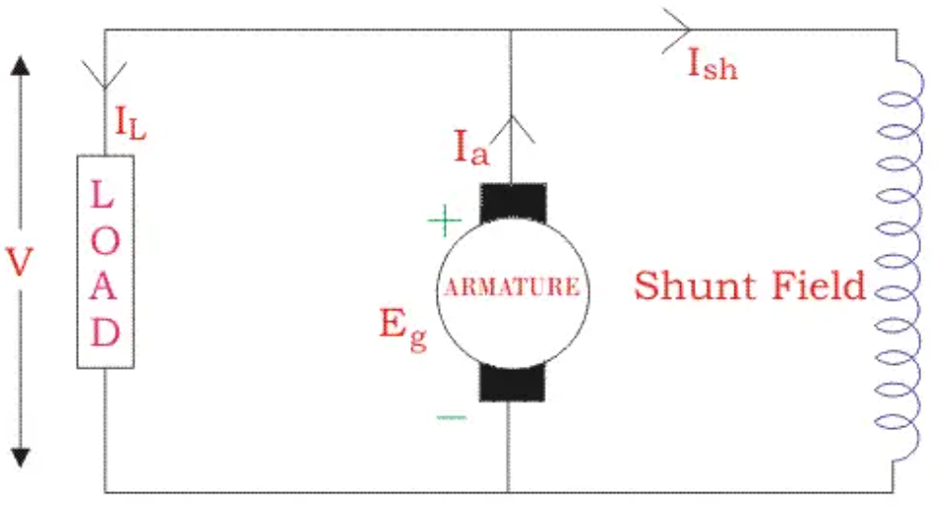
Here:
- R_{sh} = Shunt winding resistance
- I_{sh} = Current flowing through the shunt field
- R_{a} = Armature resistance
- I_{a} = Armature current
- I_{L} = Load current
- V = Terminal voltage
- E_{g} = Generated EMF

Here armature current I_{a} is dividing in two parts – one is shunt field current I_{sh}, and another is load current I_{L}.
So,$I_{a}=I_{Sh}+I_{L}$
The effective power across the load will be maximum when I_{L} is maximum. So, it is required to keep shunt field current as small as possible. For this purpose the resistance of the shunt field winding generally kept high (100 Ω) and large number of turns are used for the desired EMF.
Shunt field current is equal to,
$$I_{Sh}=\frac{V}{R_{Sh}}$$
Voltage across the load is equal to,
$$V=E_{g}-I_{a}R_{a}$$
Power generated is equal to,
$$P_{g}=E_{g}×I_{a}$$
Power Delivered to the load is equal to
$$P_{L}=V×I_{L}$$
[5 Marks]
- An ideal transformer has a turns ratio of 8:1 and the primary current is 3A when it is supplied at 240V. Calculate the secondary Voltage [5 Marks]
Solutions:
The Turns Ratio 8:1 means, $\frac{N_{1}}{N_{2}}=\frac{8}{1}, it is step down transformer,$ [1 mark]
$\frac{N_{1}}{N_{2}}=\frac{V_{1}}{V_{2}} or secondary Voltage$ , $V_{2}=V_{1}\left(\frac{N_{2}}{N_{1}}\right)=240(\frac{1}{8})$=30Volts [2 marks]

Also, $\frac{N_{1}}{N_{2}}=\frac{I_{2}}{I_{1}} or secondary CurrentI_{2}=I_{1}\left(\frac{N_{1}}{N_{2}}\right)=3\left(\frac{8}{1}\right)=24A$ [2 marks]

Diwedd/End

