

Name – Ancuta FURNICA
Student Number-1818821
Module Title-Academic and Employability Skills (BMSW4001_LON)
Assignment Title-Academic and Employability Skills
Module Lecturer’s Name-Lloyd Beharry

Table of Contents
Introduction 3
Academic Skills Analysis 3
Employment Skills Analysis 5
Conclusion 7
Reference List 8
Appendix 10

Introduction
As opined by Johnston (2017) reflection is considered as the process of continuous evaluation of one’s own performance or activity in order to identify the effectiveness. Reflective practice enables an individual to identify personal strengths and weaknesses and develop strategies to enhance the strengths and address the weaknesses in an effective manner (Schön, 2017). Reflection helps an individual to identify loop holes in their performance or activity and make adequate decisions in order to avoid such mistakes in future practice. By doing this reflective practice allows an individual to induce self-development while improving the available skills as well as developing new skills (Farrell and Ives, 2015). Therefore, it can be said that reflective practice is one of the simplest process of learning from one’s own experience (Walsh and Mann, 2015). Due to such significance of reflective practice in personal development, I will reflect on my academic and employability skills that I have acquired and enhanced through my in-class activities. It will help me to induce a continuous process of learning and identify the areas of improvement in order to build successful career in desired filed.

Academic Skills Analysis
According to McWilliams and Allan (2014), academic skills or study skills are defined as the approaches that are utilised in order to facilitate learning process. Such skills are considered to be critical in order to achieve successful outcomes during study period. As stated by Cottrell (2019) communication, research abilities, paraphrasing, time management, reading proficiency and critical thinking are some of the required academic skills that a student needs to develop during learning session. Therefore, it is vital for me to develop and improve such skills in order to access better opportunities in future practice. During my learning session, I have acquired some of the aforementioned academic skills that have assisted me in performing the academic activities in an effective manner.
As opined by Sukirlan (2014), communication is one of the major academic skills that enables the students to understand others as well as to be understood by others. There are two forms of communication such as verbal and non-verbal communication and both these forms of communication are required to develop by a student in order to achieve expected outcomes in academic performance. The verbal forms of communication include oral communication with the teachers and other peers and non-verbal communication may include written communication or communication through expression, body language and various activities. In addition to this, Minei and Robinson (2014) have stated that, active listening is another critical factor for effective communication. Therefore, it is necessary for the students to reinforce active listening in order to understand the opinion of others and learn from them. The in-class activity of watching an influential film and providing brief review and personal opinion has provided me the opportunity of presenting my thoughts through written form of communication. I have successfully performed in the in-class activity and explain my view point regarding a movie. I have written the review in a simple language and try to focus on the key points rather than writing unnecessary contents which has helped the classmates to understand my opinion without any confusion. Through such performance I have identified that I have good written communication skill. Further, my interaction with my peers and teachers, my ability to start a communication and listening to others while communication has indicated that I have a good verbal communication as well. However, I am quite unsure about my non-verbal communication such as understanding facial expression or body language. Hence, I have identified this as one of my weakness and would like to work on this skill in order to adapt a better way of non-verbal communication in future.
Another important academic skill includes reading proficiency. Apart from writing and listening to others it is also necessary to have a good reading proficiency in order to understand the written communication of others and understand the information collected from various academic sources. It is impossible to perform in an academic task without understanding its requirement and thereby, it is necessary for me to develop effective reading proficiency to understand the academic tasks in a better manner and perform effectively to achieve desired outcomes (McWilliams and Allan, 2014). In our academic session we need to read different academic sources such as books, journals, newspaper articles, blogs and others. Such activities have helped me to improve my reading proficiency, because before my academic session, I was not that good in reading English without any hesitation or issue. The continuous reading process of academic sources has helped me to overcome this issue and become a good reader.
Plagiarism is considered as writing information from the papers of another writer without making any change, putting inverted commas or copy pasting such information without referring to the actual author. In academic tasks plagiarism is considered as one of the most significant misdeeds and a student may suffer from different issue including poor marks in academic tasks and he/she may fail in the academic session due to such conduct. Therefore, it is highly advisable for every student to avoid plagiarism in academic tasks and write an academic paper with own expertise and in own language (Sutherland-Smith, 2018). Paraphrasing is one of the most effective skills that enables a student to write a quality paper while avoiding plagiarism. The most significant way of paraphrasing is reading the information provided by a writer, understand the theme and meaning and write information in own words (Hagaman, Casey and Reid, 2016). In our in-class activity we are assigned to write different academic papers after reading various scholarly and peer reviewed paper. I have always tried to avoid plagiarism, hence, I used to read the information provided in the research papers and write the information as per my knowledge. Hence, I can say that I have a good paraphrasing skill which is necessary to get high score in academic performance.
Further, Grissom, Loeb and Mitani (2015) have opined that it is necessary to maintain both the physical and mental well-being for maintaining balance between physical and mental health and in order to perform effectively in academic tasks it is necessary to maintain balance among the overall health conditions. Wibrowski, Matthews and Kitsantas (2017) have stated that a student should perform different physical activities, utilise leisure properly, maintain a significant sleeping time, have proper food and give sometime to himself/herself for relaxation. In order to maintain all of these necessary things a student must know how to manage time and schedule their daily activities. I have identified that I have poor time management skill and hence, I have faced several issues while managing my daily routine. Due to this I have missed the deadline of some of my class activities as well. Therefore, I have to maintain a proper timeline for adjusting my daily activities and improve time management skills to avoid further case of missing deadline.
Critical thinking and research ability are some of the newly acquired skills during my in-class activities. The research process includes secondary research done through electronic data bases such as university library, Google Scholar and other online sites to collect relevant data and information that could assist me in my academic performance. Critical thinking includes the ability to analyse a situation properly and make decision accordingly. As I said these are two new skills that I have developed through the in-class activities, I have to work more on these skills to achieve required proficiency. Further, these two skills have helped me to improve my reasoning skill and analyse any information in order to identify the intellectual value. I believe that improving such academic skills will help me to induce self-development and support me to develop the qualities that will help to build successful career.

Employment Skills Analysis
The class activities that I have gone through, has helped achieve few of the employment ability skills. As we all know, the few of the main employability skills are collaboration, adaptability, problem-solving and information using skills (Bakhshi, et al., 2017). The class modules and the notes that were taught in class includes the employment skills enhancement. Apart from this the modules that are taught in class also includes all the information about managerial issues and real life solutions to organisational conflicts that are faced by managers on a day to day basis (Gallagher, 2016). Employment skills such as collaboration, adaptability, problem solving and information using skills are important as these are the main things of factors required to manage a team and to deliver the best to the organisation (Cirillo, 2017).
- Collaboration- the collaboration is necessary in the organizations as this is what is needed to keep the teams together and also to resolve the organizational conflicts among themselves (Cirillo, 2017). The collaboration is necessary as the organizations require and demands the best from its employees and so it is important for the employees to know about the proper collaboration process and the teamwork management as well. The activities that were done in class also included the team work as we all were divided in teams and given a short project to handle. This taught me the importance of teamwork and collaboration (Bakhshi, et al., 2017). I also learnt how to manage a team and how to deal with the issues that a team has to face. The team that I was a part of had members from different culture and nationality (Gallagher, 2016). This taught me the difficulty that the organizations face due to the cultural diversity in their team. The module also taught me how to take all the advantages and the best things from different people's thinking and turn them into an advantage for the organization.
- Adaptability- the adaptability is the skill or the ability to adapt to the change in the organizations. The change in the organization is important and must be followed regularly. The environment is changing day by day and so does the needs and the requirements of the customers (Cirillo, 2017). The changing economic situation of a country is also responsible for the change and the shift. Thus, it is important for the organizations to keep their strategies changing. Thus, the teamwork project that we had to do, included the adaptability training (Gallagher, 2016). We all had to adapt to each other's ways of working and the requirements of each of the members as well. On the other hand, there were also few of the members who could not adapt to change and were also afraid to accept the change (Bakhshi, et al., 2017). Such employees are known as change-resistant. We were also taught in class about the different ways in which the training and development process helps in the adaptability.
- Problem solving skills- The problem solving skills are important for the managers and the team leaders as well. It is important as there are many organizational conflicts that take part in an organization and it is the job of the managers and the team leaders to resolve the issues (Cirillo, 2017). There might be conflicts regarding the cultural diversity, the mismatch of the decisions that are taken and other issues like poor development of the employees. Issues like this needs to be resolved and so the class modules included the problem-solving training and activities as well (Bakhshi, et al., 2017). We were given a real life situation that we had to resolve in the given time. This enhanced my problem resolving skills and also boosted up my thinking skills (Gallagher, 2016). Apart from this, we were also taught about the different skills and knowledge that are required to resolve issues in an organization.
- Information using skills- The information using skill are important for an employee and the managers as well. This is because, it is the job of the managers and the team leaders to train the candidates and share the knowledge that they have. Thus, this is one of the main reasons that the employees must have the ability to use their information using skills (Cirillo, 2017). The more the employees utilize their knowledge and information using skills it will be easier for them to enhance their talents and knowledge. In case of the Human Resources, it is important to utilize the information as they need to identify the most suitable candidate to recruit using the information that they have collected from the candidates (Gallagher, 2016).

Conclusion
From the above study, it can be concluded that I am good in the communication skills and can communicate freely with anyone verbally. However, the non-verbal communication skills lacks in me and so I have to work hard to develop the same. Apart from this, the time management skills are poor and I have to work really hard in it as I have missed a lot of deadlines of the class projects. The critical thinking skills that I have are good and with further polishing they will be perfect. However, I had an issues with reading out loud in English. This has been resolved since the time, the class activities has started. On the other hand, the employment skills that I have are the collaboration, adaptability, problem solving and information using skills. I was being able to grab these skills quite well and as per my feedback, I must work further on them to make them perfect. The skills that I have developed in the class activities are important for me to be successful. To further polish the skills and the developments, I have decided to practice further and reach the best of my career. This is important as in order to work in an organization and to see myself in a better position, these skills and knowledge are important.

Reference List
Bakhshi, H., Downing, J.M., Osborne, M.A. and Schneider, P., 2017. The future of skills: Employment in 2030. London: Pearson.
Cirillo, V., 2017. Technology, employment and skills. Economics of Innovation and New Technology, 26(8), pp.734-754.
Cottrell, S., 2019. The study skills handbook. The USA: Macmillan International Higher Education.
Farrell, T.S. and Ives, J., 2015. Exploring teacher beliefs and classroom practices through reflective practice: A case study. Language Teaching Research, 19(5), pp.594-610.
Gallagher, K., 2016. Essential Study and Employment Skills for Business and Management Students. London: Oxford University Press.
Grissom, J.A., Loeb, S. and Mitani, H., 2015. Principal time management skills: Explaining patterns in principals’ time use, job stress, and perceived effectiveness. Journal of Educational Administration, 53(6), pp.773-793.
Hagaman, J.L., Casey, K.J. and Reid, R., 2016. Paraphrasing strategy instruction for struggling readers. Preventing School Failure: Alternative Education for Children and Youth, 60(1), pp.43-52.
Johnston, C., 2017. Reflective practice. Teaching Business & Economics, 21(1), pp.19-21.
McWilliams, R. and Allan, Q., 2014. Embedding academic literacy skills: Towards a best practice model. Journal of University Teaching & Learning Practice, 11(3), p.8.
Schön, D.A., 2017. The reflective practitioner: How professionals think in action. Abingdon: Routledge.
Sukirlan, M., 2014. Teaching communication strategies in an EFL class of tertiary level. Theory and Practice in Language Studies, 4(10), p.2033. Weger Jr, H., Castle Bell, G., Minei, E.M. and Robinson, M.C., 2014. The relative effectiveness of active listening in initial interactions. International Journal of Listening, 28(1), pp.13-31.
Sutherland-Smith, W., 2018. Is student plagiarism still a serious problem in universities today?. In Student Plagiarism in Higher Education (pp. 47-61). Abingdon: Routledge.
Walsh, S. and Mann, S., 2015. Doing reflective practice: a data-led way forward. Elt Journal, 69(4), pp.351-362.
Wibrowski, C.R., Matthews, W.K. and Kitsantas, A., 2017. The role of a skills learning support program on first-generation college students’ self-regulation, motivation, and academic achievement: A longitudinal study. Journal of College Student Retention: Research, Theory & Practice, 19(3), pp.317-332.

 In-class exercise 1: Paraphrasing - RESIT
Ex.2. Decide whether the paraphrased passages are acceptable or unacceptable by circling thes correct answer and briefly explain why.
Original Source: Nobody called him Abe--at least not to his face--because he loathed the nickname. It did not befit a respected professional who'd struggled hard to overcome the limitations of his frontier background. Frankly Lincoln enjoyed his status as a lawyer and politician, and he liked money, too, and used it to measure his worth. By the 1850's, thanks to a combination of talent a &sheer hard work, Lincoln was a man of substantial wealth. In-class exercise 1: Paraphrasing - RESIT
Ex.2. Decide whether the paraphrased passages are acceptable or unacceptable by circling He had an annual income of around $5,000-- he equivalent of many times that today-and large financial and real-estate investments.
From: Oates, Stephen B. Our Fiery Trial: Abraham Lincoln, John Brown, and the Civil War Era. Amherst, MA: University of Massachusetts Press, 1979. p. 65
Reason:
Paraphrase
No one used Lincoln's nickname, Abe, because he detested it. It didn't go with a lawyer and politician who had worked to get away from the restrictions of his country heritage. Lincoln liked his new position, and his wealth, and used it to gauge his status. By mid-century, his skill and labor had made him a fairly wealthy man. He had a yearly income of approximately $5,000 - equal to several times that now - and hefty business and land commitments.
Reason: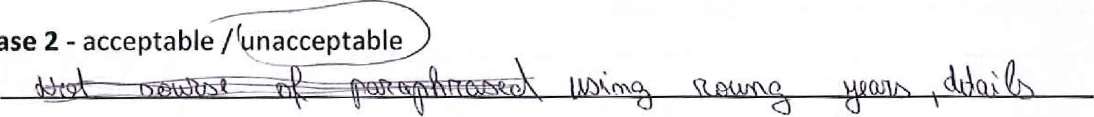
Paraphrase
By the middle of the century, Lincoln enjoyed life as a well-respected lawyer and politician, having acquired a position of status and wealth that was well removed from his early "frontier background". He now was bringing in $5,000 a year (this translates to $87,500 in 1997 dollars [Derks, 2]), and had substantial "financial and real estate investments". As a consequence, he disliked being called Abe because of its association with his rural heritage. (Oates, p.65)
Reason:
Paraphrase
When we think of Abraham Lincoln, the image of a wealthy lawyer is not the first that comes to mind. A man, who worked hard, struggled and came from a less than ideal background is often the picture we invoke. However, it is an incomplete portrait. Mr. Lincoln was successful both professionally and financially even by today's standards. (Oates, p.65)
Lecturer's signature: Date:

2 | P a g e
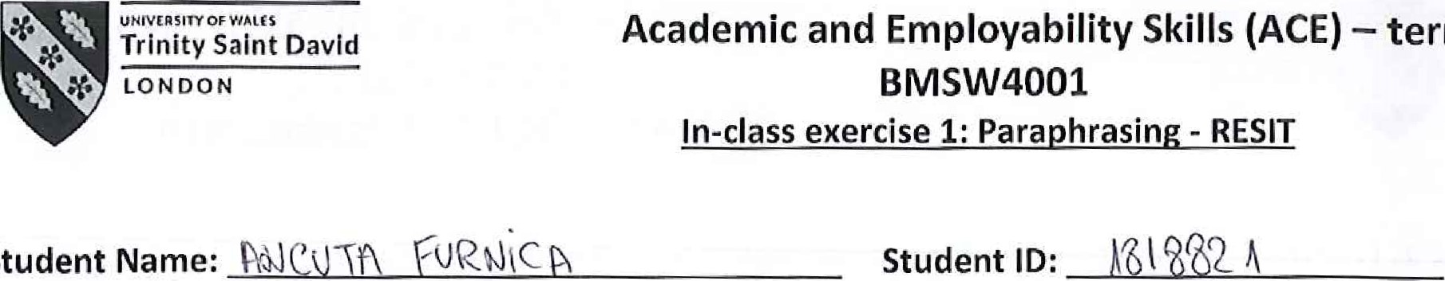
Time allocated: 1 hour. Please return your paper to the lecturer upon completion. It will be returned to you at the next session. You will need to include a scanned copy of this exercise in the form of an appendix together with you Task 1 (part of the Assignment for this module).
Student

Ex.l
Write a paraphrase of the following passage
Facebook is one the most influential social networks in the world, boasting approximately 2.2 billion monthly users. So how did a social network created in the confines of a Harvard dorm room go from being a student trend to an unprecedented, worldwide phenomenon? Facebook was born on 4th February 2004, made available exclusively to Harvard students. However, six days after "TheFacebook" was made live by Zuckerberg and co-founders, they faced accusations by Cameron and Tyler Winklevoss and Divya Narendra that the idea for the site had been stolen from them. According to the Winklevoss twins and Narendra, they had approached Zuckerberg asking for his assistance in creating a social network for Harvard students called "HarvardConnection 'l . Following a lawsuit filed against Zuckerberg, eventually all three received a settlement in 2008 that included
1.2 million shares in the company each.
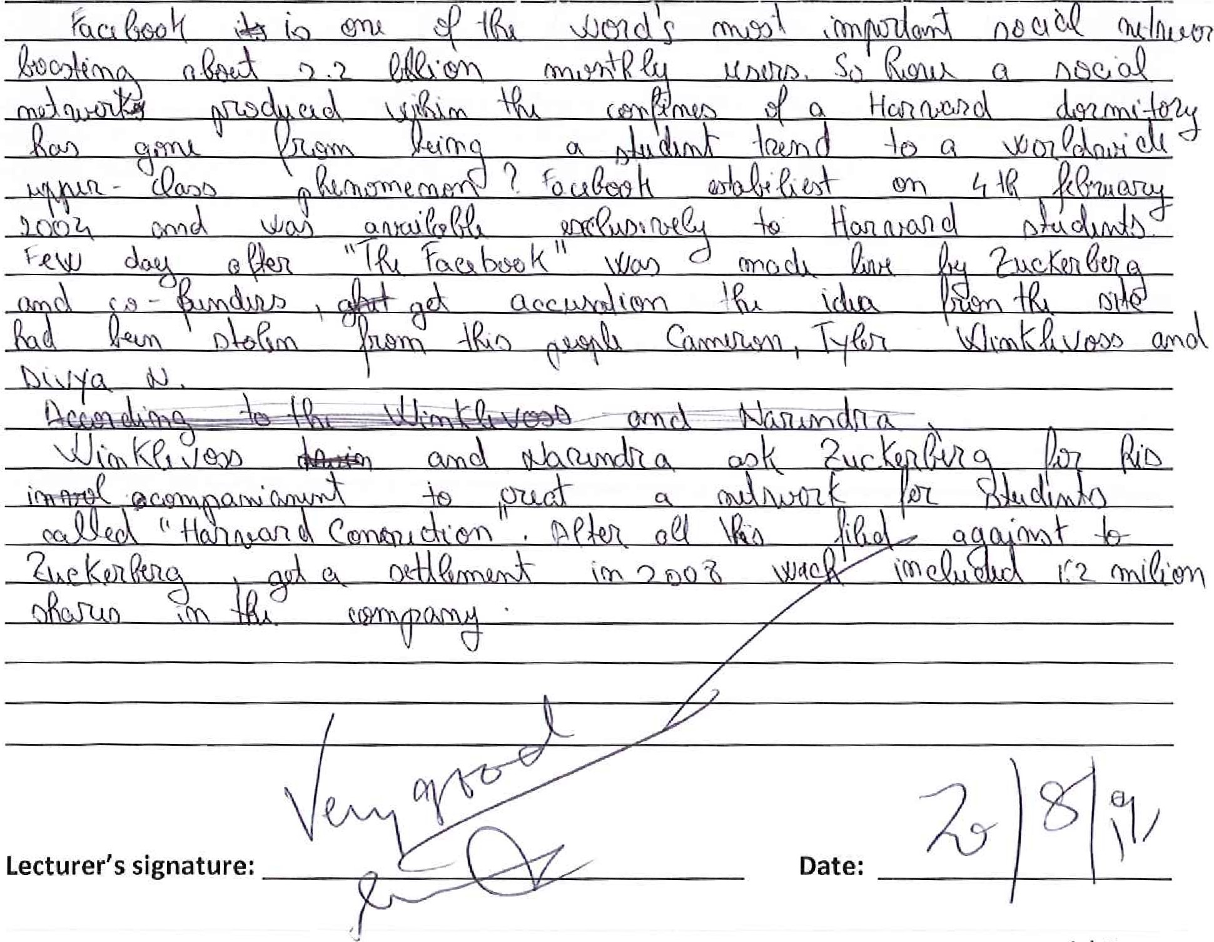
l l P a g e

--
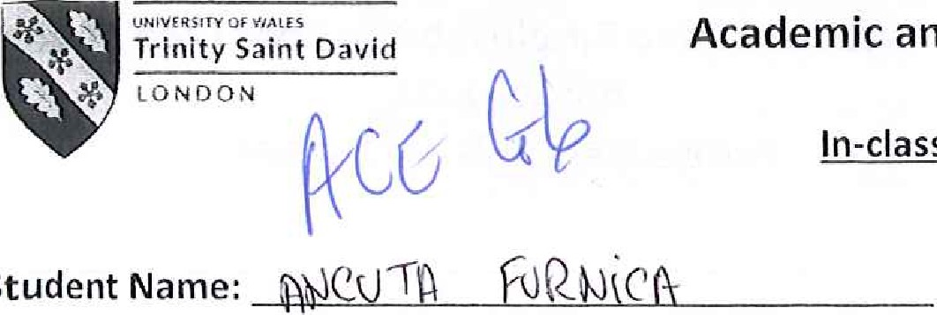
In-class exercise 2: Summarising
Student
Student ID:
Time allocated: 1 hour. Please return your paper to the lecturer upon completion. It will be returned to you at the next session. You will need to include a scanned copy of this exercise in the form of an appendix together with your Task 1 (part of the Assignment for this module).

Ex.l
Read the following text and make notes on the main ideas. You can do this on a separate piece of paper which you do not have to hand in.

The success of ALDI
The food retail industry is a highly competitive market. Aldi understands that its customers want value for money but do not want to compromise on quality. This case study will demonstrate how Aldi uses a lean approach to its business operations to offer its customers quality products at competitive prices. What distinguishes Aldi from its competitors is its competitive pricing strategy without reducing the quality of its products. In fact, in some cases Aldi's products are 30% cheaper than those offered by its competitors. Aldi can do this because the business operates so efficiently. The three core values of Aldi are simplicity, consistency and responsibility. Lean production ties in closely with these values. For example, Aldi stores are simple in design and all stores are very similar which creates consistency.
For Aldi operating efficiently involves reducing costs in all areas of the business. Some of the key areas where Aldi is able to minimise costs are by saving time, space, effort and energy. Aldi's approach to doing this is to run its business around the principles of lean thinking, Whereas other food retailers have elaborate displays, additional services and promotions that draw customers into the business, Aldi's core purpose is to 'provide value and quality to our customers by being fair and efficient in all we do' The principles of lean production are planned and built into everything that Aldi does. This starts within its supply chain. For example, up to 60% of Aldi's fruit and vegetables are sourced locally where possible, reducing the need for long and costly delivery journeys.
The principles of time based management are also built into the training provided for Aldi's employees. Through training staff to do.a variety of tasks around store Aldi can minimise its staff requirements, Staff costs can also be reduced as fewer staff are required if they can perform a variety of duties throughout the store. Aldi's 'no-nonsense' approach to retailing therefore leads to cost saving in numerous areas. These cost savings are passed on to customers in the form of lower prices, allowing the business to differentiate itself from its competitors in terms of price, as well as the quality of the products it has on offer.
Lecturer's signature: Date:
I l
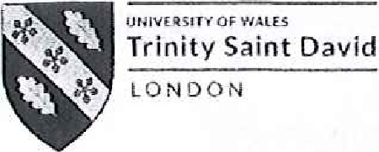 In-class exercise 2: Summarising
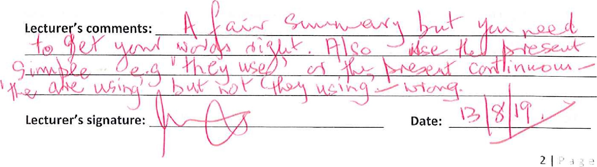
Ex.2
This task is designed to see if you can summarise ideas from course materials in your own words. Re-read the text ^{t} The success of ALDI' on previous page. Now answer the following question in your own words: What factors contribute to ALDI's success? Write about 175 words.
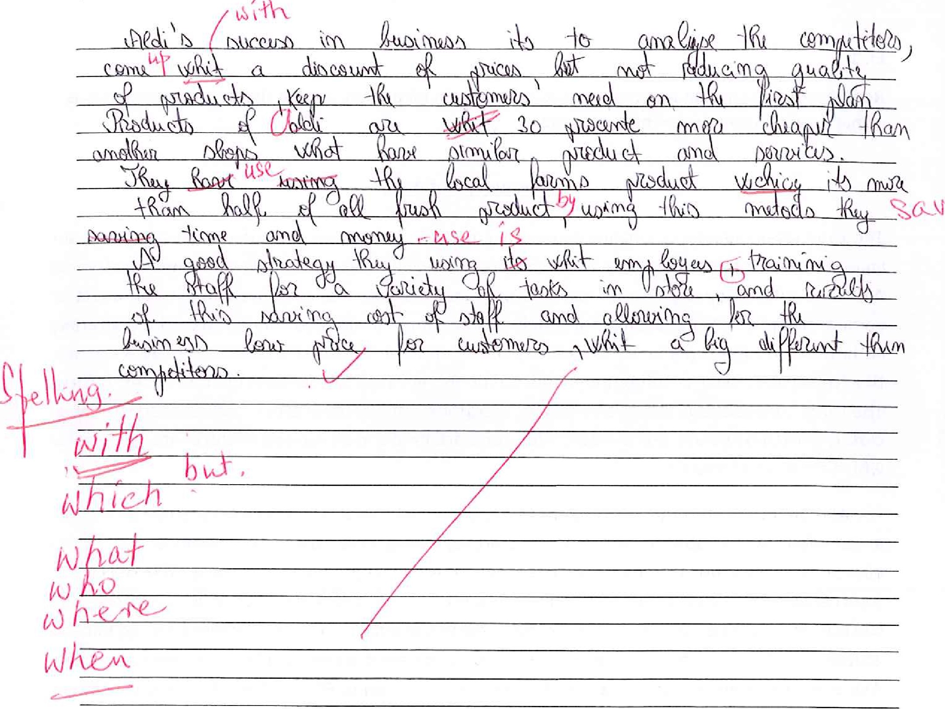

STUDENT'S
NAME: | CLASS: |  | 
To quote from Cottrel (1999),
As Cottrel (1999) points out, ...
According to Cottrel (1999)
Cottrell (1999) suggests that
In her article 'name of article', Cottrell (1999) makes the point that In 'book title' Cottrell (1999) explains that ... Writing in 1999, Cottrell proposed that
Paraphrase the Following:
l . 'If the United Kingdom withdraws from the European Union without an agreement, it will encounter financial hardships. '
From an article in the Times newspaper on 17th July 2019 by Maria Johnson.
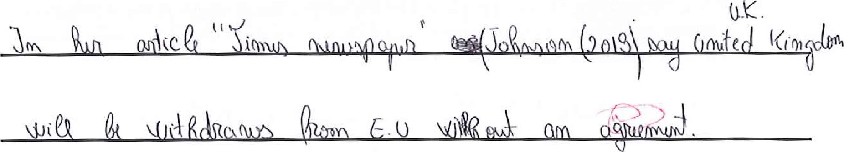
- 'Rich people, businessmen and the terminally ill are not worried by the problems ofthe poor.
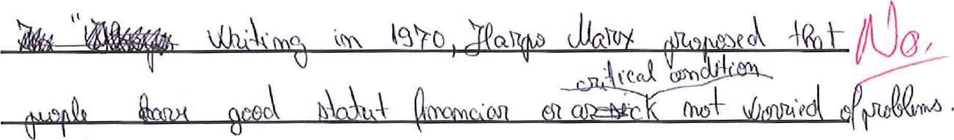
Book
by
Harpo
Marx
1970.
- Speaking directly to people is better than writing to them because you can things in their voices and see their expressions and their body
- The elderly man could not ascend the stairs without stopping because he was weak and had to pause every five or six minutes to catch his breath.
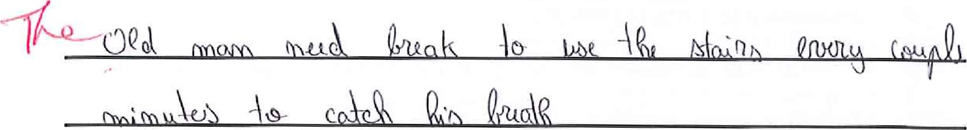
- One of the benefits of teamwork is that it gives members of the team the opportunity to listen to other viewpoints and recommendations and to broaden their own ways of looking at problems and solving them.
6. 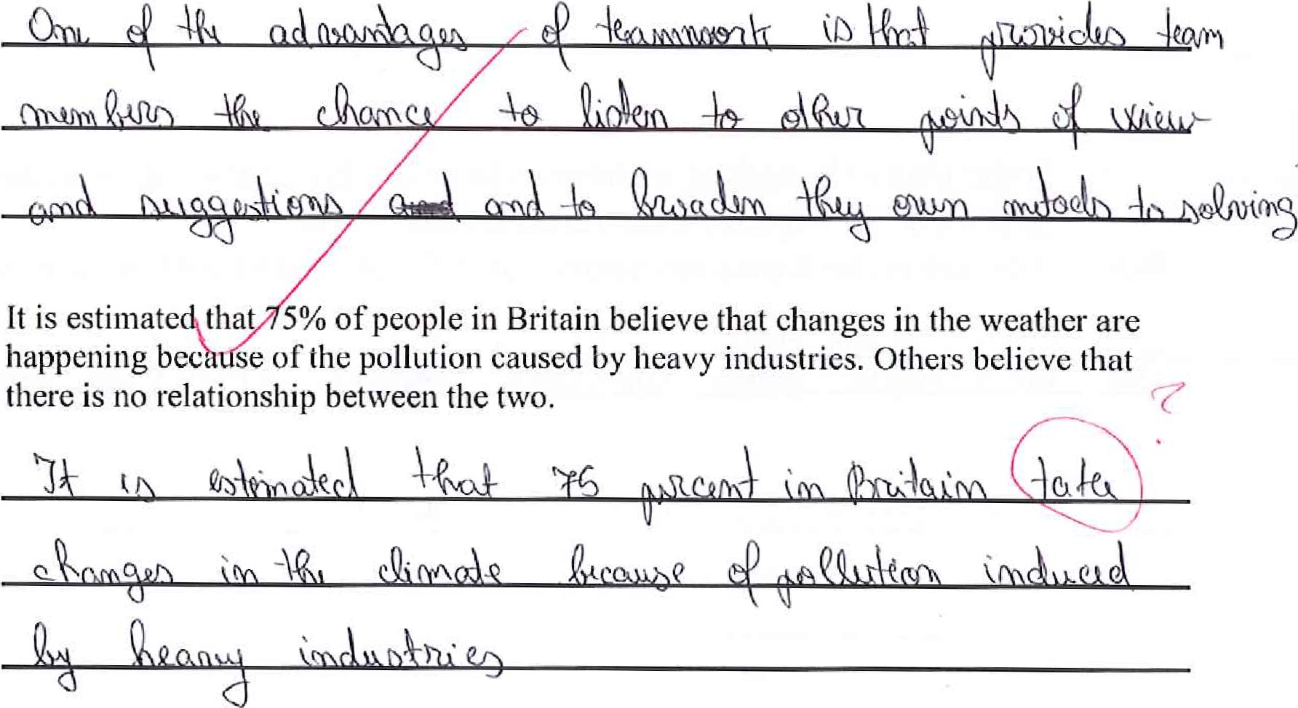

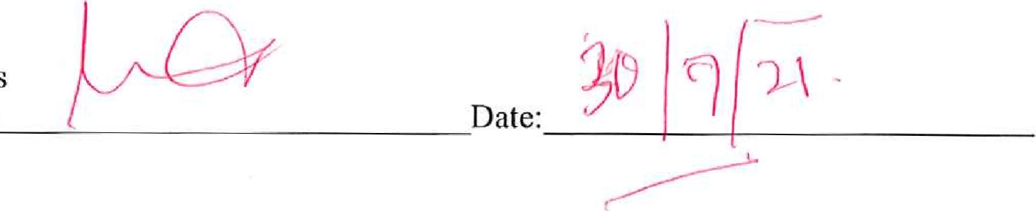
Lecturer's
Signature

