The Value and Purpose of Code-switching And Report on the Same Topic

Introduction
This purpose of this report is to introduce the specific language phenomenon--codes-witching, and further discuss its value and purposes.
Code-switching refers to going from one language to the other in mid-speech when both speakers know the same two languages. (Cook, 2008) As more people become multilingual, code-switching becomes more common phenomenon, which occurs in daily communication. For example, in mandarin we may say, “Ta shi yi ge hen ‘nice’ de ren。”（The English translation is “She is very nice. ”）. Bilingual or multiple lingual speakers can alternate between different languages in a conversation. Switching also could be found in literature works as it exemplified in T.S. Eliot, The Waste Land V
English/Italian/French:
‘London Bridge is falling down
Poi s’ascose nel foco che gli affina
O swallow swallow
Le Prince d’Aquitaine á la tour aboli’
In china, code switching, which is a speaking style, often occurs in non-native teachers’ second language teaching class for various purposes: explanation of terms, illustration of grammatical points, instruction ,encouragement and so on.
In the book，which I have reviewed recently，“A Parents’ and Teachers’ Guide to Bilingualism”（Baker 2014）, an quite meaningful and debatable question has been raised by the parents. “Does Switching between languages have any value or purpose?” To answer the question, we should stand on the side of the parents. They are afraid of the occurrence of mixing-up of languages, which is called Language mixing (be used to refer use either language indiscriminately). According to the author, although one language may sometimes influence the infants’ less dominant language, children soon become aware of those social situations and those people with whom they can and cannot code-switch. Thus, it is not sensible or real for the distinction between mixing and codes-witching. More researchers would like to stand on the points that code-switching is a valuable and purposeful communication strategy.

Why and When Code-switching happens?

In environments where multiple languages are used, bi- and multilingual speakers can combine more than one language in their conversations, a phenomenon known as code-switching. Code-switching was originally believed to be the result of a language deficiency (Weinreich, 2010), a strategy used by bilinguals to compensate for a lack of proficiency in either one or both languages (Heredia & Altarriba, 2001). Scholars today, however, overwhelmingly reject these views and recognize that code-switching is a systematic and complex linguistic phenomenon that is typical of bilingual communities (Hoff & Core, 2015; Ritchie & Bhatia, 2012; Yow, Tan &
Flynn, 2018). For the past several decades, researchers have investigated how often, where syntactically, and why code-switching occurs.

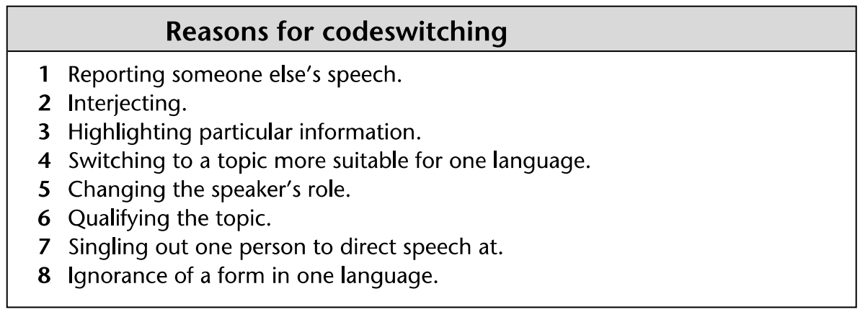
Chart 1.1 Reasons for Codes-witching (Cook, 2004)

As listed in chart 1.1, different reasons involve in code-switching depending on the purpose of interaction. First, code-switching behaviors vary significantly between different communities of bilinguals (Heller, 2010). For many, code-switching serves to reinforce a community’s identity by following the accepted local norms and functions of code-switching (Nilep, 2006). Indeed, research on children’s early productions of code-switching have found that children code-switch at a similar rate to their parents, suggesting that parental code-switching may serve as a model for developing bilinguals (Comeau, Genesee & Lapaquette, 2003; Yip & Matthews, 2016). Another important driver of code-switching in adult–adult conversations is to improve understanding of the speaker by their conversational partner (Heredia & Altarriba, 2001). There are also reports that parents sometimes code-switch in order to teach their child a new word, again using code-switching strategically to enhance their children’s comprehension and learning (Byers-Heinlein, 2013). For example, They have been observed code-switching in these circumstances may help to support children’s language learning.
Additionally, adults have been observed to code-switch in conversations to create metaphorical effects in the discourse (Blom & Gumperz, 1972; Gumperz, 1982; Ritchie & Bhatia, 2012) Metaphorical code-switching is difficult for analysts to classify, and even native-speakers do not consciously understand all of the motivations driving metaphorical code-switching (Gumperz, 1982). Parents may also code-switch to produce metaphorical effects unique to a child’s language development. This could include code-switching in order to get their child’s attention, emphasize a point, or discipline their child (Bail et al., 2015; Byers-Heinlein, 2013; Goodz, 1989). In order to adapt to their child’s knowledge bilingual parents may use code-switching, for example, it is common for Chinese parents to use “Hello” instead of “Ni hao” to greet the children. Moreover, bilingual parents give English nicknames to their kids and use as much English as possible in their daily communication.
Finally, code-switching is often used in language classroom,and plays important role in organizing classroom, controlling classroom atmosphere and order, explaining sentence grammar, promoting students' understanding and so on. It functions to speeding up the progress of classroom teaching to a certain extent.

What are the Values of Code-switching?

Colin Baker listed out 11 major uses of code-switching in “A Parents’ and Teachers’ Guide to Bilingualism”, that indicates the significant value of shifting from one language to another in mid-speech. Major Uses of Code-switching : (1) Emphasize a particular point in a conversation. (2) If a people do not know a word or a phrase in a language, they may substitute a word in another language. (3) Express more adequately an idea. (4) Repeat a phrase or a command. (5) Communicate friendship. (6) In relating a conversation held previously, the person may report the conversation in the language or languages used. (7) A way of interjecting into a conversation. (8) Ease tension and inject humor into a conversation. (9) Indicate social distance. (10) Exclude people from a conversation. (11) To indicate a change of relationship and a change of attitude.
These values are worth of further illustration from my own experience :
As for point (1), it reminds me the division of code-switching: inter-sentential and intra-sentential. As for Chinese bilingualism, the emphasizing of point often occur in intra-sentential cod-switching, for example “DJ he yue dui dou lai le, yin yue yue lai yue ‘high’ le.” which means “As the DJ and band had come, the music became more and more exciting.” At present, bilingualism is extremely common in China, the using frequency of “Hello” “Thank you” “Sorry” “cool”... are as high as the Chinese equivalents. Parents, who intend to cultivate the children’s bilingual ability at an early age, will expose them with more code-switching patterns as appeared in songs, rhymes, stories, picture books and so on.
(2) & (3) can be best illustrated in ESL classroom, because the great value of code-switching lies in ESL, especially for children and teenagers, Code switching is a very effective teaching method, which can help teachers analyze and explain sentences and facilitate students' learning and understanding. According to some domestic survey reports, the use of mother tongue in English classes in many middle schools in China is very common, and most teachers and students believe that the appropriate use of code switching can help students remember and understand vocabulary and grammar to a certain extent. Foremost, Code-switching proper can also be exploited as part of actual teaching methodology.(Morizumi, 2002). Here are examples belongs to information code switching, which I perceived from secondary English teaching classroom. 
1. Terminology translation or difficult to express English and Chinese vocabulary
T: What is the special food for Dragon Boat Festival (Duan Wu Jie)? 
S: Zong zi.
- Grammar teaching needs
T: This is bin yu cong ju. (This is objective clause.) Ta de yong fa shi ...(The usage of it is...)
Through the above code switching methods, students can improve their understanding and memory of English vocabulary and grammar, and it is also a better way for teachers to explain rare English words. Expressing in their familiar language can save a lot of time and avoid many possible mistakes.
- Repeating a phrase or a command is a common phenomenon in second language teaching. In order to achieve better understanding, language teachers would like to explain a concept in one language and then will illustrate it in another language believing that repetition adds reinforcement for depth of understanding.
- & (11) Moreover, the above mentioned points, I have deep impression of the fifth & eleventh ones: communicate friendship and changing of attitude . When I was working in Dhaka University Bangladesh, Bangladeshi intermingled with English was my Bangladeshi friends’ favorite way of communication style. Because they take the foreigners’ efforts of speaking their mother tongue as indicating deference and friendship.
- & (7) are the points that occur in the situation that one of the speakers do not know about the language of the other speakers. When I was working in Bangladesh, the students are very considerate to make English and Chinese bilinguals to explain what they are talking about in other languages. Most of the students in Dhaka university are multilingual speakers, they can easily shift from one language to another. Consequently, codes-witching occurs both inter-sentential and intra-sentential.
(8)The humor of using another language reminds me the use of “Sorry” in Chinese has a special effect of humour. The heroin of the story is a national famous TV hostess, she mistook the names of two superstars in one large scale ceremony. Because it is a lively show, millions of audiences witnessed the embarrassment of the hostess.To redeem the mistake, the hostess used English “Sorry!” instead of Chinese expression “Dui bu qi!”. So then, to admit mistakes and ask for forgiveness, “sorry” could be a better choice to ease the tension.
(10) The exclusion of other people from the conversation seems impolite and offensive as it is shown by the example given by Colin Baker. However, if the conversation goes to certain privacy or secrets, the application of another language is one of the best choices.
Actually, Code-switching is not only a linguistic phenomenon, but also indicates important social and power relationship.
What are the Purposes of Code-switching?

Code switching is a communicative strategy for speakers to achieve the ultimate goal of their intentions by means of the adaptability principle. Code switching aims at its adaptation to linguistic reality，social conventions and mental motivations（Verschueren，1999). The implementation of the adaptability principle is to realize some concrete teaching objectives which are helpful in developing students’ English skills and enhancing the teaching effect.
The use of code switching in teaching classroom can promote the communication between teachers and students, make students more interested in new language learning and improve students' learning motivation. It is a teaching method worthy of promotion. English teachers in primary and middle schools often use their mother tongue in the classroom. They create the classroom atmosphere and control classroom discipline through code switching, which has a strong purpose. In the language classroom, the biggest problem between teachers and students is the language barrier. If students with weak language foundation hear the teaching content that they can't understand, it will have a great impact on the continuation of follow-up courses. This problem is common. In response to this problem, teachers generally use code switching to analyze and explain the expressed content. Therefore, code switching occurs more frequently in lower grade classes, which depends on the students' own English level.

Conclusion
In the light of the situation that English is taught as a foreign language in Chinese context，the introduction and implementation of code switching in college English teaching is indispensable.
As a generally observed language phenomenon and teaching strategy，the appropriate use of code switching in private college is beneficial to improving students’ ability of English use，promoting students’ efficiency in studying English and reinforcing the classroom teaching effect.

A Report on the Value and Purpose of Code-switching

Time: March 25th, 2022
Subject: The Values and Purposes of Code-switching
Introduction
Code-switching (CS), ‘the alternative use by bilinguals of two or more languages in the
same conversation’ (Milroy & Muysken, 1995: 7) has been studied as one of the central
issues in bilingualism since Blom and Gu mperz published their seminal study in 1972.
Codeswitching is found wherever bilingual speakers talk to each other. According to François Grosjean (1989), bilinguals have two modes for using language. In bilingual mode they speak either one language or the other; in monolingual mode they use two languages simultaneously, by codeswitching from one to the other during the course of speech.
Generally, two kinds of code-switching functio ns have been distinguished by previous
researchers: social functions and discourse functions (Nishimura, 1995; Gumperz, 1982;
Romaine, 1995).
2.5.1 Social functions
Social functions refer to the functions CS performs in the negotiation of a speaker’s
social identity/role during the language inte raction. Researchers interested in social
functions believe that the two languages or varieties used in a given community
represent different identities and soci al roles (Gumperz, 1982; Heller, 1988;
Myers-Scotton, 1993a).

There are numerous reasons why adults code-switch in speech to other bilingual adults, as well as additional reasons why adults might code-switch when speaking to their children. The reason(s) motivating a parent’s code-switching could potentially bolster a child’s language development.
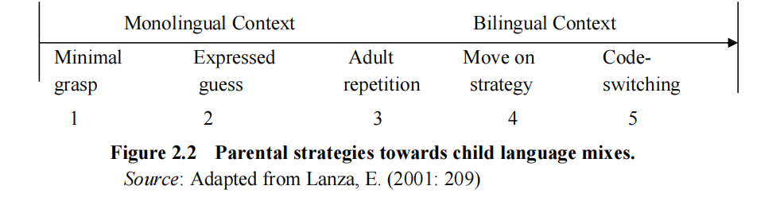

In analyzing parental response, Lanza’s ( 1992) five major parental strategies are
exemplified in the following (1997:263-267). According to Lanza, CS is the most
bilingual strategy among the five, comprising both inter-sentential and intra-sentential
code-switching. By CS, it is meant that the parents switch from their ethnic language to
the other language under discus sion. In a family where one parent–one la nguage rule is practi sed, the parents are expected to use their own ethnic language separately when communicating with their
child. But the parents in the examples above , when responding to a child’s utterance
mixed with the other language, instead of st icking to their own language, either readily
incorporated the child’s misuse of the wrong code in th eir response or alternate to the
other code completely. If the child’s code-switching behavior is an initiation for code
negotiation, the parental response could be a signal that the parents are quite open to
engage in the negotiation initiated.
27
For the child, this would mean that his c ode-switching behavior was quite appropriate
and he would take his parent’s response as a positive sign encouraging his
code-switching. As has been noted by Nicoladis and Genesee (1998), however, the
category is ‘nonspecific’; it could be used for many different purposes like move-on,
clarification request, expressing a guess, or repetition so that it should be further
explained, based on the specific context where
Questions
To achieve these purposes the following questions will be addressed:
1. What are the language choice patterns of the subjects and their parents at home?
2. When do the children code-switch when interacting with their parents in the home
situation?
3. What are the effects of the parental response upon the children’s subsequent
language choice?
4. What are the functional purposes of the children’s code-switching?
5. What are the parental attitudes towards language and language maintenance?

Recommendation
To achieve these purposes the following questions will be addressed:
1. What are the language choice patterns of the subjects and their parents at home?
2. When do the children code-switch when interacting with their parents in the home
situation?
3. What are the effects of the parental response upon the children’s subsequent
language choice?
4. What are the functional purposes of the children’s code-switching?
5. What are the parental attitudes towards language and language maintenance?

When parents express their will in the learning language, they will generally express it again in the form of their mother tongue to facilitate children’s understanding. If the content you want to express has a concept in one language, but there is no concept in another language, code switching will occur. This is a conversion phenomenon between languages, and the concepts missing in another language can be filled by code switching. If the content of learning language expression cannot be understood by children in the process of teaching, then code switching is necessary. The use of code switching in the classroom can promote the communication between the two sides of teaching, and the teachers who teach in the classroom also have great attainments in both languages. Therefore, in the process of teaching, considering the quality of students, they will make some necessary code switching.

References

