Tarek Ahmed
Student ID- 1706496
Lecturer: Renuga jayakumar
Digital skills and research methods
Level 4- Certificate in skills for the workplace

Digital Skills and Research Methods.
Introduction:
In this assignment I will be evaluating about social media and about the modern technology. I will also explain what digital skills and research methods are within a workplace. The modern technology that I will be evaluating is a smartphone and a tablet and I will also be evaluating 3 social media accounts which is Facebook, Twitter and LinkedIn.
What does digital skills mean?
Having digital skills is a very important skill because this skill is being used everywhere. These days in the modern workplace having digital skills will mean that you are highly being valued, digital skills are expanding in everyone’s lives and its not only for those who work within the IT sector. According to ‘’the house of lords’’ it has been said that digital skills must be taught to everyone as a third core subject and it should be treated with the same importance as they would treat numeracy and literacy. It has been stated that having digital skills are being related to being digitally literate, it means that it gives you the ability to communicate and interact with other people. However, in the modern workplace it shows that digital skills are increasing to a point where you will know if you need it or not. Having digital skills, it’s like speaking a language, so its very important for you to be able to adapt these skills and you are being able to use it correctly.
What are research methods and how can this help you within a workplace?
Having research methods within a work place is very important because this will help you with helping the business or organisation grow, if you have the skill or ability to be able to do some research and then apply it to your own work it will make things a lot easier. According to the ‘’Business Dictionary’’ it states that being able to use the process to collect important information and data for helping the business or organisation to make critical decisions. There is also a method for this and it may include public researches, having to do interviews, surveys and other research techniques and this can both present important source of information or not. If you use the research method it will help you and the team to organise their information into one cohesive and conceptual product idea, it will also help with finding new ideas for your company.
The two-modern technology that I have chosen to evaluate is an Apple iPhone and a Samsung tablet.
Apple and Samsung are two different types of technology and they both use completely different software’s to operate.
Apple iPhone:
Apple Inc. is an American multinational technology company headquartered in Cupertino, California that designs, develops, and sells consumer electronics, computer software, and online services. The company's hardware products include the iPhone smartphone, the iPad tablet computer, the Mac personal computer, the iPod portable media player, the Apple Watch smartwatch, the Apple TV digital media player, and the HomePod smart speaker. Apple's consumer software includes the macOS and iOS operating systems, the iTunes media player, the Safari web browser, and the iLife and iWork creativity and productivity suites. Its online services include the iTunes Store, the iOS App Store and Mac App Store, Apple Music, and iCloud.
Specification:
- Capacity- 32GB-128GB
- Software- apple
- Size and weight- 143 grams (5.04 ounces)
- Display- 4.7’’
- Camera- 12 megapixel
- Video recording- 4K video recording at 30 fps
- Facetime HD camera- 5-megapixel photos
- Touch ID- Fingerprint sensor that is built into the home button
- Apple Pay- you could pay using your iPhones touch ID in the shops within the apps to complete your purchases.
Samsung tablet:
The Samsung Galaxy Tablet is an Android-based tablet computer designed and manufactured by Samsung, introduced in 2011. It is part of the Samsung Galaxy Tab series, and features a 10.1-inch display and a 1 GHz dual-core Nvidia Tegra 2 processor.
Specification:
- Weight- 465.00
- Display- 10.50
- Camera- 8-megapixel
- Software- android
These two smart devices are two of the most popular devices that are being used all around the word. Apple iPhone is a very highly popular phone and mostly everyone prefers that because it is easy to use and operate, apple has their very own apple store where you could go on and download apps and games, and many more. You could use this to make and receive calls, send and receive text messages all around the world, to use an iPhone, you will need to insert an activated sim card and you will be ready to go. Whereas the Samsung tablet is quite similar but also different, the tablet doesn’t need a sim card to operate, all you will need to do is add the Wi-Fi on. The system that operates the Samsung tablet is a software called Android, where you could also download apps and games from. There are also apps where you could download and make calls and do video calls from, its not like the iPhone where you could use Facetime which runs on Wi-fi to work, this is a app that you can use to video call, audio call and send messages through, the Samsung doesn’t have a special app like that.
Storage:
The Apple iPhone has an account where you could back up all your important information, photos and videos, this app is called iCloud storage, the Samsung also has something like that which is called google drop box and it does the same thing such as keep your important information and files safe for you. Even if everything gets deleted from any of these devices, one of the good things about the Storages is that you will be able to restore all your information and pictures and photos because it will be saved in the storage. For example, of a tablet will be easier to work on as the screen is a bigger and it will allow you to an actually do some work on there by using the Microsoft processors, whereas on a phone it can be quite difficult because the screen size is small so if you’re working in groups then it will be harder for you to show your employees what you have done.
This is a very good smart device because you will be able to literally use them anywhere and they always come in handy. This will be perfect devices to use within any work place because you can use these types of devices to do research and help you fund useful information. people used these modern technologies to socialize and keep in touch with one another, and it effectively helps you browse the net and you will be able together important and reliable sources from using them. They both use battery and depending on how much you use it or what its being used for the battery life will last longer, if you are using it non-stop then the battery will drain out a lot quicker.

Facebook
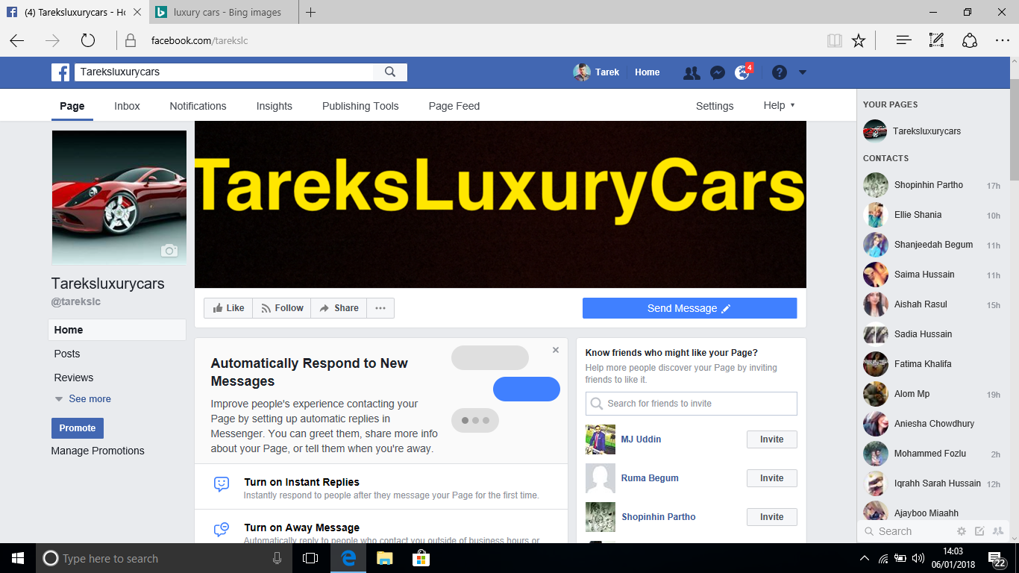
https://www.facebook.com/tarekslc/
Facebook was first created in 2004 by Mark Zuckerberg. Facebook is a social networking website and it’s also a service where people can post comments, share photographs, videos, links and share statues online. You can also you Facebook to promote business accounts, have live chats with people all over the world and you can even stream live videos on there. You can either have your Facebook account on private or on public, of you have it on private then only your friends will be able to view your account and if the account is public then anyone will be able to view it. In the modern life everyone uses Facebook to promote business and sell products. Facebook is not a very hard website to use unlike any other websites. People even use it to advertise jobs and share pages to encourage other people to add them as a friend. Facebook also has a facility where you could send private messages to others as well as send comments on your actual Facebook account. I have made a business account on Facebook to promote my business page, I have added important information which can be viewed by my friends and others.
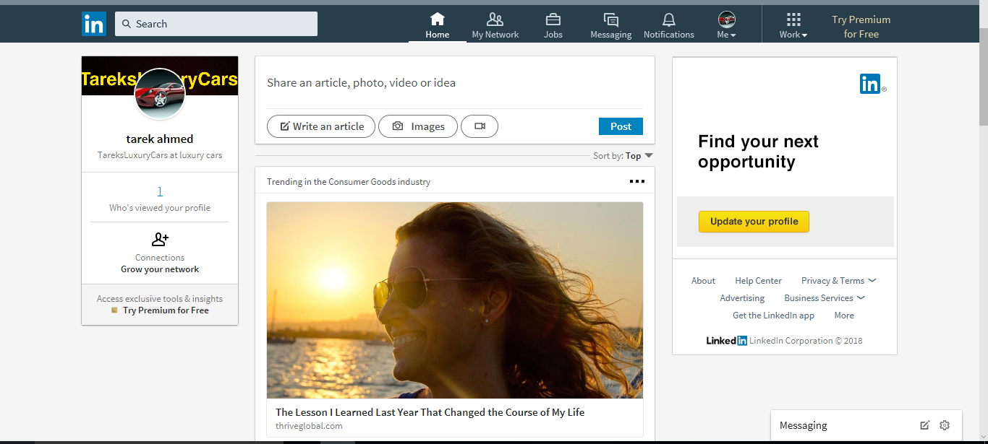
LinkedIn
https://www.linkedin.com/feed/
LinkedIn is a social networking website, but it’s mainly used for professional reasons. LinkedIn allows you to stay in contact with your current and past work colleagues, it allows you to look for jobs, it helps you to discovers new business opportunities and networks within an industry. If you’re a member on LinkedIn it lets you share information and ideas to further your careers and it helps you to achieve personal and professional goals. To use LinkedIn, you will have to give basic information such as your name, date of birth, email mail address, postal cod, the company name, the industry and the title of the job. For security reason when you make an account they will send you a confirmation email to verify your account. You can upload photos, update your personal and professional information and you can also share this without LinkedIn members.

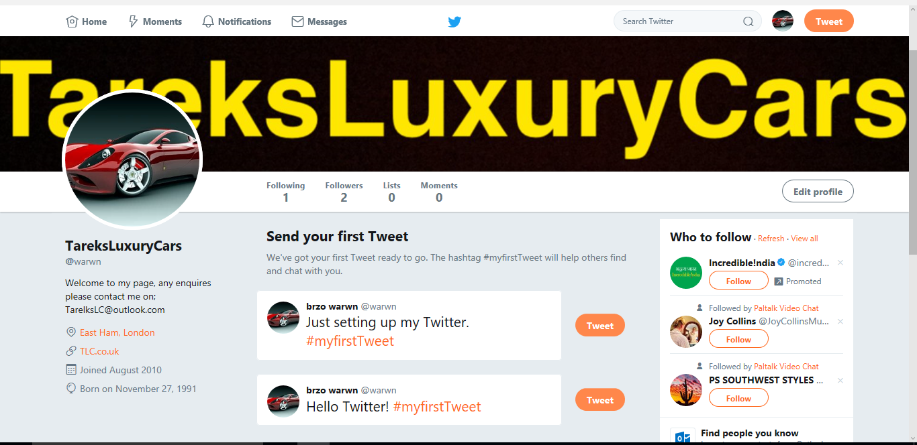
https://twitter.com/warwn
Twitter is also a social media account, on twitter you can also post comments, videos, photos, upload status and communicate with friends, work colleagues and family. Twitter is a global website so its being used all around the world. Twitter can also be used to promote business accounts and you can use it for your own benefits.
All these accounts have their own specialities and how they are being used within a workplace. For example, Facebook will come useful for sharing pages and being able to communicate with work colleagues. LinkedIn will be useful for posting up vacancies and what jobs that are available for people. And lastly twitter can be useful in some kind of way as well because you can share tweets about job opportunities and other sort of promotions or jobs that are available for people.
Conclusion:
I honestly feel that overall that the smart devices all do the same thing, but just through different systems, for example modern technology is very important within a work place because, these days everything is up online and its easier to just use a phone or a tablet to do some quick research other than a laptop or computer, you will also need to make sure you encounter having digital skills because this will make it easier for you to be able to use these modern technologies. Social networking websites such as Facebook, Twitter and LinkedIn all work the same way, but its just the way it is being used. They all do the same thing such as being able to communicate, with friends, families and work colleagues, you can upload images and videos and share links on other people’s pages. Facebook is more likely to be used for socialising with people, LinkedIn is most likely to be used for working purpose such as being able to send out recruitment messages and stuff and Twitter it can be used for any purposes built just like Facebook its mostly used to socialise with friends and family. These days social media and modern technology have become such a big role in peoples lives because this is all they use in their day to day life. These accounts are very easy to register with, they are free of charge and its unlimited you can use them whenever you want. I find that facebook is pone of the most less complicated social network out of them three, only because I had good experience with it and I have used it for a while now.

Reference
https://www.skillsyouneed.com/rhubarb/digital-skills-modern-workplace.html
https://www.bing.com/search?q=apple+iphone&qs=AS&pq=apple+ip&sk=AS1&sc=8-8&cvid=418A38E4B78E4902A095F775D3485A8A&FORM=QBRE&sp=2
https://en.wikipedia.org/wiki/Samsung_Galaxy
https://www.apple.com/uk/iphone-6s/specs/
https://www.lifewire.com/what-is-facebook-3486391

